FE Content in all conditions

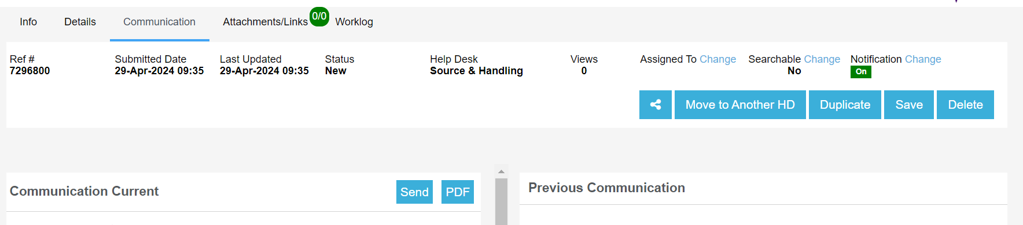

FE Content Draft

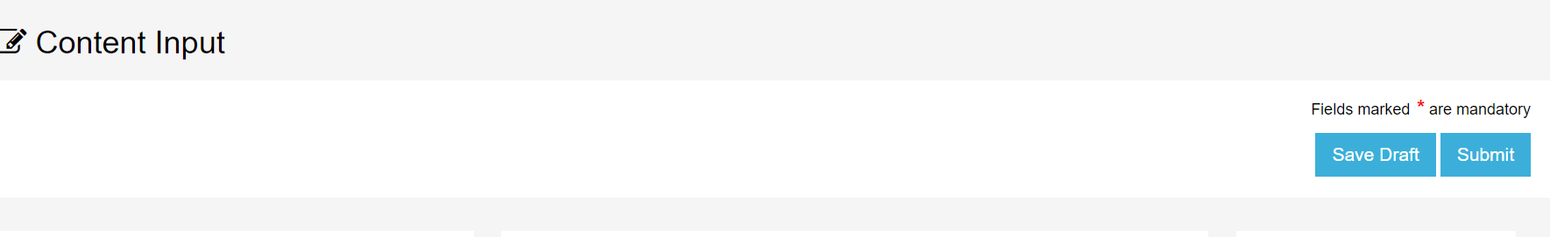

HD Content in all conditions

