------------------------------------------------------------------------------------------------------------------------------------------

_____________________________________________________________________________________

*Assignment # 2*

**ASSIGNMENT TOPIC:**

* PowerPoint.

Department: **Computer Science**

Course Title:

**Fundamental of ICT (Lab)**

Course Code: CS**-101**

**Date of Submission: 28/March/2021**

Submitted to: **Ma’am Syeda Hafsa**

Submitted by: **Muhammad (391855)**

1st Semester,

Session **2021-2025**

_____________________________________________________________________________________

**INTRODUCTION:**

Microsoft PowerPoint can be a powerful classroom tool. Used ineffectively, however, its technical bells and whistles can obscure educational content, turning a great lesson into computer chaos. The Education World Tech Team offers ideas on how to use PowerPoint to enhance, rather than overshadow, student learning. Included: A detailed lesson plan and rubric, an equation for creating your own PowerPoint rubric, a completed student presentation, and dozens of tips for ensuring effective PowerPoint presentations in your classroom.

**OVERVIEW:**

With PowerPoint on your PC, Mac, or mobile device, you can:

* Create presentations from scratch or a template.
* Add text, images, art, and videos.
* Select a professional design with PowerPoint Designer.
* Add transitions, animations, and cinematic motion.
* Save to OneDrive, to get to your presentations from your computer, tablet, or phone.
* Share your work and work with others, wherever they are.

**INTERFACE:**

When we run MS PowerPoint, we will see the following presentation window.

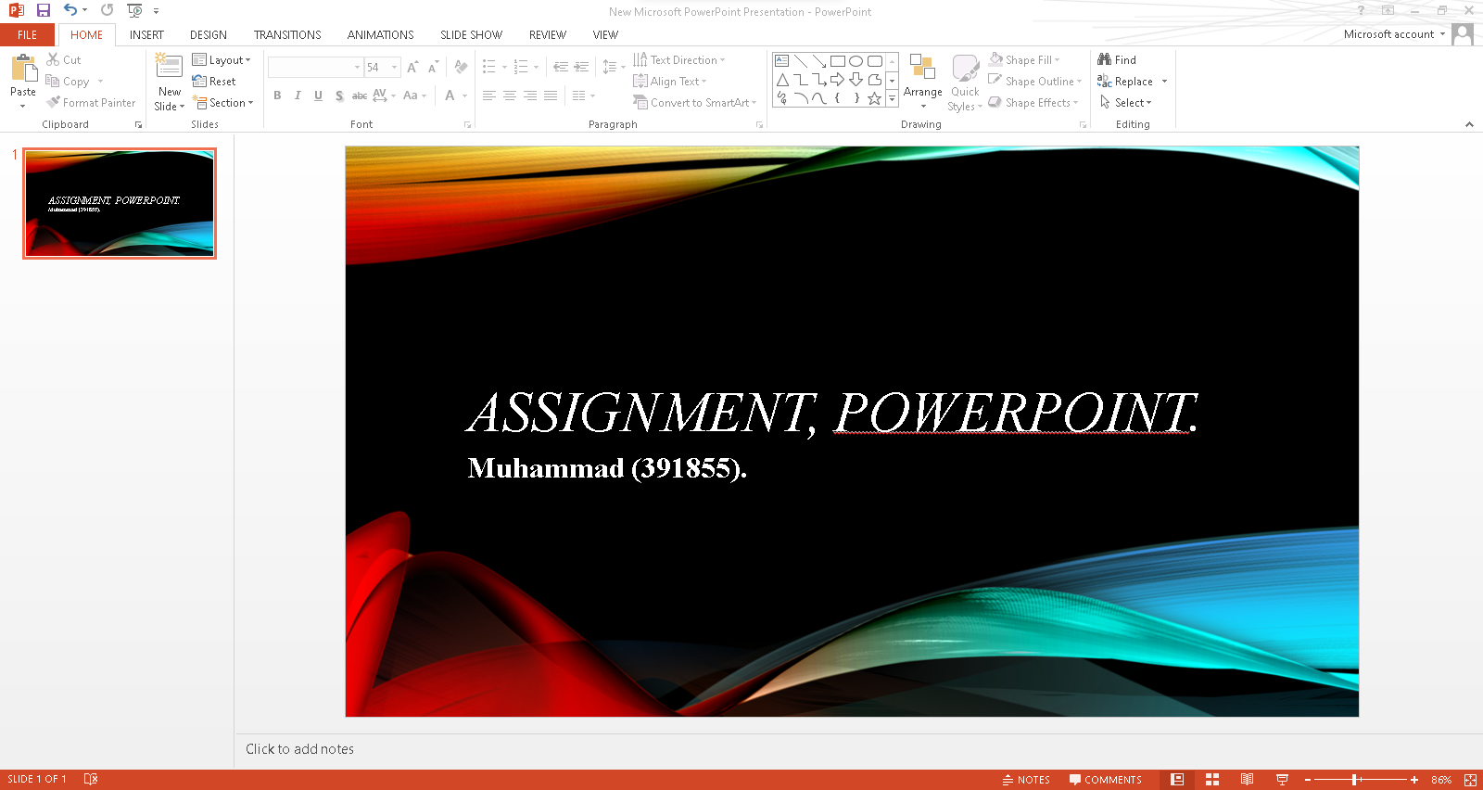

The PowerPoint interface, including the Ribbon, the Slides tab, the presentation window, the Notes pane, the Comments pane, the Quick Access toolbar, and the Status bar. The Slides tab shows a thumbnail of each slide in the presentation. The presentation window is where you can view and edit the entire slide. As labeled and given below:

**Notes pane**

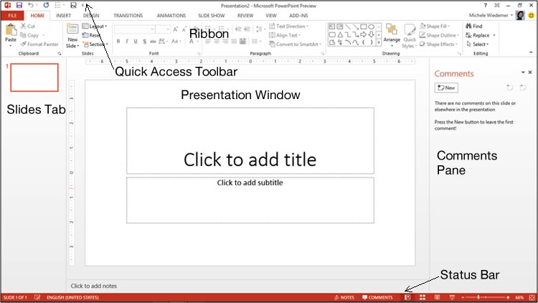

**TABS:**

The main tabs of MS PowerPoint are FILE, HOME, INSERT, DESIGN, TRANSITIONS, ANIMATIONS, SLIDE SHOW and REVIEW.

1. **File:** At one end of the ribbon is the File tab, which you use for the behind-the-scenes stuff you do with a file, such as opening, saving, sharing, exporting, printing and managing your presentation. Click the File tab to open a new view called the Backstage and to return to the presentation that you were working on.

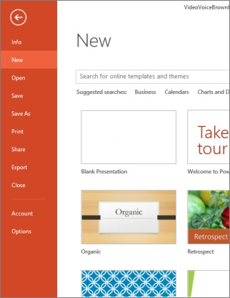

1. **Home:** It is the second tab in the menu ribbon located at the top of the screen. It is between the “File” tab and the “Insert” tab. When you open a new PowerPoint file, the “Home” tab will be open in the menu ribbon by default. The Home tab holds the Cut and Paste features, Font and Paragraph options, and what you need to add and organize slides.

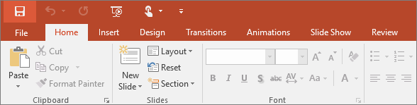

1. **Insert:** To insert tabs in PowerPoint, first enable the ruler, if needed, by checking the “Ruler” checkbox in the “Show” button group on the “View” tab of the Ribbon. Then select the paragraphs in the text-containing slide object for which to set tab stops in PowerPoint.

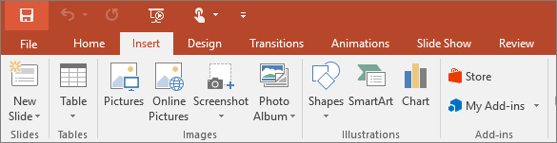

1. **Design:** It is the same whether you're using a Mac or PC computer, iPad, Android, or Windows tablet, or PowerPoint Online. If it's not already open, display the Design Ideas pane on the right side of the screen by clicking "Design Ideas" in the ribbon. You can find it in the "Design" tab. It changes the content of the slide. It adds functionality to the slide.

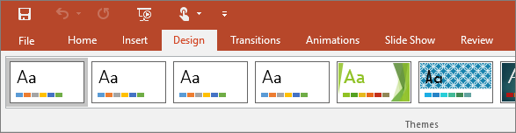

1. **Transitions:** The transitions tab contains the Transitions to This Slide group. From this group choose a special effect to be applied during the transition between the previous slides to the next slide. To apply transition schemes to all the slides in your presentation select Apply to All.

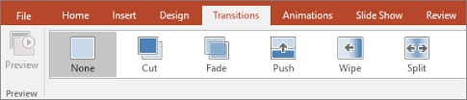

1. **Animations:** Itallows you to view and manage all of the effects that are on the current slide. You can modify and reorder effects directly from the Animation Pane, which is especially useful when you have several effects.

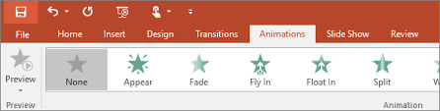

1. **Slide Show:** It is used to display the presentation on or from your computer. This is the best way to view or preview your presentation to ensure it is clear, focused and has the impact on your audience that you want.

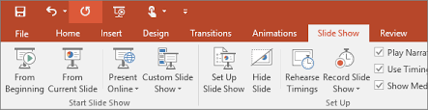

1. **Review:** The Review tab lets you add comments, run spell-check, or compare one presentation with another (such as an earlier version).

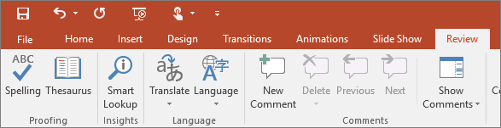

**THE END!**