

**Lab Manual**

**CS-100: Fundamentals of ICT**

**Department of Computer Science**

**Lab Engineer: Ma’am Syeda Hafsa**

**Name: Muhammad**

**CMS Id: 391855**

**Submission date: 12/April/2022**

**Total Marks: __________**

**Lab # 01:**

**Introduction to Motherboard.**

**What is the motherboard?**

MOTHERBOARD: In simple words, it is the main circuit board for a computer, it is also called, CPU board. Or the motherboard is the vertebral column that linkup the computer's components together at one patch and allows them to interact to each other. Without CPU board, not any of the computer parts, such as the CPU, GPU, or hard drive, could act together. The complete motherboard functionality is needed for a computer to work well and perfectly. It is the motherboard that connects all the components of the computer, that is to say, peripheral equipments which are known as input and output devices and storage devices and many more. Without any doubts, the absent of motherboard a computer cannot work. That is why, the above discussed one is the chief means of computer. 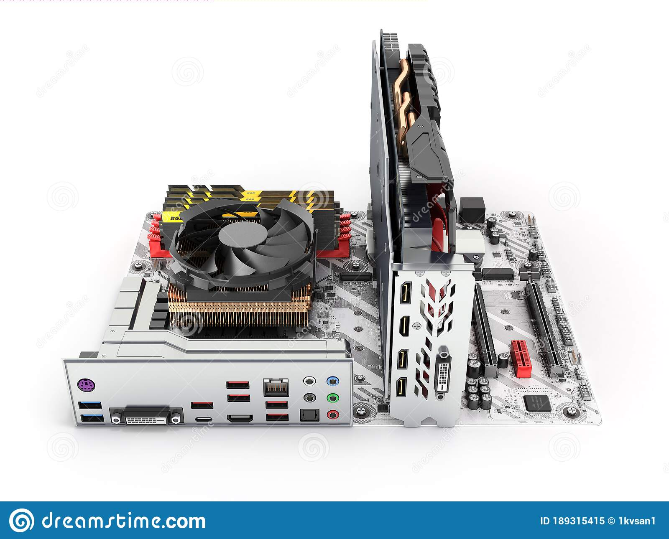

**What are the components of it?**

The major components are Optical drives, such as DVD and CD-ROM drive, Video cards and GPUs, sound cards, hard drives (SSD or HDD), processors (CPU), USB (Universal serial bus), memory sticks (RAM), Parallel port, floppy controller, CPU slot, power supply plug in and theconnector Side of Motherboard and so on.

**DVD:** It stands for digital video disc, used for recording movie and others that can be played on a computer or a television set.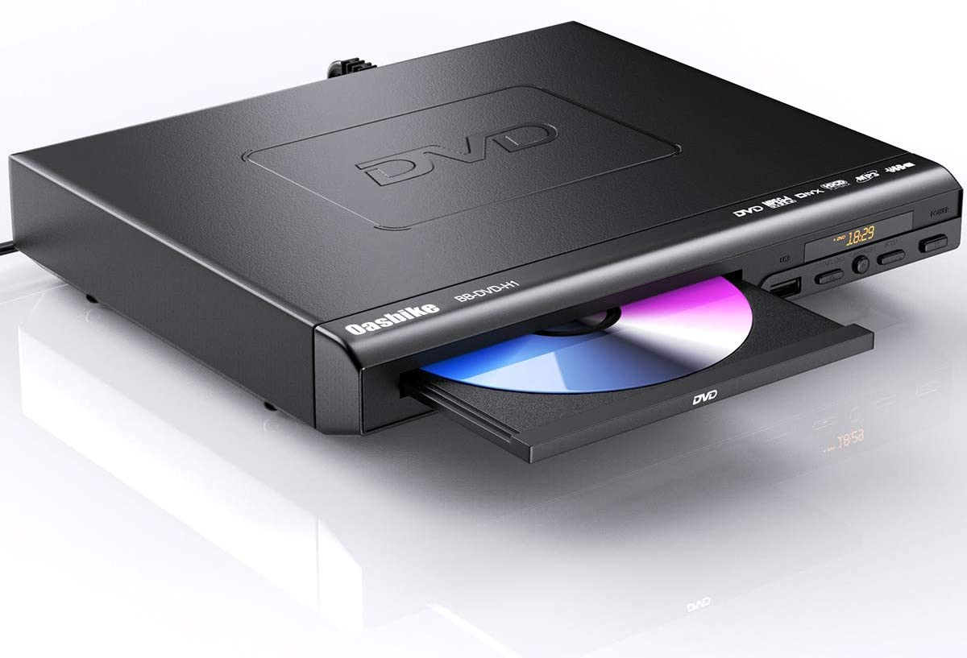

**CD-ROM drive:** “CD” stands for compact disc. CD-ROM drive is connected to a computer to play a CD-ROM.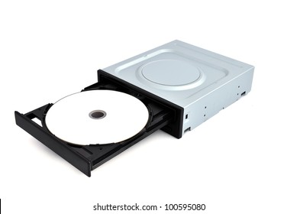

**Video Cards and GPUs:** These are also called graphics card. GPU (Graphics processing unit), provides a good graphic and used in video editing, and gaming applications.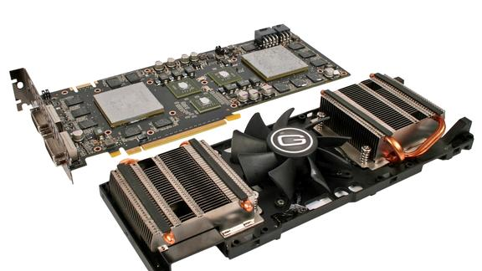

**Sound cards:** These are slotted into a computer to produce sound.

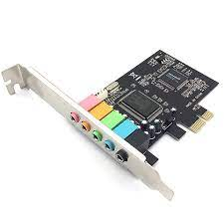

**Hard drives (SSD or HDD):** A hard disk drive (HDD), hard disk, hard drive, or fixed disk is an electro-mechanical data storage device that stores and retrieves digital data. Solid State drive (SSD) is a newer, faster type of device that stores data. 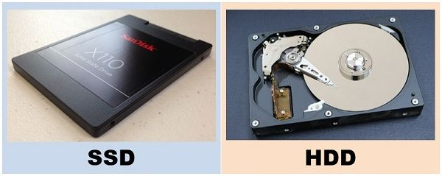

**Processors (CPU):** It is the brain of the computer and processes the instructions which are given to the computer.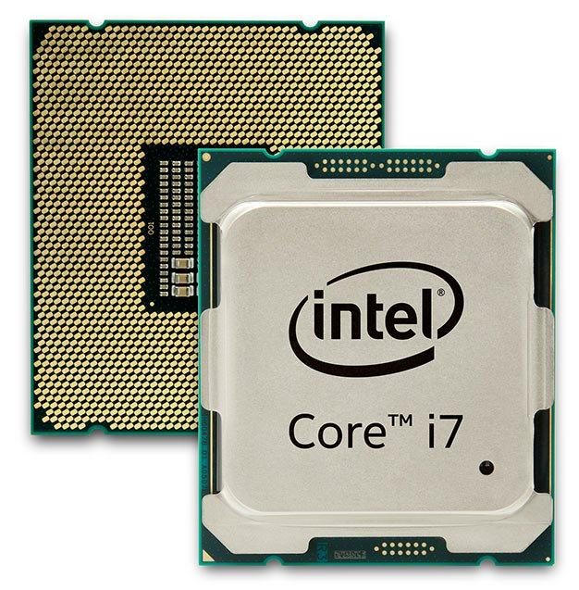

**USB (Universal serial bus)**: It is used to store data, keep the backup of it and communicate with other sources. 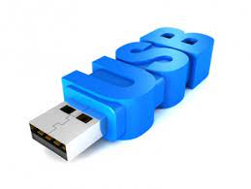

**Memory sticks (RAM):** Random Access memory (RAM) stores the data to manipulate it into useful information temporally.

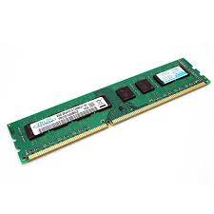

**Parallel Port:** It is a very old port can be found in early computer and functions to connect peripherals.

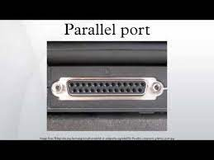

**Floppy controller:** It is an electronic chip controller used as an interface between a computer and a floppy disk drive.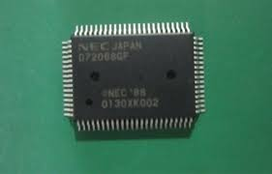

**CPU Slot:** It is slot on the motherboard to bring connection between CPU and motherboard.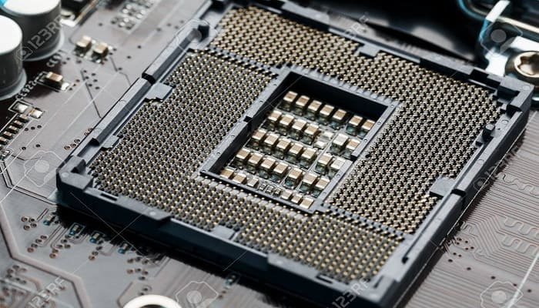

**Power Supply Plug In:** It provides supply to the motherboard.

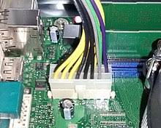

**The connector Side of Motherboard is shown in the picture below;**

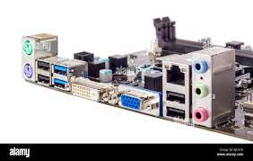

**Lab # 02**

**Introduction to HTML:**

**Part 01:**

**A research paper by html;**

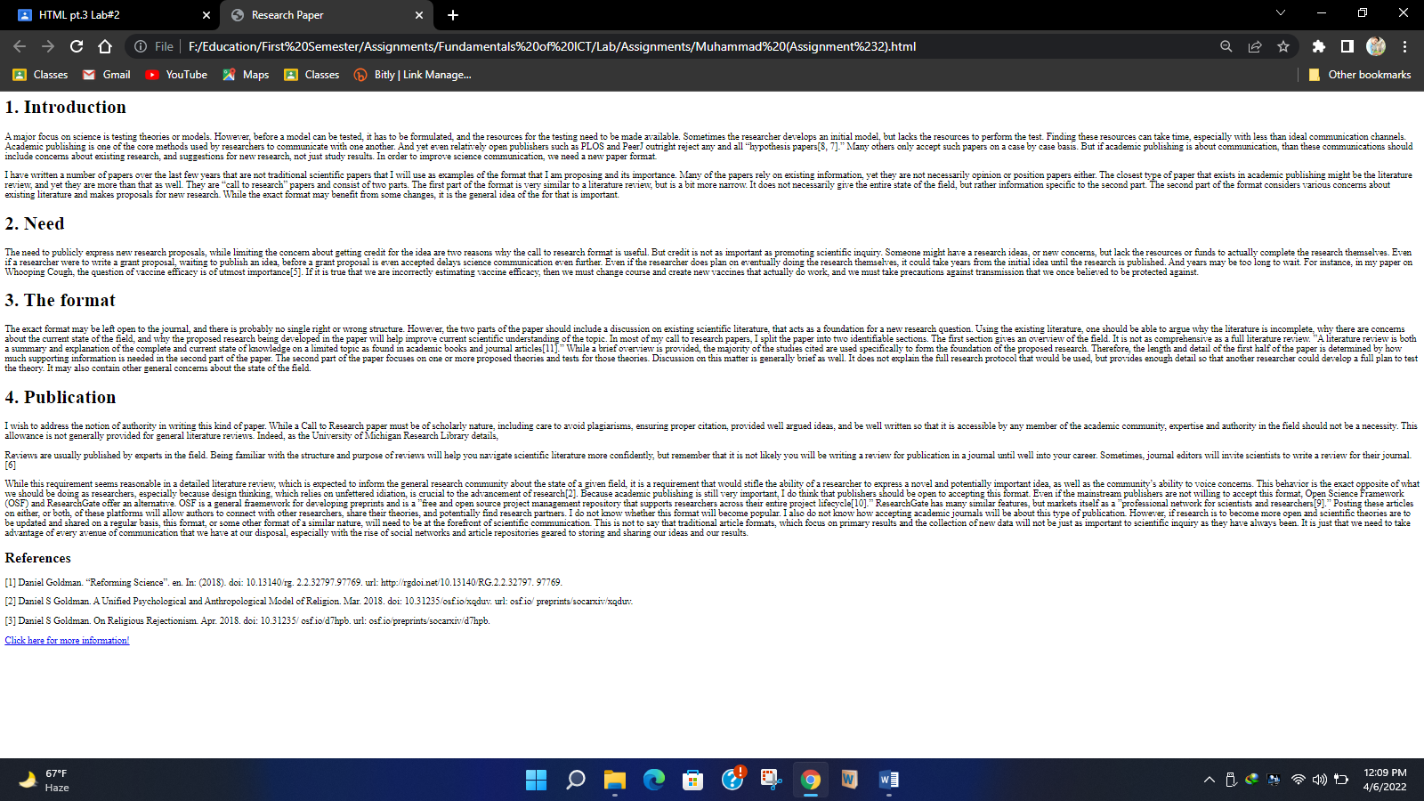

**Lab # 03**

**Introduction to HTML:**

**Part 02:**

**Headings, paragraph, color, different font style and table by html.**

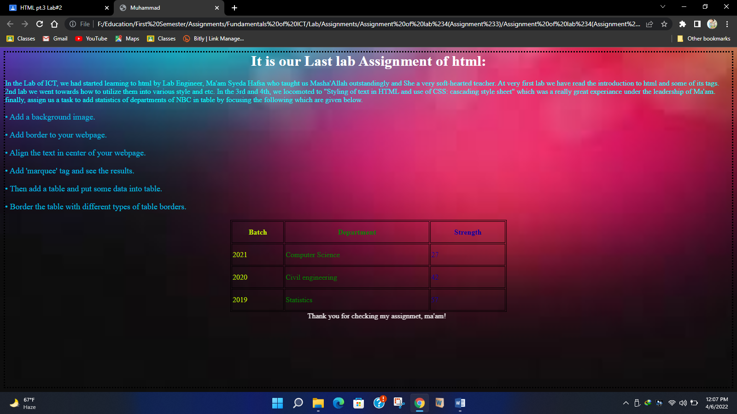

**Lab # 04**

**Pseudo code and flow chart.**

1. **Draw a flowchart of two numbers from user and display the largest of two numbers.**
2. **Write pseudo code for this program**

**FLOWCHART:**

INPUT num1;

INPUT num2;

IF num1 > num2;

**FALSE**  **TRUE**

PRINT (“The Largest number is”) num1;

PRINT (“The Largest number is”) num2;

**PSEUDO CODE:**

**BEGIN**

**INTEGER** num1, num2;

**OUTPUT** ("Enter the first number: ")

**INPUT** num1

**OUTPUT** ("Enter the second number: ")

**INPUT** num2

**IF** num1>num2

**OUTPUT** (“The largest number is num1”)

**ELSE**

**OUTPUT** (“The largest number is num2”)

**END**

**Lab # 05**

**Google docs and surveys**

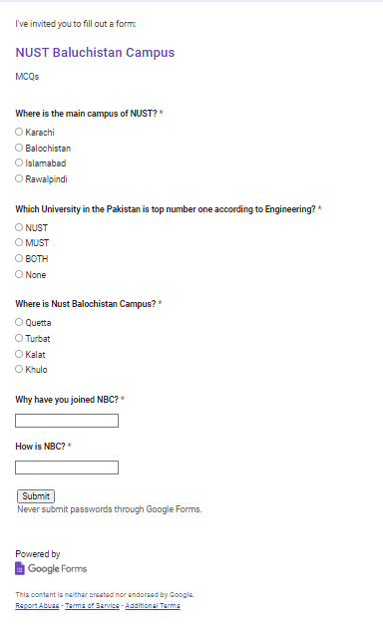

**Lab # 06**

**Search engines and Internet.**

**Search engines:**

With billions of websites online today, there is a lot of information on the Internet. Search engines make this information easier to find. Let's look at the basics of using a search engine, as well as some techniques you can use to get better search results.

**How to search the Web?**

There are many different search engines you can use, but some of the most popular include Google, Yahoo!, and Bing. To perform a search, you'll need to navigate to a search engine in your web browser, type one or more keywords—also known as search terms—then press Enter on your keyboard.

**What is the Internet?**

The Internet is a global network of billions of computers and other electronic devices. With the Internet, it's possible to access almost any information, communicate with anyone else in the world, and do much more. You can do all of this by connecting a computer to the Internet, which is also called going online. When someone says a computer is online, it's just another way of saying it's connected to the Internet.

**What is the Web?**

The World Wide Web—usually called the Web for short—is a collection of different websites you can access through the Internet. A website is made up of related text, images, and other resources. Websites can resemble other forms of media—like newspaper articles or television programs—or they can be interactive in a way that's unique to computers. The purpose of a website can be almost anything: a news platform, an advertisement, an online library, a forum for sharing images, or an educational site like us! Once you are connected to the Internet, you can access and view websites using a type of application called a web browser. Just keep in mind that the web browser itself is not the Internet; it only displays websites that are stored on the Internet.

**How does the Internet work?**

At this point you may be wondering, how does the Internet work? The exact answer is complicated and would take a while to explain. Instead, let's look at some of the most important things you should know. It's important to realize that the Internet is a global network of physical cables, which can include copper telephone wires, TV cables, and fiber optic cables. Even wireless connections like Wi-Fi and 3G/4G rely on these physical cables to access the Internet. When you visit a website, your computer sends a request over these wires to a server. A server is where websites are stored, and it works a lot like your computer's hard drive. Once the request arrives, the server retrieves the website and sends the correct data back to your computer. What's amazing is that this all happens in just a few seconds!

Lab # 07

**Microsoft Word:**

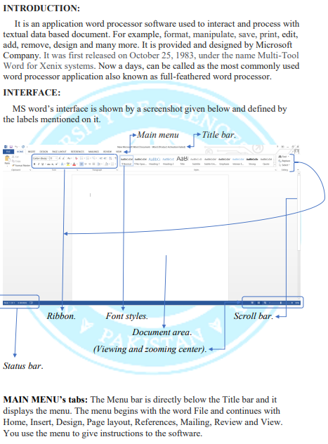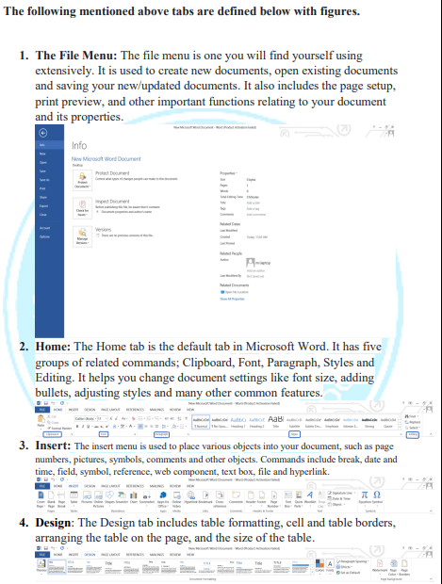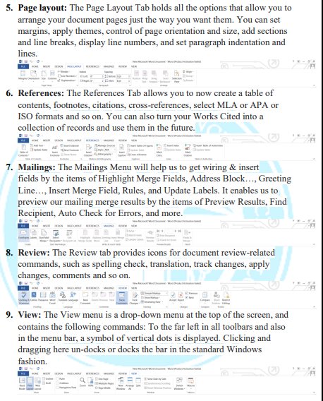

**Lab # 08**

**Microsoft PowerPoint**

**INTRODUCTION:**

Microsoft PowerPoint can be a powerful classroom tool. Used ineffectively, however, its technical bells and whistles can obscure educational content, turning a great lesson into computer chaos. The Education World Tech Team offers ideas on how to use PowerPoint to enhance, rather than overshadow, student learning. Included: A detailed lesson plan and rubric, an equation for creating your own PowerPoint rubric, a completed student presentation, and dozens of tips for ensuring effective PowerPoint presentations in your classroom.

**OVERVIEW:**

With PowerPoint on your PC, Mac, or mobile device, you can:

* Create presentations from scratch or a template.
* Add text, images, art, and videos.
* Select a professional design with PowerPoint Designer.
* Add transitions, animations, and cinematic motion.
* Save to OneDrive, to get to your presentations from your computer, tablet, or phone.
* Share your work and work with others, wherever they are.

**INTERFACE:**

When we run MS PowerPoint, we will see the following presentation window.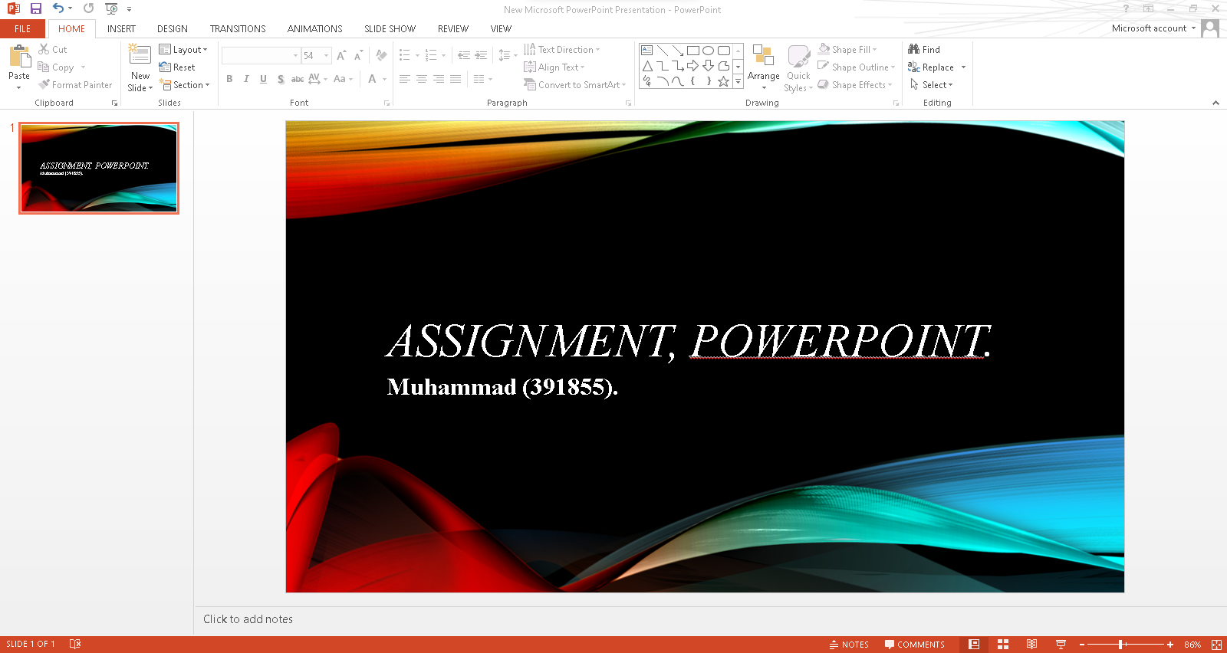

The PowerPoint interface, including the Ribbon, the Slides tab, the presentation window, the Notes pane, the Comments pane, the Quick Access toolbar, and the Status bar. The Slides tab shows a thumbnail of each slide in the presentation. The presentation window is where you can view and edit the entire slide. As labeled and given below: 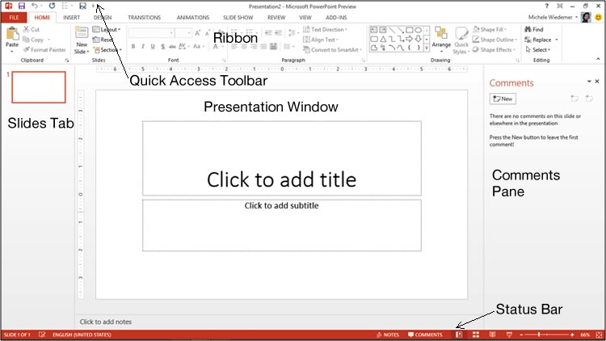

**Notes pane**

**TABS:**

The main tabs of MS PowerPoint are FILE, HOME, INSERT, DESIGN, TRANSITIONS, ANIMATIONS, SLIDE SHOW and REVIEW.

1. **File:** At one end of the ribbon is the File tab, which you use for the behind-the-scenes stuff you do with a file, such as opening, saving, sharing, exporting, printing and managing your presentation. Click the File tab to open a new view called the Backstage and to return to the presentation that you were working on.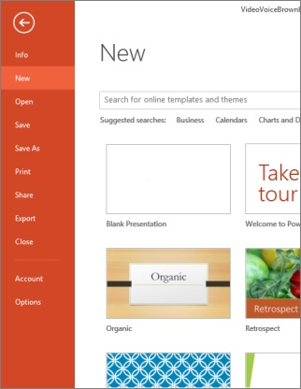
2. **Home:** It is the second tab in the menu ribbon located at the top of the screen. It is between the “File” tab and the “Insert” tab. When you open a new PowerPoint file, the “Home” tab will be open in the menu ribbon by default. The Home tab holds the Cut and Paste features, Font and Paragraph options, and what you need to add and organize slides.

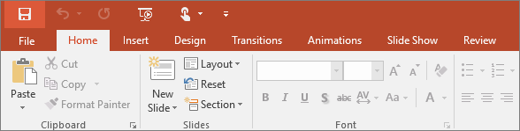

1. **Insert:** To insert tabs in PowerPoint, first enable the ruler, if needed, by checking the “Ruler” checkbox in the “Show” button group on the “View” tab of the Ribbon. Then select the paragraphs in the text-containing slide object for which to set tab stops in PowerPoint.

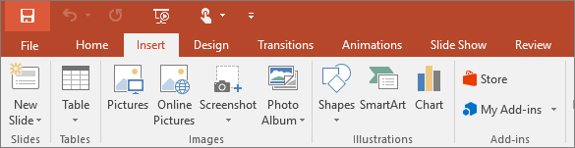

1. **Design:** It is the same whether you're using a Mac or PC computer, iPad, Android, or Windows tablet, or PowerPoint Online. If it's not already open, display the Design Ideas pane on the right side of the screen by clicking "Design Ideas" in the ribbon. You can find it in the "Design" tab. It changes the content of the slide. It adds functionality to the slide.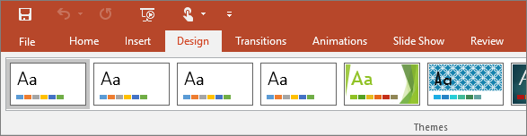
2. **Transitions:** The transitions tab contains the Transitions to This Slide group. From this group choose a special effect to be applied during the transition between the previous slides to the next slide. To apply transition schemes to all the slides in your presentation select Apply to All.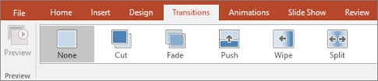
3. **Animations:** Itallows you to view and manage all of the effects that are on the current slide. You can modify and reorder effects directly from the Animation Pane, which is especially useful when you have several effects.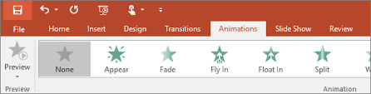
4. **Slide Show:** It is used to display the presentation on or from your computer. This is the best way to view or preview your presentation to ensure it is clear, focused and has the impact on your audience that you want. 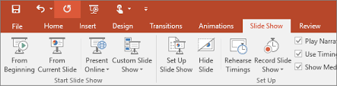
5. **Review:** The Review tab lets you add comments, run spell-check, or compare one presentation with another (such as an earlier version). 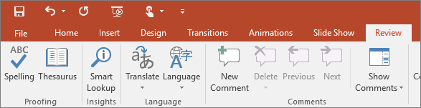

**THE END!**