

**PROMUN**

**Promob**

Promun Mobile Platform

Contents

1. Overview 3

2. Layouts and Functionality 4

2.1. Promob Start-Up Activity 4

2.1.1. The Log in screen: 4

2.1.2. Select a module 5

2.2. Electronic Meter Reading Activity 6

2.2.1. Select Route to read 6

2.2.2. Procedures: How to read a specific route 7

2.2.3. Meter Data Manipulation 8

2.2.4. The “search” function: 11

2.2.5. End meter procedure 14

2.2.6. Abort route 16

2.3. Asset Tracking Activity 17

2.3.1. Expanded Room List 17

2.3.2. Capture Screen 18

2.3.3. Summary of Scanned Room 19

2.3.4. Expanded Room Summary 20

2.3.5. Scanned Asset Details 21

2.3.4. Options List 23

2.3.5. Gallery View 24

2.4. Stock Taking 25

2.4.1. The Warehouse View 25

2.4.2. Stock Capture View 26

3. Minimum Technical Requirements 27

1. Glossary ………………………………………………………………………………..27
   1. How to swipe and long-click ……………………………………………………. 27
   2. Input Controls ……………………………………………………………………. 28

# Overview

The most widely used mobile operating systems is currently **ANDROID**. It most commonly comes installed on a variety of smartphones and tablets.

Promob is designed to allow integration with Promun to perform specific functions from outside of Promun. Currently Promob has two functions – with more to be added – electronic meter reading (EMR) and barcode scanning for asset tracking.

The EMR enables quick and easy electronic meter reading with the use of an android mobile device integrated with the PROMUN system.

This enables the user to keep track of the status of a specific route, in other words which addresses within that specific route has been visited, how many should still be visited and how many the user gave a reading to.

The benefits of the EMR is it provides a more accurate meter reading, as well as improved billing.

The barcode scanning allows for a simpler method of asset tracking without the need for a unique scanning device that will integrate with the PROMUN system.

This will allow for quicker tracking and make available summary data. This can then be used to ensure each asset recorded in Promun can be tracked. Promob will also allow a user to suggest condition and useful life changes after making physical inspections of the asset.

The benefits provided will be simplicity and accuracy as data can be recorded and added on-site as well as provide GPS coordinates for an even more precise tracking.

This manual will provide the user with a comprehensive guideline on how the application should be used on the android mobile device.

# Layouts and Functionality

## Promob Start-Up Activity

### The Log in screen:

When opening the application, it will direct the user to a log in screen.

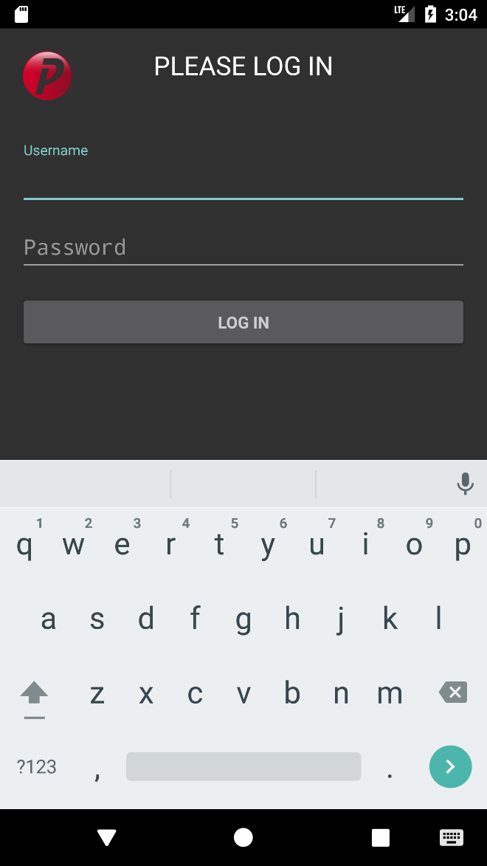

2. Enter your password

1. Enter your username

3. After completing steps 1 and 2 tap on the log in option

KEYPAD

* The user must provide his/her unique username and password.
* After this has been entered the user can now tap on the “log in” option.
* During the use of *Promob*, the user will be asked to allow *Camera, File* and *Location* permissions

### Select a module

Upon successful log in the user will then see the following screen:

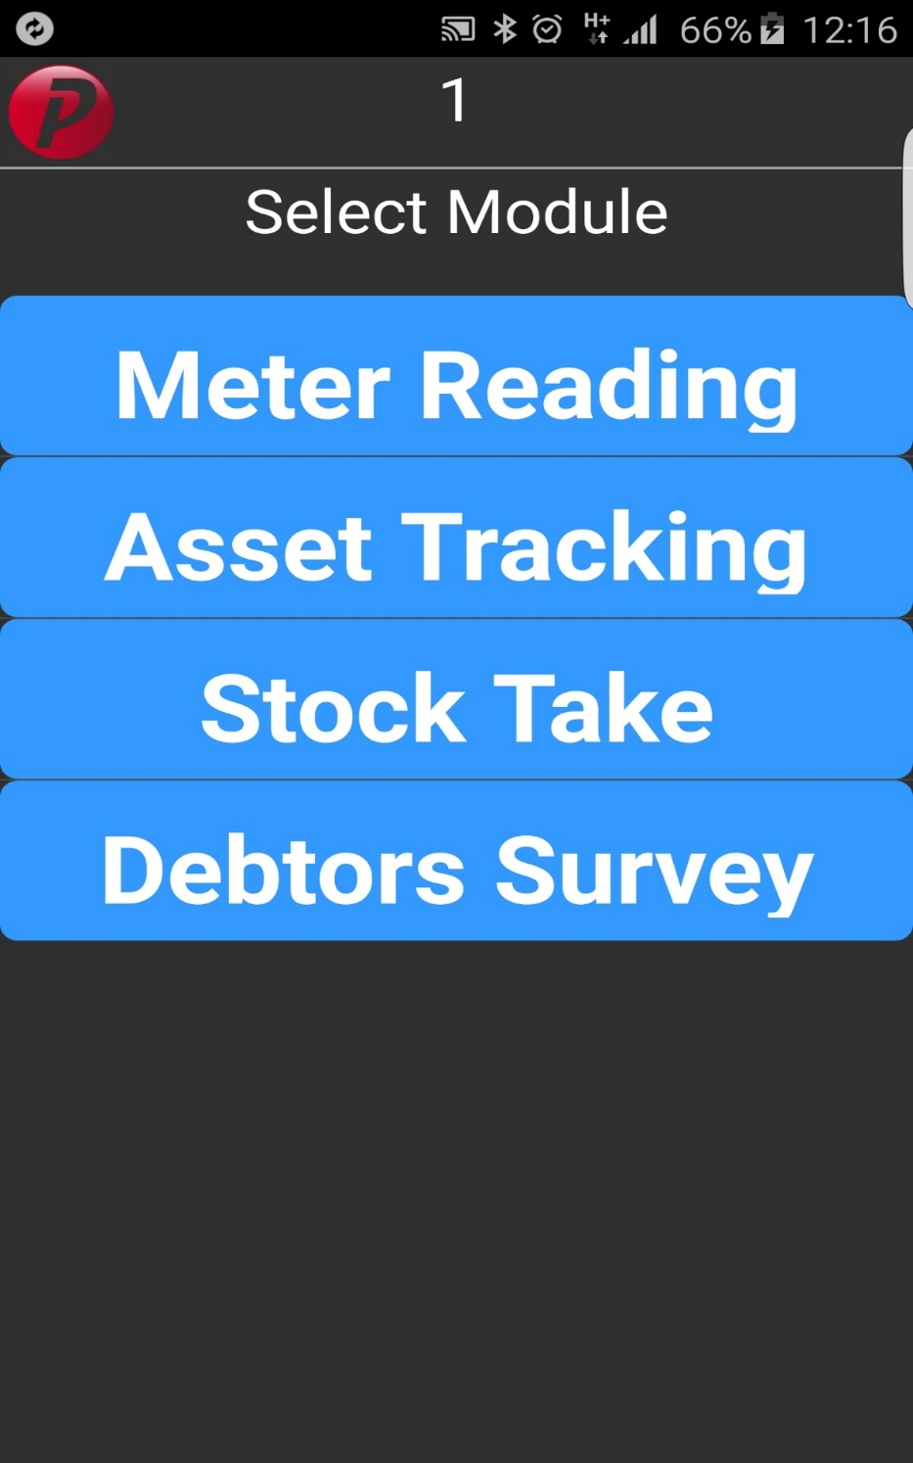

5. These are the various applications which the user can choose from.

4. Shows the current user logged in

* This screen provides all the applications which the user can access.
* The user must select the module which he/she would like to work in.

## Electronic Meter Reading Activity

## Select Route to read

After selecting your module, a new screen will open which will ask you to select the route which you wish to read.

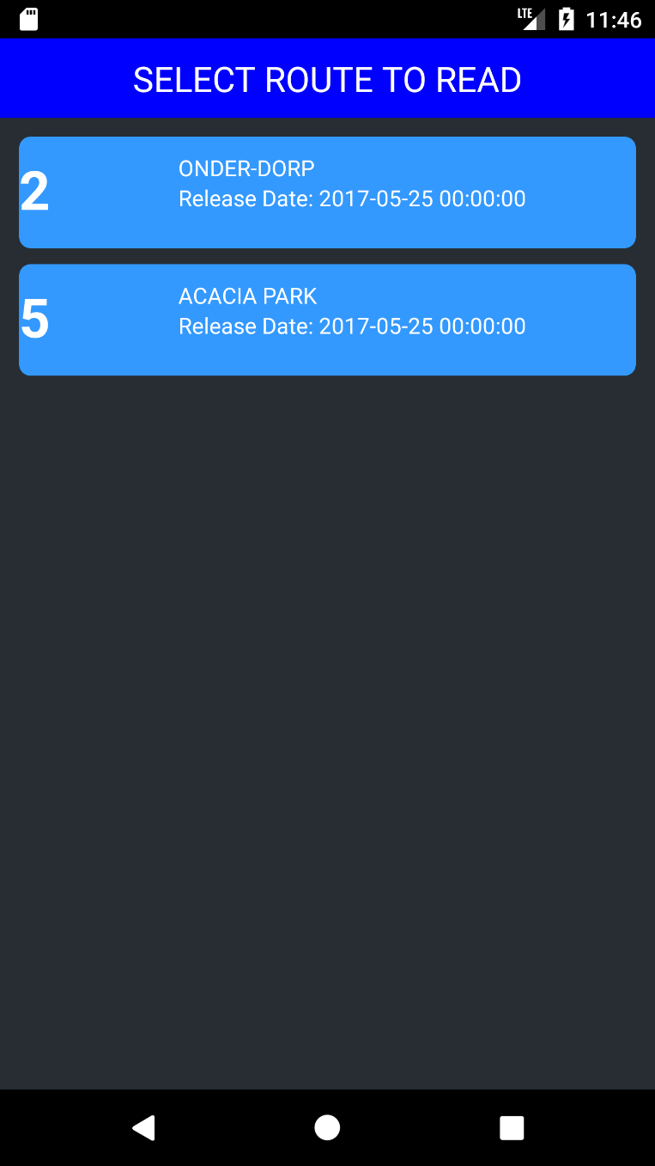

6. Available routes

* Each route has got its own unique route number and route name.
* You will also notice that below the route name there is a release date. – **This date is very important because it tells you when the route is available for reading. In other words, the reading of that specific route cannot be captured before the release date and not before the time specified.**

### Procedures: How to read a specific route

8. Address of where meter is situated.

7. Current route

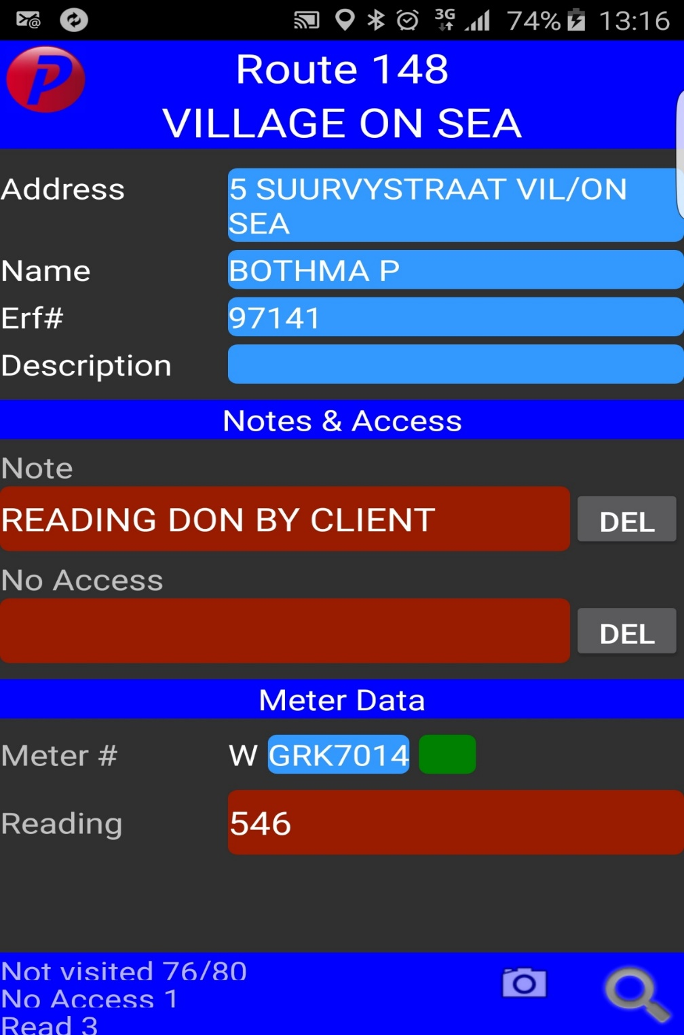

10. Specifies the erf number link to the address

11. If the user wishes to delete a note he/she must use the long-click function on the delete button

9. Specifies the name of the person living / owner at the address

12. Notes and no access: refer to glossary for ***INPUT CONTROLS***

### Meter Data Manipulation

13. Meter #: Specifies whether it is a water or an electricity meter with its meter number

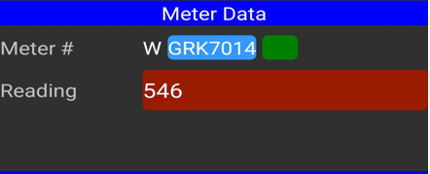

14. Reading: Here the user specifies the actual reading of the meter. (tap on the reading line provided and the below screen will appear

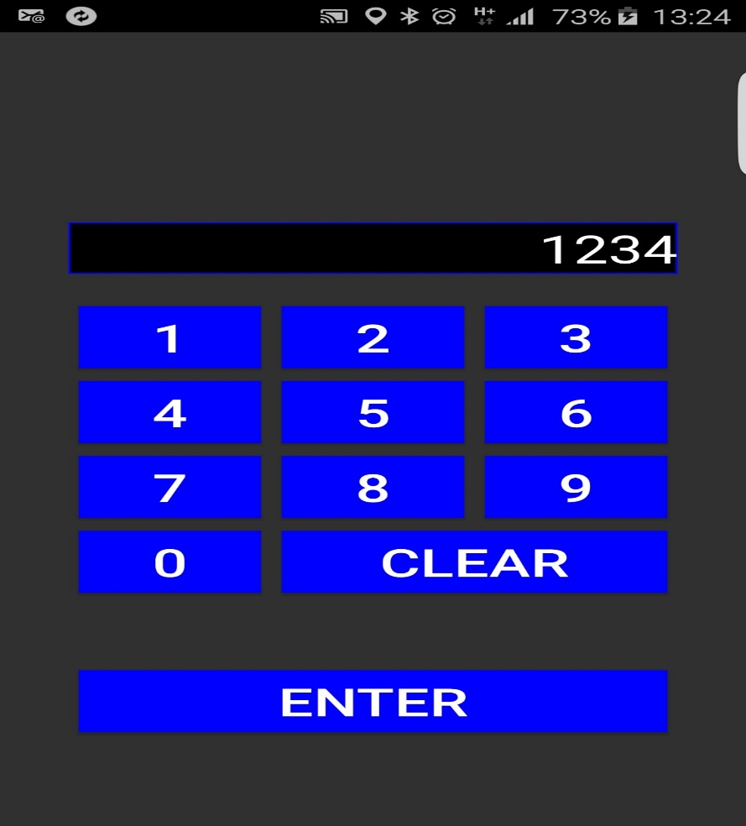

When a reading is captured incorrectly the user can long-click on the reading field again and it will take you back to the (right) keypad screen.

* Here the user has an option to clear the whole reading or just changing one digit (tap on clear once and it will backspace).
* Reader can then fix the mistake and tap on ENTER.

This icon changes colour depending on the previous and current reading data. The different colour codes are; the reader does not know the previous reading because it is not provided by the application. The above icon is there to indicate if the reading keyed in by fieldworker is in range or not.



* When colour code is “green” – It means that the reading accepted and in range.

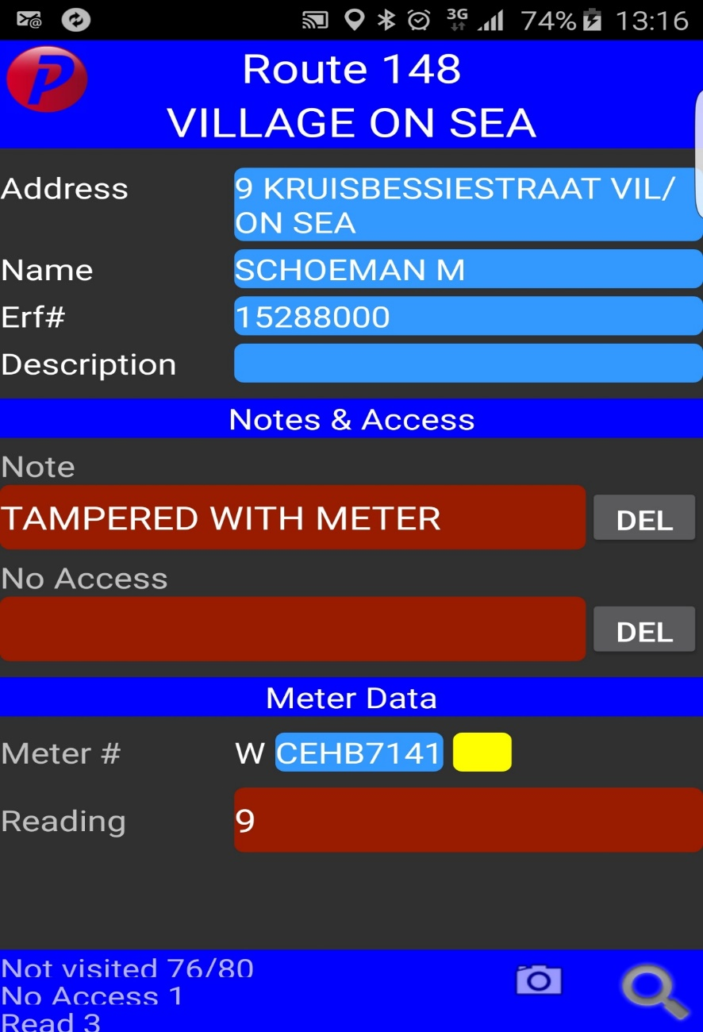

* When colour code is “yellow” – It means that the reading is out of range.
* The field worker can now type in a note to specify why this reading is out of range. (Long-click on the note line provided and the list which the user will have to choose from will appear).

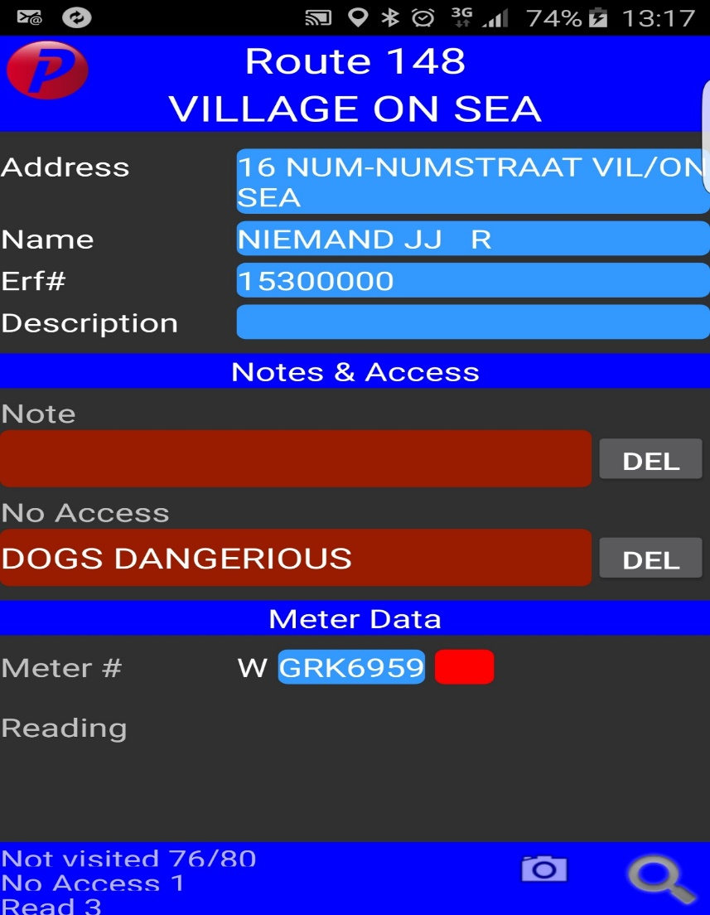

* When the colour code is “Red” – It means that there was no reading provided.
* In this case the Field worker should give a reason as to why there is no reading provided – This can be specified in the “No Access” line (long-click on the no access line provided and the list of possible reason as to why the reading could not be done will appear.
* When choosing your reason as to why you could not access the meter you will then notice that the “icon” automatically changes to red.

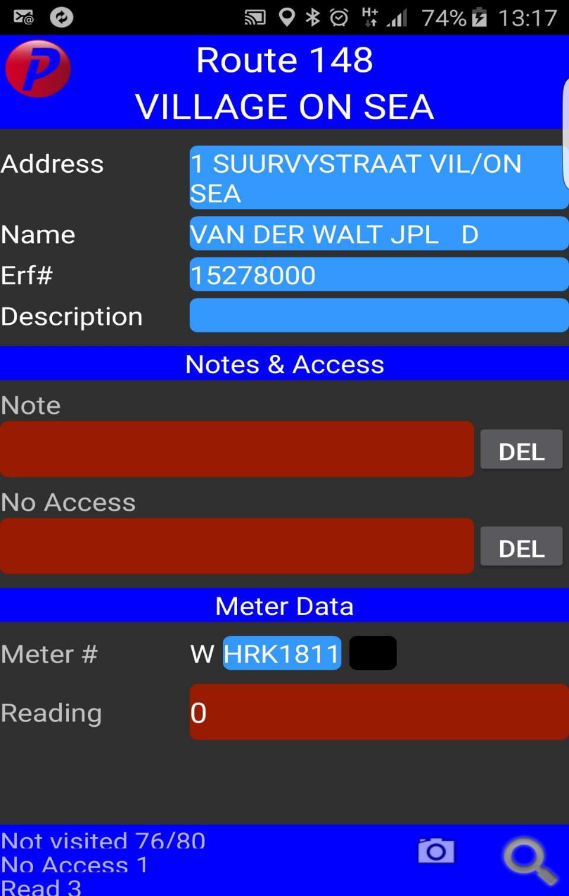

* When the colour code is “Black” – It means that this address has not been visited yet.

At the bottom of the screen you will see the below:

15. Keeps you on track of the number of meters read

16. [Search function](search#_The_)



* *Not visited* – Number of Addresses that were not visited within the specific route.
* *No Access* – Number of Addresses visited but for some reason field worker could not get access to the meter.
* *Read* – Number of meters read.

### The “search” function:

When tapping on this function the following screen will appear:

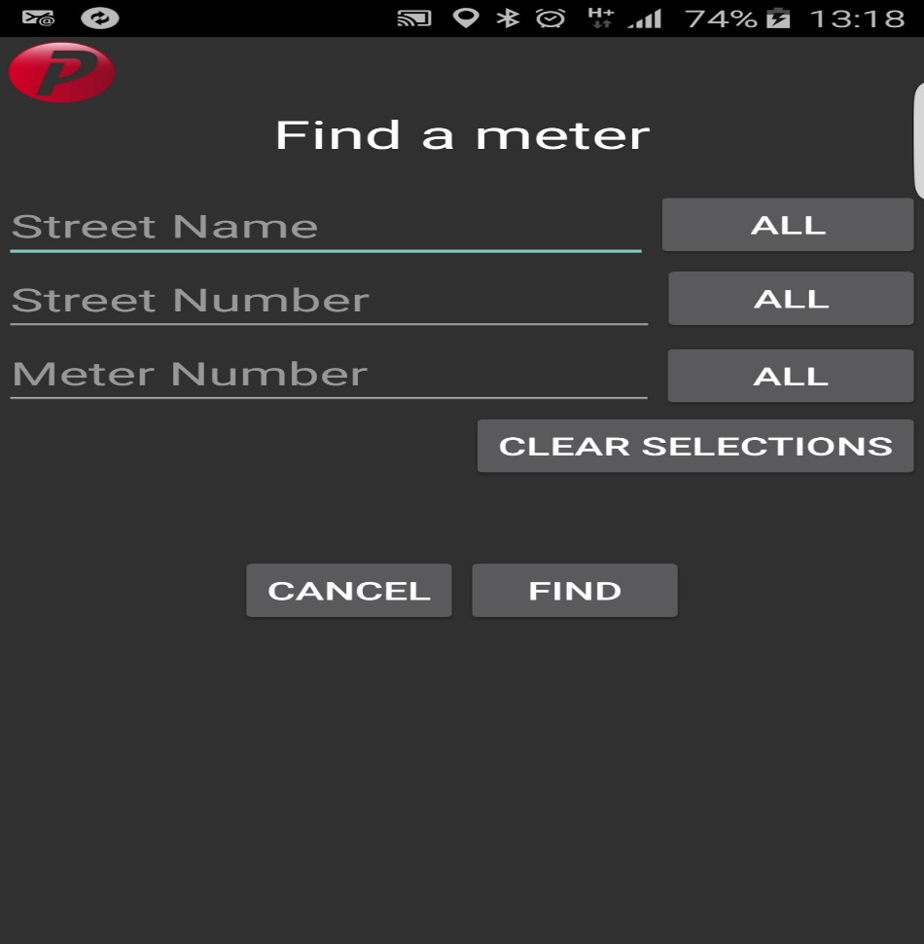

Here the user can find a meter by either typing in the street name, street number or meter number.

Finding a meter by street name:

* 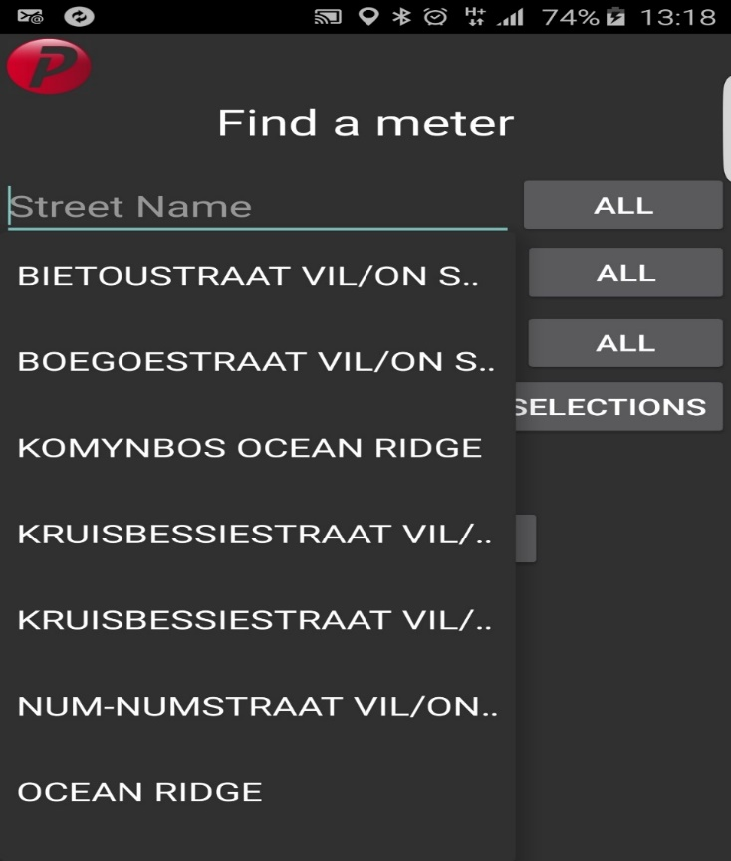If the user is not sure what the street name is there is an option to tap on “ALL” and the street names that is available in that route will appear.
* The user can now select the street name from the drop-down list.

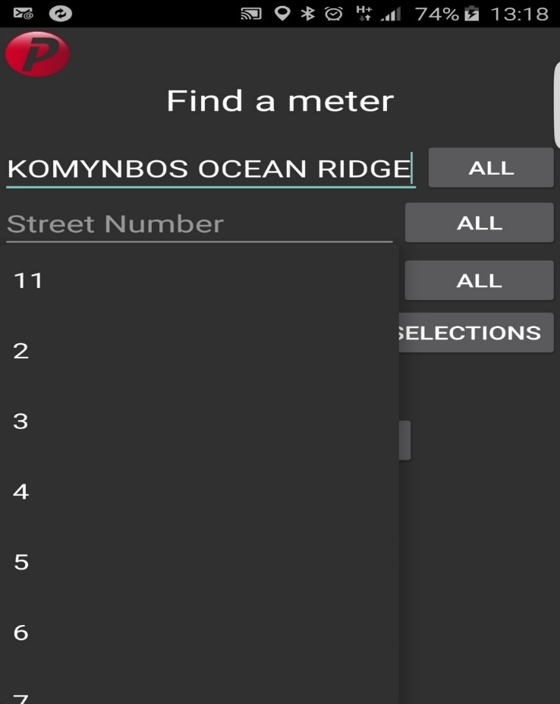

* After selecting the street name, the user can now move to the next line which is the street number. Tap on “ALL” and the application will provide you with available street numbers for the specified street name.
* 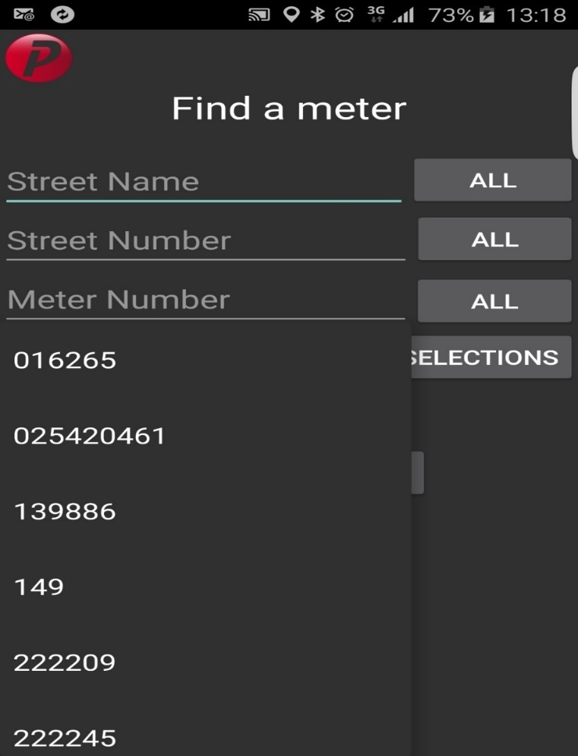If the user knows the meter number, it can just be keyed into the meter number line or use the “ALL” function to see available meters and select the meter number from the list.

### End meter procedure

After all the readings have been done the user can now go ahead and close this route. This can be done tapping on the “back option” which will then take you back to the “Select a route to read” screen



* 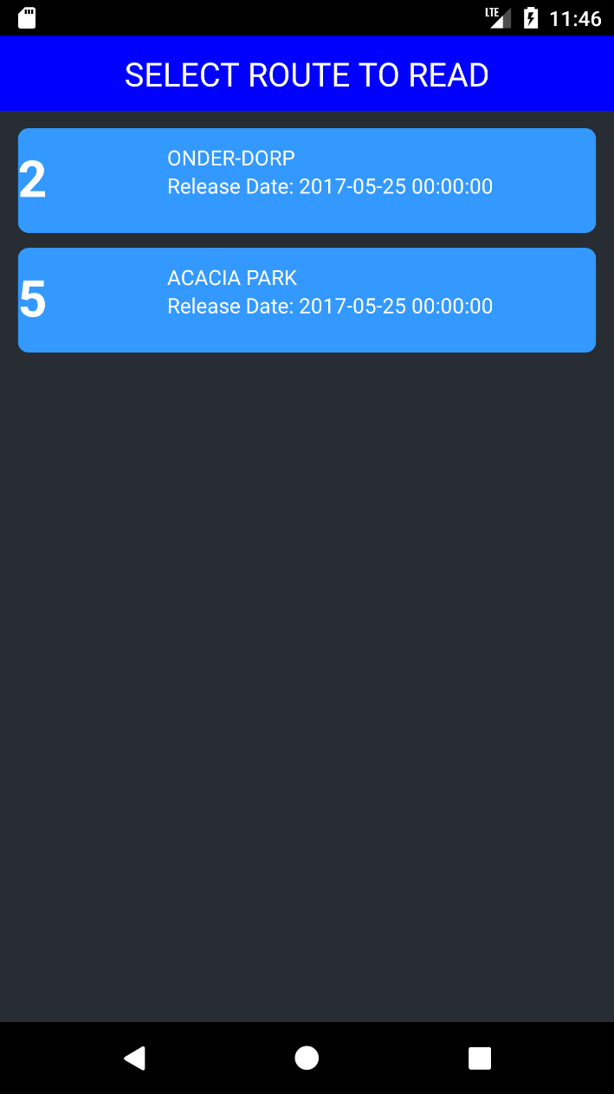Long-click on the route you wish to close. The following screen will appear:
* Tap on “CLOSE”.

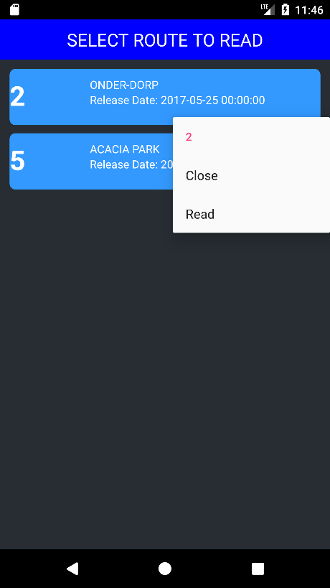

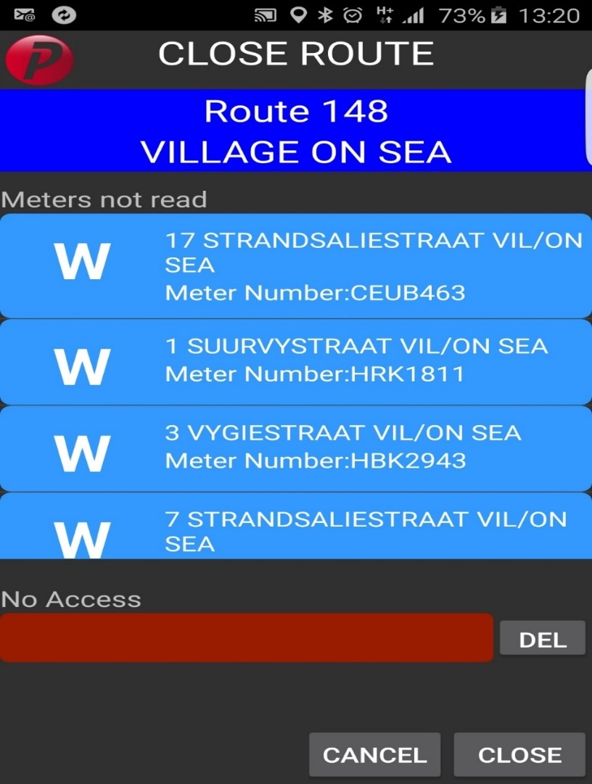

The above screen will appear, which will provide you with the meters that must still be read.

* The user can specify a reason as to why it was not read by long-clicking on the open space provided in the NO ACCESS line.
* After this is the user can close the route by tapping on close.

17. Specify a reason as to why these meters are not read

### Abort route

You will find this option on your list of NO ACCESS reason **(only on the close route screen).**

* **This is used if a field-worker can’t read this route for some reason. (maybe the person is sick)**
* **The field worker can log on to this application from where he is and abort the route.**
* **The device will return the route to the back office.**

**IF A ROUTE IS ASSIGNED TO A SPECIFIC USERNAME THE BACK OFFICE CANNOT REMOVE IT FROM THE USER… THE USER MUST ABORT THE ROUTE FROM THE HIS / HER MOBILE DEVICE THROUGH LOGIN ON TO THE ERMS APPLICATION, LONG-CLICKING ON THE ROUTE, CLICKING ON CLOSE AND CHOOSING THIS REASON (ABORT ROUTE) …**

## Asset Tracking Activity

### Expanded Room List

The following layout shows a complete list of all rooms available to the device.

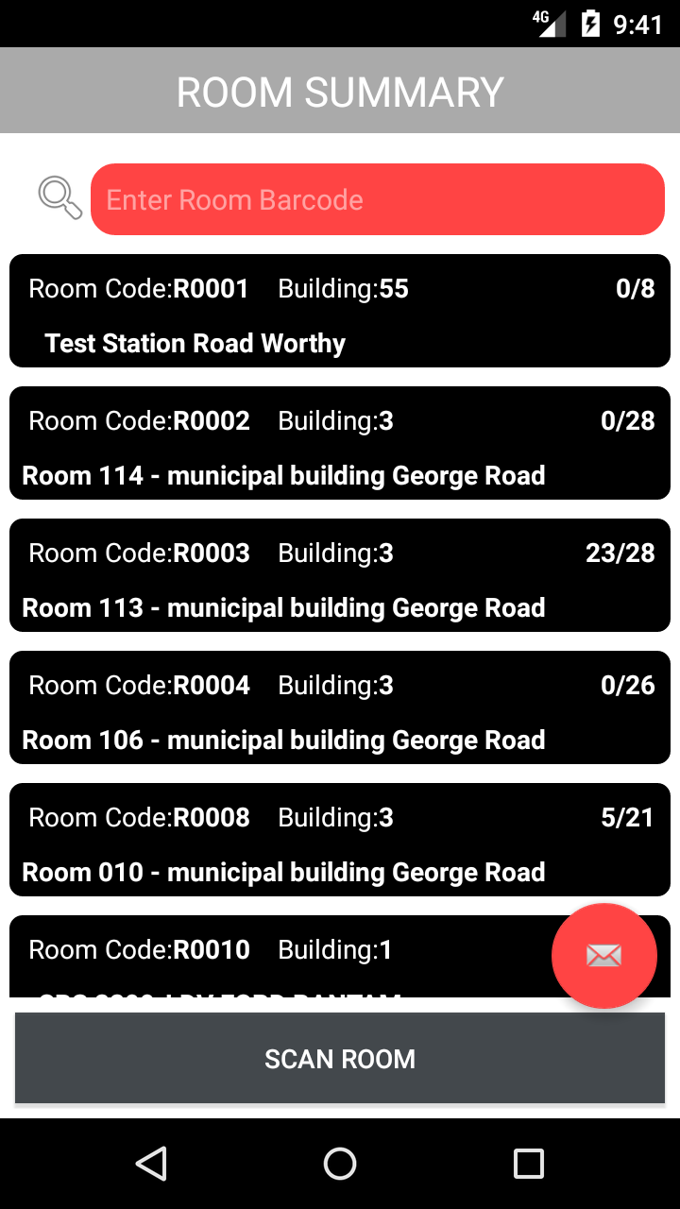

The initial load presents a list of all rooms available for scanning. These have a room code, a description and a tally of what was scanned in the room.

This search bar will filter the ListView.

Touching any room item will take the user to a summary of scans in the chosen room.

This button will initiate a room scanning activity.

Create .csv of current device content to be emailed.

### Capture Screen

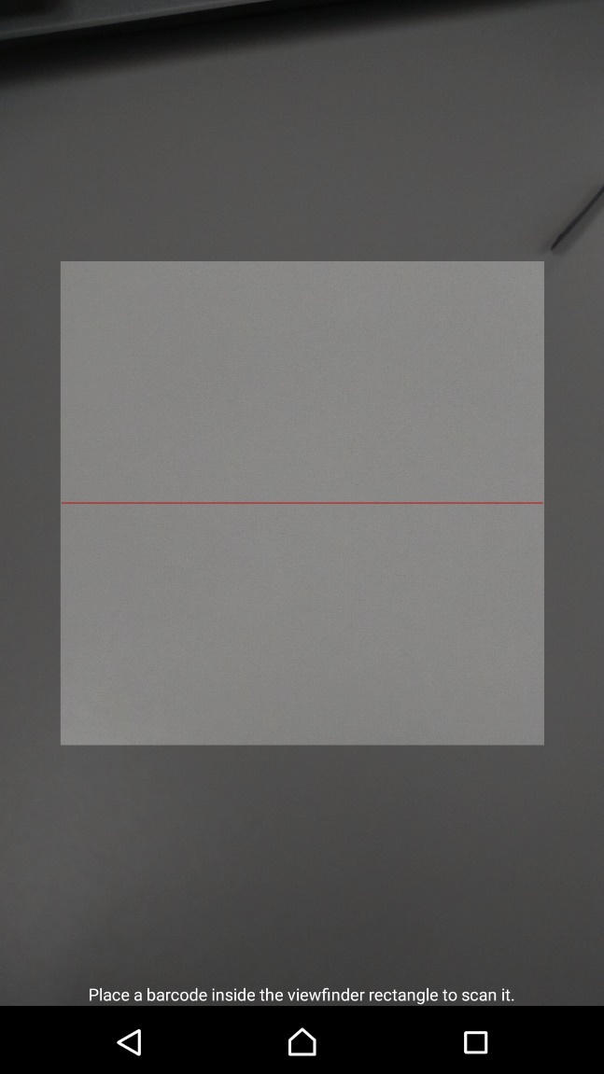

18. The scan layout presents the barcode scan. The barcode is placed under the red line. The first scan identifies the current room in which asset scanning is taking place. These barcodes will be in the format “RXXXX””

* If it is too dark and you cannot see the barcode, the volume controls on the phone can de/activate the torch.

### Summary of Scanned Room

The layout below shows the summary of scanned room screen. Each colour corresponds to a grouping of scanned assets. The number corresponds to the total number of assets in that grouping. A definition of each grouping is explained underneath.

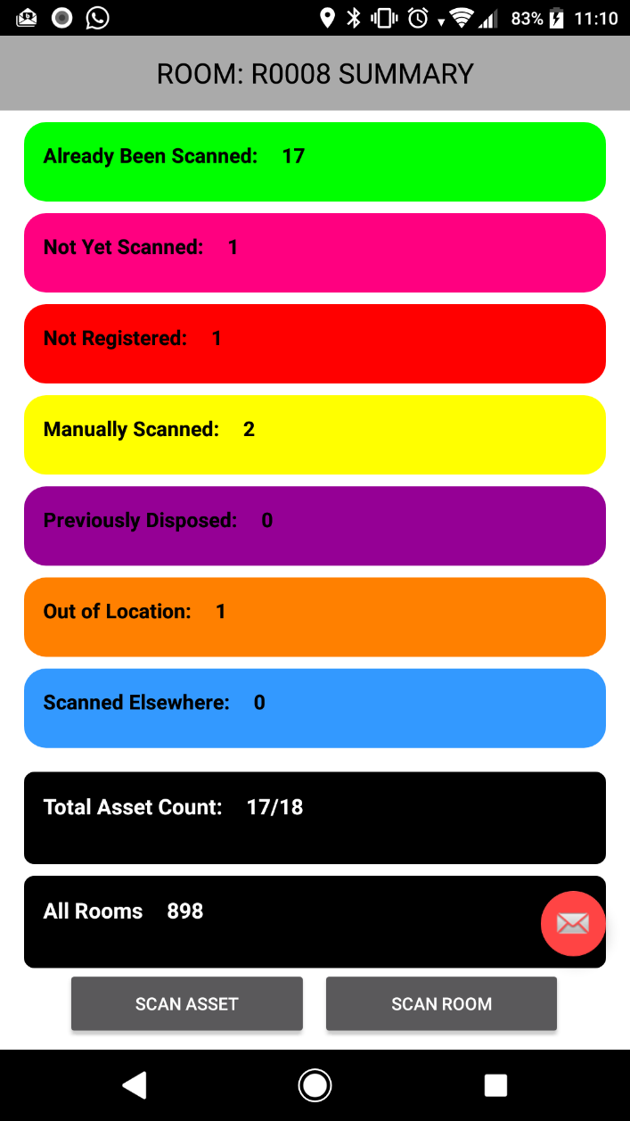

* ***Pink***: Assets which are registered to the room but have not been scanned.
* ***Red***: Assets which have been scanned but have not been added to the registry.
* ***Green***: Assets which have already been scanned and are present in the scanned asset database
* ***Yellow***: Asset which are manually marked as found and are not scanned
* ***Purple***: Assets which were scanned but are marked as inactive and are to be disposed of.
* ***Orange***: Assets which were scanned in the current room but this is not the room to which they are registered.
* ***Blue***: Assets which have been scanned in a location that is not the current room (the room they have been registered to).

Generates an email and .csv with the above information

* ***Black***: The first instance is a simple summation of the scanned and not scanned assets. Should the two numbers not be equal; this indicates there may be a duplicate barcode or a room was not first scanned. The second, takes the user to a complete list of all rooms.

Touching the numbered categories will take the user to an expanded summary list of the chosen category.

### Expanded Room Summary

Each coloured bar in the summary of scanned room is an individual button. Touching any will take the user to an expanded summary which is previewed below. The colour will match with the button from the previous screen.

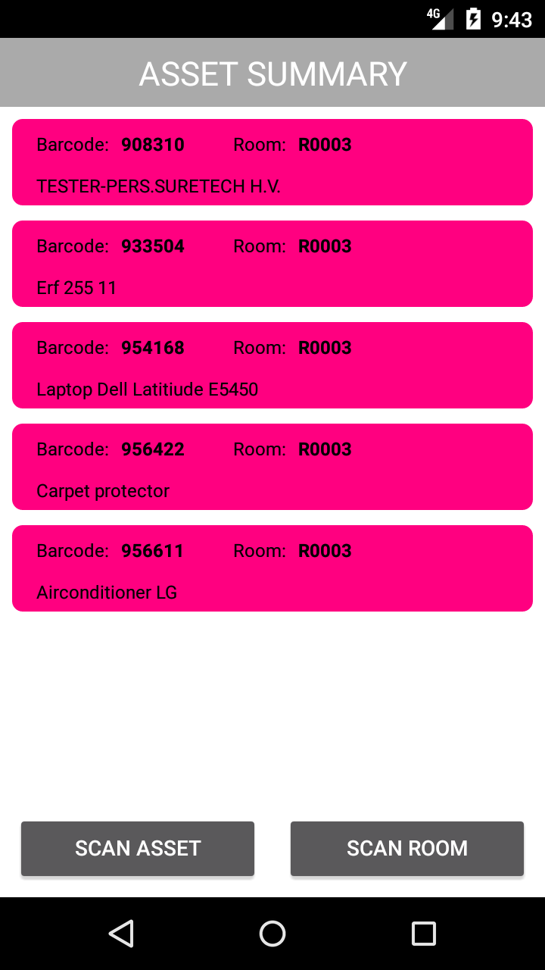

35. This is the barcode of the asset which should be on the tag

36. This is the room which the asset was scanned in or should be in.

36. Touching an item will take the user to a detailed view of the asset.

37. The short asset description as taken from the registry

38. A toast notification will appear indicating the number of assets in the category

40. Touching this button will start a new room scan instance resetting counters, room and assets.

39. The back button will return the user to the main summary screen.

42. Clicking will take the user to an expanded list of the chosen room.

### Scanned Asset Details

Once an asset scan has taken place, the layout below will appear. All the controls are now visible.

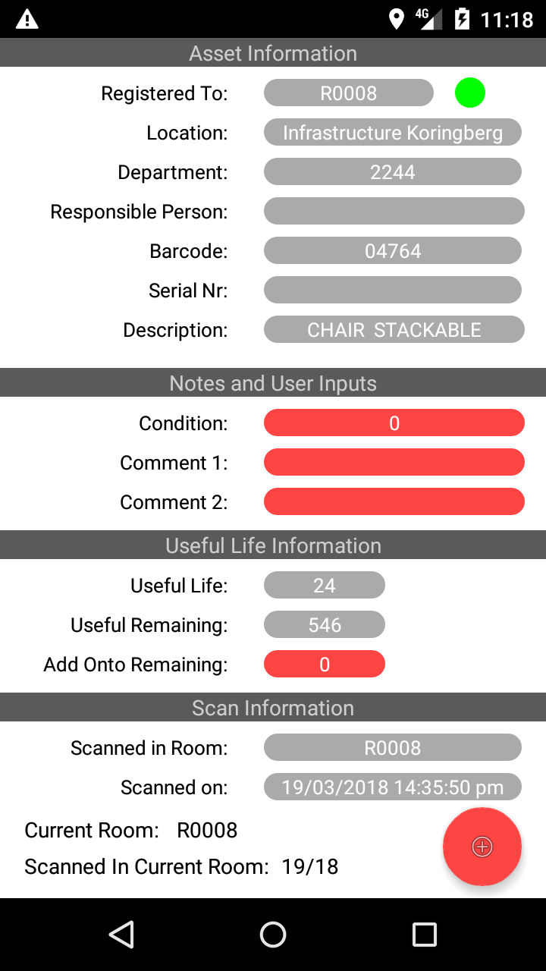

26. A short description pulled from the registry for the asset

25. Shows the serial number of the asset which was pulled from the registry

31. Scanned Status indicator.

24. Shows the barcode which was physically scanned

29. Shows the estimated remaining useful life in months

28. Shows the estimated useful life of the asset in years

This button is multifunctional. A single touch will take the user to a new asset scanning instance. A long touch will display a dialog with a series of options.

27. Input Controls which allow for user determined condition and comments.

The controls below change appearance depending on the relationship between the registry and the scanned assets.

32. The condition control is a normal input control and can be seen further in the glossary

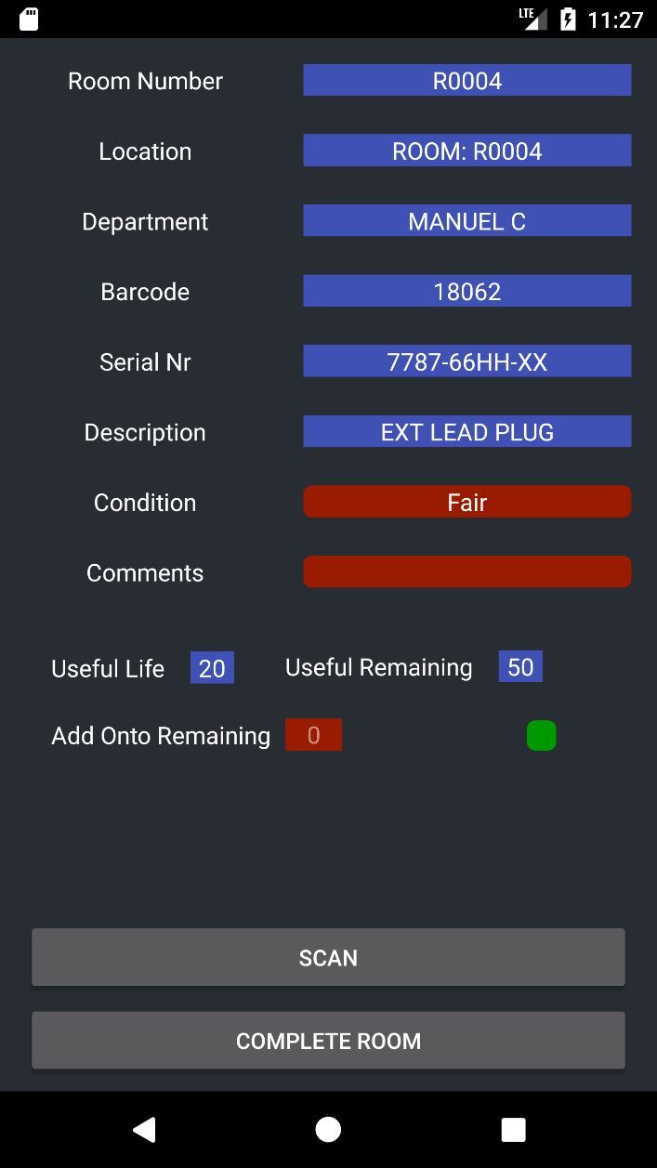

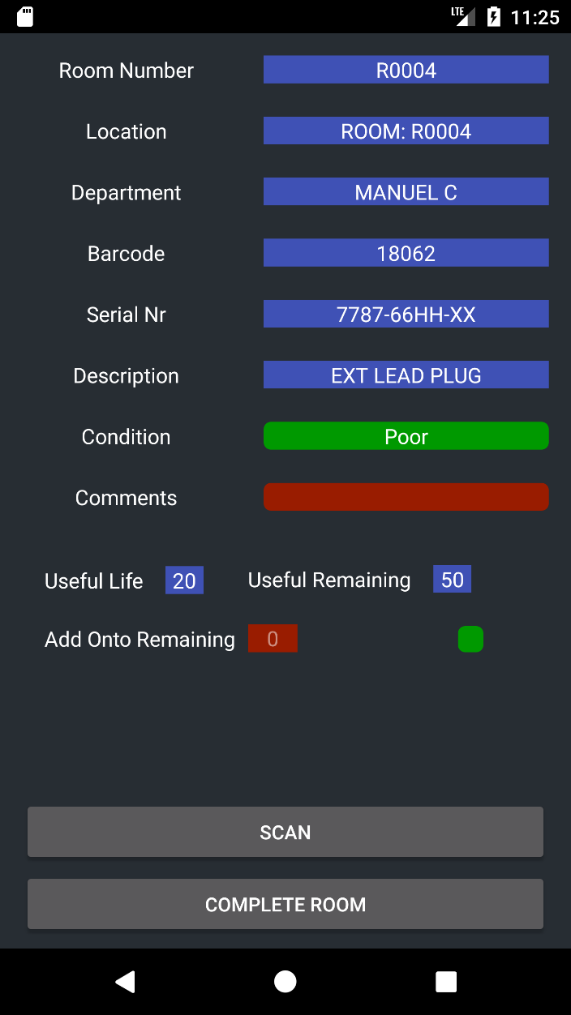

33. Both the condition and comment control can alternative between 2 colours. Red indicates the value is the same as in the registry. Green indicates the value on the input control differs from the registry value

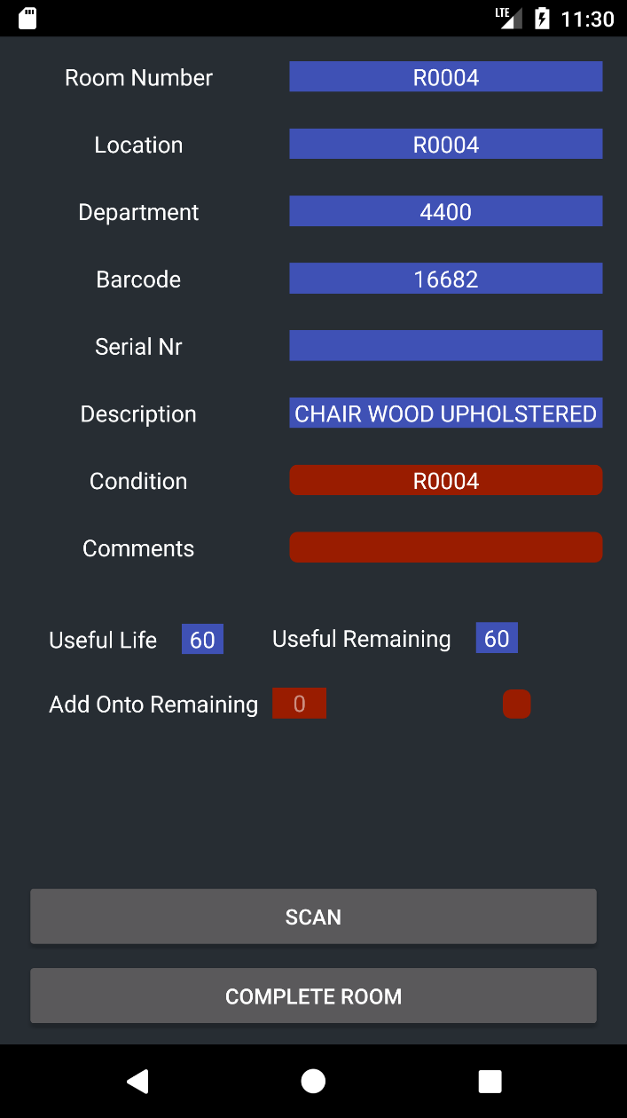

34. The scan status indicator will alternate between red and green.

* Red indicates the asset has not been scanned and will not be present in the scanned asset database. Green indicates it has already been scanned in the asset database.

### Options List

There is a variety of functions available to the user in the options list, as illustrated below.

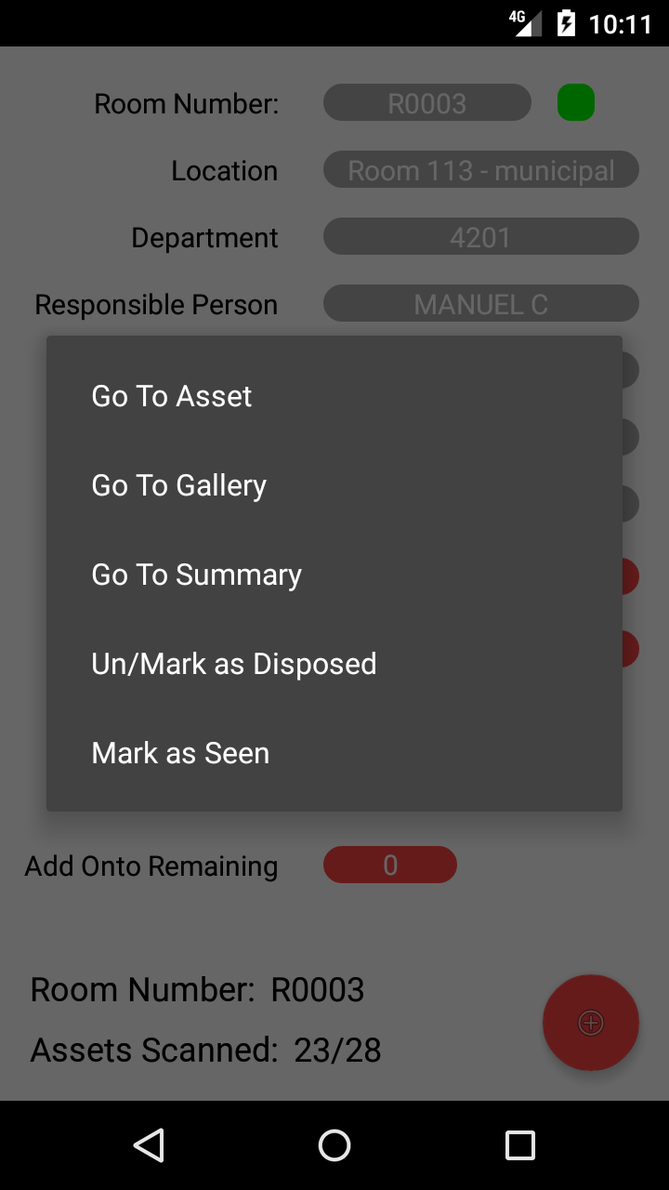

This function is for the marking of unbarcoded assets that need to be acknowledged as found, but do not have the ability to be scanned.

Opens the image gallery of the chosen asset.

Opens a dialog in which the user can search for a specific barcode within the registry.

Opens an instance of the scanned room summary for the selected room.

In the event an asset should have been marked as disposed in the registry, a user can mark it to be processed here and excluded from reports

### Gallery View

The view below shows the galley for the currently selected asset. You are taken to this

This is a list of all images relating to the asset, touching will bring it up as the centre image.

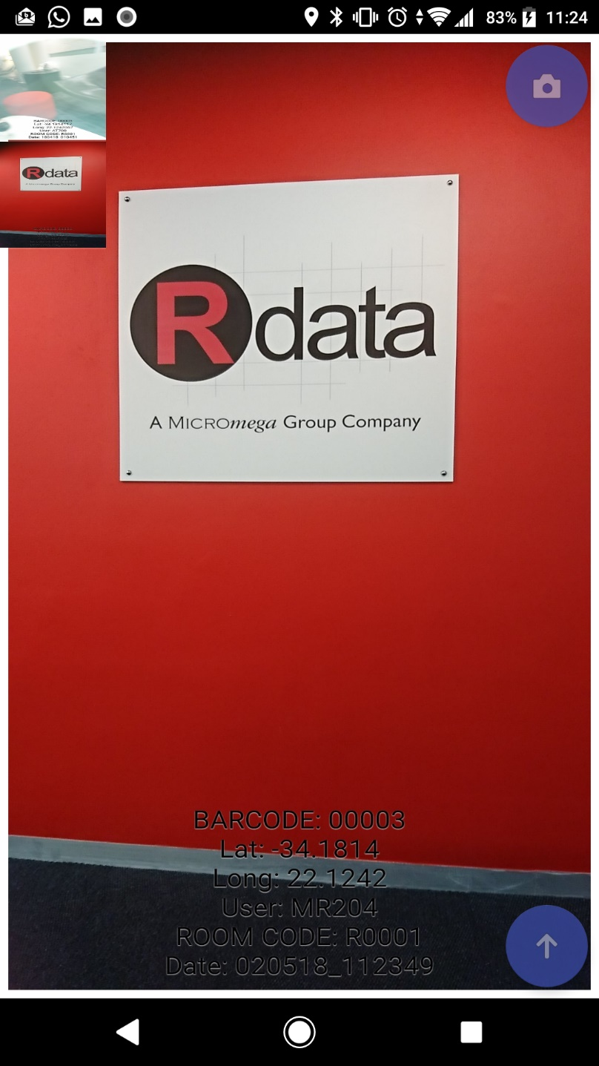

Button for taking a new picture.

The currently selected image will appear here.

This button will return you to the detailed asset screen

Name of the image, showing first the barcode, an image number, the date and then a control value

## Stock Taking Activity

### The Warehouse View

Once Stock Taking is selected from the main menu, an instance of the warehouse lists.

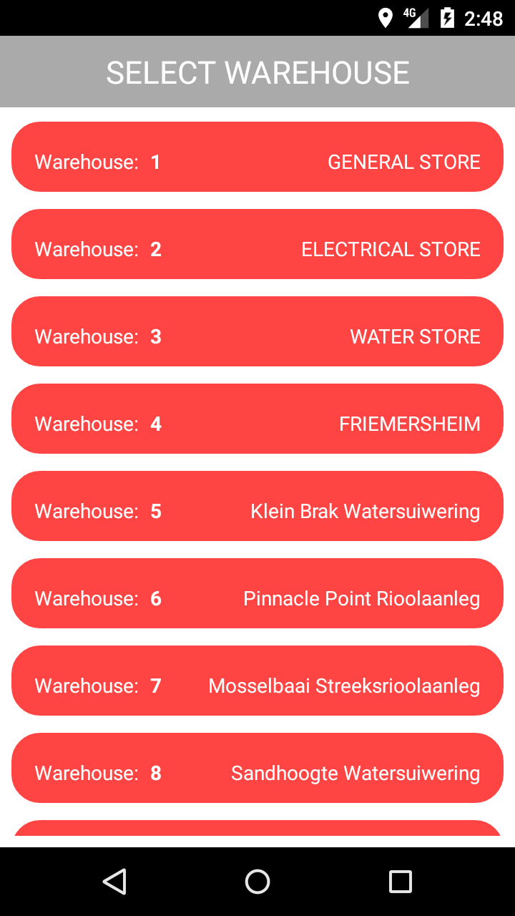

Each warehouse is numbered and shows a short description.

Touching an item will take the user to the stock capture view.

### Stock Capture View

The view below shows the bin information during a stock taking activity. Initially the view will contain no information until a bin has been scanned.

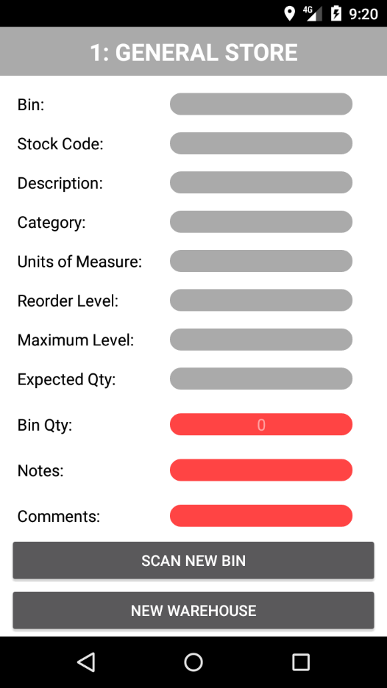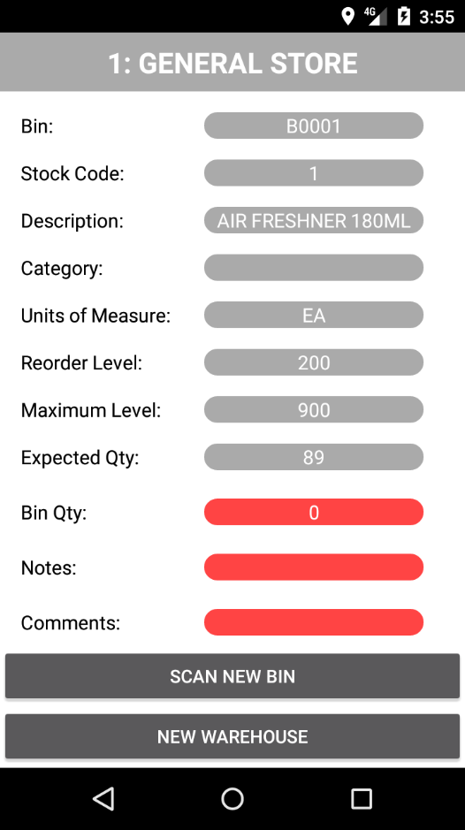

These values: bin, stock code, description, category and unit of measure; relate to the specific stock item and is taken from the database.

This is the value that must be inputted to reflect what was counted

This will start a new instance of scanning; the process and view will be the same as the capture screen.

Details here relate to the quantity criteria boundaries. The reorder level is the minimum level stock should be.

This return the user to the warehouse list

Comments and Notes can be added to a bin after a stock capture has taken place.

# Minimum Technical Requirements

|  |  |
| --- | --- |
| Item | Minimum Requirement |
| Form Factor | Candy bar |
| Device | Phone or Tablet |
| OS | 6.0 (Marshmallow) |
| Screen Size | 4.5 inches |
| Resolution | 720 x 1280 |
| Network | GSM：850/900/1800/1900（B5/B8/B3/B2） |
| WCDMA：900/2100（B8/B1） |
| CPU | Quad-Core (1.33 GHz) |
| Memory | 2GB DDR3L |
| Storage | 50MB Free Space (More for Massive Data) |
| Camera | 8 MP |
| GPS | Required (GPS or GLONASS) |
| G-Sensor | Required |

1. Glossary

The following terms will be used when explaining the procedures of Promob and what information must be captured on your mobile device:

* 1. How to swipe and long-click

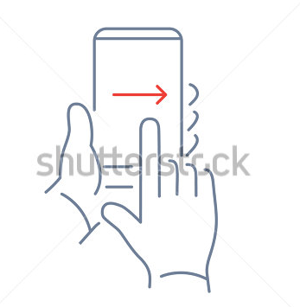

* ***Swipe***: Using your finger and sliding it from the left side of the screen to the right side. **(See image right)**

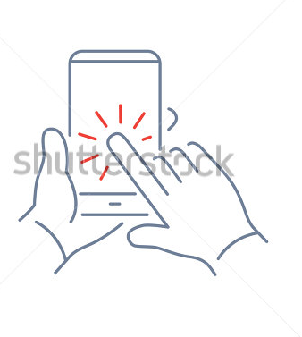

* ***Long-click***: Placing your finger on the icon you wish to select and holding it there for a few seconds. **(See image right)**
  1. Input Controls

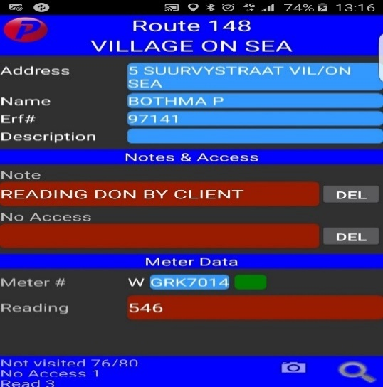Any control with this background style has the option for user input. These inputs will appear throughout Promob. Some of the common user input controls are below:

* Notes: To add a note to a meter you long-click on the “notes line” provided. This will bring up a list of all possible notes options to add to the meter.

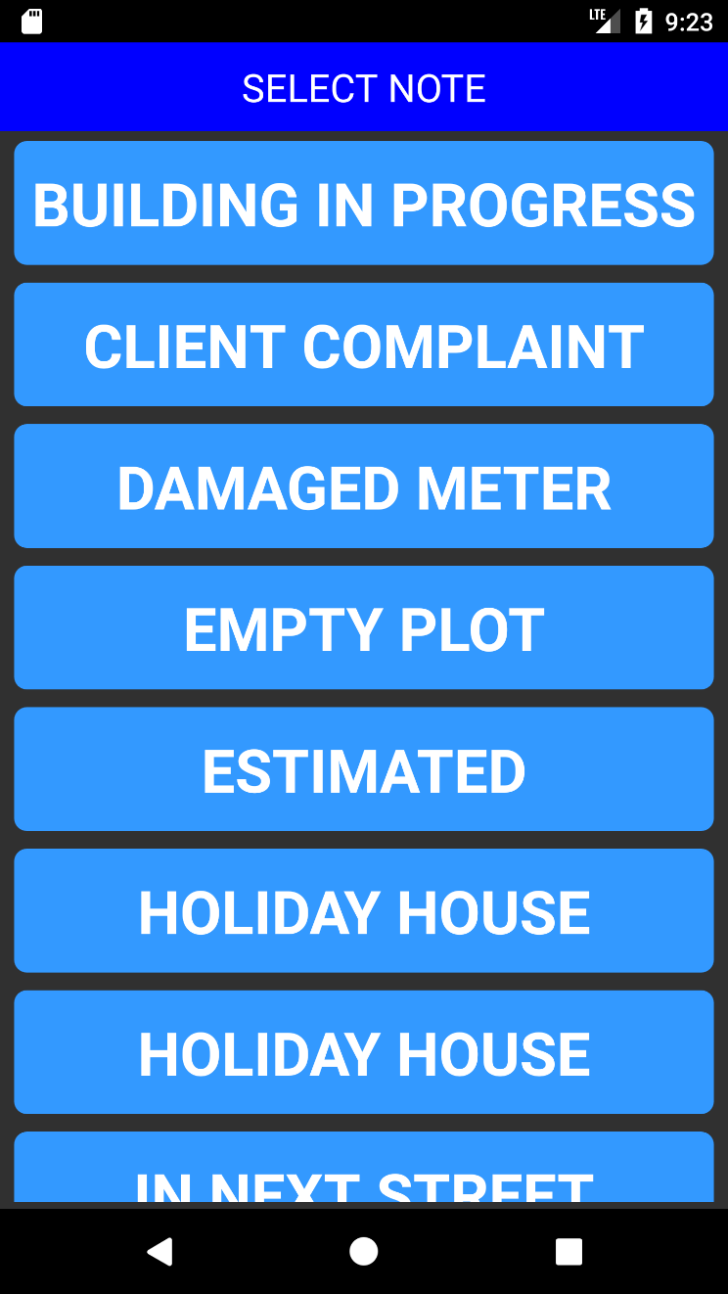

* + The user selects a note from the list by tapping on the note which he/she would like to insert, and it will appear in the notes line provided on the mobile device.
  + If the user wishes to delete the note it can be done by long-clicking on the delete option and the note will no longer appear.
  + **If more notes are needed, please contact the back-office operator who can assist you by adding more notes**
* No access: If a reading cannot be done for a meter a “NO ACCESS” note must be added. To add no-access notes to a meter long-click on the “no access” line provided, and a list will automatically pop up with possible reasons as to why the field-worker could not access the meter.

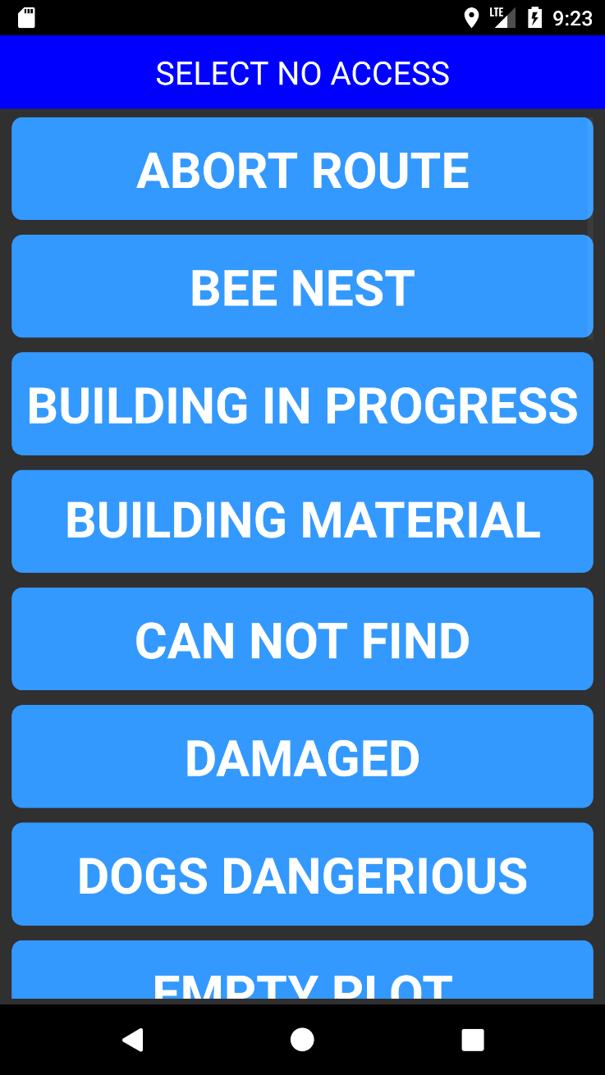

* + The user selects a reason from the list and it will appear in the “no access” line provided on the mobile device.
  + If the user wishes to delete the reason specified in the NO ACCESS line it can be done by long-clicking on the delete option.
  + **If more no- access notes are needed, please contact the back-office operator to add more.**
* Conditions: To add a condition to an asset, you long-click on the “conditions line” provided. This will bring up a list of all possible condition options to add to the asset.

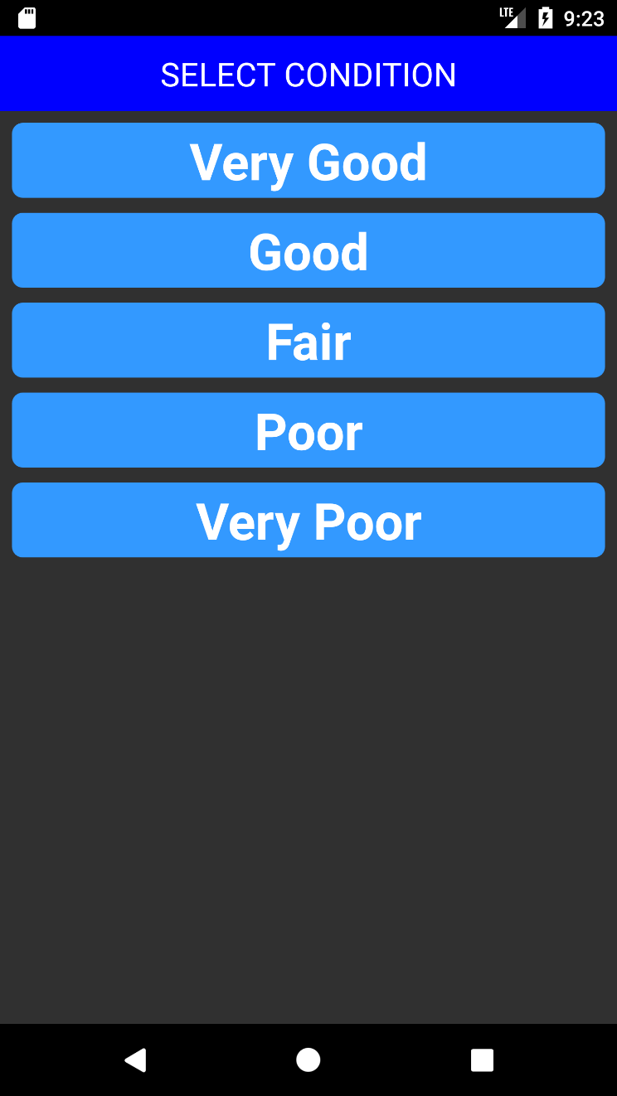

* + The user selects a condition from the list by tapping on the condition which they would like to insert, and it will appear in the condition line provided on the mobile device.
  + A condition does not have the option to be blank or deleted as an asset will always have a condition.

1. Definitions

*Activity*: The term used by android for a series of processes within the application that lead to a result or new layout.

*Camera*: A requested permission for Promob. Typically, will refer to the primary, rear device camera and not the secondary.

*Control*: Items on a screen which convey information to the user, used to input data into Promob or used to start activities.

*Device*: Refer to the cell phone or tablet on which Promob is installed.

*Layout*: The term used by Android for screen and all the controls that are associated to it.

*Location*: A requested permission by Promob which will be used to gather GPS coordinates. These are used only in Promob and the connection is terminated after each reading.

*Promob*: The application which integrates into Promun.

*Route*: A collection of meters on a specific path to be read.

*Scan*: An instance of barcode scanning which presents the scan layout used for barcode reading.

*Screen*: The currently displayed information on the device screen which includes the layout and controls.

*Toast*: The small, temporary notification that appears at the bottom of the screen during certain activities.

*Touch*: The equivalent action to clicking, except with a touch screen. Click and long-click are used for touch and long-touch and with tap being used for touch as well.

*User*: The human which is interacting with Promob.