Original

T = 100us = f = 10kHz

L= 10mH

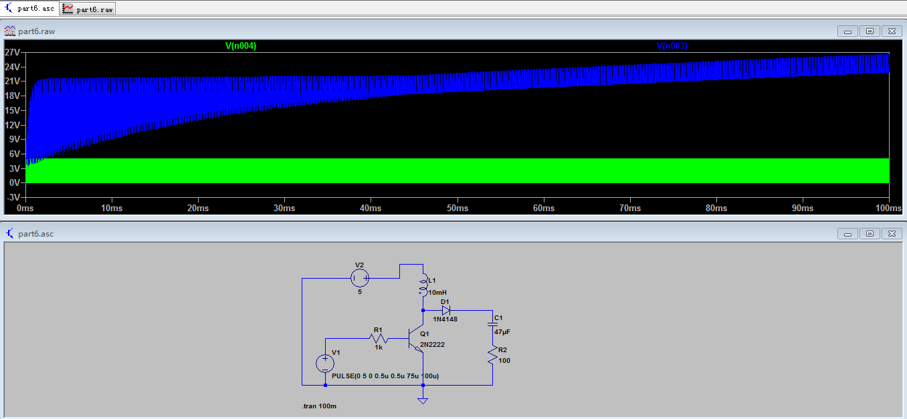

6.2 Scale up inductance

10->1000mH

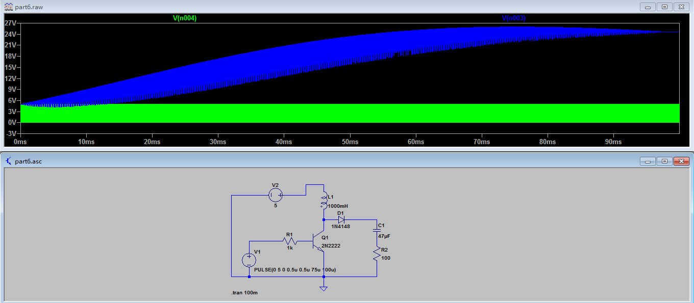

10->10000mH

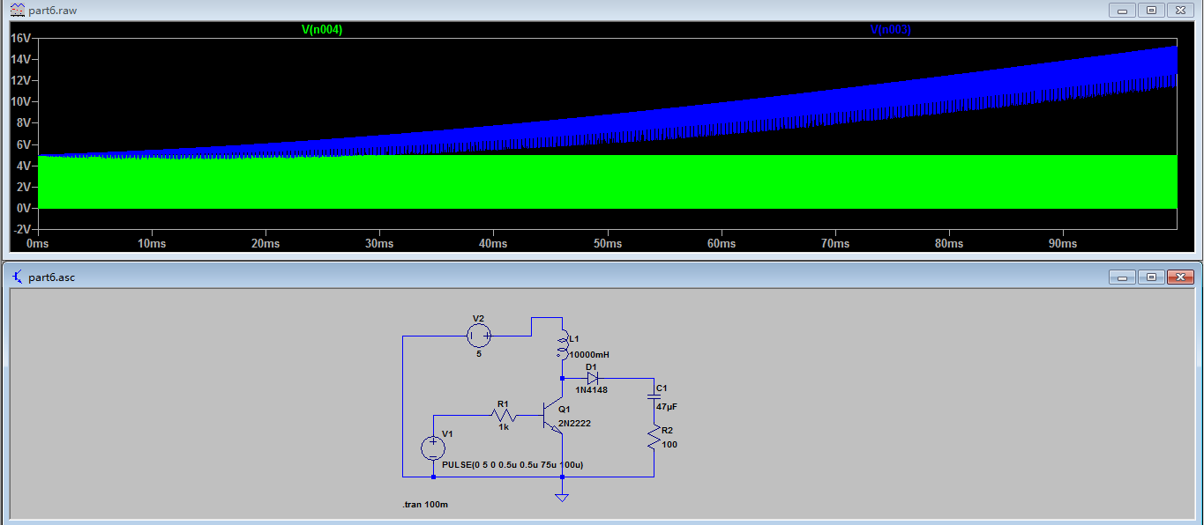

Voltage kind of decreased as the inductance increase,

But as inductance increase, the time took for the capacitor to reach its maximum voltage is longer

Step down

10mH -> 10Uh

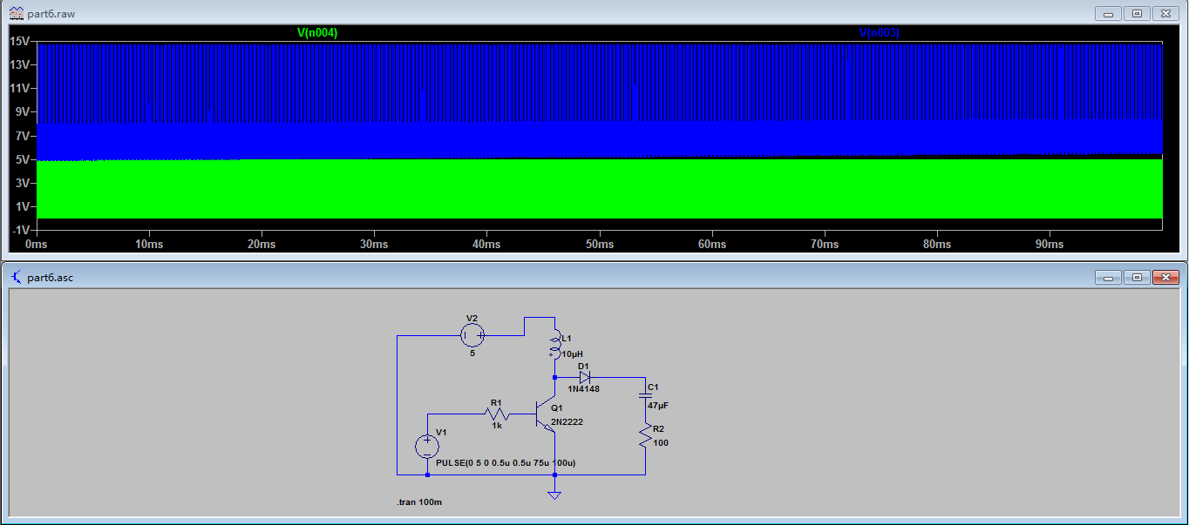

Quickly reached its maximum voltage

2. Fixed inductance, change frequency

Original frequency 10kHz, T=100us

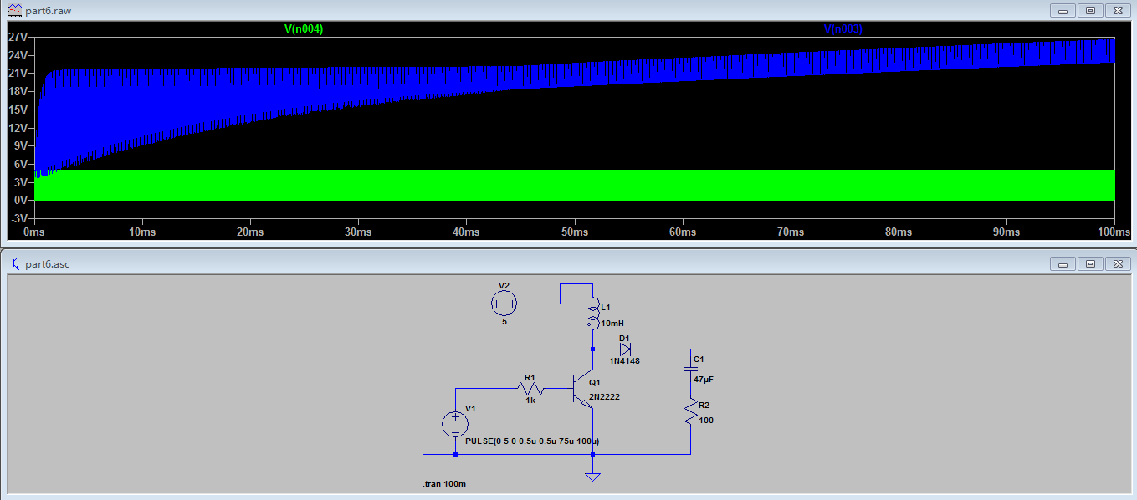

Vout(MAX) = 24V(approx.)

F increase by changing T from T=100us -> 50us

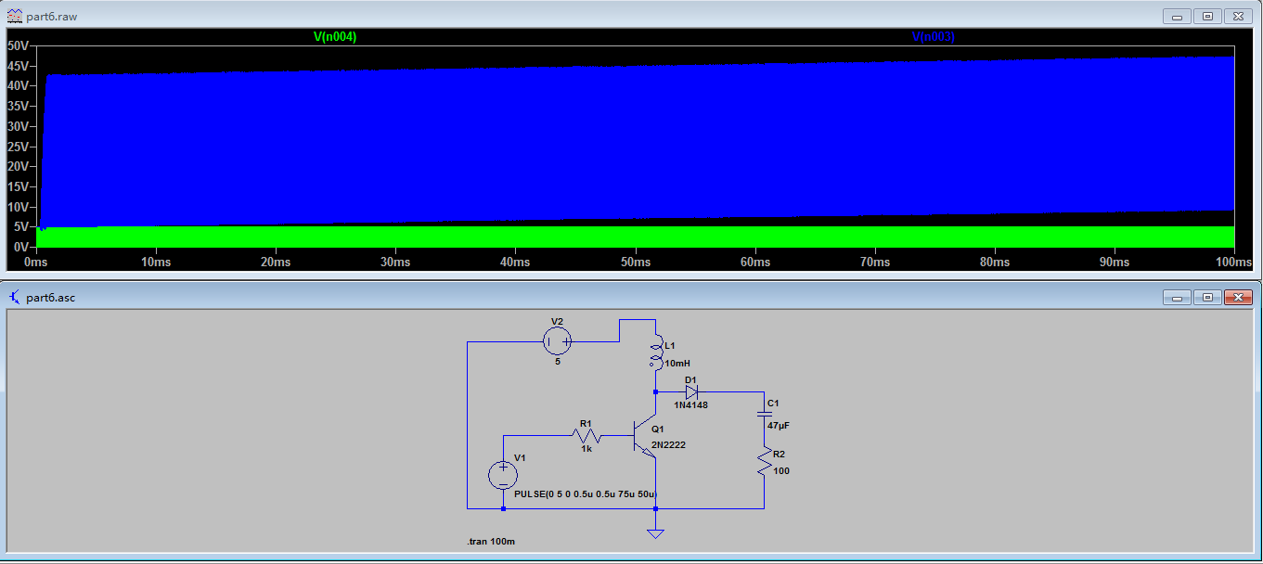

Vout(MAX) = 50V(approx.)

F decrease by changing T from T=100us -> 200us

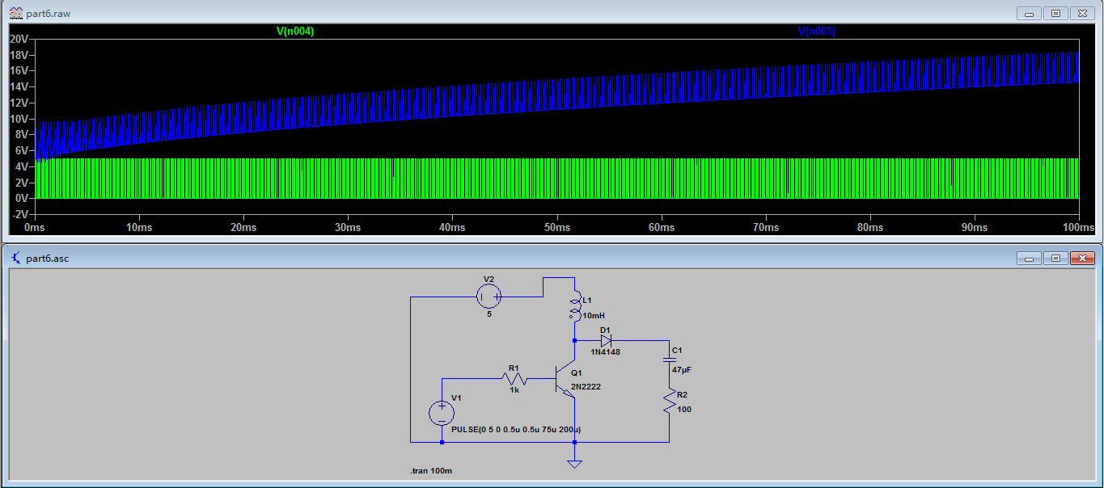

Vout(MAX) = 20V(approx.)

Therefore f increase, Vout(MAX) increase