Part2_1(a)

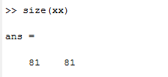

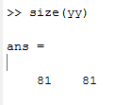

(b)

Identical to lecure note(Page16)

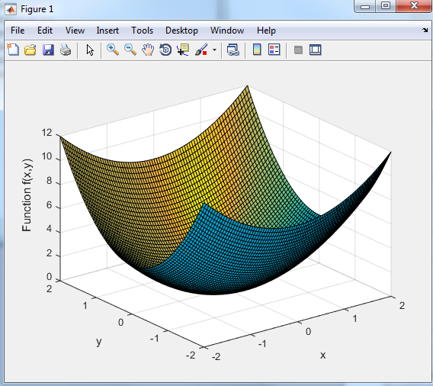

(c)

By taking arbitrary values of c, we expect different cross sections of the plot in Figure 1 (3D quadratic shape) at different levels of elevation (z-axis). Therefore, we expect the contours to be an elliptic shape .

(d)

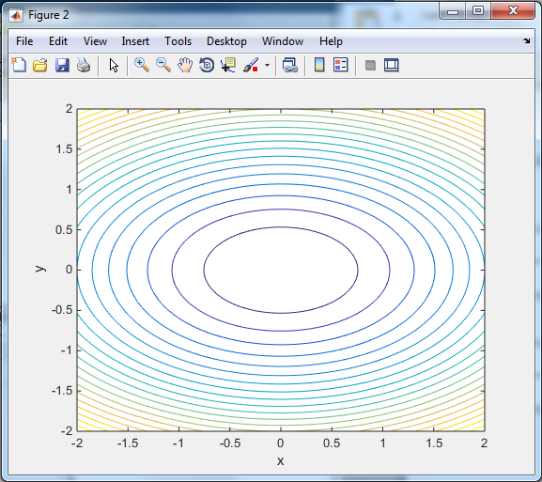

The purpose of the last argument ‘20’ in contour(xx,yy,zz,20) is to draw 20 contour lines in the plot. The levels of contour are chosen automatically.

(e)

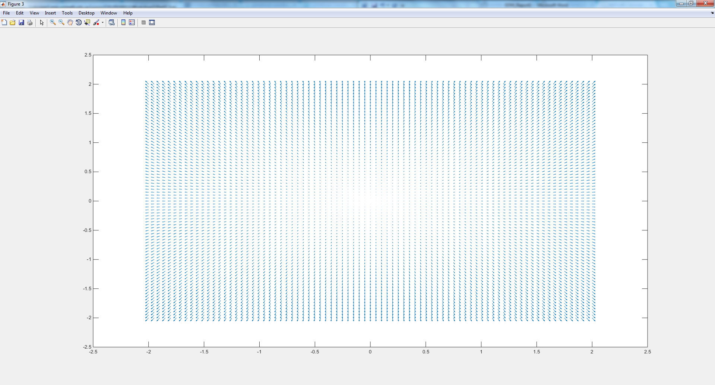

*Show gradient of function is…

Problem: cannot clearly see the magnitude and direction of the gradient vector field

(f)

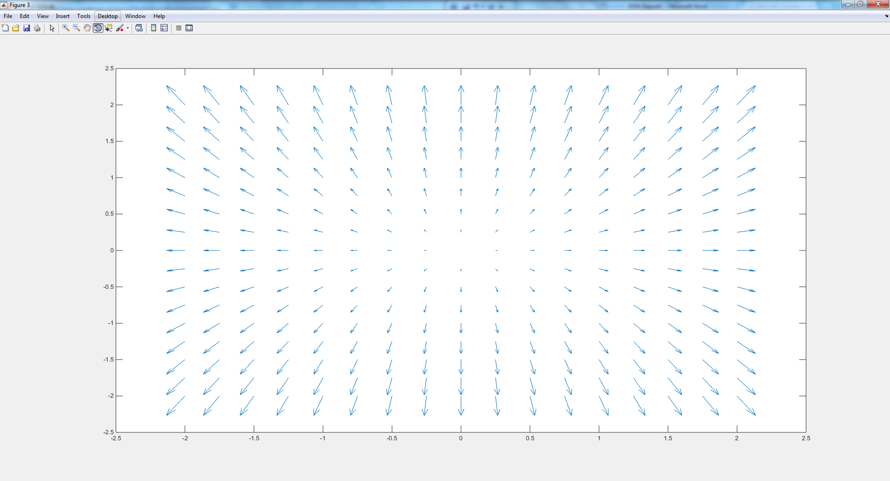

The problem from before is now resolved. We can now easily see the direction and magnitude of the vector field.

(g)

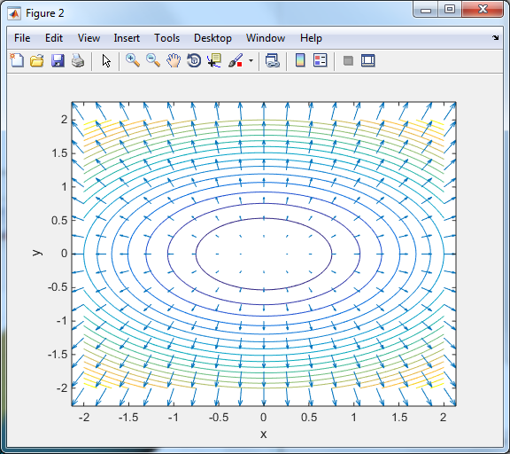

The gradient vector field is perpendicular to the contours.

(h)

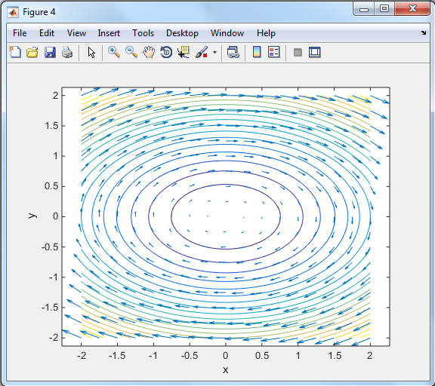

The vector field T contains vectors that are tangential to the contours of function f.

(i)

*show explicitly that the tangent vector is perpendicular to grad F

Q2. (a)

*show equation

(b)

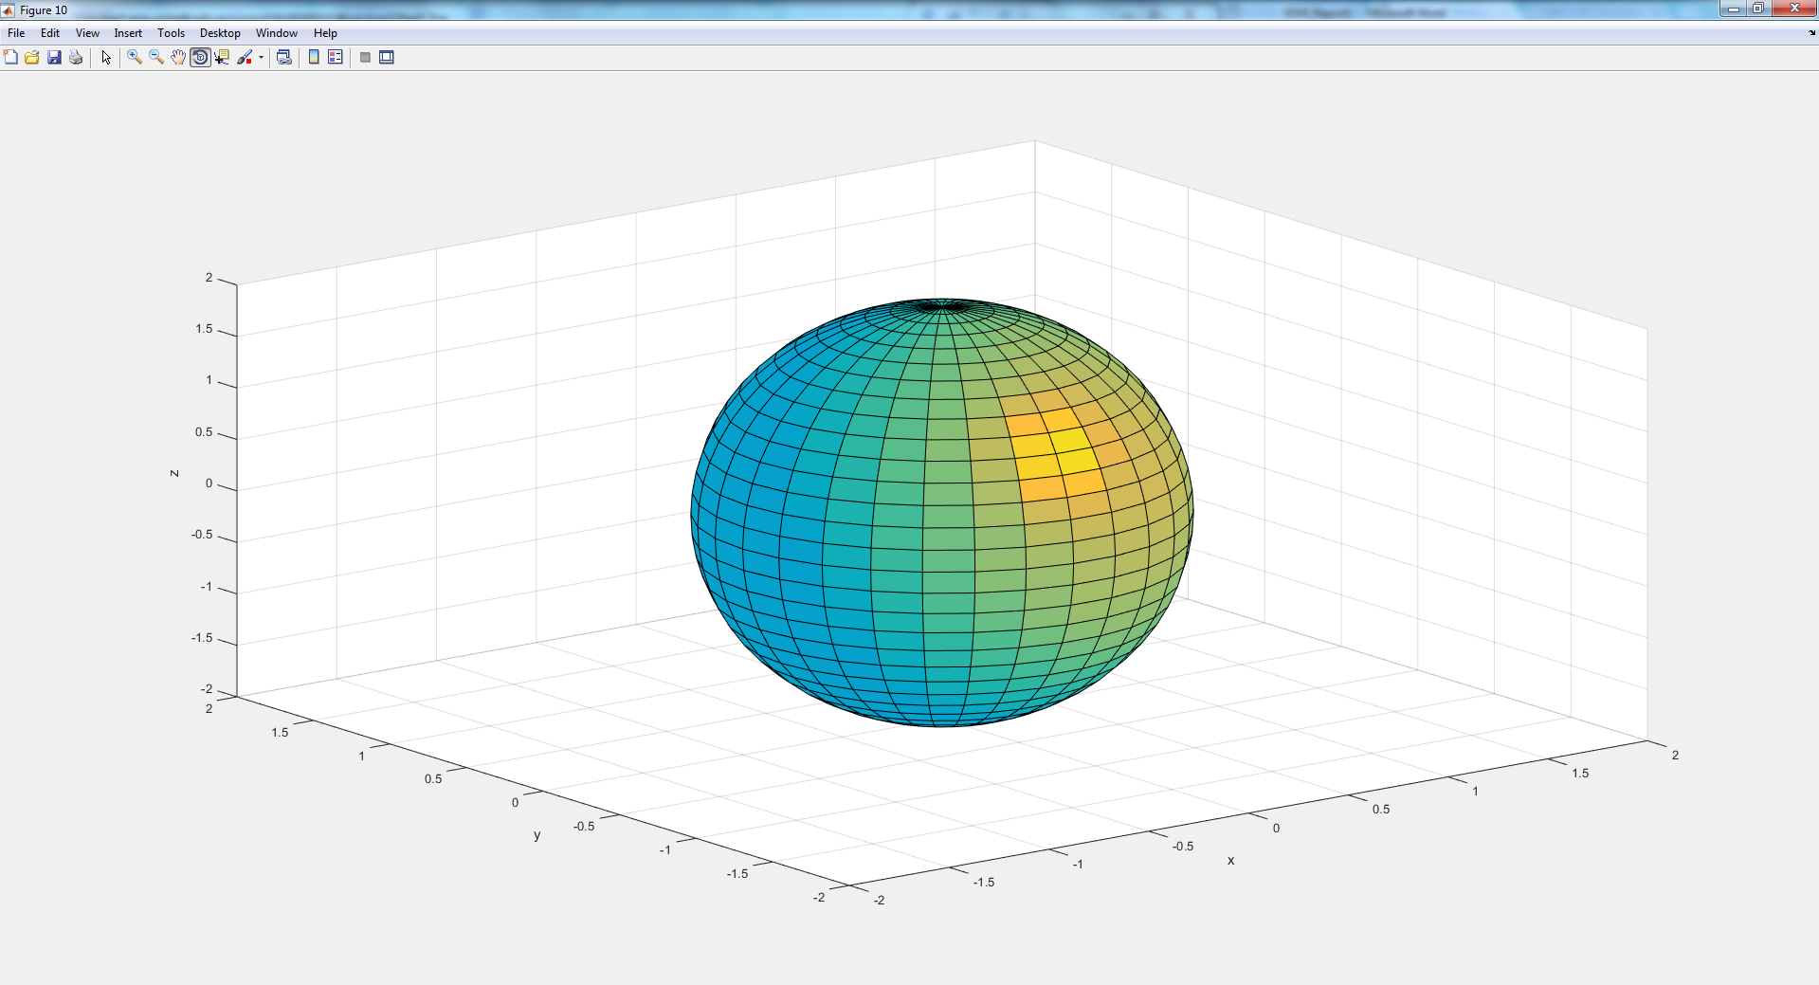

% re-align the axis of x and y

(c)

*compute gradient of grad F

(d)

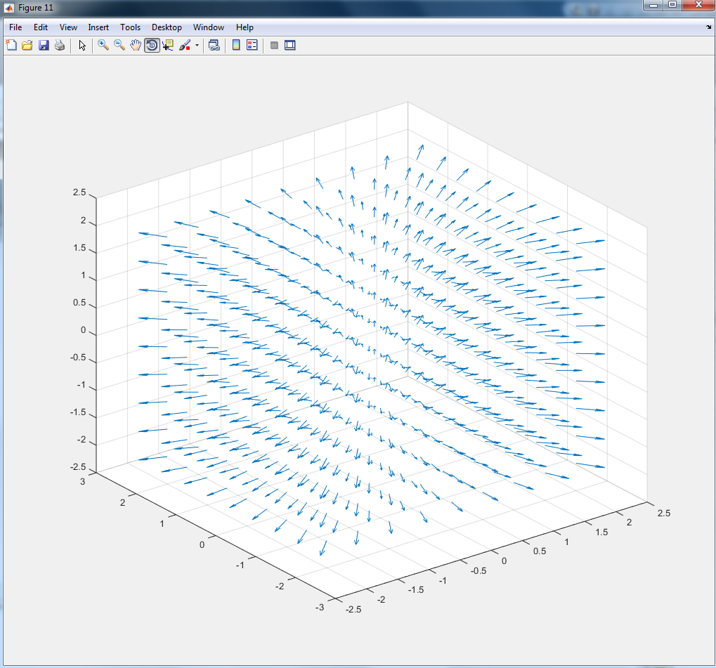

f)

