Block D

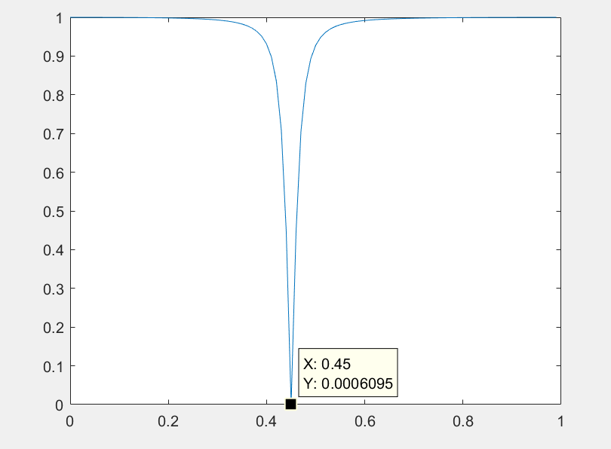

Block D

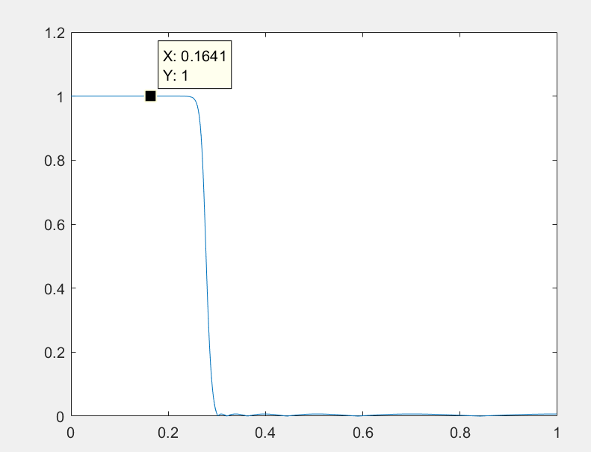

As we can see from the graph the chev2 filter has flat response

After block A+D

Only signal r1 is left

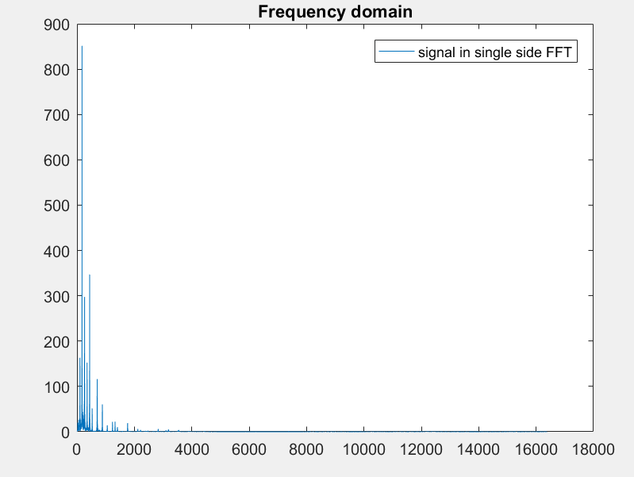

H1 analysis

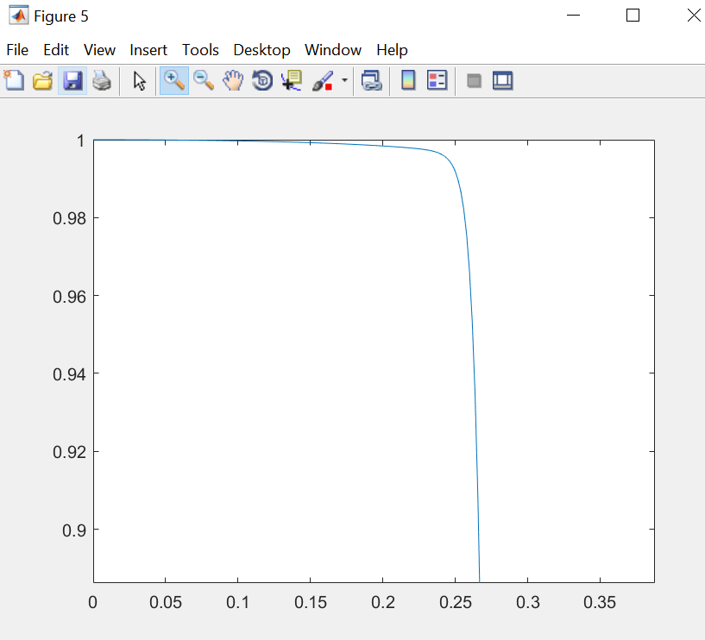

There is no ripple at the passband of H1 except for the natural decade from the low pass filter, which size up to the requirement of “ripple of passband in H1 must be less than 0.01”.

Highpass filter

H2 = A+B

After A and B

