Assignment 1

# Subject: MCEN90044 Electromagnetic Technologies

# Name: Shiyu Zhang

# Student Number: 683557

# Photo of experiment

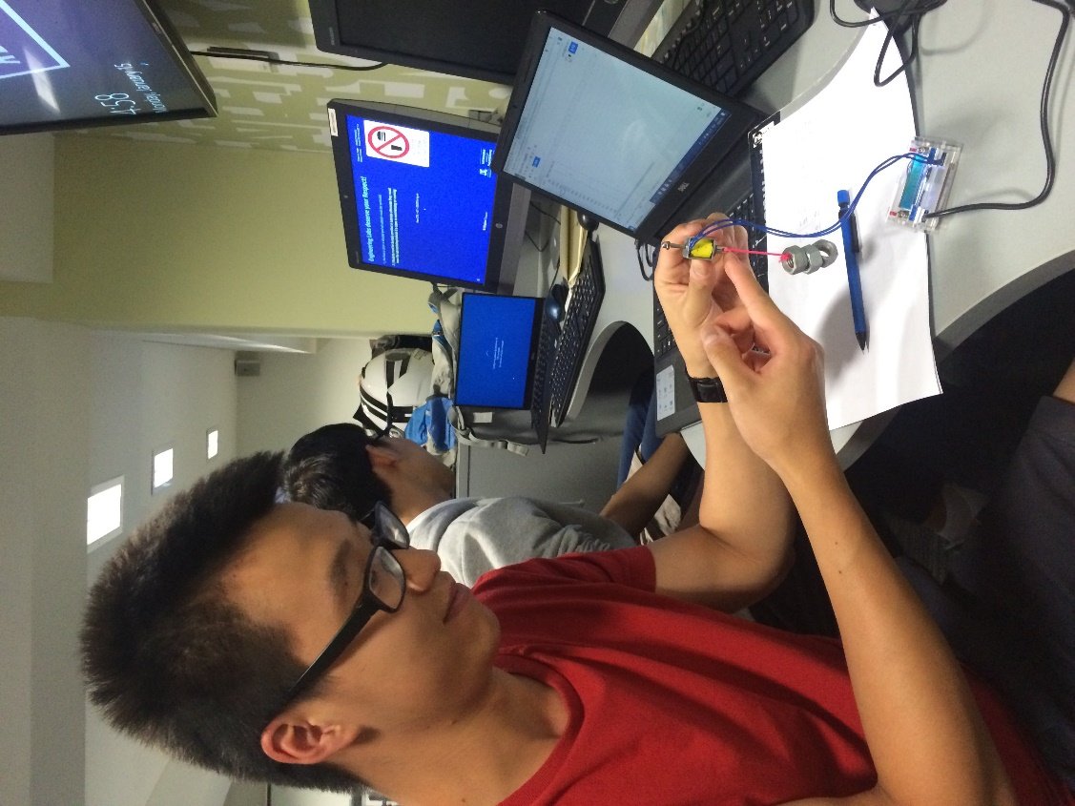

# Experimental Results

|  |  |  |
| --- | --- | --- |
| Trial | Voltage(V) | Current(A) |
| 1 | 1.15 | 0.10 |
| 2 | 1.74 | 0.16 |
| 3 | 1.16 | 0.10 |
| 4 | 1.09 | 0.10 |
| 5 | 1.09 | 0.10 |
| 6 | 1.04 | 0.09 |
| 7 | 1.09 | 0.1 |
| Mean | 1.19 | 0.12 |

# Hand calculation

The analytical expression relating to input current .

The expression has been derived by , and the following is the reasoning.

1. Calculation of total reluctance

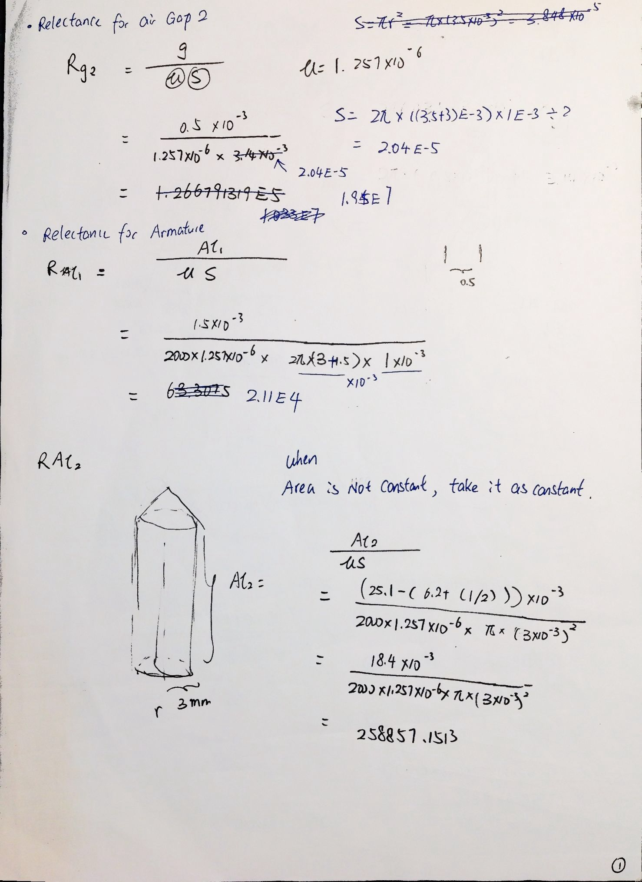

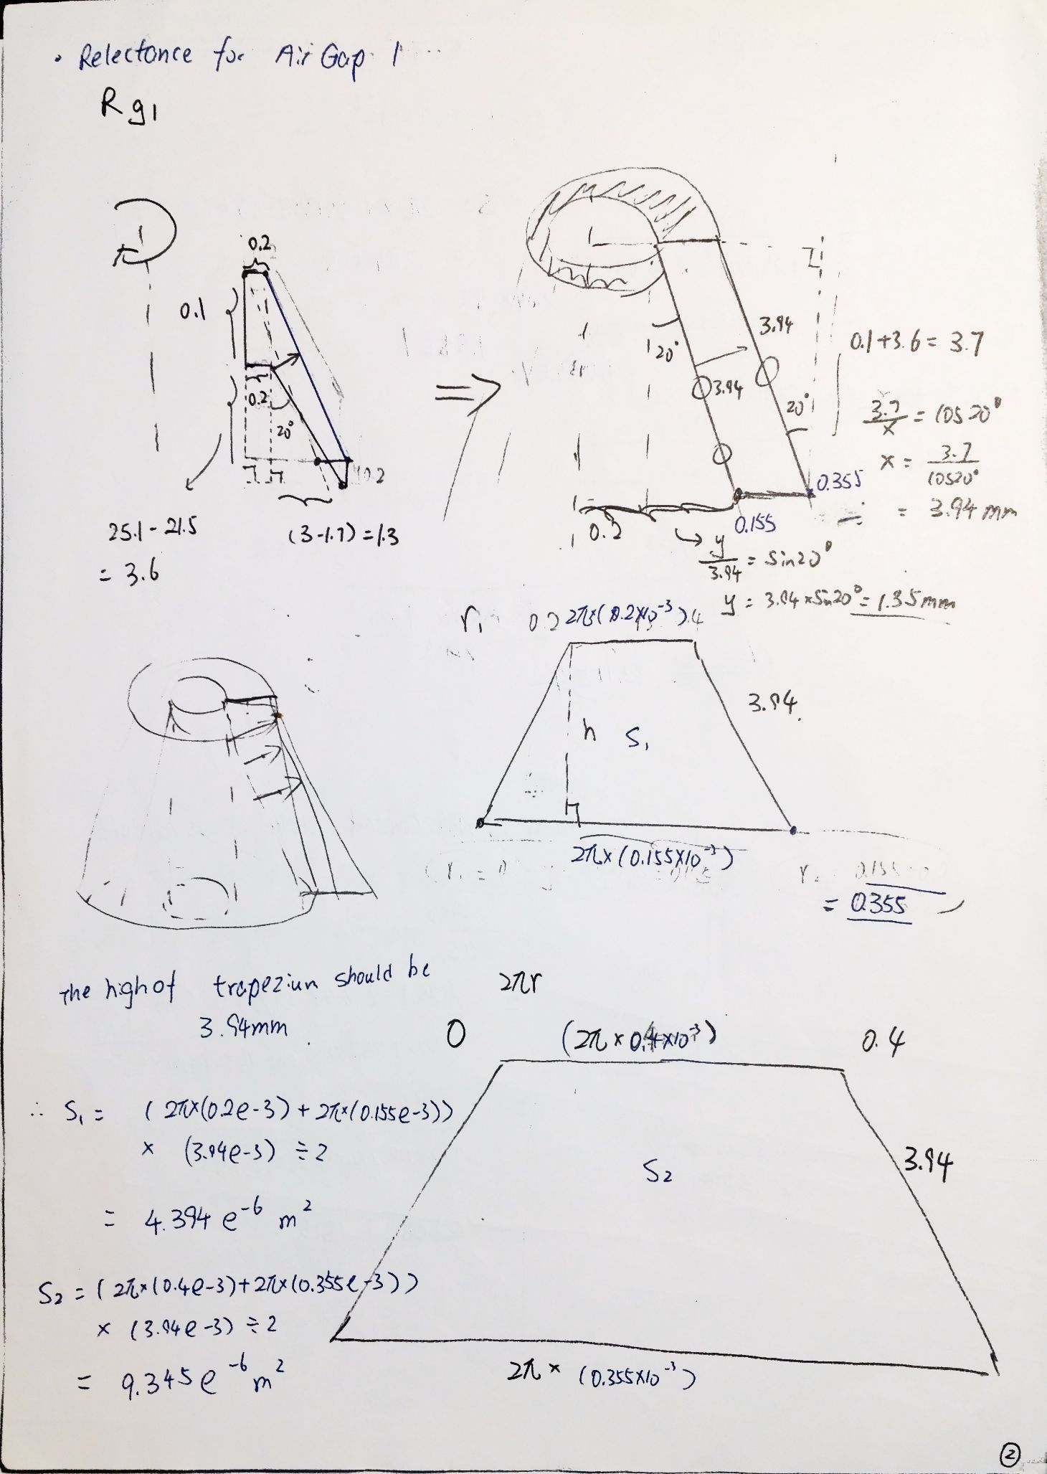

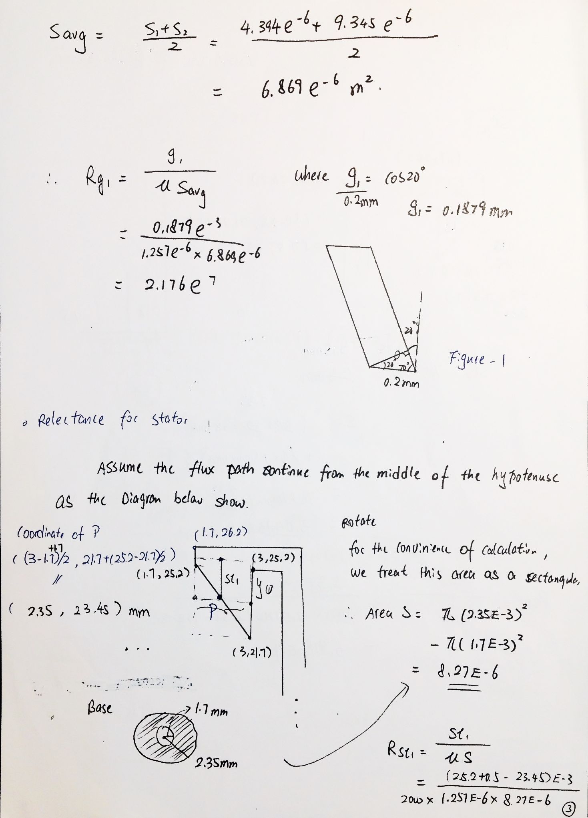

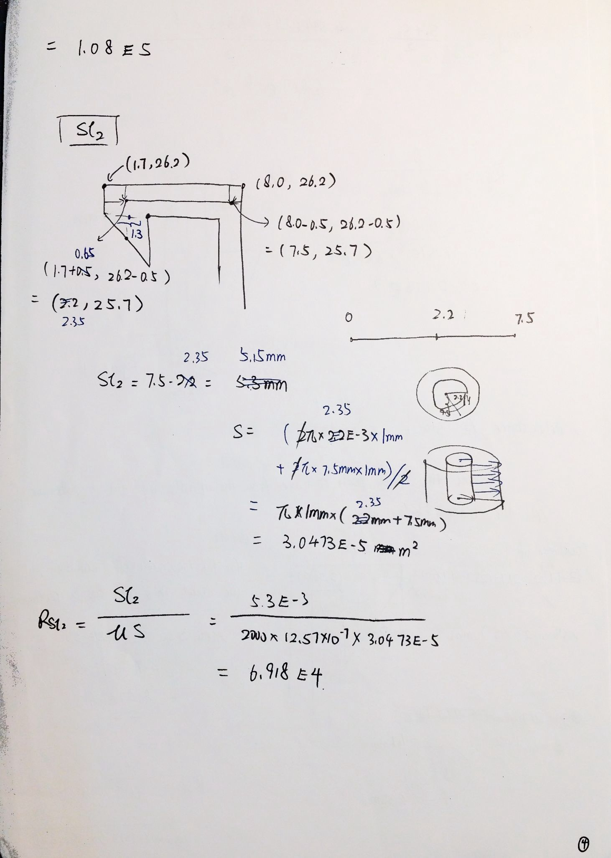

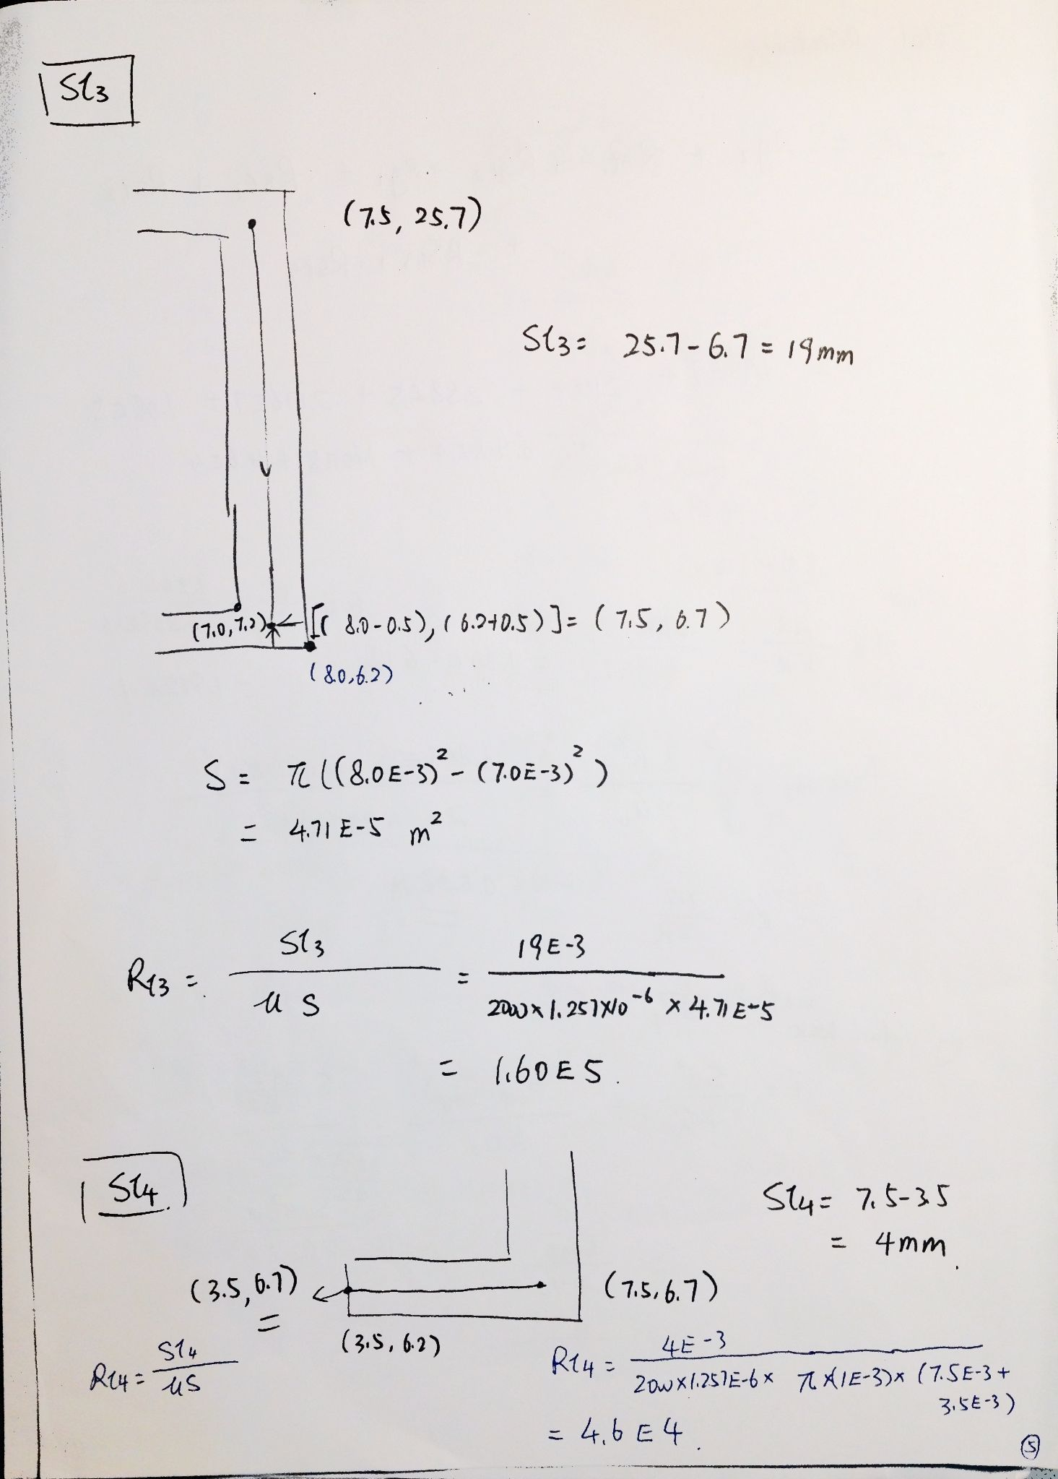

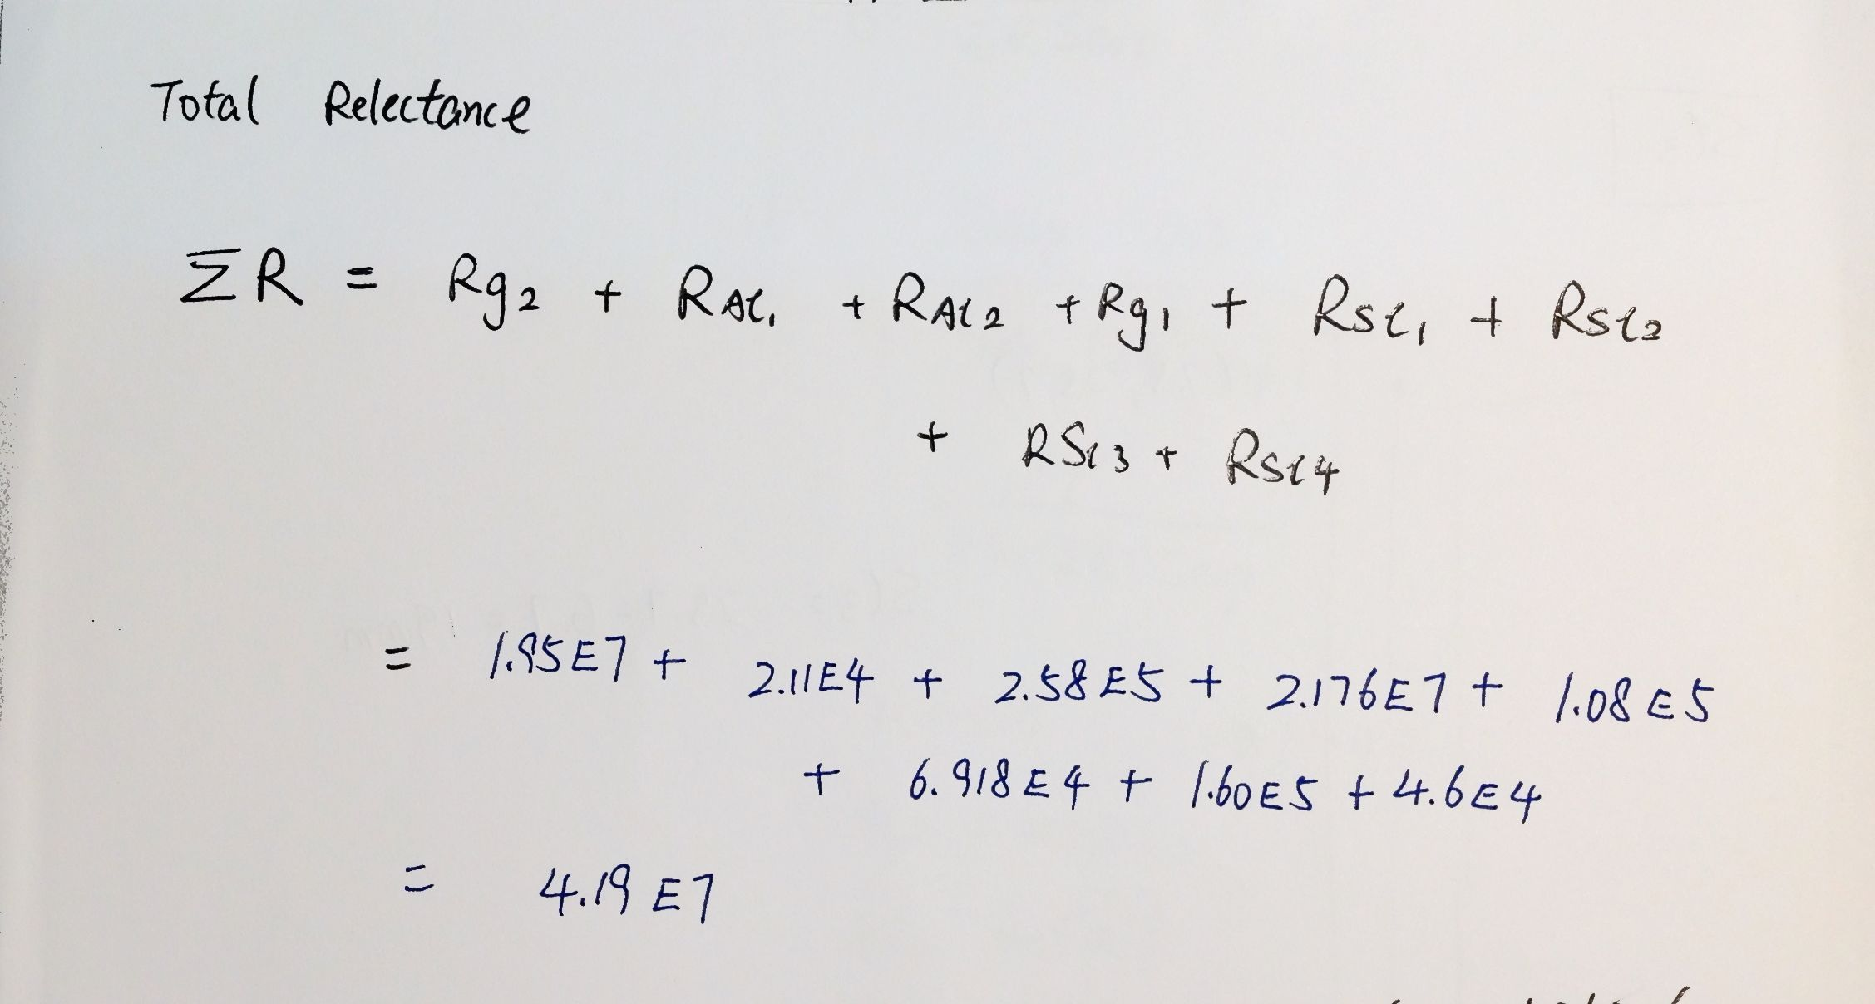

1. Finding the analytical expression for F_y and I using virtual work

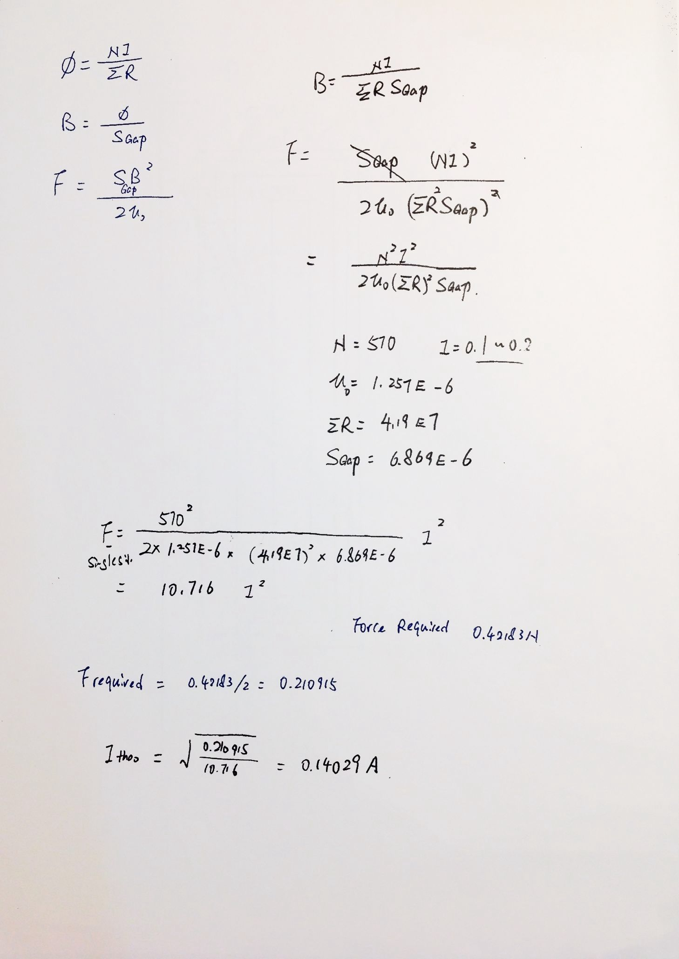

c). the theoretical current required to hold your designated weight.

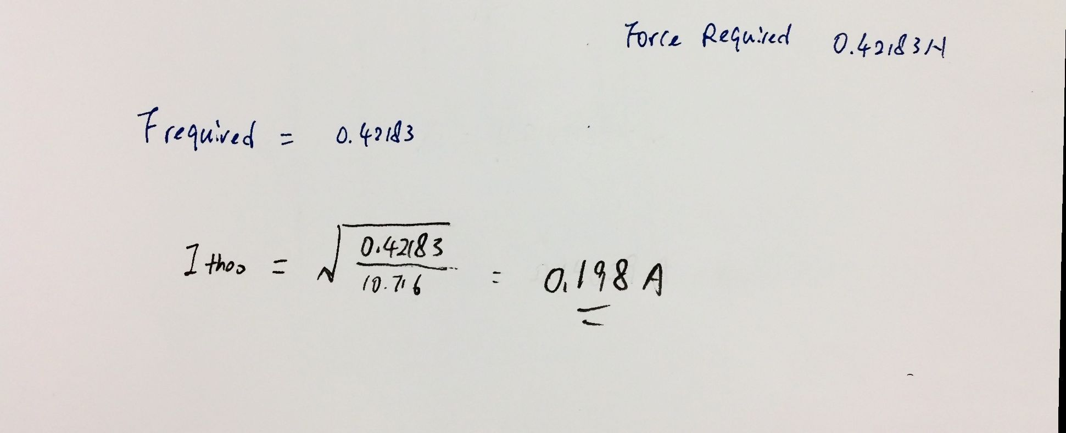

# FEMM Model

Recall the spacer and nuts combination of this experiment is 1 and 3. Therefore the FEMM model has been constructed as below shows.

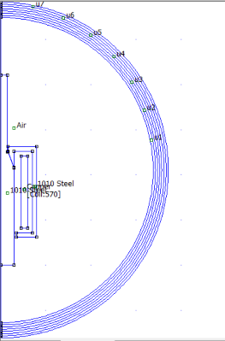

The fem file is also attached with this assignment.

Figure-1

Analysis has been carried on using FEMM and the flux intensity is shown in the diagram below shows.

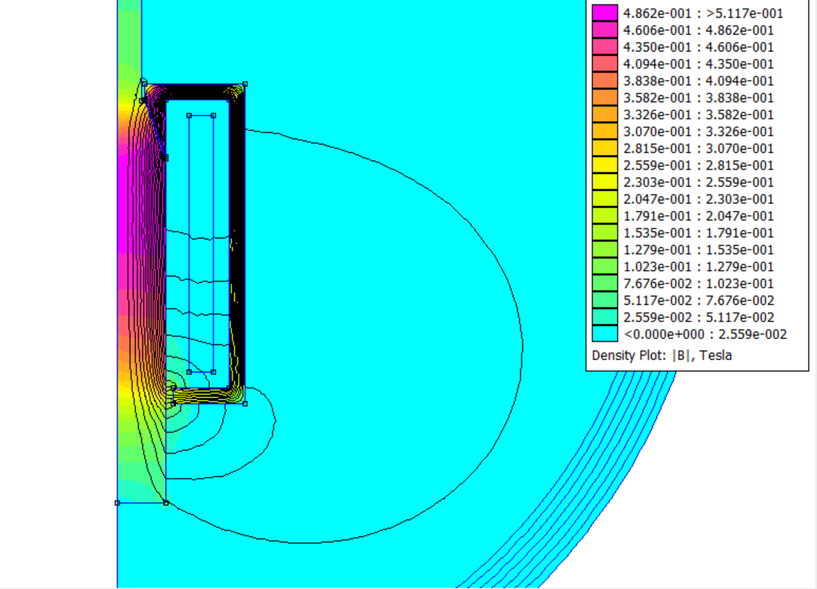

Figure-2

After a few iterations of putting in different current value, it can be concluded that when **I = 0.13A,** the armature experiences a force in Y direction with .

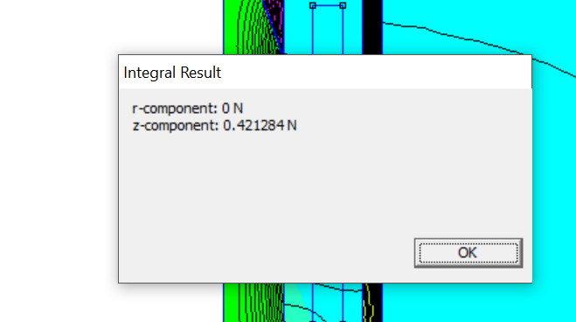

# Figure-3

# Comparison

The current required to hold the 3 nuts and the plunger under different analysis can be summarised in the following table.

|  |  |
| --- | --- |
| Experimental | 0.12A |
| Finite Element Analysis | 0.13A |
| Analytical | 0.198A |

The reason why the experimental result gave the smallest current measured among the three is that the friction between the plunger and the connection with the stator might help to hold the plunger and the nuts, therefore less force is required to be generated from the magnetic field and this leads to a lower than expected value in current to generate this field.

It has been estimated in session 3 that . And recalled the approximation of the cross-sectional area in path sl1 and g2, where the area in sl1 is calculated more than that in real life and result in a smaller total reluctance . And g2’s cross sectional area is smaller than that in real life too, resulting in smaller which will increase furthermore. These are the reasons why the analytical result shows the greatest current among the three in comparison.

Finally, FEA should give the most accurate estimation on the current required. As Figure-2 shows, the FEA model generating mesh with greater number of nodes which are essentially triangle filling into all the space that needed magnetic field calculation. This will ensure good modelling of airgap cross sessional area where the flux lines belong. Moreover, the FEA model also took flux leakage into consideration, which is a phenomenon that will happen in real life systems. Therefore, the result given by this method should be the most accurate one among the three.

# Justify analytical method

Recall that virtual work method was used to estimate the force exert by the armature and stator system in session 3. This method was chosen because the overall force exert by the system needed to be calculated. Loren’s law is not applicable here because both the armature and stator doesn’t carry current.

Maxwell stress tensor wasn’t used because this task is rather heavy for hand calculation. However, this method is used by FEMM when we use the “integral” function and choose “weighted stress tensor” option. The computer can handle line integral(approximated) like this well and provide high precision result for the DC force exert by the system.

# Justify reverse direction of current

The change in direction of current wouldn’t affect the force exert by the system, however, it would change both the direction of the path where the flux line run, and the direction of the magnetic field induced.

# Possible improvement

a). use lubricant on the places where the stator and armature contact with each other;

b). provide precise and accurate measurement of the thickness of the washer/spacer;

c). use a more reliable power source for the solenoid that can provide more accurate reading on current;

d). use known materials with specified permeability or conductivity rather than assuming the properties;

e).using a stand clamp rather than handholding the experimental target to prevent any inaccuracies caused by a unstable hand.

# Bare wire diameter

Recall the resistance of a piece of wire is given by

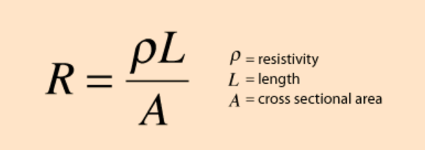

Where L in this case can be approximate as the circumference of each turn * number of turns = (Assuming all turns pass through the central of the coil area).

Therefore , where R, the theoretical resistance = , and the resitivity for copper is 1.72 x 10-8 Ω.m

D = 2*r = 3.1516E-4 m

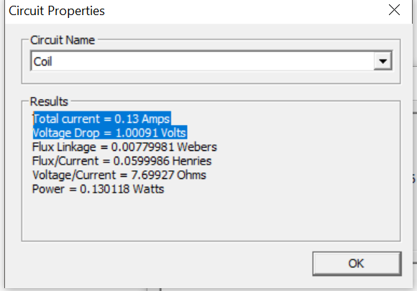

# Changing dimensions in FEA

a). dimension change

Recall again , and as analysed in session 5, changing the air gap distance will not only affect the total reluctance but also the area of the air gap that pass magnetic flux, and it can be predicted that this parameter will have the greatest impact to the force and current relationship.

To prove this prediction, the lua script for session 10 has been used to print out the force that the plunger experience as the airgap change from 0.1 to 0.1+15*0.1, and the result has been shown below.

--> 0.1 0.4212835448595377

--> 0.2 0.3861657106139686

--> 0.3 0.3697302991507228

--> 0.4 0.3588807986849947

--> 0.5 0.3476609103156712

--> 0.6 0.3381698065242314

--> 0.7000000000000001 0.3281585641246

--> 0.8 0.3187220316050828

--> 0.9 0.3085838929865309

--> 1 0.298421891467699

--> 1.1 0.2869199591885474

--> 1.2 0.2791554719305693

--> 1.3 0.2694105053399153

--> 1.4 0.2608616332325065

--> 1.5 0.2501818422620398

--> 1.6 0.2400264168141362

The force reduce as the air gap is widen.

b). change in number of turns

As the expression suggest, changing this property of system will increase the force with the rest of the parameter remains the same.

A new number of turn 5700 has been inputted into FEMM and the resulting force is shown in the figure below

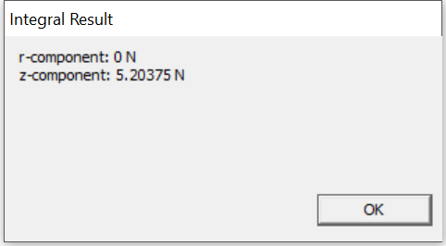

Which is bigger than the original force as expected.

c). change in length of stator(sl2)

The change of the vertical length of the stator will affect the reluctance and therefore resulting in change of the force in the plunger.

New model and the force calculation has been shown in diagrams below

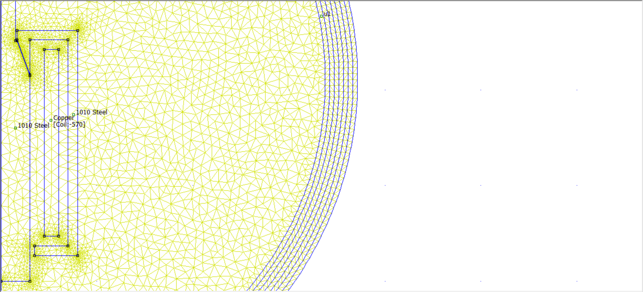 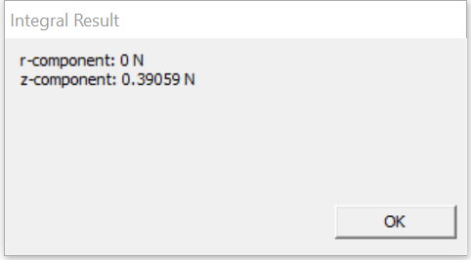

And it has been estimated that increasing the path in the stator reduce the force experience by the plunger.

# Pull curve using LUA

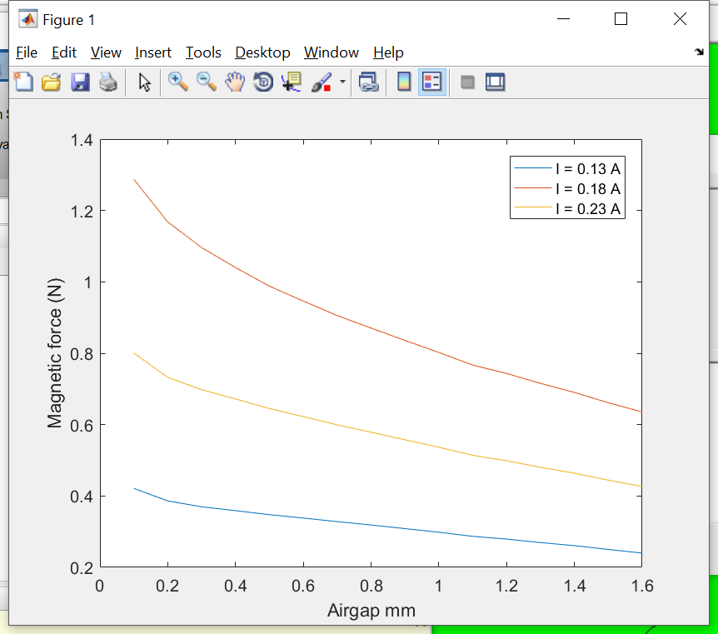

The result print in the LUA console was pasted into MATLAB and generated this plot. The LUA script and MATLAB code has been attached in the appendix.

# Appendix

Test.lua

1. showconsole()
2. mydir="./"
3. open(mydir .. "whole.fem")
4. mi_saveas(mydir .. "temp1.fem")
5. mi_seteditmode("group")
6. for n=0,15 do
7. mi_analyze()
8. mi_loadsolution()
9. mo_groupselectblock(1)
10. fz=mo_blockintegral(19)
11. print(fz)
12. if (n<15) then
13. mi_selectgroup(3)
14. mi_movetranslate(0,0.1)
15. end
16. end
17. mo_close()
18. mi_close()

lua_plot.m

clc

close all

clear all

gap = 0.1:0.1:1.6;

I_1 = [0.4212835448595377,

0.3861657106139686,

0.3697302991507228,

0.3588807986849947,

0.3476609103156712,

0.3381698065242314,

0.3281585641246,

0.3187220316050828,

0.3085838929862375,

0.298421891467699,

0.2869199591885474,

0.2791554719305693,

0.2694105053399153,

0.2608616332325065,

0.2501818422620398,

0.2400264168141362];

plot(gap,I_1);%I = 0.13

hold on

I_3 = [ 1.287181055931842,%I = 0.23

1.167942398541676,

1.096140114408854,

1.040075428268705,

0.9880323523892081,

0.9462216508443936,

0.9056168572730341,

0.8705144231651617,

0.8359111075374779,

0.8021795704341252,

0.7668230526087383,

0.7431522574263171,

0.7155563858446359,

0.6902044195179993,

0.6611934013968857,

0.6354061425429589];

plot(gap,I_3)

I_2 = [

0.8006967606977735,

0.7322161512945289,

0.6979272585623005,

0.6719120493544566,

0.6451524368258939,

0.6224283181352365,

0.5993904733702159,

0.5786081578093968,

0.5574636872201312,

0.5366341955222509,

0.5140170197585577,

0.4986556316583217,

0.4803102822645814,

0.4637496182887878,

0.4443744619564581,

0.4265896236135915];

plot(gap,I_2)

xlabel('Airgap mm');

ylabel('Magnetic force (N)');