**ELEN 90074 Introduction to Power Engineering**

**Workshop 1 Report**

**Task 1**

**Matlab simulation of the two studies**

1. Calculation of the line impedance parameter for the models.

Study 1

Given that for the Pi section, Ztl = R + j $ω_{L}$ = 0.0455 + j0.1818

$$Z_{base}= \frac{{base voltage }^{2}}{Base MVA}= \frac{{(11*10E3)}^{2}}{100*10E6}=1.21$$

Therefore

$R_{SI}=R_{PU}*Z_{base}=0.0455*1.21=0.055055 Ω$

$$Z_{SI}= ω_{L}*Z_{base}=0.1818*1.21=0.219978 Ω$$

$$L_{SI}= \frac{Z_{SI}}{ω}= \frac{0.219978 }{2* π*f}=7.00211*10E-4H$$

Given that Csh = 0.00088pu

$$X_{pu}= \frac{1}{100*π*0.00088}=3.617 Ω$$

$$X_{SI}=X_{pu}*Z_{base}=3.617*1.21=4.377 Ω$$

$$C_{SI}= \frac{1}{100π*X_{SI}}=7.273*10E-4F$$

Study 2

Given that for the T section, Ztl = R + j $ω_{L}$ = 0.1818 + j0.7273

$$Z_{base}= \frac{{base voltage }^{2}}{Base MVA}= \frac{{(11*10E3)}^{2}}{100*10E6}=1.21$$

Therefore

$$R_{SI}=R_{PU}*Z_{base}=0.1818*1.21=0.2199 Ω$$

$$Z_{SI}= ω_{L}*Z_{base}=0.7273*1.21=0.880 Ω$$

$$L_{SI}= \frac{Z_{SI}}{ω}= \frac{0.880}{2* π*f}=2.801*10E-3H$$

1. Use the simPowerSystem toolbox of Matlab/Simulink to construct the power system shown in Figure 1.

Models constructed as below show.

Study 1.

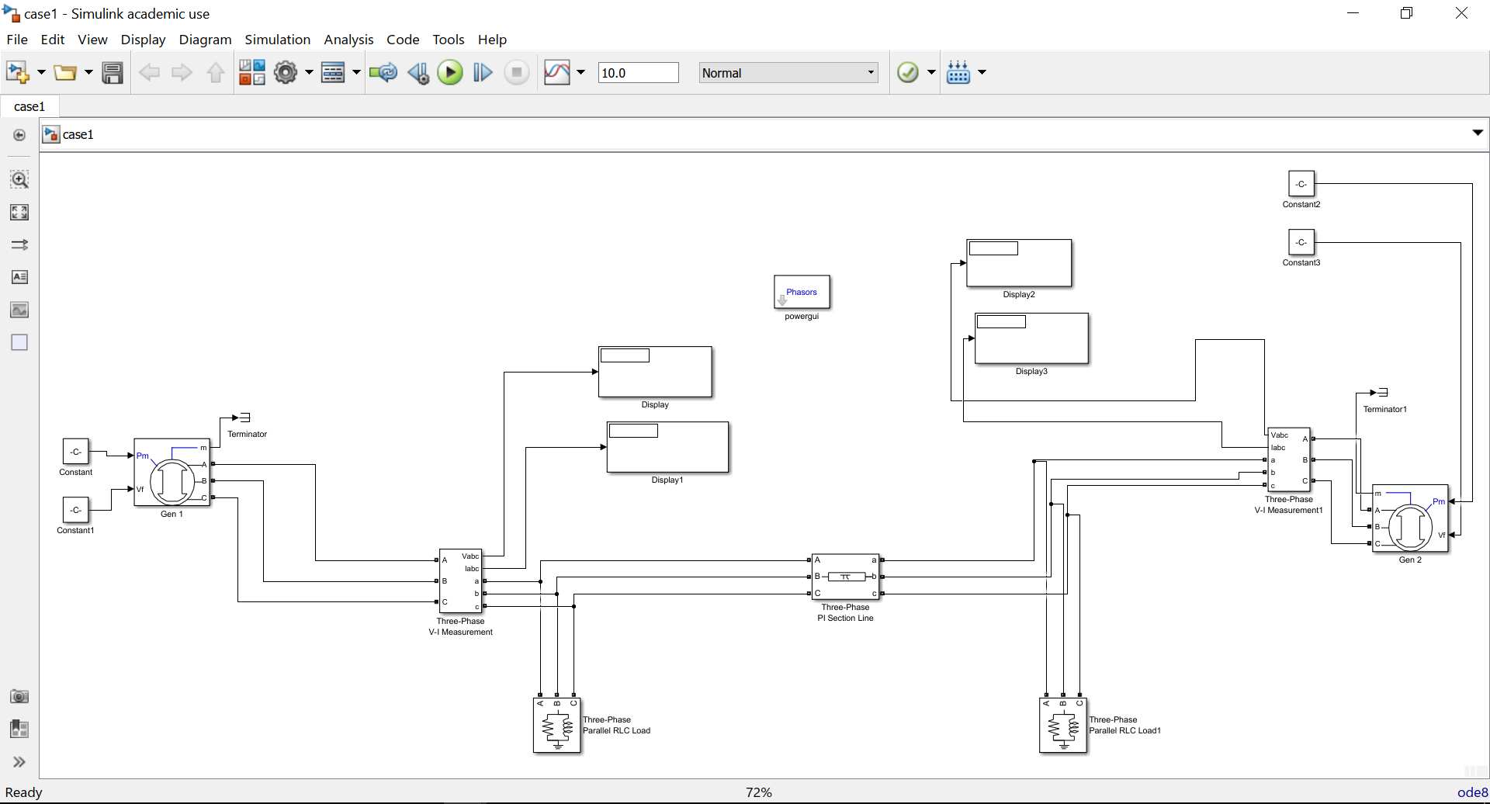

Study 2

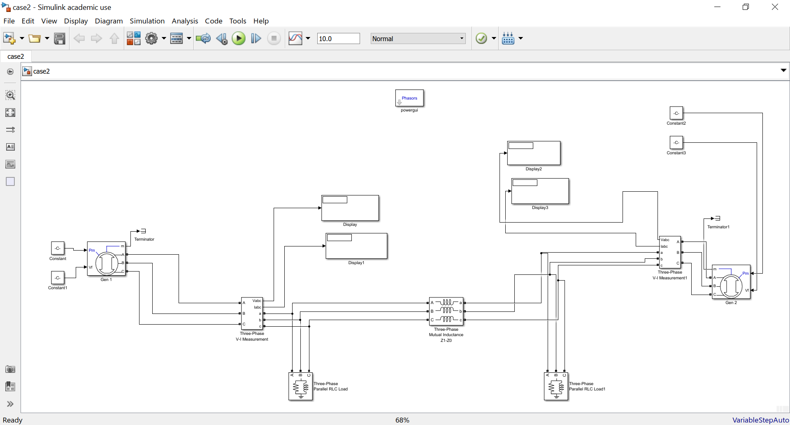

1. Report generated by simulations

Study 1

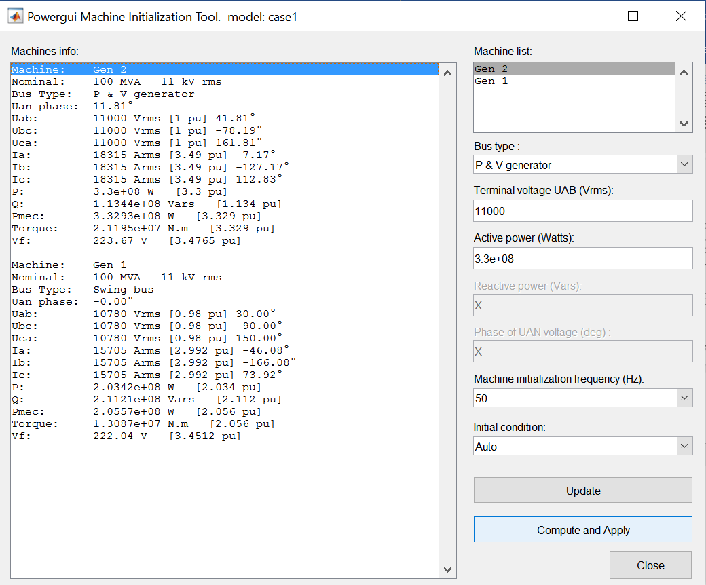

Study 2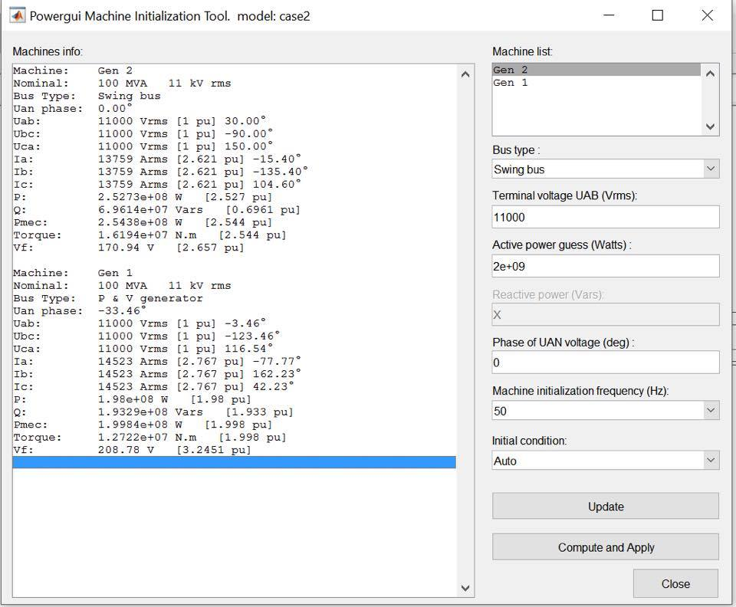

1. Power balance discussion

Make sure that solution achieves active and reactive power balance throughout the whole system.

**Task 2: Write a Matlab .m function to compute the missing variables in each of the three cases using Gauss-Seidel iterative method. In your Matlab program define (using comments) all variables and all parameters. Copy the code and paste it into your report.**

**Study 1**

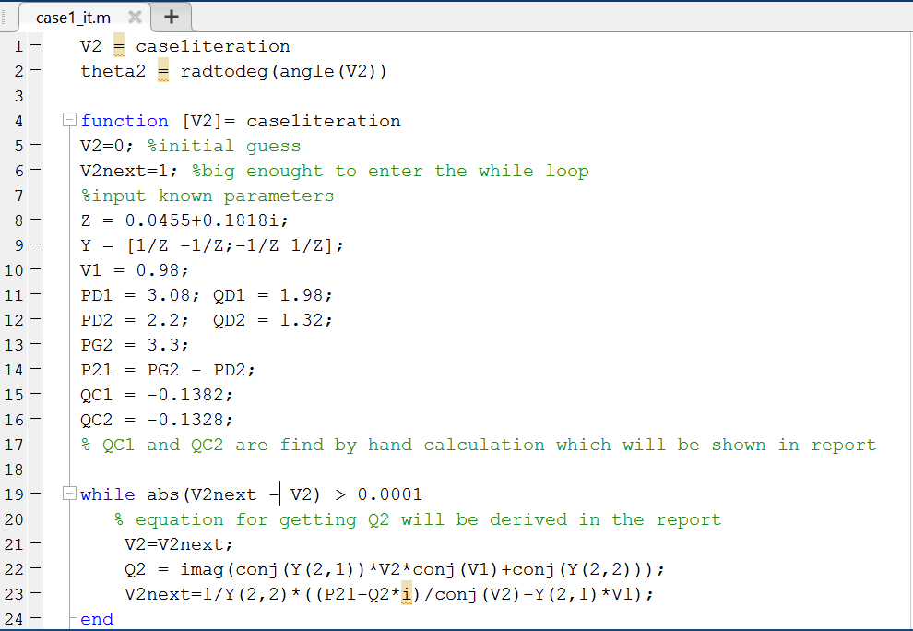

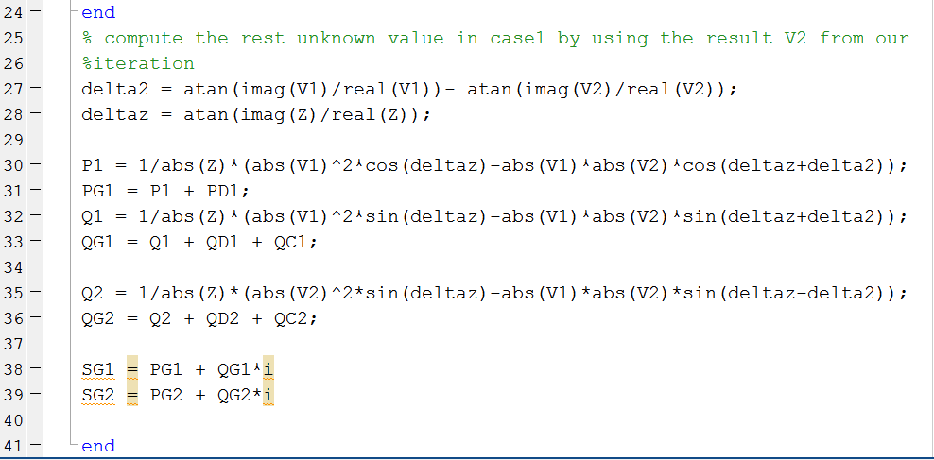

**Results**

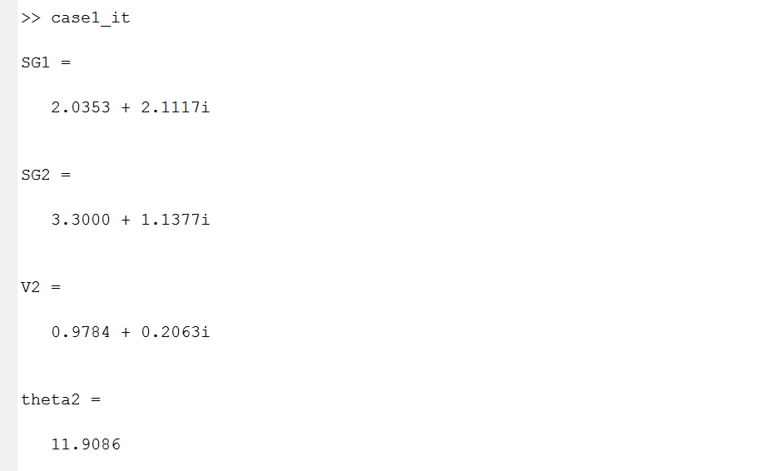

**Study 2**

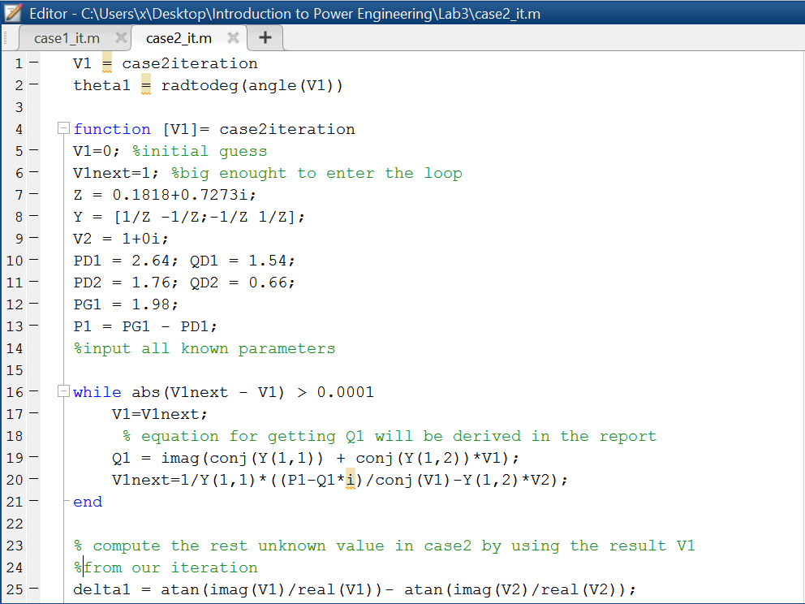

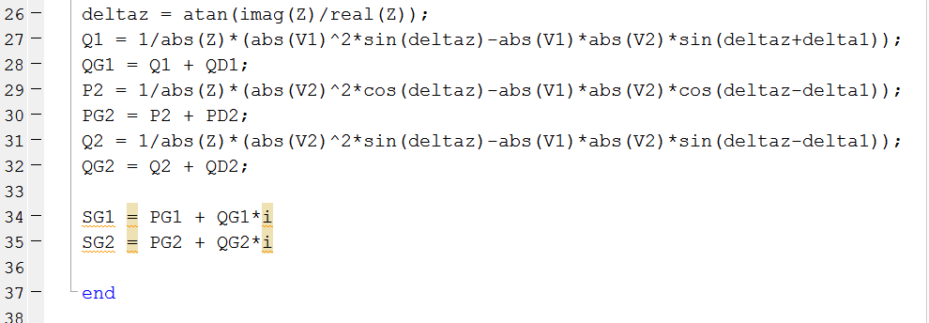

**Result**

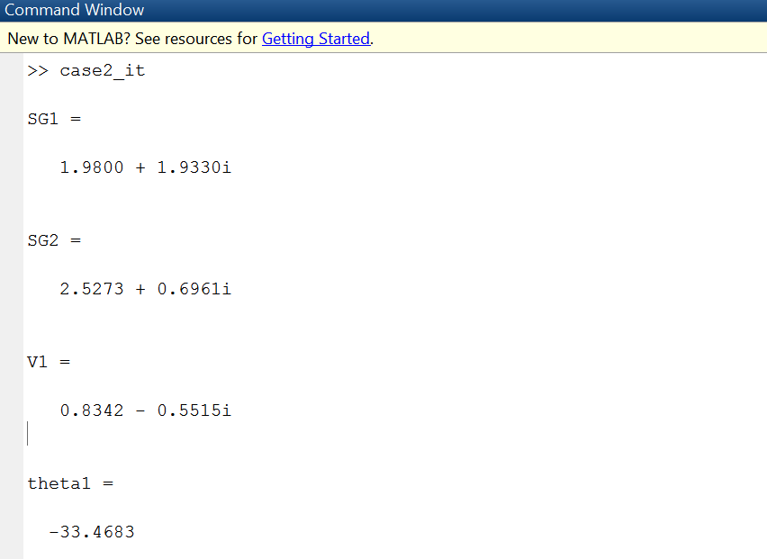

**Task 3: Calculate analytically (hand calculation) the missing variables. Verify the results for both the studies.**

**Study 1**

$$P_{2}=P_{D2}-P_{G2}=2.2-3.3= -1.1 W$$

$$P_{2}= \frac{\left|V_{1}\right|\left|V_{2}\right|}{R^{2}+ X^{2}}=(XSin\left({-δ}_{2}\right)+RCOS\left({-δ}_{2}\right)-R\frac{\left|V_{2}\right|}{\left|V_{1}\right|})$$

$$1.1 = \frac{0.98}{0.035}*(0.1818Sin\left({-δ}_{2}\right)+0.0455COS\left({-δ}_{2}\right)-0.0455*\frac{1}{0.98}$$

$$7.14E-3= 0.1818Sin\left({-δ}_{2}\right)+0.0455COS\left({-δ}_{2}\right)$$

$$7.14E-3= 0.1874[(sinθsin\left({-δ}_{2}\right)+cosθcos({-δ}_{2}))]$$

$$0.038=cos(θ+δ_{2})$$

$$δ_{2}= \cos^{-1}\left(0.038\right)- {75.95}^{。}= {11.87}^{。}$$

Therefore

$$P_{1}= \frac{\left|V_{1}\right|\left|V_{2}\right|}{R^{2}+ X^{2}}=\left(XSin\left(δ_{12}\right)- RCOS\left(δ_{12}\right)-R\frac{\left|V_{2}\right|}{\left|V_{1}\right|}\right)$$

$$= \frac{0.98}{0.035}*\left(0.1818sin\left(-11.87\right)-0.0355COS\left(-11.87\right)+0.0455*0.98\right)$$

$$P_{1}= -1.042$$

$$P_{G1}=P_{D1}+P_{1}=3.08-1.04=2.038$$

For shunt capacitance C_sh = 0.00088pu, so Csh1 = 0.00044 = C_sh2

$$Z_{C1}= \frac{1}{jwc}= \frac{1}{j*100π*0.00044}= -7.234j=Z_{C2}$$

$$Q_{C1}= \frac{{\left|V_{1}\right|}^{2}}{X}= \frac{(0.98)^2}{-7.234}= -0.133$$

$$Q_{C2}= \frac{{|V_{2}|}^{2}}{X}=\frac{1}{-7.234}= -0.138$$

$$Q_{1}= \frac{\left|V_{1}\right|\left|V_{2}\right|}{R^{2}+ X^{2}}=\left(-XCos\left(δ_{12}\right)- RSin\left(δ_{12}\right)-X\frac{\left|V_{1}\right|}{\left|V_{2}\right|}\right)$$

$$Q_{1}= \frac{0.98}{0.035}*\left(-0.1818*Cos\left(-11.87\right)-0.0455Sin\left(-11.87\right)+0.1818*\left(\frac{0.98}{1}\right)\right)$$

$$Q_{1}=0.269$$

$$Q_{G1}=Q_{1}+Q_{C1}+Q_{D1}=0.269=0.133+1.98=2.11$$

$$Q_{2}= -\frac{\left|V_{1}\right|\left|V_{2}\right|}{R^{2}+ X^{2}}=\left(XCos\left(δ_{12}\right)- RSin\left(δ_{12}\right)-X\frac{\left|V_{2}\right|}{\left|V_{1}\right|}\right)$$

$$= -28*(0.1818cOS\left(-11.87\right)-0.0455Sin\left(-11.87\right)-0.1818(1/0.98))$$

$$Q_{2}= -0.0269$$

$$Q_{G2}=Q_{2}+Q_{C2}+Q_{D2}= -0.049+\left(-0.138\right)+1.32=1.13$$

To sumup with

$$S_{G1}=2.038+j2.11$$

$$S_{G2}=3.3+j1.231$$

**Study 2**

$$P_{1}=P_{G1}-P_{D1}=1.98-2.64= -0.66$$

$$P_{1}= \frac{\left|V_{1}\right|\left|V_{2}\right|}{R^{2}+ X^{2}}=\left(XSin\left(δ_{12}\right)- RCOS\left(δ_{12}\right)-R\frac{\left|V_{2}\right|}{\left|V_{1}\right|}\right)$$

$$-0.66=\frac{1}{0.562}*\left(0.7273Sin\left(δ_{1}\right)-0.1818Cos\left(δ_{1}\right)+0.1818\right)$$

$$0.7372=Cos\left(θ+δ_{1}\right)$$

$$θ+δ_{1}=\arccos\left(0.7372\right)={42.5}^{。}, and θ=arctan\left(\frac{0.7273}{0.1818}\right)={76}^{。}$$

$$therefore δ_{1}=42.5-76={-33.5}^{。}$$

$$Q_{1}= \frac{\left|V_{1}\right|\left|V_{2}\right|}{R^{2}+ X^{2}}=\left(-XCos\left(δ_{12}\right)- RSin\left(δ_{12}\right)-X\frac{\left|V_{1}\right|}{\left|V_{2}\right|}\right)$$

$$= \frac{1}{0.562}*\left(-0.7273Cos\left(-33.5\right)-0.1818Sin\left(-33.4\right)+0.7273\right)$$

$$Q_{1}=0.39$$

$$Q_{G1}=Q_{1}+Q_{D1}=0.39+1.54=1.93$$

$$I_{L}= \frac{-0.165-j0.55}{0.1818-0.7273j}=0.76e^{\begin{aligned}-2.67j \\ \end{aligned}}$$

Therefore

$$P_{L}= {|I}_{L}^{2}|*R=0.11$$

$$Q_{L}= {|I}_{L}^{2}|*X=0.42$$

$$P_{G2}=P_{D1}+P_{D2}+P_{L}-P_{G1}=2.53$$

$$Q_{G2}=Q_{D1}+Q_{D2}+Q_{L}-Q_{G1}=0.69$$

Therefore

$$S_{G1}=1.98+j1.93$$

$$S_{G2}=2.53+j0.69$$

**Task 4: Tabulate the results obtained from Tasks 1-3. Comment on the results.**

**The unknown in each study are tabulated for comparison purpose.**

**Study 1**