INDIAN INSTITUTE OF INFORMATION TECHNOLOGY, ALLAHABAD
(Deemed University)
(A centre of excellence in IT, established by Ministry of HRD, Govt. of India)
Object Oriented Methodology Lab
Project No. #10 Prof. Dr. O.P. Vyas & Ranjana Vyas

Project: Software Drawing 2D shapes & 3 D graphics
ABSTRACT
In this project you have to draw 2D shapes such as Square, Circles. And there are buttons to control the rotation shapes.
Also, draw of 3D Squares/Rectangle, circles. In addition to this, keep a buttons to control the rotation in different orientations.
Abstract Images:

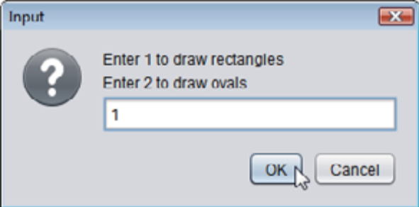
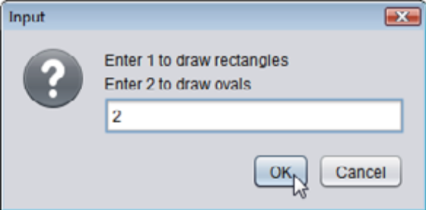
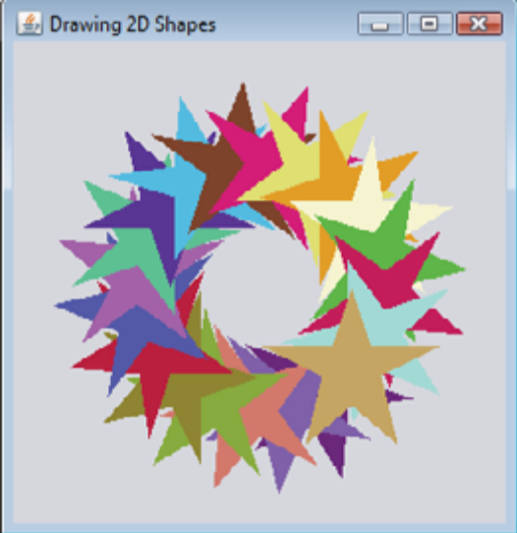

Specific Technology
JAVA, Swing
Project Tasks
Use case analysis, Design: Class Diagram, CRC and Implementation, User -Interface

FEATURES
- Draw a dialog box, in which you have to enter your choice.
- According to choice you have to draw a 2D shape.
- There should be a component by which you can control the rotation of shape.

Submission
The project presentation has to be done by each member to show periodically the progress and the complete project submission should contain the following:
- UML diagrams:-Use Case diagram, Class diagram, CRC diagram(s), illustrating the design of your program.
- All the Java source code should necessary to compile and execute.

