

ATLAS Operator Interface
Requirements Specification

APS AES/CTL  Specifications Document # |  |  | ATLAS Operator Interface Requirements Specification | Revision |  | 0.1
Functional Specification for ATLAS OPI
Version | Sections Affected | Description of Change |  |  | Author |  | Date
  Alex Dunn
  Intern, Technical (Author) | Signature | Date
  Bryan Orr
  Co-op, Technical (Author) | Signature | Date
  Richard Farnsworth
  Controls Group Leader | Signature | Date
  Ned Arnold
  Computer Systems Engineer | Signature | Date
0.1 | All | Initial Document Release |  |  | Bryan, Alex |  | 2012, Jul 23

CONTENTS
1 INTRODUCTION 5
1.1 Purpose 5
1.2 Scope 5
1.3 Assumptions and Constraints 5
1.3.1 Assumptions 5
1.3.2 Constraints 5
1.4 Document Overview 5
2 DESIGN MEHODOLOGY 6

Table 1: Magnet Interlocks 11
Table 2: Current Lead Interlocks 12
Table 3: SCU0 Warnings Provided 15

INTRODUCTION
An operator interface for the Argonne Tandem Linac Accelerator System (ATLAS) utilizing CSS BOY is required to provide remote control and monitoring of the system.

Purpose
This document describes the functional design requirements of the operator interface to be constructed and operated at the ATLAS project. The interface is a GUI built on an Eclipse framework called CSS BOY which will interface with an EPICS database.

Scope
In order to maintain consistency for the ATLAS project, the interface design will utilize CSS BOY version 3.1.0 available online at http://ics-web.sns.ornl.gov/css/products.html . Since many of the widgets and display components have already been chosen for this project; the interface will be designed with these specific components in mind.

Assumptions and Constraints

Assumptions
Before the operator interface design can begin, the functional requirements document must first be completed and all interested parties must agree to the information contained herein.
Functional testing of the operator interface can be performed utilizing a previously setup EPICS system with live PV’s.

Constraints
Time frames???

Document Overview
A summary table of functional requirements (FRQ) is first presented with all requirements being numbered; these FRQ numbers will not be changed from this point forward. If there is an FRQ that is not needed it should be noted in the table as well as within the part of the document describing the requirement.
The design methodology will be briefly described before presenting the details of the functional requirements. A section for other requirements will be presented.
The appendices include a glossary of terms used throughout this document as well as various system diagrams. These appendices are included at the end of the document for reference.

DESIGN METHODOLOGY
This document was developed through communications with members of the Magnetic Devices Group. The information contained herein was provided in particular, by Matt Kasa and Chuck Doose who are currently working hands on with the device prototype. Information was also obtained from ICMS.

FUNCTIONAL REQUIREMENTS

User Requirements
There are several different types of users from the standpoint of the control system and they include machine physicists, beamline users, and maintenance personnel. All of these users will generally have the same requirements, differences will be noted.
SCU1.9 Beamline user control shall be in units of energy (eV)
SCU2.0 Machine physicists and SCU0 team shall have control over main coil in (Amps)
SCU2.1 User display shall be either MEDM or CSS BOY to comply with APS standards

Main Power Supply
SCU 1.0 Main power supply requirements:
SCU 1.0.1 Remote communications interface.
This will allow for remote control/monitoring of the main power supply
Shall use an IEEE standard communication protocol.
(Preferred interfaces RS232 or Ethernet TCP/IP)
SCU 1.0.2 Remote and local enable/disable of power supply output.
This feature will likely be used for maintenance and storage-ring operations for to disable device operation during studies and possible maintenance periods.
SCU 1.0.3 Remote reset capability.
The control shall provide a reset for over voltage conditions which can ocurr due to superconductor quenching
SCU1.0.4 Output Voltage Range
The output voltage to the main coil of the device shall have a remote and locally adjustable range of 0 – 5 VDC.
Analog voltage used to program current output
SCU1.0.5 Remote and local voltage read backs
The power supply shall have both remote and local readbacks for the output coil voltage of 0 – 5 VDC.
SCU1.0.6 Over Voltage Protection
The power supply shall have an output over voltage protection which can be adjusted both locally and remotely between 0.12 – 5 VDC

SCU1.1 Current Control
The main coil power supply shall have an adjustable current control which can be adjusted both locally and remotely.
SCU1.1.1 Output Current Range
The main coil power supply shall have an output current range of 0 – 850 Amps DC.
SCU1.1.2 Current Read Back Values
The main coil power supply shall have current read backs available both locally and remotely with a range of 0 – 805 Amps DC.

SCU1.2 Current Ramping Control
The main coil power supply shall have remote current ramping capability.
SCU1.2.1 Up/Down Current Ramping
The main coil power supply shall have the capability of providing remote current ramping using analog voltage control.
The main coil power supply shall have a slew rate of the lesser value between what the APS storage-ring will permit during beam operations and 10 Amps/second. This will insure not only minimal storage-ring beam disturbance but also that the main coil magnet does not quench; this can occur in about 10 ms. [3]
Note:
Existing power supply is Agilent 6680A which only has a GPIB interface, output voltage range of 0 – 5 VDC, output current range of 0 – 875 amps, programming accuracy of voltage 0.04% + 5mv and current of 0.1% + 450ma, 1.5mv rms ripple and 10mv pk-pk. There is a desire to use this power supply due to a low ripple current.

SCU1.3 Correction Power Supply
SCU1.3.1 Corrector Power Supply Synchronization
The corrector coil supply(s) shall be sychronized to the main coil power
supply according to lookup table provided my Magnetic Devices group.
SCU1.3.2 Corrector Supply Output Current Range
The corrector power supply has an output current range between 0 – 100
Amps DC.
SCU1.3.3 Corrector Supply Current Readbacks
The corrector power supply shall have both local and remote current
readbacks in the range of 0 – 100 Amps DC.
SCU1.3.4 Corrector Supply Voltage Output
The corrector power supply shall have a voltage output range of 0 – 10
VDC.
SCU1.3.5 Corrector Supply Voltage Readbacks
The coorector supply shall have both local and remote readbacks in the
range of 0 – 10 VDC.

SCU1.3.6 Overvoltage Protection
The corrector supply shall have an adjustable overvoltage protection
setpoint range between 0.12 – 10 VDC which can be adjusted locally and
remotely.

SCU1.4 Cryogenic Temperature Monitoring
The cryogenic temperature monitoring system must meet all requirements within this section SCU1.4.
SCU1.4.1 Maximum Number of Temperature Sensors
There shall be a maximum of 32 temperature sensors located in various places within the cryogenic chamber. These locations can be found in Figure 3 in Appendix B at the end of this document.
SCU1.4.2 Temperature Range
The temperature range to be measured is between 4 – 300 Kelvin
SCU1.4.3 Temperature Measurement Resolution
The control system shall have a 0.1 Kelvin measurement resolution
between 4 – 150 Kelvin otherwise 1 Kelvin
SCU1.4.4 Temperature Measurement Speed
The control system shall provide a minimum of one reading per second
per sensor
SCU1.4.5 Temperature Measurement Accuracy
All temperature measurements shall have an accuracy of ±0.3 Kelvin
between 4 – 150 Kelvin, otherwise best effort.
SCU1.4.6 Parallel Measurements
All temperature measurements can be performed 8 at a time in parallel
from each of up to 4 temperature monitor devices.
SCU1.4.7 Remote and Local Temperature Read Back
Local temeperature read backs shall be available for local operation of the
SCU0 ID. Remote temperature read backs shall be available using a
standard IEEE communication protocol with RS232 being preferred.
SCU1.4.8 Hardware Alarm Outputs
High temperature hardware alarm outputs must be provided for each
temperature sensor
Note:
Currently using the Lakeshore Model 218s (APS_1418321) temperature monitor which could have GPIB, IEEE-488 or RS232 interface with over temperature alert for each sensor.

SCU1.5 Liquid Helium (LHe) Level Monitoring
Liquid helium level shall be maintained for device cooling with the monitoring
being performed by a hardware device with an RS232 or Ethernet IEEE standard
interface to the control system for value read back
SCU1.5.1 Level Monitoring Accuracy
The control system shall provide accuracy of level monitoring appropriate
for the hardware device providing measurements.
SCU1.5.2 Level Monitoring Resolution
The control system shall provide a monitoring resolution appropriate for
the hardware device providing measurements and measurements shall be
in cm.
SCU1.5.3 Remote and Local Level Read Backs
LHe level read backs shall be present both locally and through a standard remote interface in compliance with SCU1.4.7.
SCU1.5.4 Hardware Alarm Outputs
To be provided to the control system by the monitoring device with the
threshold value to be determined
SCU1.5.5 Maximum Number of Devices
There shall be a maximum of 2 LHe level monitors to be used in the
system
Note:
Currently using American Magnetics Model AMI-135-2K (APS_1418323) with the following specifications:
- resolution of 0.1%, 0.1cm, or 0.1 inches
- Hi/Lo alarm relay outputs rated at 30 VAC or 60 VDC up to 0.5 amps max
- Sample and hold time from 0.1 to 600 minutes or hours
- Analog output of 0 – 10 VDC 16-bit resolution with an error of ±1.1% and a voltage drift of 100ppm per degree C.
- 4 – 20ma analog output at 24 VDC and a resoultion of 16-bits with an error of ±0.25% and current drift of 75ppm per degree C.
- Input power requirement of 90 – 132 VAC
- 19-inch rack mounted

SCU1.6 Main Coil DC Current Transducer
Currently using an obsolete Ultrastab 860R manufactured by Danfisyk and it is unclear which exact model is going used if any. These units have status, interlock, and analog output connectors. This would be used to monitor output current from both the main and the correector power supplies.
A current transducer may not be used at all but rather a analog output from the power supplies could be used to provide the current output feed back required for control of the main coil supply.
SCU1.6.1 Main Coil Current Transducer Communications
The communications shall be IEEE standard compliant or analog.
The exisitng device has a GPIB interface as well as 0 – 1 VDC analog
output voltage that is proportional to the current being measured.
SCU1.7 Magnet Voltage Tap Read Backs
Remote read back of magnet voltage taps shall be provided; the range is 0 – 10
VDC
SCU1.8 Heater Current Power Supply
The power supply for the heater current shall provide 20 VDC output at a
maximum current of 2 Amps.
SCU1.9, SCU2.0, and SCU 2.1 were previous discussed in this document.

SCU3.0 Interlocks
All deivce interlocks shall be performed using hardware optionally being
processed by a microprocesor for decision making if necessary. This section
describes the types of interlocks required by the system.

SCU3.1 Magnet Interlocks
The following table provides information on magnet interlocks
Sub-system | Event | Signal | Action
Magnet | Magnet overheat | (TT19 OR TT20) > Tmax2 | Start current ramp down
 | Quench | Power supply over-voltage trigger | Start current ramp down
 | Main coil voltage increase | (V7) or (V8) > Vmax1 | Start current ramp down
 | Corrector coil voltage increase | VT9or VT10 > Vmax2 | Start current ramp down
Table 1: Magnet Interlocks

SCU3.3 LHe Tank Level
When the liquid helium level is less than Lmin2 (TBD) ramp main power
supply to zero amps. LI1 or LI2 < Lmin2.
SCU3.4 Current Leads
The following table provides information about the current leads to the
magnets of the device.
HTS current lead overheat:
500A HTS lead 1 | (TT09 – TT02) > T2max2 | Start current ramp down
500A HTS lead 2 | (TT10 – TT02) > T2max2 | Start current ramp down
100A-US HTS lead 1 | (TT13 – TT04) > T1max2 | Start current ramp down
100A-US HTS lead 2 | (TT14 – TT04) > T1max2 | Start current ramp down
100A-DS HTS lead 1 | (TT11 – TT04) > T1max2 | Start current ramp down
100A-DS HTS lead 2 | (TT12 – TT04) > T1max2 | Start current ramp down
HTS current lead overvoltage
500A HTS lead1 | VT1 > Vmax3 | Start current ramp down
500A HTS lead2 | VT2 > Vmax3 | Start current ramp down
100A-DS HTS lead1 | VT3 > Vmax4 | Start current ramp down
100A-DS HTS lead2 | VT4 > Vmax4 | Start current ramp down
100A-US HTS lead1 | VT5 > Vmax4 | Start current ramp down
100A-US HTS lead2 | VT6 > Vmax4 | Start current ramp down
Table 2: Current Lead Interlocks

SCU4.0 Warnings
The following table shows the warning information that the control system shall provide.
Sub-system | Event | Signal | Action
Beam chamber | Beam chamber is hot | (TT21 OR TT22 OR TT23 ) > Tbc max | Start warning image on control panel (SWI)
Magnet | Coils are warm | (TT19 OR TT20) > Tmax1 | SWI
Current leads | HTS current lead overheat:
 | 500A HTS lead 1 | (TT09 – TT02) > T2max1 | SWI
 | 500A HTS lead 2 | (TT10 – TT02) > T2max1 | SWI
 | 100A-US HTS lead 1 | (TT13 – TT04) > T1max1 | SWI
 | 100A-US HTS lead 2 | (TT14 – TT04) > T1max1 | SWI
 | 100A-DS HTS lead 1 | (TT11 – TT04) > T1max1 | SWI
 | 100A-DS HTS lead 2 | (TT12 – TT04) > T1max1 | SWI
Radiation shields | Shield is hot:
 | 60K shield | TT24 > TT24max | SWI
 | 20K shield | TT25 > TT25max | SWI
LHe tank | LHe level is low | LI1 < Lmin2 | SWI
 | LHe level is low | LI2 < Lmin2 | SWI
 | Pressure is high | PT2 > PT2max | SWI
 | Recondenser temperature is high | TT15 > TT15max | SWI
 | Tank temperature is high | TT16 > TT16max | SWI
Cryostat vessel | Insulating vacuum is poor | PT1 > P1max | SWI
Cryocoolers | Stage is hot:
 | Cryocooler DS TOP – 1st stage | TT01 > TT01max | SWI
 | Cryocooler DS TOP – 2nd stage | TT02 > TT02max | SWI
 | Cryocooler US TOP – 1st stage | TT03 > TT03 max | SWI
 | Cryocooler US TOP – 2nd stage | TT04 > TT04 max | SWI
 | Cryocooler DS BOT – 1st stage | TT05 > TT05max | SWI
 | Cryocooler DS BOT – 2nd stage | TT06 > TT06max | SWI
 | Cryocooler US BOT – 1st stage | TT07 > TT07 max | SWI
 | Cryocooler US BOT – 2nd stage | TT08 > TT08 max | SWI

Cryocooler compressors
 | Compressor DS TOP | CI1 = High | SWI
 | Compressor DS TOP | CI2 = High | SW1
 | Compressor DS TOP | CI3 = High | SW1
 | Compressor DS TOP | CI4 = High | SW1
 | Compressor US TOP | CI5 = High | SWI
 | Compressor US TOP | CI6 = High | SWI
 | Compressor US TOP | CI7 = High | SWI
 | Compressor US TOP | CI8 = High | SWI
 | Compressor DS BOT | CI9 = High | SWI
 | Compressor DS BOT | CI10 = High | SWI
 | Compressor DS BOT | CI11 = High | SWI
 | Compressor DS BOT | CI12 = High | SWI
 | Compressor US BOT | CI13 = High | SWI
 | Compressor US BOT | CI14 = High | SWI
 | Compressor US BOT | CI15 = High | SWI
 | Compressor US BOT | CI16 = High | SWI
(Threshold parameters to be defined)
Table 3: SCU0 Warnings Provided

OTHER REQUIREMENTS

Hardware Interfaces
A power supply controller is being developed by the Power Supply Group. The controller will be responsible for synchronizing the corrector coil power supplies with the main coil power supplies as well as providing electronic level interlock logic. The preferred device interface is either RS232 or Ethernet, although the currently selected main power supply only has a GPIB interface available.
For the RS232 type devices the communication could be over Ethernet to a Moxa box (Ethernet to serial port converter) and be monitored and controlled via a soft Input Output Controller (IOC) running on a workstation or laptop computer.
The main power supply which has a GPIB interface (if used) would most likely be an Ethernet to GPIB converter which could also be monitored and controlled via a soft IOC.
It is not clear at this time that a VME crate would be required for actual hardware input/output since the devices currently in use typically have an external interface and are commercially available off the shelf (COTS).

Software Interfaces
Currently there is not an interface control document which specifies the software interfaces but for APS all interfaces would be compatible with other APS project applications and would use the EPICS software toolkit which would be developed, deployed, and maintained by the AES Controls Group.

Communications Interfaces
This control shall be capable of communicating information to and from the system via the LAN using the EPICS Channel Access (CA) communication protocol.

Hardware/Software Requirements
If a soft IOC were to be used then the system would require an already existing workstation for the IOC to run on; however, if other hardware I/O were to be required then the hardware platform would most likely be the standard APS VME64x rack mounted crate manufactured by Dawn VME Products. The workstation would likely be running Red Hat Linux Enterprise operating system while the VME crate would run the vxWorks operating system; both are compatible with EPICS.

Operational Requirements
This control system must be operational 24/7 during APS beam time.

Security
Standard Channel Access Security (CAS) is to be used to control which users have access to the control system operation and when. This is typical for other APS control systems.

System Reliability
- Magnet quenching which can occur in as little as 10ms could cause stored beam to be inadvertently dumped and should be avoided whenever possible.
- Since the device is cooled with a closed liquid He system there exists the possibility of the vessel pressure going to a high level which should also be avoided.

Recoverability
The foreseen failure modes of this system are related to hardware, software, and computer issues; including PV gateway problems. In the event that the system is unavailable to the user due to system failure either hardware or software system recovery must be performed in a timely manner consistent with APS call-in procedures for system recovery and repair.
In the event of a power outage all systems should be powered on with the power supply currents at zero amp output.
A clear role of system component responsibility must be conveyed to those that will be responsible for the equipment required to operate the device.

Error Handling
Any system errors should be handled automatically by the control system in a failsafe way whenever possible.

Validation Rules
SCU3.0 System validation shall be performed after every shutdown to insure proper device operation. A clear understanding of personnel responsible for device testing should be conveyed.

Conventions/Standards
All data formats and communication interfaces shall be IEEE compliant.

APPENDIX A – GLOSSARY
ATLAS - Argonne Tandem Linac Accelerator System
EPICS – Experimental Physics Industrial Control System
MEDM – Motif Editor Display Manager (Standard APS EPICS Display Screens)
CSS BOY- Control System Studio, Best Operator Interface Yet (Updated version of MEDM)

APPENDIX B - Figures

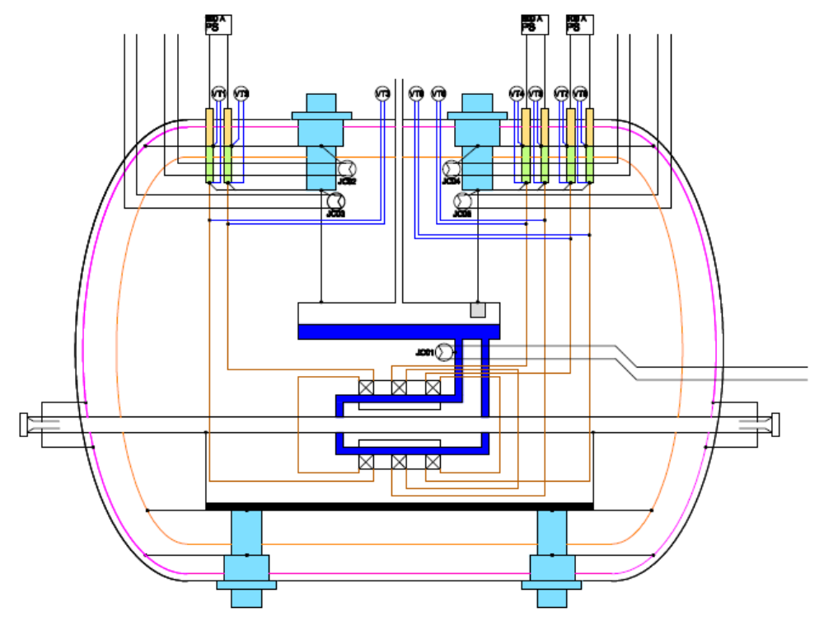

Figure 1: SCU ID Electrical Connections

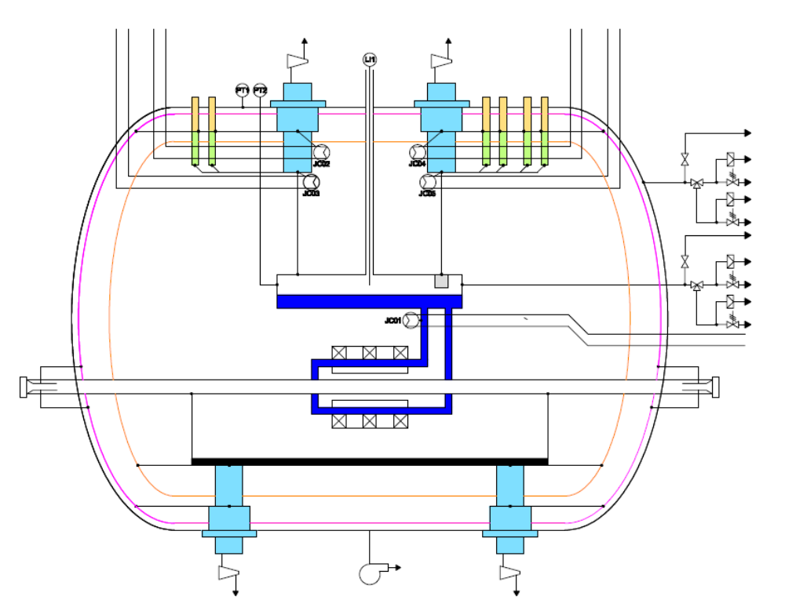
Figure 2: SCU ID Pressure Sensor Connections

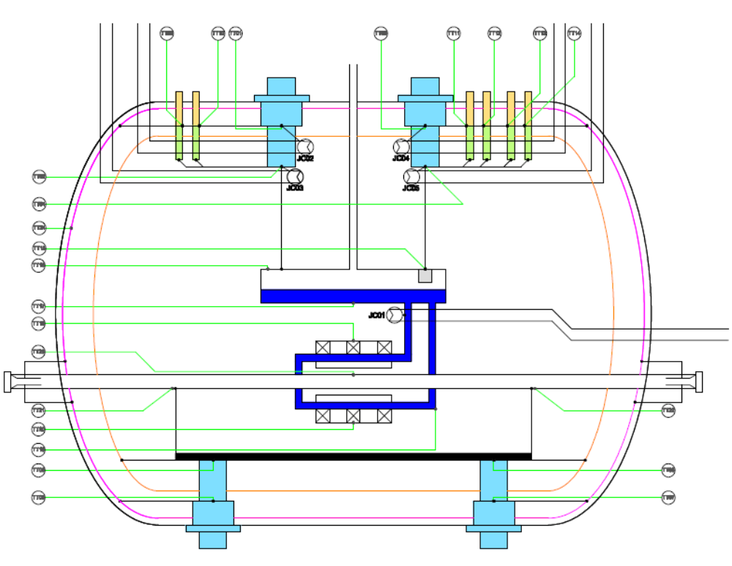

Figure 3: SCU ID Temperature Sensor Diagram

APPENDIX C - SCU0 INSTRUMENTATION LIST
SCU0 Instrumentation List
Sensor | Label | Location | Sensor type |  | Device type |  | No. of pins |  | no. of Signals
 |  |  |  |  |  |  | 192 |  | 62
Temperature sensors all use Lakeshore model 218S monitor |  |  |  |  |  |  | 128 |  | 32
Sensor | Label | Location | Sensor type |  | Wire type |  | No. of pins
1 | TT01 | Cryocooler DS TOP 1st stage | Cernox |  | 4-wire QT-36 |  | 4
2 | TT02 | Cryocooler DS TOP 2nd stage | Cernox |  | 4-wire QT-36 |  | 4
3 | TT03 | Cryocooler US TOP 1st stage | Cernox |  | 4-wire QT-36 |  | 4
4 | TT04 | Cryocooler US TOP 2nd stage | Cernox |  | 4-wire QT-36 |  | 4
5 | TT05 | Cryocooler DS BOTTOM 1st stage | Cernox |  | 4-wire QT-36 |  | 4
6 | TT06 | Cryocooler DS BOTTOM 2nd stage | Cernox |  | 4-wire QT-36 |  | 4
7 | TT07 | Cryocooler US BOTTOM 1st stage | Cernox |  | 4-wire QT-36 |  | 4
8 | TT08 | Cryocooler US BOTTOM 2nd stage | Cernox |  | 4-wire QT-36 |  | 4
9 | TT09 | 500A HTS lead1 top | Cernox |  | 4-wire QT-36 |  | 4
10 | TT10 | 500A HTS lead2 top | Cernox |  | 4-wire QT-36 |  | 4
11 | TT11 | 100A-DS HTS lead1 TOP | Cernox |  | 4-wire QT-36 |  | 4
12 | TT12 | 100A-DS HTS lead2 TOP | Cernox |  | 4-wire QT-36 |  | 4
13 | TT13 | 100A-US HTS lead1 top | Cernox |  | 4-wire QT-36 |  | 4
14 | TT14 | 100A-US HTS lead2 top | Cernox |  | 4-wire QT-36 |  | 4
15 | TT16 | LHe tank top | Cernox |  | 4-wire QT-36 |  | 4
16 | TT17 | LHe tank bottom | Cernox |  | 4-wire QT-36 |  | 4
17 | TT15 | LHe recondenser | Cernox |  | 4-wire QT-36 |  | 4
18 | TT18 | LHe bottom supply pipe | Cernox |  | 4-wire QT-36 |  | 4
19 | TT19 | SC Magnet top core | Cernox |  | 4-wire QT-36 |  | 4
20 | TT20 | SC Magnet bottom core | Cernox |  | 4-wire QT-36 |  | 4
21 | TT21 | Beam chamber DS | Cernox |  | 4-wire QT-36 |  | 4
22 | TT22 | Beam chamber US | Cernox |  | 4-wire QT-36 |  | 4
23 | TT23 | Beam chamber centre | Cernox |  | 4-wire QT-36 |  | 4
24 | TT24 | 60K radiation shield | Cernox |  | 4-wire QT-36 |  | 4
25 | TT25 | 20K radiation shield | Cernox |  | 4-wire QT-36 |  | 4
26 | TT26 | Reserve |  |  | 4-wire QT-36 |  | 4
27 | TT27 | Reserve |  |  | 4-wire QT-36 |  | 4
28 | TT28 | Reserve |  |  | 4-wire QT-36 |  | 4
29 | TT29 | Reserve |  |  | 4-wire QT-36 |  | 4
30 | TT30 | Reserve |  |  | 4-wire QT-36 |  | 4
31 | TT31 | Reserve |  |  | 4-wire QT-36 |  | 4
32 | TT32 | Reserve |  |  | 4-wire QT-36 |  | 4
Voltage tap signals 16 Bit A-D or better Voltage Range |  |  |  |  |  |  | 40 |  | 20
1 | VT1 | 500A HTS lead1 top and Bottom |  | +-10V |  | 2-wire TP DT-36 |  |  |  | 2
2 | VT2 | 500A HTS lead2 top and bottom |  | +-10V |  | 2-wire TP DT-36 |  |  |  | 2
3 | VT3 | 100A-DS HTS lead1 top and bottom |  | +-10V |  | 2-wire TP DT-36 |  |  |  | 2
4 | VT4 | 100A-DS HTS lead2 top and bottom |  | +-10V |  | 2-wire TP DT-36 |  |  |  | 2
5 | VT5 | 100A-US HTS lead1 top and bottom |  | +-10V |  | 2-wire TP DT-36 |  |  |  | 2
6 | VT6 | 100A-US HTS lead2 top and bottom |  | +-10V |  | 2-wire TP DT-36 |  |  |  | 2
7 | VT7 | SC Top main coil |  | +-10V** |  | 2-wire TP DT-36 |  |  |  | 2
8 | VT8 | SC Bottom main coil |  | +-10V** |  | 2-wire TP DT-36 |  |  |  | 2
9 | VT9 | SC US correction coils |  | +-10V** |  | 2-wire TP DT-36 |  |  |  | 2
10 | VT10 | SC DS correction coils |  | +-10V** |  | 2-wire TP DT-36 |  |  |  | 2
11 | VT11 | Reserve |  | +-10V |  | 2-wire TP DT-36 |  |  |  | 2
12 | VT12 | Reserve |  | +-10V |  | 2-wire TP DT-36 |  |  |  | 2
13 | VT13 | Reserve |  | +-10V |  | 2-wire TP DT-36 |  |  |  | 2
14 | VT14 | Reserve |  | +-10V |  | 2-wire TP DT-36 |  |  |  | 2
15 | VT15 | Reserve |  | +-10V |  | 2-wire TP DT-36 |  |  |  | 2
16 | VT16 | Reserve |  | +-10V |  | 2-wire TP DT-36 |  |  |  | 2
17 | VT17 | Reserve |  | +-10V |  | 2-wire TP DT-36 |  |  |  | 2
18 | VT18 | Reserve |  | +-10V |  | 2-wire TP DT-36 |  |  |  | 2
19 | VT19 | Reserve |  | +-10V |  | 2-wire TP DT-36 |  |  |  | 2
20 | VT20 | Reserve |  | +-10V |  | 2-wire TP DT-36 |  |  |  | 2
 |  | Heaters |  | V and I for PS |  |  |  |  |  | 16 | 8
1 | JC01 | Cryocooler DS TOP 2nd stage |  | 20V 2A |  | 2-wire 24 AWG? |  |  |  | 2
2 | JC02 | Cryocooler US TOP 2nd stage |  | 20V 2A |  | 2-wire 24 AWG? |  |  |  | 2
3 | JC03 | LHe tank |  | 20V 2A |  | 2-wire 24 AWG? |  |  |  | 2
4 | JC04 | LHe thermosyphon return pipe |  | 20V 2A |  | 2-wire 24 AWG? |  |  |  | 2
5 | JC05 | SCU TOP core to force quench |  | 20V 2A |  | 2-wire 24 AWG? |  |  |  | 2
6 | JC06 | SCU Bottom core to force quench |  | 20V 2A |  | 2-wire 24 AWG? |  |  |  | 2
7 | JC07 | Vacuum chamber |  | 20V 2A |  | 2-wire 24 AWG? |  |  |  | 2
8 | JC08 | Reserve |  | 20V 2A |  | 2-wire 24 AWG? |  |  |  | 2
 |  | LHe Level Sensors using American Magnetics model 135 display unit |  |  |  |  |  |  |  | 8 | 2
1 | LI1 | LHe tank* |  | Probe |  | 4-wire QT-36 |  |  |  | 4
2 | LI2 | LHe tank* |  | Probe |  | 4-wire QT-36 |  |  |  | 4
*these signals exit on the center turret port using 9 pin sub D CF feedthrough
**these voltage taps will be divided by 4
128 pins are available on the four 32 pin connectors on the large turrets,
 |  | all other leads can exit through center turret vacuum port
Compressor Alarm DIO (not included in total signals or pins for cryomodule)>> |  |  |  |  |  |  |  | 64 |  |  |  | 32
1 | CI1 | DS TOP Pressure Alarm |  | DIO Relay |  | 2
2 | CI2 | DS TOP He discharge High Temp |  | DIO Relay |  | 2
3 | CI3 | DS TOP He after cooler High Temp |  | DIO Relay |  | 2
4 | CI4 | DS TOP H2O High Temp |  | DIO Relay |  | 2
5 | CI5 | US TOP Pressure Alarm |  | DIO Relay |  | 2
6 | CI6 | US TOP He discharge High Temp |  | DIO Relay |  | 2
7 | CI7 | US TOP He after cooler High Temp |  | DIO Relay |  | 2
8 | CI8 | US TOP H2O High Temp |  | DIO Relay |  | 2
9 | CI9 | DS BOT Pressure Alarm |  | DIO Relay |  | 2
10 | CI10 | DS BOT He discharge High Temp |  | DIO Relay |  | 2
11 | CI11 | DS BOT He after cooler High Temp |  | DIO Relay |  | 2
12 | CI12 | DS BOT H2O High Temp |  | DIO Relay |  | 2
13 | CI13 | US BOT Pressure Alarm |  | DIO Relay |  | 2
14 | CI14 | US BOT He discharge High Temp |  | DIO Relay |  | 2
15 | CI15 | US BOT He after cooler High Temp |  | DIO Relay |  | 2
16 | CI16 | US BOT H2O High Temp |  | DIO Relay |  | 2
17 | CI17 | Reserve DIO |  |  |  | 2
18 | CI18 | Reserve DIO |  |  |  | 2
19 | CI19 | Reserve DIO |  |  |  | 2
20 | CI20 | Reserve DIO |  |  |  | 2
21 | CI21 | Reserve DIO |  |  |  | 2
22 | CI22 | Reserve DIO |  |  |  | 2
23 | CI23 | Reserve DIO |  |  |  | 2
24 | CI24 | Reserve DIO |  |  |  | 2
25 | CI25 | Reserve DIO |  |  |  | 2
26 | CI26 | Reserve DIO |  |  |  | 2
27 | CI27 | Reserve DIO |  |  |  | 2
28 | CI28 | Reserve DIO |  |  |  | 2
29 | CI29 | Reserve DIO |  |  |  | 2
30 | CI30 | Reserve DIO |  |  |  | 2
31 | CI31 | Reserve DIO |  |  |  | 2
32 | CI32 | Reserve DIO |  |  |  | 2

