# Lab: Ownership Chain

|  |
| --- |
| * This is an in-class lab, and worth 10 points. * This is due on Saturday, March 28, 2020 at midnight. * Use the following naming convention: homework, underscore, last name, first initial, and extension (e.g., Lab_Ownchain_ImG.docx). |

* (**Task 1**) Show the outcome of this task in a screenshot. Also, explain briefly why you have received that result.

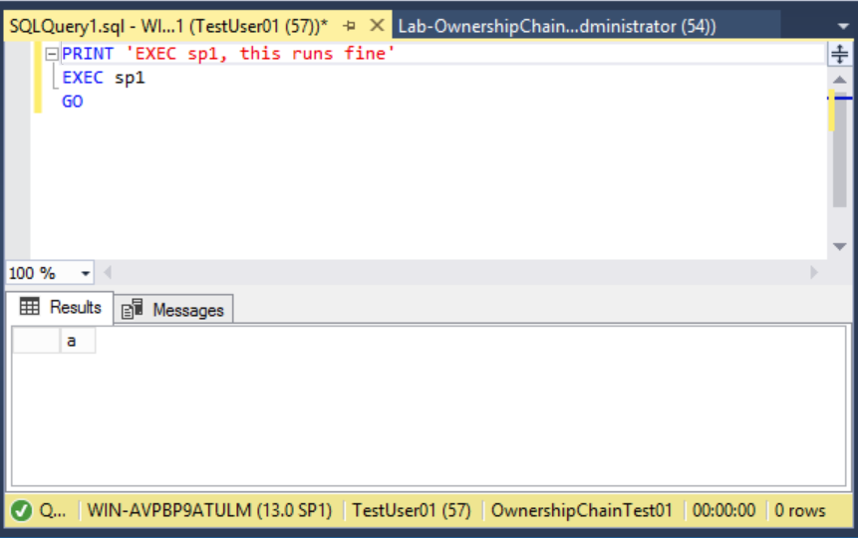

The SP works correctly as does the message. The SP works because permission has been granted to execute sp1 sp2 and sp3 to TestUser01.

* (**Task 2**) Show the outcome of this task in a screenshot. Also, explain briefly why you have received that result.

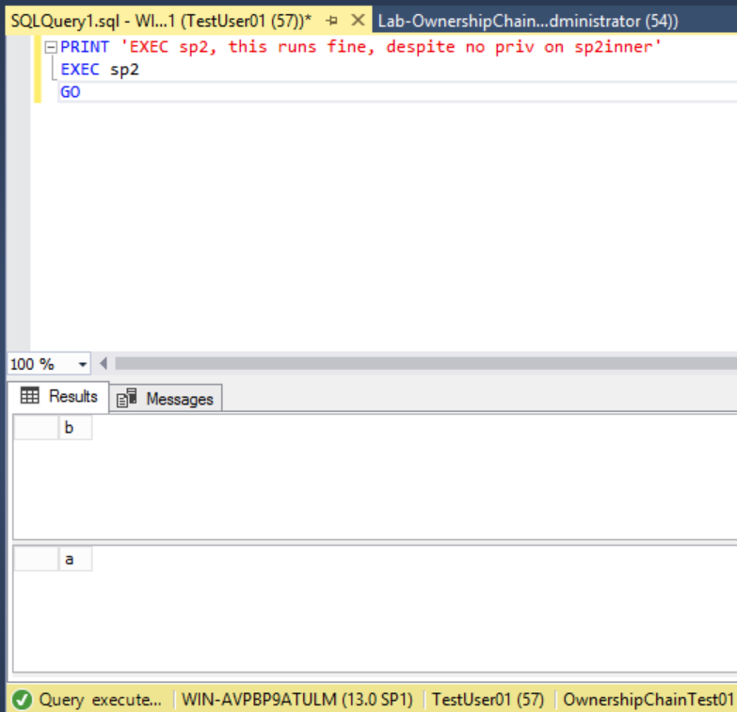

The SP itself is able to run sp2inner, despite TestUser01 not having permission to do so.

* (**Task 3**) Show the outcome of this task in a screenshot. Also, explain briefly why you have received that result.

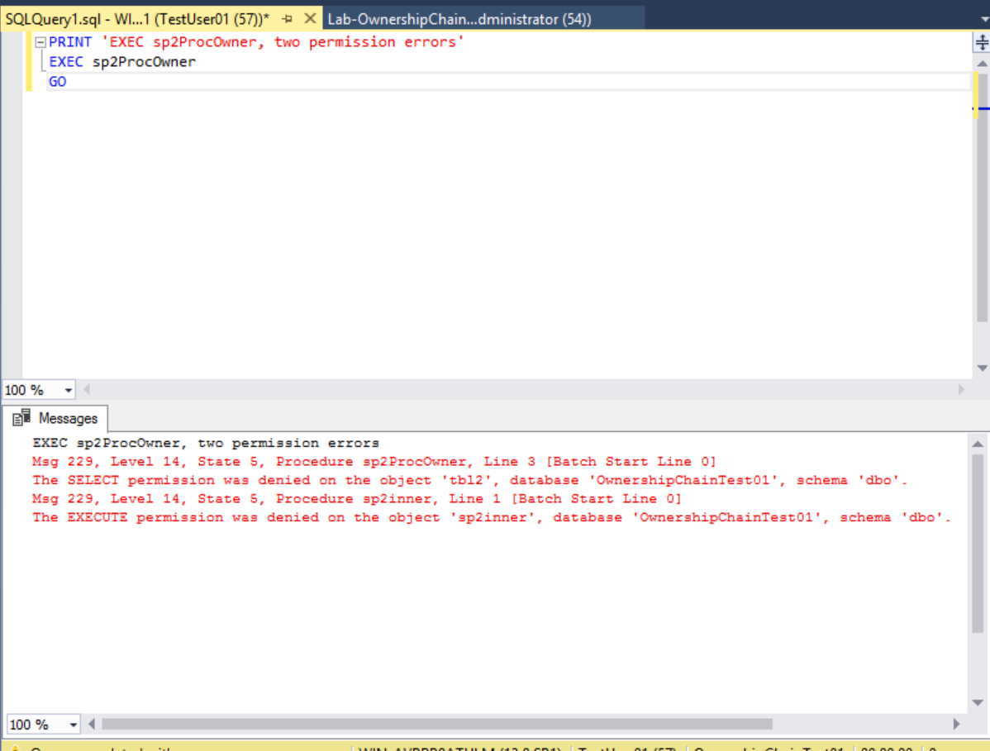

The query failed twice, once because TestUser01 is not the owner of tbl2, and twice because sp2ProcOwner is owned by ProcOwner01 and not TestUser01

* (**Task 4**) Show the outcome of this task in a screenshot. Also, explain briefly why you have received that result.

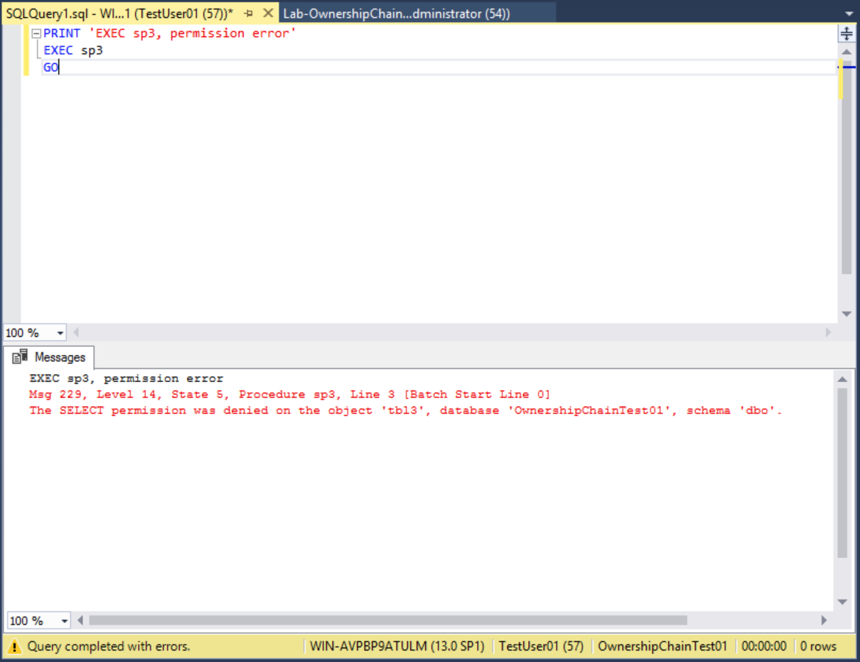

While TestUser01 has privilege to execute sp3, tbl3 is owned by TableOwner01, and that supercedes SP ownership

* (**Task 5**) Show the outcome of this task in a screenshot. Also, explain briefly why the result is different from the one from Task #4?

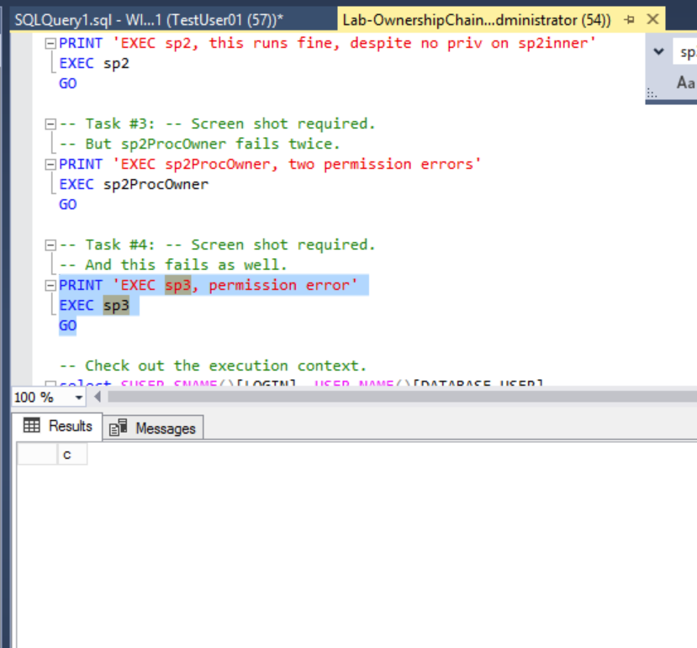

The admin is able to run any stored procedure and access any table regardless of ownership. An admin account is not checked for privileges or ownership.