# Lab: WebGoat

|  |
| --- |
| * This is due tonight and worth 10 points. * Use the following naming convention: homework, underscore, last name, first initial, and extension (e.g., Lab_SQLi_ImG.docx). * Zoom in your screenshot, please. |

* **Task 1-1.** Provide a screenshot for your trial for Lesson 9. Your trail does not need to be successful.

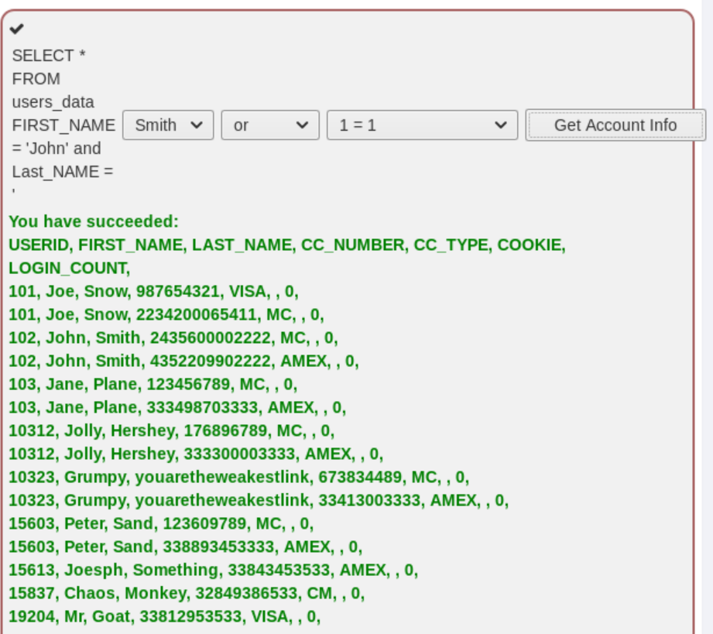

* **Task 1-2.** Provide a screenshot for your trial for Lesson 10.

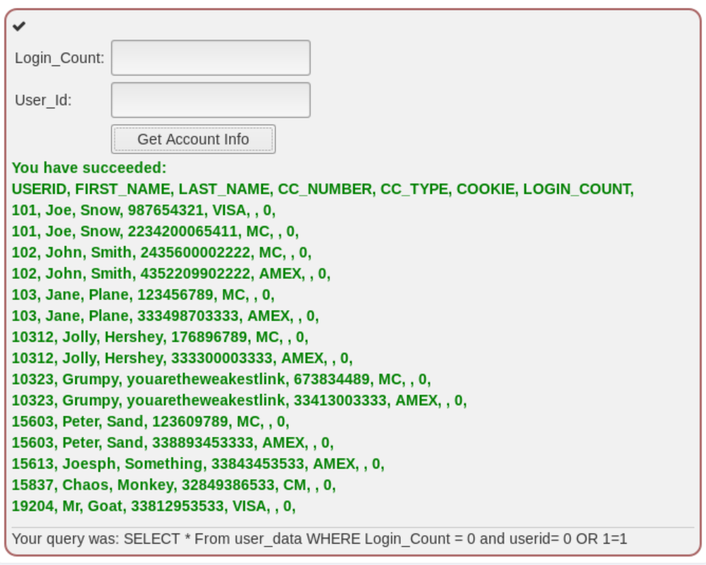

* **Task 1-3.** Provide a screenshot for your trial for Lesson 11.

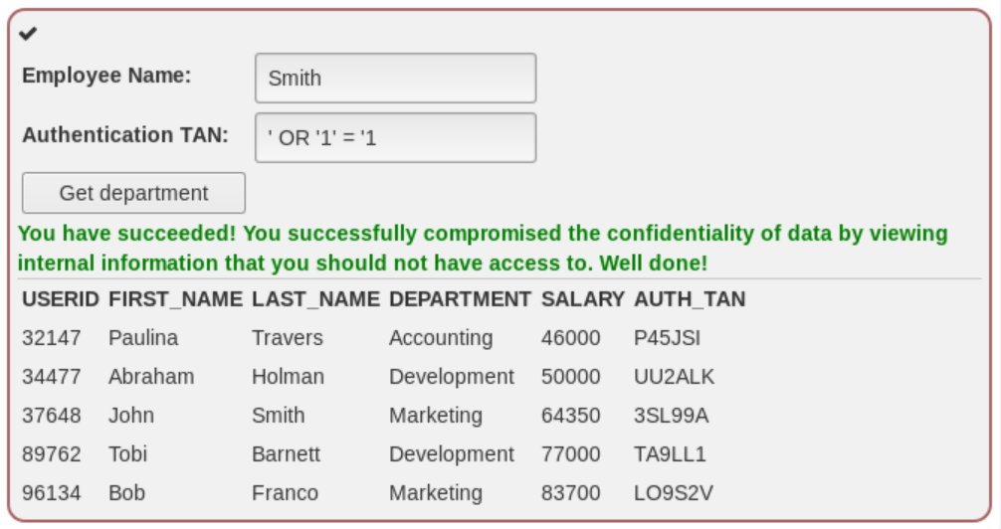

* **Task 1-4.** Provide a screenshot for your trial for Lesson 12.

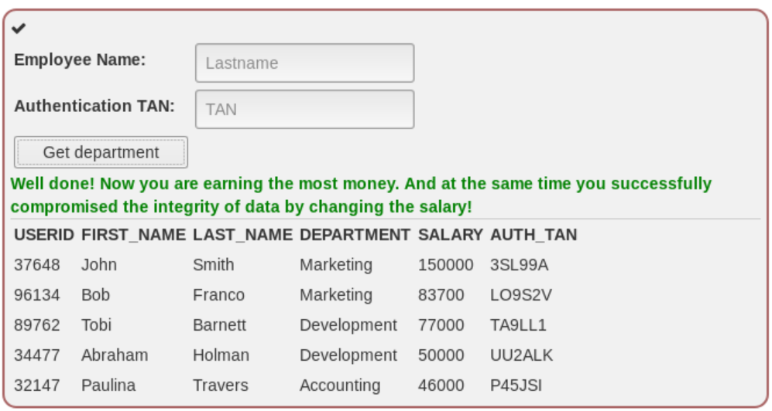

* **Task 1-5.** Provide a screenshot for your trial for Lesson 13.

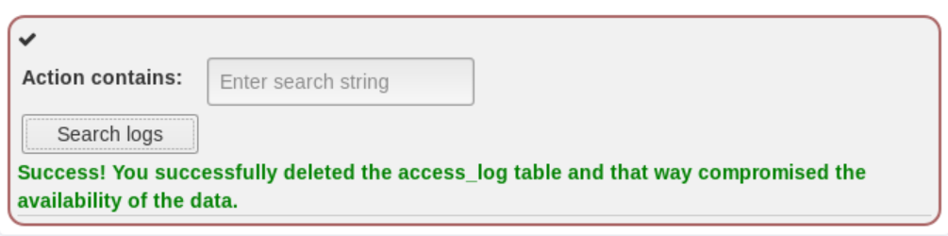

* **Task 2-1.** Provide a screenshot for your trial for Lesson 5.

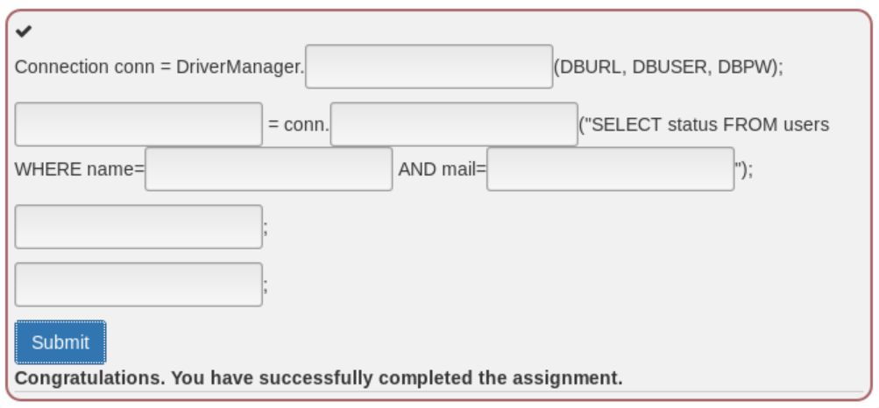

* **Task 2-2.** Provide a screenshot for your trial for Lesson 6.

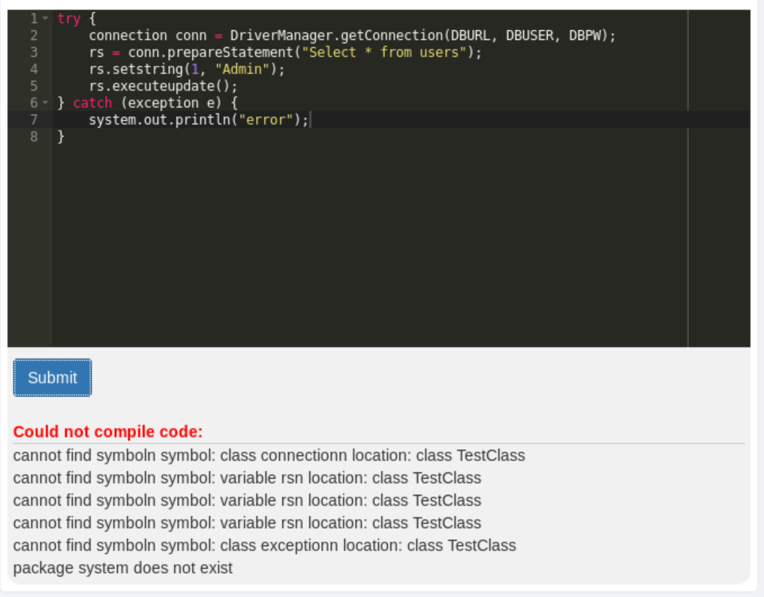

* **Task 2-3.** Provide a screenshot for your trial for Lesson 10.

Could not figure this one out!