TestRun_20251122_235215
Generated: 2025-11-22 23:53:37
Total Steps: 2

Step 1: Untitled
Expected Result | Actual Result
N/A | This is first test

Screenshots:
Screenshot 1:
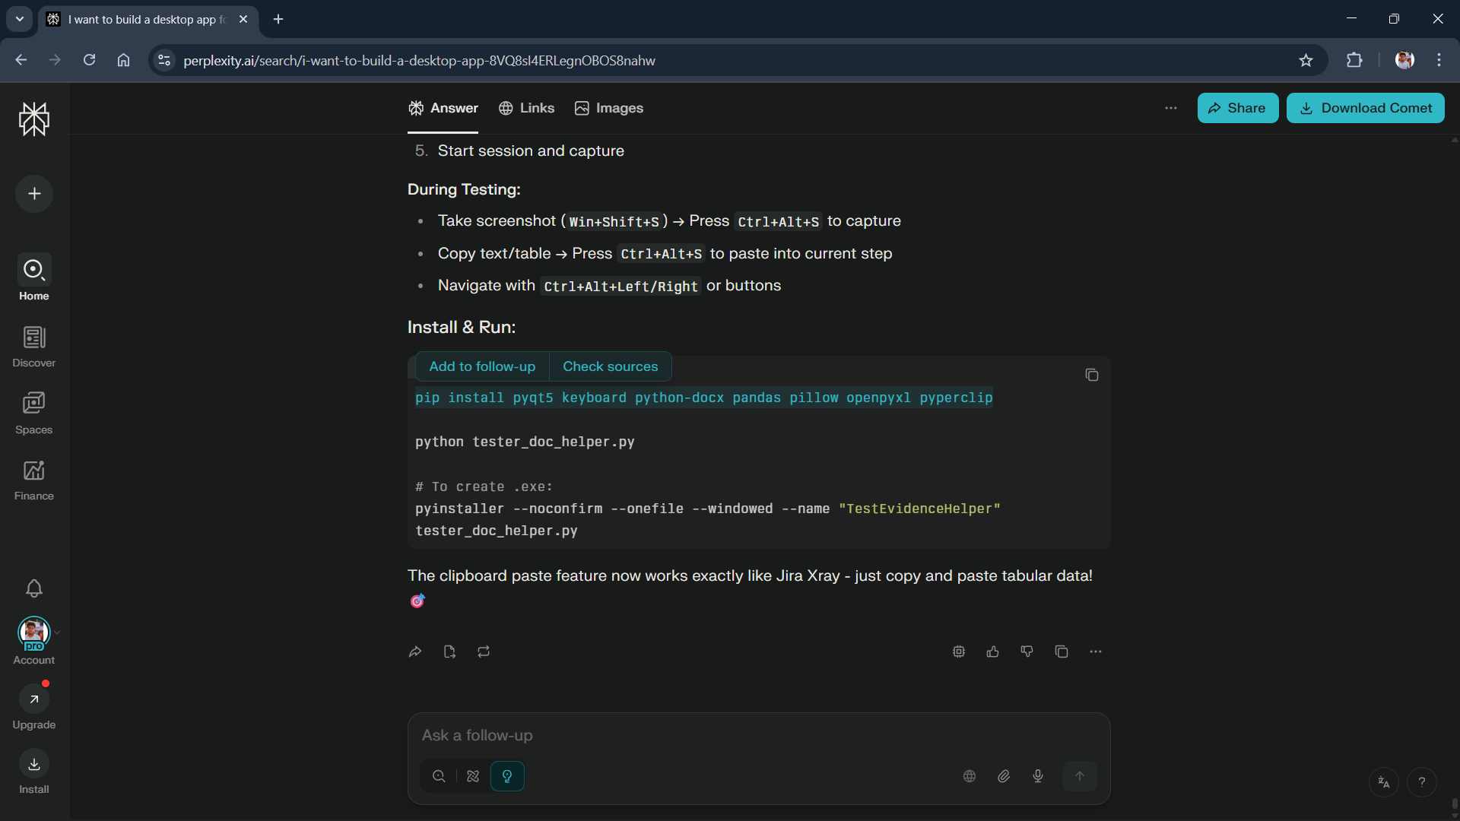

Screenshot 2:


Step 2: Untitled
Expected Result | Actual Result
N/A | New 2

Screenshots:
Screenshot 1:

Screenshot 2:

