DevOps is a culture of communication,   
collaboration and integration between  
software developers and the operations team, where modern methods and tools, such as automation and containers, enable fluid Continuous Integration, Delivery or Deployment (CI/CD) piplelines where we find:

Rapid evolution of products or  
services

Reduction in risk and costs, as well as improvement in quality across our portfolios

This brings us to the DevOps Lifecycle,

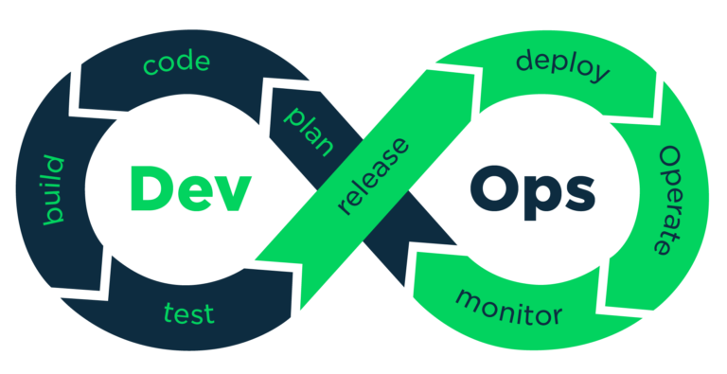

where we find:

Continuous Business Planning

Collaborative Development and Continuous Integration / Testing

Continuous Release and Deployment

Continuous Monitoring

CML is extremely useful in DevOps because, with it, we can update, test and maintain our networks and configurations with automation. As developers continue to implement DevOps principles and practices, the legacy methods of manual network configurations and testing cannot keep up any longer.

CML helps break down the barriers between the development and ops silos by making it possible to build and test our networks at light speed, based on a programmatic source of truth. The days of storing configurations in worksheets and typing every command in the CLI are gone and CML will help us build our Infrastructure-as-Code (IaC), to keep our networks flexible, resilient, and compliant.