**Querry 1: Completati următorul cod pentru a afișa cel mai mare numar dintre cele trei numere prezentate:**

declare @n1 int, @n2 int, @n3 int;

declare @mai_mare int;

set @n1 = 60*rand();

set @n2 = 60*rand();

set @n3 = 60*rand();

set @mai_mare = @n1;

if @n2 > @mai_mare set @mai_mare = @n2;

if @n3 > @mai_mare set @mai_mare = @n3;

print @n1;

print @n2;

print @n3;

print 'Mai mare = ' + cast(@mai_mare as varchar(2));

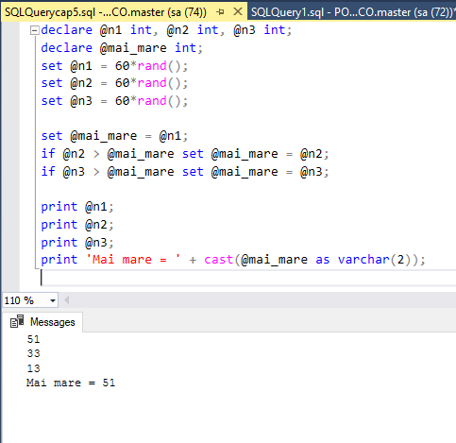

## Querry 2: Afișati primele zece date (numele, prenumele studentului) în funcție de valoarea notei (cu excepția notelor 6 și 8) a studentului la primul test al disciplinei Baze de date, folosind structura de altemativă IF. .. ELSE. Sa se foloseasca variabilele.

declare @MARK1 int = 6;

declare @MARK2 int = 8;

declare @test char(50) = 'Testul 1' ;

declare @disciplina char(50) = 'Baze de date';

declare @count int = 1;

while @count = 1

begin

select distinct TOP 10 s.Nume_Student,s.Prenume_Student,sr.Nota

from studenti s inner join studenti_reusita sr

on s.Id_Student=sr.Id_Student

inner join discipline d

on sr.Id_Disciplina=d.Id_Disciplina

and d.Disciplina = @disciplina

and sr.Tip_Evaluare=@test

and sr.Nota != @MARK1

and sr.Nota != @MARK2

if @count = 1 break

end

[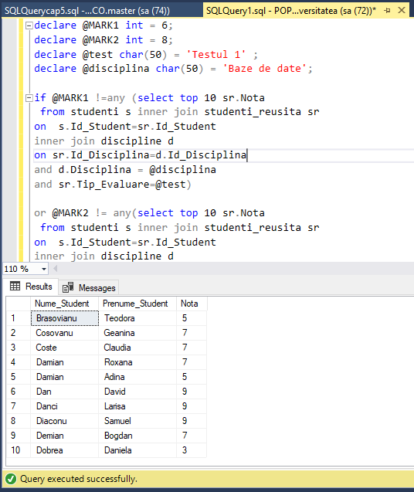](https://github.com/EliodorPopov/DB/blob/master/Lab5/querry2.png)

## Querry 3: Rezolvați aceeași sarcină, 1, apelând la structura selectivă CASE.

declare @N1 int, @N2 int, @N3 int;

declare @MAI_MARE int;

set @N1 = 60 * RAND();

set @N2 = 60 * RAND();

set @N3 = 60 * RAND();

set @MAI_MARE = @N1;

set @MAI_MARE = case

when @n2>@MAI_MARE and @N2>@N3 then @N2

when @n3<@MAI_MARE and @N3>@N2 then @N3

else @MAI_MARE

end

print @N1;

print @N2;

print @N3;

print 'Mai mare = ' + cast(@MAI_MARE as varchar(2));

[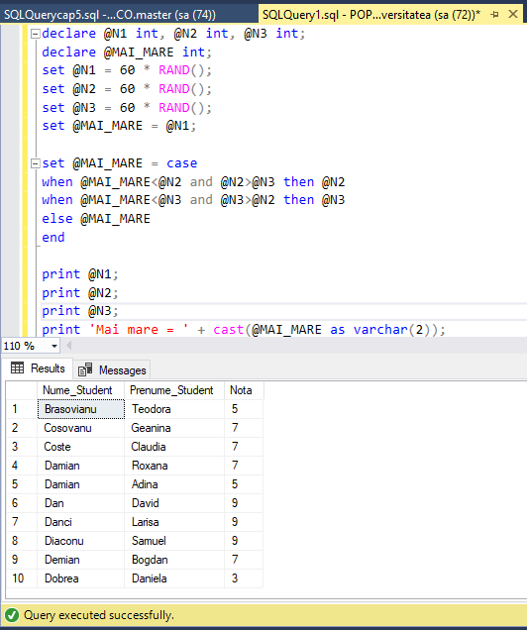](https://github.com/EliodorPopov/DB/blob/master/Lab5/querry3.png)

## Querry 4.1: Modificati exercitiile din sarcinile 1 și 2 pentru a include procesarea erorilor cu TRY și CATCH, și RAISERRROR.

declare @N1 int, @N2 int, @N3 int;

declare @MAI_MARE int;

set @N1 = 60 * rand();

set @N2 = 60 * rand();

set @N3 = 60 * rand() ;

begin try

if @N1 = @N2 and @N2 = @N3

raiserror ('Numbers are equal', 1,1)

else

begin

set @mai_mare = @n1;

if @n2 > @mai_mare set @mai_mare = @n2;

if @n3 > @mai_mare set @mai_mare = @n3;

print @N1;

print @N2;

print @N3;

print 'Mai mare = ' + cast(@MAI_MARE as varchar(2));

end

end try

begin catch

print ' An error has been occured!'

print 'The details of the error'

print ' The error status:' + cast(ERROR_STATE() as varchar(20))

print ' The error line:' + cast(ERROR_LINE() as varchar(20))

end catch

[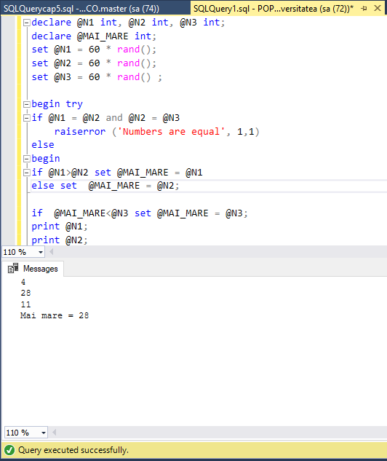](https://github.com/EliodorPopov/DB/blob/master/Lab5/querry4.1.png)

## Querry 4.2:

declare @MARK1 int = 6;

declare @MARK2 int = 8;

declare @test char(50) = 'Testul 1' ;

declare @disciplina char(50) = 'Baze de date';

begin try

if @MARK1 =any (select top 10 sr.Nota

from studenti s inner join studenti_reusita sr

on s.Id_Student=sr.Id_Student

inner join discipline d

on sr.Id_Disciplina=d.Id_Disciplina

and d.Disciplina = @disciplina

and sr.Tip_Evaluare=@test)

or @MARK2 = any(select top 10 sr.Nota

from studenti s inner join studenti_reusita sr

on s.Id_Student=sr.Id_Student

inner join discipline d

on sr.Id_Disciplina=d.Id_Disciplina

and d.Disciplina = @disciplina

and sr.Tip_Evaluare=@test)

raiserror('Toti studenti au numai note de 6 si 8',2,2);

else

begin

select distinct top 10 s.Nume_Student,s.Prenume_Student

from studenti s inner join studenti_reusita sr

on s.Id_Student=sr.Id_Student

inner join discipline d

on sr.Id_Disciplina=d.Id_Disciplina

and d.Disciplina = @disciplina

and sr.Tip_Evaluare=@test

end

end try

begin catch

print ' An error has been occured!'

print 'The details of the error'

print ' The error status:' + cast(ERROR_STATE() as varchar(20))

print ' The error line:' + cast(ERROR_LINE() as varchar(20))

end catch

[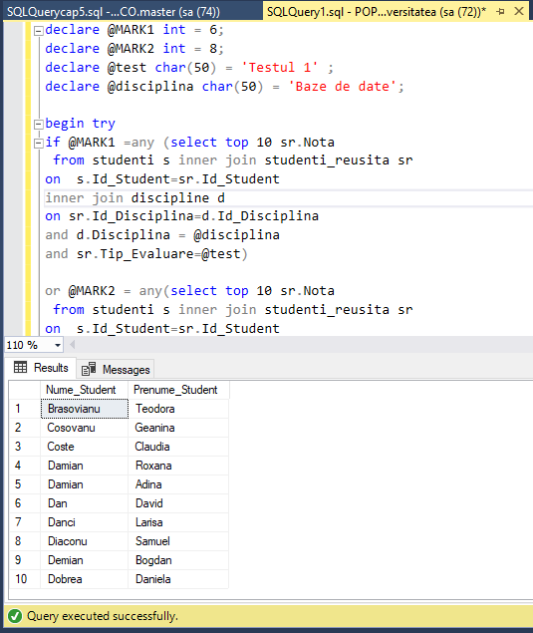](https://github.com/EliodorPopov/DB/blob/master/Lab5/querry4.2.png)