**Lab 9 : Crearea procedurilor stocate si a functiilor definite de utilizator**

**Task 1**

**Sa se creeze proceduri stocate in baza exercitiilor (2 exercitii) din capitolul 4. Parametrii de intrare trebuie sa corespunda criteriilor din clauzele WHERE ale exercitiilor respective.**

--Afisati numarul de studenti care au sustinut testul (Testul 2) la disciplina Baze de date in 2018

create procedure proc_20

@Tip_Evaluare varchar(50)

as

select count(Distinct s.Nume_Student)

from rs_s sr

inner join s_s s on sr.Id_Student = s.ID_Student

inner join ds_ps d on sr.Id_Disciplina = d.ID_Disciplina

where sr.Tip_Evaluare = @Tip_Evaluare and sr.Data_Evaluare like '2018%'

exec proc_20 @Tip_Evaluare = 'Testul 2'

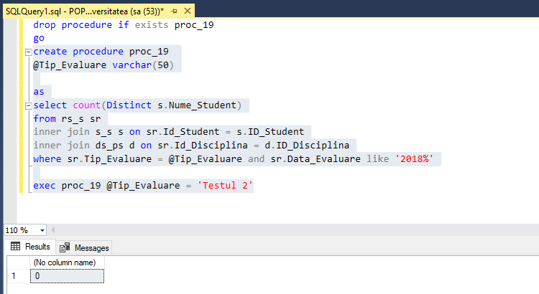

--39 Gasiti denumirile disciplinelor la care nu au sustinut examenul, in medie, peste 5% de studenti.

create procedure proc_39

@Percentage float

as

select distinct d.Disciplina

from rs_s sr

inner join ds_ps d on sr.Id_Disciplina = d.Id_Disciplina

inner join s_s s on sr.Id_Student = s.ID_Student

where sr.Tip_Evaluare = 'Examen'

group by d.Disciplina

having cast(count ( case when sr.Nota<5 then sr.Nota else null end) as float) / count(s.Nume_Student) < @Percentage

exec proc_39 @Percentage = 0.05

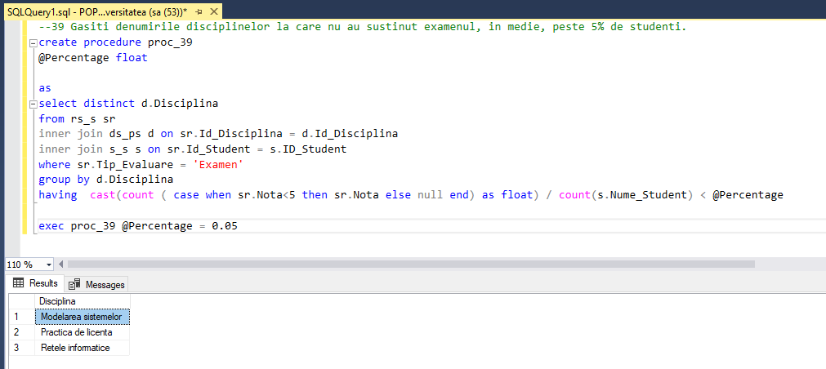

**Task 2**

**Sa se creeze o procedura stocata, care nu are niciun parametru de intrare si poseda un parametru de iesire. Parametrul de iesire trebuie sa returneze numarul de studenti, care nu au sustinut cel putin o forma de evaluare (nota mai mica de 5 sau valoare NULL).**

create procedure proc2_20

@Nr int = null output

as

select @Nr = count(Distinct s.Nume_Student)

from rs_s sr

inner join s_s s on sr.Id_Student = s.ID_Student

inner join ds_ps d on sr.Id_Disciplina = d.ID_Disciplina

where sr.Tip_Evaluare = 'Examen' and sr.Data_Evaluare like '2018%';

declare @output int

exec proc2_20 @output output

print 'numarul de studenti care au sustinut testul (Testul 2) la disciplina Baze de date in 2018: ' + cast(@output as VARCHAR(3))

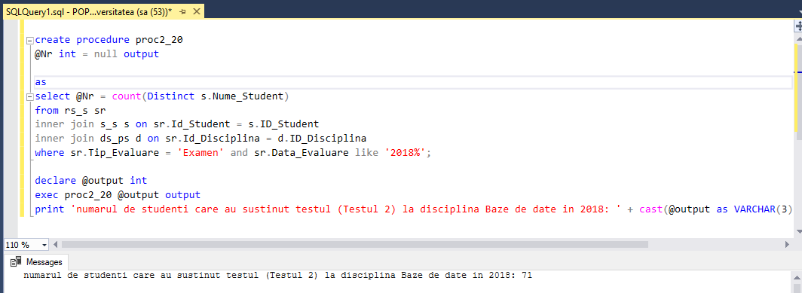

**Task 3**

**Sa se creeze o procedura stocata, care ar insera in baza de date informatii despre un student nou. In calitate de parametri de intrare sa serveasca datele personale ale studentului nou si Cod_Grupa. Sa se genereze toate intrarile-cheie necesare in tabelul studenti_reusita. Notele de evaluare sa fie inserate ca NULL.**

create procedure addStudent

@nume varchar(60),

@prenume varchar(60),

@data date,

@adresa varchar(100),

@codGrupa char(10)

as

insert into s_s

values ((select max(Id_Student)from s_s) +1, @nume, @prenume, @data, @adresa);

insert into rs_s

values ((select max(Id_Student)from rs_s), 108, 101 ,

(select Id_Grupa from grupe where Cod_Grupa = @codGrupa), 'Examen', NULL, '2018-11-25')

exec addStudent 'Popov','Eliodor','1997-12-10','Mun. Chisinau, str. Independentei','FAF171'

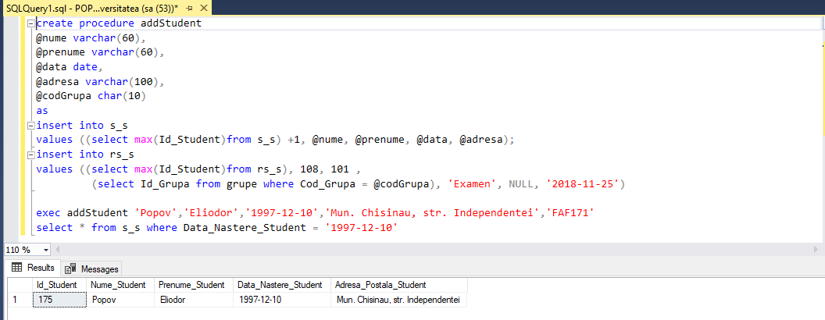

**Task 4**

**Fie ca un profesor se elibereaza din functie la mijlocul semestrului. Sa se creeze o procedura stocata care ar reatribui inregistrarile din tabelul studenti_reusita unui alt profesor. Parametri de intrare: numele si prenumele profesorului vechi, numele si prenumele profesorului nou, disciplina. in cazul in care datele inserate sunt incorecte sau incomplete, sa se afiseze un mesaj de avertizare.**

create procedure procedure4

@old_last_name VARCHAR(50),

@old_first_name VARCHAR(50),

@new_last_name VARCHAR(50),

@new_first_name VARCHAR(50),

@disciplina VARCHAR(50)

as

if(( select ds_ps.Id_Disciplina

from ds_ps

where Disciplina = @disciplina) in (select distinct rs_s.Id_Disciplina

from rs_s

where Id_Profesor = (select pf_cd.Id_Profesor

from pf_cd

where Nume_Profesor = @old_last_name

and Prenume_Profesor = @old_first_name)))

begin

update rs_s

set Id_Profesor = (select Id_Profesor

from pf_cd

where Nume_Profesor = @new_last_name

and Prenume_Profesor = @new_first_name)

where Id_Profesor = (select Id_profesor

from pf_cd

where Nume_Profesor = @old_last_name

and Prenume_Profesor = @old_first_name)

end

else

begin

print 'ERROR! Check input!!!'

end

exec procedure4 'Mocanu','Diana','Nagy','Alexandru','Programarea aplicatiilor Windows'

**ERROR**

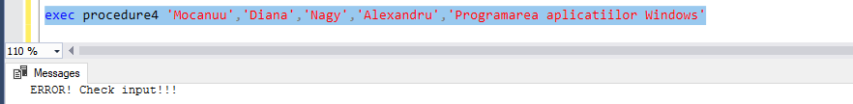

**SUCCESS**

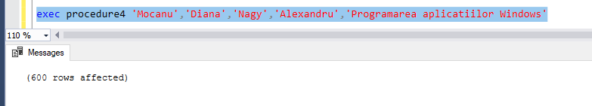

**Task 5**

**Sa se creeze o procedura stocata care ar forma o lista cu primii 3 cei mai buni studenti la o disciplina, si acestor studenti sa le fie marita nota la examenul final cu un punct (nota maximala posibila este 10). In calitate de parametru de intrare, va servi denumirea disciplinei. Procedura sa returneze urmatoarele campuri: Cod_Grupa, Nume_Prenume_Student, Disciplina, Nota_ Veche, Nota_Noua.**

create procedure procedure5

@disciplina VARCHAR(50)

as

declare @studenti_lista table (Id_Student int, Media float)

insert into @studenti_lista

select top (3) rs_s.Id_Student, AVG(cast (Nota as float)) as Media

from rs_s, ds_ps

where ds_ps.Id_Disciplina = rs_s.Id_Disciplina

and Disciplina = @disciplina

group by rs_s.Id_Student

order by Media desc;

select cod_grupa, s_s.Id_Student, CONCAT(nume_student, ' ', Prenume_Student) as Nume, Disciplina, nota AS Nota_Veche, iif(nota > 9, 10, nota + 1) AS Nota_Noua

from rs_s, ds_ps, grupe, s_s

where ds_ps.id_disciplina = rs_s.id_disciplina

and grupe.Id_Grupa = rs_s.Id_Grupa

and s_s.Id_Student = rs_s.Id_Student

and s_s.Id_Student in (select Id_Student from @studenti_lista)

and Disciplina = @disciplina

and Tip_Evaluare = 'Examen';

declare @id_discipl smallint = (select Id_Disciplina

from ds_ps

where Disciplina = @disciplina);

update rs_s

set rs_s.Nota = (CASE WHEN nota >= 9 THEN 10 ELSE nota + 1 END)

where Tip_Evaluare = 'Examen'

and Id_Disciplina = @id_discipl

and Id_Student in (select Id_Student from @studenti_lista)

go

execute procedure5 @disciplina = 'Sisteme de calcul'

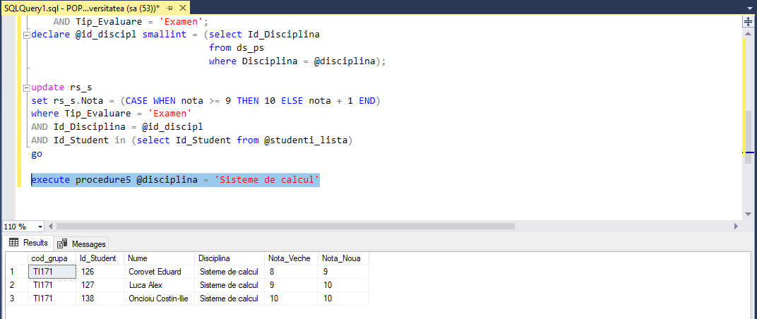

**Task 6**

**Sa se creeze functii definite de utilizator in baza exercitiilor (2 exercitii) din capitolul 4. Parametrii de intrare trebuie sa corespunda criteriilor din clauzele WHERE ale exercitiilor respective.**

create function fun19 (@nume_student VARCHAR(10), @reusita SMALLINT)

returns table

as

return

(

select distinct Nume_Profesor,Prenume_Profesor

from rs_s sr

inner join pf_cd p on sr.Id_Profesor = p.Id_Profesor

inner join s_s s on sr.Id_Student = s.Id_Student

where s.Nume_Student = @nume_student

and sr.Nota < @reusita

)

select * from fun19 ('Cosovanu',5)

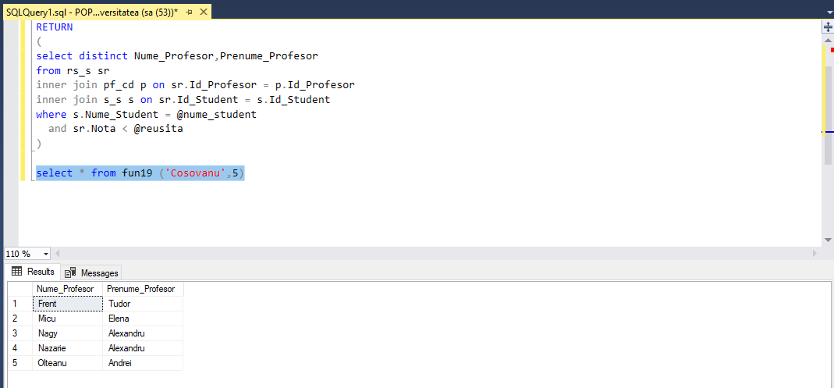

create function fun39 (@Percentage float)

returns table

as

return

(

select distinct d.Disciplina

from rs_s sr

inner join ds_ps d on sr.Id_Disciplina = d.Id_Disciplina

inner join s_s s on sr.Id_Student = s.ID_Student

where sr.Tip_Evaluare = 'Examen'

group by d.Disciplina

having cast(count ( case when sr.Nota<5 then sr.Nota else null end) as float) / count(s.Nume_Student) < @Percentage

)

select * from fun39 (0.05)

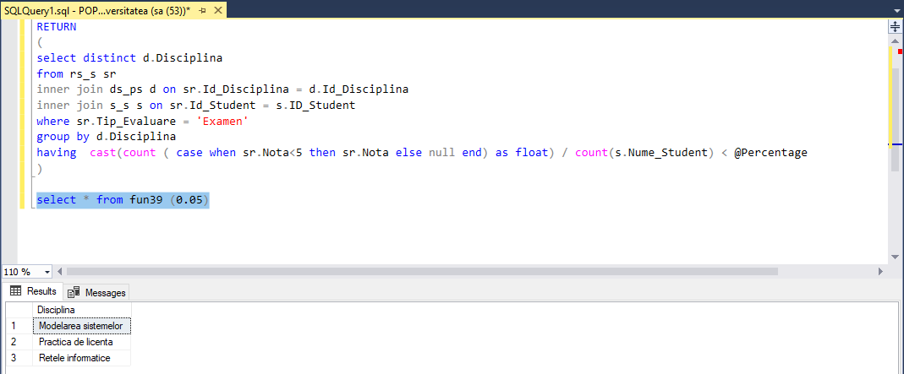

**Task 7**

**Sa se scrie functia care ar calcula varsta studentului. Sa se defineasca urmatorul format al functiei: <nume_functie>(<Data_Nastere_Student>).**

create function fun7 (@data_nasterii date )

returns int

begin

declare @varsta int

select @varsta = (select (year(getdate()) - year(@data_nasterii) - case

when (month(@data_nasterii) > month(getdate()))

or (month(@data_nasterii) = month(getdate())

and day(@data_nasterii) > day(getdate()))

THEN 1

ELSE 0

END))

return @varsta

end

go

select dbo.fun7 ('1997-12-10') as Varsta

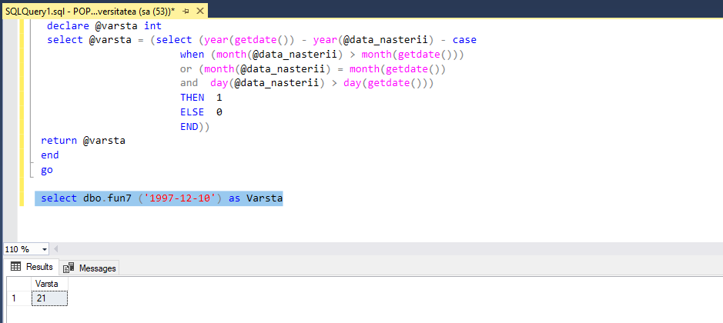

**Task 8**

**Sa se creeze o functie definita de utilizator, care ar returna datele referitoare la reusita unui student. Se defineste urmatorul format al functiei : < nume_functie > (<Nume_Prenume_Student>). Sa fie afisat tabelul cu urmatoarele campuri: Nume_Prenume_Student, Disticplina, Nota, Data_Evaluare.**

create function fun8 (@st_nume_prenume VARCHAR(50))

returns table

as

return

(select concat(Nume_Student, ' ',Prenume_Student) as Student, Disciplina, Nota, Data_Evaluare

from s_s, ds_ps, rs_s

where s_s.Id_Student = rs_s.Id_Student

and ds_ps.Id_Disciplina = rs_s.Id_Disciplina

and Nume_Student + ' ' + Prenume_Student = @st_nume_prenume )

go

select * from dbo.fun8 ('Gadalean Gabriela')

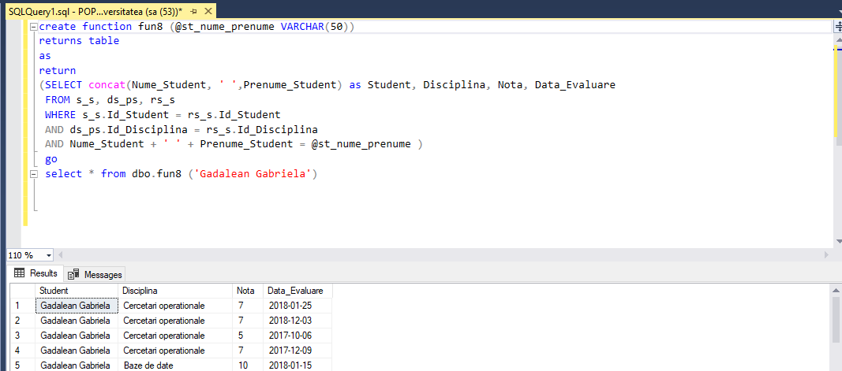

**Task 9**

**Se cere realizarea unei functii definite de utilizator, care ar gasi cel mai sarguincios sau cel mai slab student dintr-o grupa. Se defineste urmatorul format al functiei: <nume_functie> (<Cod_Grupa>, <is_good>). Parametrul <is_good> poate accepta valorile "sarguincios" sau "slab", respectiv. Functia sa returneze un tabel cu urmatoarele campuri Grupa, Nume_Prenume_Student, Nota Medie , is_good. Nota Medie sa fie cu precizie de 2 zecimale.**

create function fun9 (@cod_grupa VARCHAR(10), @is_good VARCHAR(20))

returns @Student Table (Cod_Grupa varchar(10), Student varchar (100), Media decimal(4,2), Reusita varchar(20))

as

begin

if @is_good = 'sarguincios'

begin

insert into @Student

select top (1) Cod_Grupa, concat(Nume_Student,' ',Prenume_Student) as Student,

CAST(AVG( Nota * 1.0) as decimal (4,2)) as Media, @is_good

from grupe,s_s, rs_s

where grupe.Id_Grupa = rs_s.Id_Grupa

AND s_s.Id_Student = rs_s.Id_Student

AND Cod_Grupa = @cod_grupa

group by Cod_Grupa, Nume_Student, Prenume_Student

order by Media desc

end

else

begin

insert into @Student

select top (1) Cod_Grupa, concat(Nume_Student,' ',Prenume_Student) as Student,

CAST(AVG( Nota * 1.0) as decimal (4,2)) as Media, @is_good

from grupe,s_s, rs_s

where grupe.Id_Grupa = rs_s.Id_Grupa

AND s_s.Id_Student = rs_s.Id_Student

AND Cod_Grupa = @cod_grupa

group by Cod_Grupa, Nume_Student, Prenume_Student

order by Media

end

RETURN

end

go

select * from fun9 ('INF171','sarguincios')

go

select * from fun9 ('INF171','slab')

