XangVo
Created date: 2017/10/25
Update date: 2018/07/24
Version: 0.3

2018/07/24 | Install laravel-dompdf

Install for XAMPP
https://phpunit.de/manual/5.7/en/installation.html#installation.phar.windows
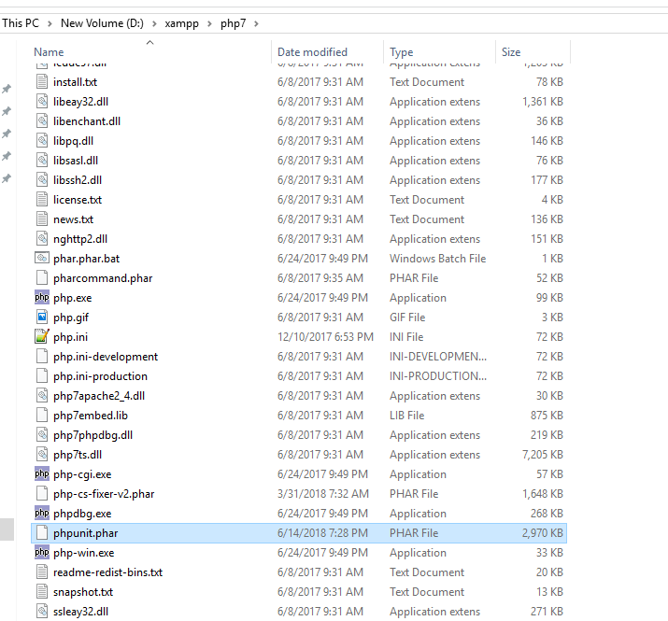

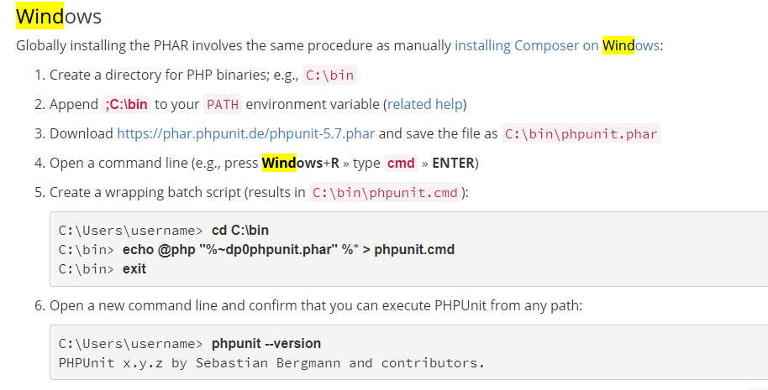

D:\xampp\php7 | echo @php "%~dp0phpunit.phar" %* > phpunit.cmd
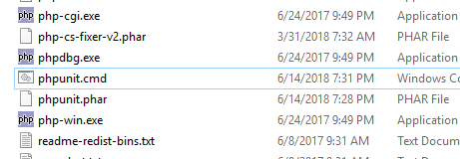 | 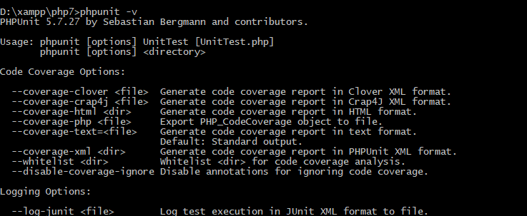

Ok nhé

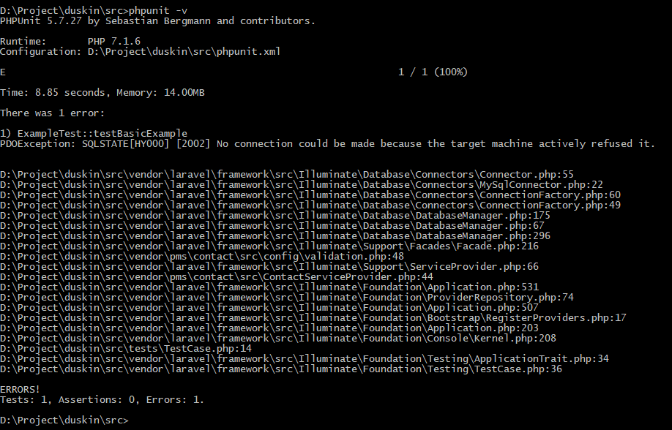

HOMESTEAD
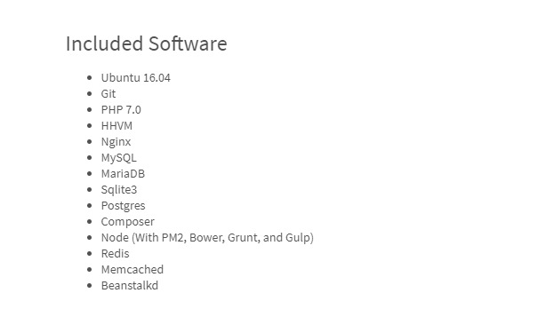

composer create-project laravel/laravel=5.2 phpunit --prefer-dist

composer update --no-scripts

composer global require "phpunit/phpunit=4.1.*"

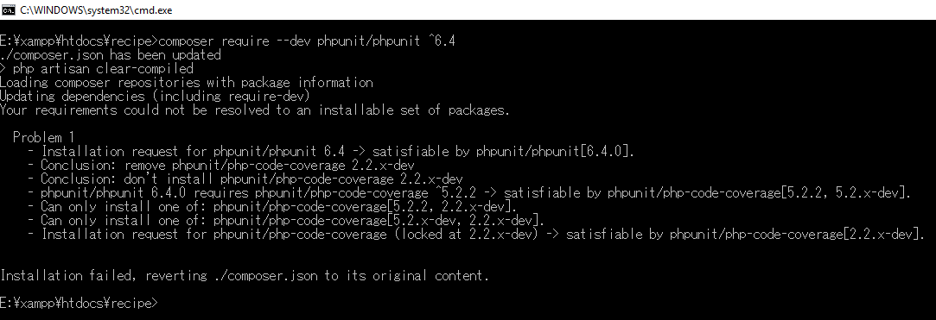

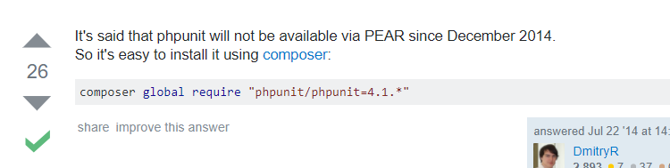

composer global require "phpunit/phpunit=4.1.*"

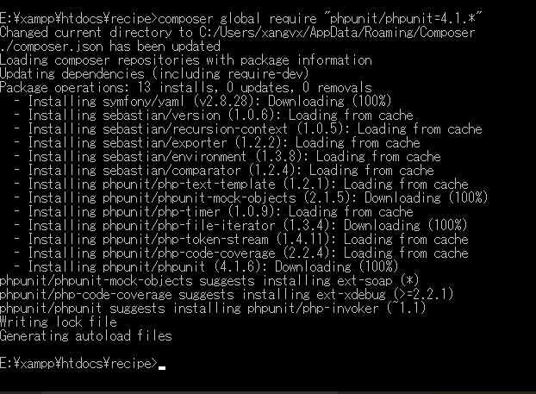

II. HomeStead:

https://laravel.com/docs/5.2/homestead
vagrant box add laravel/homestead  git clone https://github.com/laravel/homestead.git Homestead  C:\Windows\System32\drivers\etc\hosts | Hostnamectl
composer require "guzzlehttp/guzzle":"^6.1"
E:\xampp\htdocs\homestead\Homestead\Homestead.yaml | folders:  - map: E:/xampp/htdocs/phpunit/  to: /home/vagrant/code  sites:  - map: homestead.app  to: /home/vagrant/code/public
php artisan make:provider GuzzleClientProvider
php artisan make:test GuzzleClientTest
phpunit --filter testExample
hostnamectl | 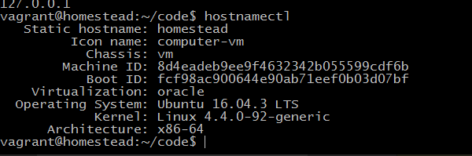
sudo apt list --installed

php -m | zend_extension=/usr/lib/php/20160303/xdebug.so
https://xdebug.org/download.php | Xdebug 2.5.4  Xamp php7  32bit
phpunit --coverage-html tests tests
php -i | grep "php.ini"
locate xdebug.so

Ubuntu common command:  ============check php, mysql in Ubuntu==========  php -i | grep "php.ini"  sudo apt list --installed  sudo apt list --installed | grep php  sudo apt list available | grep php  sudo service php7.1-fpm restart  locate xdebug.so  find / -name 'xdebug.so' 2> /dev/null  +++++++++++++++fix+++++++++  /usr/lib/php/20160303  /home/vagrant/code  /etc/php/7.1/mods-available  sudo service php7.1-fpm restart  +++++++++++++++fix+++++++++  ============check php, mysql in Ubuntu========== | 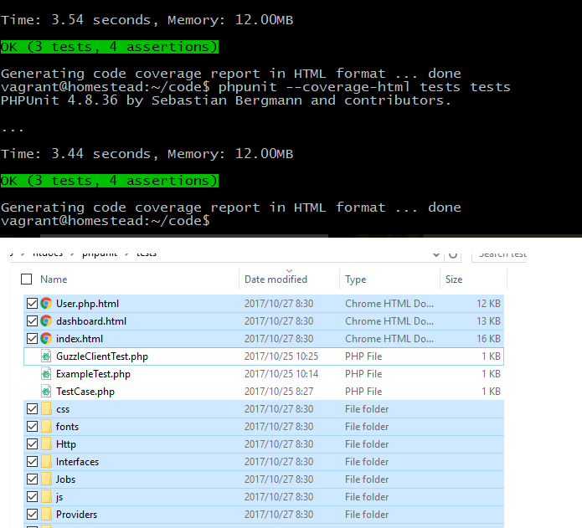

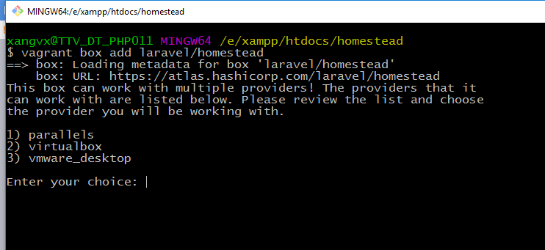

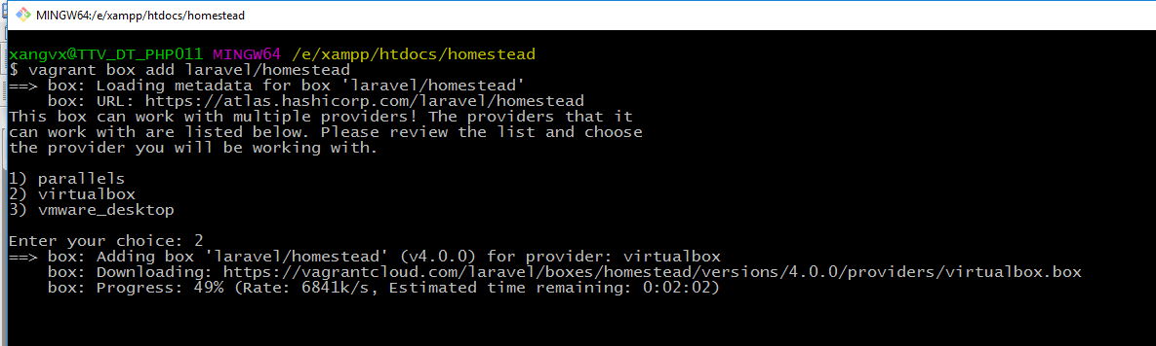
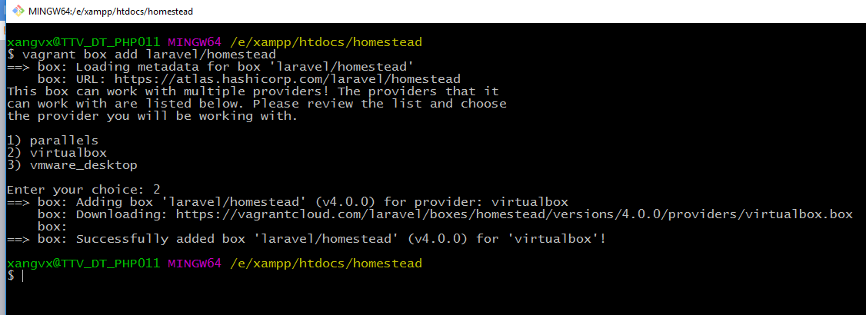
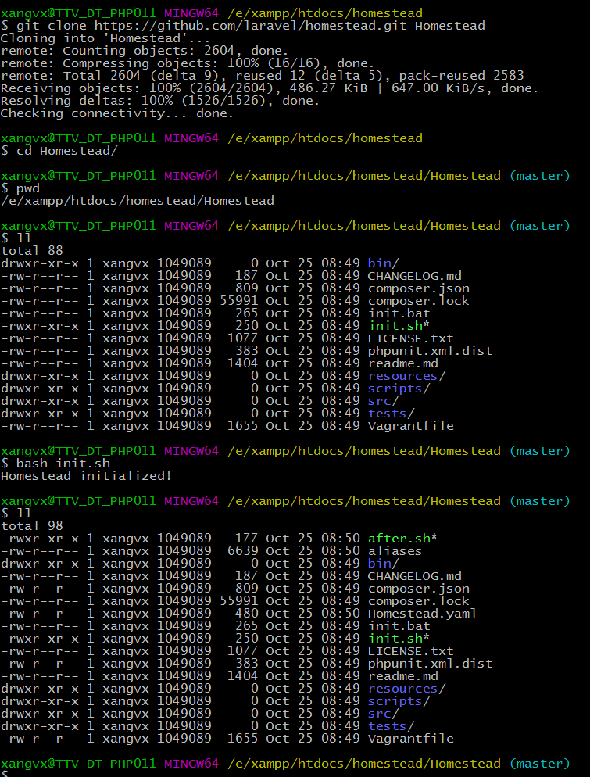

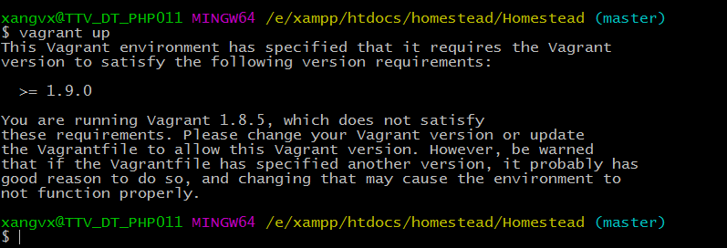
Ko can restart:
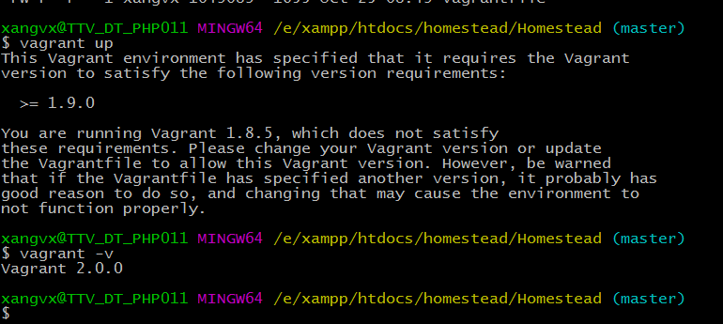
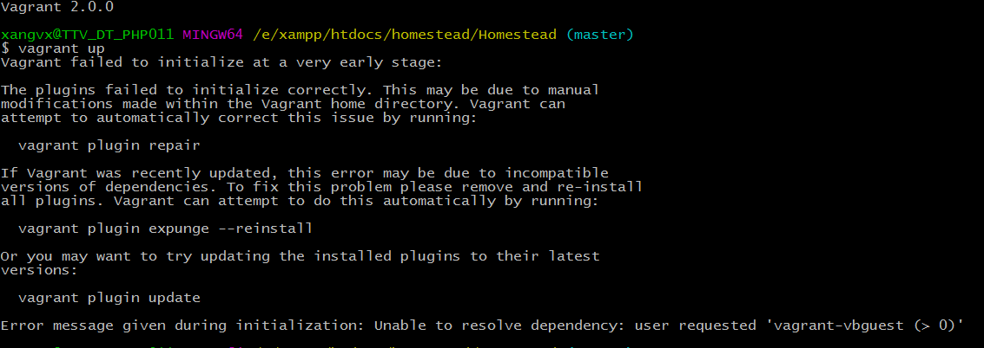

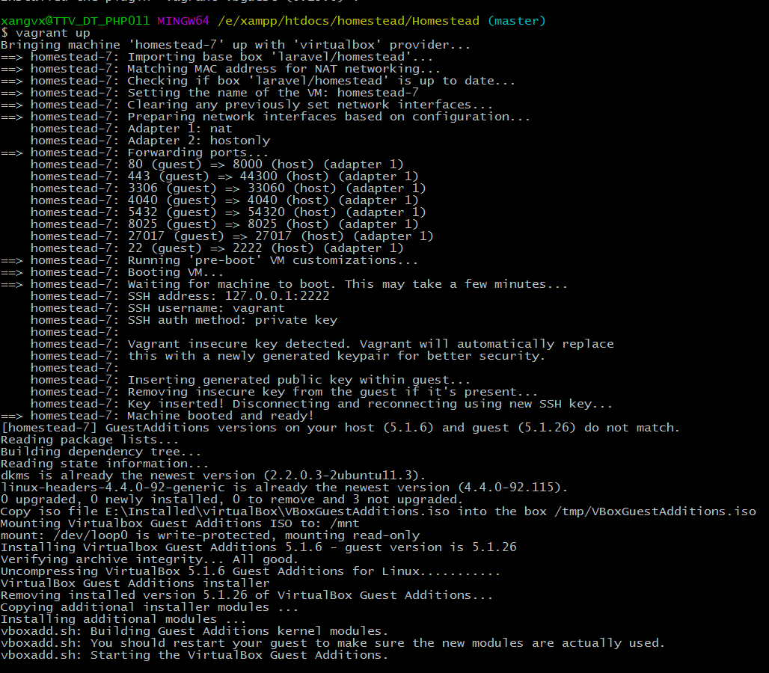

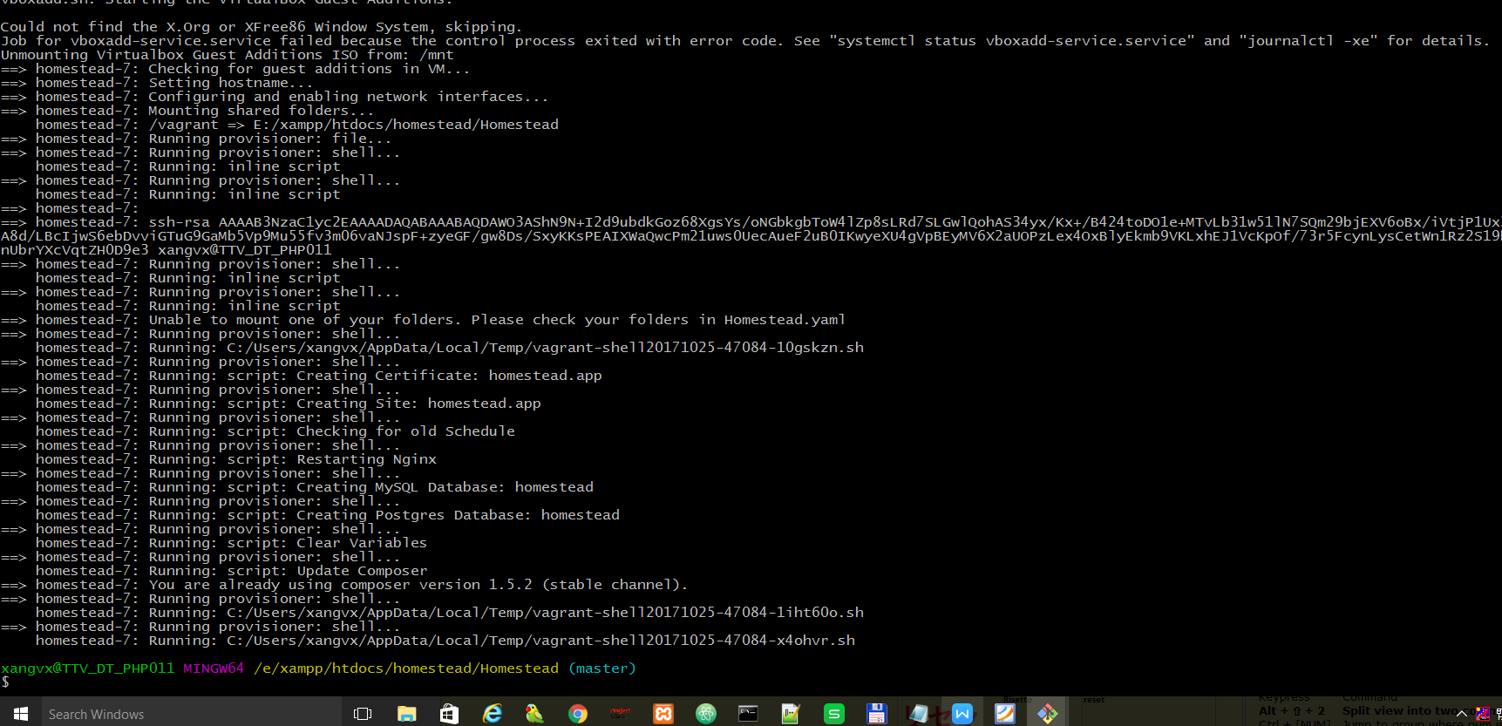

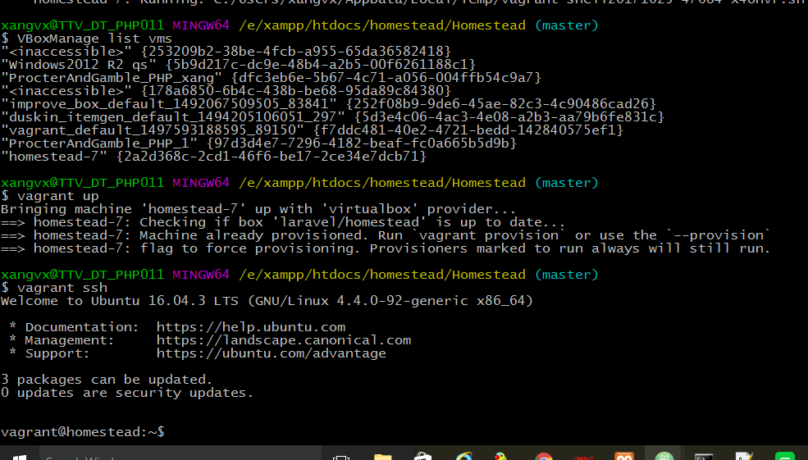

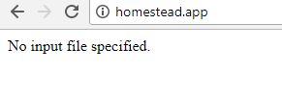
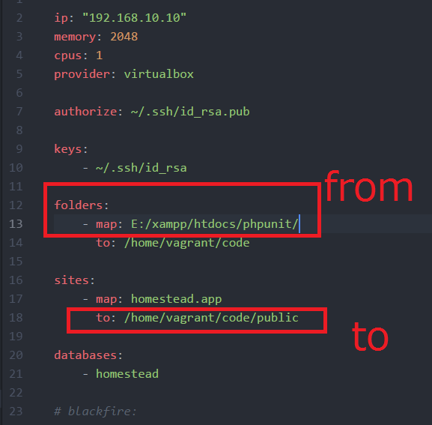
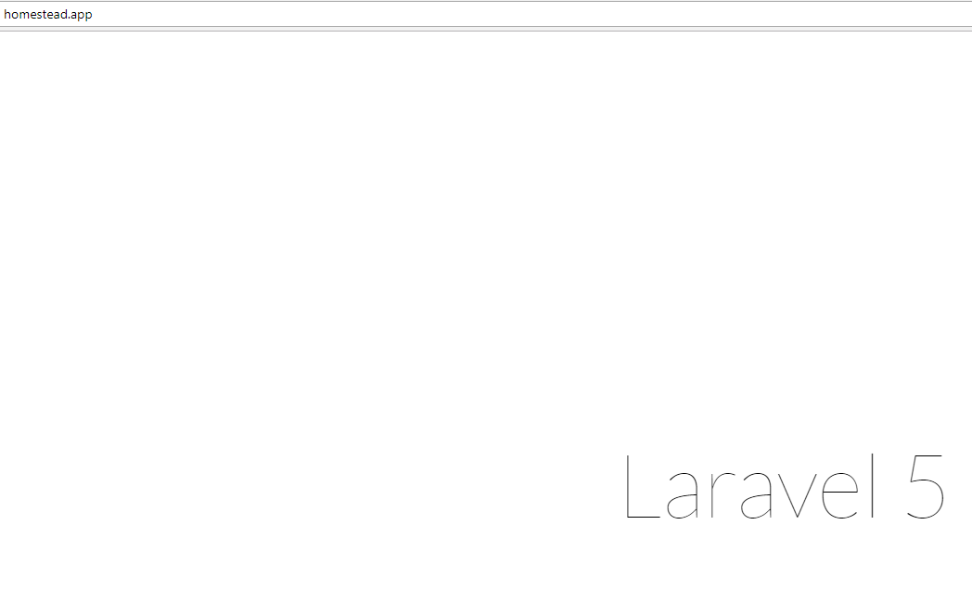

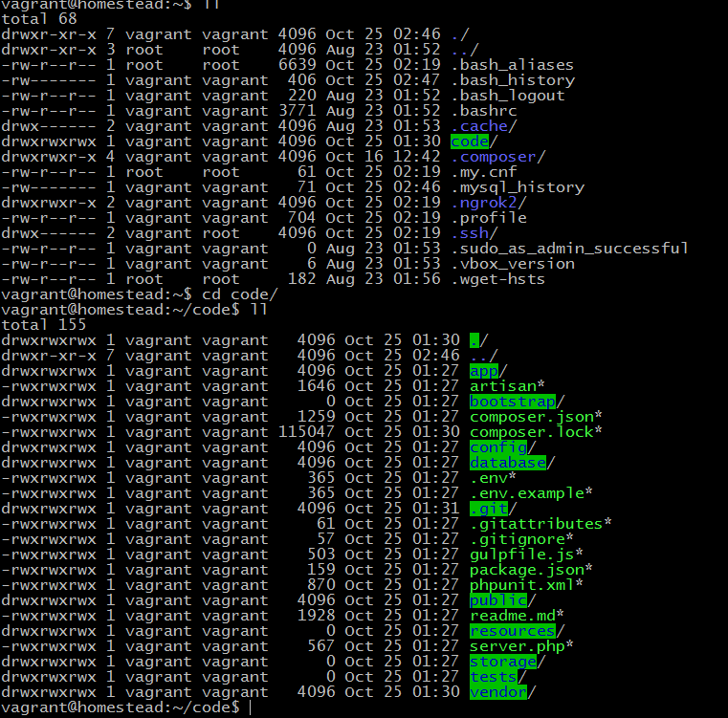
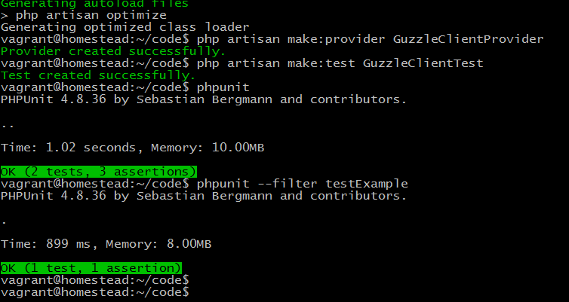
Ko có test_ ==> err
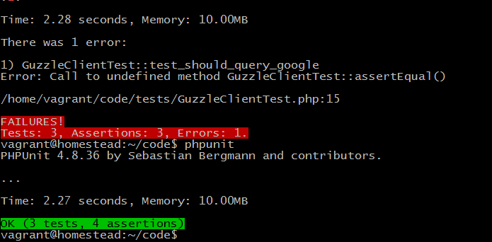
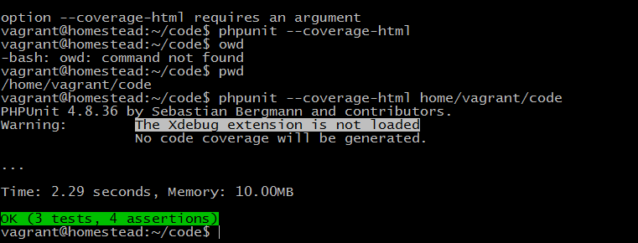

phpunit --coverage-html tests tests
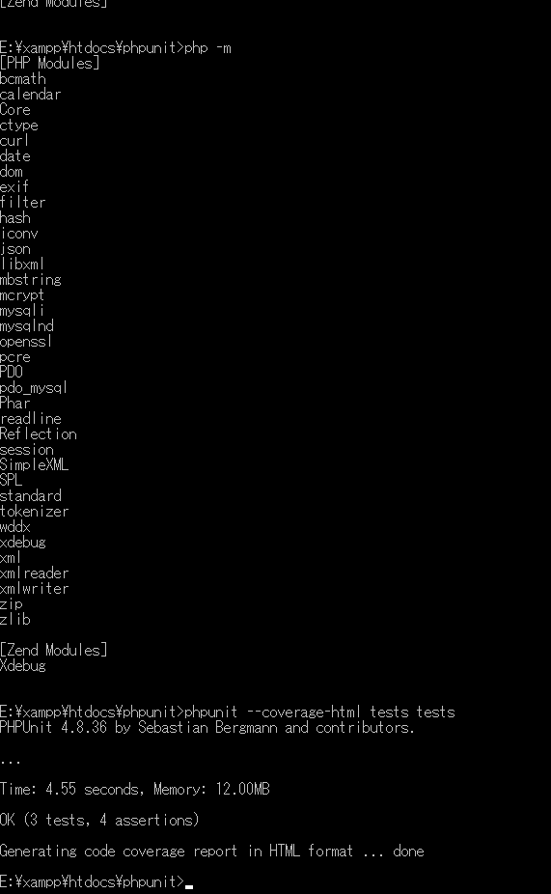
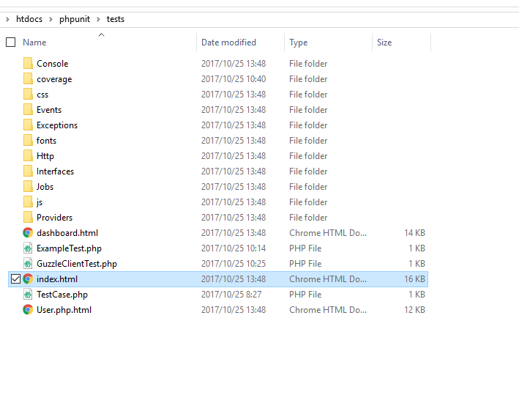
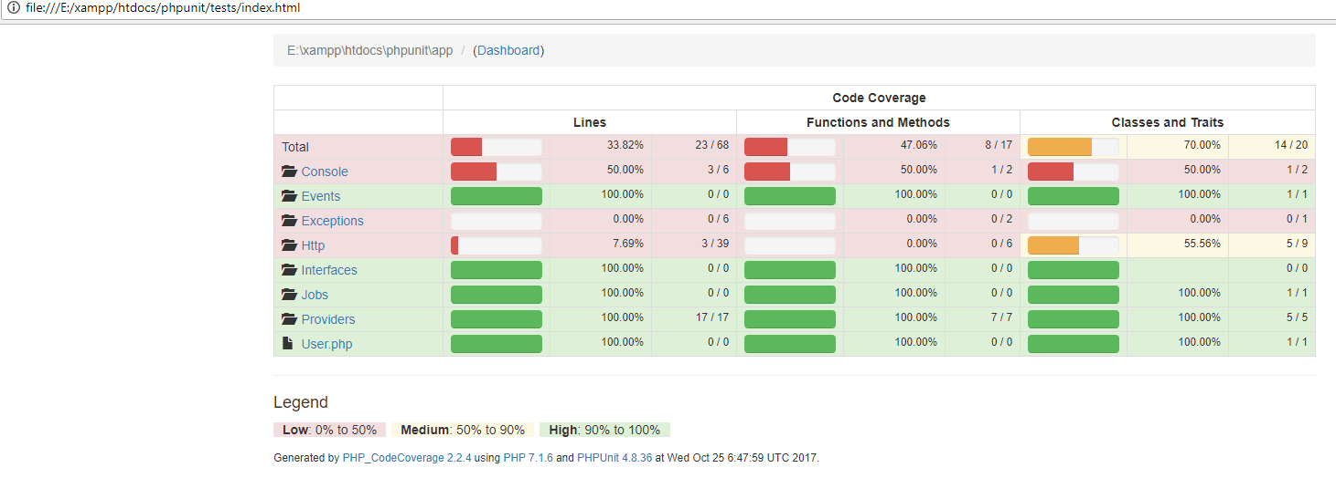
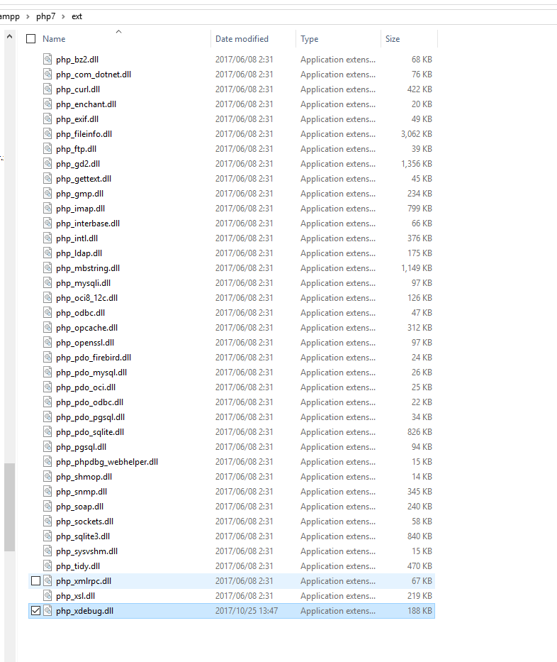
Ubuntu 16.x fix bug: can not load Xdebug for PHPUnit Code Coverage:
/etc/php/7.1/mods-available
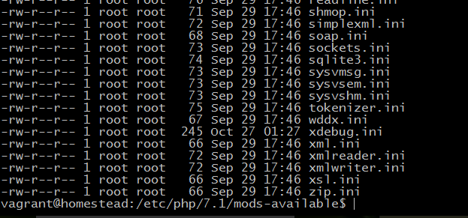

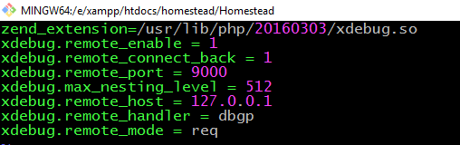
/usr/lib/php/
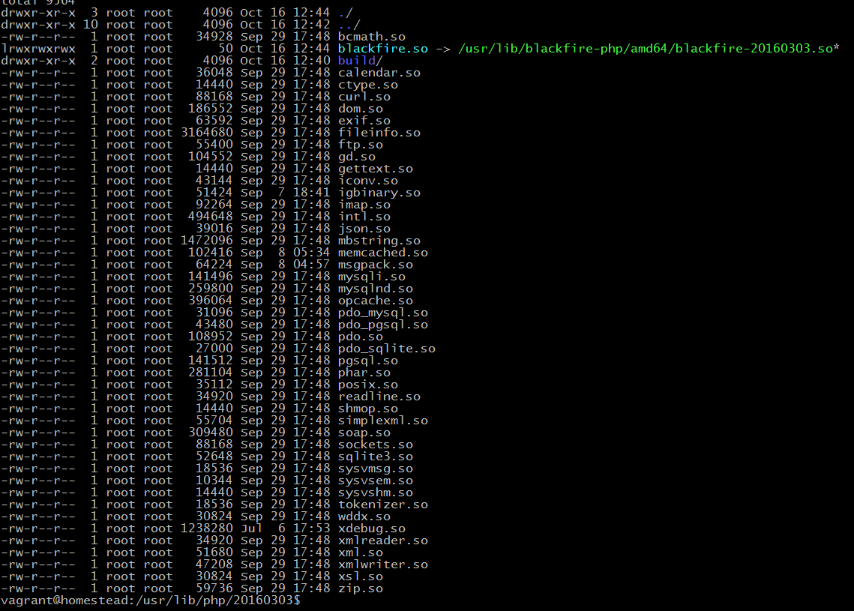
===================Done================

2018/06/14
E:\projects\Resona\resona_brandunity\tests
E:\projects\Resona\resona_brandunity>php artisan make:test UserLoginTest

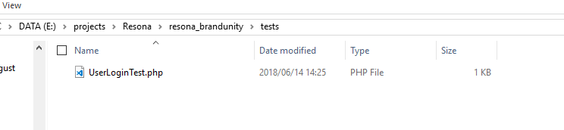

<?php

use Illuminate\Foundation\Testing\WithoutMiddleware;
use Illuminate\Foundation\Testing\DatabaseMigrations;
use Illuminate\Foundation\Testing\DatabaseTransactions;

class UserLoginTest extends TestCase
{
/**
* A basic test example.
*
* @return void
*/
public function testExample()
{
$this->assertTrue(true);
}
}

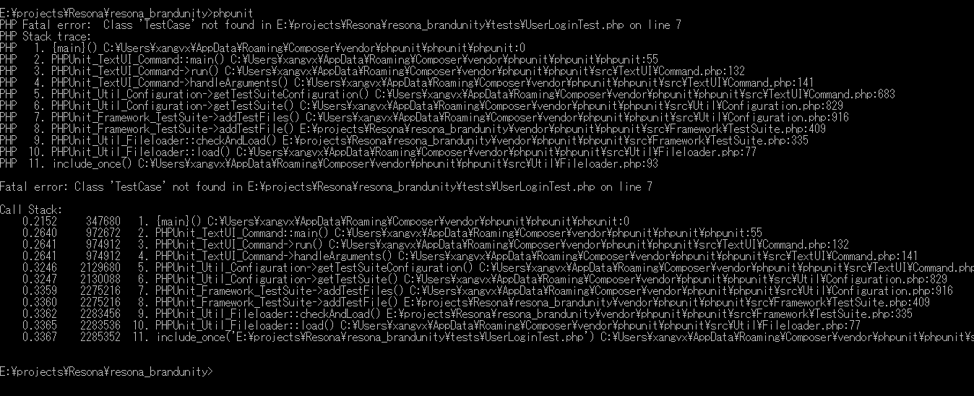
Solv:
https://laracasts.com/discuss/channels/laravel/php-fatal-error-class-testcase-not-found?page=1

TestCase.php
<?php

class TestCase extends Illuminate\Foundation\Testing\TestCase
{
/**
* The base URL to use while testing the application.
*
* @var string
*/
protected $baseUrl = 'http://localhost';

/**
* Creates the application.
*
* @return \Illuminate\Foundation\Application
*/
public function createApplication()
{
$app = require __DIR__.'/../bootstrap/app.php';

$app->make(Illuminate\Contracts\Console\Kernel::class)->bootstrap();

return $app;
}
}

Composer.json
"autoload-dev": {
"classmap": ["tests/TestCase.php"]
},

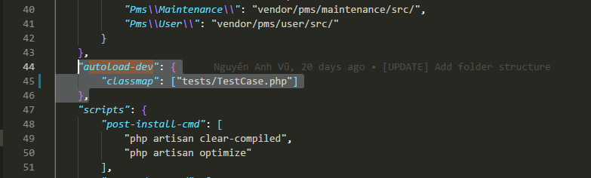

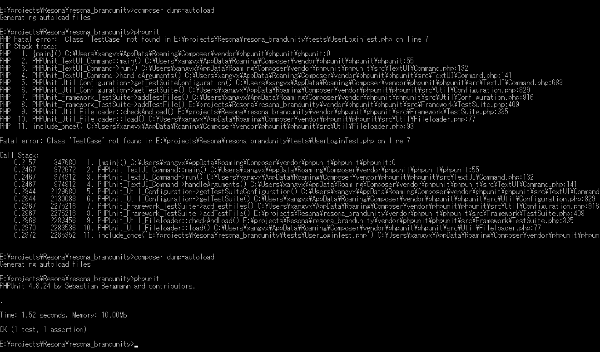

phpunit vendor/pms/user

E:\projects\Resona\resona_brandunity\vendor\pms\user\tests\UserLoginTest.php | <?php  use Illuminate\Foundation\Testing\WithoutMiddleware;  use Illuminate\Foundation\Testing\DatabaseMigrations;  use Illuminate\Foundation\Testing\DatabaseTransactions;  class UserLoginTest extends TestCase  {  /**  * A basic test example.  *  * @return void  */  public function testExample()  {  $this->assertTrue(true);  }  }
E:\projects\Resona\resona_brandunity\tests\TestCase.php | <?php  class TestCase extends Illuminate\Foundation\Testing\TestCase  {  /**  * The base URL to use while testing the application.  *  * @var string  */  protected $baseUrl = 'http://localhost';  /**  * Creates the application.  *  * @return \Illuminate\Foundation\Application  */  public function createApplication()  {  $app = require __DIR__.'/../bootstrap/app.php';  $app->make(Illuminate\Contracts\Console\Kernel::class)->bootstrap();  return $app;  }  }
phpunit vendor/pms/user | 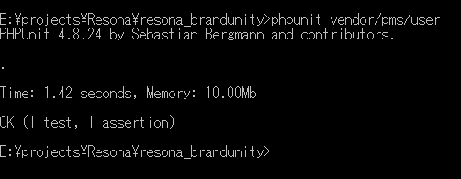

php artisan make:test unitTest/homepage/TestLoginHomePage

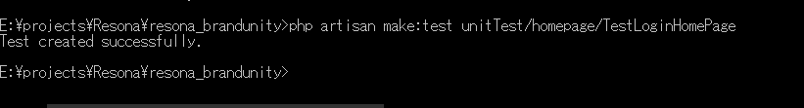
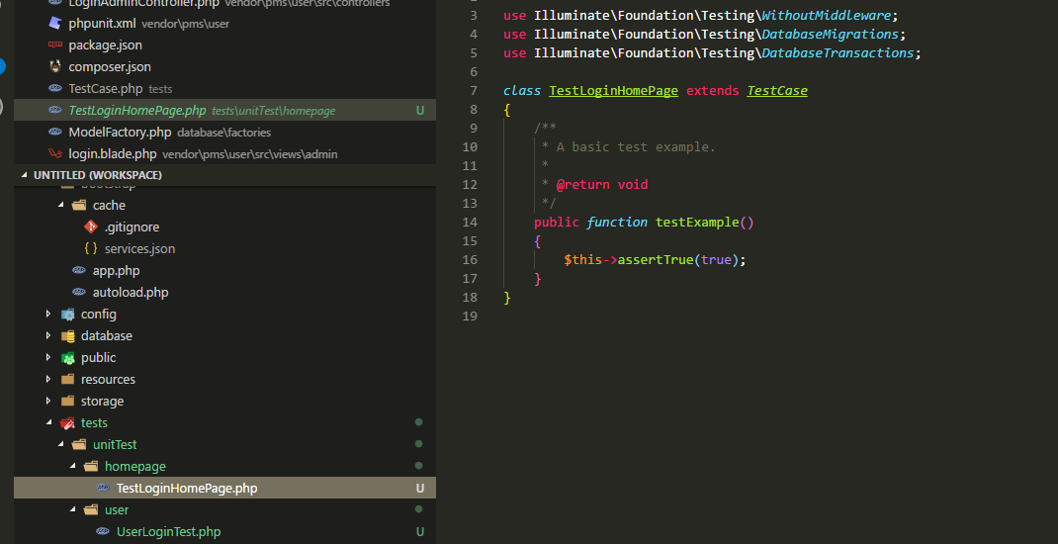

Err:
https://stackoverflow.com/questions/28073239/how-to-execute-all-tests-in-phpunit

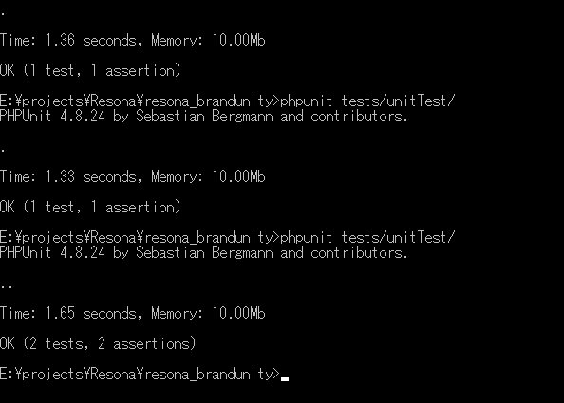

Chạy từ 1 case sang 2 là do:

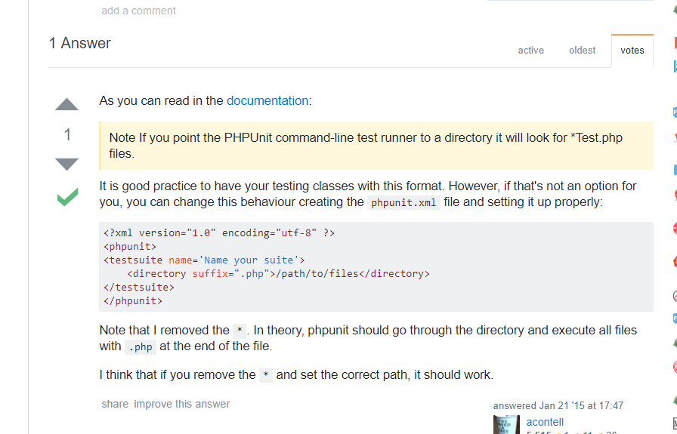

2018/07/24 Install laravel-dompdf

https://appdividend.com/2017/05/08/generate-pdf-blade-laravel-5-4/

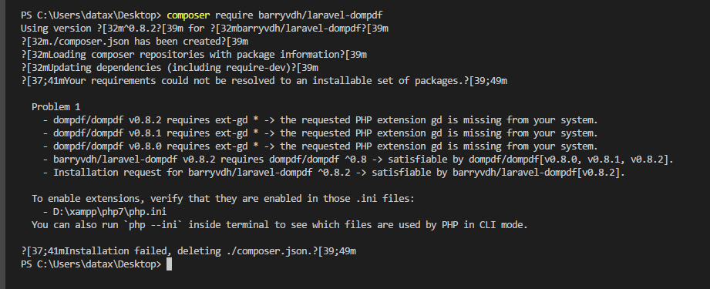

Problem 1
- dompdf/dompdf v0.8.2 requires ext-gd * -> the requested PHP extension gd is missing from your system.
- dompdf/dompdf v0.8.1 requires ext-gd * -> the requested PHP extension gd is missing from your system.
- dompdf/dompdf v0.8.0 requires ext-gd * -> the requested PHP extension gd is missing from your system.
- barryvdh/laravel-dompdf v0.8.2 requires dompdf/dompdf ^0.8 -> satisfiable by dompdf/dompdf[v0.8.0, v0.8.1, v0.8.2].
- Installation request for barryvdh/laravel-dompdf ^0.8.2 -> satisfiable by barryvdh/laravel-dompdf[v0.8.2].

To enable extensions, verify that they are enabled in those .ini files:
- D:\xampp\php7\php.ini
You can also run `php --ini` inside terminal to see which files are used by PHP in CLI mode.

extension=php_gd2.dll
extension=php_gettext.dll

D:\xampp\php7

