

LORAWAN-GATEWAY



DIGISENSOR CO., LTD
May,5,2020
RAK 7243C pilot gateway

- Passwork gateway :

The default username is “pi” and the default password is “raspberry”.

- Accessing Your Gateway :

- Connect mode:
You connect your PC with the LoRa Gateway through an Ethernet Cable via the Raspberry Pi port.
You can find IP of gateway through router/switch/hub.
SSH (Secure Shell) is typically used to log in to a remote machine and execute commands.
Feel free to choose one that fits your needs, you will be using Putty for this guide.

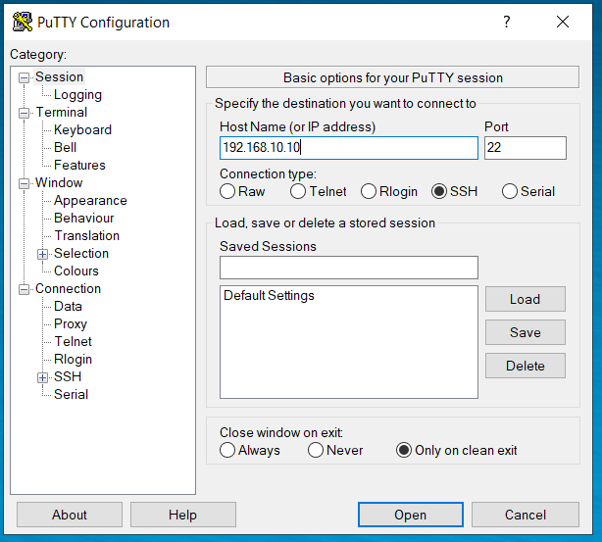
- Configuring the Gateway:
Assuming you have successfully logged into your LoRa Gateway using SSH. Enter the following command in the command line:
sudo gateway-config
You will now see a page like the following picture below.

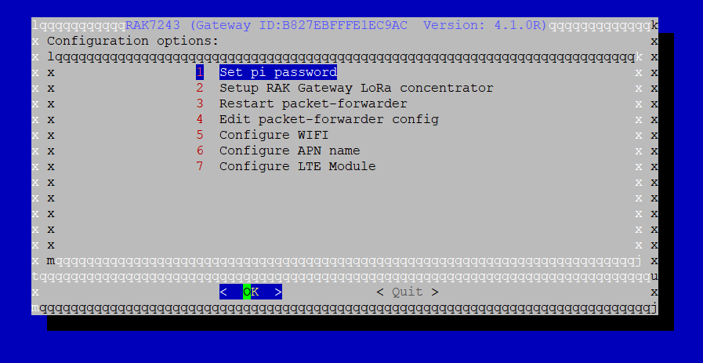

1/Set pi password : - used to set/change the password of the LoRa Gateway.

2/Set up RAK Gateway LoRa Concenterator: - used to configure the frequency, which the LoRa Gateway will operate on, and the LoRa Server which the LoRa Gateway will work with.

3/Restart packet –forwarder: - used to restart the LoRa packet forwarded process.

4/Edit packet-forwarder config:- used to open the global_conf.json file, in order to edit LoRaWAN parameters manually.

5/Configure Wifi: - used to configure the Wi-Fi settings in order to connect to a network.

6/Configure APN name:

7/Configure LTE module: 3G/4G/LTE.

- Connecting through Wifi :
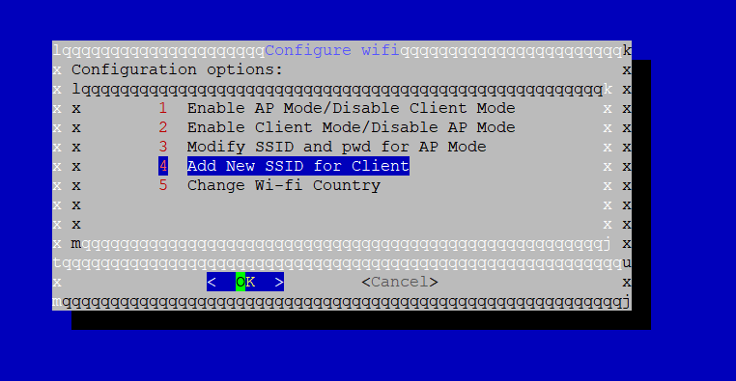
There are 4 options to choose from in the Wi-Fi configuration menu:
1/Enable AP Mode/Disable Client Mode - the LoRa Gateway will work in Wi-Fi Access Point Mode after rebooting while the Wi-Fi Client Mode will be disabled (this is the default mode).
2/Enable Client Mode/Disable AP Mode - the LoRa Gateway will work in Wi-Fi Client mode after rebooting, while Wi-FI AP Mode will be disabled.
3/Modify SSID and pwd for AP Mode - used to modify the SSID and password of the Wi-Fi AP. Only works if the Wi-Fi AP Mode is enabled.
4/Add New SSID for Client - this is used if you want to connect to a new Wi-Fi Network. Only works in Wi-Fi Client mode.
5/Change Wifi country choose location.

Connecting through Ethernet:
Use IP DHCP.
You connect your gateway with router/switch/hub through an Ethernet Cable via the Raspberry Pi port.

Connect the LTE:
First, make sure that you have already inserted a suitable SIM Card into the RAK7243C Pilot Gateway. If there is no SIM card inside the RAK724C, then turn off the gateway using the command sudo shutdown now and insert the card.
Login to your gateway using SSH and enter the command sudo gateway-config and choose Item 7. Configure LTE Module.

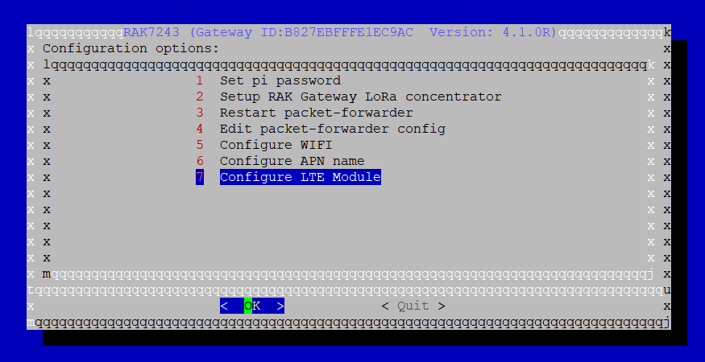

You will see 2 items:

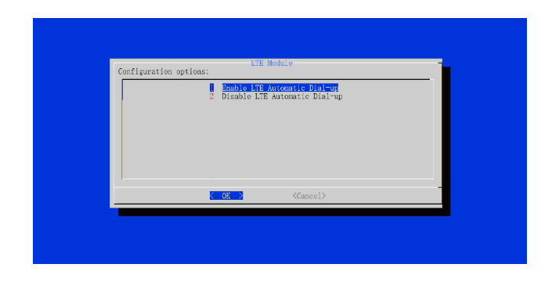
There are 2 configuration Options for the LTE Module:
1/Enable LTE Automatic Dial-up - the LoRa Gateway will connect to LTE Automatically, when it boots.
2/Disable LTE Automatic Dial-up - the LoRa Gateway will not connect to LTE Automatically.
After that, you choose configure APN name (item 6 in RAK7243 ).
- Set up RAK gateway lora concentrator:
You choose Application Server.
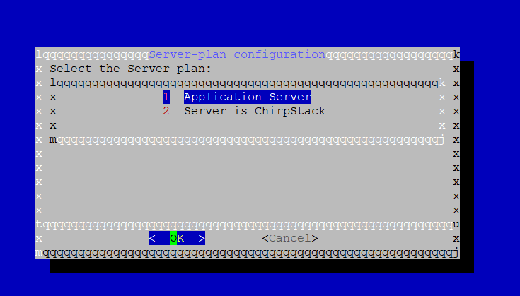
You choose US_902_928.
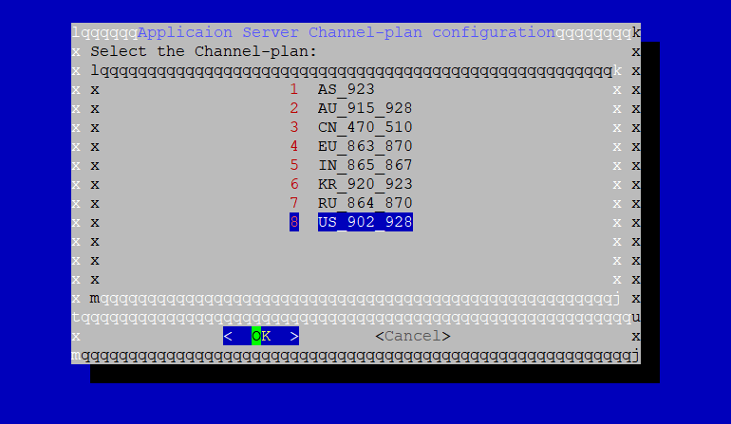

- Reboot:
Reboot the LoRa Gateway using the command sudo reboot now in the command line and it will work.
- Configure port of server:
Before booting, you need to plug the USB into the gateway which has already the installation file. Plug power adapter (5v) into the gateway and wait for it to download and finish.
The file is config_gateway.txt
- Creating file : config_gateway.txt
Note: config_gateway.txt the name of this file is unchangeable, you won’t be able to change it.
Inside the file is included:
X.X.X.X,Y,

-X.X.X.X: is IP of server.
-Y : is port of server.

Example:
113.161.71.163: is IP of server.
54345 : is port of server.
Obligation Note: there’s a commas between IP and Port and a commas at the end. These two commas are crucial for the system to work.

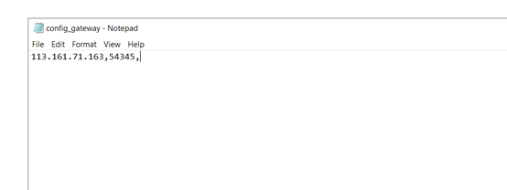
- Copying to USB
You copy the file config_gateway.txt into the USB.
- Loading file config_gateway.txt into gateway Lorawan
Step 1: Plug the USB into the gateway.
Note : Turn off the gateway .
Step 2: Plug power adapter into the gateway.
Step 3: Wait for about 5 minutes then remove the USB from the gateway. After that, remove power adapter from the gateway (turn off the gateway).
Step 4: Plug power adapter into the gateway.
Step 5 :Wait until the gateway is activated.
- Other, no use Putty:
In addition, you can also connect the Raspberry to the monitor via the HDMI port. Turn on your monitor or TV set and make sure it is ready for connecting. You need to use the mouse and keyboard to connect to the gateway.

