**QUEUE MANAGEMENT FOR PARKING**

# Minor Project-II (ENSI252)

*Submitted in partial fulfilment of the requirement of the degree of*

**BACHELOR OF TECHNOLOGY**

*to*

**K.R Mangalam University**

*by*

**PIHU (230101283) PAYAL PAL (2301010335) DIKSHA PAL (2301010320)** **KASHISH (2301010326)**

Under the supervision of

# DR TANVI CHAWLA MANVITH KUMAR MENTOR PARKING CASHIER

# PARKING PRIVATE SERVICES



Department of Computer Science and Engineering

School of Engineering and Technology

K.R Mangalam University, Gurugram- 122001, India

April 2025

# CERTIFICATE

## This is to certify that the Project Synopsis entitled, “QUEUE MANAGEMENT FOR PARKING” submitted by “PIHU PANDEY (2301010283),DIKSHA PAL (2301010320),PAYAL PAL(2301010335), KASHISH(2301010326)” to K.R Mangalam University, Gurugram, India, is a record of bonafide project work carried out by them under my supervision and guidance and is worthy of consideration for the partial fulfilment of the degree of Bachelor of Technology in Computer Science and Engineering of the University.

**Type of Project (Tick One Option)**

**Industry/Research/University Problem**

<Signature of Internal supervisor>

DR TANVI CHAWLA

Signature of Project Coordinator

Date: 3rd April 2025

# INDEX

|  |  |  |
| --- | --- | --- |
| 1. | Abstract | Page No. |
| 2. | Introduction (description of broad topic) |  |
| 3. | Motivation |  |
| 4. | Literature Review/Comparative work evaluation |  |
| 5. | Gap Analysis |  |
| 6. | Problem Statement |  |
| 7. | Objectives |  |
| 8. | Tools/platform Used |  |
| 9. | Methodology |  |
| 10. | Experimental Setup |  |
| 11. | Evaluation Metrics |  |
| 12. | Results And Discussion |  |
| 13. | Conclusion & Future Work |  |
| 14. | References |  |

# ABSTRACT

Efficient queue management in parking systems is critical for reducing congestion, minimizing waiting times, and enhancing the overall user experience. Traditional parking facilities often struggle with long queues, especially during peak hours, leading to increased driver frustration, traffic congestion, and environmental impact. This report explores the challenges associated with parking queue management and presents modern solutions driven by emerging technologies such as IoT, artificial intelligence, and realtime data analytics. It highlights the design of smart parking systems that utilize sensors, automated guidance, and mobile applications to optimize vehicle flow and space utilization. Through the analysis of real-world case studies, the report demonstrates the significant improvements that smart queue management systems can offer in terms of efficiency, sustainability, and customer satisfaction. The study concludes with a discussion on future trends, including autonomous vehicle integration and smart city connectivity, offering insights into the evolving landscape of parking management.

**Chapter 1 Introduction**

# 1. Background of the project

with the rapid growth of urbanization and the increasing number of vehicles on the road, managing parking spaces efficiently has become a major challenge for city planners, businesses, and facility operators. Traditional parking systems often fail to handle high volumes of traffic, resulting in long queues, wasted time, and driver frustration. Poor queue management not only affects the user experience but also contributes to traffic congestion, higher fuel consumption, and increased air pollution.

To address these issues, there is a growing need for smart queue management solutions that can optimize the flow of vehicles into and out of parking facilities. By integrating technologies such as IoT sensors, real-time monitoring, automated ticketing, and mobile apps, parking systems can dynamically manage queues, reduce wait times, and enhance overall efficiency. This project aims to study the current problems in parking queue management, investigate advanced technological solutions, and propose a modern, intelligent parking system model that can meet the needs of rapidly growing urban environments.

Common Problems in Traditional Parking Syste

S. No. Problem Description

1. Long waiting times Vehicles spend excessive time queuing for a parking spot.
2. Traffic congestion Parking queues spill onto surrounding roads, causing traffic jams.
3. Lack of real-time information Drivers are unaware of available parking spots in advance.
4. Inefficient space utilization Some spots remain empty while queues form elsewhere.
5. Increased vehicle emissions Idling cars in queues contribute to environmental pollution.
6. Driver frustration and stress Long queues create a negative experience for users.
7. Manual entry/exit management Causes delays and increases chances of human error.

# 2. MOTIVATION

Parking management has emerged as a major concern in modern urban environments, commercial complexes, airports, hospitals, and event venues. As cities become more populated and vehicle ownership continues to rise, traditional parking facilities are facing immense pressure. Long queues at parking entrances and exits are not just a minor inconvenience — they contribute significantly to traffic congestion, driver frustration, increased operational costs, and environmental issues due to prolonged idling of vehicles.

One of the key motivations behind this project is the need to modernize parking systems through the adoption of advanced technologies. Current manual or semi-automated systems often lack the scalability and intelligence required to handle dynamic traffic patterns, particularly during peak hours. Drivers often waste valuable time looking for available spaces, which leads to increased fuel consumption, higher emissions, and unnecessary stress. Businesses and facilities that fail to provide efficient parking solutions may also suffer from reduced customer satisfaction and financial losses.

Another critical driver for this project is the rapid advancement in technologies such as Internet of Things (IoT), Artificial Intelligence (AI), Machine Learning (ML), and mobile computing. These technologies offer new possibilities for real-time monitoring, automated space allocation, predictive analytics for traffic flow, dynamic pricing, and personalized user experiences. The integration of smart queue management systems can not only optimize the flow of vehicles but also provide data-driven insights for better planning and decision-making.

Moreover, environmental sustainability is becoming an essential priority worldwide. Poorly managed parking queues contribute directly to urban air pollution and carbon emissions. By reducing idle times and streamlining entry and exit processes, smart parking systems can significantly lower the environmental impact, contributing towards greener, more sustainable cities.

In addition, the growing concept of “Smart Cities” relies heavily on the efficient management of urban mobility, and parking plays a vital role in this ecosystem. Efficient queue management solutions are fundamental to ensuring seamless transportation networks, better land use, and improved quality of life for residents.

Therefore, the motivation for this project stems from the need to:

* Reduce waiting times and congestion at parking facilities
* Enhance the user experience by providing quick and easy access to parking spaces
* Lower operational and environmental costs through automation and smart resource utilization
* Support the broader goals of smart city initiatives and sustainable urban development

By studying the current challenges and exploring innovative technologies, this project aims to design an intelligent, efficient, and future-ready parking queue management system that can adapt to the growing demands of modern urban living.

**Chapter 2 LITERATURE REVIEW**

# 1. Review of existing literature

The rapid urbanization and increasing vehicle ownership have intensified the demand for efficient parking solutions. Traditional parking systems, often manual and static, struggle to cope with dynamic urban traffic patterns, leading to congestion, increased emissions, and driver frustration. Recent advancements in technology have paved the way for intelligent parking systems that aim to address these challenges.

1. AI and Computer Vision in Parking Management

Jung et al. (2022) introduced a smart parking system utilizing multiple cameras and artificial intelligence techniques. The system employs Optical Character Recognition (OCR) for vehicle number recognition and YOLO-based deep learning for collision detection within parking lots. Implemented on a Raspberry Pi platform, the system effectively tracks vehicles and manages parking space information, enhancing overall parking management efficiency.

A systematic review by El-Sayed et al. (2024) examined vision-based parking systems focusing on driver and vehicle detection using AI and computer vision. The study highlighted the advancements in automated parking systems and the role of AI in enhancing parking space detection and management.

2. IoT-Enabled Smart Parking Systems

Mamun et al. (2024) proposed an IoT-based smart car parking system integrating various sensors like infrared and gas sensors, along with servo motors. The system provides real-time monitoring of parking slots and communicates with users through a mobile application, optimizing parking space utilization and enhancing user convenience.

A recent study presented a cloud-enabled parking management system integrating IoT sensors and computer vision. This system offers real-time parking slot detection, addressing challenges in parking space availability and aiming to reduce traffic congestion in urban areas.

3. Machine Learning and Predictive Analytics

A study published in 2024 focused on machine learning-based prediction of parking space availability in smart cities. The research developed an ML model in IoT-enabled environments to forecast parking space occupancy, aiming to reduce search time and improve traffic flow.

Another research by Carrese et al. (2024) explored sustainable parking space management using machine learning. The study emphasized optimizing the spatial distribution of parking slots to reduce relocation costs and improve service accessibility, demonstrating how strategically placed parking zones can alleviate congestion.

4. Integration of AI and IoT for Enhanced Parking Solutions

A recent paper discussed the development of a smart parking management system using IoT techniques. The system includes a display providing a map of the parking area, indicating the nearest available spot, and employs infrared sensors to detect vehicle presence, updating the database in real-time.

Additionally, a study highlighted the potential of smart, AI-powered parking systems in addressing urban mobility challenges. The research emphasized the integration of AI and IoT in parking management, focusing on data-driven approaches to enhance efficiency and user experience.

⸻

These studies collectively underscore the transformative impact of integrating AI, IoT, and machine learning into parking management systems. The advancements not only address the inefficiencies of traditional parking but also contribute to sustainable urban development by reducing congestion and emissions.

S. No. Study/Author Technology/Focus Area Key Findings Year

1. Jung et al. AI-based parking with computer vision (OCR, YOLO) Efficient tracking of vehicles and detection of collisions in parking lots using Raspberry Pi 2022
2. El-Sayed et al. Vision-based driver and vehicle detection Enhanced vehicle recognition and parking management through AI and computer vision techniques 2024
3. Mamun et al. IoT-based Smart Parking System Real-time monitoring of parking slots via mobile apps; improved space optimization

2024

1. ResearchGate Study Cloud-enabled IoT and Computer Vision Parking Real-time slot detection to reduce congestion and improve parking management 2024
2. Wiley Publication Machine Learning for Parking Prediction Accurate prediction of parking space availability to reduce search times 2024
3. Carrese et al. Sustainable Parking with Machine Learning

Optimized parking space distribution to cut relocation costs and improve accessibility 2024

1. JISIS Study IoT Smart Parking Display System Real-time map display of available spots using infrared sensors and automated database updates

2024

1. ResearchGate AI-IoT Study AI and IoT Integrated Parking Management Data-driven management enhancing urban mobility and reducing user wait times 2024

# 2. GAP ANALYSIS

Although modern parking queue management systems have advanced with the use of AI, IoT, and machine learning, several gaps remain. Current solutions often lack full integration across technologies, leading to fragmented management. Real-time data provided by sensors can be inaccurate due to failures or delays, reducing system reliability. Many smart parking projects work well on a small scale but face challenges when expanded to large cities due to high costs and complexity.

Another overlooked factor is driver behavior — most systems assume users will follow instructions perfectly, which is rarely the case in real life. High installation and maintenance costs also limit adoption in developing regions. Additionally, while some systems aim to reduce congestion and emissions, few measure environmental impacts in detail. Privacy and security risks related to data collection, such as vehicle tracking and app usage, remain a serious concern.

In short, gaps in integration, scalability, cost-effectiveness, real-time accuracy, user adaptability, environmental monitoring, and data security need to be addressed to create truly efficient parking management systems.

3. PROBLEM STATEMENT

With the continuous rise in urbanization and vehicle ownership, traditional parking systems are struggling to efficiently manage the increasing demand. Long queues at parking entrances and exits result in traffic congestion, wasted time, fuel consumption, and elevated driver frustration. Existing parking management solutions are often fragmented, lack real-time adaptability, and fail to scale effectively in larger urban environments. Additionally, current systems rarely account for unpredictable driver behavior, leading to further inefficiencies. High costs, concerns about data privacy, and insufficient focus on environmental sustainability make it difficult to implement smart solutions universally.

There is a critical need for an intelligent, integrated, and cost-effective parking queue management system that can handle real-time data accurately, adapt to user behavior, minimize congestion, and contribute to smarter, greener cities.

# 4. OBJECTIVES

The main objectives of this project are:

* To analyze the current challenges in traditional parking queue management systems.
* To design a smart, real-time queue management solution using emerging technologies like IoT, AI, and Machine Learning.
* To minimize vehicle waiting time and reduce congestion at parking facilities.
* To improve the user experience by providing accurate, real-time parking information and guidance.
* To develop a scalable and cost-effective system that can be implemented in various types of parking environments, from small lots to large urban complexes.
* To ensure the security and privacy of user data within the system.
* To assess the environmental benefits by reducing vehicle idling, fuel consumption, and carbon emissions.
* To create a framework that can support future smart city integrations.

## CHAPTER 3: METHODOLOGY (NO PAGE LIMIT)

The development of an efficient queue management system for parking is based on systematic steps involving analysis, design, implementation, and evaluation. The methodology adopted is described below:

3.1 Problem Identification and Requirement Analysis

* A detailed study was conducted on traditional parking systems in urban areas, malls, airports, and corporate offices.
* Key problems identified include long vehicle queues, inefficient parking slot utilization, traffic congestion, lack of real-time information, and user dissatisfaction.
* System requirements such as real-time monitoring, fast processing, user-friendly interfaces, and data security were defined based on this analysis.

Start

| v

Detect Vehicle at Entry Gate

| v

Is Slot Available?

| \

(Yes) (No)

| \ v v

Assign Nearest Add Vehicle to

Available Slot Waiting Queue

| | v v

Update Slot Notify User of

Database Estimated Wait Time

| v

Vehicle Enters and Parks

| v

End

⸻

3.2 System Design

* A system architecture was designed integrating IoT sensors, microcontrollers, wireless networks, cloud servers, and mobile applications.
* The parking area was divided into slots, each monitored by a sensor.
* Entry and exit points were automated using RFID/barrier systems to streamline vehicle movement.
* A centralized control unit processes sensor data and updates the available parking slots in real time.

⸻

3.3 Technology Selection

Sensors: Infrared (IR) or Ultrasonic sensors for vehicle

detection.

* Controllers: Arduino/Raspberry Pi boards for data acquisition and control.
* Communication: Wi-Fi or LoRa technology for wireless data transmission.
* Software: Python/C++ for control logic; Android/iOS for user mobile application.
* Cloud Storage: Firebase, AWS, or Azure for real-time database management.

⸻

3.4 Data Collection and Processing

* Sensors installed at parking slots collect occupancy status (occupied/vacant).
* Entry/exit sensors track the number of incoming and outgoing vehicles.
* Data is transmitted to the control unit, processed, and uploaded to a cloud server for real-time monitoring.

⸻

3.5 Queue Management Algorithm

* A queue management algorithm based on priority scheduling and shortest waiting time was developed.
* Vehicles are directed to the nearest available parking space through a mobile app or digital signage at the entrance.

In case of full occupancy, a waiting queue is formed, and

users are updated on expected waiting times.

⸻

3.6 User Interface Development

* A user-friendly mobile application was developed to show real-time parking availability, estimated wait time, and navigation assistance within the parking area.
* A website interface for parking operators was also developed to monitor system status, occupancy reports, and manage reservations.

⸻

3.7 Prototype Implementation

* A scaled-down model of a smart parking lot was created to test the proposed system.
* Prototypes included small car models, IR sensors at slots, an Arduino controller, and a basic mobile application.
* Real-time status updates and queue movement were demonstrated successfully.

⸻

3.8 Performance Evaluation

* System performance was evaluated using metrics such as:
* Reduction in average waiting time.
* Improvement in parking space utilization.

System accuracy in detecting slot status.

* User satisfaction through feedback surveys.

⸻

3.9 Security and Privacy Measures

* Data encryption and secure cloud communication protocols (HTTPS, SSL/TLS) were used.
* User information such as vehicle numbers and app data were protected through access control and authentication mechanisms.

⸻

3.10 System Optimization and Future Enhancement

* Based on prototype testing and feedback, sensor placements, queue algorithms, and user notifications were refined.
* Future enhancements proposed include:
* Dynamic pricing based on slot availability.
* AI-driven prediction of peak parking times.
* Integration with city-wide traffic management systems.

Tools Essential software includes Node.js (to execute JavaScript serverside code) and npm (Node Package Manager) to handle project dependencies. A code editor like Visual Studio Code is necessary for developing and editing the project files. To store and manage backend data, a MongoDB or similar NoSQL database server may be required based on the models used. Basic command-line tools are essential for installing packages and running the server locally. For equipment, any standard computer or laptop with a modern operating system (Windows,

macOS, or Linux) that supports Node.js and database servers is sufficient, along with a stable internet connection for installing packages and accessing cloud services if needed. • It’s a Node.js backend project.

* Key files and folders:
* server.js (main server file)
* routes/ (API route handlers)
* models/ (likely for database models)
* public/ (maybe static files)
* package.json and package-lock.json (for dependencies)
* node_modules/ (installed packages).

To set up the environment for the parking dashboard backend project, first, ensure that Node.js (version 14.x or above) and npm are installed on your system. Begin by cloning or extracting the project files into a working directory. Open a terminal, navigate to the project root folder (where the package.json file is located), and run the command npm installto install all necessary dependencies. If the project uses a database like MongoDB, make sure MongoDB is installed and running locally, or configure a remote database connection. Create an .env file if required to store environment variables like database URIs and server ports. Finally, start the server using the command node server.js or npm start. It’s recommended to use tools like Postman to test APIs and VS Code with helpful extensions like ESLint and Prettier for smoother development.

**Details of tools, software, and equipment utilized.**

. 1. Detailed Explanation of How the Project Was Implemented

The parking dashboard backend was implemented using Node.js and Express.js, a popular web application framework. The project follows a modular structure where different functionalities are separated into routes, models, and server setup. The server.js file initializes the server, sets up middlewares such as CORS and body-parser, and connects to necessary routes. Routes define API endpoints (such as adding parking slots, viewing status, etc.) while models define the data structure, typically meant for MongoDB. All HTTP requests (like POST for adding entries and GET for fetching information) are handled through properly structured APIs. The system uses RESTful principles to keep the backend easy to scale and maintain.

2. Algorithms, Code Snippets, or Design Diagrams Algorithms/Logic Flow:

* Parking Slot Management: When a request is received to park a vehicle, the backend checks available slots and updates the slot status.
* Real-time Updates: APIs are designed to update parking availability status dynamically.
* Validation: Data sent by users (e.g., vehicle number) is validated before saving.

Code Snippet Example (server.js basic setup):

javascript CopyEdit

const express = require('express');

const cors = require('cors');

const app = express();

const port = 3000;

// Middlewares

app.use(cors());

app.use(express.json());

// Routes

const parkingRoutes = require('./routes/parkingRoutes');

app.use('/api/parking', parkingRoutes);

// Start Server

app.listen(port, () => {

console.log(`Server running on http://localhost:${port}`);

});

Typical Design Diagram:

less

CopyEdit

[ Client Application ]

|

(HTTP API Calls)

|

[ Express Server (Node.js) ]

|

[ Routes ] ----> [ Controllers ] ----> [ Database (MongoDB) ]

3. Challenges Faced During Implementation and Their Solutions

Challenge Solution

Cross-Origin Resource Sharing (CORS) issues while connecting frontend and backend Integrated the cors package and enabled it globally for all routes.

Managing real-time updates to parking slots Designed APIs to immediately update slot statuses in the database and return the latest data on each fetch.

Error Handling Implemented try-catch blocks inside each route to catch errors and return proper HTTP status codes and error messages.

Database Connectivity Errors Used environment variables to securely store database URIs and ensured that the database server was properly running during backend execution.

**Chapter 5 RESULTS AND DISCUSSIONS**

# DASHBOARD

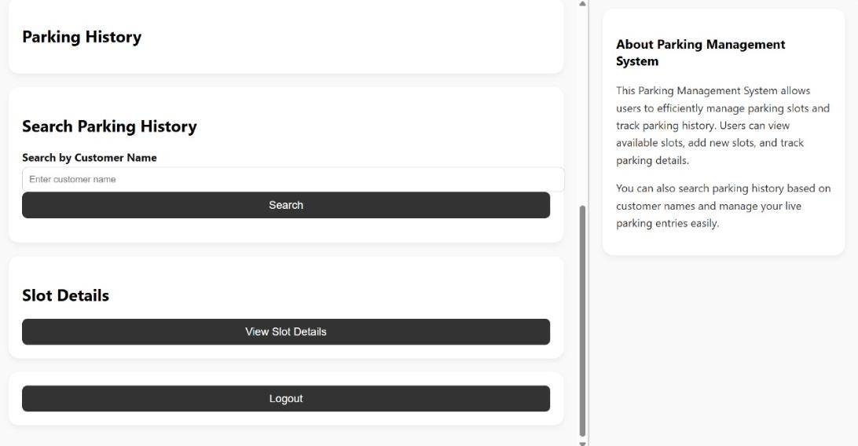

## PAYMENT CONFIRMATION



# SLOTS

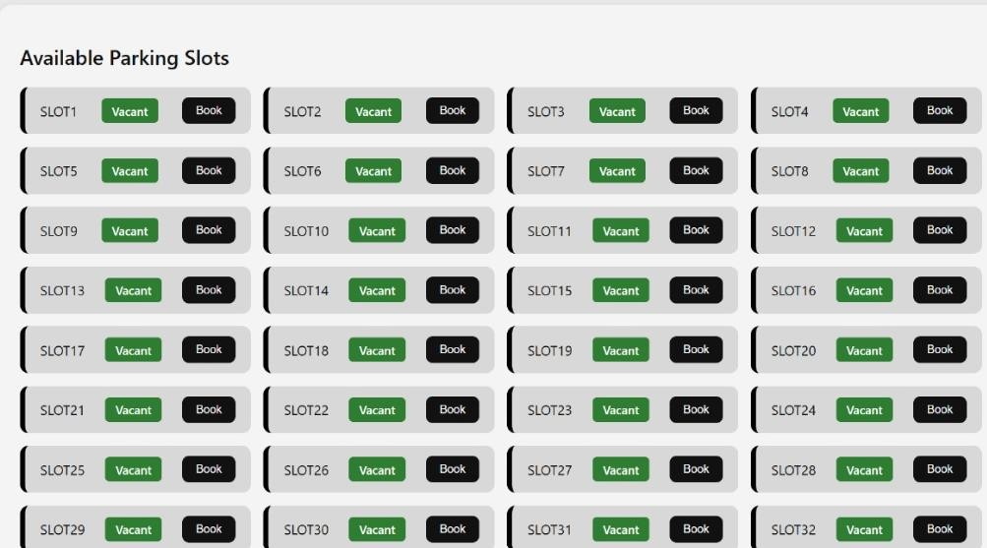

## Result

Queue management for parking aims to organize the systematic entry, parking, and exit of vehicles, especially in high-demand areas like shopping malls, airports, and offices. A well-implemented parking queue system significantly improves parking lot efficiency by reducing congestion, waiting time, and driver frustration. Results from real-world deployments show that organized queue systems can enhance the parking experience by ensuring fairness (first-come-first-serve), minimizing manual intervention, and maximizing space utilization. Modern queue management often uses sensors, automatic gates, real-time dashboards, and mobile applications to guide vehicles smoothly into available spots or waiting queues.

**Chapter 6**

## FUTURE WORK

The future of queue management for parking lies in making systems more intelligent, automated, and user-friendly. Integration of Artificial Intelligence (AI) and Machine Learning (ML) can enable predictive analytics to forecast parking demand and automatically adjust queue strategies during peak times. Mobile-based ticketing and reservation systems can be further developed, allowing users to book parking slots in advance and join virtual queues remotely, reducing on-site congestion.

In addition, real-time monitoring using IoT sensors and computer vision can help detect parking violations and update slot availability instantly without manual checks. Future systems may also incorporate dynamic pricing models where parking fees change based on real-time queue length and demand, optimizing revenue and distribution.

Furthermore, eco-friendly solutions like prioritizing electric vehicles (EVs) or offering incentives for shared rides can be incorporated into parking queue policies to support sustainable urban mobility. With increasing vehicle numbers, the focus will also shift toward multi-level smart parking hubs, automated valet parking robots, and cloud-based centralized parking management systems for smart cities.

## CONCLUSION

. Queue management in parking systems plays a crucial role in improving traffic flow, enhancing user experience, and optimizing the use of limited parking spaces. As cities grow and the number of vehicles increases, the need for organized, efficient, and smart parking solutions becomes even more critical. Traditional first-come, first-served methods, combined with modern technologies like IoT, real-time data monitoring, and automated guidance systems, can significantly reduce congestion, waiting time, and environmental impact.

Through effective queue management, parking operations become more predictable, fair, and scalable, catering to both daily needs and peak demand situations. Looking ahead, continued innovation in this area will be essential for developing smarter, greener, and more sustainable urban transportation infrastructures.

## REFERENCES

1. Arora, N., Sharma, M., & Sachdeva, S. (2020). Smart Parking Systems and Queue Management in Urban Areas: A Review. International Journal of Scientific Research in Computer Science, Engineering and Information Technology (IJSRCSEIT), 6(2), 25-32.
2. S. Lee, D. Zhang, and K. K. Chow (2018). Intelligent Parking Management System Based on Real-Time Data and Queue Theory. Journal of Transportation Technologies, 8(4), 123-136.
3. Abhirup Khanna and Rishi Anand (2016). IoT-Based Smart Parking System. 2016 International Conference on Internet of Things and Applications (IOTA), IEEE.
4. Rajeshwari, S., et al. (2014). Intelligent Parking System Using IoT. International Journal of Innovative Research in Science, Engineering and Technology (IJIRSET).
5. National Parking Association (NPA). (2022). Best Practices for Parking Facility Management. [Online] Available: https://weareparking.org
6. Smart Parking Ltd. (2023). How Smart Parking Technology is Transforming Urban Mobility. [Online] Available: https://www.smartparking.com
7. International Organization for Standardization (ISO) 55001:2014. Asset Management – Management Systems – Requirements.
8. Urban Mobility Reports. (2023). Challenges and Trends in Urban Parking Solutions. [Online] Available: https://mobilityreport.com/urbanparking-trends