**Project Confirmation Certificate**

This is to formally acknowledge that the following student(s) from K.R. Mangalam University have successfully undertaken and completed an industry-based project under our mentorship, in alignment with the stated objectives and requirements of our organization.

**Project Details:**

* **Project Title:** queue management for parking
* **Domain/Technology Used:** HTML,REACT,NODE JS,MONGO DB,EXPRESS JS,JWT AUTHENTICATION,
* **Industry Use Case / Business Problem Addressed:**

The project *"Queue Management for Parking"* tackles issues like congestion, long wait times, and inefficient space use in parking facilities. By using real-time tracking, pre-booking, and dynamic pricing, it aims to improve traffic flow, enhance customer satisfaction, and maximize revenue, creating a smoother and more efficient parking experience.

* **Expected Outcome/Utility of the Project in Our Organization:**

1. Reduced Congestion: Minimize traffic buildup and waiting times inside and around the parking facility
2. Improved Customer Satisfaction: Provide a smoother parking experience with real-time availability and easy navigation
3. Optimized Space Utilization: Efficiently manage parking slots to maximize usage and minimize empty spaces.
4. Increased Revenue: Boost earnings through dynamic pricing, faster turnover, and better parking management.

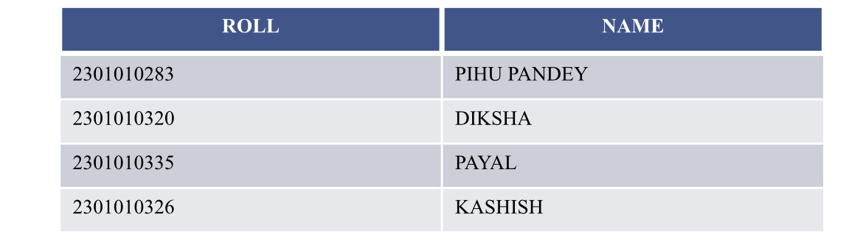**STUDENT DETAILS**:-

**Industry Mentor Details:**

* **Name:** mr.manvith kumar
* **Designation:** parking cashier
* **Contact Number:** 8779264739
* **Email ID:** manvithh.k85@gmail.com

**Signature & Seal:**

