## horizontal line



Group activity 1

Group 8

Prajwal - 22BCE10643

Bhavana Koli - 22BCE11384

Mohammad Farhan Assari - 22BCE10343

Ayushman Shekhawat - 22BAI10373

Abhinav Tiwari - 22BCE10597

Ansh Sureka-22BCE11156

N Kushal Rao-22BAI10304

Shripati Vaibhav-22BCE11338

Komal Saraf-22BCE10643

Suhail-22BCE11583

# **1. Write the algorithm, pseudo code and python code for the given flowchart.**

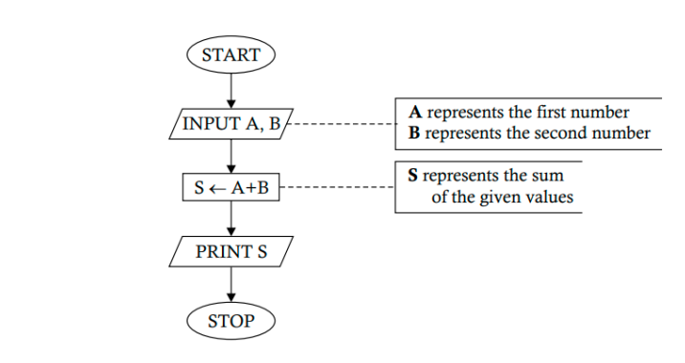

## Algorithm

1. Define A as an input value
2. Define B as second input value
3. Define S as sum of A & B in floating point
4. Print S

## Pseudo code

1. Input A , B
2. S = A+B (converted to floating point)
3. Print S

## Python code

*# summation of two numbers in python*

A = input('first number ')

B = input('second number ')

S = float(A)+float(B)

print('Sum = ', S)



# 

# **2. Draw the flowchart for the given algorithm and write the pseudo code and python code**

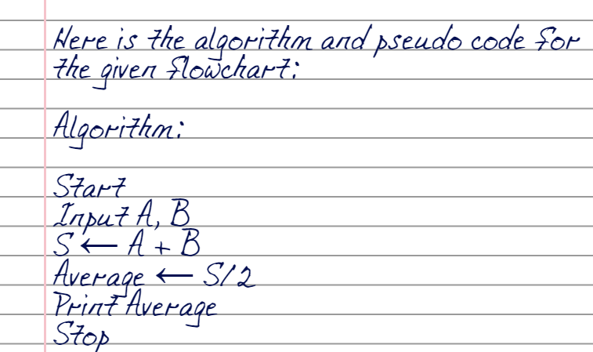

Now below is the pseudo code:

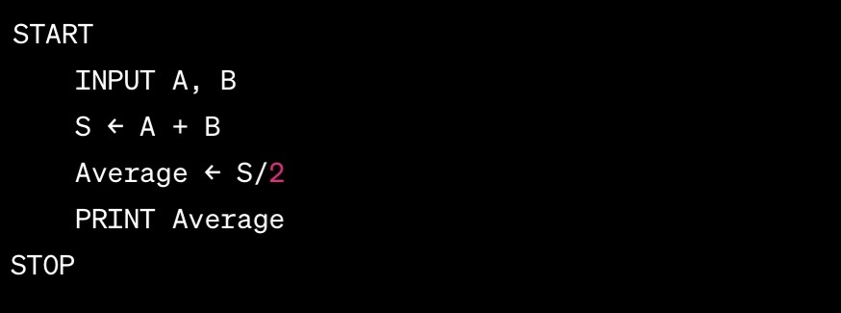

Now below is the Python code which

has been written on VS Code:

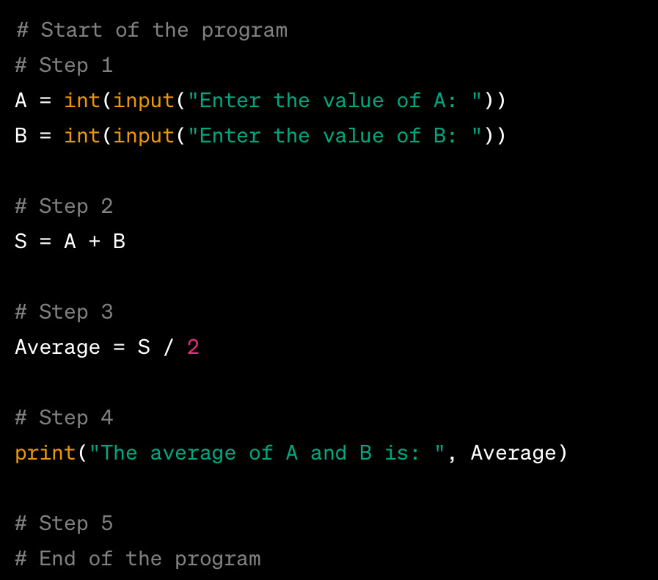

**3.Construct a flowchart to show how to obtain the volume of a rectangular box with the help of given algorithm and write the pseudo**

**code and python code.**

## Flowchart

## Algorithm

Step 1 : INPUT TO L,B,H

Step 2 : Compute V=L*B*H

Step 3 : Print V

Step 4 : STOP

## Pseudo Code

1. Input L,B,H

2.V=L*B*H( converted to floating point)

3.Print V

Python Code

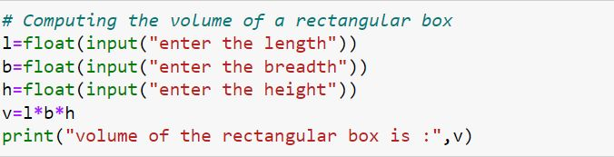

**4. Write the algorithm to show how to obtain the daily wage of a worker on the basis of the hours worked during the day and write the pseudo code and python code.**

**Flowchart :**

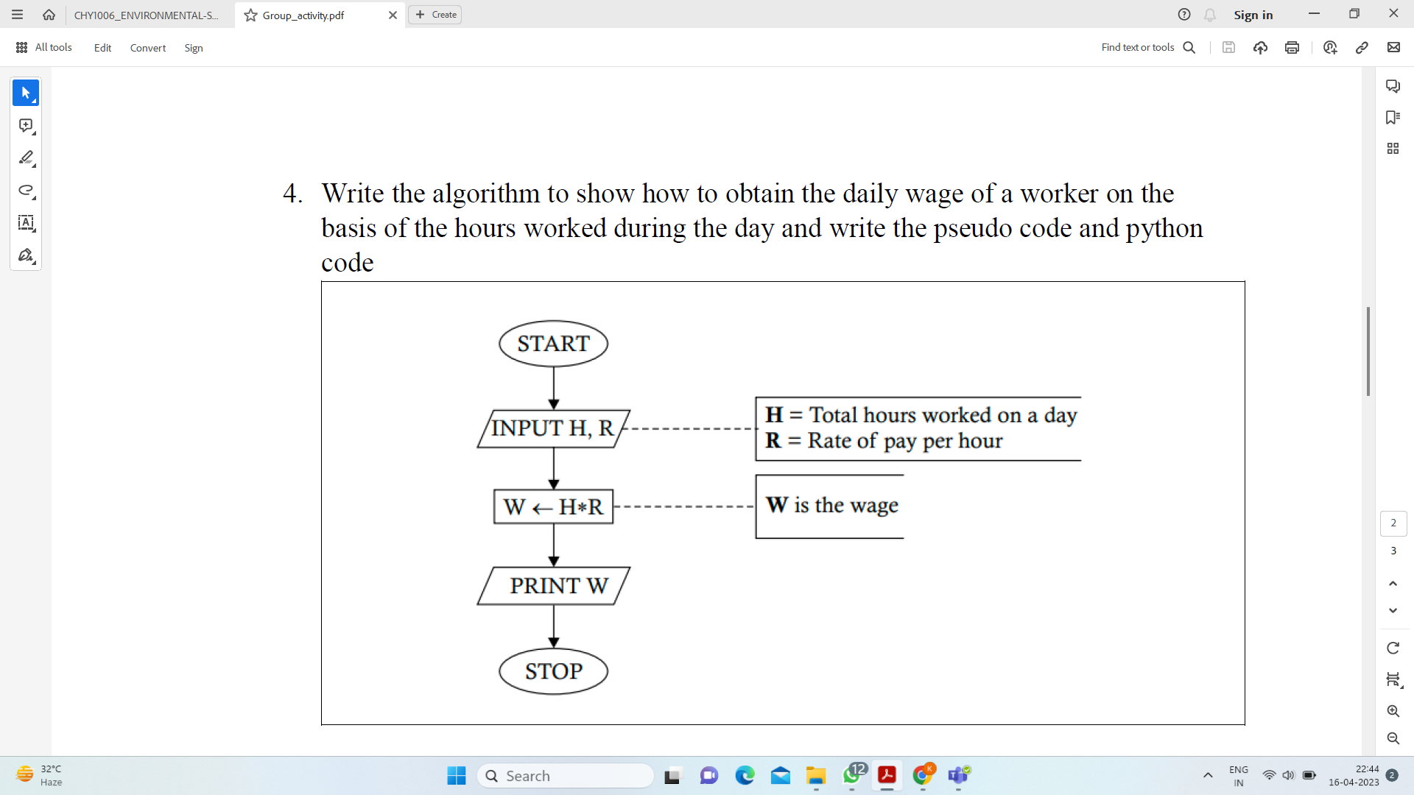

**Algorithm:**

STEP 1 : Start.

STEP 2 : Input the rate of pay per hour R and the hours worked H by the worker .

STEP 3 : Calculate the daily wage by multiplying pay per hour and hours worked.

STEP 4 : Return the daily wage.

STEP 5 : Stop.

**Pseudo code :**

1. Input H,R.
2. W = H*R
3. Print W.

**Python code:**

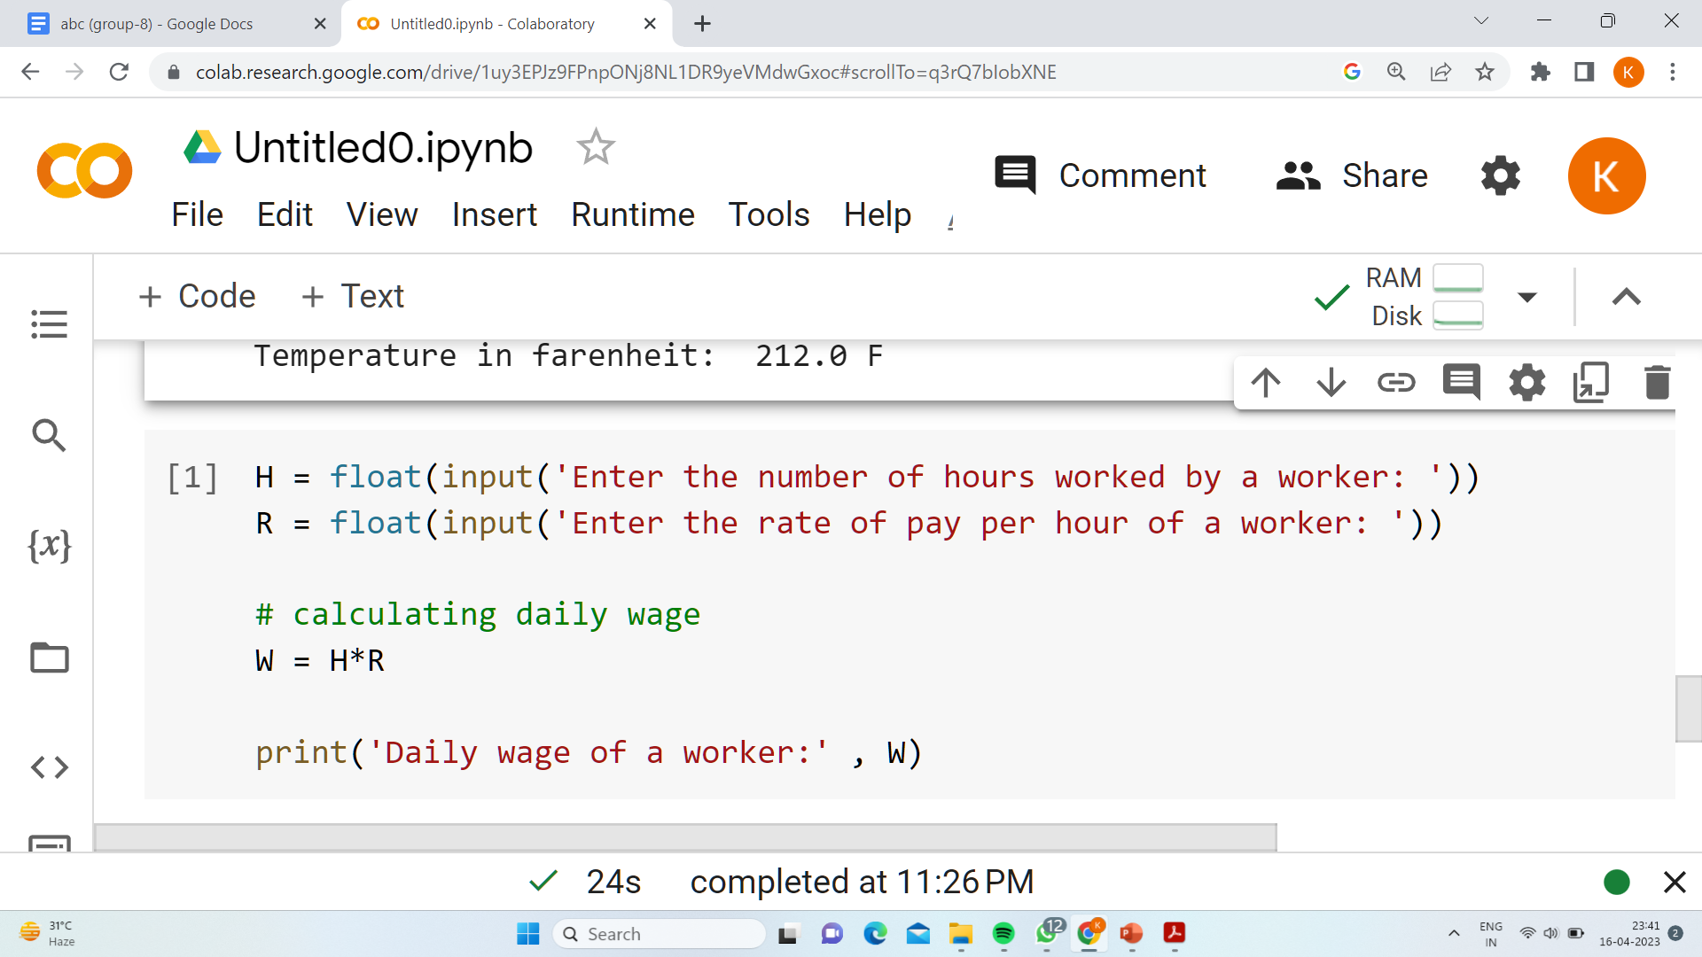

**5. Construct a flow chart to show how to obtain the area of a triangle on the basis of the base and height and write the algorithm, the pseudo code and python code.**

**Flowchart:**

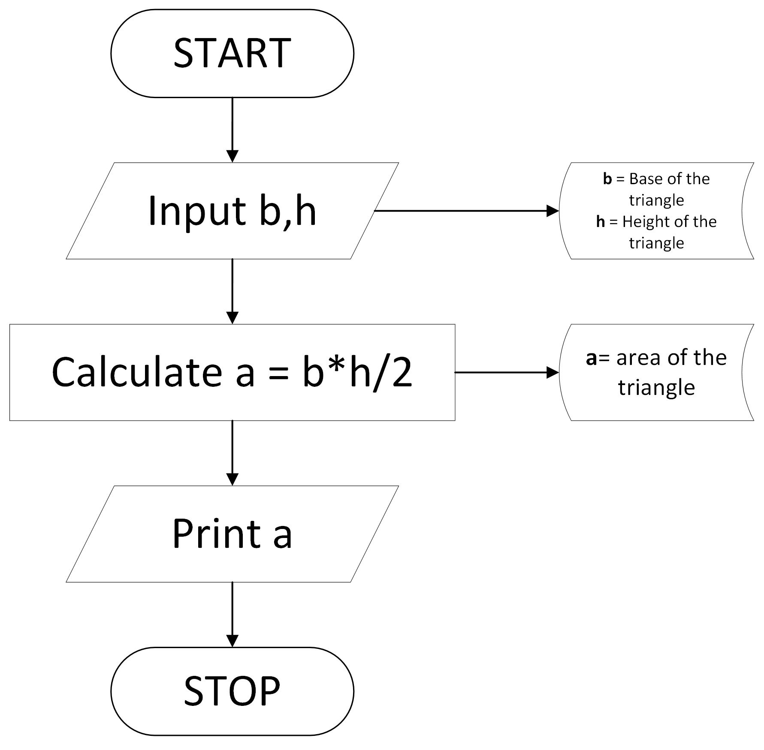

**Algorithm:**

1. **Start**
2. Define b as an input value
3. Define h as an input value
4. Define a as product of b & h divided by 2
5. Print a
6. **Stop**

**Pseudo Code:**

**1.** Input b and h

**2.** a=b*h/2

**3.** Print a

**Python Code:**

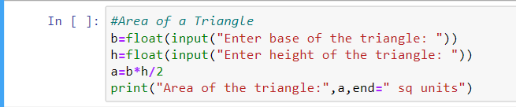

**6. Develop a flowchart to show the steps in finding the simple interest on a given rate of interest and write the algorithm, the pseudo code and pseudo code.**

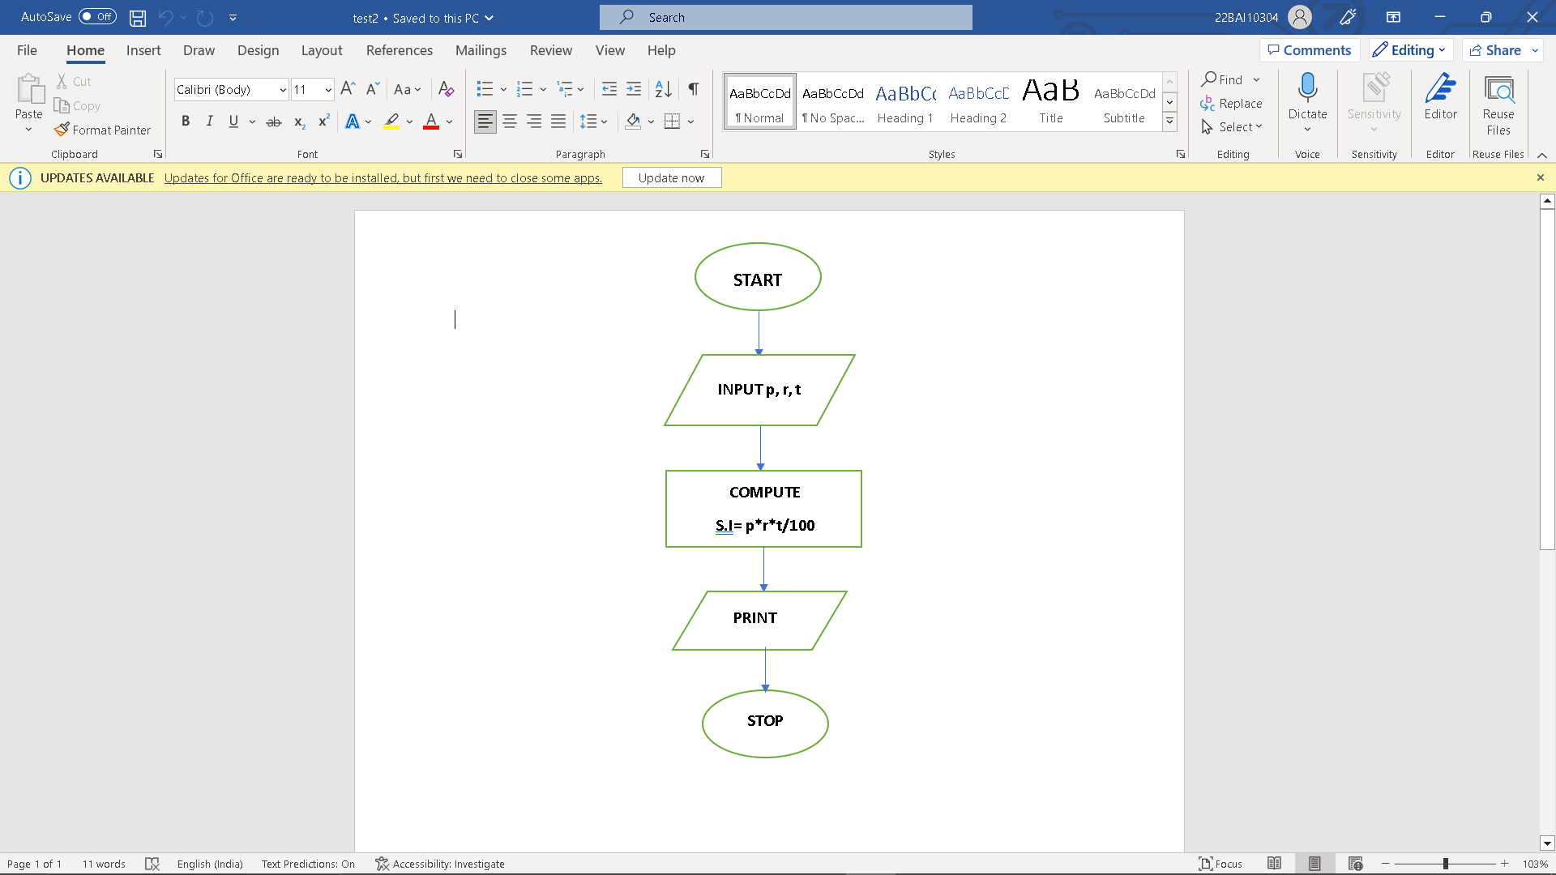

**p - principal amount**

**r- rate of interest**

**t - time**

**S.i - simple interest**

## Algorithm

1. Take input of p, r and t.
2. Do computation of p*r*t/100
3. Return the computed value

## Pseudocode

1. Input p , r and t
2. S.i. = p*r*t/100
3. Print S.i.

## Python code

*****# Simple interest in python*

p = int(input("Enter the amount: "))

*# Enter the number of years*

t = int(input("Enter the number of years: "))

*# Enter the rate of interest*

r = float(input("Enter the rate of interest: "))

SimpleInterest = (p*r*t)/100

print("The simple interset is:", SimpleInterset)

****

**7. If P amount of money is invested for N years at an annual rate of interest I, the money grows to an amount T, where T is given by T = P (1 + I/100)N . Draw a flowchart to show how T is determined and write the algorithm, the pseudo code and python code**

Flow Chart: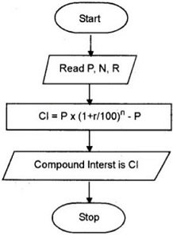

**p= principal amount**

**r- rate of interest**

**n - time**

**C.i - Compound interest**

## Algorithm:

1. Take input of p, r and t.
2. Do computation of p*(1+r/100)^n - p
3. Return the computed value

## Pseudocode:

1. Input p , r and t
2. S.i. = p*r*t/100
3. Print C.i.

## Code:

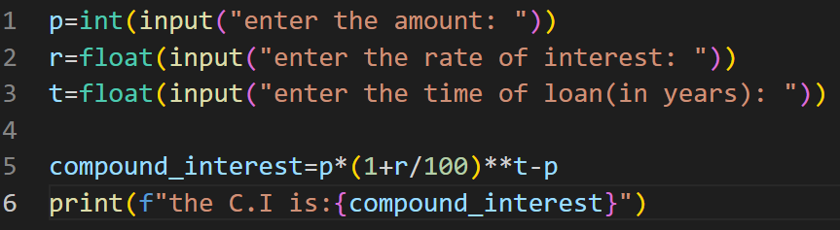

**8. Construct a flowchart to show how a student’s registration number and grades in 3 subjects, m1, m2, and m3, are displayed along with the total average grade.**

**Flowchart:**

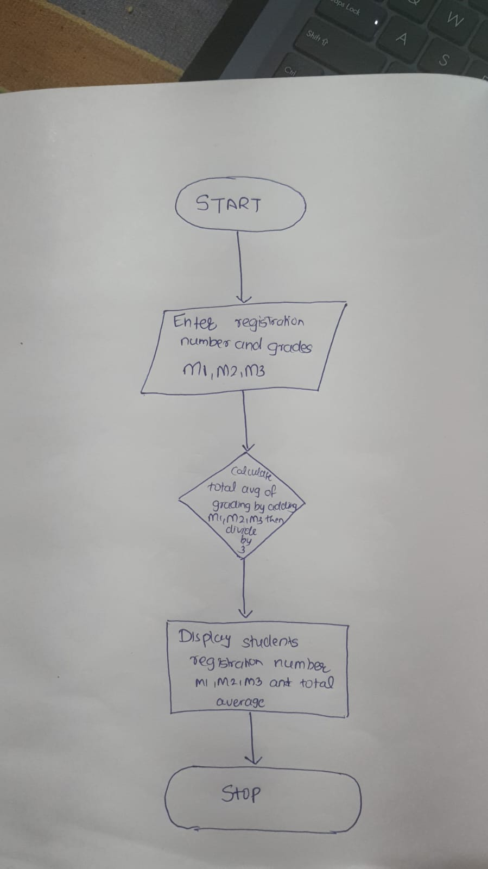

**Algorithm:**

**Step 1:Prompt the user to enter the student's registration number, m1, m2, and m3 grades.**

**Step 2:Convert the m1, m2, and m3 grades from string to float.**

**Step 3:Compute the total grade by adding m1, m2, and m3.**

**Compute the average grade by dividing the total grade by 3.**

**Step4:Print the registration number, m1, m2, m3, total grade, and average grade.**

**Pseudo Code:**

1. **Input registration number**
2. **Input marks m1, m2, and m3**
3. **Calculate total = m1 + m2 + m3**
4. **Calculate average = total / 3**
5. **Display "Registration number:", registration number**
6. **Display "Marks obtained in M1:", m1**
7. **Display "Marks obtained in M2:", m2**
8. **Display "Marks obtained in M3:", m3**
9. **Display "Total:", total**
10. **Display "Average:", average**

**Code:**

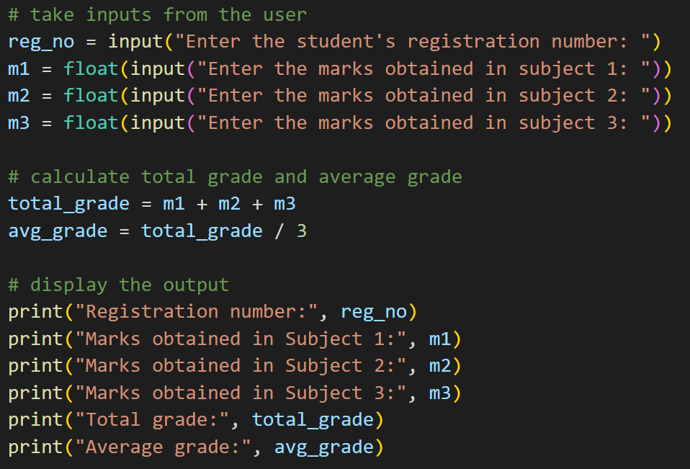

**9. Draw a flowchart to determine the volume V2 of a certain mass of gas at a pressure P2 if the initial volume is V1 at a pressure P1, keeping the temperature constant.**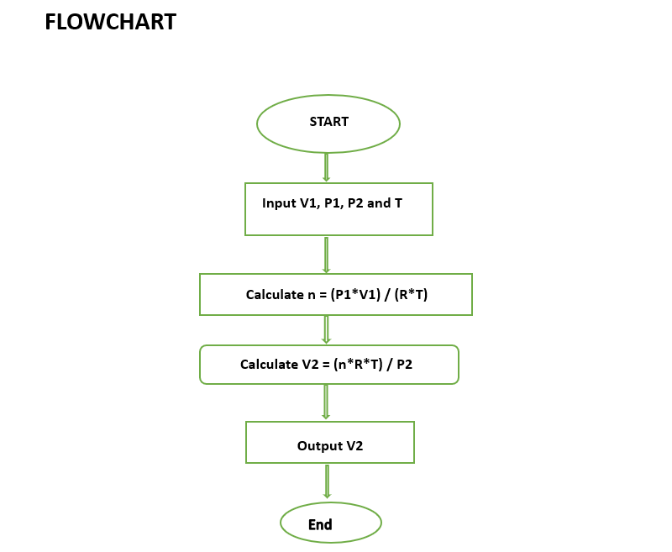

**PSEUDO CODE**

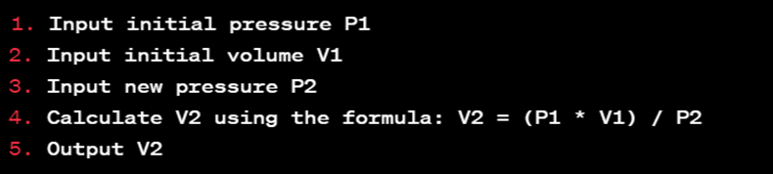

**PYTHON CODE**

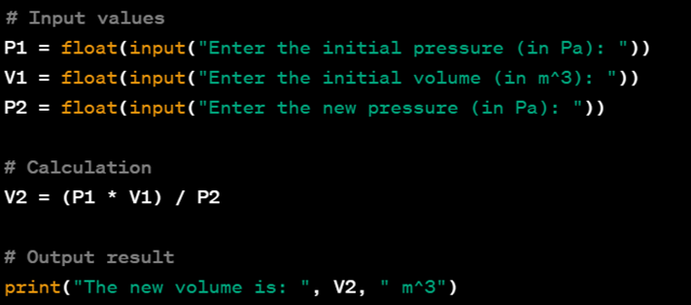

**10.Draw a flowchart to show how to interchange the value of two variables and write the algorithm, the pseudo code and the python code.**

**Flowchart:**

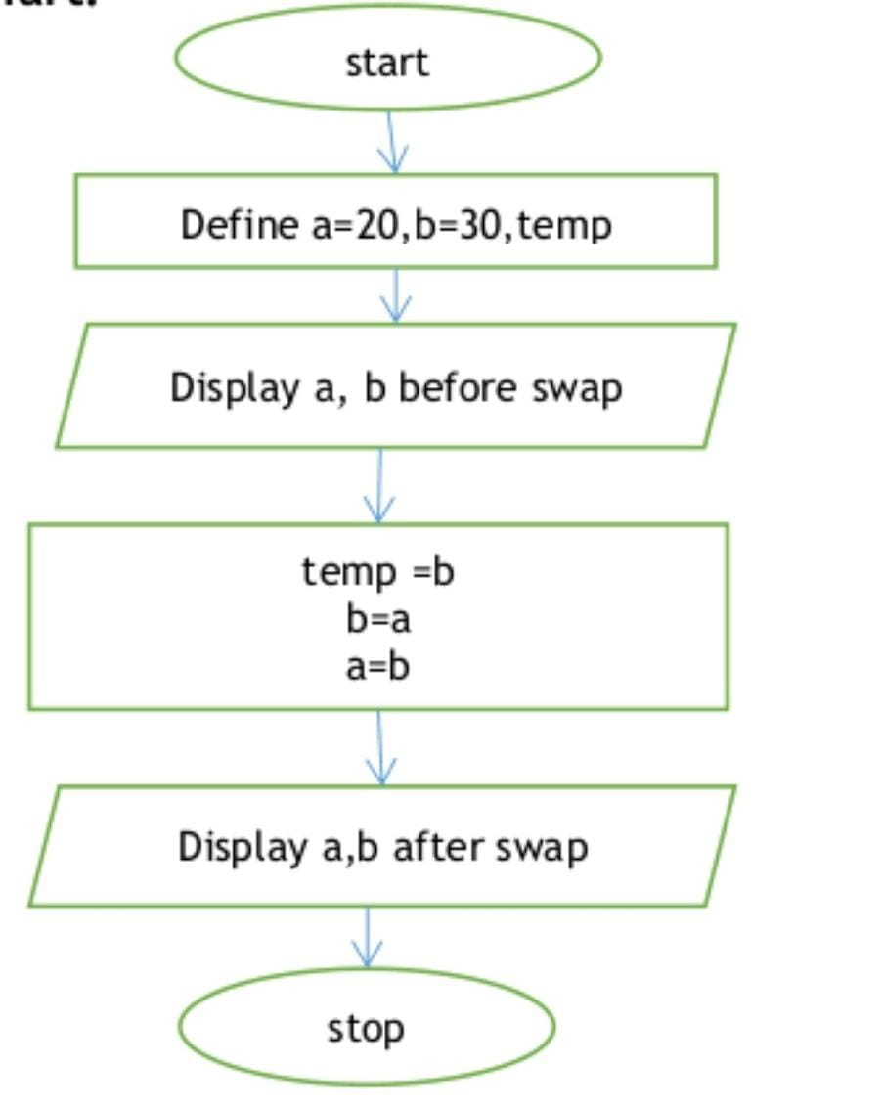

**Algorithm:**

1**.** Start

2. Input the values of a and b

3. Set a temporary variable to the value of a

4. Set the value of a to the value of b

5. Set the value of b to the value of the temporary variable

6. Output the new values of a and b

7. End

**Pseudo code:**

Input a, b

temporary = a

a = b

b = temporary

Output a, b

**Python code:**

a = 5

b = 10

print("Before swapping: a =", a, "and b =", b)

temp = a

a = b

b = temp

print("After swapping: a =", a, "and b =", b).