

SCHOOL OF INFOCOMM TECHNOLOGY
Diploma in CSF / IT

Cloud Architecture and Technologies (CAT)
April 2026 Semester
Assignment 1

Contents
1. Proposed Network Architecture 3
1.1 Network Diagram 3
1.2 Design Explanation 3
1.2.1 Network Architecture and High Availability 3
1.2.2 Compute and Security 4
1.2.3 Elasticity and Scalability 4
1.2.4 Storage and Database Services 4
2. Compute and Scalability 5
2.1 EC2 Instance Configuration 5
2.2 Network Security and Inbound Rules 7
2.3 Automated Deployment 7
2.4 Implementation Verification 8
3. Auto Scaling Configuration 9
3.1 Auto Scaling Group Setup 9
3.2 Network and Availability 10
3.3 Scaling Limits and Capacity 10
3.4 Dynamic Scaling Policy 11
3.5 Testing and Performance 12
3.5.1 Load Generation via Stress Test 12
3.5.2 Scaling Activity History 13
4. Storage and Database Implementation 14
4.1 S3 Public Storage 14
4.2 S3 Internal Storage 16
4.3 NoSQL Database 16
5. Web Server Optimisation 17
5.1 Introduction 17
5.2 Implementing Gunicorn as the WSGI Gateway 17
5.3 Utilising Nginx for Reverse Proxying 17
5.4 Conclusion 18
References 19

1. Proposed Network Architecture

1.1 Network Diagram
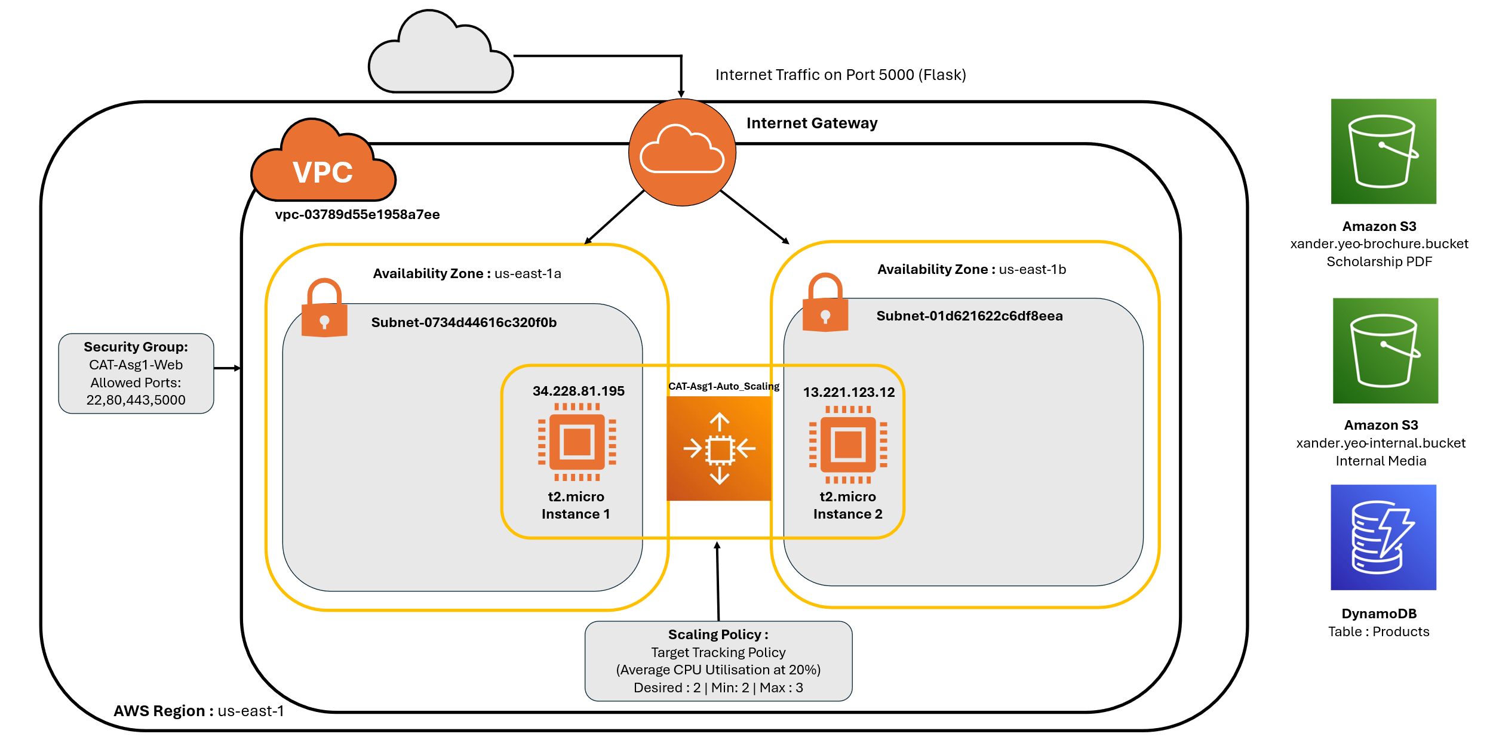

1.2 Design Explanation

1.2.1 Network Architecture and High Availability
The infrastructure is deployed within the us-east-1 (N. Virginia) region. To ensure the application remains resilient against datacentre failures, I implemented a High Availability (HA) design by distributing resources across two separate Availability Zones (AZs): us-east-1a and us-east-1b.
- Subnet Strategy: I deployed a public subnet in each AZ (subnet-0734d44616c320f0b and subnet-01d621622c6df8eea). This ensures that if one zone goes offline, the application stays live through the other.
- Internet Gateway (IGW): This serves as the single-entry point for all external web traffic. It is configured to route incoming requests specifically on Port 5000 directly to the active Flask web servers.

Compute and Security
The application runs on t2.micro EC2 instances, chosen for their balance of 1 vCPU and 1GB RAM, which meets the assignment’s technical specifications while remaining Free Tier eligible .
- Security Controls: I created a custom Security Group, CAT-Asg1-Web, following the principle of least privilege. It only allows necessary traffic:
  - SSH (Port 22) for secure remote management.
  - HTTP/HTTPS (Ports 80/443) for standard web access.
  - Custom TCP (Port 5000) specifically for the Flask development environment.
  - Automated Provisioning: To keep deployments consistent and repeatable, I used a Launch Template. It includes a User Data Bash script that automatically updates the system, sets up a Python virtual environment, and starts the Flask server whenever a new instance is launched.

1.2.3 Elasticity and Scalability
I used an Amazon EC2 Auto Scaling Group (ASG) named CAT-Asg1-Auto_Scaling to handle fluctuating traffic demands automatically.
- Capacity Limits: The group is set with a Minimum of 2 and a Maximum of 3 instances.
- Target Tracking Policy: Scaling is automated based on Average CPU Utilization at 20%.
- Fault Tolerance: By using a "Balanced best effort" distribution, the ASG ensures that instances are always spread across the two configured AZs.

1.2.4 Storage and Database Services
Global AWS services are utilized outside the VPC for managed data handling:
- Amazon S3 (Object Storage):
  - Public Bucket (xander.yeo-brochure.bucket): Configured with specific ACLs to allow public read access for the scholarship PDF.
  - Internal Bucket (xander.yeo-internal.bucket): Kept strictly private for storing system evidence, such as scaling logs and videos.
- Amazon DynamoDB (NoSQL Database): A managed "Products" table handles structured data. Using a NoSQL approach allows for a flexible schema to store ID, Category, Name, Price, and Stock fields without the overhead of a traditional relational database .

2. Compute and Scalability

2.1 EC2 Instance Configuration
To ensure a standardized and repeatable deployment for the application, a Launch Template named CAT-Asg1 was configured. This template serves as the blueprint for all instances within the infrastructure.
- Amazon Machine Image (AMI): The environment runs on Ubuntu Server 26.04 LTS (HVM), which provides a stable, long-term supported Linux environment for the web server.
- Instance Type: The t2.micro instance type was selected.
- Authentication: Access to the instances is secured via my MyEC2keypair RSA key pair.
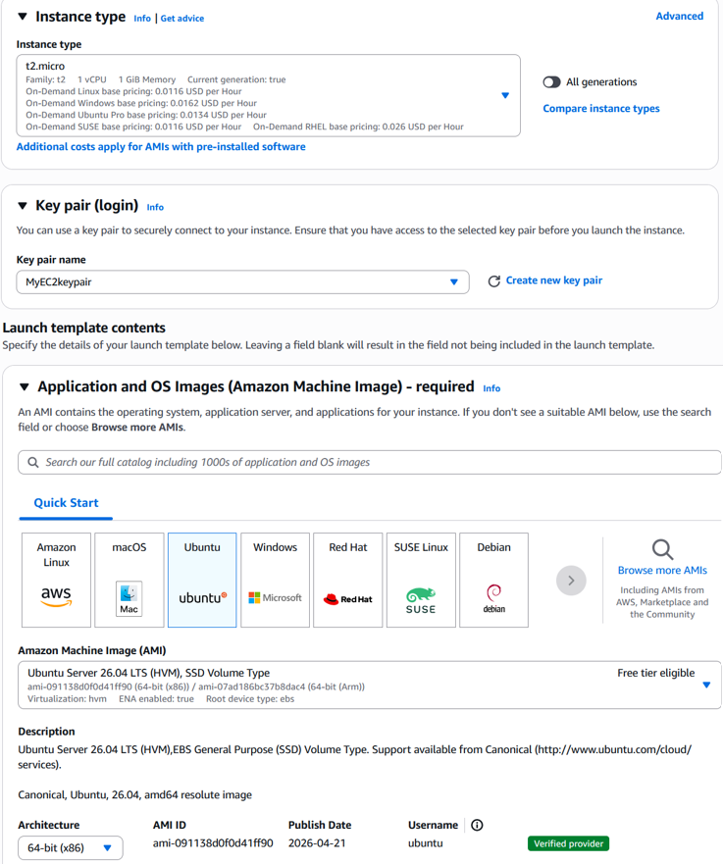
Figure 2.1.1 : Launch Template details showing the AMI and Instance Type selection.

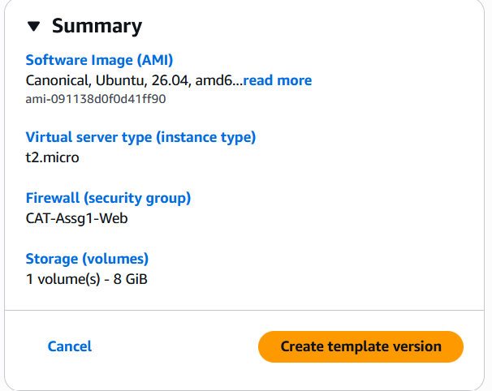
Figure 2.1.2 : Summary of the template configuration

2.2 Network Security and Inbound Rules
A custom Security Group, CAT-Asg1-Web, was implemented to manage traffic flow. The inbound rules were specifically configured to support both administrative access and web functionality:
- SSH (Port 22)
- HTTP/HTTPS (Ports 80/443)
- Custom TCP (Port 5000)
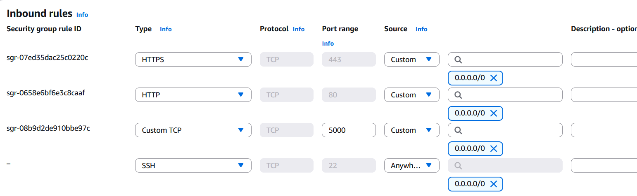
Figure 2.2.1 : Inbound security rules defining the allowed protocols and port ranges.

2.3 Automated Deployment
To automate the provisioning of the web server, a Bash script was included in the User Data field of the launch template to update repositories, install Python dependencies, configure a virtual environment, and execute the Flask application server.
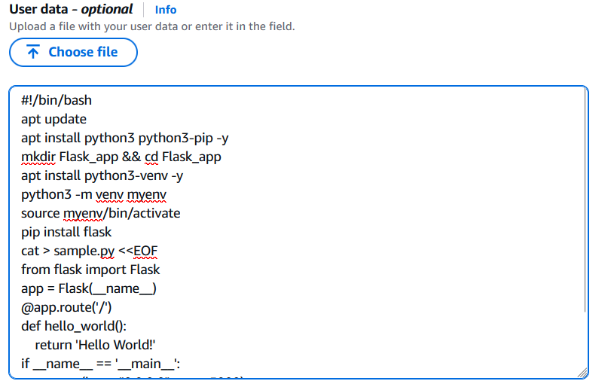
Figure 2.3.1: The complete User Data script used to automate the environment setup and launch the Flask application.

2.4 Implementation Verification
Following the deployment of the launch template, two initial instances were launched to verify the configuration. Both instances achieved a "Running" state and successfully passed their status checks in the us-east-1a availability zone.
The successful deployment was verified by accessing the public IP addresses of the instances through a web browser on port 5000:
- Instance A: 34.228.81.195:5000
- Instance B: 13.221.123.12:5000
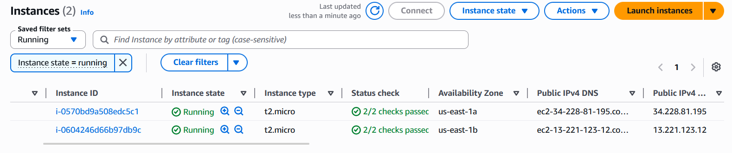
Figure 2.4.1: AWS Console showing two instances running in two different AZs
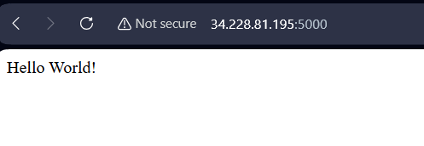
Figure 2.4.2: Browser verification of Instance A displaying the ‘Hello World!’ output


Figure 2.4.3: Browser verification of Instance B displaying the ‘Hello World!’ output

3. Auto Scaling Configuration
To maintain application availability and automatically adjust capacity to meet fluctuating demand, an Amazon EC2 Auto Scaling Group (ASG) was implemented. This ensures that the infrastructure remains cost-effective during low-traffic periods while staying responsive during spikes.

3.1 Auto Scaling Group Setup
The ASG, named CAT-Asg1-Auto_Scaling, was linked directly to the previously defined CAT-Asg1 launch template. This ensures that every new instance provisioned by the scaling engine automatically inherits the standardised Ubuntu environment and Flask configuration.
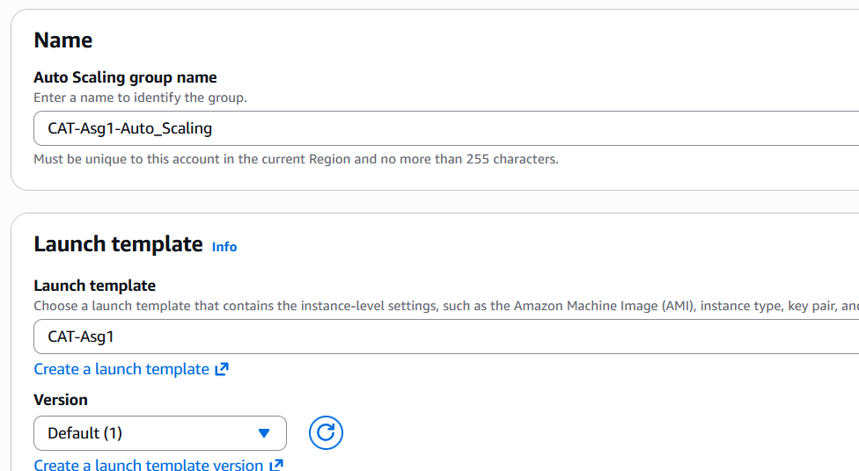
Figure 3.1.1: Auto Scaling group name and associating it with the CAT-Asg1 launch template created earlier.

3.2 Network and Availability
To achieve high availability and fault tolerance, the ASG was configured to distribute instances across multiple Availability Zones (AZs) within the default VPC.
- Subnets: The group utilizes subnets in us-east-1a and us-east-1b.
- Distribution Strategy: A "Balanced best effort" strategy was selected to ensure instances are evenly spread across zones, protecting the application against a single zone failure.
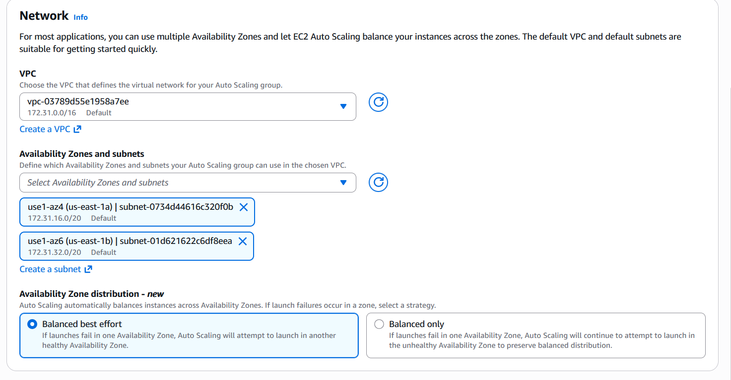
Figure 3.2.1: Network configuration showing multi-AZ deployment across us-east-1a and us-east-1b.

3.3 Scaling Limits and Capacity
The group size is governed by specific capacity boundaries to manage both performance and cloud expenditure:
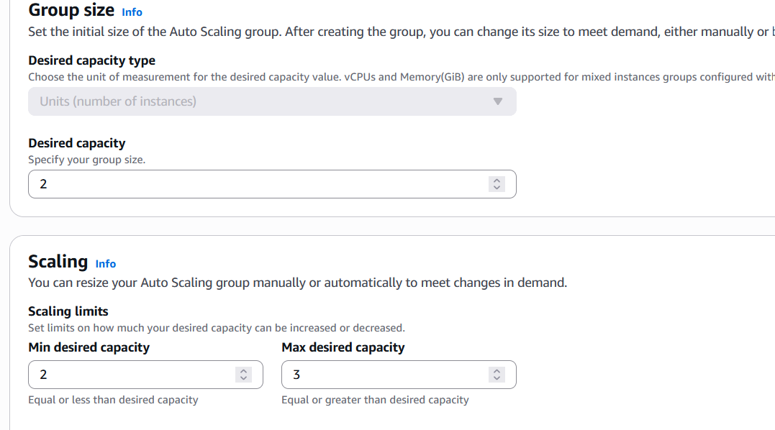
Figure 3.3.1: Group size settings defining the desired, minimum, and maximum instance limits.

3.4 Dynamic Scaling Policy
A Target Tracking Scaling Policy was implemented to automate the scaling process based on real-time resource consumption.
- Metric Type: Average CPU Utilization.
- Target Value: 20%.
The policy is designed to monitor the average CPU load across the fleet. If the utilization exceeds the 20% threshold, the ASG will automatically trigger the launch of a third instance to redistribute the load.
Conversely, if the load remains consistently below this value, it will scale back to the desired capacity of two.
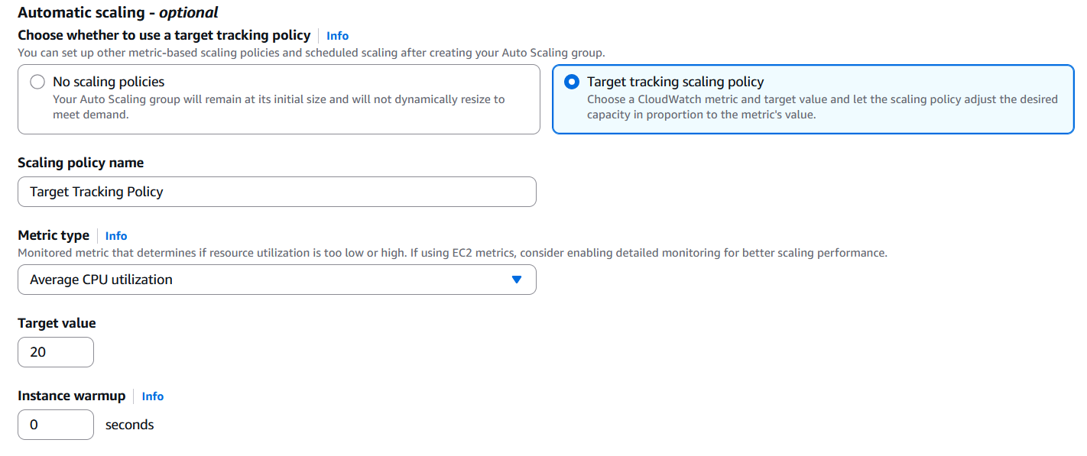
Figure 3.4.1: Target tracking policy configuration for CPU-based scaling

3.5 Testing and Performance
To verify the effectiveness of the Target Tracking Scaling Policy, a high-load simulation was performed using the stress utility to intentionally trigger the CPU utilization threshold.

3.5.1 Load Generation via Stress Test
I accessed one of the active instances via the Bitvise SSH Client using the public IP 34.228.81.195. Once connected, I executed the following command:
stress --cpu 2 --timeout 300

This command dispatched "hogs" across 2 CPUs for 300 seconds, driving the average utilization well above the 20% target threshold.
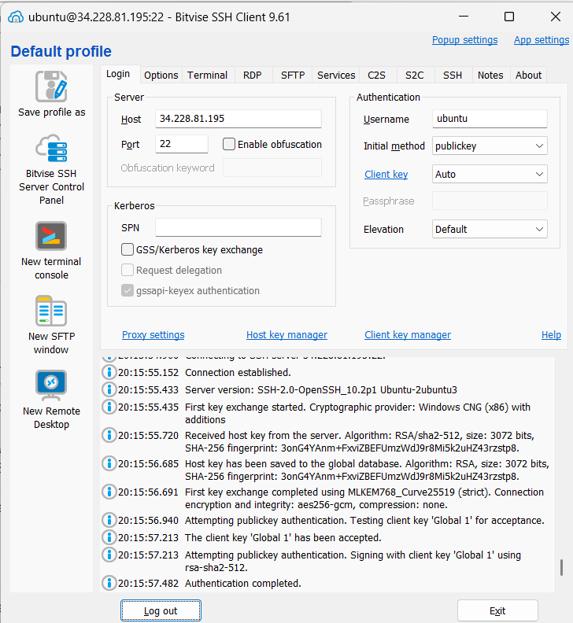
Figure 3.5.1.1 : Successful SSH connection to the web server instance using Bitvise.

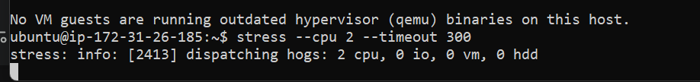
Figure 3.5.1.2 : Executing the stress command to simulate high CPU utilisation.

3.5.2 Scaling Activity History
Following the increase in CPU load, the CloudWatch Alarm associated with the Target Tracking Policy moved into the ALARM state. As shown in the Activity History, at approximately 12 May 2026 08:21:20PM +08:00, the Auto Scaling Group identified a difference between the desired capacity of 2 and the actual capacity required of 3.
The system successfully initiated the launch of a new EC2 instance (i-01f4176feb080cb1e) to redistribute the load and maintain system stability.
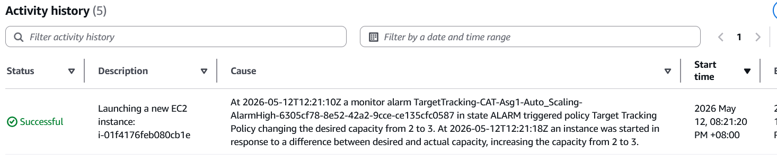
Figure 3.5.2.1 : Auto Scaling Activity History logging the successful scale-out event from 2 to 3 instances.

Upon completion, it launched the maximum capacity of 3 instances. As seen in the instance dashboard, all three instances—located across availability zones us-east-1a and us-east-1b—reached a "Running" state and passed their health checks. This confirms the infrastructure's ability to automatically scale according to traffic spikes without manual intervention. A new instance of IP address 54.162.249.224 on AZ us-east-1b was created.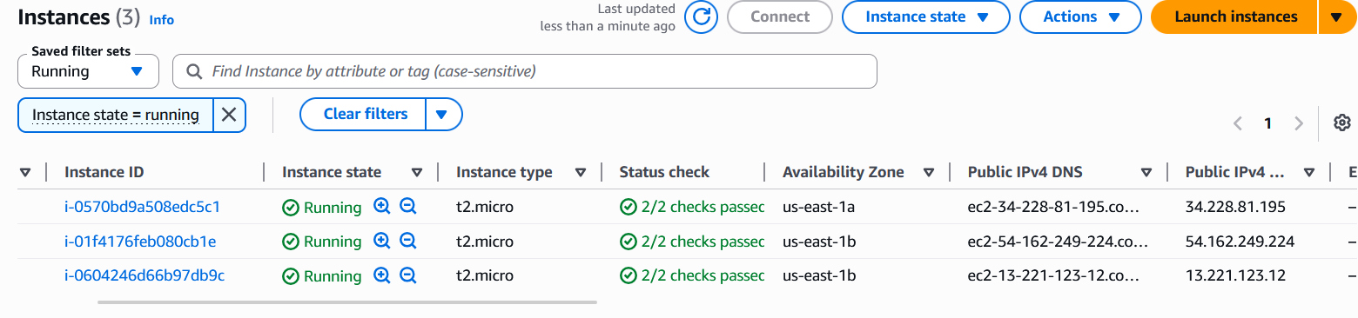
Figure 3.5.2.2: 3 running instances following the automated scaling response.

4. Storage and Database Implementation

4.1 S3 Public Storage
An Amazon S3 bucket named xander.yeo-brochure.bucket was created to host public-facing documents.
- Configuration: Access Control Lists (ACLs) were enabled with the "Bucket owner preferred" setting.
- Public Access: To allow users to view the brochure, the "Block all public access" setting was disabled.
- Verification: A scholarship brochure (Scholarships&Awards_NP.pdf) was uploaded. Individual ACL permissions were modified to grant "Everyone" read access, confirmed by successfully viewing the document via its public S3 URL, https://xander.yeo-brochure.bucket.s3.us-east-1.amazonaws.com/Scholarships%26Awards_NP.pdf

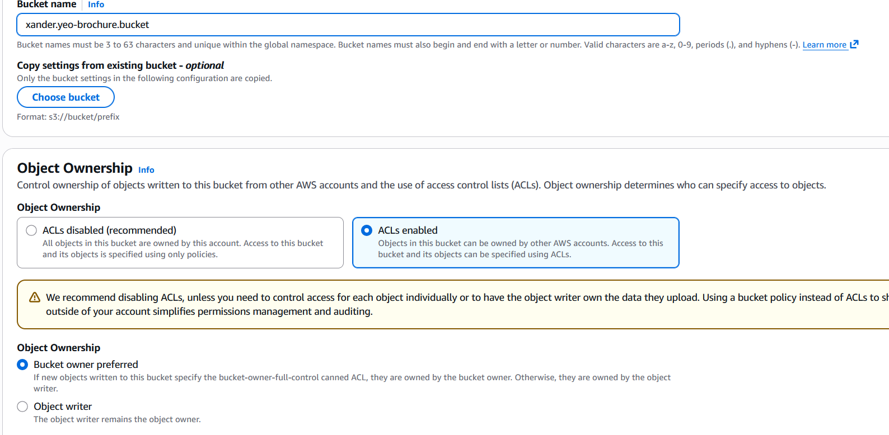
Figure 4.1.1: Configuration of the public brochure bucket with ACLs enabled.

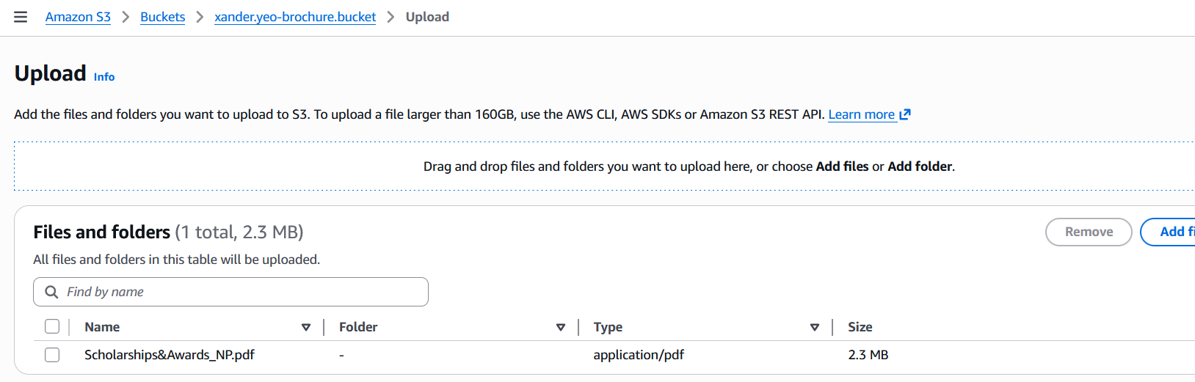
Figure 4.1.2: Uploading of the PDF file into the S3 bucket


Figure 4.1.3 : Successful public retrieval of the PDF brochure from the S3 bucket

4.2 S3 Internal Storage
A separate, private S3 bucket named xander.yeo-internal.bucket was established for internal data management.
- Purpose: This bucket serves as a secure repository for system-related files, such as documentation images and media.
- Security: Unlike the brochure bucket, this storage remains private, with objects like autoscaling-activityhistory.png and autoscaling.mp4 restricted to internal use.
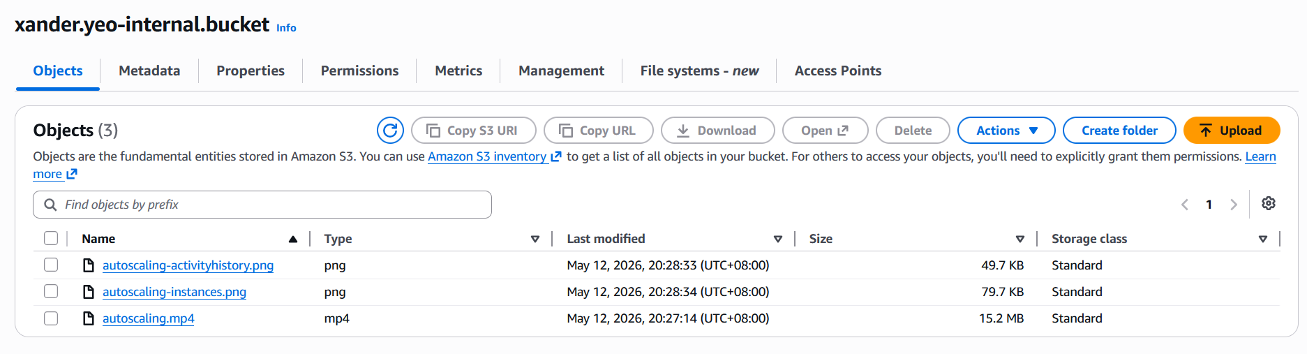
Figure 4.2.1 : Internal bucket objects containing the autoscaling evidence

4.3 NoSQL Database
Amazon DynamoDB was utilized as a NoSQL database solution to manage the application's product catalogue.
- Table Structure: A table titled Products was created using a String type for the Partition Key (ID).
- Data Schema: The table stores structured items including Category, Name, Price, and Stock.
- Sample Data: Three initial items were populated into the database covering Electronics, Networking, and Storage categories.
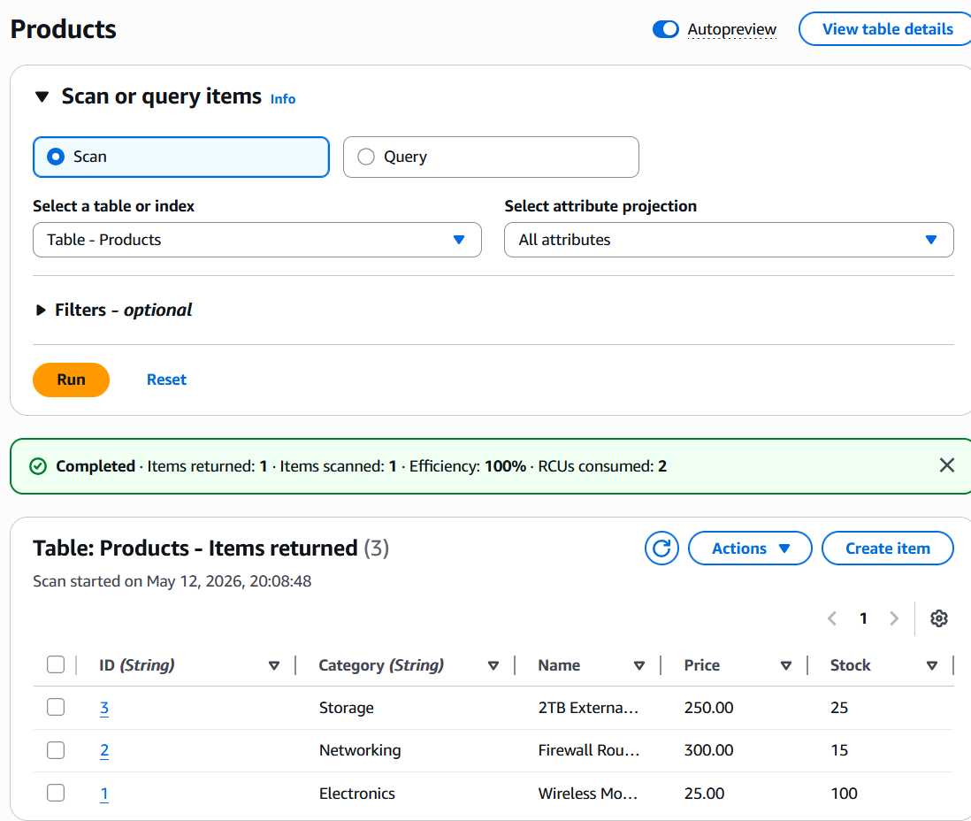
Figure 4.2.1 : DynamoDB showing the Products table.

5. Web Server Optimisation

5.1 Introduction
While Flask includes a built-in development server (Werkzeug), its utility is limited to local testing and debugging phases. This internal server is fundamentally unsuitable for production environments, as it lacks the robust security protocols, process management capabilities, and stability required to manage high volumes of concurrent traffic. To achieve a scalable and reliable deployment, developers typically implement a tiered architecture featuring a WSGI server (Gunicorn) and a reverse proxy (Nginx).

5.2 Implementing Gunicorn as the WSGI Gateway
Because Python cannot natively interpret high-performance HTTP requests at scale, the Web Server Gateway Interface (WSGI) serves as the essential communication bridge between the web server and the Python application code. Gunicorn serves this role through several key mechanisms:
- Scalability via Worker Processes: Gunicorn generates multiple worker processes to manage incoming requests. This allows the application to handle numerous tasks simultaneously and maximizes the performance of multi-core hardware.
- Resilience and Self-Healing: Unlike the standard Flask development server, which can stall under pressure, Gunicorn actively monitors its workers. If a process fails or becomes unresponsive, Gunicorn automatically restarts it, ensuring the application remains accessible.
- Interface Translation: It serves as the primary execution environment, converting raw HTTP traffic into a format that Flask can process to execute specific business logic.3. Nginx as a Reverse Proxy

5.3 Utilising Nginx for Reverse Proxying
While Gunicorn manages the application logic, it is not designed to be the public-facing entry point of a web infrastructure. Nginx is positioned in front of Gunicorn to act as a high-performance shield and optimizer.
- Traffic Management and Routing: Nginx functions as the "front door," receiving requests on standard public ports (80/443) and intelligently directing them to Gunicorn on a protected internal port.
- Static Content Optimization: Nginx is significantly more efficient than Python at delivering static assets such as CSS, JavaScript, and images. By serving these files directly, Nginx prevents Gunicorn from being bogged down by non-dynamic tasks.
- Security and Performance Offloading: Nginx manages resource-heavy tasks like SSL/TLS termination (handling encryption), load balancing, and request buffering. This offloading allows the Flask application to focus entirely on generating dynamic responses.

5.4 Conclusion
Relying solely on Flask for a live deployment creates significant security risks and performance bottlenecks. A professional-grade pipeline uses a modular approach: Nginx handles the external interface, security, and static content, while Gunicorn provides a stable, multi-process environment for the application’s core logic. This combination ensures the system is both secure and capable of handling production-level demand.

References
Haripriya Veluchamy. (2025, November 14). Why Do We Need WSGI for Python Web Apps? (And Why Flask Uses Gunicorn). DEV Community. https://dev.to/techwithhari/why-do-we-need-wsgi-for-python-web-apps-and-why-flask-uses-gunicorn-dm0#:~:text=Because%20Flask%20itself%20is%20not,.0.0%3A8000%20app%3Aapp&text=Web%20Server%20Gateway%20Interface,WSGI%20solves%20one%20major%20problem%3A
In, E. (2025, September). Using Nginx as a Reverse Proxy for Flask + Gunicorn. Medium. https://medium.com/@eunice.dev.contact/using-nginx-as-a-reverse-proxy-for-flask-gunicorn-d48e77828bac
shikha.sen. (2024, April 4). Deploying Machine Learning Model Using Flask on AWS with Gunicorn and Nginx. Analytics Vidhya. https://www.analyticsvidhya.com/blog/2024/04/ml-using-flask-on-aws-gunicorn-nginx/
Talbot, L. P. (2024, August 29). Deploying Flask Apps on Microsoft Azure Using Gunicorn. Medium. https://medium.com/@liam.p.talbot/deploying-flask-apps-on-microsoft-azure-using-gunicorn-ecf9bfa6bc2a
Vasist, S. G. (2023, September 18). Building Scalable Python Web Apps: Nginx, Gunicorn and Falcon. Medium. https://medium.com/@samarthgvasist/building-scalable-python-web-apps-nginx-gunicorn-and-falcon-7d74000099d0

