

SCHOOL OF INFOCOMM TECHNOLOGY

Cloud Architecture and Technologies (CAT)
Assignment – April 2025 Semester

35% of CAT Module – (Team: 70%, Individual 30%)

13 July – 2 August 2026 (Weeks: 13 - 15)

Deadline for submission:
SOFTCOPY: Submit in Brightspace by 2 August 2026, 23:59hrs SGT

Plagarism Warning:
If a student is found to have submitted work not done by him/her, he/she will not be
awarded any marks for this assignment. Disciplinary action may also be taken. Similar
action will be taken for the student who allows other student(s) to copy his/her work.

Reminder:
- Penalty for late submission: 10% will be deducted for each day (including Sunday and Public holiday).
- Only 1 report submission for each group is required.

Contents
1 Introduction - 4 -
2 Architecture Diagram of the Cloud Infrastructure - 6 -
2.1 Architecture Diagram - 6 -
2.2 AWS VPC Design and Components - 7 -
3 Description of the Cloud Solution Implemented - 12 -
3.1 Compute, Load Balancing and Auto Scaling Policy - 12 -
3.2 Database and Security - 17 -
3.3 Monitoring and Alarm Notification - 20 -
3.3.1 SNS - 20 -
3.3.2 EC2 - 21 -
3.3.3 Load Balancer - 23 -
3.3.4 RDS - 25 -
3.3.5 Dashboard - 26 -
3.4 Serverless Product Application - 28 -
3.5 Notification Services - 38 -
3.6 Image Watermarking Service - 42 -
3.6.1 Input and Output Buckets - 42 -
3.6.2 Pillow Image-Processing Dependency - 43 -
3.6.3 Email Notification Service - 46 -
3.6.4 Lambda Function Configuration - 47 -
3.6.5 Environment Variables - 48 -
3.6.6 Lambda Function code - 49 -
3.6.7 Event Trigger - 50 -
3.6.8 Low-Cost Storage Configuration - 52 -
4 Lambda Function Code - 54 -
4.1 ProductsCRUD - 54 -
4.2 NotifyOnProduct - 56 -
4.3 ImageWatermarkFunction - 57 -
5 Testing and Results - 65 -
5.1 Web Application Infrastructure - 65 -
5.1.1 CRUD Functionality Testing via the Application Load Balancer - 68 -
5.1.2 Target Group Health Test - 68 -
5.1.3 Auto Scaling Group Capacity Test - 70 -
5.1.4 Auto Scaling Scale-Out Test - 71 -
5.1.5 Auto Scaling Scale-In Test - 72 -
5.1.6 Auto Scaling Self-Healing Test - 73 -
5.2 Monitoring and Alarms - 75 -
5.2.1 EC2 CPU Utilisation - 77 -
5.2.2 Load Balancer Traffic Alarms - 79 -
5.2.3 Failure Alarms - 82 -
5.2.4 RDS Free Storage - 85 -
5.2.5 CloudWatch Dashboard - 87 -
5.3 Serverless Application and Notifications - 89 -
5.4 Image Watermarking Service - 96 -
6 Problems and Resolutions - 99 -
6.1 API Gateway Route Mismatch - 99 -
6.2 CORS Preflight Errors - 99 -
7 AWS Well-Architected Framework - 100 -
7.1 Security - 100 -
7.2 Reliability - 100 -
7.3 Performance Efficiency - 101 -
7.4 Cost Optimisation - 101 -
7.5 Sustainability - 102 -
7.6 Operational Excellence - 102 -
8 Cloud Monitoring Plan - 103 -
8.1 Monitoring Techniques - 103 -
8.1.1 Metric-based monitoring - 103 -
8.1.2 Health Check Monitoring - 104 -
8.1.3 Alerting and Notification - 104 -
8.2 Monitoring Principles - 105 -
9 References - 106 -
10 Gen-AI Usage Reflection Form - 107 -

Introduction

In modern enterprise IT operations, migrating legacy on-premises applications to the cloud is vital for achieving high availability, elasticity, operational resilience, and cost efficiency. Cloud Solutions Consulting Pte Ltd was appointed by Real World Pte Ltd to modernise and migrate their existing on-premises .NET Core 6.0 web application to Amazon Web Services (AWS).

The primary objective of this project is to architect, deploy, and validate an enterprise-grade cloud infrastructure tailored for Real World Pte Ltd. The implementation addresses two core operational requirements:

- Scalable Infrastructure Migration: Establishing a Virtual Private Cloud (using block 10.1.0.0/16) to host the core .NET Core application.

The design incorporates an Elastic Load Balancer (ELB) and an Auto Scaling Group (ASG) maintaining a baseline of 2 EC2 web instances, with the elasticity to scale up to 4 instances during peak demand and scale back during low load.

A managed Amazon RDS instance serves as the persistent relational database backend.

- Serverless Application Integration & Event Automation: Modernising operations by introducing event-driven, serverless workflows utilizing Amazon API Gateway, AWS Lambda, Amazon DynamoDB, Amazon S3, and Amazon Simple Notification Service (SNS). These services support:

- A serverless product catalog application serving a static front-end via Amazon S3, integrated via API Gateway and Lambda to manage NoSQL product records stored in DynamoDB.

- An event-driven administrative notification pipeline configured using DynamoDB Streams, S3 Event Notifications, and SNS to dispatch email alerts upon database updates and direct image uploads.

- An automated, cost-optimized image processing pipeline that executes watermark transformations on uploaded images prior to cold storage.

To maintain continuous visibility across all cloud assets, comprehensive resource monitoring, custom CloudWatch dashboards, and metric-driven alarms were implemented alongside the AWS Well-Architected Framework pillars: Security, Reliability, Performance Efficiency, Cost Optimization, and Sustainability.

This report details the technical implementation, architecture diagrams, testing results, and operational strategies executed for Real World Pte Ltd.

Architecture Diagram of the Cloud Infrastructure

Architecture Diagram
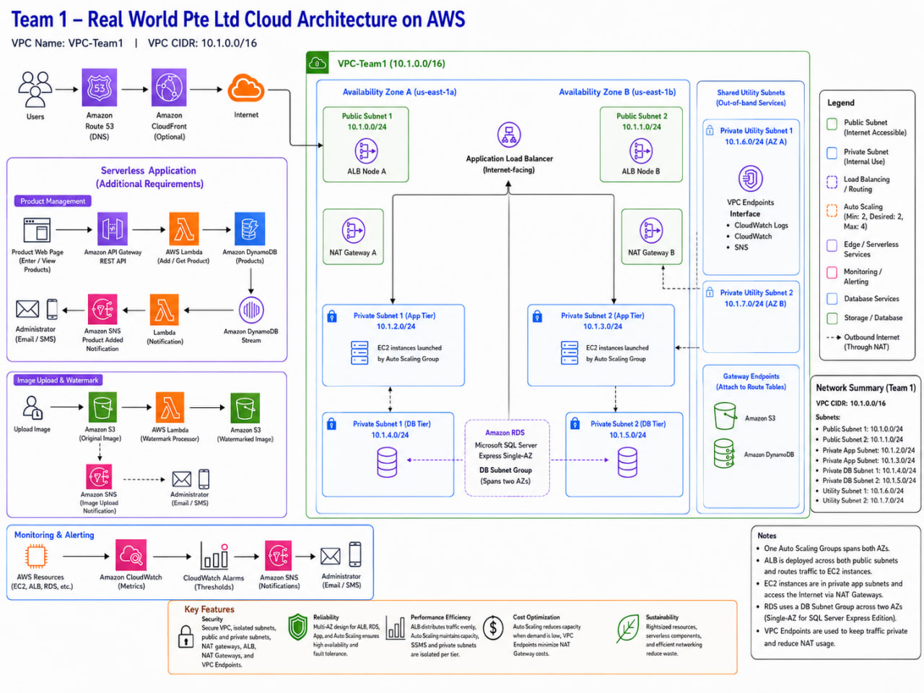

User traffic first enters through the Internet Gateway, which provides connectivity between the VPC and the public internet.

The traffic is then directed to the internet-facing Application Load Balancer, which distributes incoming HTTP requests across the healthy EC2 web servers deployed in the two public subnets and Availability Zones.

These EC2 instances run the Windows, IIS and .NET web application and are managed by the Auto Scaling Group to maintain availability and handle changing demand.

When the application needs to retrieve or update data, the EC2 instances connect securely to the Amazon RDS SQL Server through port 1433.

The RDS database is placed in private subnets and is not directly accessible from the internet, ensuring that all database access must pass through the authorised application servers.

AWS VPC Design and Components

- Virtual Private Cloud (VPC) Design

- A dedicated VPC is configured to isolate and secure all cloud resources. The VPC is segmented into public and private subnets across two Availability Zones (AZs) to enhance fault tolerance and availability.

- Public subnets host the Application Load Balancer (ALB) and NAT Gateway, while private subnets host backend EC2 instances and RDS databases, ensuring that internal servers are not directly exposed to the internet.

- NAT Gateway is deployed in the public subnets to enable outbound internet access for EC2 instances in private subnets. This allows the instances to download updates or access external APIs without exposing them to inbound internet traffic.

- Security Groups and Network ACLs are implemented to restrict access to only necessary traffic, providing an additional layer of network security.

- Load Balancing and Auto Scaling

- An Application Load Balancer (ALB) is deployed in the public subnets to manage incoming client requests. The ALB distributes traffic across EC2 instances hosted in private subnets, providing high availability and fault tolerance.

- The EC2 instances are part of an Auto Scaling Group (ASG), which dynamically adjusts the number of running instances based on workload demand. During periods of high traffic, the ASG scales out to maintain performance, while scaling in during low demand helps optimize operational costs. This design ensures the application can handle variable traffic loads automatically without manual intervention.

- Compute and Database Layer

- Backend EC2 instances are deployed on general-purpose instances suitable for hosting the .NET Core 6.0 web application.

- For data persistence, Amazon RDS is configured in private subnets, providing a managed relational database service that offers high availability, automated backups, and security. The RDS instance is integrated with EC2 instances via private IPs to ensure secure communication within the VPC.

- Monitoring and Alerts

Amazon CloudWatch is extensively used to monitor both compute and storage resources as well as serverless events:

- EC2 metrics such as CPU utilization and network traffic are monitored to trigger Auto Scaling actions.

- RDS metrics including Free Storage Space, CPU, and Database Connections are monitored to prevent resource exhaustion.

- DynamoDB Streams are monitored using CloudWatch Events (or EventBridge), which triggers notifications via SNS whenever a new item is added to the database.

- S3 bucket events are monitored using CloudWatch Events or S3 Event Notifications to detect when new files are uploaded. Notifications are sent via SNS to alert administrators immediately.

This ensures that both application activity (e.g., new product data) and system-level metrics are actively monitored, enabling proactive incident response and improving system reliability.

- Serverless and Event-Driven Automation

AWS Lambda is incorporated to enable serverless, event-driven processing. Lambda functions are triggered by CloudWatch alarms or specific AWS events, allowing automated responses such as logging incidents, processing alerts, or executing predefined tasks.

This eliminates the need for continuous server management, improving operational efficiency while keeping the architecture lightweight and scalable.

- Storage and Data Management

Amazon S3 is used for secure, durable, and cost-effective object storage. The S3 bucket stores static application content, backups, or logs. Access is tightly controlled using IAM policies, and public access is restricted, ensuring data confidentiality and integrity.

For seldom-accessed content, S3 Infrequent Access (IA) or Glacier storage classes are utilized to reduce costs.

- Security and Reliability

The architecture adheres to AWS Well-Architected Framework principles, covering:

- Security: EC2 instances in private subnets, ALB for controlled access, NAT Gateway for secure internet connectivity, strict IAM policies, and encrypted S3/RDS storage.

- Reliability: Multi-AZ deployment, Auto Scaling, and ALB ensure high availability.

- Performance Efficiency: Dynamic scaling, appropriate instance types, NAT Gateway for outbound connectivity, and event-driven Lambda functions optimize system performance.

- Cost Optimization: Auto Scaling reduces unnecessary compute usage; S3 IA/Glacier reduces storage costs; NAT Gateway ensures secure but efficient internet access for private resources.

- Sustainability: Efficient resource utilization reduces waste and energy consumption.

Overall, this cloud solution provides a secure, resilient, and scalable environment for the .NET Core web application while integrating automated monitoring, alerts, serverless automation, and reliable data storage.

The inclusion of the NAT Gateway ensures secure outbound connectivity for private instances without compromising security. This architecture demonstrates industry-standard best practices for cloud deployments.

Description of the Cloud Solution Implemented

Compute, Load Balancing and Auto Scaling Policy

Amazon Virtual Private Cloud (VPC)

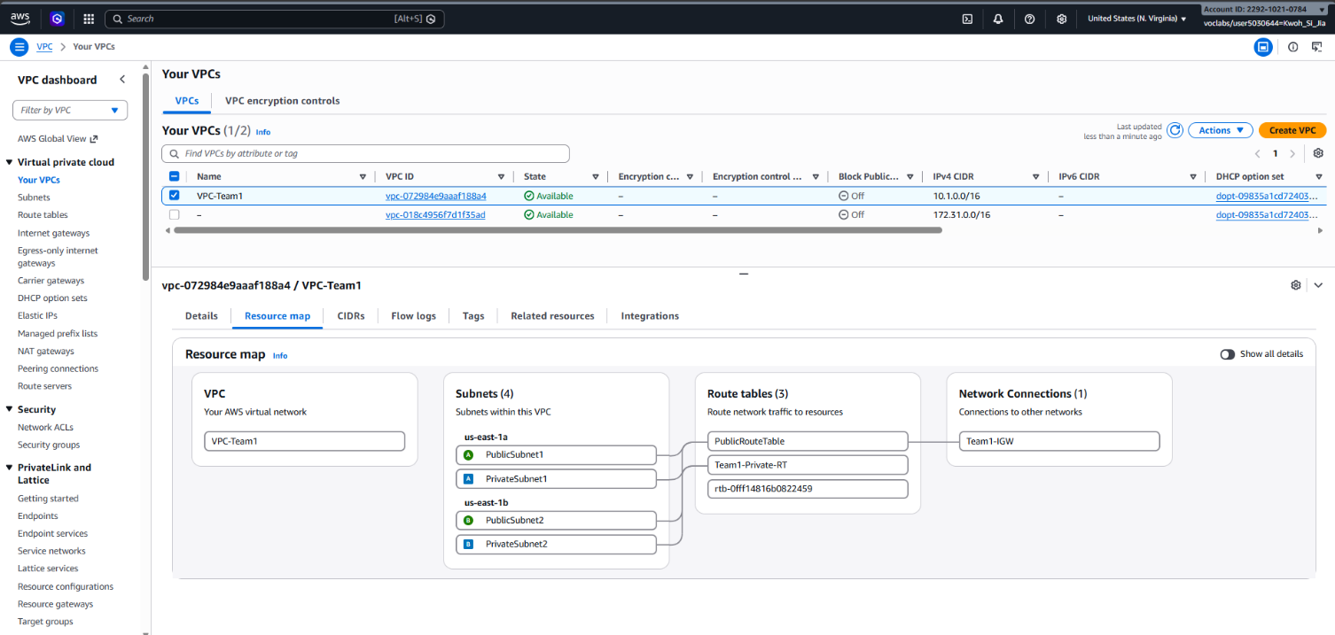
Figure 3.1.1: VPC Dashboard resource map showing VPC-Team1 subnets, route tables, and Internet Gateway

A dedicated VPC was deployed across two Availability Zones to isolate and secure infrastructure components.

Setting | Configuration Details
VPC Name | VPC-Team1
IPv4 CIDR Block | 10.1.0.0/16
Availability Zones | us-east-1a, us-east-1b
Internet Gateway | Team1-IGW
Public Access | Enabled for resources in public subnets via Internet Gateway
Subnet Layout | 1 Public Subnet & 1 Private Subnet per Availability Zone

Subnet Configuration

Availability Zone | Subnet Name | Subnet Type | IPv4 CIDR | Auto-Assign Public IPv4
us-east-1a | PublicSubnet1 | Public | 10.1.0.0/24 | Enabled
us-east-1a | PrivateSubnet1 | Private | 10.1.2.0/24 | Disabled
us-east-1b | PublicSubnet2 | Public | 10.1.1.0/24 | Enabled
us-east-1b | PrivateSubnet2 | Private | 10.1.3.0/24 | Disabled

Route Table Configuration

Route Table Name | Target | Destination | Associated Subnets | Traffic Routing Details
PublicRouteTable | Team1-IGW | 0.0.0.0/0 | PublicSubnet1, PublicSubnet2 | Routes internet-bound traffic through Team1-IGW for public assets like ALB.
Team1-Private_RT | Local | 10.1.0.0/16 | PrivateSubnet1, PrivateSubnet2 | Restricts traffic strictly to internal VPC communication; no internet access.

Amazon EC2 and EC2 Auto-Scaling Group
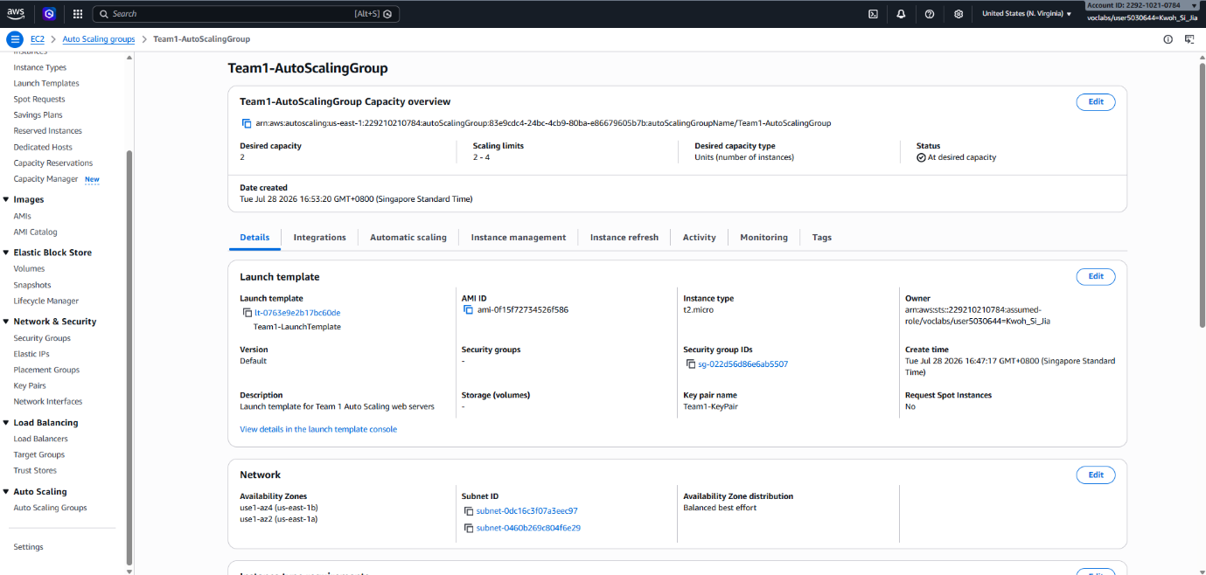
Figure 3.1.2: Auto Scaling Group configuration overview for Team1-AutoScalingGroup.

Auto Scaling Group Configuration

Component | Configuration Specification
Auto Scaling Group Name | Team1-AutoScalingGroup
Launch Template | Team1-LaunchTemplate
Capacity Constraints | Desired: 2 | Minimum: 2 | Maximum: 4
Subnet Associations | PublicSubnet1, PublicSubnet2
AZ Distribution Strategy | Balanced best effort
Scaling Policy Type | Target Tracking Scaling
Monitored Metric | Average EC2 CPU Utilization
Target Utilization Value | 70% (temporarily lowered to 20% during scale-out testing)

The Auto Scaling Group maintains a minimum fleet of two EC2 instances across dual Availability Zones to ensure fault tolerance.

If average CPU utilization exceeds the 70% threshold, the group automatically provisions additional instances (up to 4). When load subsides, surplus instances are terminated to optimize runtime costs.

Application Load Balancer Configuration
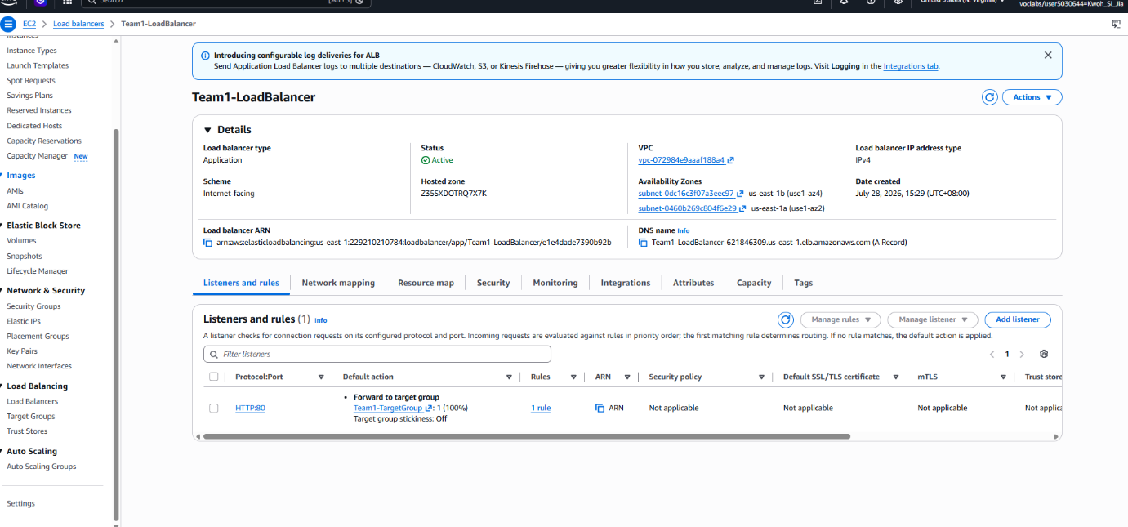
Figure 3.1.3: Application Load Balancer details and HTTP listener rules for Team1-LoadBalancer.

Parameter | Configuration Setting
Load Balancer Name | Team1-LoadBalancer
Type & Scheme | Application Load Balancer / Internet-facing
IP Address Type | IPv4
Subnet Deployment | PublicSubnet1 (us-east-1a), PublicSubnet2 (us-east-1b)
Listener Configuration | Protocol: HTTP | Port: 80
Default Forwarding Action | Forward requests to Team1-TargetGroup
Health Check Parameters | Protocol: HTTP | Path: /

Amazon Machine Image (AMI) Creation for Instance Reusability

Launch Template Property | Specification (Team1-LaunchTemplate)
Base Image (AMI) | Custom Windows Server AMI containing IIS, .NET 6, and web app
Instance Type | t2.micro
Key Pair | Team1-KeyPair
Security Group Rules | Allows HTTP from ALB Security Group; RDP from Admin IP

Key Architectural Benefits

- Accelerated Provisioning: Eliminates post-boot installation scripts during scale-out events.
- Standardization: Guarantees identical software configurations across all fleet instances.
- Operational Resilience: Direct alignment with the Reliability and Operational Excellence pillars of the AWS Well-Architected Framework.

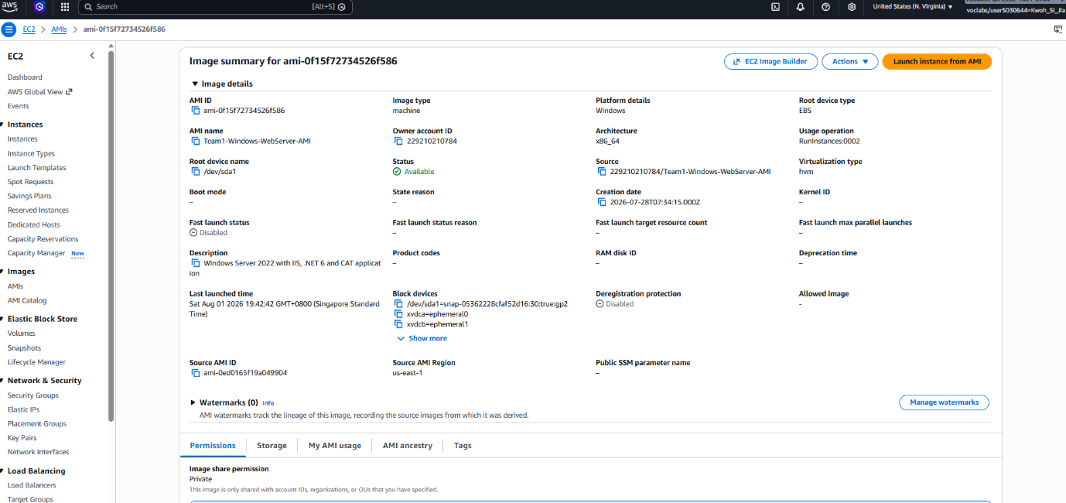
Figure 3.1.4: Image summary for custom Windows Server AMI (Team1-Windows-WebServer-AMI).

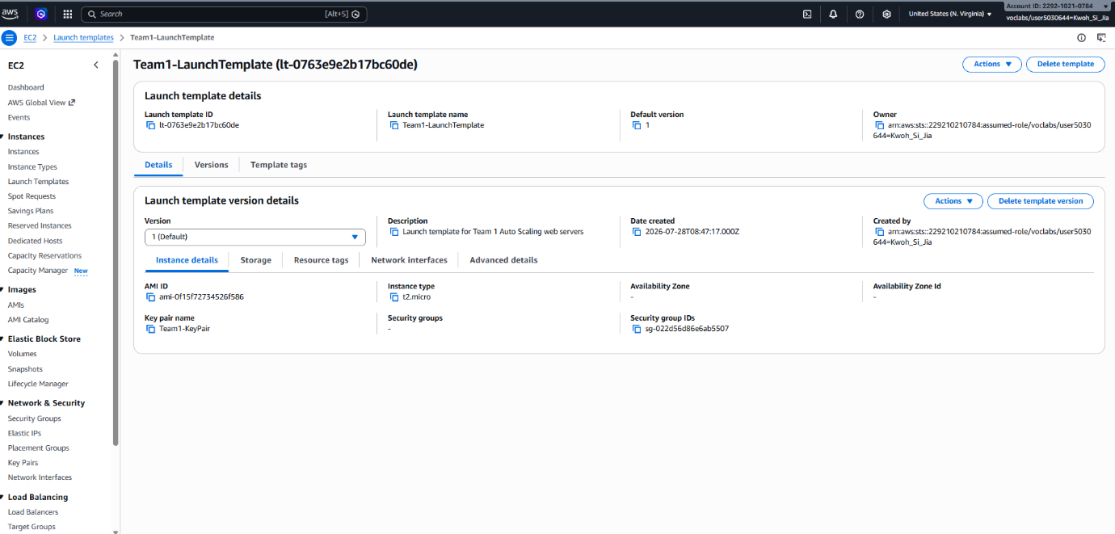
Figure 3.1.5: Launch template version details for Team1-LaunchTemplate.

Database and Security

Amazon RDS
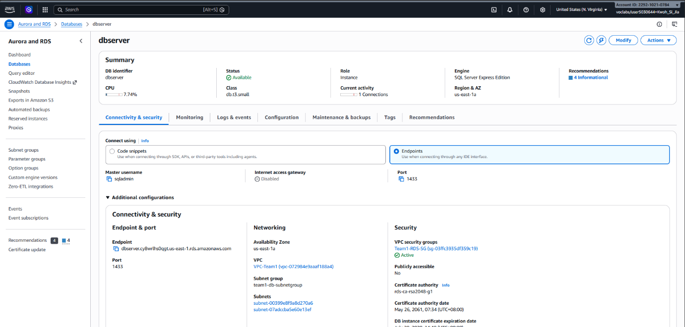
Figure 3.2.1: Amazon RDS instance summary and connectivity details for dbserver.

Amazon RDS Configuration

Configuration Field | Database Specification
DB Instance Identifier | dbserver
Database Engine | Microsoft SQL Server Express Edition
DB Instance Class | db.t3.small
Storage Allocation | 20 GiB (General Purpose SSD)
Network & Deployment | IPv4 | Single-AZ (us-east-1a)
VPC & Subnet Group | VPC-Team1 / team1-db-subnetgroup (Spans us-east-1a & us-east-1b)
Database Port | 1433
Public Accessibility | No (Isolated in Private Subnets)
Security Group | Team1-RDS-SG

Security Group Configuration

Security Group | Inbound Protocol & Port | Allowed Source / Access Constraints
ALB Security Group | HTTP (Port 80) | Public Internet (0.0.0.0/0)
EC2 Security Group | HTTP (Port 80) | ALB Security Group ID only
EC2 Security Group | RDP (Port 3389) | Administrator's approved IP address
RDS Security Group | MSSQL (Port 1433) | EC2 Security Group ID only

Application Connection to RDS

The application connection string was configured in:
C:\inetpub\wwwroot\appsettings.json

The configuration securely binds the private RDS endpoint address, designated MSSQL port (1433), and database authentication credentials.

Database Connectivity Testing

Testing Stage | Command / Method | Result
Network Connectivity | Test-NetConnection dbserver.cy8wrlhs0qgt.us-east-1.rds.amazonaws.com -Port 1433 | TcpTestSucceeded : True over internal VPC IPs
Authentication | sqlcmd -S tcp:dbserver.cy8wrlhs0qgt.us-east-1.rds.amazonaws.com,1433 -U sqladmin | Successfully authenticated
Application Operations | Web App CRUD interface operations | Transaction persistence verified on Amazon RDS

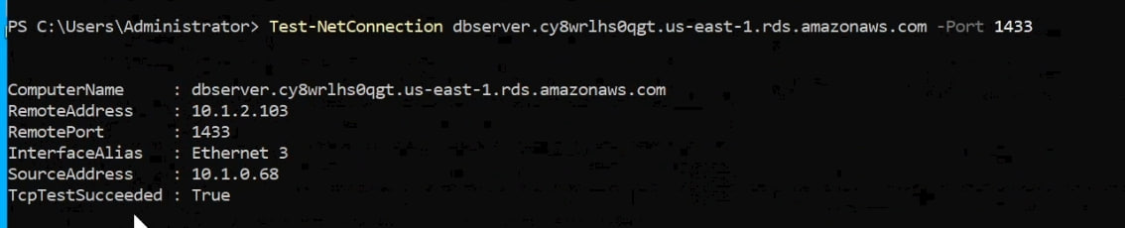
Figure 3.2.2: Successful PowerShell network connectivity test (Test-NetConnection) to RDS on port 1433.

Figure 3.2.3: Verification of SQL Server authentication using sqlcmd.

Database Functionality Testing
The web application was tested using Create, Read, Update and Delete operations. All operations were successfully stored and retrieved from Amazon RDS.

Security Measures Implemented
Security Feature | Implementation Details
Network Isolation | RDS deployed in private subnets with public access disabled.
Port Filtering | Database port 1433 restricted strictly to web-tier EC2 security groups.
Controlled Web Access | EC2 instances reject direct HTTP requests; accept traffic strictly from ALB.
Secure Administration | RDP access locked down to single administrator IP address.
Credential Hygiene | Sensitive connection strings and credentials excluded from screenshots/report.

Monitoring and Alarm Notification

The monitoring solution uses two managed AWS services in the us-east-1 region: Amazon CloudWatch for metric collection, alarm evaluation and dashboarding, and Amazon SNS for delivery of alert notifications to the administrator.

The alarms are separated into two classes. Performance alarms that detect if the system is under strain but still serving traffic, while the failure alarms detect if a component has stopped serving traffic altogether.

This distinction is crucial as CPU Utilisation on a crashed instance would drop to near zero, but a performance alarm would still read as healthy, hence a total outage would be unnoticed if only first class were implemented.

SNS

A Standard Amazon SNS topic named CAT_Assignment2_Alerts was created as the delivery channel for all infrastructure alarms, with a single Email subscription to the administrator address. The subscription was confirmed through the link in the AWS confirmation email before any alarm was attached to the topic.

All infrastructure alarms share one topic such that all infrastructure alarms share the same audience and the same urgency. Grouping them would keep subscription management simple unlike the application event streams that should stay independent as they are functionally different signals.

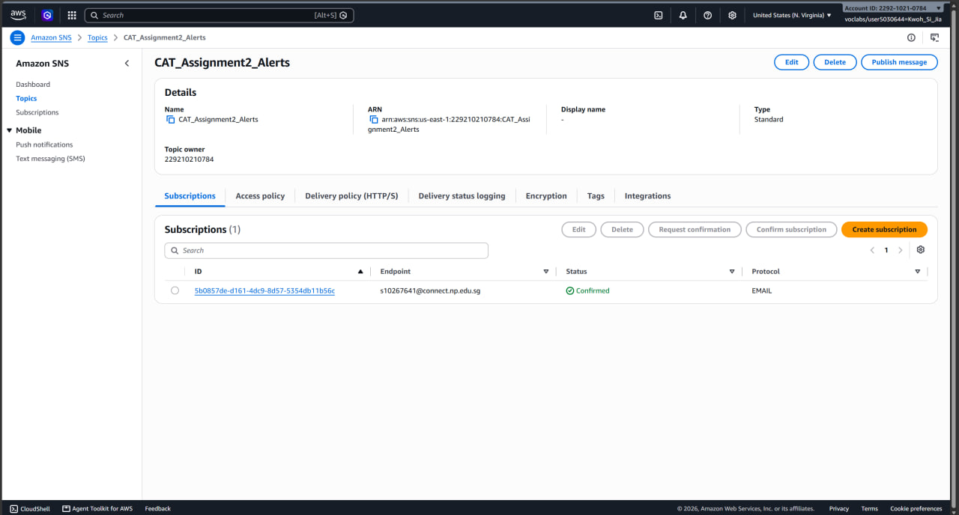
Figure 3.3.1.1: SNS topic CAT_Assignment2_Alerts with confirmed email subscription

EC2

EC2-HighCPU-Alarm watches CPUUtilization across the Auto Scaling Group using the Average statistics over a 5-minute period, entering the alarm state when utilisation exceeds 70% for 2 out of 3 datapoints. The use of Average statistic is to ensure that it was a fleet as a whole and not that one instance briefly spiked.

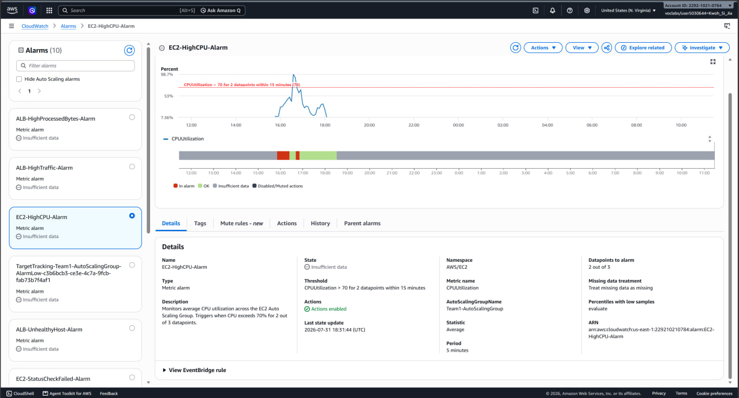
Figure 3.3.2.1: EC2-HighCPU-Alarm configuration

EC2-StatusCheckFailed-Alarm covers the corresponding failure case, alarming when StatusCheckFailed reaches 1 or more on a single datapoint within 5 minutes.

The Maximum statistic is used instead of Average as averaging would dilute a genuine failure. With 2 instances running, one failed check would average to 0.5, and it would never reach the threshold of 1, hence Average-based alarm would only fire once every instance had failed.

Maximum-based alarm would report the worst instance in the group so that a single failure is detected immediately regardless of how many healthy instances surround it.

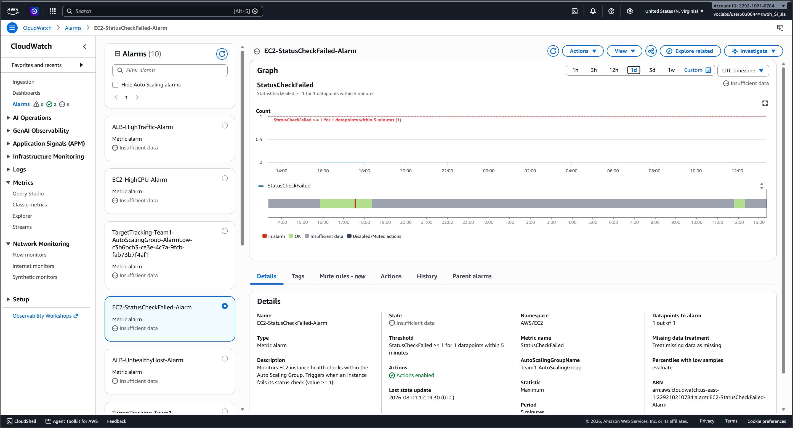
Figure 3.3.2.2: EC2-StatusCheckFailed-Alarm Configuration

Load Balancer

ALB-HighTraffic-Alarm monitors the RequestCount with the Sum statistic, firing when the count exceeds 20 for 2 out of 3 datapoints over 5-minute periods.

As RequestCount is a count of events within the period, averaging it would divide the count across reporting intervals and produce a value that would never approach a meaningful threshold.

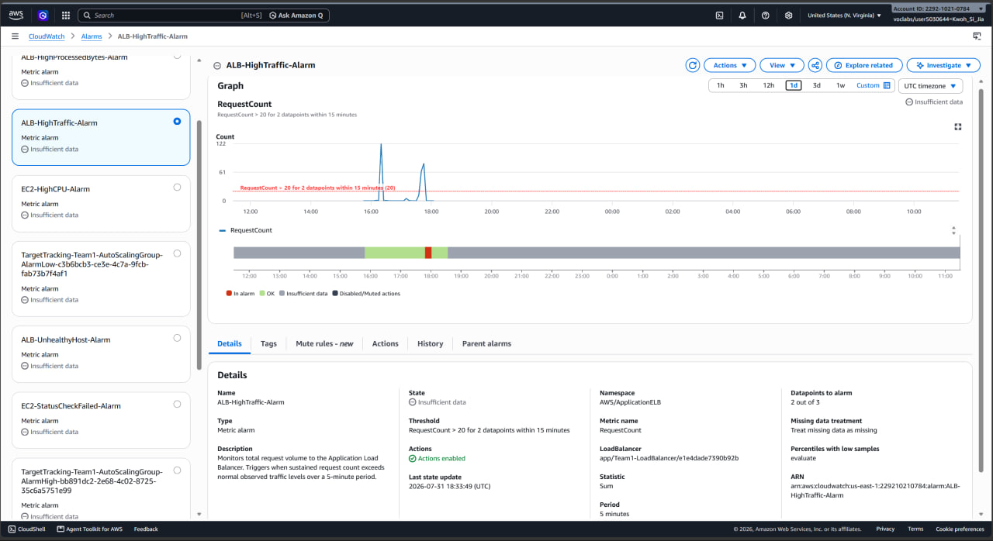
Figure 3.3.3.1: ALB-HighTraffic-Alarm Configuration

ALB-UnhealthyHost-Alarm is the failure alarm at the load balancer layer. It detects when a registered target stops passing its health check, which indicates the application has failed on an instance that is otherwise still running.
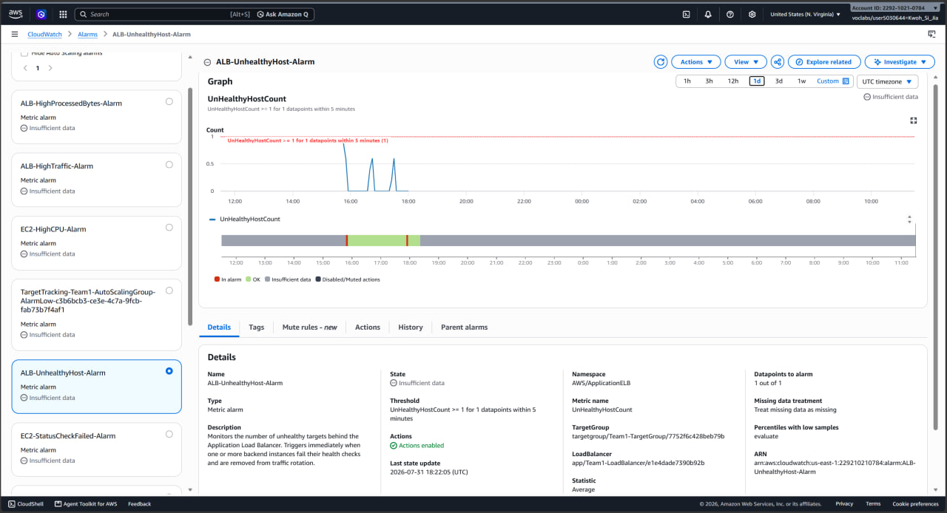
Figure 3.3.3.2: ALB-UnhealthyHost-Alarm Configuration

ALB-HighProcessedBytes-Alarm tracks data transfer volume rather than request volume, using the Sum statistic on ProcessedBytes with a threshold of 45,000 bytes for 2 out of 3 datapoints.

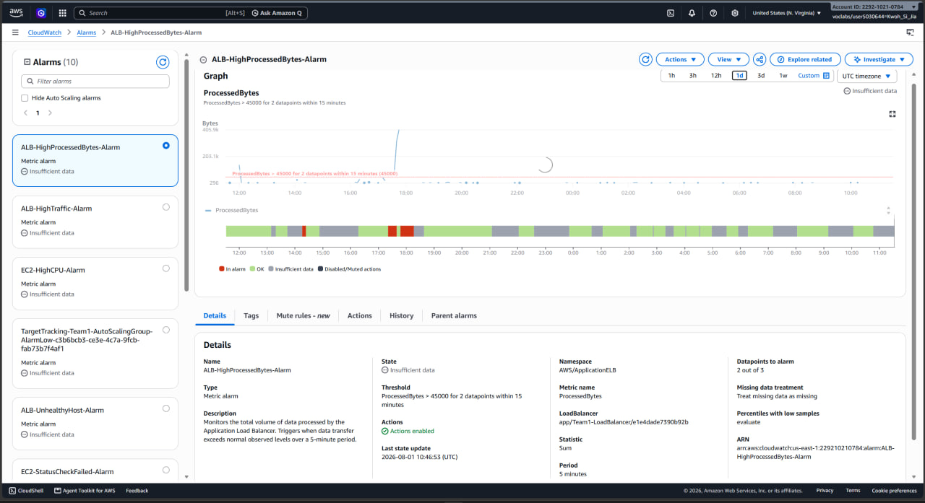
Figure 3.3.3.3: ALB-HighProcessedBytes-Alarm Configuration

RDS

RDS-LowFreeStorage-Alarm monitors FreeStorageSpace on the dbserver instance.

The metric is reported in bytes, hence the threshold was entered as 4,000,000,000 bytes (4GB). In normal operation, there is roughly 21Gb of free space, hence 4Gb is low enough not to fire spuriously but high enough to leave time to act.

A single datapoint is used here instead of 2 out of 3 as free storage does not fluctuate like how CPU or request count does. One reading would be trustworthy and storage exhaustion degrades gradually and then fails completely, hence early warning is the entire value of the alarm.

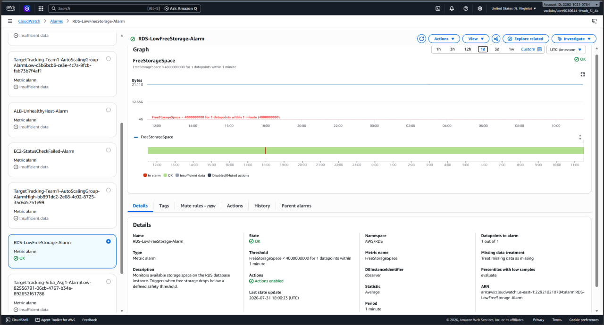
Figure 3.3.4.1: RDS-LowFreeStorage-Alarm

Dashboard

CAT_Assignment2 is the dashboard that consolidates 8 widgets into one view so that the system state can be assessed without opening each console separately. Widgets are grouped by function instead of creation order. This is such that a related set of symptoms can be read together.

- Compute Health: HealthyHostCount and UnhealthyHostCount, StatusCheckFailed and StatusCheckFailed_Instance and EC2 CPUUtilization
- Database: RDS FreeStorageSpace, RDS CPUUtilization and DatabaseConnections
- Network and Traffic: ALB ProcessedBytes and RequestCount, EC2 NetworkIn and NetworkOut

For metrics where trend over time carries the information, a line graph was used, while for host-count and status-check metrics, a single-value widget was used.

RDS CPUUtilization and DatabaseConnections are displayed without a corresponding alarm as they are more of a diagnostic context rather than an alert condition which would be useful for interpreting a storage or performance problem once one has already been raised and adding alarms for every displayed metric would generate noise without adding actionable information.
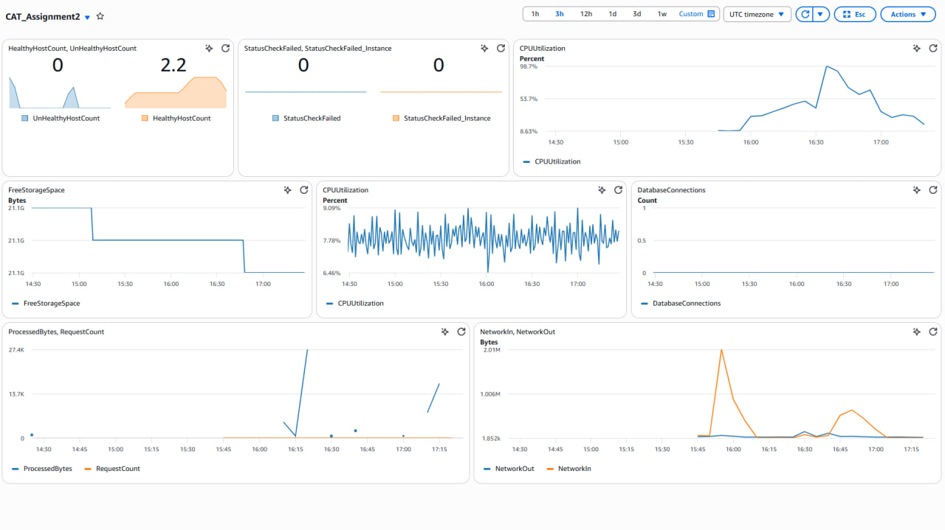
Figure 3.3.5: CloudWatch Dashboard

Serverless Product Application

The serverless product application uses four managed AWS services in the us-east-1 region: Amazon DynamoDB for storage, AWS Lambda for compute, Amazon API Gateway for the REST interface, and Amazon S3 for hosting the front end.

A DynamoDB table named Products stores the product catalogue. ID was chosen as the partition key and is populated with an ID generated by the Lambda function, guaranteeing a unique, evenly distributed key so that write traffic spreads across partitions.

The remaining attributes: Category, Name, Price and Stock, carry the same data fields used in Assignment 1. Because DynamoDB is schemaless, only the key attribute is declared at creation time and the other four are written as item attributes at insert time.

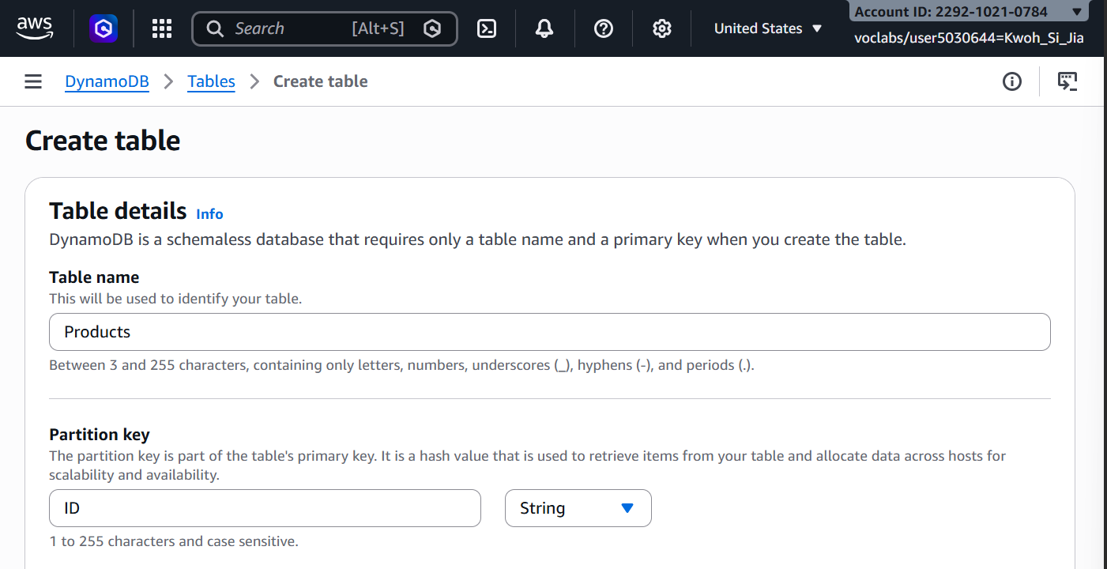
Figure 3.4.1: DynamoDB Products table Overview tab, showing table name and partition key ID

A single Lambda function, ProductsCRUD, handles both read and write operations on the table. Consolidating GET and POST into one function rather than two reduces the number of cold starts and keeps a single IAM execution role and a single CloudWatch log group to monitor.

The function runs on the Python 3.12 runtime under the LabRole execution role, which grants the DynamoDB and CloudWatch Logs permissions the function requires. It inspects the HTTP method supplied in the API Gateway v2.0 event payload and branches accordingly:

- GET: Performs a table scan and returns the full catalogue as a JSON array.
- POST: Parses the request body, generates the item ID, and writes the record with put_item.
- OPTIONS: Returns an empty 200 response to satisfy the browser's CORS preflight check.

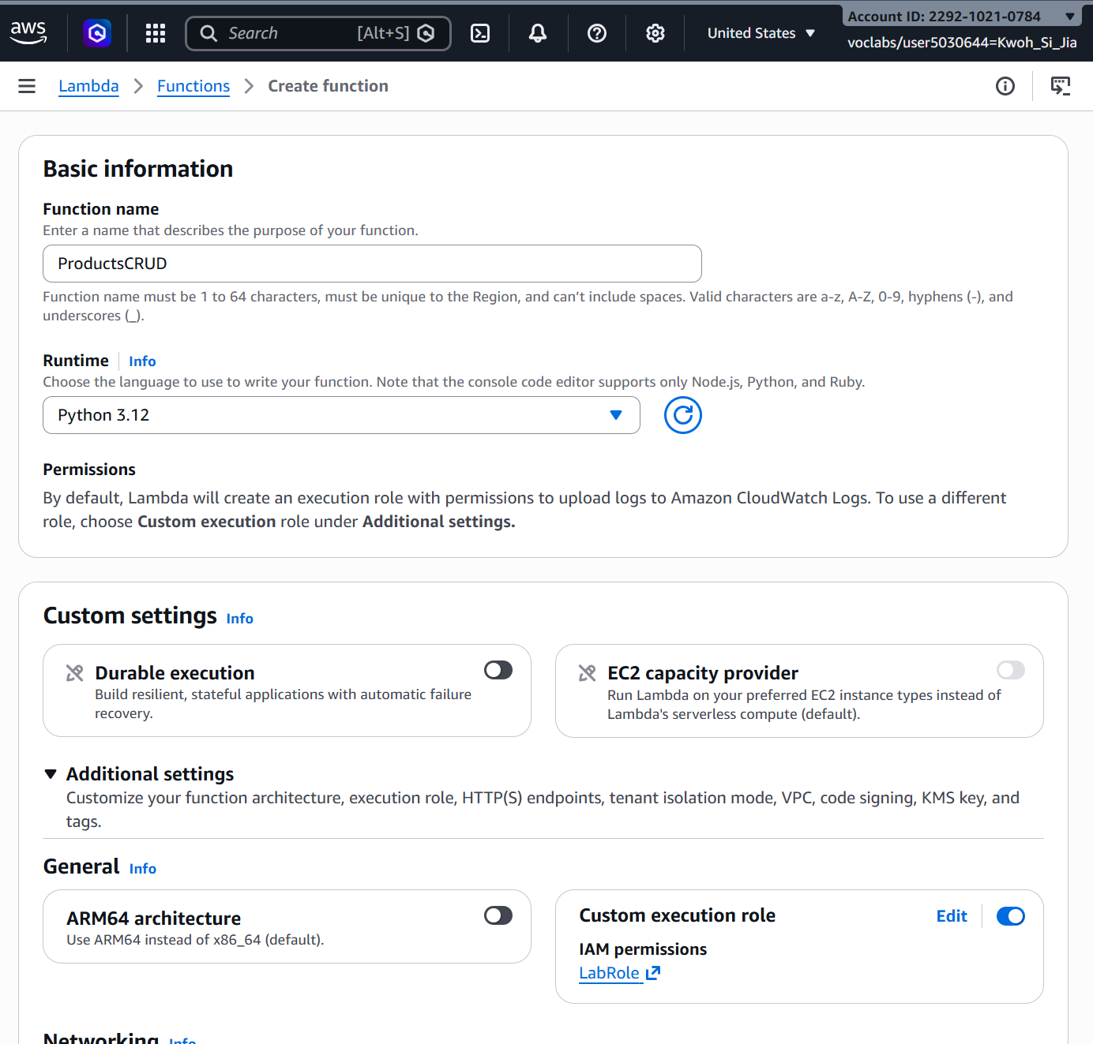
Figure 3.4.2: Basic information and custom settings configuration for the ProductsCRUD function
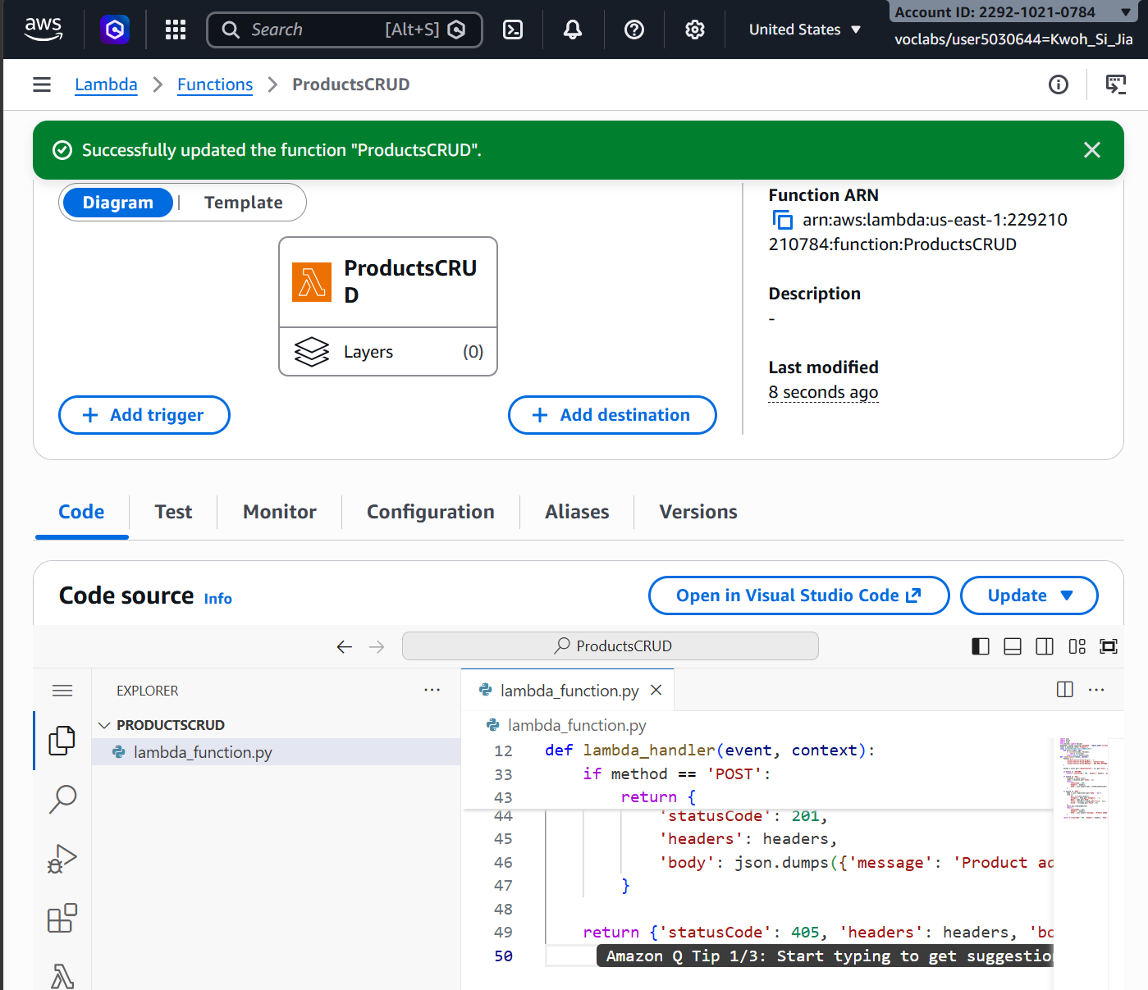
Figure 3.4.3: Lambda ProductsCRUD Function overview showing runtime, Function ARN, and code source

Amazon API Gateway exposes the function as a REST endpoint.

A HTTP API named ProductsAPI was created with a Lambda proxy integration targeting ProductsCRUD and payload format version 2.0. Three routes are defined on the /products resource: GET, POST, and OPTIONS, all pointing at the same integration.

The API deploys to the $default stage with auto-deploy enabled, so configuration changes take effect without a manual deployment step and are reachable at: https://a5v2m05a8c.execute-api.us-east-1.amazonaws.com/

HTTP API was selected over REST API because it provides the same Lambda proxy behaviour at roughly one-third of the per-request cost, which suits a low-volume internal catalogue.

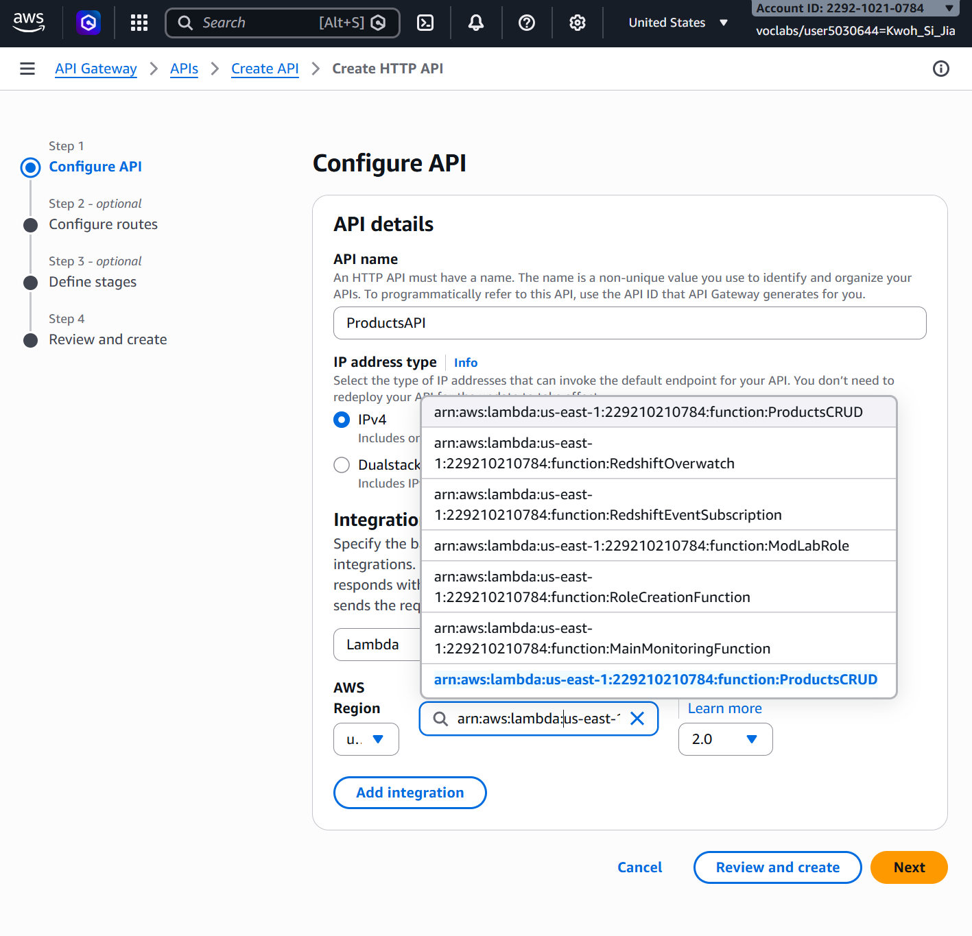
Figure 3.4.4: Integration target setup for ProductsAPI selecting ProductsCRUD
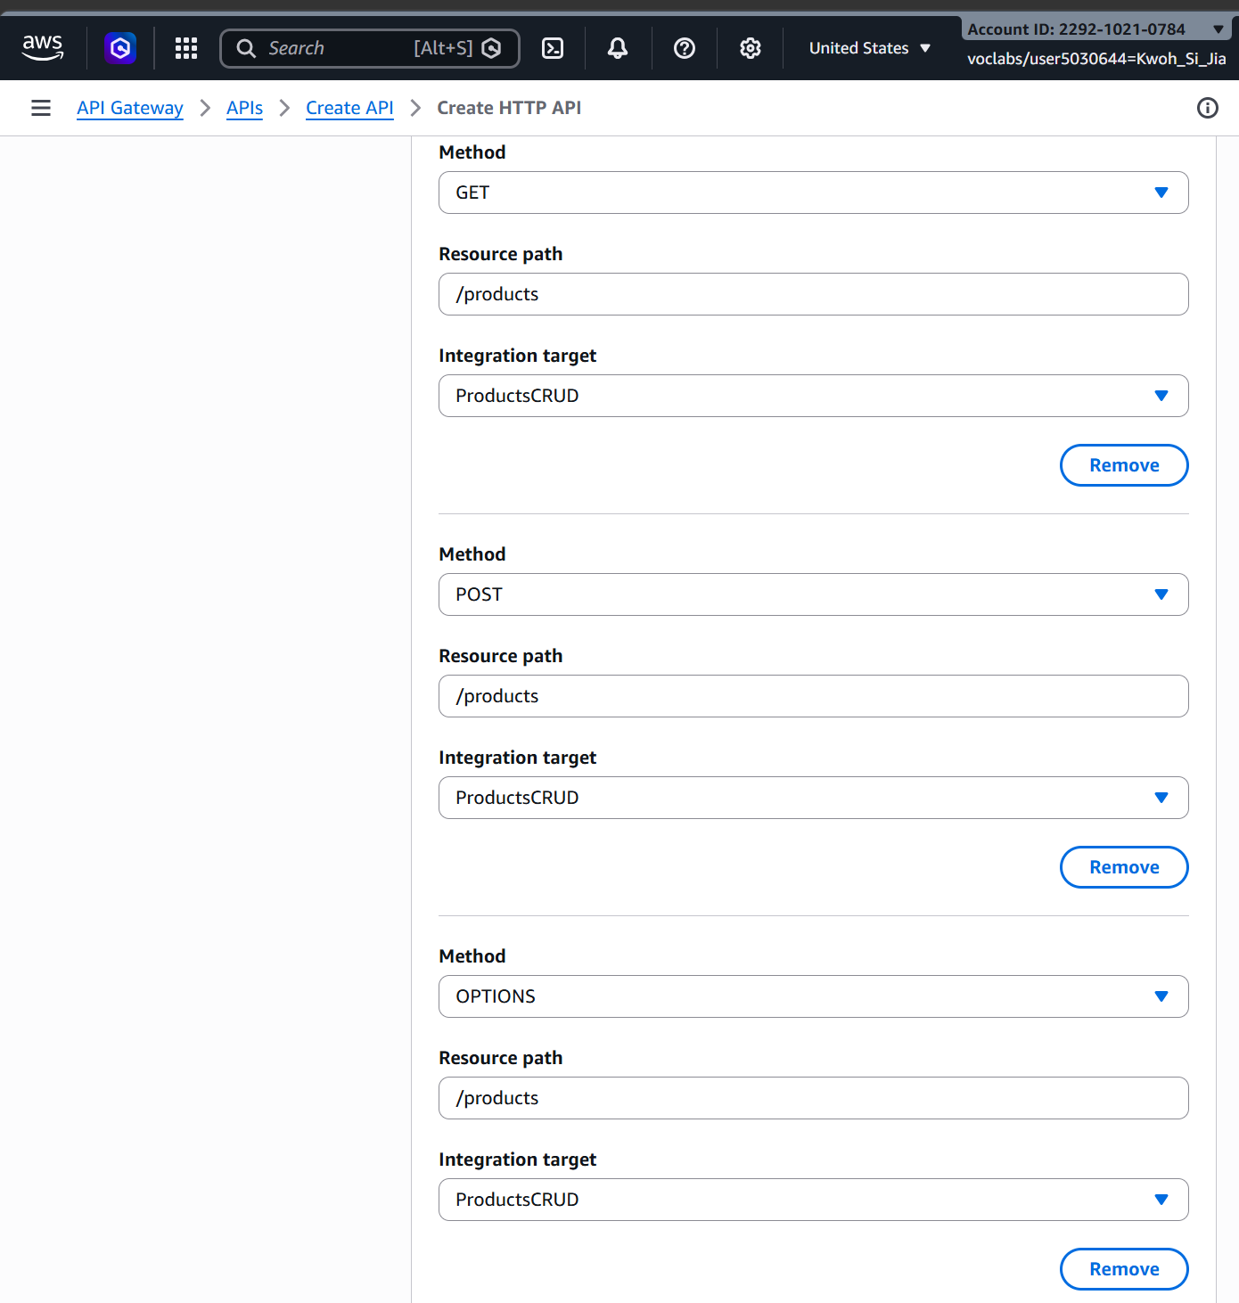
Figure 3.4.5: API Gateway routes configured for the /products resource (GET, POST, OPTIONS)

Cross-Origin Resource Sharing (CORS) is configured at the API Gateway level rather than left to the function, so preflight requests are answered before they reach Lambda. Access-Control-Allow-Origin is set to *, Access-Control-Allow-Headers to content-type, and Access-Control-Allow-Methods to GET, POST, and OPTIONS.
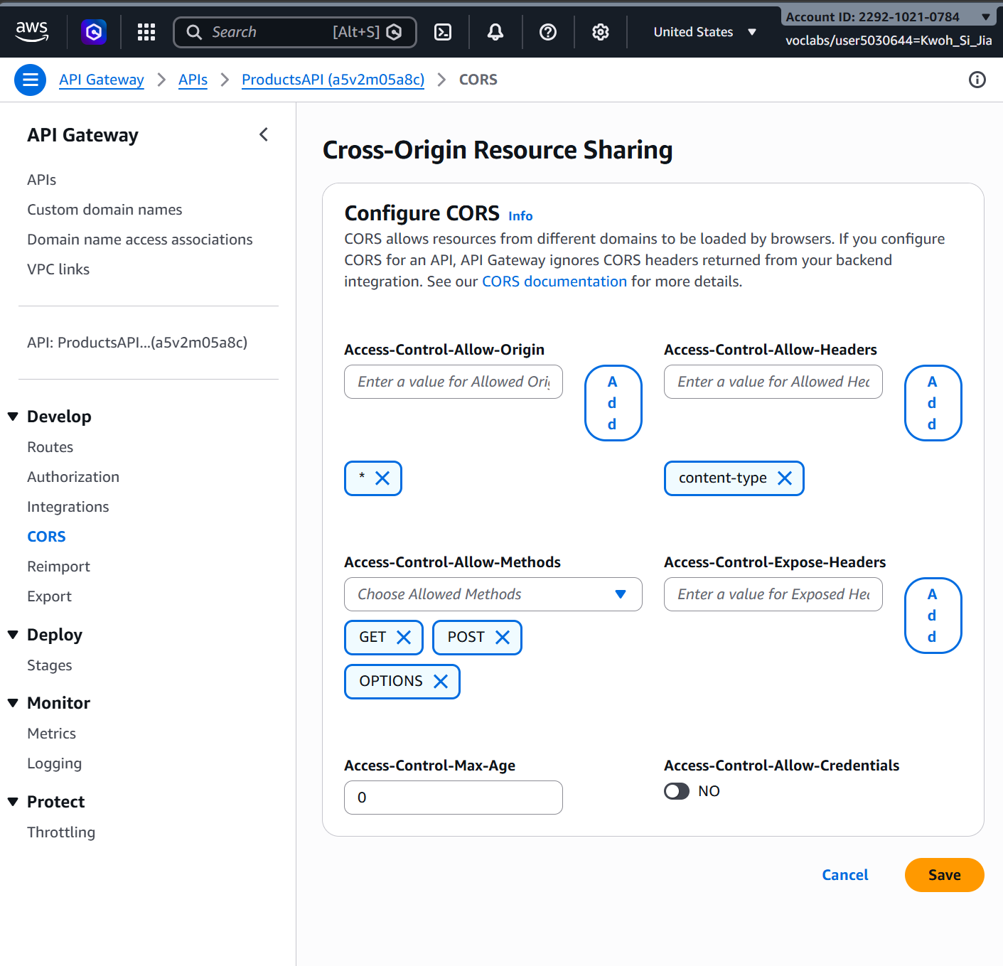Figure 3.4.6: CORS configuration applied to ProductsAPI

The front end is a single static HTML page hosted directly from Amazon S3. The bucket cat-asg2-products-website has static website hosting enabled with index.html as the index document, and a bucket policy granting s3:GetObject to all principals so the page is publicly readable.

The page presents a form capturing Category, Name, Price, and Stock, and issues a fetch POST to the API on submit; a second fetch GET runs on page load and on demand via a Refresh button, rendering the current table contents.

Serving the interface from S3 rather than from an EC2 instance removes a server from the design entirely and costs cents per month.

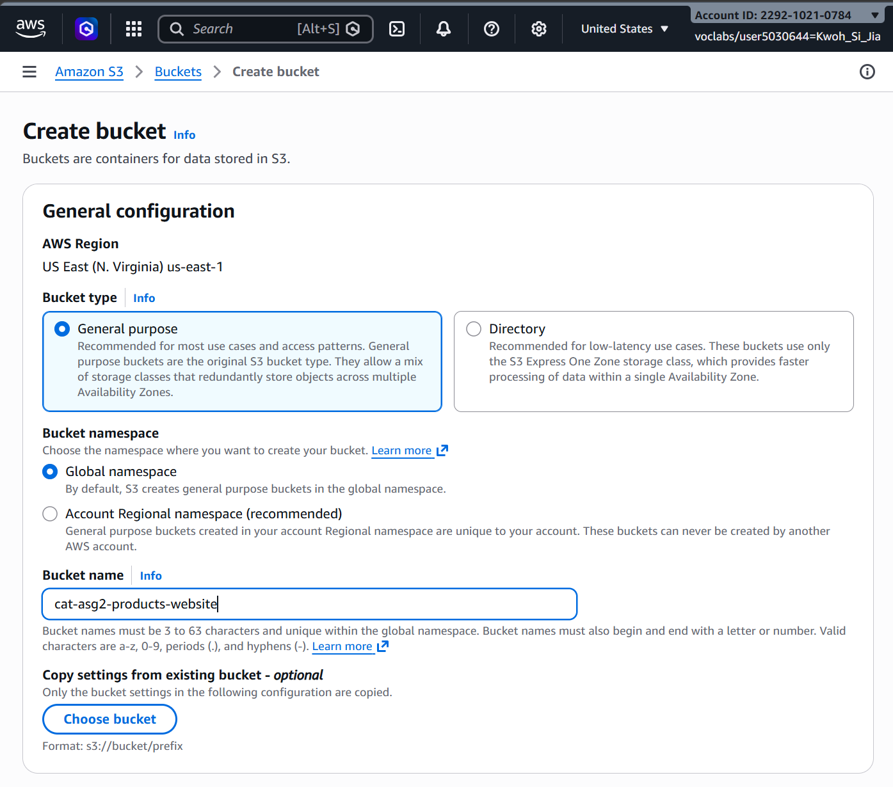
Figure 3.4.7: Creating the S3 bucket cat-asg2-products-website
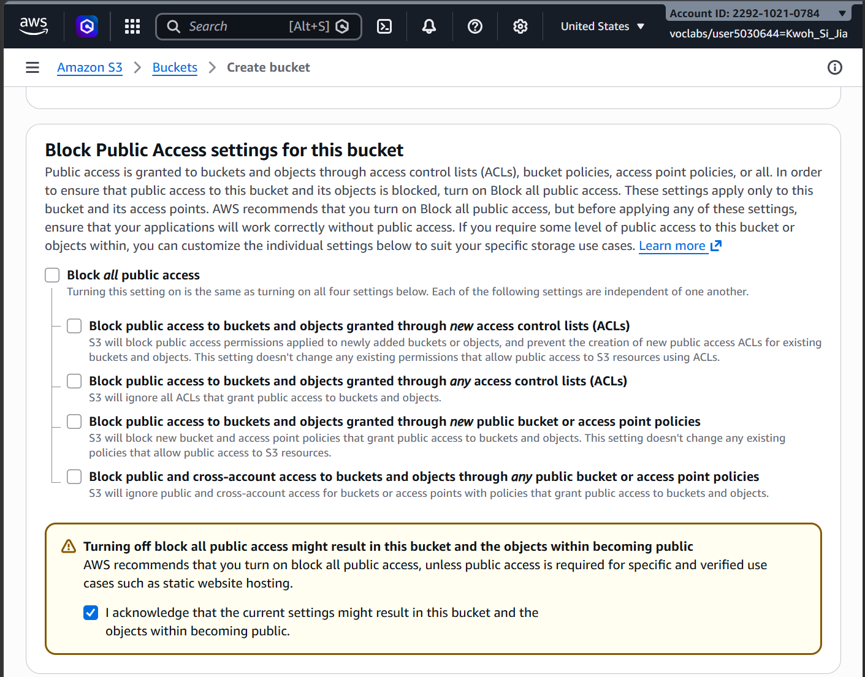
Figure 3.4.8: Disabling Block Public Access settings for public static website hosting
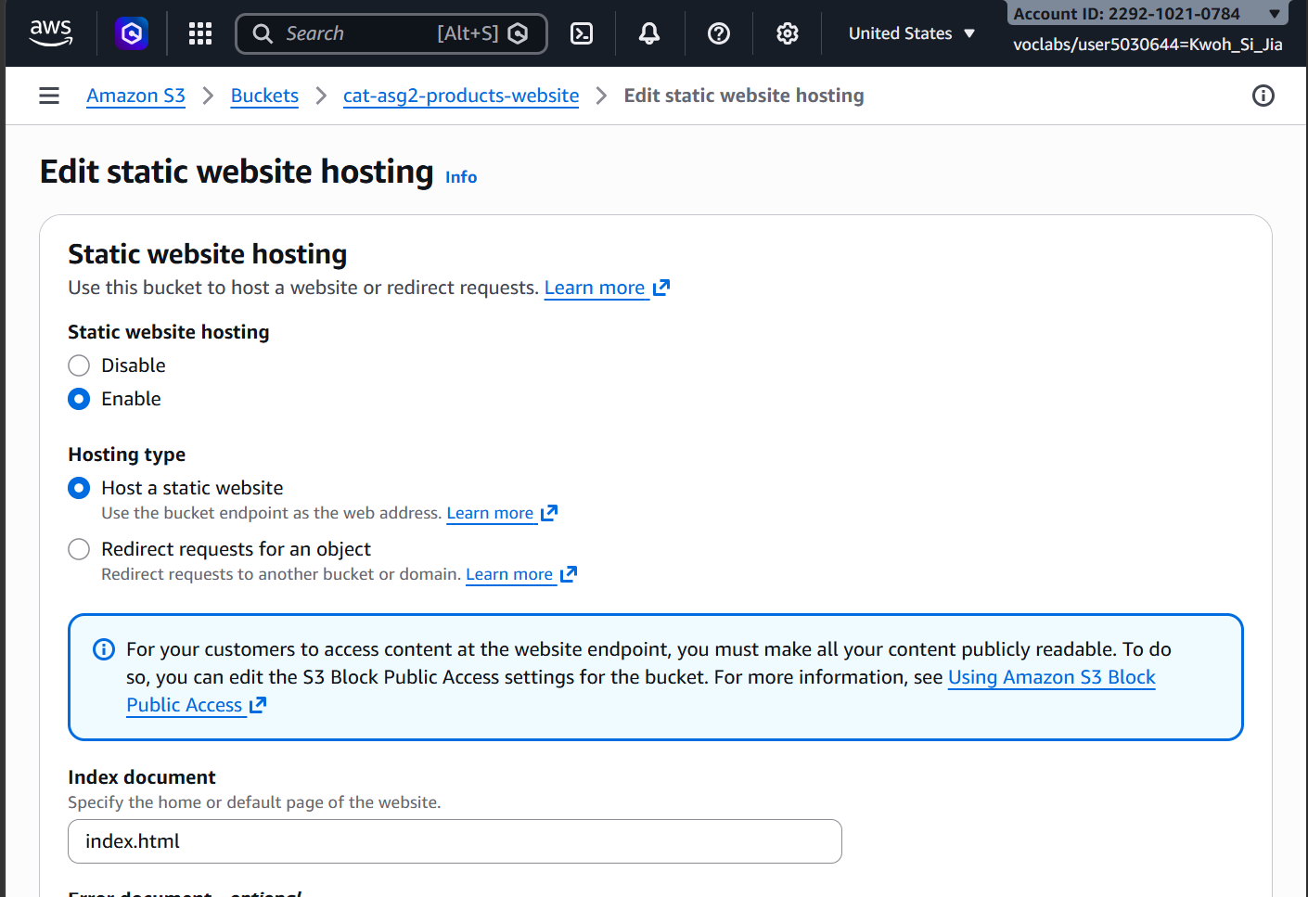
Figure 3.4.9: Enabling static website hosting with index.html as the index document
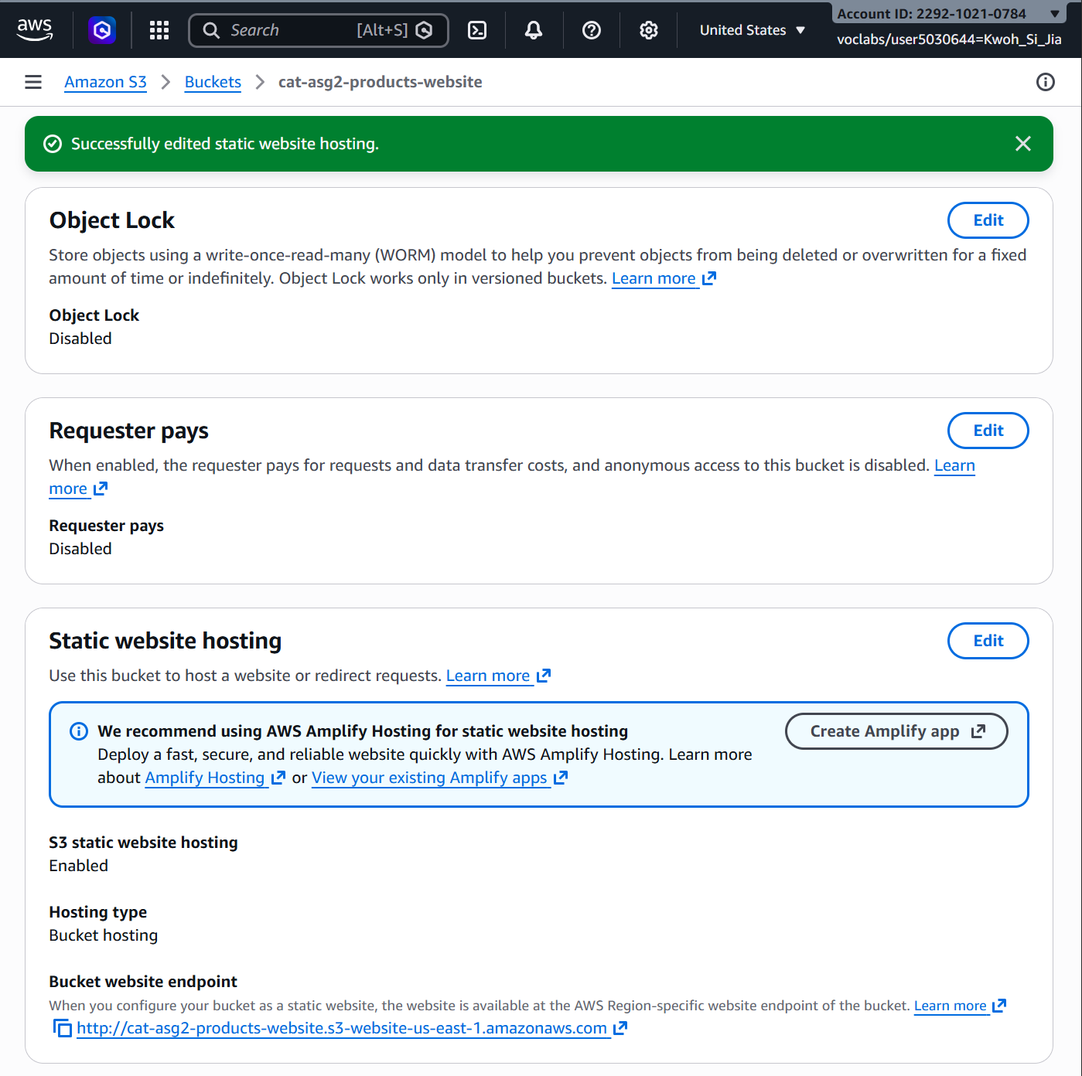
Figure 3.4.10: S3 static website hosting endpoint overview
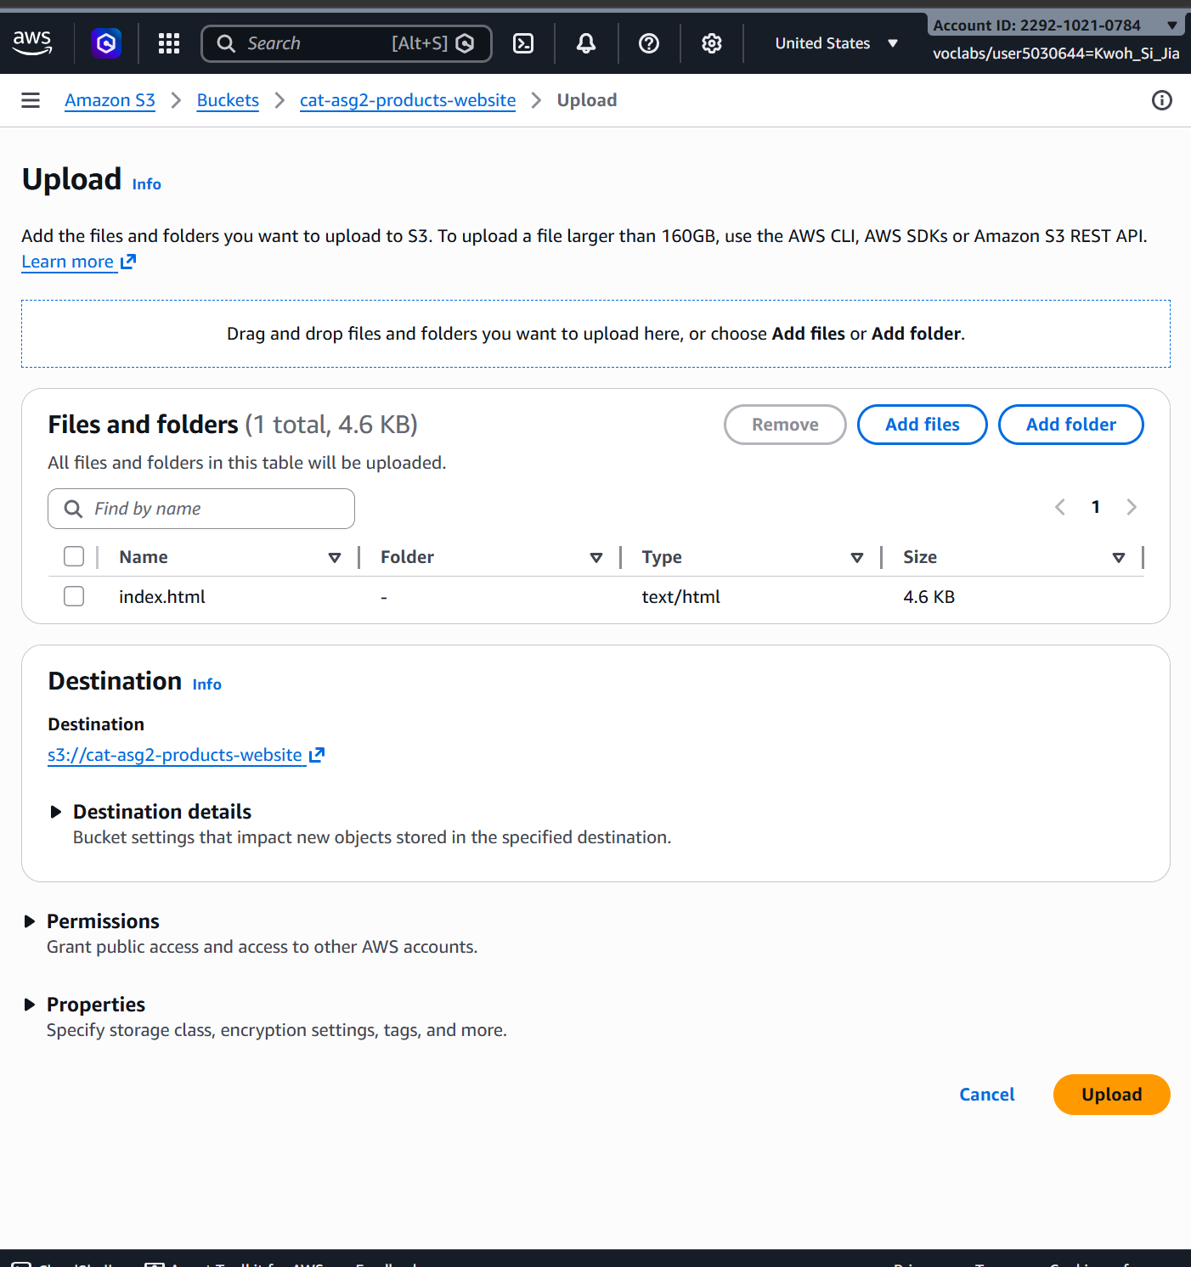
Figure 3.4.11: Uploading index.html to the static website bucket
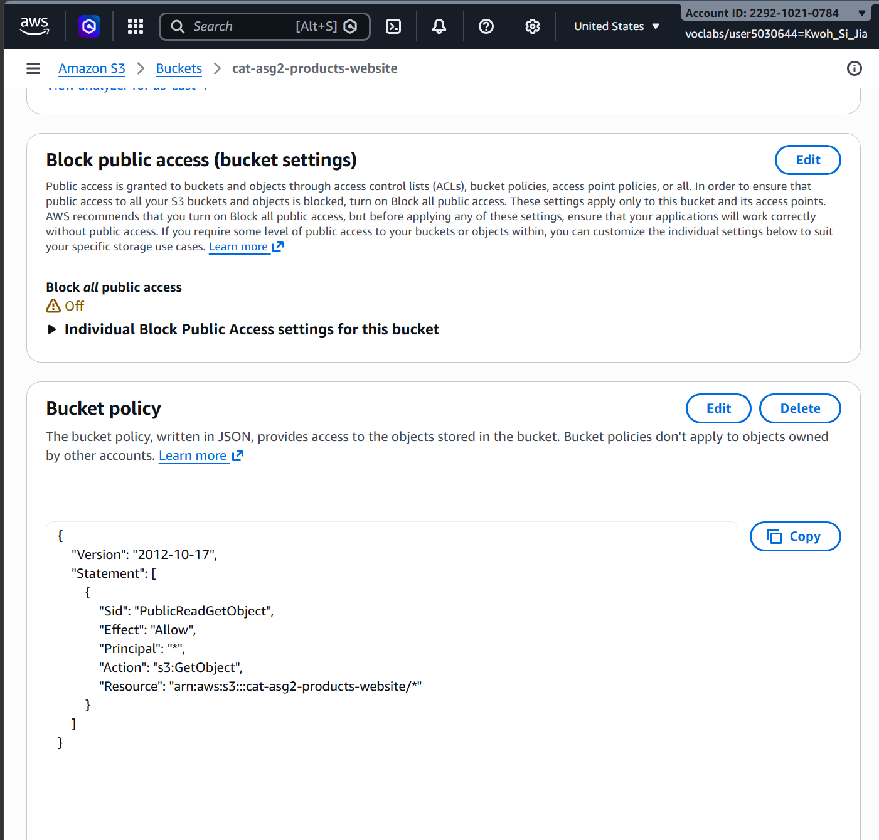
Figure 3.4.12: Applying a public read GetObject bucket policy to cat-asg2-products-website

Notification Services

The administrator is to be notified when a new product is added to the NoSQL database and when a file is uploaded to an S3 bucket.

Two Amazon SNS topics were created for this purpose: ProductAddedAlert and S3UploadAlert, each with a confirmed email subscription.

Separate topics rather than one shared topic allow the two alert streams to be subscribed to, filtered, or muted independently, and make it clear from the topic name alone which subsystem raised an alert.

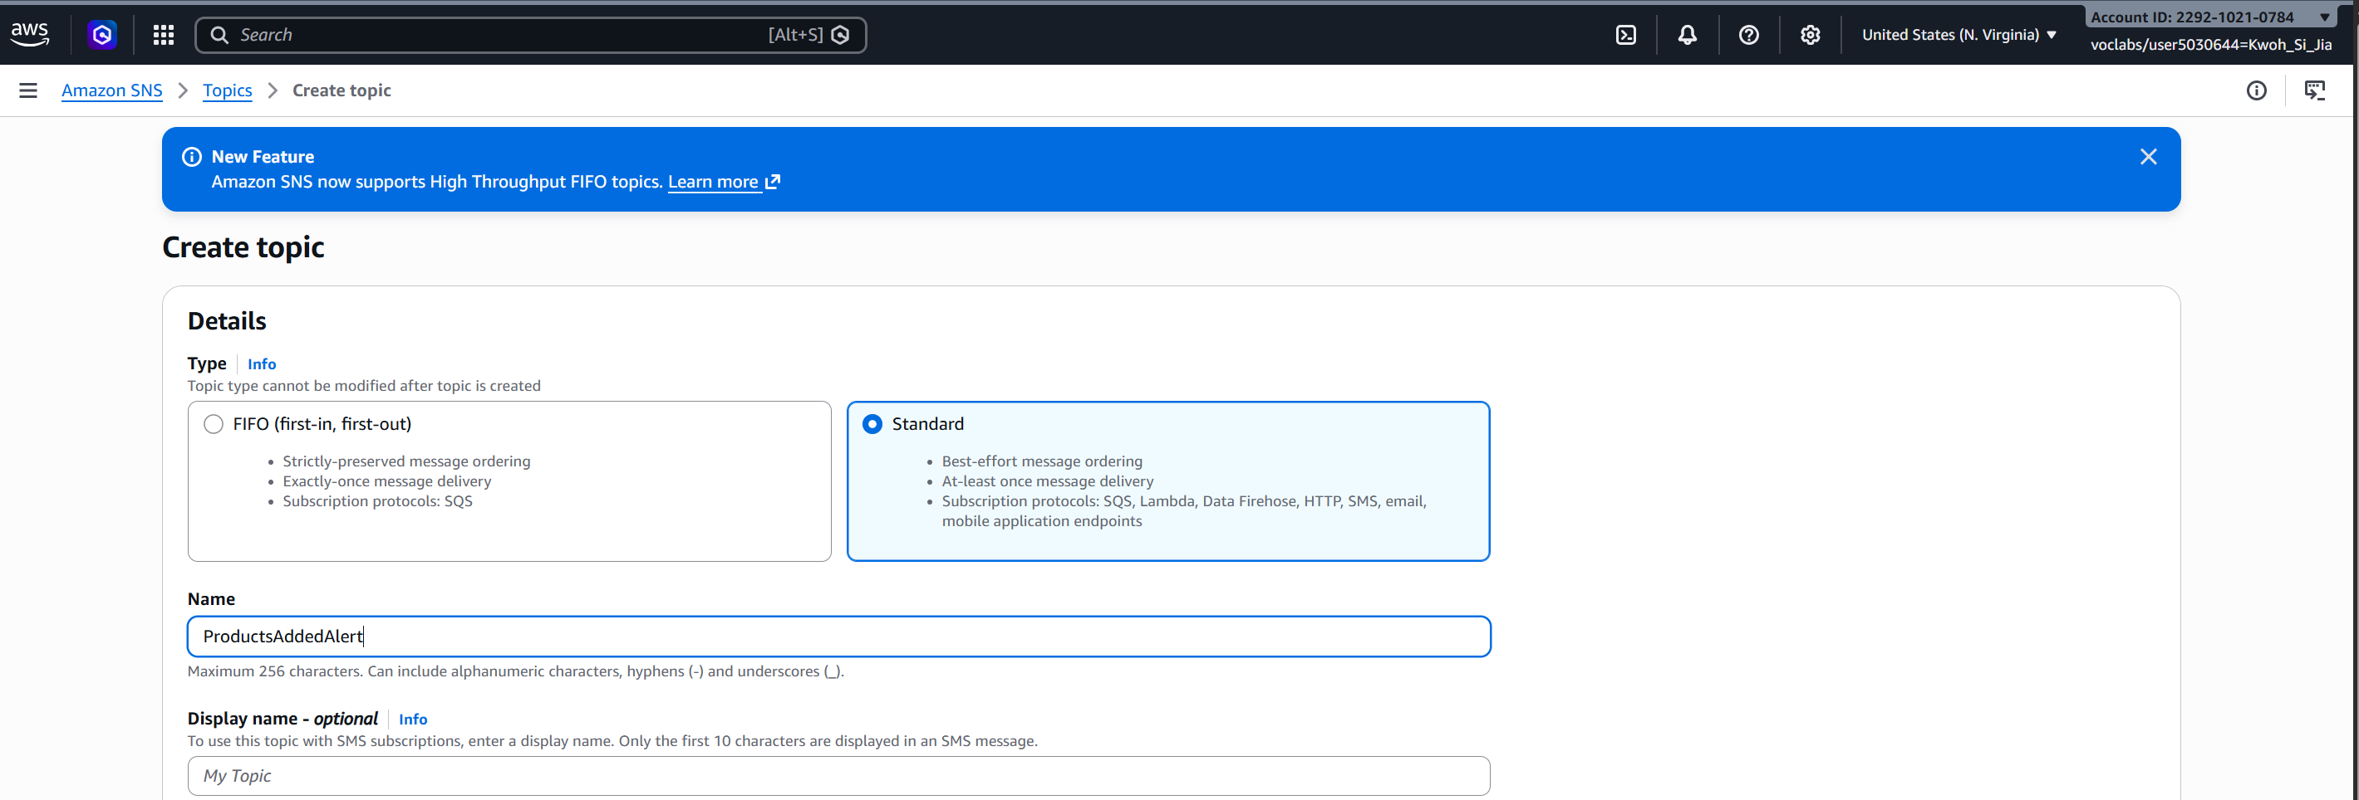
Figure 3.5.1: Creating the Standard SNS topic ProductAddedAlert

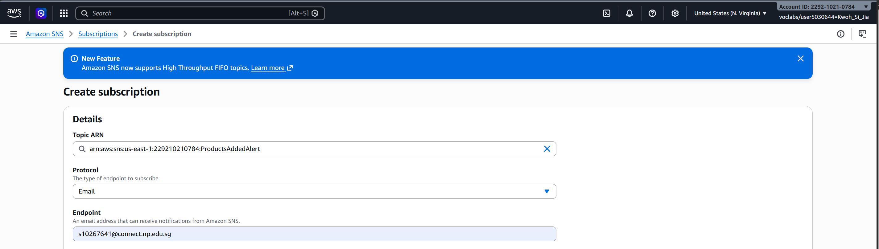
Figure 3.5.2: Configuring an Email subscription for ProductAddedAlert
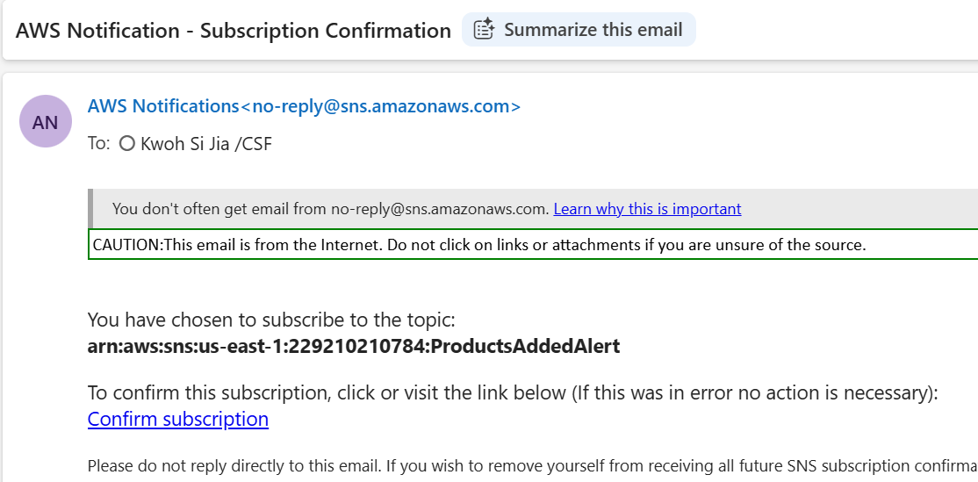
Figure 3.5.3: Subscription confirmation email sent by AWS SNS

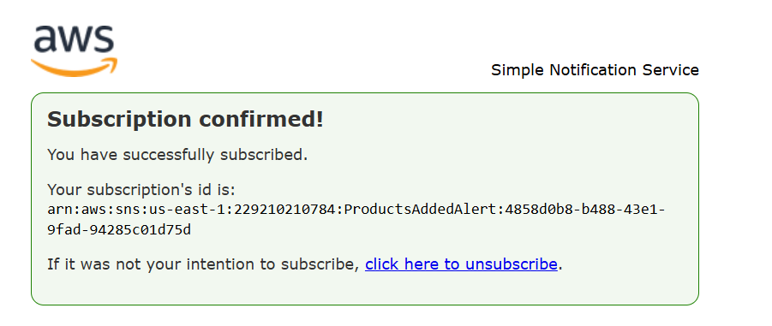
Figure 3.5.4: Successful subscription confirmation page

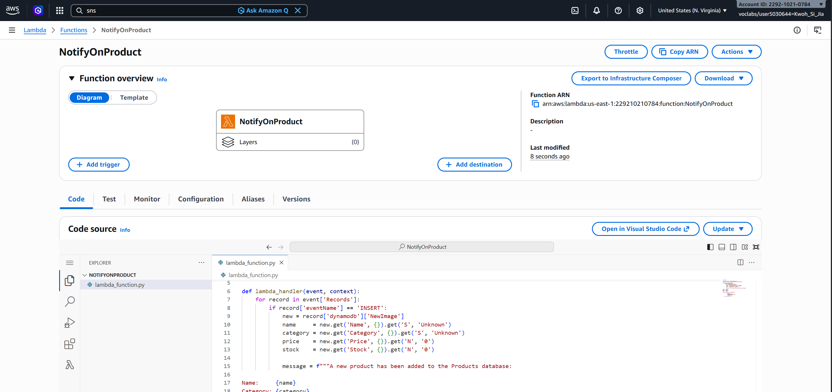Figure 3.5.5: Overview of the NotifyOnProduct Lambda function

Product notifications are driven by DynamoDB Streams rather than by the ProductsCRUD function publishing directly to SNS.

The stream is enabled on the Products table with the New image view type, which places a copy of each item as it appears after the change onto the stream.

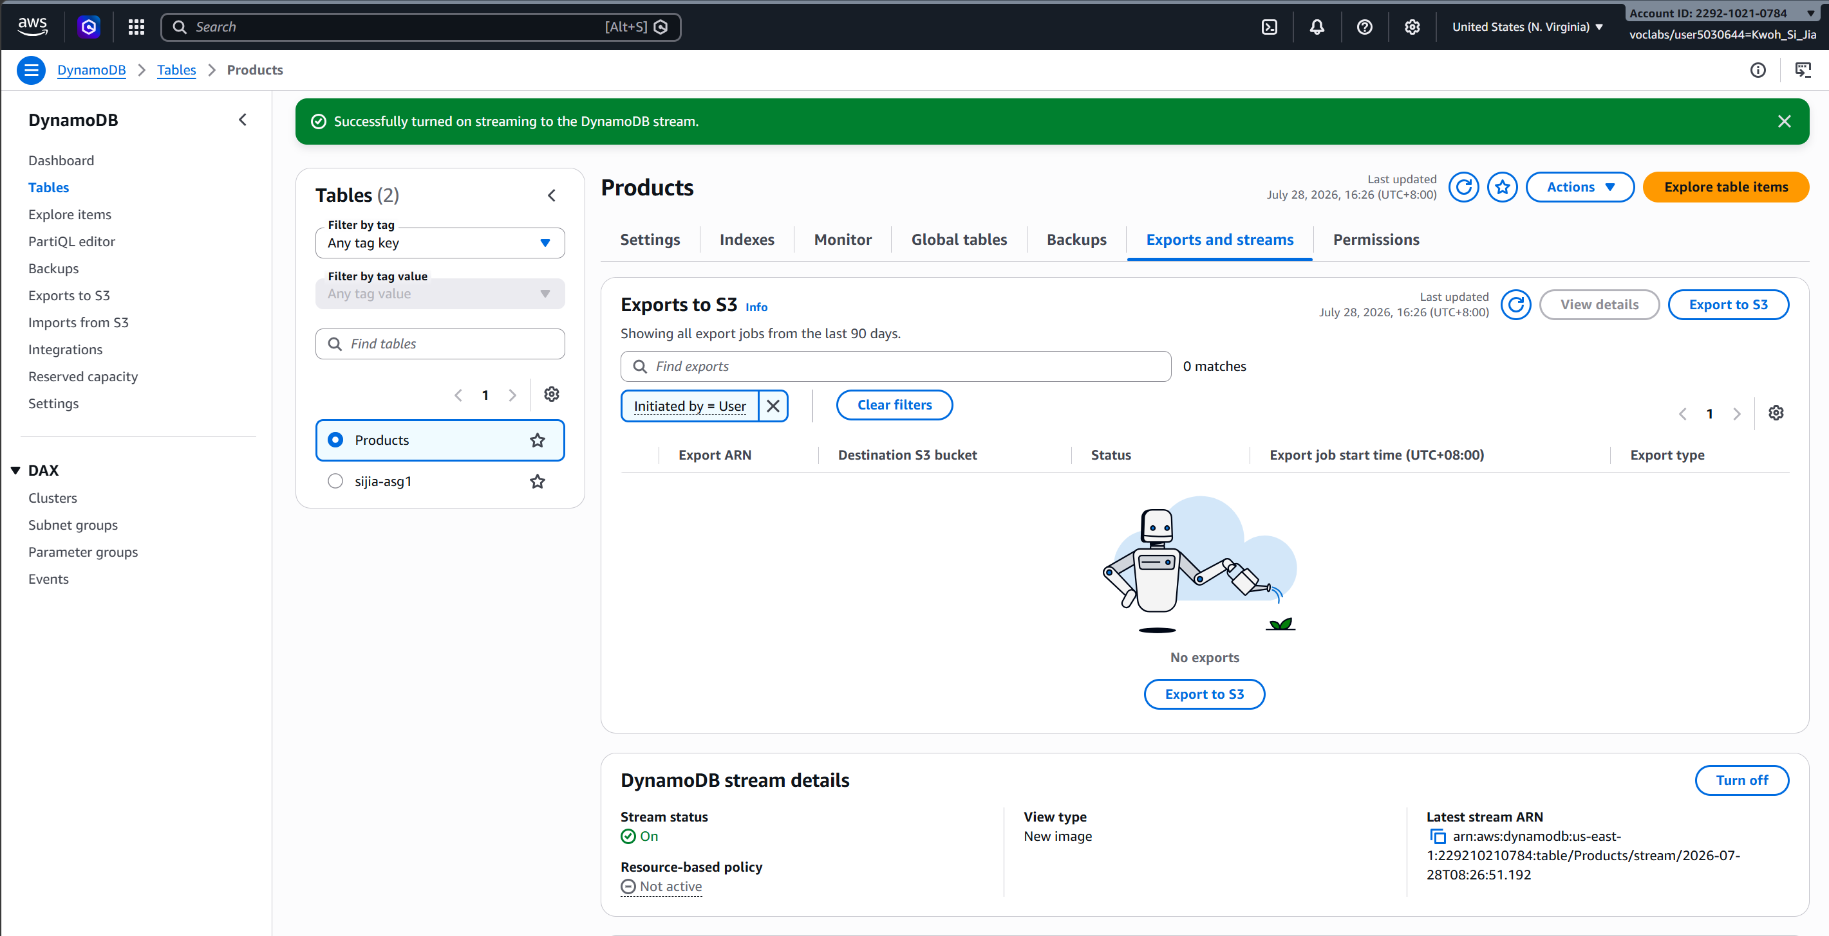
Figure 3.5.6: DynamoDB Streams enabled with the New image view type on the Products table

The second Lambda function, NotifyOnProduct, is registered as an event source mapping against that stream. It iterates the delivered records, filters for eventName == "INSERT" so that updates and deletes do not raise a false "new product" alert, extracts the four product attributes from the DynamoDB-typed image, and publishes a formatted plain-text message to ProductAddedAlert.

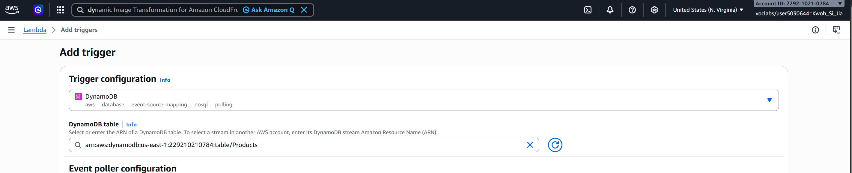Figure 3.5.7: Configuring the DynamoDB stream trigger for the NotifyOnProduct function

This event-driven approach was chosen deliberately over adding an SNS publish call inside ProductsCRUD. Decoupling the notification from the write path provides key advantages:

- Latency: The API response is returned to the user as soon as the item is committed, without waiting on SNS.
- Fault Tolerance: A failure in the notification path cannot cause a product write to fail.
- Extensibility: Any future writer to the table automatically produces a notification without requiring code changes.

Image Watermarking Service

The image watermarking service utilizes an event-driven serverless pattern to decouple raw image ingestion from automated image transformation and notification dispatch.

When a user uploads an image to the input S3 bucket (cat-asg2-image), Amazon S3 triggers two parallel execution streams:

- Automated Watermark Transformation: S3 executes an event-driven invocation of the ImageWatermarkFunction Lambda function to overlay business metadata and store the asset.

- Notification Dispatch: An S3 Event Notification dispatches object metadata directly to the S3UploadAlert Amazon SNS topic to immediately alert system administrators via email.

Input and Output Buckets

Two dedicated Amazon S3 buckets were provisioned to handle the image processing lifecycle:
Bucket Role | S3 Bucket Name | Purpose & Access Profile
Input Bucket | cat-asg2-image | Ingests original, unwatermarked image uploads submitted by users.
Output Bucket | cat-asg2-watermarked | Stores processed, watermarked output images produced by the Lambda function.

Separating input and output into isolated S3 buckets strictly prevents recursive Lambda invocations.
If transformed images were written back to the triggering input bucket, the s3:ObjectCreated:* event would recursively re-invoke the Lambda function, resulting in an infinite processing loop and unbudgeted compute/storage costs.
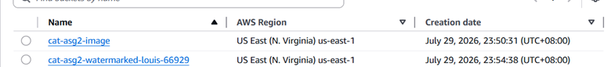Figure 3.6.1.1: Separate input and output S3 buckets created for original and processed images.

Pillow Image-Processing Dependency

The watermarking function requires the Pillow Python image-processing library. Because Pillow contains C-extension binaries that are not natively included in the standard AWS Lambda Python execution environment, a custom Lambda Layer was compiled.
- Compilation & Packaging: The Linux-compatible Pillow dependency was packaged into a standard .zip archive structure compatible with the Lambda runtime environment.

- Layer Publishing: Published as a reusable custom Lambda Layer named PillowImageProcessing.

- Layer Binding: Attached directly to ImageWatermarkFunction, granting the execution environment native access to image manipulation libraries.

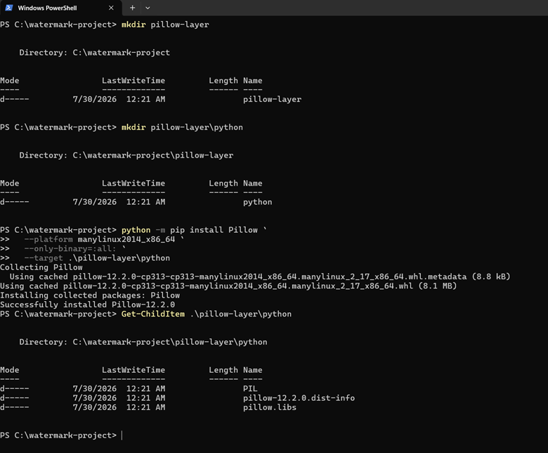Figure 3.6.2.1: Installation of the Linux-compatible Pillow dependency for use in AWS Lambda.

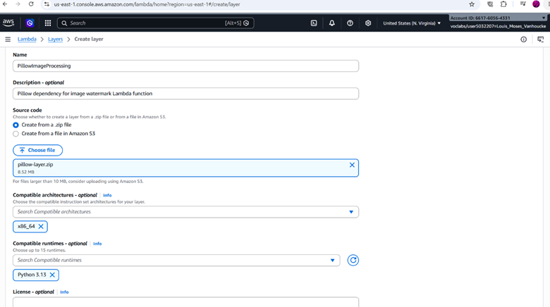Figure 3.6.2.2: Pillow file attached to PillowmageProcessing layer
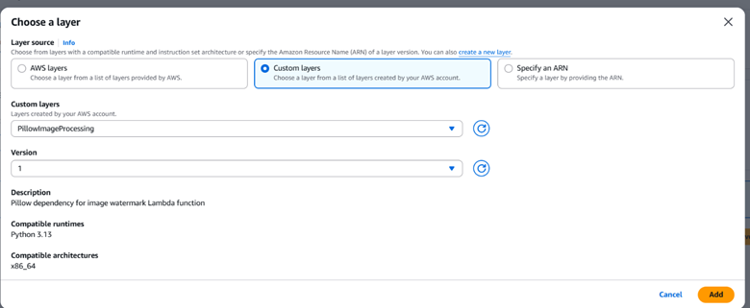Figure 3.6.2.3: PillowImageProcessing layer attached to the image-watermarking Lambda function.

Email Notification Service

An Amazon SNS Standard topic was created to handle asynchronous event alerts upon image processing.
The administrator’s email address was added as an SNS email subscription. Amazon SNS sent a confirmation email containing a confirmation link.

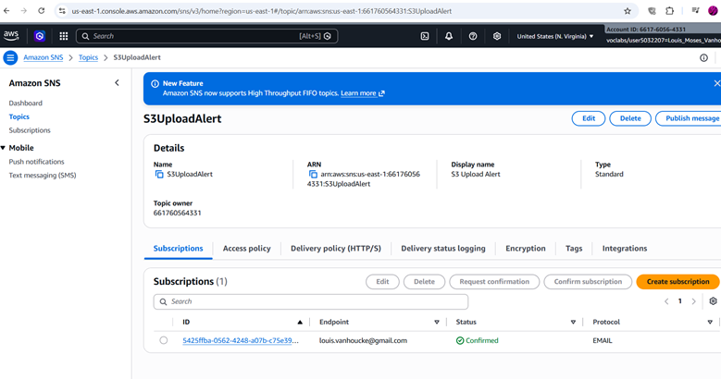Figure 3.6.3.1: Creation of SNS topic for notification
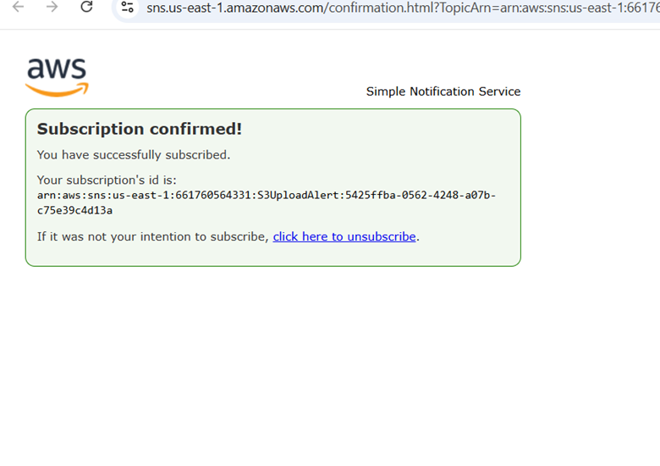Figure 3.6.3.2: Subscription Confirmation

Lambda Function Configuration

The ImageWatermarkFunction Lambda function was deployed using the AWS LabRole execution profile with optimized resource allocation:

- Runtime: Python 3.12
- Memory Allocation: 512 MB
- Ephemeral Storage (/tmp): 512 MB
- Execution Timeout: 30 seconds
- IAM Role: LabRole
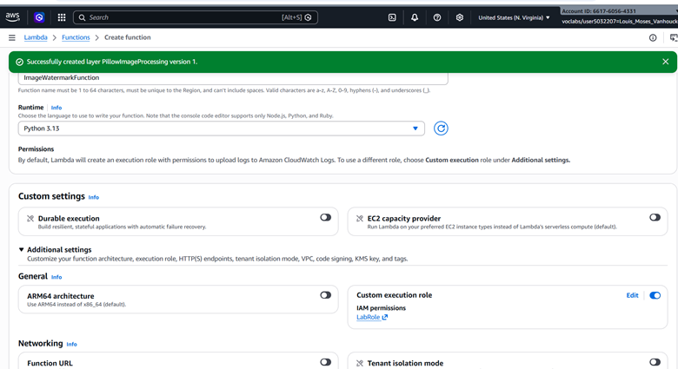Figure 3.6.4.1: Creation of Lambda function

Environment Variables
To avoid hardcoding parameters into the application source code, operational variables were decoupled into environment settings:
Environment Variable | Configured Value | Purpose
DEST_BUCKET | cat-asg2-watermarked | Identifies the destination S3 bucket for transformed output assets.
WATERMARK_TEXT | REAL WORLD PTE LTD | Defines the string overlay applied to ingested images.
SNS_TOPIC_ARN | arn:aws:sns:us-east-1:...:S3UploadAlert | Designates the target SNS topic for dispatching delivery alerts.

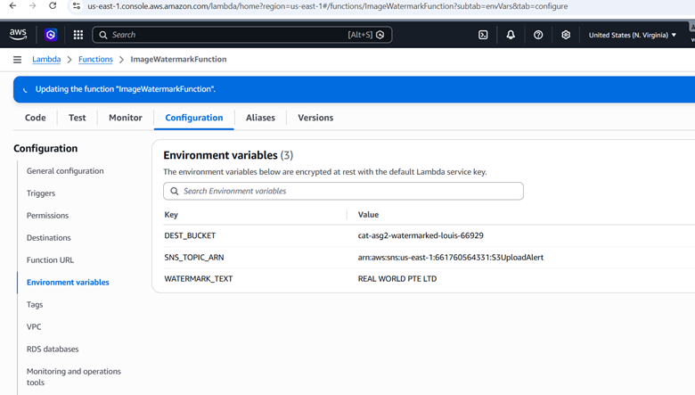Figure 3.6.5.1: Environment variables

Lambda Function code
The Python implementation inside ImageWatermarkFunction follows a 10-step execution pipeline:
- Reads the input bucket name and object key from the S3 event.
- Checks whether the file is a supported JPEG or PNG image.
- Downloads the original image from the input bucket.
- Opens the image using Pillow.
- Corrects the image orientation using available EXIF information.
- Draws a semi-transparent watermark in the bottom-right corner.
- Saves the processed image in memory.
- Uploads the result to the destination S3 bucket.
- Publishes a formatted message to the SNS topic.
- Records the execution result in CloudWatch Logs.
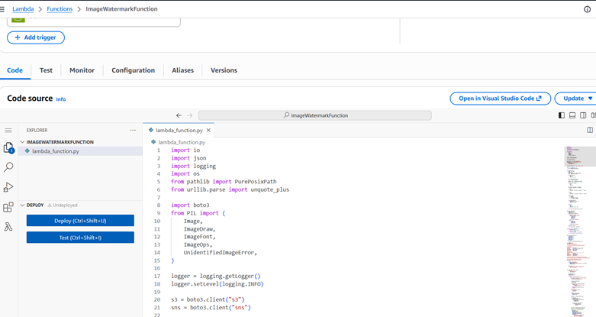Figure 3.6.6.1: Lambda Function code

Event Trigger
To establish an automated, event-driven pipeline, an Amazon S3 Event Notification trigger was configured directly on the input bucket (cat-asg2-image).
When a user uploads a new file, Amazon S3 automatically generates an event payload and invokes the ImageWatermarkFunction Lambda function asynchronously.
Connecting the trigger directly to the function removes the need for manual batch processing or polling infrastructure.
The system operates on a zero-idle-cost model, executing compute resources only during the exact milliseconds required to process newly ingested images.

Trigger Parameter | Configuration Detail | Operational Purpose
Source Service | Amazon S3 | Listens for object activity on cat-asg2-image.
Event Type | s3:ObjectCreated:* | Fires on all object creation events (e.g., Put, Post, Copy, CompleteMultipartUpload).
Target Integration | ImageWatermarkFunction | Invokes the watermarking Lambda function with file metadata.
Invocation Type | Asynchronous | Ensures immediate client response without blocking S3 upload operations.

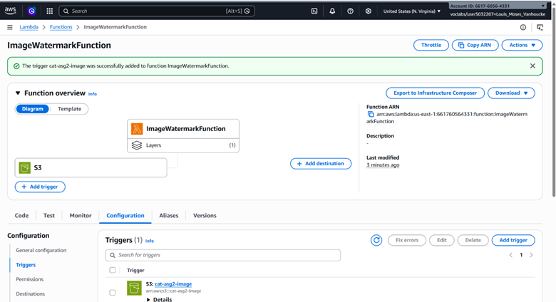Figure 3.6.7.1: Event trigger connected to the function

Low-Cost Storage Configuration

To satisfy requirement constraints for non-critical, seldom-accessed data, automated Amazon S3 Lifecycle rules were implemented to minimize long-term storage expenditures.

Targeted Bucket | Lifecycle Policy Name | Action | Timing | Justification
Output Bucket (cat-asg2-watermarked) | ArchiveWatermarkedImages | Transition to S3 Glacier Deep Archive | 1 Day after creation | Provides the lowest storage price point for cold assets. The 1-day delay retains immediate availability for initial testing and demonstration.
Output Bucket (cat-asg2-watermarked) | ArchiveWatermarkedImages | Abort incomplete multipart uploads | 7 Days after initiation | Prevents orphan upload fragments from accumulating and incurring storage fees.
Input Bucket (cat-asg2-image) | DeleteProcessedOriginals | Permanent Object Expiration (Deletion) | 7 Days after creation | Eliminates duplicate storage of raw assets once the watermarked asset is successfully archived.

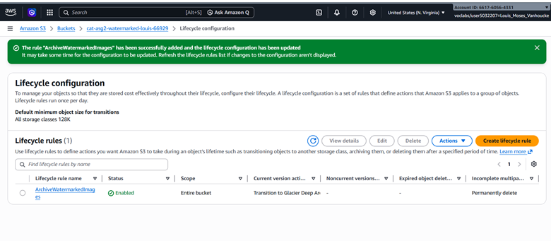Figure 3.6.8.1: Lifecycle rule created

Lambda Function Code

ProductsCRUD

The function creates a module-level DynamoDB resource and table handle. A DecimalEncoder class extends json.JSONEncoder to convert DynamoDB's Decimal type to a float. Without it, json.dumps raises a serialisation error on any item containing a numeric attribute.

The handler defines a CORS header dictionary applied to every response path, reads the HTTP method from the API Gateway v2.0 event structure, and branches accordingly.

On POST, Price is cast through Decimal(str(...)) to avoid binary floating-point rounding artefacts being persisted to the table. A UUID4 is generated for the ID key. Unmatched methods return HTTP 405.

import json
import boto3
import uuid
from decimal import Decimal
dynamodb = boto3.resource('dynamodb', region_name='us-east-1')
table = dynamodb.Table('Products')
class DecimalEncoder(json.JSONEncoder):
def default(self, obj):
if isinstance(obj, Decimal):
return float(obj)
return super().default(obj)
def lambda_handler(event, context):
headers = {
'Access-Control-Allow-Origin': '*',
'Access-Control-Allow-Headers': 'Content-Type',
'Access-Control-Allow-Methods': 'GET,POST,OPTIONS'
}

method = event.get('requestContext', {}).get('http', {}).get('method', '')

if method == 'OPTIONS':
return {'statusCode': 200, 'headers': headers, 'body': ''}

if method == 'GET':
response = table.scan()
items = response.get('Items', [])
return {
'statusCode': 200,
'headers': headers,
'body': json.dumps(items, cls=DecimalEncoder)
}

if method == 'POST':
body = json.loads(event.get('body', '{}'))
item = {
'ID': str(uuid.uuid4()),
'Category': body.get('Category', ''),
'Name': body.get('Name', ''),
'Price': Decimal(str(body.get('Price', 0))),
'Stock': int(body.get('Stock', 0))
}
table.put_item(Item=item)
return {
'statusCode': 201,
'headers': headers,
'body': json.dumps({'message': 'Product added', 'ID': item['ID']})
}

return {'statusCode': 405, 'headers': headers, 'body': 'Method not allowed'}

NotifyOnProduct

The function is invoked by the DynamoDB stream with a batch of records.

It iterates event['Records'] and processes only those where eventName is INSERT, ignoring modifications and deletions.

Stream records present attributes in DynamoDB's typed JSON format, so each field is read through its type descriptor (e.g. .get('S') for strings and .get('N') for numbers) with fallback defaults to prevent key errors.
import boto3

sns = boto3.client('sns', region_name='us-east-1')
TOPIC_ARN = 'arn:aws:sns:us-east-1:278778358971:ProductAddedAlert'

def lambda_handler(event, context):
for record in event['Records']:
if record['eventName'] == 'INSERT':
new = record['dynamodb']['NewImage']
name = new.get('Name', {}).get('S', 'Unknown')
category = new.get('Category', {}).get('S', 'Unknown')
price = new.get('Price', {}).get('N', '0')
stock = new.get('Stock', {}).get('N', '0')

message = f"""A new product has been added to the Products database:

Name: {name}
Category: {category}
Price: ${price}
Stock: {stock}

Logged by AWS Lambda - ProductAddedAlert"""

sns.publish(
TopicArn=TOPIC_ARN,
Subject='New Product Added',
Message=message
)
return {'statusCode': 200}

ImageWatermarkFunction

import io
import json
import logging
import os
from pathlib import PurePosixPath
from urllib.parse import unquote_plus

import boto3
from PIL import (
Image,
ImageDraw,
ImageFont,
ImageOps,
UnidentifiedImageError,
)

logger = logging.getLogger()
logger.setLevel(logging.INFO)

s3 = boto3.client("s3")
sns = boto3.client("sns")

DEST_BUCKET = os.environ["DEST_BUCKET"]
SNS_TOPIC_ARN = os.environ["SNS_TOPIC_ARN"]
WATERMARK_TEXT = os.environ.get(
"WATERMARK_TEXT",
"REAL WORLD PTE LTD",
)

SUPPORTED_EXTENSIONS = {".jpg", ".jpeg", ".png"}

def get_font(image_width: int):
return ImageFont.load_default()

def add_watermark(
image: Image.Image,
text: str,
) -> Image.Image:
image = ImageOps.exif_transpose(image)
base = image.convert("RGBA")

overlay = Image.new(
"RGBA",
base.size,
(255, 255, 255, 0),
)

draw = ImageDraw.Draw(overlay)
font = get_font(base.width)

margin = max(12, int(base.width * 0.025))
padding = max(8, int(base.width * 0.015))

text_box = draw.textbbox(
(0, 0),
text,
font=font,
)

text_width = text_box[2] - text_box[0]
text_height = text_box[3] - text_box[1]

x = max(
margin,
base.width - text_width - (padding * 2) - margin,
)

y = max(
margin,
base.height - text_height - (padding * 2) - margin,
)

background_box = (
x - padding,
y - padding,
x + text_width + padding,
y + text_height + padding,
)

draw.rounded_rectangle(
background_box,
radius=max(4, padding // 2),
fill=(0, 0, 0, 150),
)

draw.text(
(x, y),
text,
font=font,
fill=(255, 255, 255, 220),
)

return Image.alpha_composite(base, overlay)

def save_image_to_buffer(
image: Image.Image,
extension: str,
) -> tuple[io.BytesIO, str]:
output_buffer = io.BytesIO()

if extension in {".jpg", ".jpeg"}:
image.convert("RGB").save(
output_buffer,
format="JPEG",
quality=90,
optimize=True,
)
content_type = "image/jpeg"
else:
image.save(
output_buffer,
format="PNG",
optimize=True,
)
content_type = "image/png"

output_buffer.seek(0)

return output_buffer, content_type

def format_file_size(size_bytes: int) -> str:
if size_bytes < 1024:
return f"{size_bytes} bytes"

if size_bytes < 1024**2:
return f"{size_bytes / 1024:.2f} KB"

return f"{size_bytes / (1024**2):.2f} MB"

def send_upload_notification(
source_bucket: str,
source_key: str,
object_size: int,
output_bucket: str,
output_key: str,
event_time: str,
aws_region: str,
):
file_name = PurePosixPath(source_key).name

message = f"""
REAL WORLD PTE LTD
IMAGE PROCESSING NOTIFICATION

A new image was uploaded and watermarked successfully.

UPLOAD DETAILS
--------------------------------------------------
File name: {file_name}
File size: {format_file_size(object_size)}
Input bucket: {source_bucket}
Upload time: {event_time}
AWS region: {aws_region}

PROCESSING RESULT
--------------------------------------------------
Status: Successful
Watermark: {WATERMARK_TEXT}
Output bucket: {output_bucket}
Output key: {output_key}
--------------------------------------------------

The processed image will be transitioned to the configured
low-cost archival storage class according to the S3 lifecycle policy.

This is an automated notification from the
Real World Pte Ltd image-processing system.
""".strip()

response = sns.publish(
TopicArn=SNS_TOPIC_ARN,
Subject=f"Image processed successfully: {file_name}",
Message=message,
)

logger.info(
"SNS notification published. MessageId: %s",
response["MessageId"],
)

def lambda_handler(event, context):
logger.info(
"Received event: %s",
json.dumps(event),
)

processed_objects = []
skipped_objects = []
failed_objects = []

for record in event.get("Records", []):
try:
source_bucket = record["s3"]["bucket"]["name"]
source_key = unquote_plus(
record["s3"]["object"]["key"]
)

extension = PurePosixPath(
source_key
).suffix.lower()

if extension not in SUPPORTED_EXTENSIONS:
logger.warning(
"Skipping unsupported file: %s",
source_key,
)
skipped_objects.append(source_key)
continue

logger.info(
"Processing s3://%s/%s",
source_bucket,
source_key,
)

response = s3.get_object(
Bucket=source_bucket,
Key=source_key,
)

image_bytes = response["Body"].read()

with Image.open(
io.BytesIO(image_bytes)
) as original_image:
watermarked_image = add_watermark(
original_image,
WATERMARK_TEXT,
)

output_buffer, content_type = (
save_image_to_buffer(
watermarked_image,
extension,
)
)

file_name = PurePosixPath(source_key).name
output_key = f"watermarked/{file_name}"

# First, save the watermarked image.
s3.put_object(
Bucket=DEST_BUCKET,
Key=output_key,
Body=output_buffer.getvalue(),
ContentType=content_type,
ServerSideEncryption="AES256",
Metadata={
"source-bucket": source_bucket,
"source-key": source_key,
"watermark": WATERMARK_TEXT,
},
)

logger.info(
"Successfully saved watermarked image "
"to s3://%s/%s",
DEST_BUCKET,
output_key,
)

# Then, send the SNS email.
object_size = (
record["s3"]["object"].get("size", 0)
)

event_time = record.get(
"eventTime",
"Unknown",
)

aws_region = record.get(
"awsRegion",
"Unknown",
)

send_upload_notification(
source_bucket=source_bucket,
source_key=source_key,
object_size=object_size,
output_bucket=DEST_BUCKET,
output_key=output_key,
event_time=event_time,
aws_region=aws_region,
)

processed_objects.append(
{
"source": (
f"s3://{source_bucket}/{source_key}"
),
"destination": (
f"s3://{DEST_BUCKET}/{output_key}"
),
}
)

except UnidentifiedImageError:
logger.exception(
"Uploaded file was not a valid image"
)

failed_objects.append(
{
"key": (
record.get("s3", {})
.get("object", {})
.get("key", "unknown")
),
"reason": "Invalid image file",
}
)

except Exception as error:
logger.exception(
"Failed to process S3 object"
)

failed_objects.append(
{
"key": (
record.get("s3", {})
.get("object", {})
.get("key", "unknown")
),
"reason": str(error),
}
)

result = {
"processed": processed_objects,
"skipped": skipped_objects,
"failed": failed_objects,
}

if failed_objects:
raise RuntimeError(json.dumps(result))

return {
"statusCode": 200,
"body": json.dumps(result),
}

Testing and Results

Web Application Infrastructure

CRUD Functionality Testing on the Base Web Server
Figure 5.1.1.0 – Public IP of the web server

The base EC2 instance (WebServer-BaseTeam1) was tested directly via its public IP address prior to AMI creation, to confirm the full application stack worked correctly before being replicated across the Auto Scaling Group

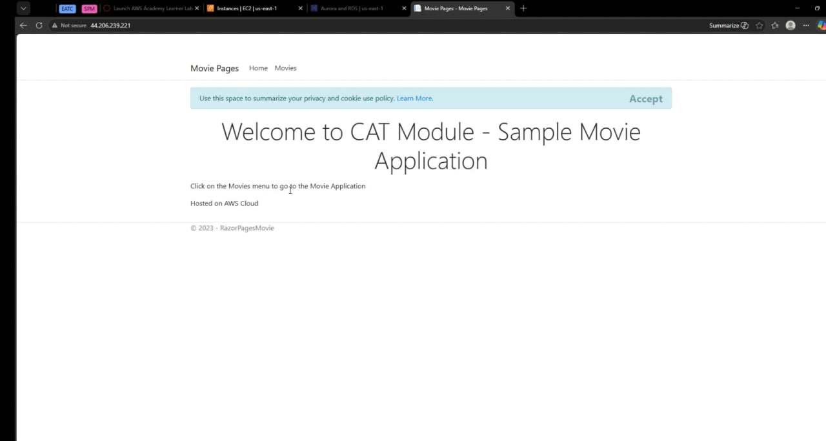
Figure 5.1.1.1 – Accessed the database using the public IP – http://44.206.239.221

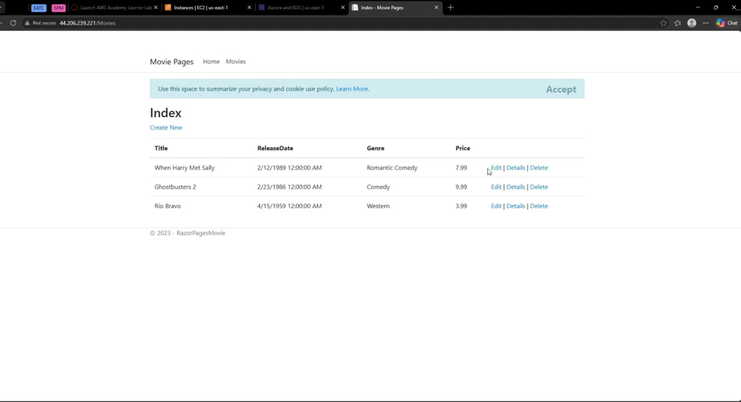
Figure 5.1.1.2 Accessed the movie page

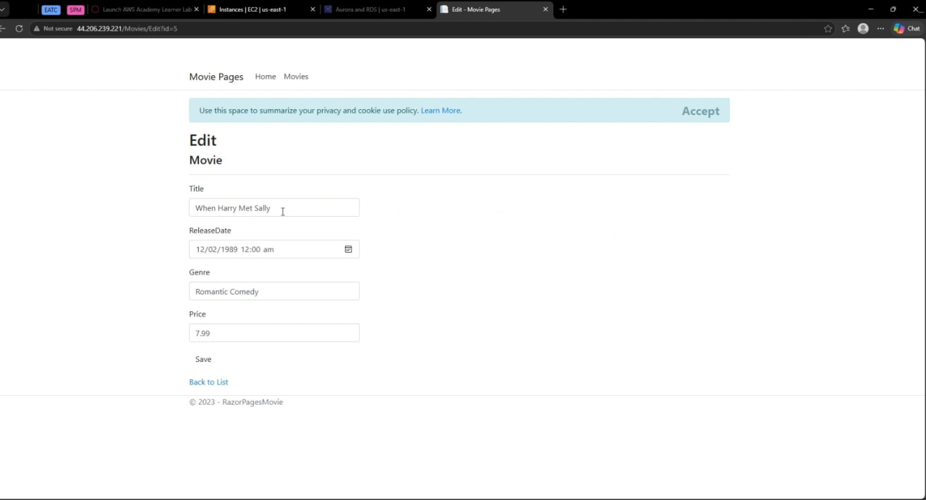
Figure 5.1.1.3 Edit the Movie name to “Hi”
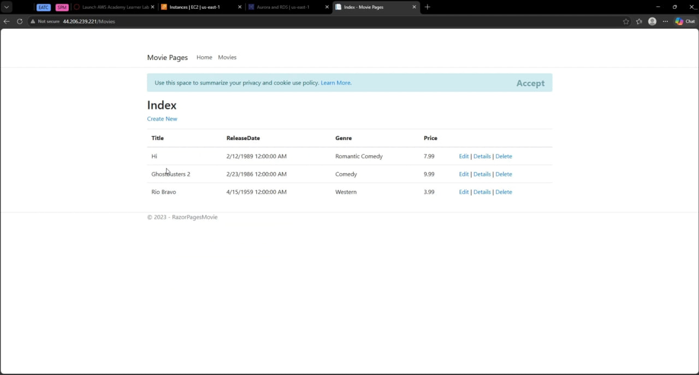
Figure 5.1.1.3 Successfully edited the Movie name to “Hi”

Create operation were performed on the Movies page, with operation verified to persist correctly in the RDS database. This confirmed the chain Browser → EC2 → IIS → .NET application → RDS was functioning end-to-end before the instance was imaged.

CRUD Functionality Testing via the Application Load Balancer

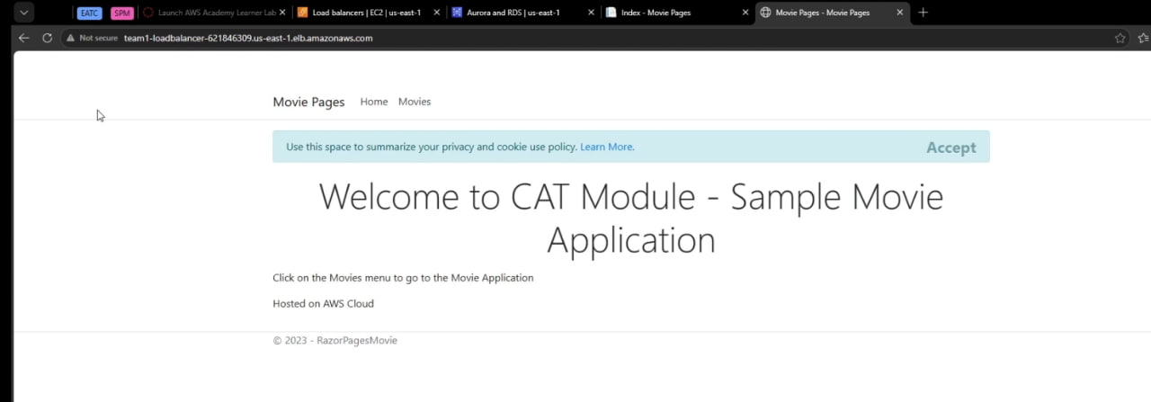
Figure 5.1.2 – Accessed the database using the DNS name

The same CRUD test was repeated through the Application Load Balancer's DNS name once the Auto Scaling Group and target group were healthy.

This confirmed that requests routed through the ALB to either of the two Auto Scaling-managed instances could also reach the shared RDS database correctly, validating that the load-balanced path preserves full application functionality rather than relying on a single instance.

Target Group Health Test
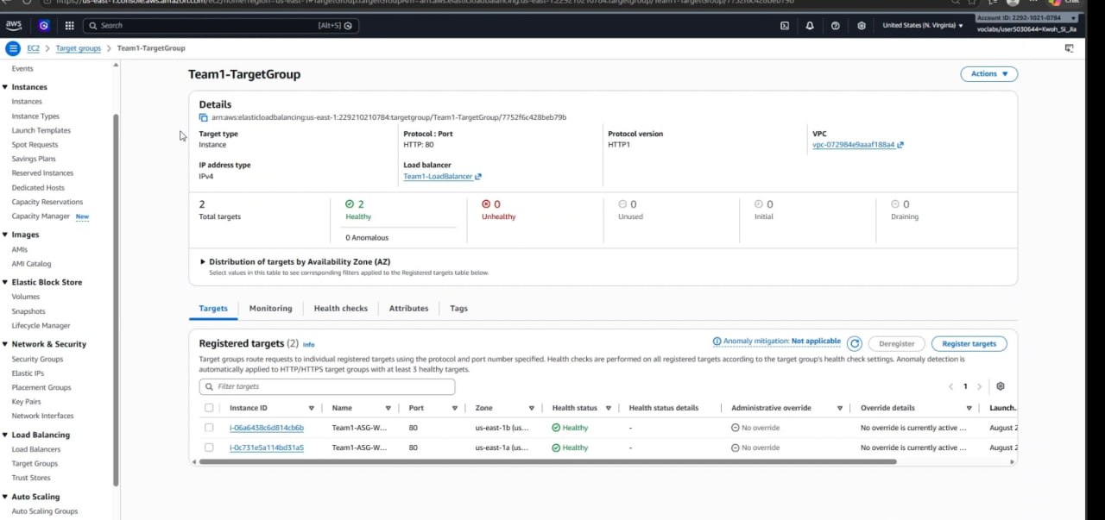
Figure 5.1.3.1 – 2 Healthy targets under target group

The target group was checked to confirm that the Application Load Balancer could communicate with the EC2 instances.

Target Group Setting | Configuration Value
Protocol | HTTP
Port | 80
Health Check Path | /
Target Fleet Health | 2 / 2 Healthy (0 Unhealthy)

This showed that IIS was running correctly on both EC2 instances and that the load balancer security group could access the EC2 instances through port 80.

The targets initially displayed an initializing or unhealthy status while Windows and IIS were starting. After the health checks completed, both targets became healthy.

Auto Scaling Group Capacity Test

The Auto Scaling Group configuration was reviewed to confirm that it met the assignment requirements.

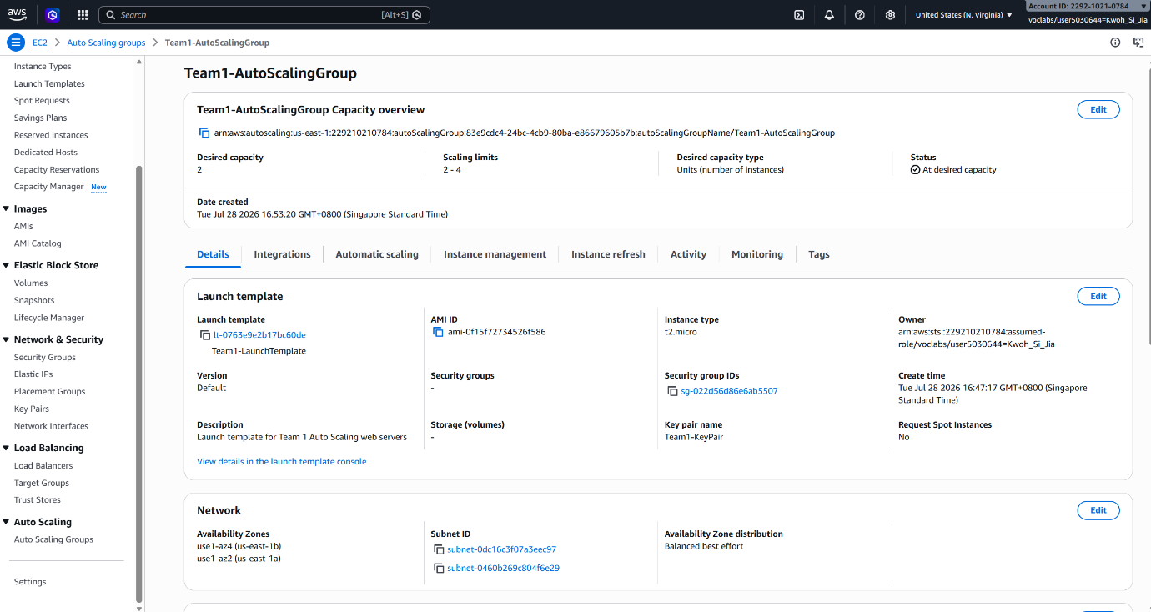
Figure 5.1.4.1 – Auto Scaling Group with accurate settings

The following settings were verified:

Parameter | Observed Setting
Auto Scaling Group Name | Team1-AutoScalingGroup
Launch Template Used | Team1-LaunchTemplate
Desired Capacity | 2
Minimum Capacity | 2
Maximum Capacity | 4
Availability Zones | us-east-1a, us-east-1b

The group successfully maintained two running EC2 instances under normal demand. The instances were launched using the custom Windows Server AMI and the launch template.

The instances were distributed across the selected Availability Zones using balanced best-effort placement.

Auto Scaling Scale-Out Test

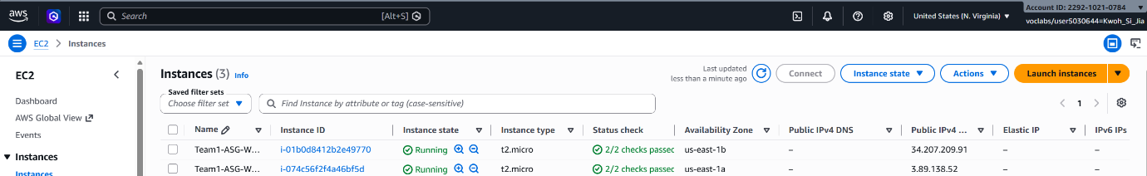
Figure 5.1.5 – Instances before the Auto Scaling Scale-Out Test

A scale-out test was performed to confirm that the Auto Scaling Group could increase capacity during high CPU demand.

For testing, the target-tracking CPU threshold was temporarily reduced from the final value of 70% to 20%. This made it easier to trigger a scaling event within the available testing time.

A PowerShell CPU workload was started on the EC2 instances using background jobs and Get-Job confirmed that the background jobs were running.

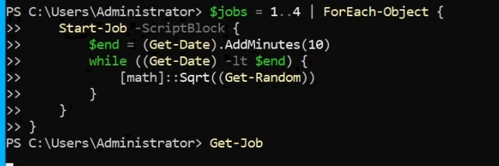
Figure 5.1.5.2 – Powershell to get the CPU workload started and confirm if it is running

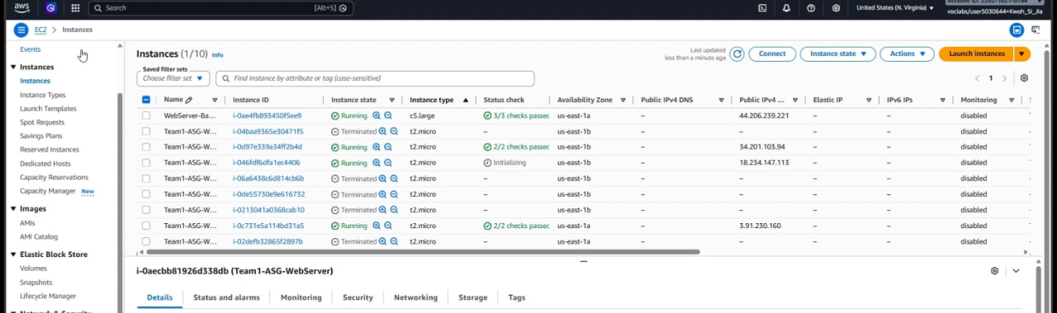
Figure 5.1.5.3 – Increase number of instances from 2 to 4 after CPU utilisation increased

As average CPU utilisation increased above the target value, the Auto Scaling Group increased the desired capacity and launched additional EC2 instances.

The number of Auto Scaling instances increased from two to four. The newly launched instances entered the initializing state before passing the EC2 and target-group health checks.

Auto Scaling Scale-In Test
After the scale-out test, the PowerShell CPU jobs were stopped and removed.

Get-Job | Stop-Job
Get-Job | Remove-Job

Stopping the jobs removed the artificial CPU load. The Auto Scaling Group did not terminate the additional instances immediately because CloudWatch required time to collect the lower CPU metrics and the target-tracking policy applied a stabilisation period.

After CPU utilisation remained below the target value, the desired capacity was reduced, and the excess Auto Scaling instances were terminated. The group eventually returned to its minimum capacity of two instances.

The separate base EC2 instance remained running because it was not managed by the Auto Scaling Group.

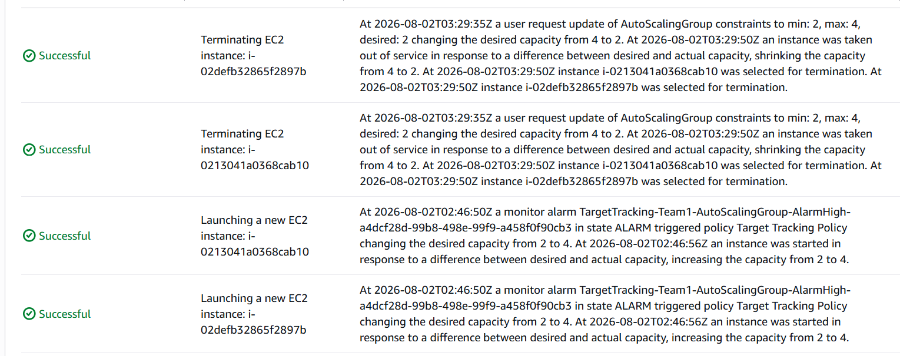
Figure 5.1.6.1 – Shows EC2 scaling in and out while testing for CPU utilization

Auto Scaling Self-Healing Test
The self-healing capability of the Auto Scaling Group was tested by deliberately terminating one EC2 instance managed by Team1-AutoScalingGroup.

Before termination, the following conditions were confirmed:
- 2 instances running
- 2 / 2 targets healthy
- Both fully accessible via Application Load Balancer DNS endpoint

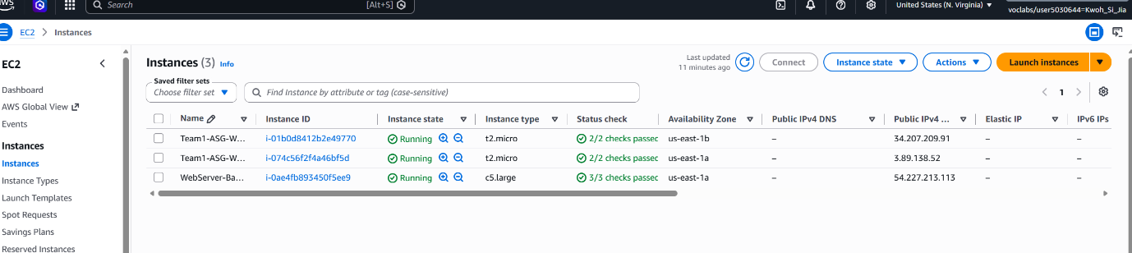
Figure 5.1.6.1 – Two healthy instances running

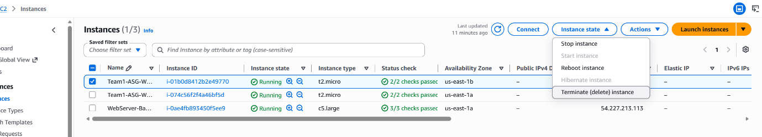
Figure 5.1.6.2 – Terminating one instance

One Auto Scaling-managed instance was then terminated manually. The ALB URL was refreshed during the test, and the application remained accessible because traffic was routed to the remaining healthy EC2 instance.

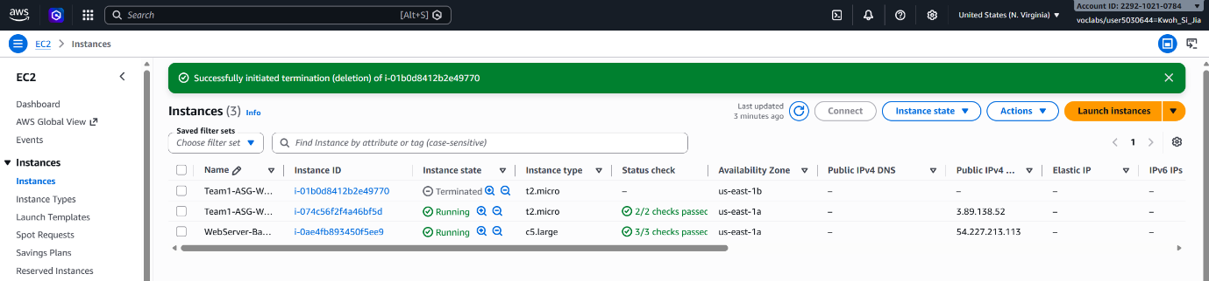
Figure 5.1.6.3 – One instance terminated

The Auto Scaling Group detected that the actual capacity had fallen below the desired capacity of two. It automatically launched a replacement EC2 instance using Team1-LaunchTemplate.

The replacement instance passed through the following stages:
Pending → Running → Status checks initializing → Status checks passed → Target group initial → Target group healthy

The target group eventually returned to two healthy targets.

Figure 5.1.6.4 – Back to two healthy instances

This test successfully demonstrated that the architecture detects compute instance failure, maintains live application availability via load balancing, and self-heals back to full desired capacity without administrator intervention.

Monitoring and Alarms

Each alarm was tested individually such that a state change could be attributed to one specific alarm and so that no alarm was accidentally left with a temporary threshold in place. The general procedure for every alarm was:

- Record the alarm’s real threshold before making any change.

- Either generate genuine load or temporarily edit the threshold to a value the current metric already breaches.

- Wait for the next evaluation period and confirm the state transitions from OK to In Alarm

- Capture the alarm graph in the In Alarm state and the corresponding SNS email

- Revert the threshold to its real value and confirm the alarm returns to OK

Two different trigger methods were used depending on what the metric measures.

For CPU, Request Count and Processed Bytes, where load could be generated safely, were all driven across their real thresholds by genuine activity.

The alarms were verified without altering the configurations. For the remaining three metrics, threshold adjustments were used instead.

Alarm | Trigger Method | Observed Result | SNS Email | Reverted
EC2-HighCPU-Alarm | Real load – CPU driven up to 100% | OK -> ALARM at 16:41:44 UTC; datapoints 100.0 and 98.73 against threshold 70 | Yes | N/A
ALB-HighTraffic-Alarm | Real load – repeated page loads | OK -> ALARM at 17:48:49 UTC; datapoints 41 and 34 against threshold 20 | Yes | N/A
ALB-HighProcessedBytes-Alarm | Real load – same traffic burst | OK -> ALARM at 17:47:53 UTC; datapoints 319.467 and 81,419 against threshold 45,000 | Yes | N/A
EC2-StatusCheckFailed-Alarm | Threshold lowered to >= 0 | OK -> ALARM on next evalaution | Yes | Yes, revert to >= 1
ALB-UnhealthyHost-Alarm | Threshold lowered to >= 0 | OK -> ALARM at 17:32:27 UTC; datapoint 0.0 against threshold 0.0 | Yes | Yes, revert to >= 1
RDS-LowFreeStorage-Alarm | Threshold raised to 25GB | OK -> ALARM at 17:57:50 UTC; datapoint 21.10GB against threshold 25GB | Yes | Yes, revert to 4GB
Table 5.2.1: Alarm Testing Log

EC2 CPU Utilisation

The alarm was tested with real load rather than by adjusting the threshold, so the evidence reflects the alarm operating exactly as it would in production.

CPU Utilisation on the Auto Scaling Group was driven to 100%, and with two consecutive datapoints of 100.0 and 98.73 against the configured threshold of 70, the alarm transitioned to In Alarm at 16:41:44 UTC.

The notification email arrived shortly afterwards and states the breaching values and timestamps explicitly. Since the threshold was not altered, there was no need to revert it.

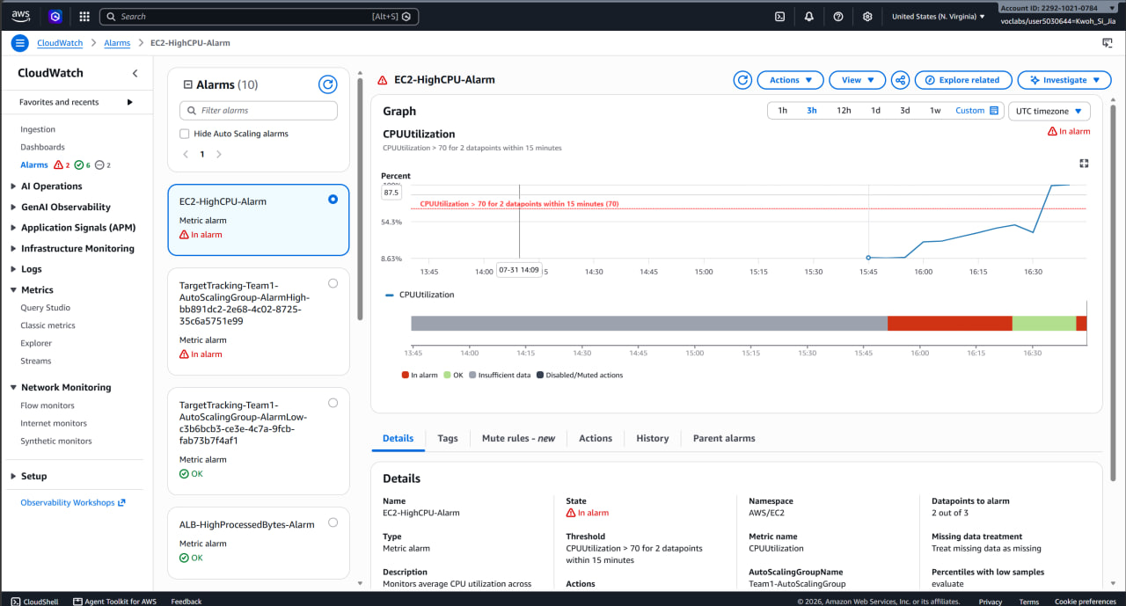
Figure 5.2.1.1: EC2-HighCPU-Alarm in the In Alarm state
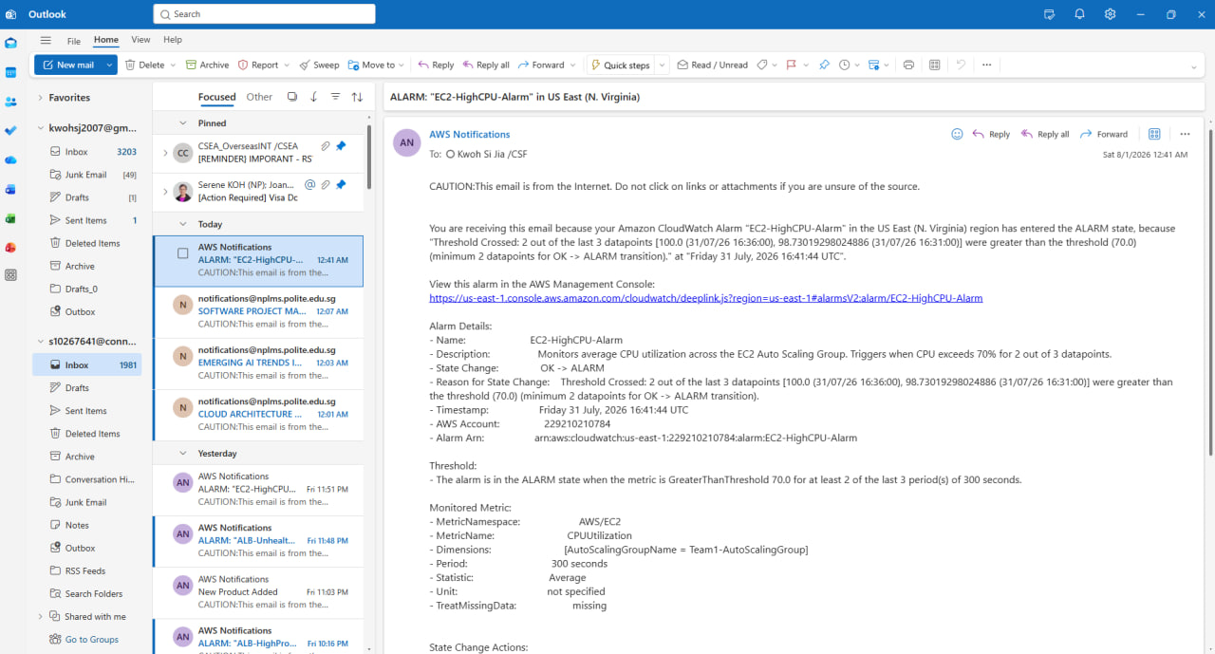
Figure 5.2.1.2: Email notification received via SNS for the CPU alarm

Load Balancer Traffic Alarms

ALB-HighTraffic-Alarm and ALB-HighProcessedBytes-Alarm were tested together in one traffic-generation session, since both respond to the same underlying activity and a single burst produces a consistent, mutually verifying set of evidence.

Repeatedly loading the application through the load balancer raised RequestCount to 41 and 34 across consecutive periods against a threshold of 20, and the same burst pushed ProcessedBytes to 319,467 and 81,419 bytes against a threshold of 45,000.

Both alarms transitioned within a minute of each other, at 17:48:49 and 17:47:53 UTC respectively, and both delivered email notifications. Neither threshold was modified.

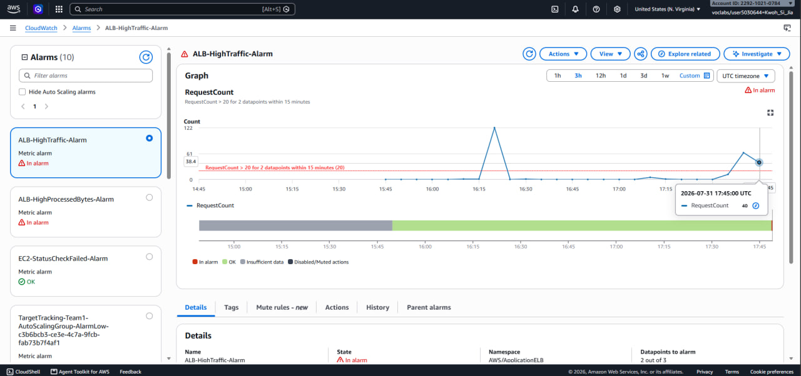
Figure 5.2.2.1: ALB-HighTraffic-Alarm in the In Alarm state
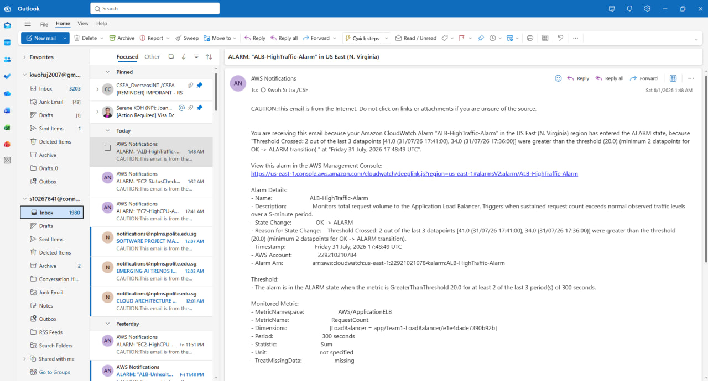
Figure 5.2.2.2: Email notification received for ALB-HighTraffic-Alarm

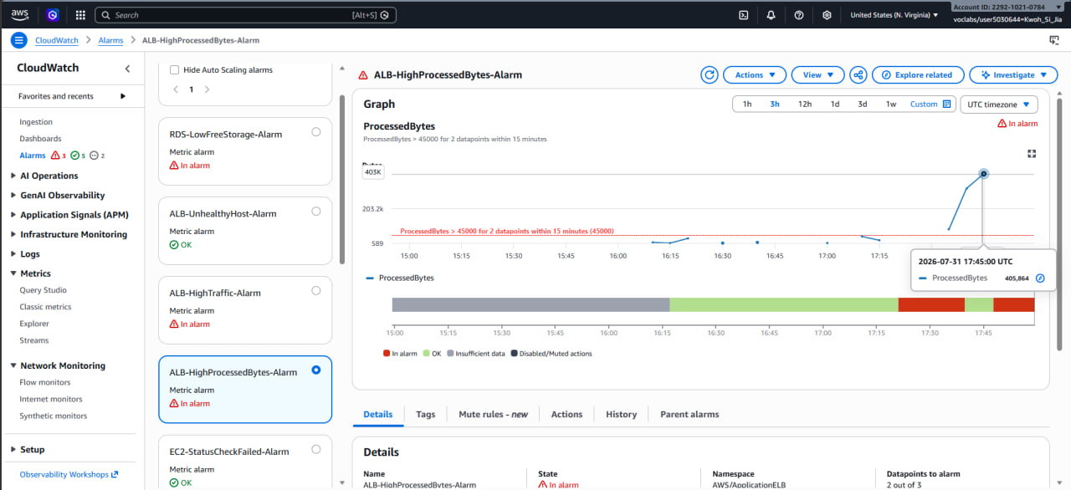
Figure 5.2.2.3: ALB-HighProcessedBytes-Alarm in the In Alarm state
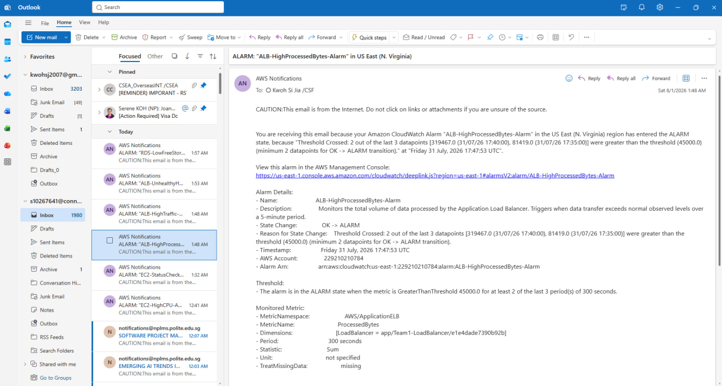
Figure 5.2.2.4: Email notification received for ALB-HighProcessedBytes-Alarm

Failure Alarms

EC2-StatusCheckFailed-Alarm and ALB-UnhealthyHost-Alarm were both verified by temporarily changing the threshold to “greater than or equal to 0”, such that the healthy baseline value of zero satisfies the conditions.

In each case, the alarm transitioned on the next evaluation period and the notification email arrived within a few minutes.

The email for ALB-UnhealthyHost-Alarm records the reason as a datapoint of 0.0 meeting a threshold of 0.0 at 17:53:26 UTC, which confirms the full evaluation and delivery path even though no host had actually failed.

Both thresholds were then restored to their real value of 1 and each alarm was observed returning to the OK state, which additionally confirms that the alarms reset correctly rather than latching.

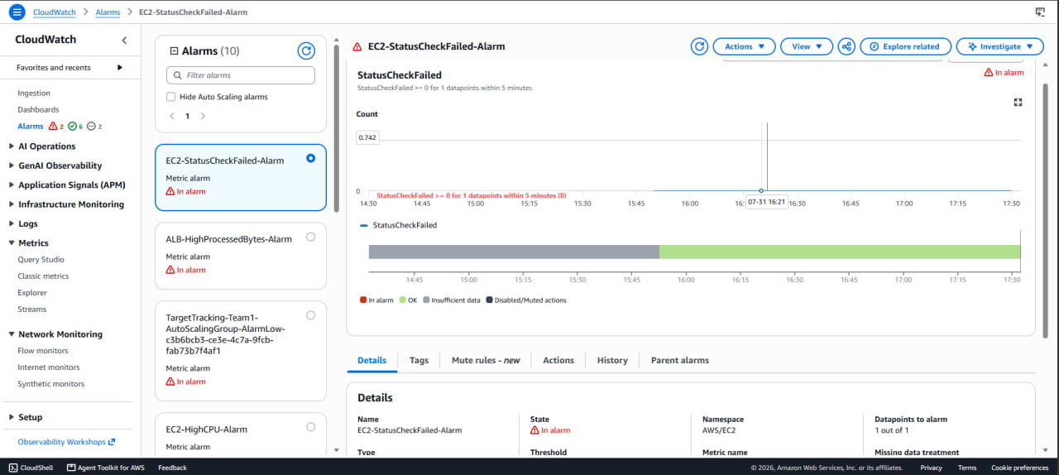
Figure 5.2.3.1: EC2-StatusCheckFailed-Alarm in the In Alarm state
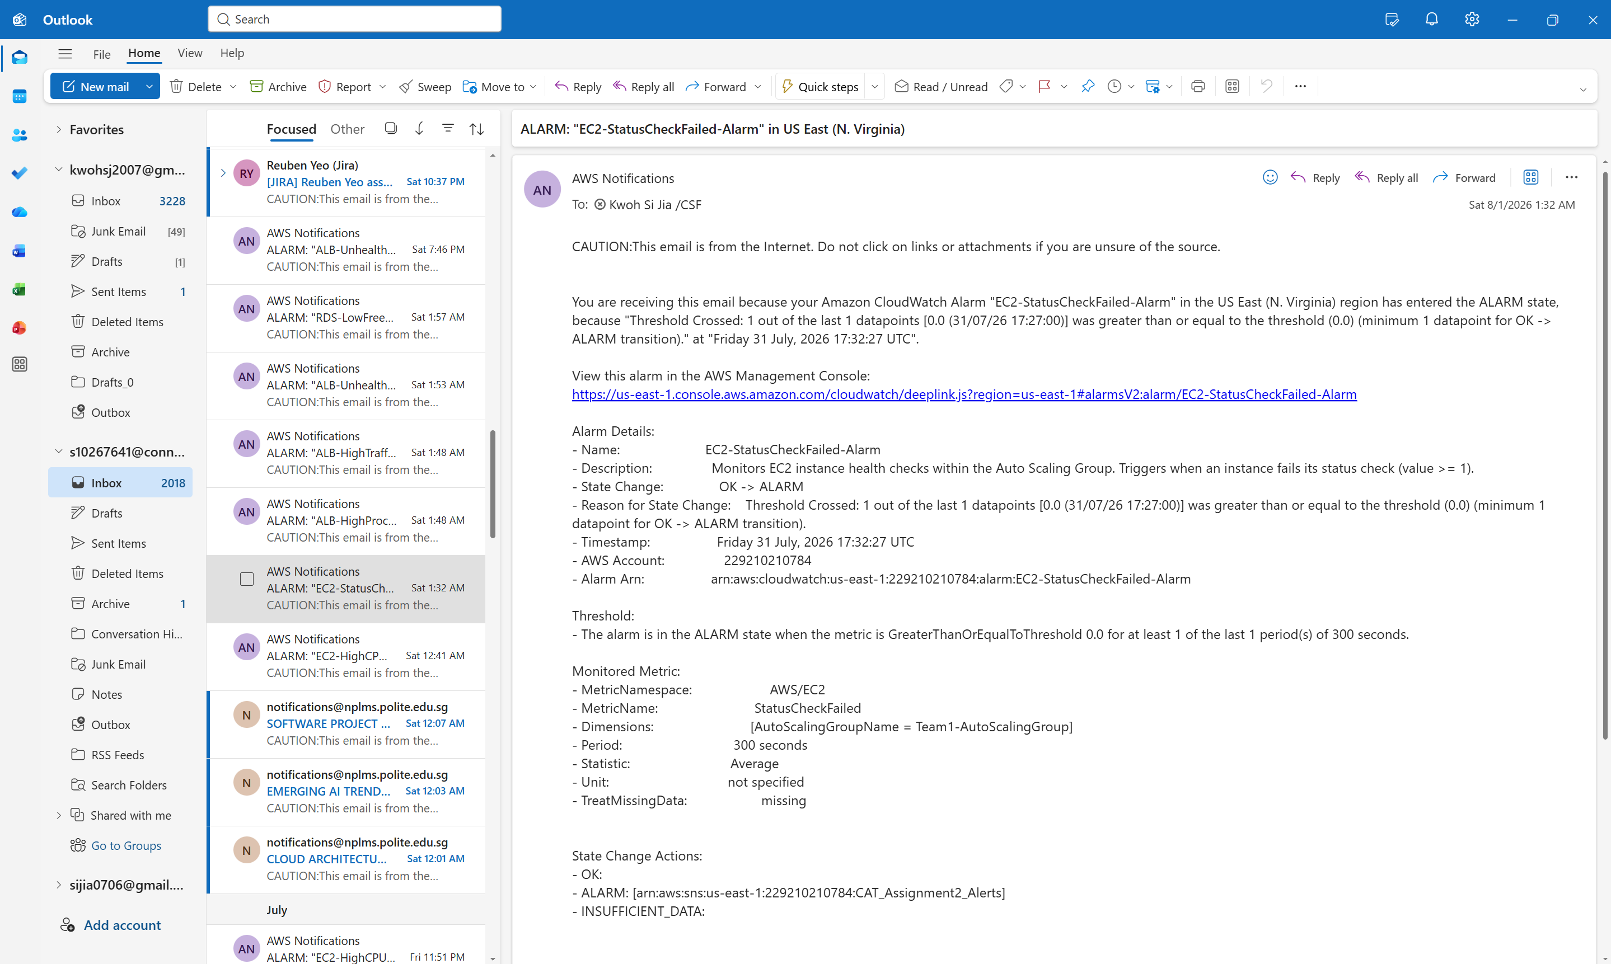
Figure 5.2.3.2: Email notification received for EC2-StatusCheckFailed-Alarm

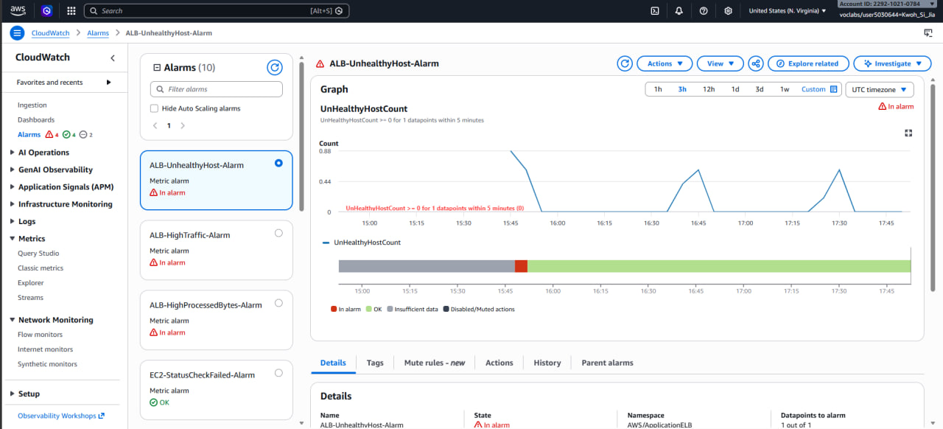
Figure 5.2.3.3: ALB-UnhealthyHost-Alarm in the In Alarm state
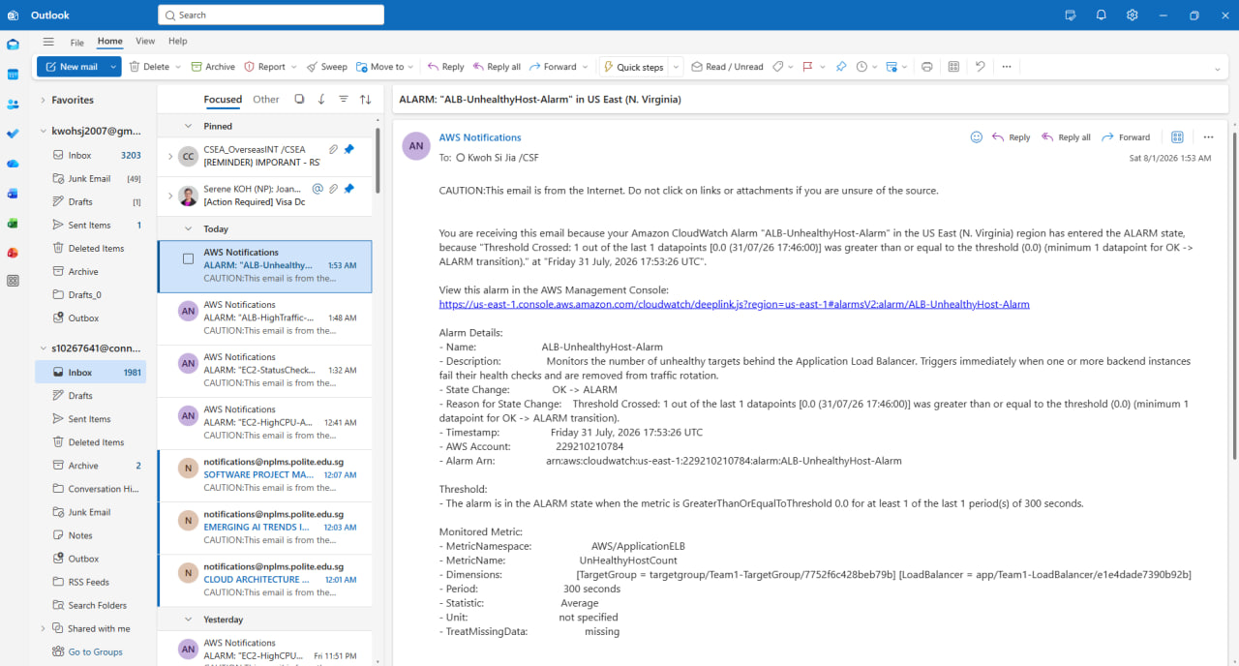
Figure 5.2.3.4: Email notification received for ALB-UnhealthyHost-Alarm

RDS Free Storage

Since this alarm uses a “lower than” comparison, it was tested by raising the threshold above the current reading rather than by consuming real disk space, which would have risked leaving the database unwritable for the rest of the team.

The threshold was temporarily raised from 4GB to 25GB, and with actual free storage at 21.10GB the condition was immediately satisfied and the alarm transitioned at 17:57:50 UTC and the email recorded the breaching datapoint and threshold. The threshold was then restored to 4GB.

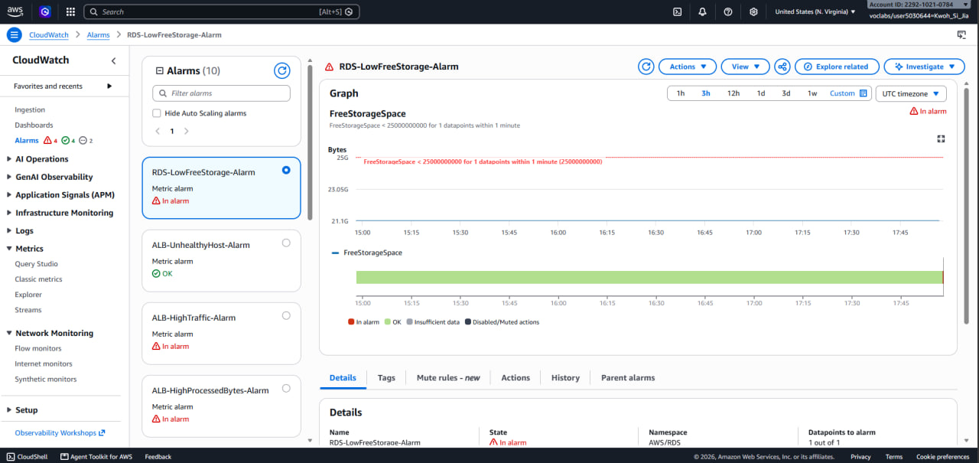
Figure 5.2.4.1: RDS-LowFreeStorage-Alarm in the In Alarm state
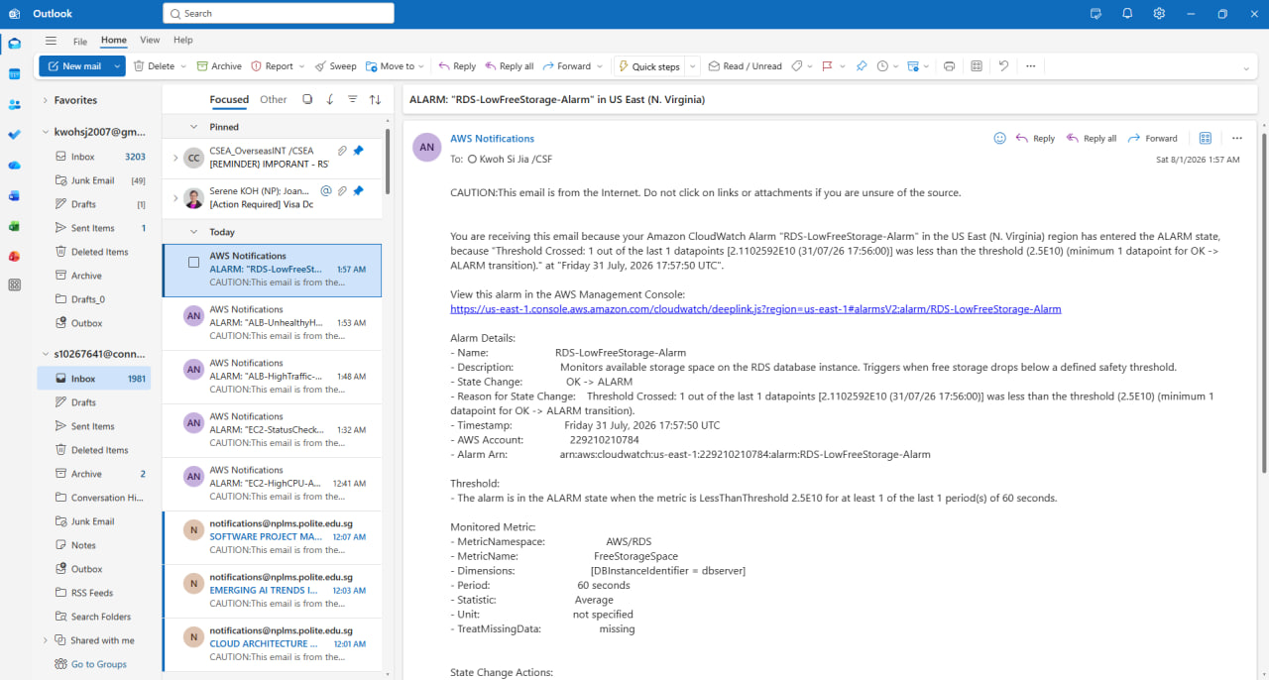
Figure 5.2.4.2: Email notification received for RDS-LowFreeStorage-Alarm

CloudWatch Dashboard

The dashboard was reviewed to confirm that it reflects live system behaviour rather than static placeholders.

EC2 CPU utilisation sits flat at roughly 8% until 15:50 then climbs to a peak of 98.7% shortly after 16:30 before decaying away, the same event that placed EC2-HighCPU-Alarm into the alarm state at 16:41:44 UTC.

NetworkIn spikes to approximately 2MB just before the CPU rise, and ProcessedBytes and RequestCount spike past 27,400 shortly afterwards.

StatusCheckFailed held at zero throughout, which indicates that no instance failed under load.

FreeStorageSpace held at 21.1GB against a 4GB threshold.

Database Connections remained at zero and RDS CPU oscillated within a narrow idle band, confirming that the CPU spike originated in the web tier rather than a database bottleneck.

The correlated movement across independent widgets confirms the dashboard is collecting genuine metrics and that grouping them by function makes a change in system state readable briefly.
Figure 5.2.5.1: CloudWatch Dashboard

Serverless Application and Notifications

Testing proceeded from the innermost component outward so that any failure could be attributed to a specific layer rather than the entire pipeline.
The ProductsCRUD function was first tested in isolation using the Lambda console's test facility. A test event replicating an API Gateway v2.0 POST payload was constructed:

{
"version": "2.0",
"routeKey": "POST /products",
"rawPath": "/products",
"headers": {
"content-type": "application/json"
},
"requestContext": {
"http": {
"method": "POST",
"path": "/products",
"sourceIp": "175.156.233.124"
}
},
"body": "{\"Category\":\"Electronics\",\"Name\":\"Monitor\",\"Price\":249.90,\"Stock\":15}",
"isBase64Encoded": false
}

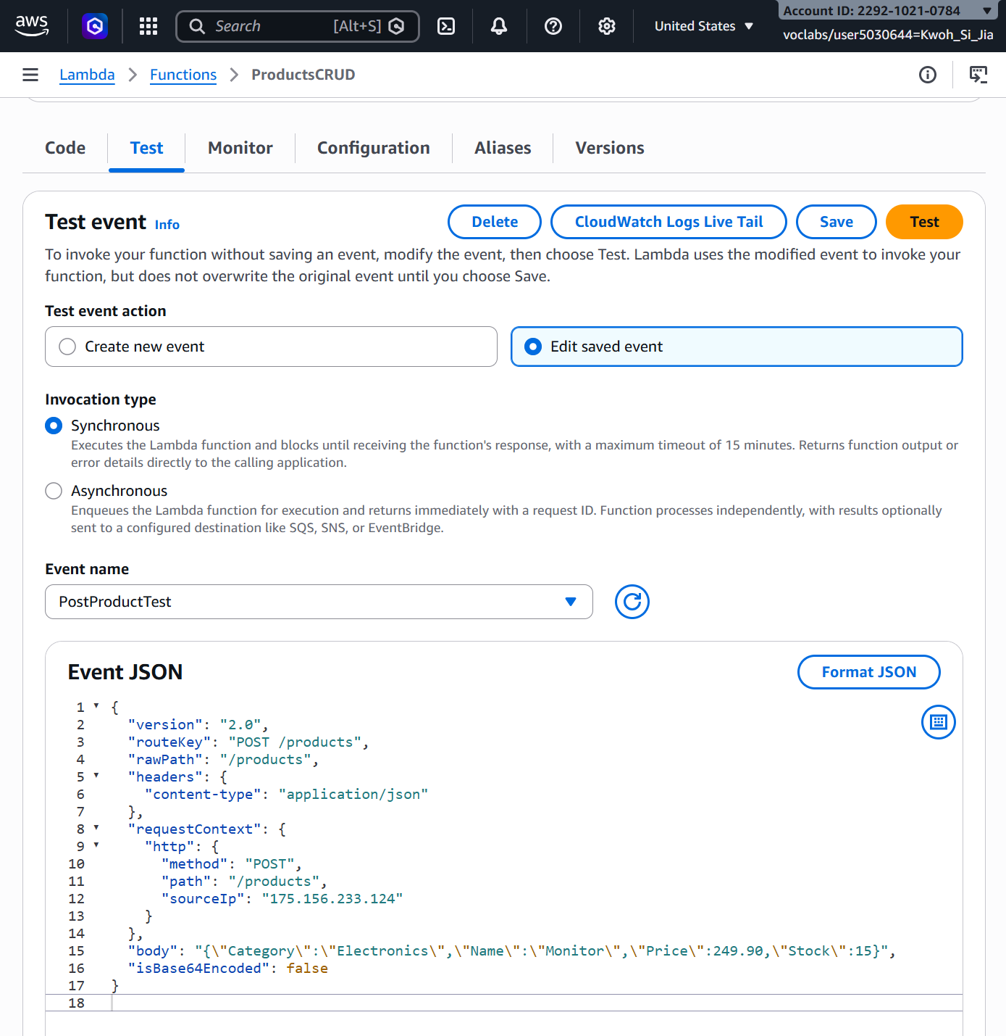
Figure 5.3.1: Constructing the PostProductTest event payload in the Lambda Console
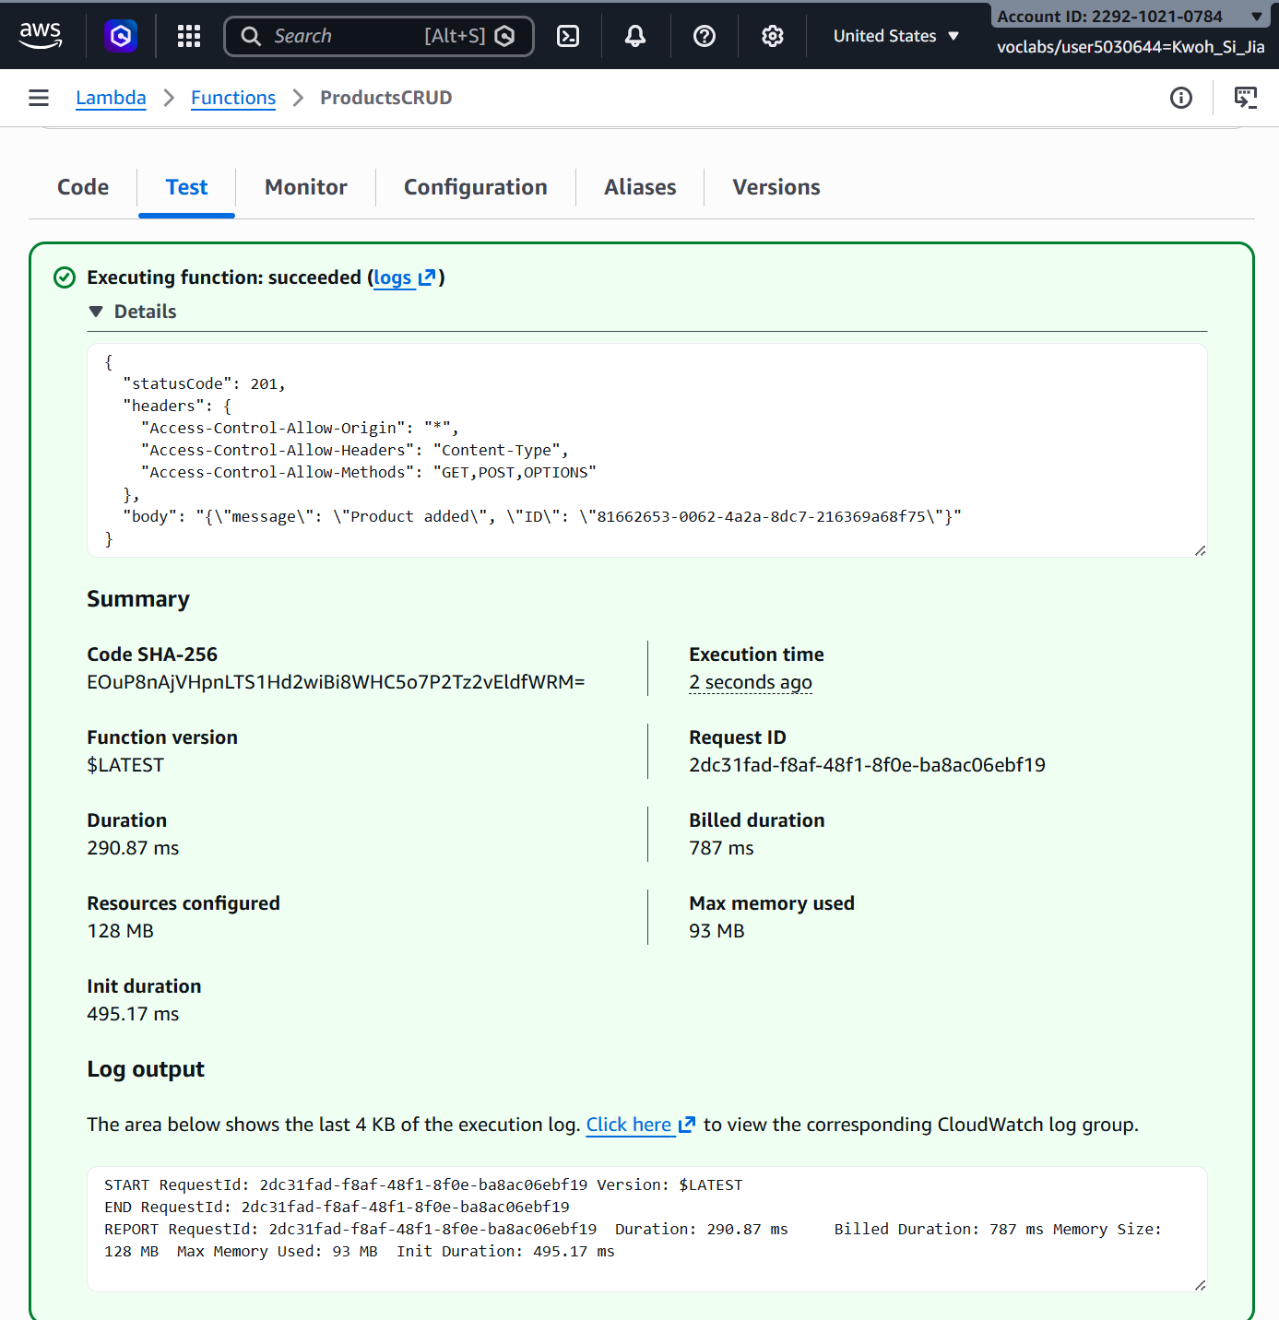
Figure 5.3.2: Test execution result showing HTTP 201 status code and generated product ID

With the function proven, the API layer was tested by invoking the /products endpoint directly. End-to-end testing was then performed through the hosted web page: a product was submitted via the form, the success banner was displayed, and the record appeared in the Current Products table upon clicking refresh.

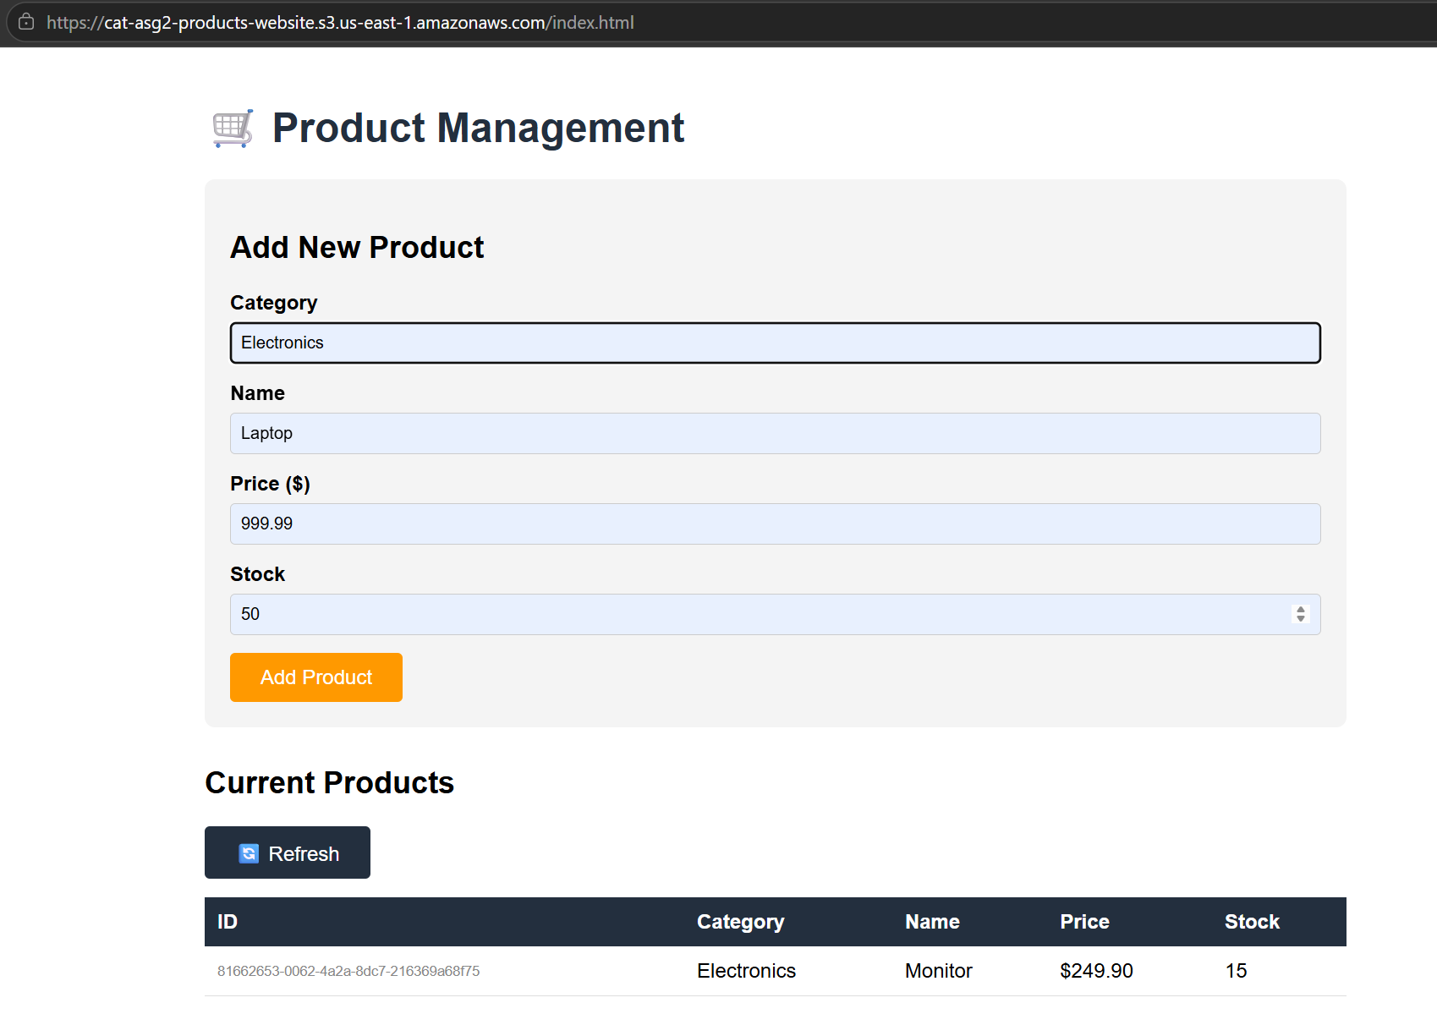
Figure 5.3.3: Submitting a new product through the hosted S3 web page interface
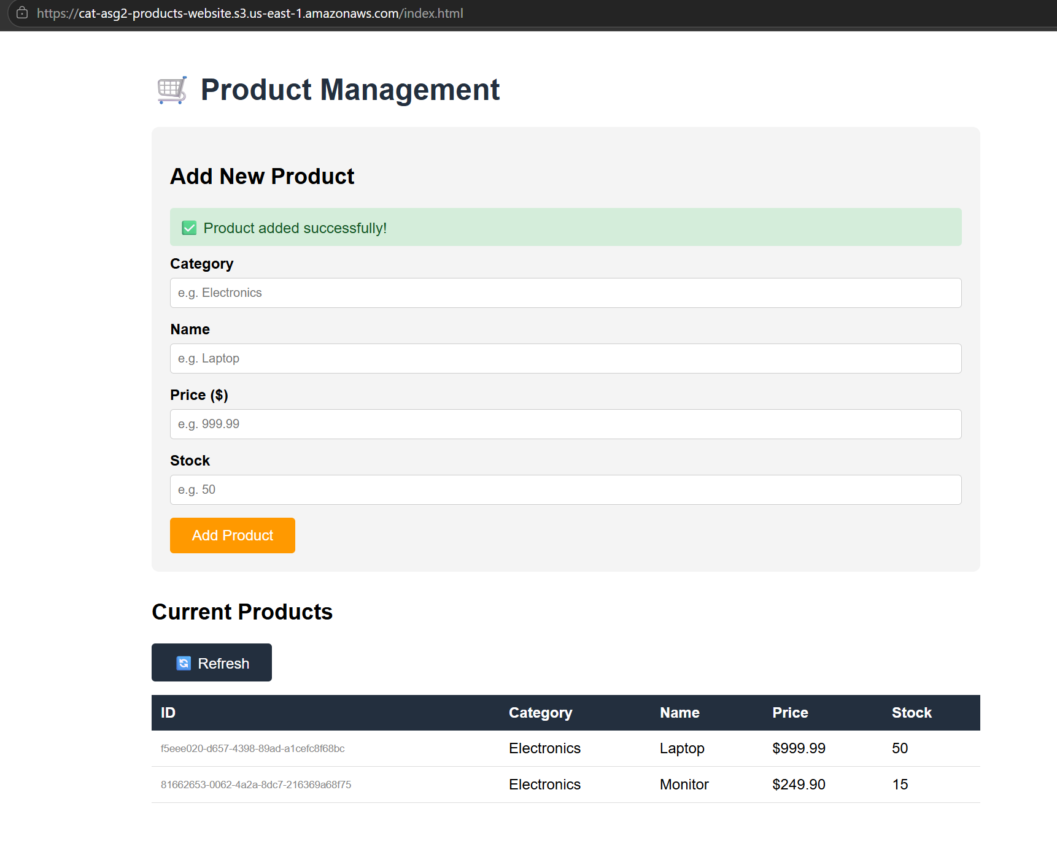
Figure 5.3.4: Product added successfully banner and updated records table view

The presence of the item was independently verified in the DynamoDB console using Explore table items, confirming actual database persistence.

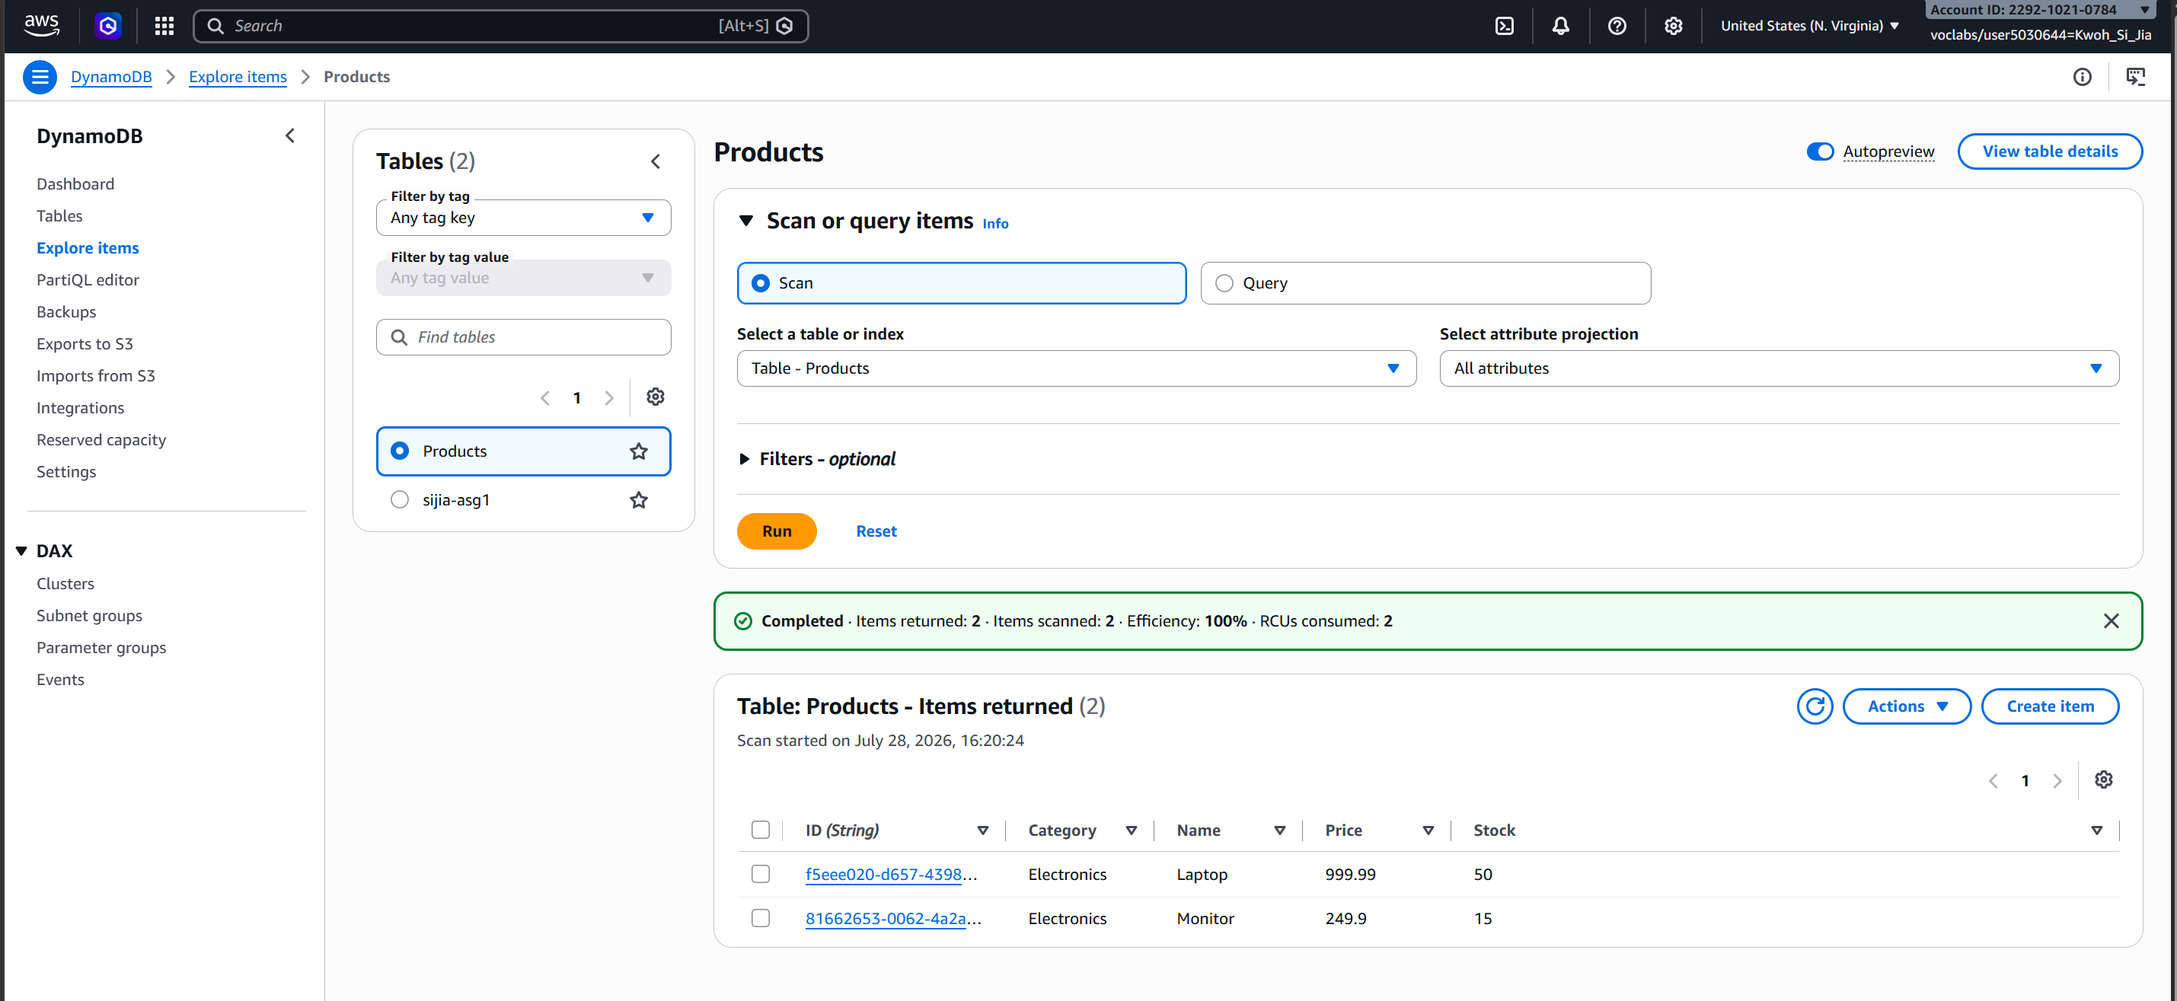
Figure 5.3.5: Verifying persisted records in the DynamoDB Products table console

The notification path was verified by the arrival of a formatted email at the subscribed administrator address within seconds of each insert.

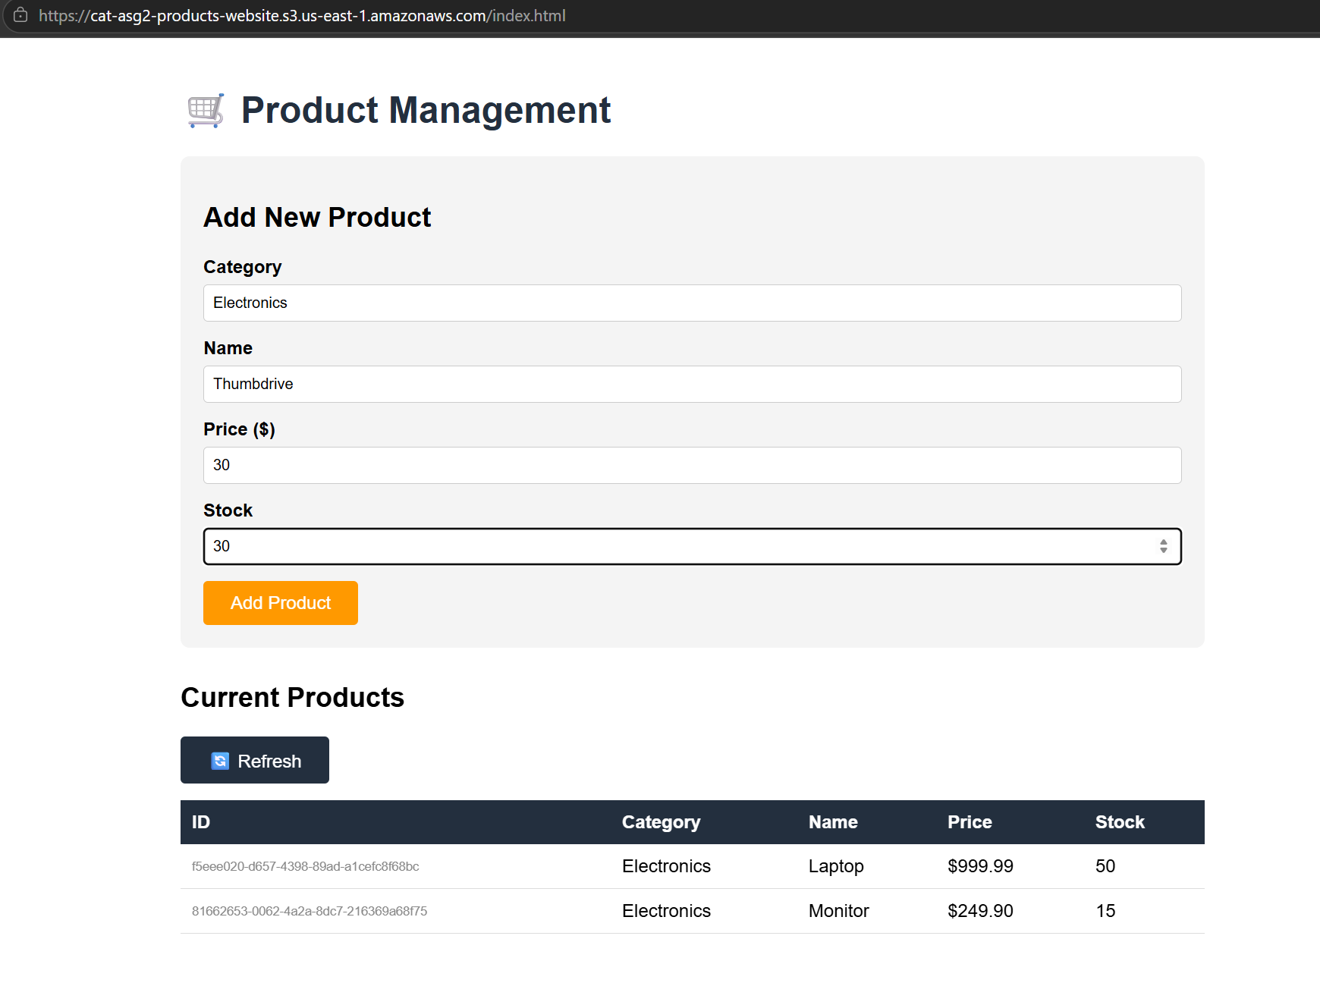
Figure 5.3.6: Submitting an additional item (Thumbdrive) via the web interface

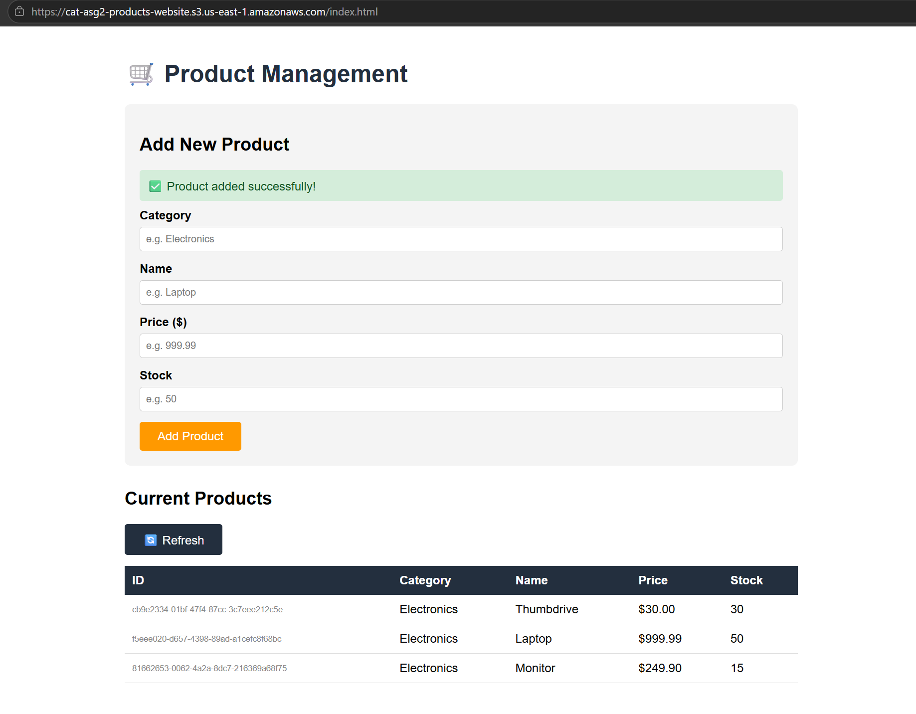
Figure 5.3.7: Refreshed current products table reflecting the newly added Thumbdrive
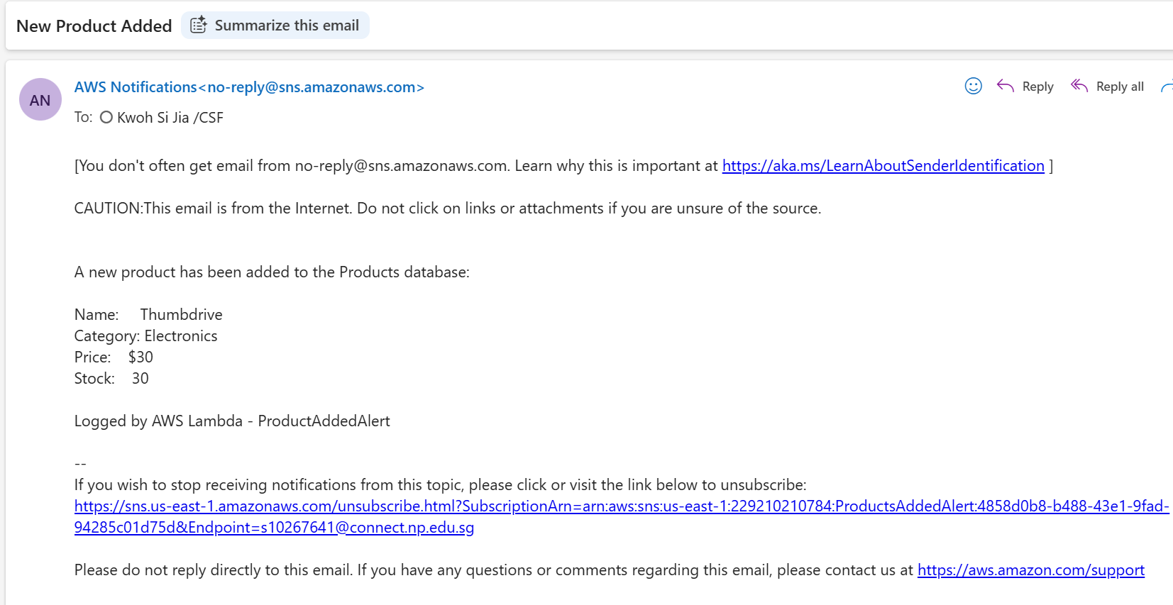

Figure 5.3.8: Formatted email notification received via SNS for the added product

Image Watermarking Service


Figure 5.4.1: Original test image

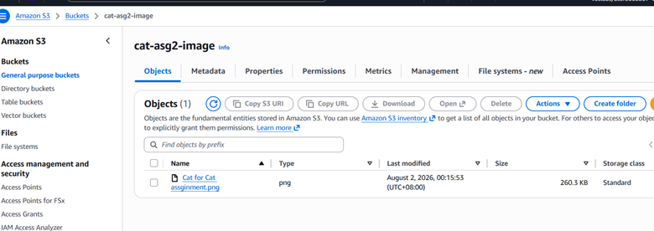
Figure 5.4.2: Uploading test image to input bucket
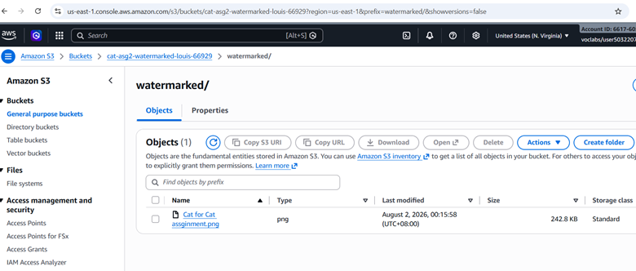
Figure 5.4.3: Image successfully uploaded to output bucket

Figure 5.4.4: Test image successfully watermarked

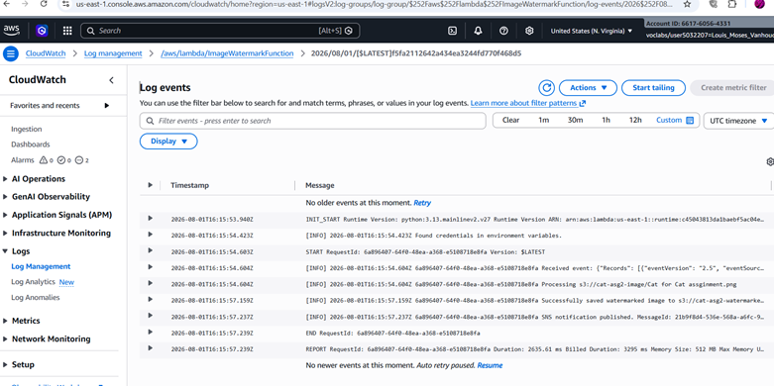Figure 5.4.5: Cloudwatch logs
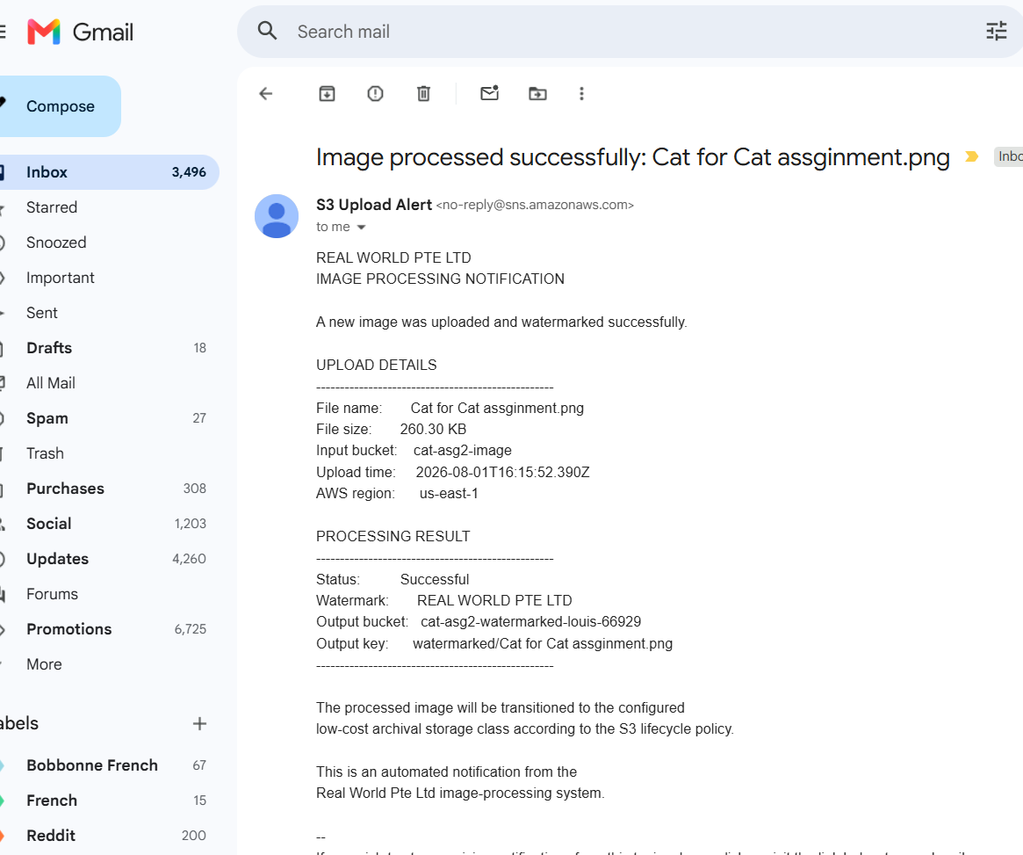
Figure 5.4.6: Email Received

Problems and Resolutions

API Gateway Route Mismatch

- Problem: When testing the serverless product application via the web front end, the initial fetch requests to API Gateway failed with HTTP 404 Not Found or 403 Forbidden errors. The route configured in the API Gateway endpoint script was set to /products/ (with a trailing slash), whereas the frontend request and API Gateway resource path definition were expecting /products.

- Resolution: API Gateway treats /products/ and /products as two distinct resource routes. The Lambda function code and API Gateway route configurations were updated to explicitly match /products without the trailing slash. Additionally, route paths in the front-end JavaScript were standardized to ensure seamless endpoint routing.

CORS Preflight Errors

- Problem: When attempting to submit new product records from the static HTML website hosted on Amazon S3 (cat-asg2-products-website) to API Gateway, the browser blocked the request due to a Cross-Origin Resource Sharing (CORS) policy failure.

- Resolution: CORS handling was configured directly at the API Gateway level under the ProductsAPI settings. The headers Access-Control-Allow-Origin: *, Access-Control-Allow-Headers: Content-Type, and Access-Control-Allow-Methods: GET, POST, OPTIONS were explicitly declared.

AWS Well-Architected Framework

Security

- Apply security at all layers: All browser-to-API traffic is encrypted in transit via API Gateway TLS. Data at rest is encrypted automatically by DynamoDB (AWS-owned key) and S3 (server-side encryption).

- Restrict public access: Block Public Access is enforced on the upload bucket, while public read access is strictly limited to the static web hosting bucket.

- Principle of least privilege: CORS headers are locked down to explicit methods (GET, POST, OPTIONS) and specific headers rather than allowing wildcards everywhere.

- Maintain traceability: Every Lambda invocation generates logs in CloudWatch Logs, while SNS delivers real-time audit records for data writes and uploads.

Reliability

- Automatically recover from failure: Lambda automatically retries failed DynamoDB stream batches, and SNS handles email delivery retries without application intervention. The Auto Scaling Group automatically replaces unhealthy or failed instances.

- Decoupled architecture: Decoupling stream processing from API writes ensures alerting issues cannot fail database transactions.

- Stop guessing capacity: Serverless services (DynamoDB, Lambda) auto-scale with real-time request volume.

- Test recovery procedures: Component-level testing (Console Test Events → API Gateway → Front-end) isolates failures quickly, while stream filtering on INSERT prevents erroneous alerts.

Performance Efficiency

- Use serverless architectures: Eliminates server management, OS patching, and manual capacity provisioning.

- Offload static content: Serving front-end code via S3 offloads static file delivery completely from backend compute resources.

Cost Optimisation

- Adopt a consumption model: Charges are purely event-driven (billed per request, invocation millisecond, and storage usage). Idle resources incur zero compute costs.

- Stop spending money on undifferentiated heavy lifting: Managed services remove database administration and server maintenance overhead, while S3 web hosting costs cents per month compared to running EC2 instances.

- Measure overall efficiency: Auto Scaling ensures that EC2 instance run only when needed.

Sustainability

- Maximize utilization: Compute resources execute only during invocation milliseconds rather than idling 24/7 on dedicated hardware.

- Resource efficiency: Consolidating CRUD actions into a single function minimizes idle environment initialization.

- Use managed multi-tenant services: DynamoDB, Lambda, API Gateway, and SNS operate on shared AWS infrastructure tuned for high baseline efficiency.

- Reduce downstream workload impact: Static S3 delivery minimizes unnecessary server-side compute cycles per page visit.

Operational Excellence

- Anticipate failure: Alarms are split into performance and failure classes. Failure alarms catch conditions that performance alarms structurally cannot, since a crashed instance registers as low CPU.

Cloud Monitoring Plan

The monitoring plan covers both the migrated web application infrastructure and the serverless components and is built on the principle that monitoring exists to shorten the time between a problem occurring and someone knowing about it.

Monitoring Techniques

Metric-based monitoring

CloudWatch collects numeric metrics at fixed intervals from every deployed service. These provide the quantitative baseline against which alarm thresholds are set and trends are assessed.

Service | Metrics Collected
EC2/Auto Scaling | CPUUtilization, StatusCheckFailed, NetworkIn, NetworkOut, Scaling activities
Application Load Balancer (ALB) | RequestCount, ProcessedBytes, HealthyHostCount, UnhealthyHostCount
Amazon RDS | FreeStorageSpace, CPUUtilization, DatabaseConnections

Not every collected metric has a corresponding alarm.

RDS CPUUtilization and DatabaseConnections are displayed on the dashboard for diagnostic context but are not alarmed.

This is because they inform the interpretation of a problem rather than signalling one independently. Alarming on every visible metric would produce noise without adding actionable information.

Health Check Monitoring
The Application Load Balancer continuously probes each registered target.

An instance that fails consecutive checks would be removed from the target group so that user traffic stops being routed to it and the Auto Scaling Group would replace it.

This is monitoring that acts and not just report which makes the architecture self-healing for common cases of a single instance falling.

Alerting and Notification

All infrastructure alarms are delivered by email through CAT_Assignment2_Alerts SNS topic, while application event notifications use their own topics such that two streams can be filtered or muted independently.

Every notification would name the alarm, the breaching datapoints, the threshold and a timestamp such that the recipient can begin diagnosis from the email itself.

Alert quality was also a concern where performance alarms on volatile metrics would require two out of three breaching datapoints before firing.

This is such that transient spikes do not generate noise while failure alarms and the storage alarm evaluate just a single datapoint as any delay would costs a lot and the metrics does not fluctuate. This purpose of this asymmetry is to prevent alert fatigue.

Monitoring Principles

- Proactive Monitoring: Thresholds give warning before users are affected so that problems are addressed rather than discovered from a user complaint. For example, free storage is flagged with 4 GB remaining out of 21GB and not at zero.

- Observability: Metrics provide a clear visibility into the system’s behaviour where infrastructure, request path, code and business activity are covered respectively. A fault at nay layer would surface somewhere.

- Automation: Auto Scaling and ALB health checks remediate compute-capacity and instance-failure conditions without human involvement. Conditions where automated remediation could worsen the outage are escalated to a person instead.

- Scalability: Metrics are collected against the Auto Scaling Group and Load Balancer dimensions instead of individual instance IDs so that instances added or removed by scaling are covered automatically with no configuration change.

References

Sarthak. (2018, August 22). How create a serverless website using AWS Lambda, AWS S3, AWS API Gateway and AWS DynamoDB with node.js? Full Tutorial! The Web Spark. https://sarthaksrivastavablog.wordpress.com/2018/08/22/how-create-a-serverless-website-using-aws-lambda-aws-s3-aws-api-gateway-and-aws-dynamodb-with-node-js-full-tutorial/

‌

