

Cybersecurity Operations & Threat Intelligence
Year 2 (2025/26), Semester 4

SCHOOL OF INFOCOMM TECHNOLOGY
Diploma in Cybersecurity & Digital Forensics

ASSIGNMENT

Tutorial Group: T03 Team Number: _______ Team Grade: _______

Executive Summary 3
Introduction 5
Environment Setup 6
Splunk Universal Forwarder 6
Identified Common Cybersecurity Attacks 8
SQL Injection (SQLi) 8
Server Message Block (SMB) Abuse 10
Cross-Site Scripting (XSS) 12
Network Scanning 14
Directory Enumeration 15
Insecure Direct Object Reference (IDOR) 16
Unauthorised Administrative Endpoint Access 17
Brute Force Attack 19
Denial of Service (DOS) 20
Malware Infection 21
Business Logic Abuse (Negative Quantity Manipulation) 23
Cross-Site Request Forgery (CSRF) 25
Attack Simulations 26
SQL Injection (SQLi) 26
Server Message Block (SMB) Abuse 43
Cross-Site Scripting (XSS) 53
Network Scanning 61
Directory Enumeration 69
Insecure Direct Object Reference (IDOR) 77
Unauthorised Administrative Endpoint Access 87
Brute Force Attack 95
Denial of Service (DoS) 104
Malware Infection 114
Business Logic Abuse (Negative Quantity Manipulation) 123
Cross Site Request Forgery (CSRF) 132
Conclusion 141

Executive Summary
This project investigates potential cybersecurity threats affecting BrightMart, a medium-sized online retail company that experienced unusual login activity, application errors, and abnormal network behaviour. To assess these risks, a controlled virtual lab environment was designed to replicate BrightMart’s e-commerce infrastructure and simulate realistic attack scenarios targeting its systems.

Common cyberattacks relevant to BrightMart’s operating environment, including brute-force authentication attempts, network scanning, web application attacks, SMB abuse, malware infection, and denial-of-service activity, were researched and safely simulated using synthetic data. A centralised Security Information and Event Management (SIEM) solution was deployed to collect and analyse logs from BrightMart’s application server, operating systems, and security components.

Using log correlation, alert rules, and dashboard visualisation, the SIEM successfully identified indicators of compromise such as repeated failed logins, unauthorised access attempts, suspicious file activity, and abnormal network connections. Each simulated attack was analysed based on the triggering events, supporting logs, and recommended mitigation actions relevant to BrightMart’s business context.

The results demonstrate how a SIEM can enhance BrightMart’s ability to detect, investigate, and respond to cyber threats in a timely manner. The project concludes with recommendations to strengthen BrightMart’s cybersecurity posture, including improved authentication controls, tighter access management, and continuous SIEM tuning to support early threat detection and effective incident response.

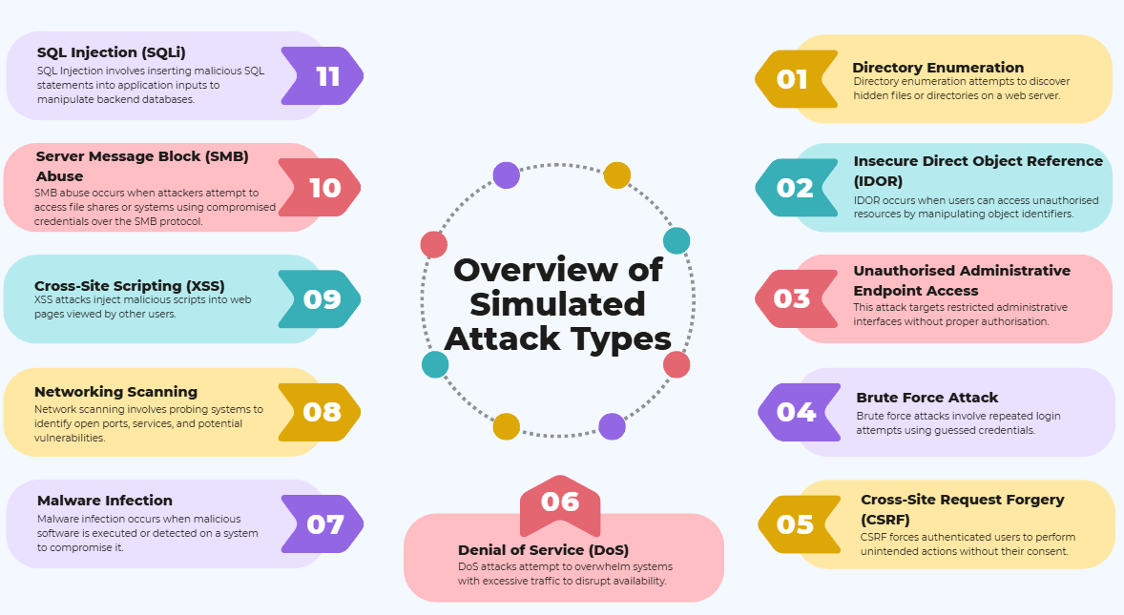
Figure 1: Overview of Simulated Attack Types Evaluated Against BrightMart

Introduction
In the past month, BrightMart, a growing medium-sized online retail company, began noticing strange spikes in network traffic: login attempts occurring at odd hours, unexpected error messages from their web store, and unusual outbound connections from internal systems.
At first, these spikes were dismissed as routine technical glitches. But as customers started reporting failed logins and slow responses on the website, BrightMart’s management realised that something far more serious might be happening behind the scenes.

Concerned that these irregular activities could be early signs of a cyberattack, the company reached out to our cybersecurity team. Our mission is to investigate the root cause, simulate real-world threats targeting their environment, and deploy a robust detection solution using a modern Security Information and Event Management (SIEM) platform.

To recreate BrightMart’s environment, our team built a controlled lab setup consisting of multiple virtual machines connected through the same virtual network. Their vulnerable e-commerce platform was mirrored using OWASP Juice Shop running on Windows. A separate VM running Kali Linux acted as the attacker, launching realistic threat scenarios that an online retailer like BrightMart is likely to face.

All activity across this miniature ecosystem was monitored and logged through Splunk Enterprise, chosen as the SIEM tool due to its powerful analytics, dashboards, and customisable detection capabilities. To ensure accurate and real-time log ingestion, we installed and configured the Splunk Universal Forwarder on the Juice Shop VM. This lightweight agent continuously forwarded application logs (such as access logs and audit events) to the central Splunk Indexer hosted on the Windows Server VM for easy analysis, detection and mitigation.

Through this simulation, we aimed to uncover the threats BrightMart may be exposed to, how attackers could exploit their weaknesses, and most importantly, how Splunk can assist their security team to detect, investigate, and respond to attacks before they cause significant damage.

Environment Setup
To simulate BrightMart’s online retail infrastructure and demonstrate realistic cyberattacks, our team deployed a controlled lab environment using three virtual machines connected on the same VM network adapter. Each system serves a distinct purpose in the simulation.

IP Address | System / VM | Purpose
192.168.8.130 | Windows 10 (OWASP Juice Shop) | Target web application. Hosts the vulnerable retail platform used for simulating SQLi, XSS, IDOR, and other attacks.  The Splunk Universal Forwarder is installed here to monitor Juice Shop logs and forward them to the Splunk server.
192.168.8.131 | Windows Server 2012 | Central log collection server.  Runs Splunk Enterprise and acts as the SIEM indexer, receiving logs over TCP port 9997.  Processes events, attack patterns, and generating security alerts.
192.168.8.132 | Kali Linux | Attacker machine. Used to launch security attacks against the Juice Shop application.

Splunk Universal Forwarder
As an additional feature to enable real-time log visibility and seamless import of logs into the SIEM, the Splunk Universal Forwarder was installed on the Windows 10 VM hosting OWASP Juice Shop. The forwarder acts as an agent designed to collect log files and transmit them to the central Splunk Enterprise Indexer on the Windows Server VM.

We set up the forwarder to monitor the Juice Shop application logs – specifically the access.log located in the application’s /logs/ directory. These logs contain information such as HTTP requests, authentication attempts and user interactions.

By modifying the inputs.conf file and specifying the Splunk server as the destination in outputs.conf, Splunk Universal Forwarder will continuously send new log entries to the Indexer over the default TCP port 9997.

This made sure that all attack activities simulated from the Kali Linux VM will be captured in real time and made available for analysis, alerting and detection within Splunk.

Using the Universal Forwarder enhances the realism and accuracy of the simulation by replicating how enterprises collect logs from actual production systems.

Identified Common Cybersecurity Attacks

SQL Injection (SQLi)

Overview
SQL Injection (SQLi) is a web application attack where an attacker injects malicious SQL syntax into input fields or URL parameters that are used to construct backend database queries. If the application fails to validate input and uses unsafe query construction, the attacker’s input may be interpreted as executable SQL logic.

In this simulation, SQLi behaviour was simulated against the OWASP Juice Shop application, focusing on:
- Authentication bypass attempts at the login function, and
- Injection attempts against the /rest/products/search endpoint, including automated probing using sqlmap.

The observed responses, such as successful authentication bypass in the login flow and repeated server-side errors for crafted queries, indicate inadequate input handling and potential exposure to SQL injection-style manipulation.

Impact on Client
For a retail platform such as BrightMart, SQL injection can create both confidentiality and availability risks depending on what the vulnerable endpoint can access.

Potential business impact includes:
- Unauthorised access to user accounts or privileged functions like login bypass
- If backend queries can be retrieved or listed, sensitive data exposure could include customer profiles, orders, and addresses.
- Data integrity loss if attackers can tamper with product/pricing/order records
- Service disruption due to heavy malformed queries or automated testing causing repeated server errors
- Compliance and reputational damage if customer data is exposed

In this simulation, the strongest demonstrated risk is abnormal authentication and automated injection probing visible in web access logs, which can be used as early warning signals even before confirmed data extraction.

SIEM Indicators of Compromise (IoCs)
SQL injection attempts are typically detectable in SIEM through abnormal request patterns and injection markers in web logs.

In Splunk, the following indicators were used for detection based on the Juice Shop access logs:
- Repeated requests to injection-prone endpoints within a short time window
  - /rest/user/login
  - /rest/products/search
- Suspicious query patterns/keywords appearing in URLs or parameters:
  - ' OR 1=1
  - UNION / SELECT
  - URL-encoded payload fragments
  - Tool fingerprints and function patterns associated with automation
- Unusual response behaviour consistent with testing or injection:
  - Increased HTTP 4xx / 5xx responses
  - High request frequency from a single source IP

Server Message Block (SMB) Abuse

Overview
Server Message Block (SMB) is a Windows network file-sharing protocol used to access shared resources such as files, printers, and named pipes over a network. SMB commonly relies on Windows authentication mechanisms, and when valid credentials are compromised, attackers can abuse SMB to access systems and move laterally within an internal network.

In this simulation, authenticated SMB access was performed against a Windows 10 host running OWASP Juice Shop. The objective was to demonstrate how compromised credentials, obtained through phishing and subsequent credential guessing, can be abused to authenticate over SMB and access shared resources without exploiting vulnerabilities or modifying system files.

Impact on Client
The abuse of valid credentials over SMB significantly increases an organization’s exposure to internal attacks. Even without exploiting software vulnerabilities, authenticated SMB access allows attackers to blend in with legitimate user activity and bypass many perimeter-based security controls.

The impact of credential-based SMB abuse includes:
- Unauthorized access to user-accessible network shares and files
- Increased risk of lateral movement across internal systems
- Potential exposure of sensitive data stored within user profile directories
- Facilitation of further attacks such as privilege escalation, persistence, or data exfiltration

For an organization such as BrightMart, successful SMB authentication using compromised credentials could enable attackers to move laterally within the internal network, increasing the likelihood of widespread compromise.

SIEM Indicators of Compromise (IoCs)
Credential-based SMB abuse can be identified in SIEM platforms through authentication-related patterns rather than SMB service enumeration. Relevant indicators include:
- Multiple failed authentication attempts (Event ID 4625) from a single source host
- A subsequent successful network logon (Event ID 4624) using the same account
- Logon Type 3 events indicating network-based authentication commonly associated with SMB access
- Authentication activity originating from unusual source IP addresses or workstations

These patterns deviate from normal user behaviour, as legitimate users rarely generate repeated failed logons followed by successful access in a short time window. Such activity strongly suggests credential misuse leading to authenticated SMB access and potential lateral movement.

Cross-Site Scripting (XSS)

Overview
XSS is a web vulnerability which is exploited through the execution of malicious scripts by injecting them into web pages. They can steal sensitive information (such as credentials or session cookies), perform unauthorized actions or deface websites. This attack typically occurs when user input is not properly sanitized or validated.

There are 3 types:
- Reflected
  - Executed without being stored in the server
  - It is reflected typically through URL parameters.
  - Requires user to click on curated link.
- Stored
  - Payload is stored in the server
  - Triggered when the user visits the affected page.
- DOM-based
  - Client-side attack.
  - Does not interact with the server.

In this simulation, reflected XSS is demonstrated by replacing URL parameters with a malicious payload, which performs an alert to pop up.

Impact on Client
If successful, XSS can result in unauthorized access to customer accounts through impersonation or session hijacking. Attackers could steal customer data (such as cookies) or use the account to perform illegal acts, putting BrightMart’s customers at severe risk. They could also be led to phishing sites or exposure to misinformation by visiting BrightMart. This could cause mistrust and a strain in customer relations, as well as reputation damage.

SIEM Indicators of Compromise (IoCs)
Reflected XSS
- Suspicious URL parameters
- Scripts spotted in request headers

Stored XSS
- JavaScript in POST request body
- JavaScript in database

DOM-Based
- Payloads after URL fragments (#, ?)

Network Scanning

Overview
Network scanning is a reconnaissance technique used by attackers to identify active hosts, open ports, running services, and operating systems within a target environment. Tools such as Nmap are commonly used to probe and scan a system and map out its attack surface before launching more targeted attacks

In this simulation, network scanning was performed from the Kali Linux attacker VM against the OWASP Juice Shop server to identify accessible services and exposed ports.

Impact on Client
If successfully performed against a production environment, network scanning provides attackers with critical intelligence about an organisation’s infrastructure. Open or misconfigured services identified through scanning can be exploited to gain unauthorised access, escalate privileges, or pivot deeper into more important parts of the network.

For an e-commerce client like Brightmart, this reconnaissance phase increases the likelihood of follow-up attacks such as brute force login attempts, web exploitation, or lateral movement, which could lead to service disruption or data compromise.

SIEM Indicators of Compromise (IoCs)
Indicators of network scanning activity that an SIEM solution can detect include:
- A high volume of connection attempts from a single source IP within a short timeframe
- Sequential connection attempts targeting multiple ports on the same host
- Repeated TCP SYN requests without a full connection
- Unusual/Suspicious ICMP echo requests or service probes from non-trusted sources

These behaviours are unusual for normal user traffic and can be flagged by the SIEM as suspicious behaviour.

Directory Enumeration

Overview
Directory enumeration is a web reconnaissance technique used to discover hidden or unlinked directories, files, and endpoints within a web application. Attackers commonly use automated tools to send large numbers of HTTP requests to guess directory and filenames, attempting to uncover any unsecured administrative panels, important backup files, or exposed APIs

In this simulation, directory enumeration was conducted against the OWASP juice shop application from the Kali Linux VM to identify restricted and accessible paths.

Impact on Client
Successful directory enumeration can expose sensitive application components that were not intended to be publicly accessible. These can include administrator interfaces, configuration files, backup directories, or undocumented API endpoints

For an online e-commerce retail platform such as BrightMart, such exposure can lead to unauthorised access, information leakage, or further exploitation of application vulnerabilities, increasing the risk of data breaches and service compromise.

SIEM Indicators of Compromise (IoCs)
Directory enumeration activities can be identified in SIEM logs through patterns such as:
- Many HTTP GET requests to different URL paths from the same source IP
- High frequency of HTTP 404, 403, or 200 responses within a short time period
- Requests to common directory names such as /admin, /config, /backup, or /api
- Automated request behaviour that is clearly not a normal user’s browsing pattern

These indicators suggest systematic probing of application directories and can be used by the SIEM to trigger alerts for reconnaissance activity.

Insecure Direct Object Reference (IDOR)

Overview
Insecure Direct Object Reference (IDOR) is a vulnerability that arises when an application exposes internal object identifiers, such as user IDs, order IDs, or account numbers, without enforcing proper authorisation checks on the backend.

As a result, attackers may manipulate URL paths or API parameters to directly access objects that do not belong to them, bypassing access control mechanisms.

Impact on Client
In the context of an e-commerce platform, IDOR vulnerabilities can have significant security and privacy implications. Attackers may gain unauthorised access to other customers’ order histories and personal information, such as names, addresses, and transaction details.

In more severe cases, attackers could modify other users’ profiles, shopping carts, or orders. If exploited at scale, IDOR can also enable automated data harvesting attacks, leading to large-scale data leakage and potential regulatory and reputational consequences for the organisation.

SIEM Indicators of Compromise (IoCs)
Some indicators that suggest the exploitation of an IDOR vulnerability are:
- Sequential access patterns to object identifiers from a single source, such as /orders/1, /orders/2, and /orders/3.
- Large requests for resources that do not belong to the authenticated user
- Sudden spikes in API requests targeting order, account, or profile endpoints.

Monitoring these behaviours through a SIEM solution can help identify and respond to potential IDOR exploitation attempts.

Unauthorised Administrative Endpoint Access

Overview
Unauthenticated administrative endpoint access is a vulnerability that occurs when sensitive management or configuration endpoints are exposed without enforcing authentication or authorization controls.

In such cases, attackers do not need valid credentials or an authenticated session to retrieve internal system information. By directly accessing administrative API endpoints, attackers can obtain configuration details, application metadata, and security-relevant settings that are intended to be restricted to privileged users.

This type of exposure is commonly exploited during the reconnaissance phase of real-world attacks, as it allows adversaries to gather intelligence about the target environment before launching more targeted or damaging attacks.

Impact on Client
For an e-commerce platform such as BrightMart, unauthenticated access to administrative configuration endpoints presents a significant security risk.

Attackers may retrieve sensitive internal information such as server configuration, application settings, enabled features, third-party integrations, OAuth client identifiers, and environment details. This information can be leveraged to identify misconfigurations, exposed services, or known vulnerabilities associated with specific software components.

In addition, disclosure of internal configuration data lowers the barrier for further exploitation, enabling attackers to plan credential attacks, privilege escalation attempts, or targeted abuse of exposed functionality. If left unaddressed, this vulnerability could contribute to a broader compromise of the platform and damage customer trust and organisational reputation.

SIEM Indicators of Compromise (IoCs)
Indicators that suggest unauthenticated administrative endpoint access include:
- Direct HTTP requests to /rest/admin/* endpoints without prior authentication events.
- Successful HTTP 200 responses from administrative endpoints originating from unauthenticated clients.
- Repeated access to configuration or version endpoints from a single external source IP.

Monitoring these indicators using a SIEM solution enables early detection of reconnaissance activity targeting sensitive administrative interfaces.

Brute Force Attack

Overview
A brute force attack is an authentication-based attack in which an attacker systematically attempts multiple username and password combinations to gain unauthorized access to a system. This is typically achieved using automated tools that rapidly test large numbers of credentials until the correct one is found.
Basic brute force attacks involve guessing passwords through trial and error. More advanced variants include dictionary attacks, which use predefined lists of commonly used passwords, and credential stuffing attacks, where attackers reuse leaked username–password pairs obtained from previous data breaches.
In the BrightMart simulation, this attack was reproduced by targeting the /rest/user/login endpoint of the e-commerce platform, generating repeated failed authentication attempts within a short period of time.

Impact on Client
A successful brute force attack could result in unauthorised access to customer or administrative accounts within BrightMart’s e-commerce platform. This may lead to data breaches, identity theft, fraudulent transactions, or misuse of sensitive customer information.
Even when unsuccessful, brute force attempts can negatively impact system performance due to the high volume of authentication requests. This can cause login delays, account lockouts for legitimate users, and degradation of overall service availability, ultimately affecting customer trust and business operations.

SIEM Indicators of Compromise (IoCs)
Common indicators may include the following:
- High volume of failed login attempts within a short time frame
- Repeated authentication failures targeting the same account
- Multiple login attempts from a single IP address. Other indicators include
- Login attempts from unusual geographic locations
- Abnormal login times
- Rapid sequential attempts using different usernames or passwords, which may indicate automated attack activity.

Denial of Service (DOS)

Overview
A Denial of Service (DoS) attack is designed to disrupt the availability of a system by overwhelming it with excessive or malicious traffic. By consuming network bandwidth or system resources, the attack prevents legitimate users from accessing the targeted service or significantly degrades performance.
Web applications are frequent targets of DoS attacks, as attackers can flood specific HTTP endpoints with large volumes of requests to exhaust server CPU, memory, or network capacity.

Difference between DOS and DDOS
A DoS attack originates from a single source, whereas a Distributed Denial of Service (DDoS) attack involves traffic coming from multiple sources simultaneously, often using a botnet. DDoS attacks are generally more difficult to mitigate due to the distributed nature of the traffic and the large number of attacking hosts involved.

Impact on Client
A successful DoS attack against BrightMart’s web application could prevent customers from accessing the online store, leading to service outages, transaction failures, and loss of revenue. Prolonged downtime may also damage the organisation’s reputation and customer confidence, especially in a competitive e-commerce market.
In severe cases, resource exhaustion may cause application crashes or data corruption or require manual system recovery, further increasing operational impact.

SIEM Indicators of Compromise (IoCs)
Common network-level indicators include the following:
- A sudden spike in network traffic
- Abnormally high connection rates
- A large number of SYN packets indicating a possible SYN flood attack
- Unusual source IP behaviour, such as repeated requests from the same IP or traffic from unexpected regions.
Common application-level indicators include the following:
- A surge in HTTP 5XX error codes (500, 501, etc.), which suggests the server is failing to process requests, as well as excessive GET or POST requests targeting the same resource-intensive endpoint.

Malware Infection

Overview
Malware infection refers to the presence of malicious software on a system that is designed to disrupt operations, steal information, or provide attackers with persistent access to compromised environments. In enterprise environments, malware is often deployed after initial access has been achieved, rather than as the first stage of an attack.
Attackers commonly leverage compromised credentials to introduce malware into a target system, disguising malicious executables as legitimate files or documents to evade detection. Once deployed, malware may execute additional payloads, harvest credentials, establish persistence mechanisms, or communicate with external command-and-control infrastructure.
Malware infections are a critical concern for modern organisations, as they often represent the transition from reconnaissance or access-based attacks into active exploitation and long-term compromise.

Impact on Client
For an e-commerce platform such as BrightMart, a malware infection can have severe operational, financial, and reputational consequences.
Malware deployed using compromised user credentials may allow attackers to:
- Steal customer personal and payment-related data
- Capture authentication credentials for administrative or service accounts
- Manipulate application or system files, impacting service availability
- Establish persistent access for future attacks or data exfiltration

In addition, malware infections can degrade system performance, trigger unexpected outbound connections, and increase the risk of regulatory non-compliance if sensitive customer information is exposed. A successful malware incident could result in service disruptions, loss of customer trust, and significant remediation costs for the organisation.

SIEM Indicators of Compromise (IoCs)
Indicators that suggest a malware infection within the environment include:
- Endpoint protection alerts indicating malware detection, quarantine, or remediation actions.
- Detection of malicious or suspicious files within user-writable directories such as Documents or Downloads.
- Malware detections associated with previously compromised or suspicious user accounts.
- High-severity security events generated by endpoint protection services (e.g., Windows Defender).
- Correlation between malware detection events and earlier authentication or SMB activity from the same account or host.

By monitoring these indicators through a SIEM solution, security teams can quickly identify malware infections, investigate affected systems, and initiate appropriate containment and remediation actions before further damage occurs.

Business Logic Abuse (Negative Quantity Manipulation)

Overview
Business logic abuse occurs when an application’s core transactional rules are not properly enforced, allowing users to perform actions that violate intended operational constraints. Unlike technical vulnerabilities that exploit system flaws, business logic weaknesses arise from insufficient validation of expected behaviour within normal application workflows.

In transactional systems such as e-commerce platforms, certain parameters are expected to follow strict rules. For example, product quantities should be positive integers, and order totals should not fall below zero. When these constraints are not validated on the server side, manipulated values may be accepted and processed as legitimate transactions.

Negative quantity manipulation represents a failure to enforce transactional integrity. By submitting values outside the expected range, an individual can alter pricing calculations and impact financial outcomes without triggering application errors. Because the request format remains syntactically valid and the server responds successfully, this type of abuse can go undetected without proper logging and monitoring controls.

Business logic vulnerabilities are particularly dangerous because they exploit trusted functionality rather than technical misconfigurations. They often bypass traditional security controls and may not generate obvious error conditions.

Impact on Client
For an e-commerce platform such as BrightMart, business logic abuse can introduce financial, operational, and integrity risks.
Potential impact includes:
• Financial loss through manipulated pricing or transaction totals
• Corruption of order records and inventory calculations
• Exploitation of promotional or reward mechanisms
• Bypassing intended purchasing constraints
• Increased risk of fraud and abuse of transactional workflows
Because the application processes manipulated values as valid transactions, such abuse may not immediately disrupt service availability. However, over time, it can result in inaccurate financial reporting, revenue leakage, and loss of customer trust.
In addition, repeated manipulation attempts may indicate automated abuse or fraudulent activity targeting transactional endpoints.

SIEM Indicators of Compromise (IoCs)
Indicators suggesting business logic abuse within transactional systems include:
• Abnormal numeric parameter values in transaction-related API calls
• Negative or zero values where only positive integers are expected
• Successful HTTP responses associated with invalid business parameters
• Repeated modification requests to transactional endpoints from a single source IP
• Transaction totals or calculated values that fall outside expected operational boundaries
By monitoring transactional parameters through enhanced application logging and SIEM correlation rules, security teams can detect deviations from expected business behaviour. Continuous monitoring of abnormal values enables early identification of manipulation attempts before financial or operational damage escalates.

Cross-Site Request Forgery (CSRF)

Overview
CSRF occurs due to the browser getting tricked into thinking the cross-site request the victim is sending is really from the victim, as the cookies are the same. This happens when the victim opens a link that executes a request (e.g., changing of profile details) on the browser with the target site open and logged in.

As a result of no validation of CSRF tokens and unvalidated request origins, CSRF can edit sensitive details or perform malicious actions, making the victim seem malicious.

Impact on Client
Clients can be misled to the wrong suspect of malicious actions, leading to difficult investigations for the real perpetrator. Data manipulation and account takeover of its customers can also be possible when making requests to change sensitive things like email, password or username.

This can lead to an increased number of malicious users disguised as legitimate customers and an increased rate of impersonation. Business records can become unreliable and lead to financial loss since the attacker can change the shipping address, so when a customer doesn’t receive their order, they may file a refund. BrightMart’s reputation may be jeopardized.

SIEM Indicators of Compromise (IoCs)
Indicators can be:
- Requests coming from unvalidated origin URLs
- Unusual referrers (external domains)
- Actions performed without user interaction (no GET request for target page before POST)

Attack Simulations

SQL Injection (SQLi)

Simulations

Simulation 1: Authentication Bypass
This simulation demonstrates an SQL injection authentication bypass vulnerability affecting the OWASP Juice Shop login functionality. By injecting malicious SQL logic into the email input field, an attacker can alter the backend authentication query and gain unauthorized access without providing valid credentials.

The vulnerability exists because the application fails to properly sanitize and parameterize user-supplied input before constructing SQL queries. As a result, attacker-controlled input is interpreted as executable SQL syntax, allowing the attacker to manipulate query conditions used for authentication.

In this scenario, the attacker submits the payload into the email field while providing an arbitrary password value. This payload forces the authentication condition to evaluate as true and uses an inline comment to ignore the remaining portion of the query, resulting in a successful login despite invalid credentials.

' OR 1=1--

Attempts to use a username-specific payload such as this did not produce a successful login in this environment. However, the success of the payload is sufficient to confirm that the login function is vulnerable to SQL injection-based authentication bypass.

admin'--

A successful bypass is evidenced by the application granting access to the authenticated area without a valid account/password combination.

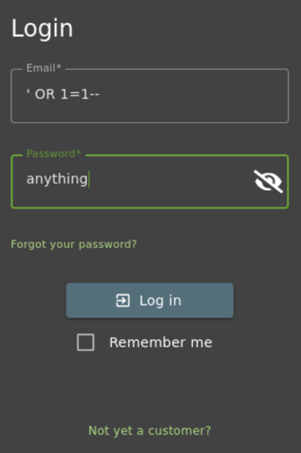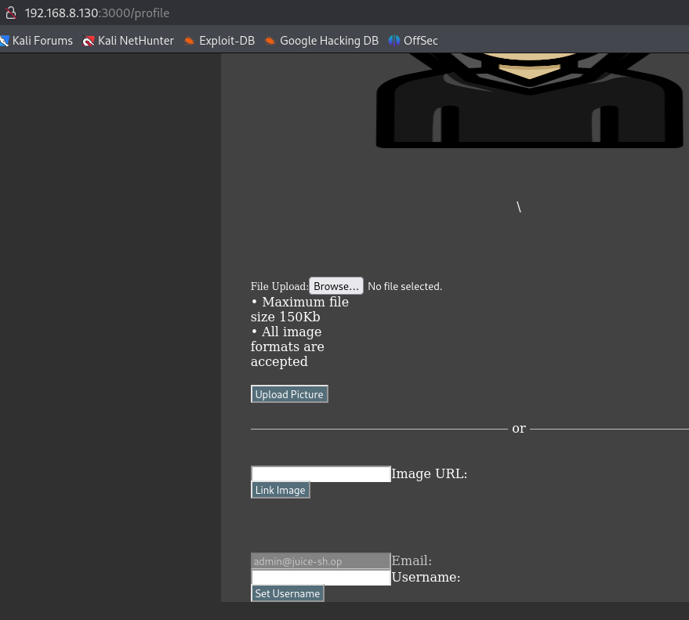
Figure 2.1: Successful login using SQL injection payload ' OR 1=1--

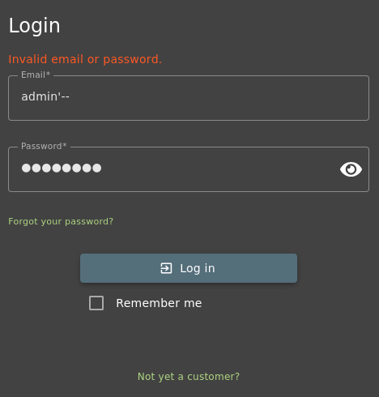
Figure 2.2: Unsuccessful SQL injection payload (admin'--) submitted to the login form, demonstrating that not all injection attempts result in authentication bypass.

Simulation 2: SQL Injection Attempt on Product Search
This simulation documents an attempted SQL injection attack against the OWASP Juice Shop product search functionality via the /rest/products/search endpoint. While the injected payload did not result in successful data extraction or manipulation, the application’s response behaviour and backend error messages confirm unsafe SQL query handling.

The vulnerability arises from the application’s failure to fully sanitize user-supplied input before incorporating it into dynamically constructed SQL queries. As a result, malformed SQL expressions submitted through the search parameter are passed to the SQLite database engine for parsing.

In this scenario, the attacker submits a manipulated search query using the following payload:
q=apple AND 1=1
When processed by the backend, the application returns an HTTP 500 Internal Server Error, accompanied by a SQLite syntax error message, as shown in the figure below. The error message explicitly references SQL parsing near the injected condition, indicating that the user input is being interpreted as part of the SQL statement rather than treated as a literal search string.
Although the injected payload does not successfully alter query logic or return unauthorized data, the presence of a database error response confirms that SQL input validation and query parameterisation are insufficient. Properly secured applications should handle such input gracefully without exposing backend database errors.
Additional attempts using similar Boolean-based SQL payloads produced consistent server-side errors, further reinforcing that the search endpoint is vulnerable to SQL injection attempts, even though full exploitation was not achieved in this environment.

The successful detection of backend SQL errors, combined with corresponding access log entries capturing the injected payload, provides sufficient evidence to classify this behaviour as an SQL injection vulnerability with partial mitigation or error-based exposure.

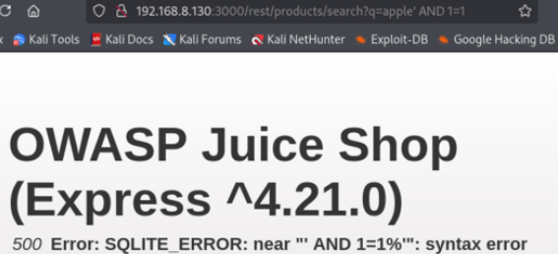
Figure 2.3: SQLite syntax error triggered by a Boolean-based SQL injection payload using the AND 1=1 condition against the OWASP Juice Shop product search endpoint.
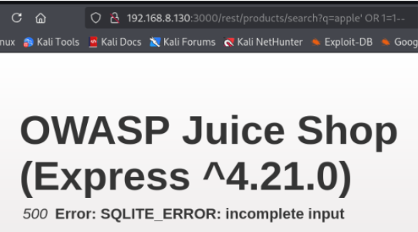
Figure 2.4: SQLite incomplete input error generated by a Boolean-based SQL injection payload using the OR 1=1 condition against the OWASP Juice Shop product search endpoint.

Simulation 3: Automated SQL Injection Detection and Enumeration
This simulation demonstrates the use of sqlmap to validate the SQL injection vulnerability identified in earlier manual testing. Automated testing was conducted from the Kali Linux attacker machine against the OWASP Juice Shop product search endpoint.

The following commands were executed:
sqlmap -u "http://192.168.8.130:3000/rest/products/search?q=test" --batch
sqlmap -u "http://192.168.8.130:3000/rest/products/search?q=test" --level=5 --risk=3 --batch

Sqlmap identified the GET parameter as it is dynamic and injectable and successfully detected the backend database management system as SQLite. The tool confirmed the presence of both Boolean-based blind and time-based blind SQL injection techniques.

Multiple HTTP 500 error responses were observed during testing, indicating improper input handling and backend SQL query execution. These results confirm that the application is vulnerable to automated SQL injection exploitation, significantly increasing the severity of the issue.

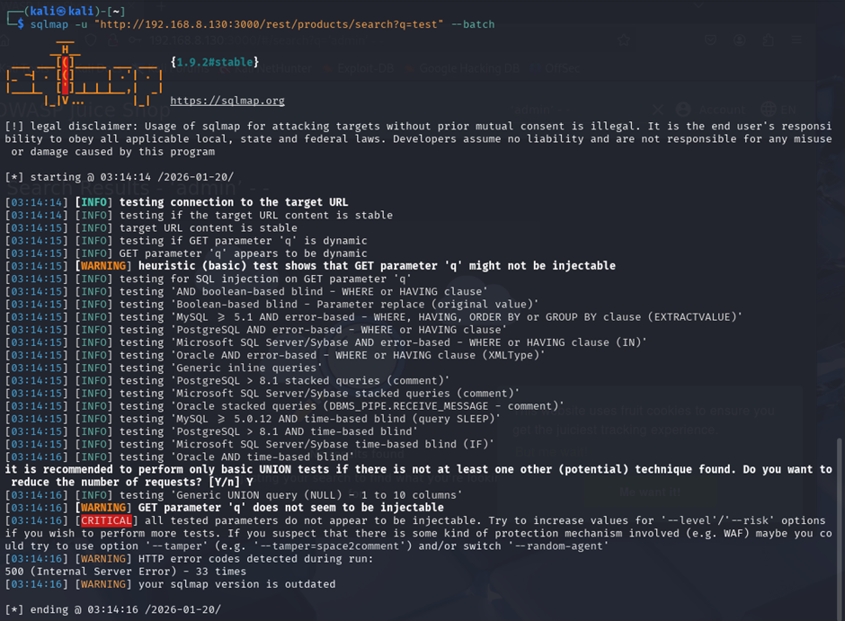
Figure 2.5:
sqlmap detecting a Boolean-based SQL injection condition (OR 1=1) on the OWASP Juice Shop product search parameter, resulting in SQLite input error responses.

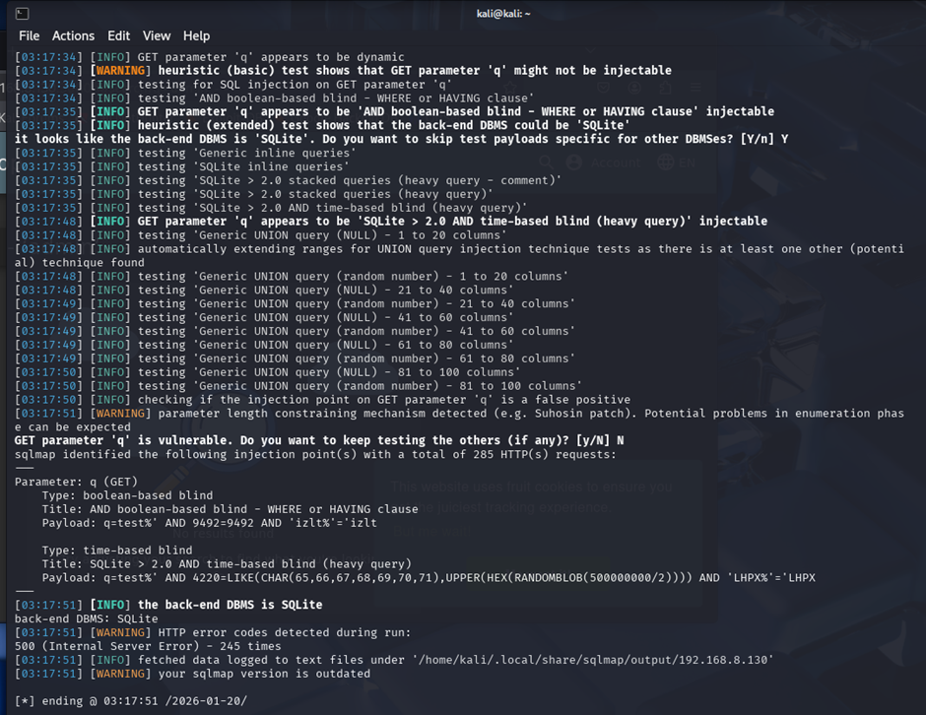
Figure 2.6:
sqlmap confirming the injectability of the product search parameter and identifying the backend database as SQLite with Boolean-based and time-based blind SQL injection techniques.

Logs Collected
During the SQL injection attack simulation, application access logs were generated by the OWASP Juice Shop product search functionality and forwarded to the Splunk Enterprise Indexer via the Splunk Universal Forwarder.

The logs captured detailed HTTP request information, including request methods, target endpoints, injected query parameters, HTTP response codes, source IP addresses, and user-agent strings. Notably, multiple requests contained SQL keywords and encoded payloads targeting the /rest/products/search endpoint, indicating deliberate manipulation of input parameters.

These logs provided sufficient visibility to analyse attack patterns, payload structure, and server responses associated with SQL injection attempts.

Figure 2.7:
Splunk inputs.conf configuration for OWASP Juice Shop application access logs

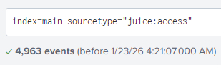
Figure 2.8:
Splunk verification of juice:access application log ingestion

Detection
Analysis in Splunk revealed multiple POST requests to the OWASP Juice Shop login endpoint (/rest/user/login) originating from the same source IP address (192.168.8.132) within a short time window.

The events show both:
- Successful authentication attempts (HTTP 200), indicating valid login credentials were accepted, and
- Failed authentication attempts (HTTP 401), indicating invalid credentials or unsuccessful login attempts.

This pattern demonstrates repeated login activity rather than normal browsing behaviour. The presence of multiple consecutive login attempts with mixed outcomes (200 and 401) is consistent with credential testing behaviour such as trial-and-error login attempts and can be used as an indicator for suspicious authentication activity.

An initial Splunk search was used to isolate login-related events:
host="owaspjuicebox" sourcetype=juice:access "/rest/user/login"

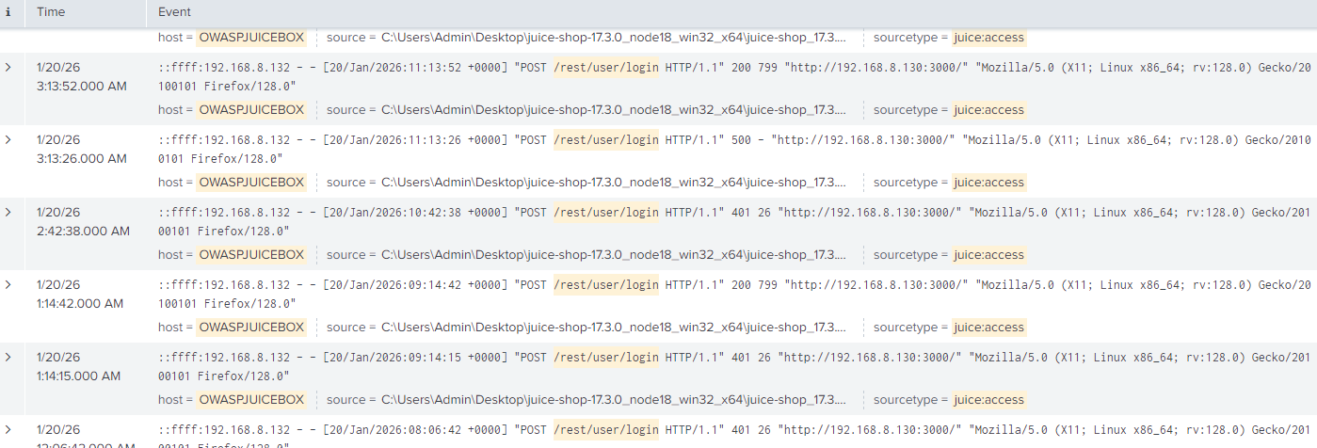
Figure 2.9:
Splunk search results showing successful and failed login attempts to the /rest/user/login endpoint

Analysis in Splunk revealed multiple HTTP GET requests to the OWASP Juice Shop product search endpoint (/rest/products/search) originating from the same source IP address (192.168.8.132) within a short time window. The requests contained abnormally long and URL-encoded query strings, including SQL keywords and payload structures consistent with automated SQL injection testing.

The observed events show:
- Malformed SQL payloads such as AND 1=1, OR 1=1 resulting in HTTP 500 Internal Server Error responses, indicating backend SQL parsing errors.
- Automated SQL injection payloads generated by sqlmap, identifiable by:
  - Repeated requests with systematically modified parameters
  - Highly encoded UNION SELECT payloads
  - User-Agent strings referencing sqlmap
- Consistent error responses from the SQLite backend, confirming error-based and blind SQL injection behaviour.

This access pattern is not consistent with normal user behaviour. Legitimate users typically submit short, readable search terms, whereas the captured requests contain complex SQL syntax and excessive encoding. The high request volume, repetitive structure, and payload complexity strongly indicate automated SQL injection testing and enumeration rather than manual browsing.

An initial Splunk search was used to isolate SQL injection–related events targeting the product search endpoint:
host="owaspjuicebox" sourcetype=juice:access "/rest/products/search"

Further analysis of the raw logs confirmed repeated SQL injection attempts, including Boolean-based, UNION-based, and time-based blind SQL injection techniques executed using sqlmap.

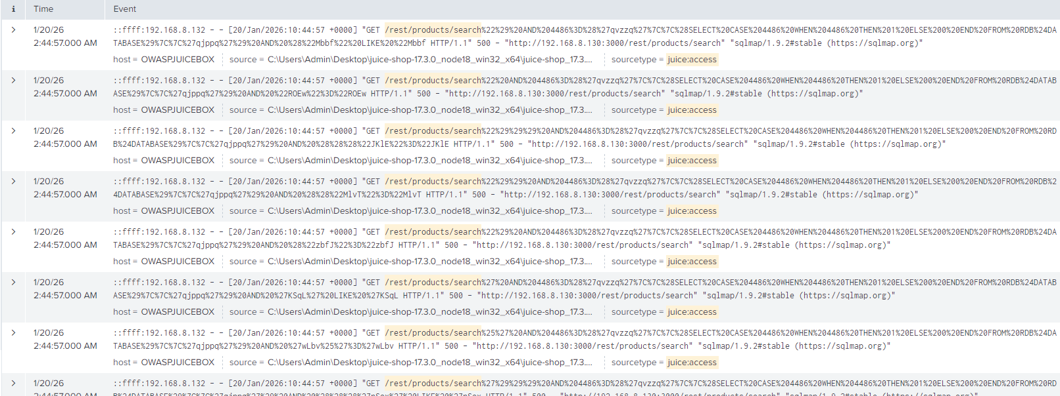
Figure 2.10:
Splunk log evidence of SQL injection attempts against the /rest/products/search endpoint

Mitigation
To make SQL injection attack behaviour more clearly observable and actionable, an enhanced Splunk search query was implemented to identify suspicious request patterns commonly associated with SQL injection attempts:
host="owaspjuicebox" sourcetype=juice:access
("/rest/products/search" OR "/rest/user/login")
(
("%27" AND ("%20OR%20" OR "%20AND%20" OR "UNION" OR "randomblob"))
OR ("UNION" AND "SELECT")
OR "randomblob"
)

Splunk SQL Injection Detection Query Breakdown
Query Component | Explanation
host="owaspjuicebox" | Filters events to only logs generated by the OWASP Juice Shop host.
sourcetype=juice:access | Restricts results to Juice Shop HTTP access logs forwarded to Splunk.
"/rest/products/search" | Targets the product search API endpoint, a common SQL injection attack surface.
"/rest/user/login" | Includes login-related API requests that may also be targeted during injection or credential testing.
("%27" AND (...)) | Detects URL-encoded single quotes (%27), a classic SQL injection indicator used to break SQL queries.
%20OR%20 | Matches URL-encoded logical OR, commonly used in Boolean-based SQL injection payloads.
%20AND%20 | Matches URL-encoded logical AND, often used to manipulate SQL conditions.
UNION | Identifies UNION-based SQL injection attempts used to combine malicious queries with legitimate ones.
randomblob | Detects SQLite-specific functions frequently used by sqlmap for time-based or heavy SQL injection testing.
("UNION" AND "SELECT") | Flags classic UNION SELECT patterns, a strong indicator of UNION-based SQL injection.
OR "randomblob" | Ensures detection of SQLite-focused sqlmap payloads even if other SQL keywords are absent.

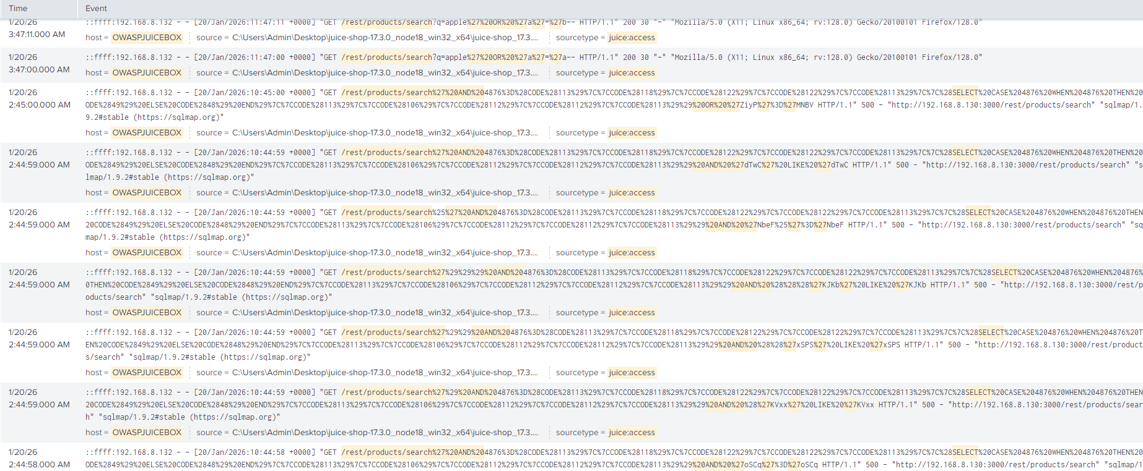
Figure 2.11:
Splunk detection of SQL injection attempts based on SQL keyword and payload pattern matching

Alert Configuration
This alert configuration ensures that potential SQL injection attempts against the OWASP Juice Shop application are detected and logged in Splunk in near real time.
Setting | Value
Alert Name | Potential SQL Injection Attempt Detected
Alert Type | Scheduled
Time Range | Last 24 hours
Schedule | Every 1 minute (cron-based: * /1 * * * *)
Trigger Condition | Number of results > 0
Severity | High
Trigger Action | Add to Triggered Alerts

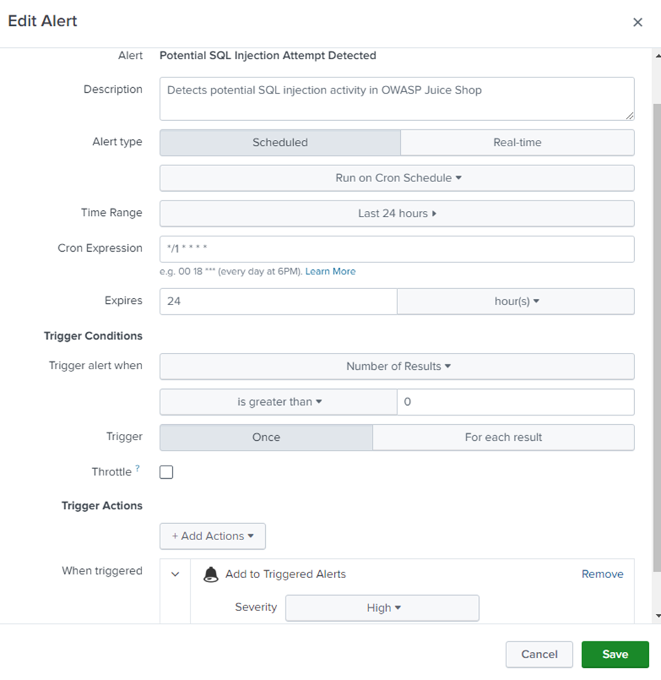
Figure 2.12: Splunk alert configuration for detecting possible SQL Injection activity.

Alert Trigger Explanation
The alert is designed to detect potential SQL injection attempts against the OWASP Juice Shop application by monitoring application access logs in Splunk for suspicious SQL-related request patterns.

The alert runs on a scheduled basis every minute, analysing events from the last 24 hours to ensure both recent and slightly delayed attack attempts are captured. It is triggered whenever the number of matching events is greater than zero, indicating at least one request matching a known SQL injection indicator.

The underlying search query focuses on HTTP requests to sensitive application endpoints, specifically:
- /rest/products/search
- /rest/user/login

These endpoints are commonly targeted during SQL injection attacks due to their reliance on user-supplied input.

The alert looks for SQL injection indicators within request parameters, including:
- URL-encoded single quotes (%27)
- Logical operators such as OR and AND
- SQL keywords like UNION and SELECT
- SQLite-specific payloads such as randomblob

These patterns are consistent with Boolean-based, UNION-based, and time-based blind SQL injection techniques, including those generated by automated tools such as sqlmap.

When any event matching these conditions is detected, the alert is triggered and logged under Triggered Alerts with High severity, allowing security analysts to quickly identify and investigate potential SQL injection activity in near real time.

This alert provides early detection of SQL injection attempts and supports timely incident response before successful exploitation or data compromise occurs.

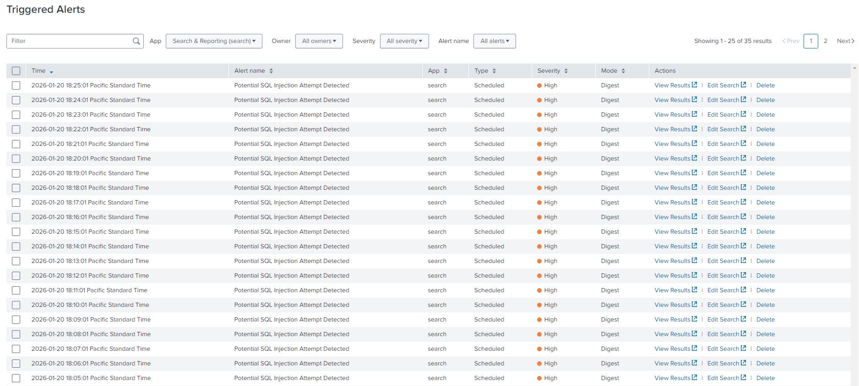
Figure 2.13: Splunk Triggered Alerts

Recommended Mitigation Steps
To mitigate SQL injection vulnerabilities and minimise the risk of unauthorised data access or database compromise, the following measures are recommended:

Application-Level Controls
- Use parameterised queries (prepared statements) to ensure user input is treated strictly as data and not executable SQL code.
- Implement input validation and sanitisation to restrict unexpected characters and enforce strict input formats on all user-supplied parameters.
- Avoid exposing detailed database error messages to users, as these can aid attackers in crafting more effective SQL injection payloads.
- Apply the principle of least privilege to database accounts, ensuring applications have only the minimum permissions required.

Security Controls
- Deploy Web Application Firewall (WAF) rules to detect and block common SQL injection patterns such as UNION, SELECT, logical operators, and time-based payloads.
- Enable rate limiting on high-risk endpoints such as search and login APIs to reduce the effectiveness of automated SQL injection tools such as sqlmap.
- Maintain SIEM-based monitoring and alerting to identify repeated SQL-related request patterns and abnormal error responses in real time.

Monitoring and Response
- Monitor application logs for repeated SQL syntax errors, abnormal HTTP 500 responses, and automated tool user agent's indicative of SQL injection attempts.
- Temporarily block or throttle source IP addresses exhibiting persistent SQL injection behaviour.
- Conduct regular security testing, including automated scanning and manual code reviews, to identify and remediate SQL injection risks before deployment.

Server Message Block (SMB) Abuse

Simulations

Simulation 1: SMB Authentication Abuse
In this simulation, it is assumed the attacker obtained a valid internal username (jimmy) through a phishing attempt. Since the password was not captured, the attacker attempted a small number of password attempts against the Windows 10 host over SMB.

These unsuccessful attempts generated Windows Security Event ID 4625 (failed logon). After identifying the correct credential combination, the attacker successfully authenticated to the Windows 10 endpoint over SMB, generating Windows Security Event ID 4624 (successful logon) with Logon Type 3 (network logon).

Following successful authentication, the attacker established an SMB session from Kali to the Windows 10 host using smbclient, accessed the Users share, and retrieved multiple files from the user profile directory.

This demonstrates authenticated lateral movement via SMB driven by compromised credentials rather than exploitation.
smbclient //192.168.8.130/Users -U jimmy

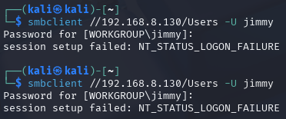
Figure 3.1: Unsuccessful SMB Access to Windows 10 via smbclient (jimmy)

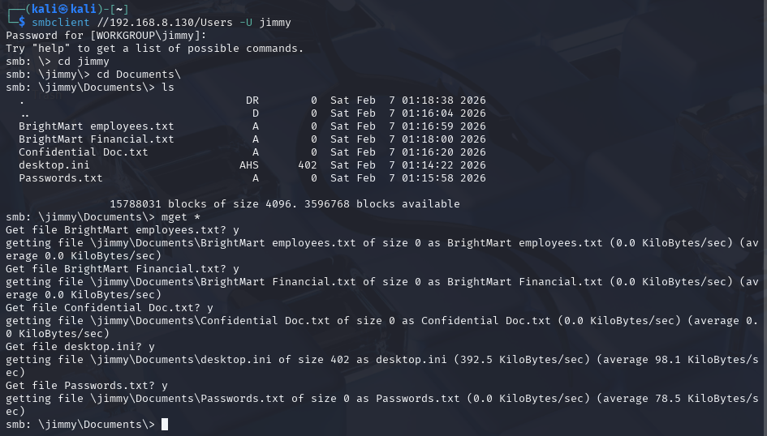
Figure 3.2: Successful SMB Access to Windows 10 via smbclient (jimmy)

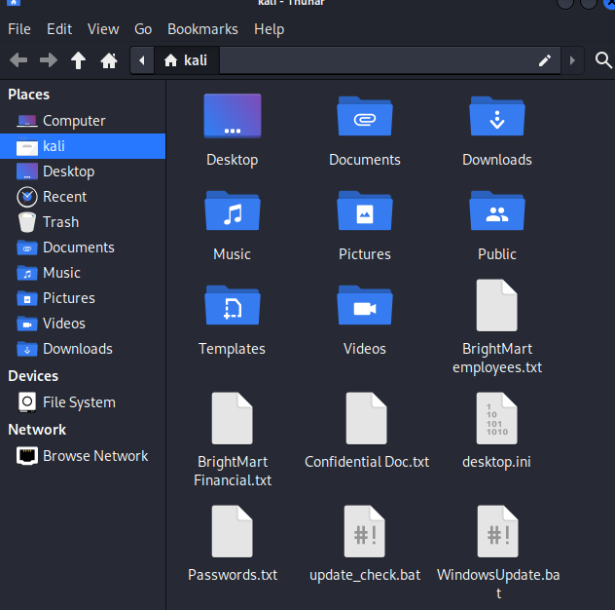
Figure 3.3: Successful lateral movement to a Windows host via smbclient (jimmy)

Logs Collected
The figures below show the configuration and verification of Windows Security log collection using the Splunk Universal Forwarder on the Windows host. The inputs.conf file was configured to collect Windows Security events via the WinEventLog://Security input, with logs indexed into the main index and parsed using the XmlWinEventLog:Security sourcetype.

The configuration enables structured XML event rendering, allowing detailed fields such as Event ID, logon type, target username, source IP address, and workstation name to be extracted during analysis. Log ingestion was verified by querying Splunk for events with the XmlWinEventLog:Security sourcetype, confirming that Windows Security logs were successfully forwarded and indexed.

These logs form the primary data source for detecting authentication-related activity, including failed and successful network logons (Event IDs 4625 and 4624), which are later used to identify suspicious SMB access and potential lateral movement activity.

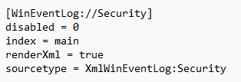
Figure 3.4:
Splunk inputs.conf configuration for Windows Event Security Log

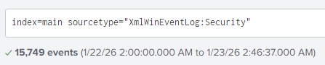
Figure 3.5: Log verification in Splunk for "XmlWinEventLog:Security"

Detection
Analysis in Splunk identified multiple authentication-related events originating from a single source host. Using Windows Security logs collected from the Windows 10 target (OWASPJUICEBOX), the analysis focused on Event ID 4625 (failed logon) and Event ID 4624 (successful logon), which correspond to authentication attempts over network-based services such as SMB.

The events originated from the Kali Linux attacker machine and targeted the Windows host OWASPJUICEBOX. The presence of repeated failed authentication attempts followed by a successful network logon indicates credential-guessing activity that ultimately resulted in authenticated access to the target system.

This behaviour deviates from normal user activity, as legitimate users typically do not generate multiple failed authentication attempts in rapid succession before successfully authenticating. The sequence of events suggests an attempted misuse of valid credentials, which subsequently enabled authenticated SMB access and potential lateral movement within the internal network.

An initial search filter was used to verify the ingestion of Windows Security authentication events related to network logons:
index=main sourcetype=XmlWinEventLog:Security ("<EventID>4624</EventID>" OR "<EventID>4625</EventID>")

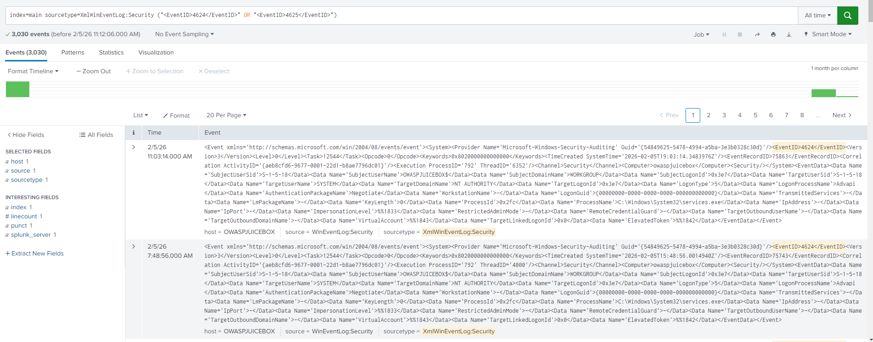
Figure 3.6:
Windows Security Authentication Events (Event IDs 4624 and 4625) Captured in Splunk

Mitigation
To identify suspicious authentication activity associated with SMB-based network access, Windows Security authentication events were filtered and analysed using the following Splunk query:
host=OWASPJUICEBOX sourcetype=XmlWinEventLog:Security ("<EventID>4624</EventID>" OR "<EventID>4625</EventID>")
| search "<Data Name='LogonType'>3</Data>"
| rex "<Data Name='TargetUserName'>(?<target_user>[^<]+)"
| rex "<Data Name='IpAddress'>(?<src_ip>[^<]+)"
| rex "<Data Name='WorkstationName'>(?<workstation>[^<]+)"
| rex "<Data Name='LogonType'>(?<logon_type>\d+)"
| rex "<Data Name='FailureReason'>(?<failure_reason>[^<]+)"
| rex "<EventID>(?<event_id>[^<]+)"
| table _time target_user src_ip workstation logon_type failure_reason event_id

The query filters Windows Security events to identify repeated failed and successful network logons, extracts key authentication fields, and presents them in a structured table for analysis.

Query Component | Explanation
host=OWASPJUICEBOX | Restricts results to authentication events generated by the target Windows 10 host (OWASPJUICEBOX).
sourcetype=XmlWinEventLog:Security | Limits results to Windows Security logs, which record authentication-related activity.
"<EventID>4624</EventID>" OR "<EventID>4625</EventID>" | Filters for successful (4624) and failed (4625) authentication events.
search "<Data Name='LogonType'>3</Data>" | Restricts results to network logons (Logon Type 3), commonly associated with SMB access.
rex "<Data Name='TargetUserName'>(?<target_user>[^<]+)" | Extracts the target account username involved in the authentication attempt.
rex "<Data Name='IpAddress'>(?<src_ip>[^<]+)" | Extracts the source IP address initiating the authentication request.
rex "<Data Name='WorkstationName'>(?<workstation>[^<]+)" | Extracts the originating workstation name associated with the logon attempt.
rex "<Data Name='FailureReason'>(?<failure_reason>[^<]+)" | Extracts the reason for authentication failure, when applicable.
rex "<EventID>(?<event_id>[^<]+)" | Extracts the Windows Security Event ID for classification of logon outcomes.
table _time target_user src_ip workstation logon_type failure_reason event_id | Displays key authentication details in a structured table for analysis and correlation.

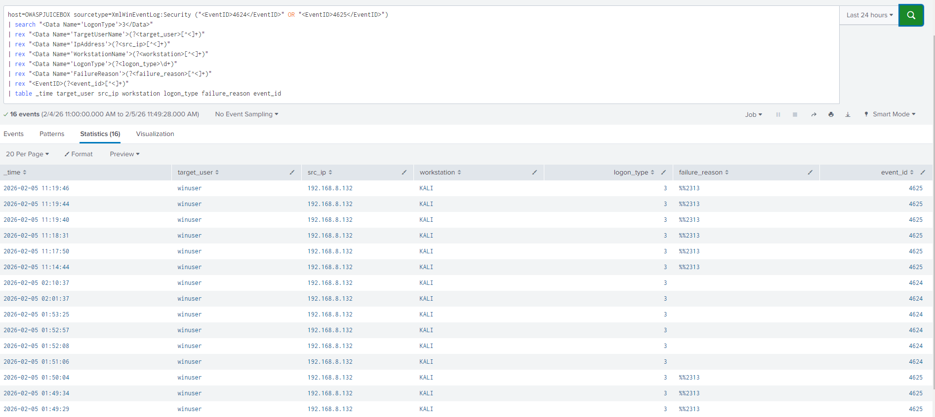
Figure 3.7: SMB authentication activity (failed and successful network logons)

Alert Configuration
To ensure suspicious SMB activity is detected in near real-time, a scheduled alert was configured in Splunk.
Setting | Value
Alert Name | Possible SMB Activity Detected
Alert Type | Scheduled
Time Range | Last 24 hours
Schedule | Every 1 minute (cron-based: * /1 * * * *)
Trigger Condition | Number of results > 0
Severity | Medium
Trigger Action | Add to Triggered Alerts

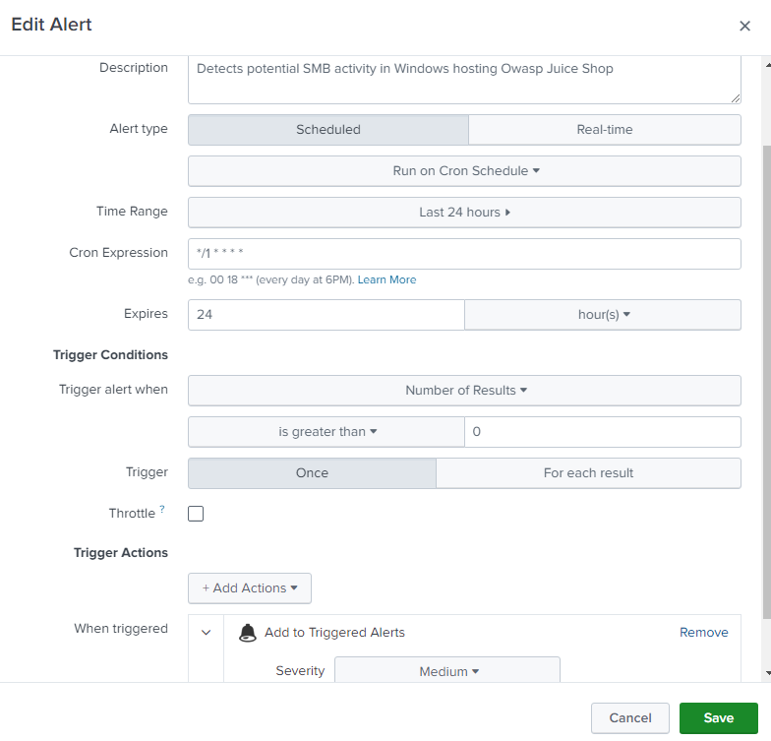
Figure 3.8: Splunk alert configuration for detecting possible SMB activity

Alert Trigger Explanation
This alert is triggered when repeated Windows Security authentication events related to network-based access are detected from the same source host. The alert specifically monitors failed authentication attempts (Event ID 4625) followed by a successful network logon (Event ID 4624) with Logon Type 3, which is commonly associated with SMB access.

The following indicators were used to confirm suspicious activity:
- Multiple failed network logon attempts (Event ID 4625) originating from the same source IP
- A subsequent successful network logon (Event ID 4624) using the same target account
- Logon Type 3 indicating authentication over network services such as SMB
- Authentication activity deviating from normal user behaviour, where legitimate users rarely generate multiple failed logons in rapid succession before successful access

This pattern suggests potential credential-guessing activity that resulted in authenticated SMB access and possible lateral movement within the internal network.

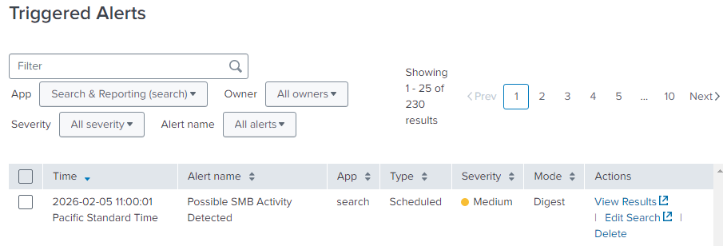
Figure 3.9: Splunk Triggered Alerts

Recommended Mitigation Steps
To reduce the risk of credential-based SMB abuse and authenticated lateral movement, the following mitigation measures are recommended:

System-Level Controls
- Enforce strong password policies and account lockout thresholds to reduce the effectiveness of credential guessing attempts
- Disable SMBv1 to eliminate legacy protocol weaknesses
- Enforce SMB signing to prevent credential relay and session tampering
- Restrict the use of local administrator accounts and avoid credential reuse across systems
- Limit exposure of administrative shares such as ADMIN$ and C$ to only authorised administrative accounts

Network Controls
- Restrict SMB access using firewall rules to allow connections only from trusted internal hosts
- Block SMB access from untrusted or external network segments
- Implement network segmentation to limit east-west movement following successful authentication
- Monitor and restrict lateral SMB traffic between workstations where not operationally required

Monitoring and Response
- Continuously monitor Windows Security authentication events (Event IDs 4624 and 4625) for abnormal patterns
- Alert on multiple failed authentication attempts followed by successful network logons from the same source
- Investigate hosts generating repeated authentication failures to identify potential credential misuse
- Temporarily isolate or block source IP addresses associated with suspicious authentication activity
- Conduct regular reviews of user account privileges and SMB access permissions

Cross-Site Scripting (XSS)

Simulations

Simulation 1: Reflected XSS
This simulation shows an example of a reflected XSS. Making use of a URL parameter, we can inject a payload, and it will execute. This payload will not be stored on the server and will only work if the modified URL is executed.

It works as the website does not properly sanitize inputs, resulting in unauthorised scripts running and executing authorised actions.
For this scenario, the attacker, with an account and logged in will be able to spot a possible exploit when he checks his orders. When he is at the tracking page, it is observed that the URL takes in a parameter “id”, which is the order ID.

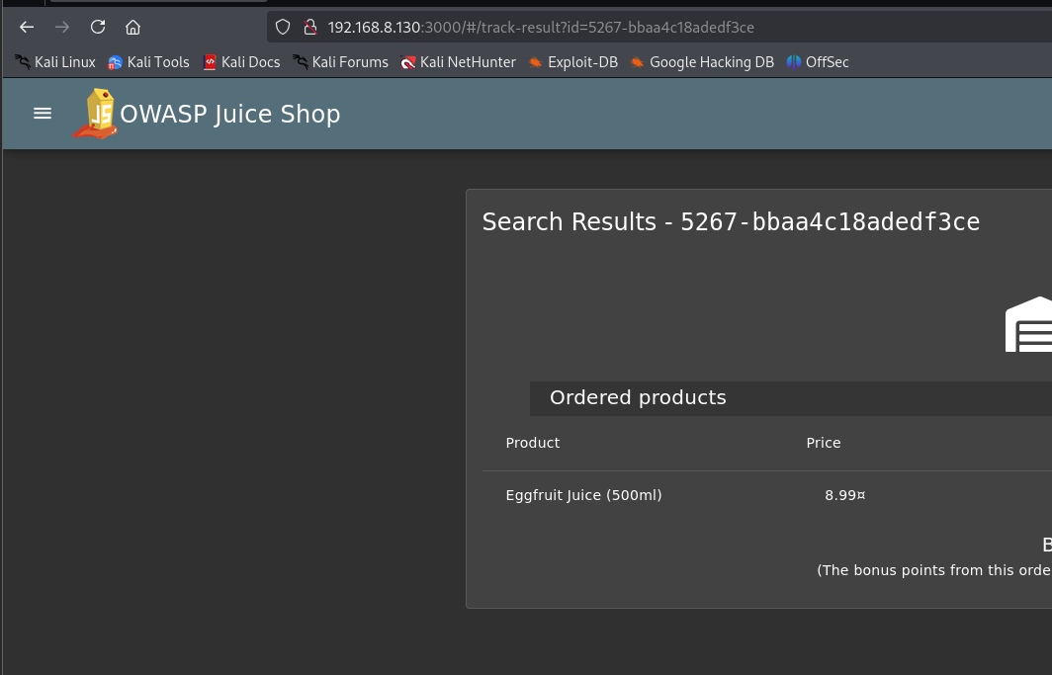
Figure 4.1: Track Orders Page

A simple payload can be crafted and injected into the URL to demonstrate XSS. The following payload was used:
<iframe src="javascript:alert('xss')">

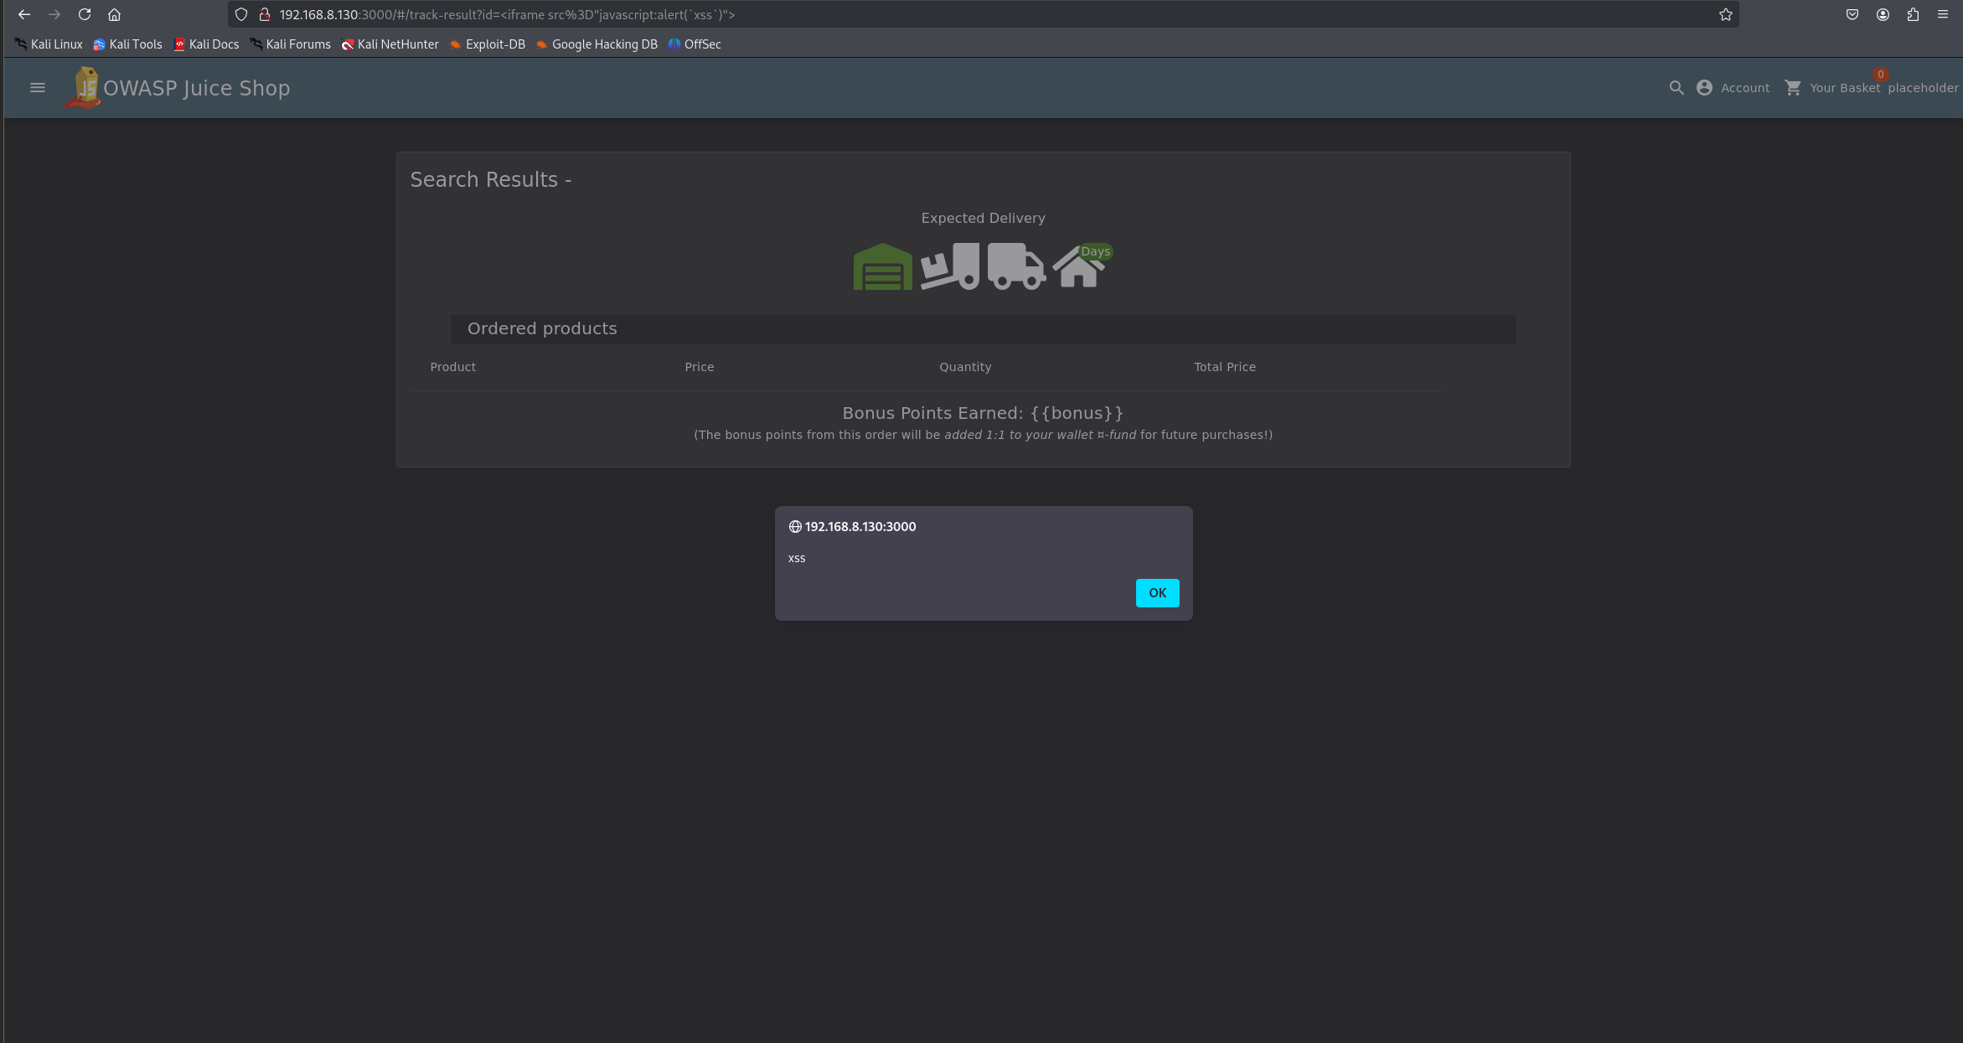
Figure 4.2: An alert with “xss” will appear, which means the attack was successful

Logs Collected
When the XSS attacks were conducted, application logs were generated by OWASP Juice Shop and forwarded to the Splunk Enterprise Indexer via the Splunk Universal Forwarder.

Capturing HTTP request headers, the method and target endpoint are also collected, and requests containing scripts in the URL query parameter are also logged, indicating XSS.

Detection
Analysis in Splunk shows logs of requests from “/rest/track-order” with encoded JavaScript when an initial query of “/rest/track-order” was done using the query:
index=main sourcetype=juice:access | search "/rest/track-order"
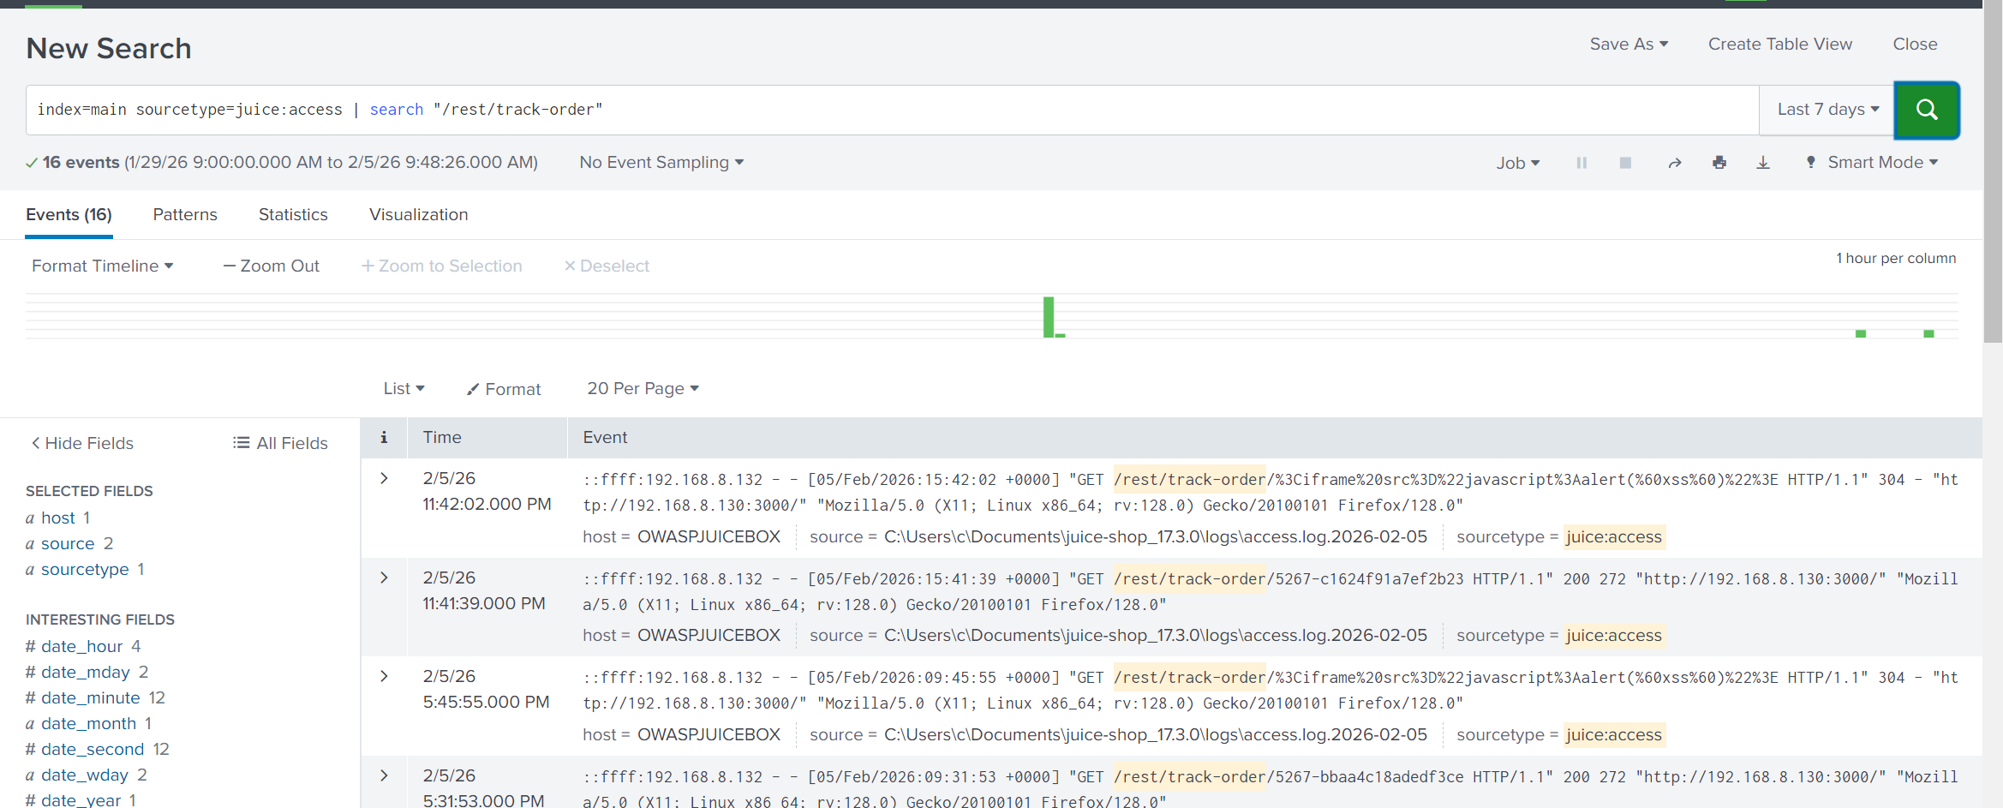
Figure 4.3: Splunk Search Results for /rest/track-order Endpoint Showing Encoded JavaScript Activity

Mitigation
This already is a sign of XSS, but to specifically detect it (as the attacker might send more requests to “/rest/track-order” to flush out the suspicious logs), we will need to query something more specific:
index=main sourcetype=juice:access | search "/rest/track-order"
| eval decoded=urldecode(_raw)
| where match(decoded,"(?i)<iframe|javascript:|<script")

Query Component | Explanation
index=main sourcetype=juice:access | Specify search in JuiceShop logs
search "/rest/track-order" | Target order tracking endpoint, where an id is an input in the URL
eval decoded=urldecode(_raw) | URL decoder which decodes the URL and returns the original readable script embedded
where match(decoded,"(?i)<iframe|javascript:|<script") | Compares the decoded URL with common XSS signs (embedded JavaScript)

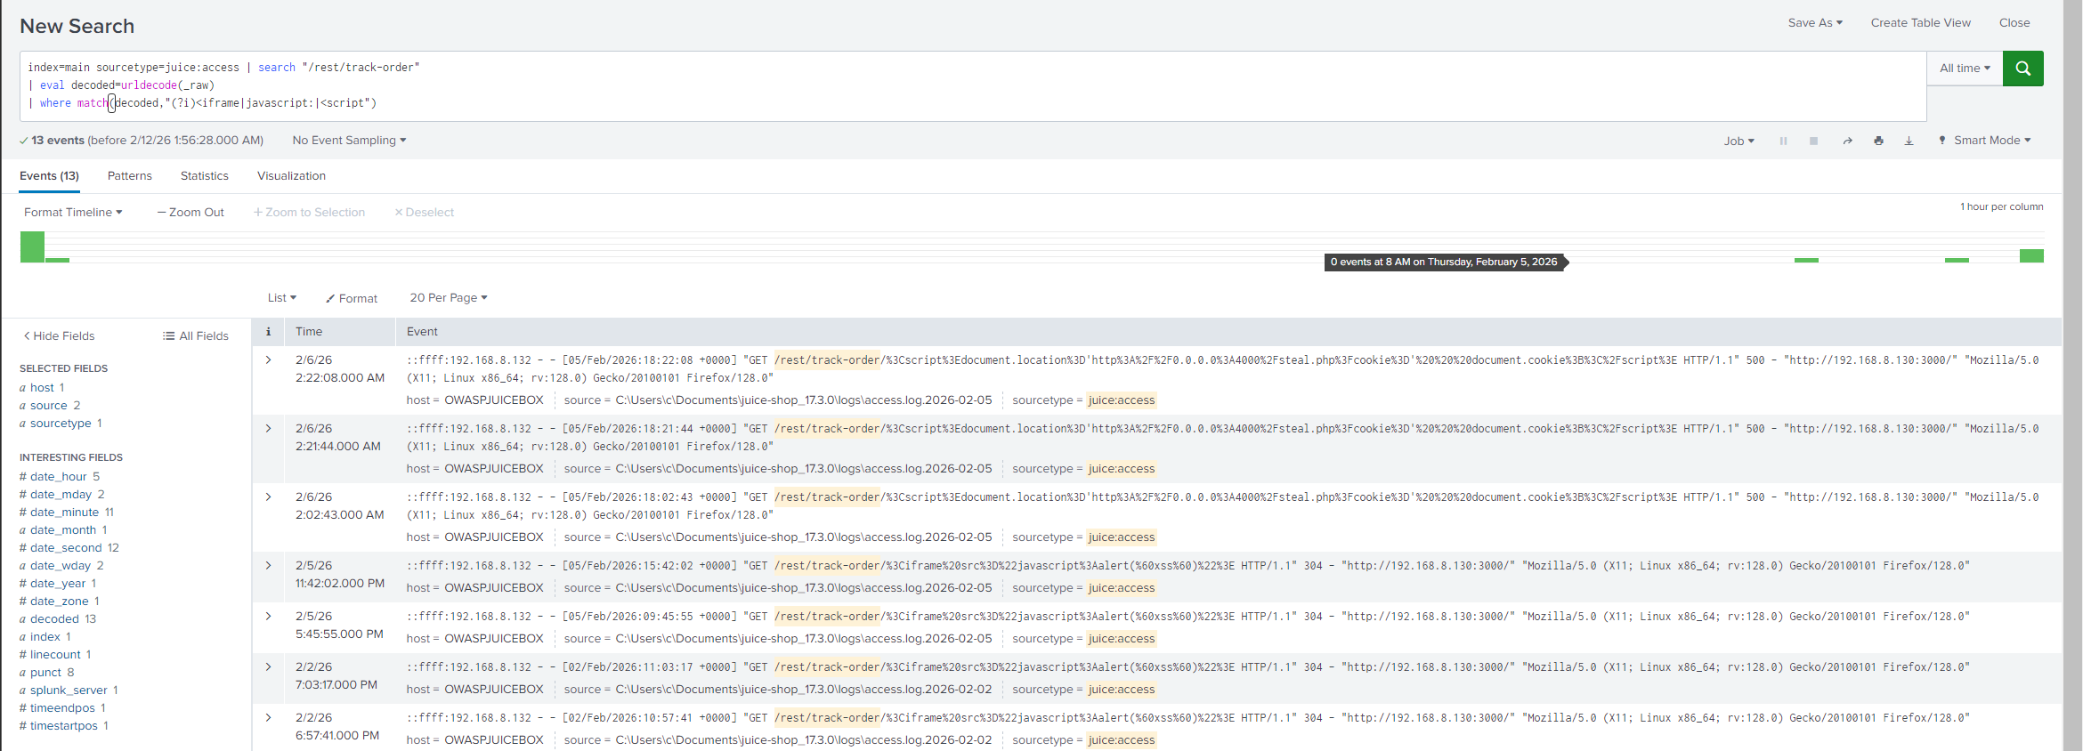
Figure 4.4: Splunk detection of XSS attempts based on payload

Alert Configuration
Setting | Value
Alert Name | Possible Reflected XSS Detected - Unauthorized Alert
Alert Type | Scheduled
Time Range | Last 24 hours
Schedule | Every 1 minute (cron-based : */1 * * * * )
Trigger Condition | Number of results > 0
Severity | Medium
Trigger Action | Add to Triggered Alerts

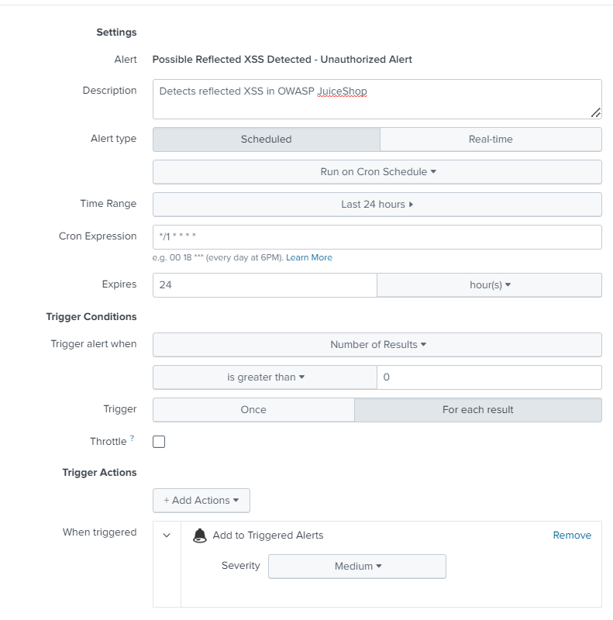
Figure 4.5: Splunk alert configuration for detecting possible XSS activity.

Alert Trigger Explanation
This alert is triggered when there are traces of JavaScript in the HTTP URL header, which indicates XSS attempts. These traces are found through the decoding of the URL and matching it with signs like:
- <iframe
- <script>
- javascript:

The query aims to focus on requests to endpoints with URL query parameter, particularly “/rest/track-order” which has “id” as a parameter as payloads can be injected into these parameters.

The alert is configured to be scheduled and will add itself to triggered alerts when the query hits something. This ensures that the alert will only trigger when a suspected reflected XSS attempt is detected. Every 1 minute is crucial, as XSS attacks can happen anytime, and it is good to have early detection. The alert will trigger if the query results are more than 0, as if the attack can happen once, it can happen again if the vulnerability is not patched.

The attack severity is medium, as Reflected XSS, especially an unauthorised alert does not pose too much danger to the client, as there is no data loss or leak, just an affected customer. But that customer can be misled by the alert and lead to actions which might cause harm to the customer, leading to jeopardy of BrightMart.
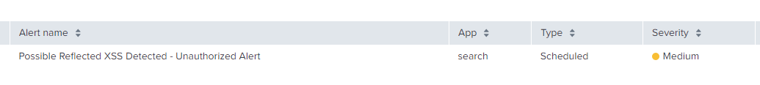
Figure 4.6: XSS triggered alert

Recommended Mitigation Steps
Reflected XSS can be prevented by:
- Input validation:
Sanitize all URL headers and reject all foreign scripts
- Output Encoding:
Encode data before rendering so that any scripts is interpreted as text and will not execute.
- Content security policy (CSP):
Provides control over where scripts can execute and trusted sources of scripts

Network Scanning

Simulations

Simulation 1: TCP SYN Stealth Scan (The sneakiest type of scan) Detection
This simulation demonstrates the detection of a TCP SYN scan against the Windows host. Unlike a standard connection attempt, a SYN scan sends a SYN packet and then abruptly tears down the connection (RST) before the handshake is complete. This technique is commonly used by attackers to map out open ports while attempting to evade legacy logging mechanisms that only record completed sessions.

Snort was deployed to monitor network traffic and detect abnormal connection patterns.
The IDS was started using the following command:
snort -i 4 -c C:\Snort\etc\snort.conf -l C:\Snort\log -A console
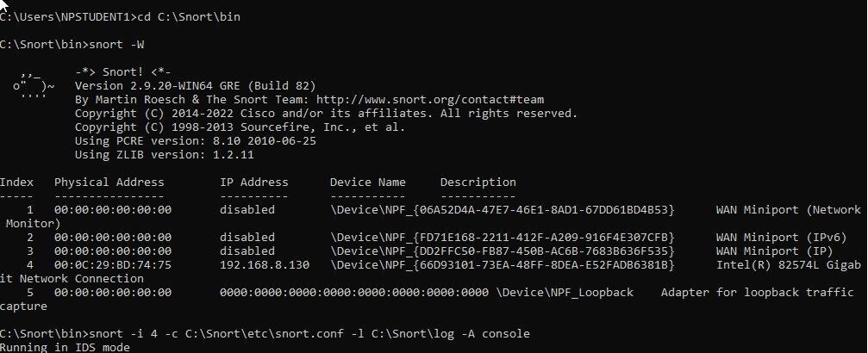
Figure 5.1: Snort IDS Deployment and Interface Configuration Output

In this simulation, the attacker machine (Kali Linux) performed an Nmap TCP SYN scan against the target system (Windows 10 OWASP Juicebox) using the -sS option. Because a SYN scan does not complete the TCP three-way handshake, Windows Event Logs did not generate meaningful records of the activity, as no full session was established.

However, the Snort IDS—configured with the sfPortscan preprocessor—successfully detected the reconnaissance behavior. The system identified a pattern of rapid, incomplete TCP connection attempts across multiple ports, which is characteristic of SYN-based port scanning.

nmap -sS -p 1-1000 192.168.8.130

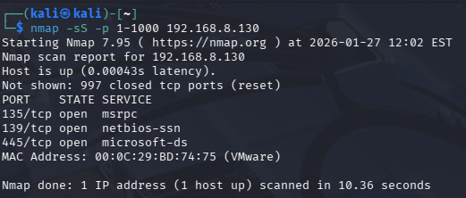
Figure 5.2: Nmap Stealth Scan initiated from Kali Linux targeting the top 1000 ports

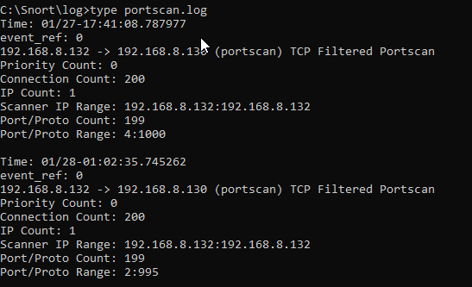
Figure 5.3: Raw Snort logs showing "Portscan detected" events captured locally on the target

Simulation 2: Service Version & OS Detection
While the first simulation focused on "stealth" discovery of open ports, this second simulation demonstrates a more aggressive "interrogation" scan. Attackers use this technique to query the specific application versions running on open ports (e.g., identifying "Apache 2.4.41" vs. just "Port 80 Open"). This intelligence is critical for attackers to match specific vulnerabilities (CVEs) to the host.

In this scenario, the attacker executed an Nmap version scan against the target. This scan performs a full TCP handshake and sends data probes to solicit service banners. Because this generates significantly more traffic than a stealth scan, it serves as a stress test for the IDS detection logic.

nmap -sV -p 1-1000 192.168.8.130

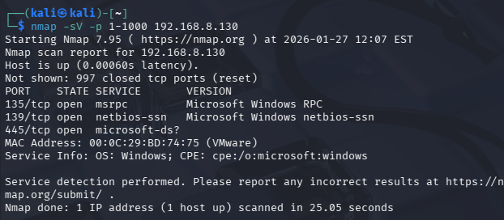
Figure 5.4: Nmap Version Detection scan initiated to fingerprint services

Logs Collected
To enable network-level visibility, we installed Snort IDS on the target Windows machine. Snort was configured to inspect raw network packets and generate alert logs when scan patterns were detected. Specifically, the sfportscan preprocessor was enabled in snort.conf to output detection events to:
C:\Snort\log\portscan.log

This configuration ensures reconnaissance activity is captured even when TCP sessions are not fully established.

The Splunk Universal Forwarder was then configured to monitor this specific log file. A new line was added to inputs.conf to tag these events with the sourcetype snort:portscan, ensuring they were indexed correctly by the Splunk Enterprise server for analysis.

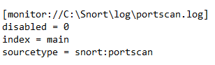
Figure 5.5: Splunk Universal Forwarder Configuration Monitoring Snort Portscan Log

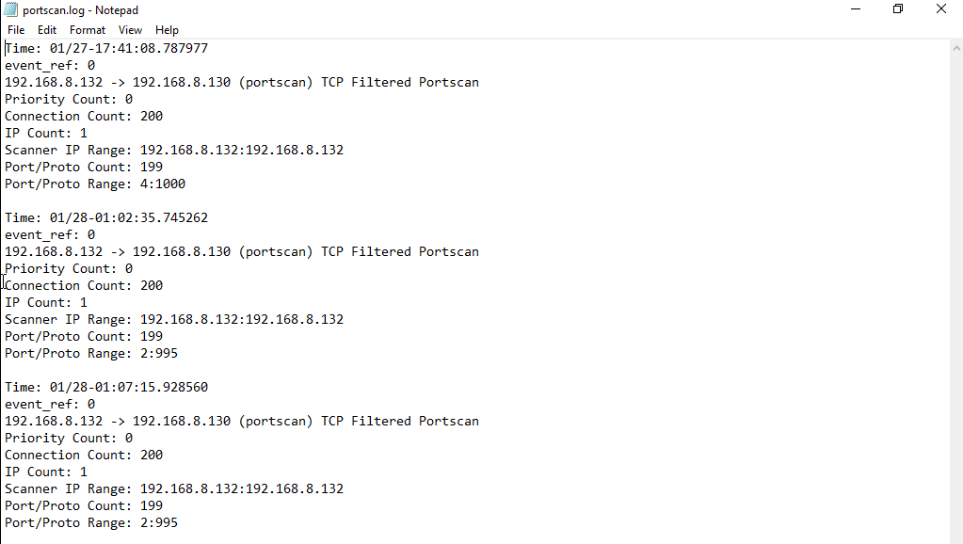
Figure 5.6 : Splunk Universal Forwarder configuration monitoring the Snort portscan log

Detection
Analysis in Splunk revealed a high volume of alert events generated by the Snort packet engine. These events identified the source IP address (192.168.8.132/Kali Linux) performing a "TCP Portscan" against the victim host.

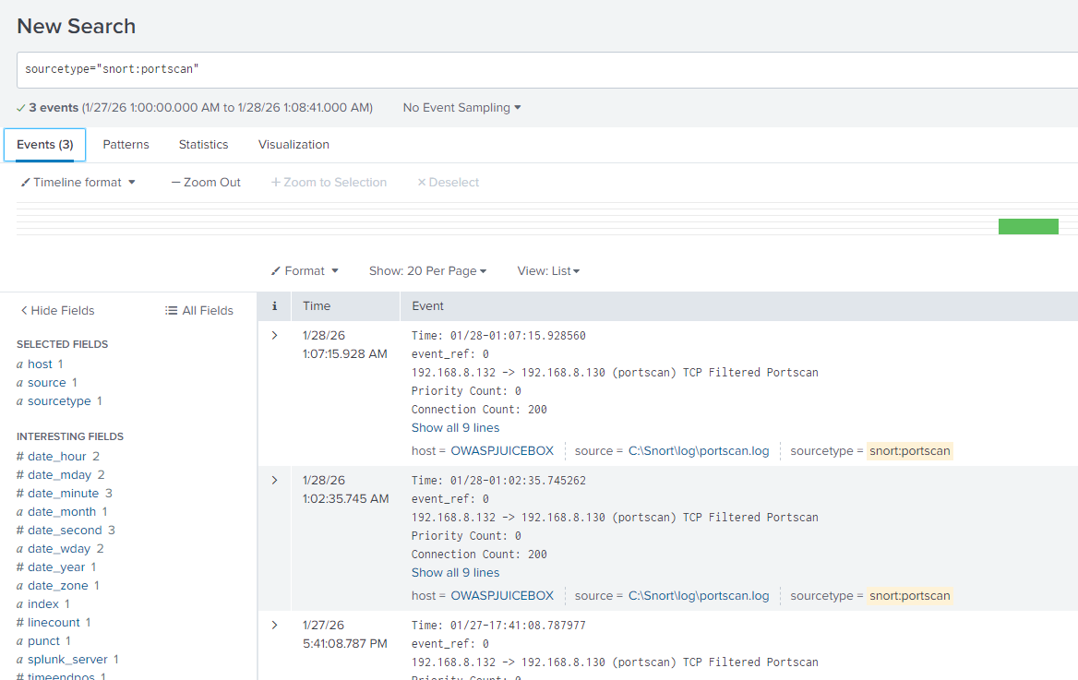Figure 5.7 : Splunk Analysis Identifying Source IP and Portscan Signature

The detected events provided critical network-level evidence that was not visible in host-based logs:
- Attack Signature: TCP Filtered Portscan
- Source IP: 192.168.8.132 (The Kali Machine)
- Protocol: TCP
- Priority: 0 (indicating a preprocessor-generated alert)

These alerts confirm that the detection was triggered at the packet-analysis level rather than through application or system logging.

Detection accuracy was verified by correlating the Snort alert timestamps with the controlled simulation windows. The alert bursts aligned precisely with the execution of each Nmap command, confirming causal linkage between attacker activity and IDS detection.

The IDS demonstrated consistent behaviour across multiple scan types:

Simulation 1 – TCP SYN Stealth Scan (-sS):
Generated a concentrated burst of alerts corresponding to rapid SYN probes across ports 1–1000. The incomplete TCP handshakes triggered sfPortscan detection thresholds.

Simulation 2 – Version Detection Scan (-sV):
Produced a sustained volume of alerts over a longer duration. Because the -sV flag requires additional service probes per open port, the scan generated more observable traffic, resulting in prolonged alert activity.

The consistent classification of both scan types under the “TCP Portscan” signature confirms that the detection logic is behaviour-based rather than flag-dependent. This demonstrates robustness against minor scan variations intended to evade simplistic detection mechanisms.

Mitigation
To ensure immediate visibility of reconnaissance activity, a real-time alert was configured in Splunk to monitor Snort port scan events. The alert triggers whenever the snort:portscan sourcetype generates detection events, indicating active network scanning behaviour. This configuration ensures that any new port scan detection event immediately generates an alert for analyst review.

Setting | Value
Alert Name | Network Port Scan Detected
Alert Type | Scheduled
Time Range | Last 24 hours
Schedule | Real-time
Trigger Condition | sourcetype="snort:portscan"  (Number of results > 0)
Severity | High
Trigger Action | Add to Triggered Alerts

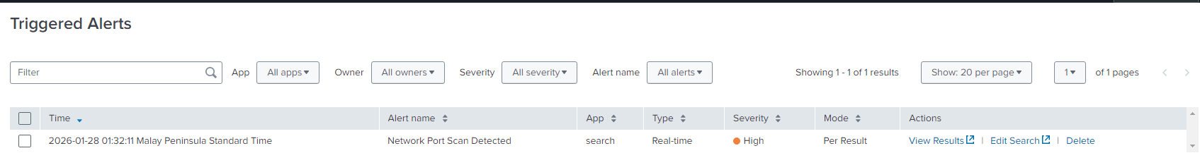Figure 5.8: Splunk Triggered Alerts Displaying Real-Time Detection of Nmap Port Scan Activity

Recommended Mitigation Steps
- Source Blocking:
Block the malicious source IP address (192.168.8.132) at the perimeter firewall or network gateway to prevent further reconnaissance attempts. This limits attacker visibility into open services and reduces exposure to follow-up exploitation.
- Preventive Control – Transition from IDS to IPS:
Reconfigure Snort from IDS mode (passive monitoring) to IPS mode (inline enforcement). In IPS mode, packets matching port scan signatures can be automatically dropped or rate-limited, preventing reconnaissance from progressing beyond the scanning phase.
- Harden Services:
Review all open ports identified during the scan and:
- Disable unnecessary services
- Close unused SMB, RPC, or legacy services
- Implement host-based firewall rules
- Enforce least privilege network exposure
Reducing the exposed service footprint minimizes attack surface and lowers risk of exploitation.

Directory Enumeration

Simulations

Simulation 1: Automated Directory Brute-Forcing
This simulation demonstrates a directory enumeration attack (also called fuzzing). Attackers use this technique to discover hidden resources such as administrative portals, configuration files, or backup directories that are not publicly linked on the web application but remain accessible if the correct URL is guessed.

In this scenario, the attacker (Kali Linux) used the tool gobuster to launch a dictionary-based attack against the OWASP Juice Shop. The tool cycled through a common wordlist (common.txt) to check for the existence of thousands of directory paths. A filter (--exclude-length) was applied to bypass the application's Soft 404 behavior (where the server returns a 200 OK status even for non-existent pages), allowing the attacker to distinguish valid hidden paths from default error pages.

gobuster dir -u http://192.168.8.130:3000 –w /usr/share/wordlists/dirb/common.txt --exclude-length 80150

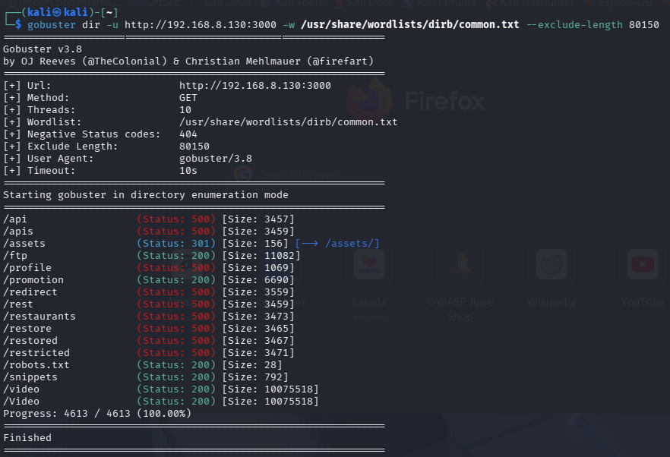
Figure 6.1: Gobuster identifying hidden directories (e.g., /ftp, /assets) by filtering out default response lengths

Simulation 2: Manual Access to Sensitive Directories
The second simulation demonstrates the exploitation phase, where an attacker manually accesses a sensitive resource identified during the scan. During the enumeration phase, the /ftp directory was discovered. The attacker manually navigated to this path to verify its contents. This activity generates a specific access log entry confirming successful unauthorized access to a restricted area.

curl -I http://192.168.8.130:3000/ftp

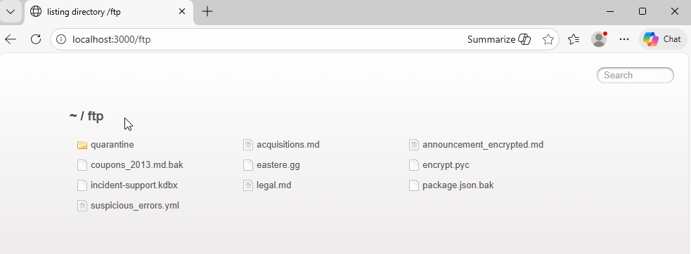Figure 6.2: Manual verification that the OWASP Juicebox has a /ftp page via browser

Logs Collected
The attack generated a high volume of application-layer access logs on the OWASP Juicebox host. These logs were ingested into Splunk via the Splunk Universal Forwarder, which was configured to monitor the Juice Shop access.log file.

This ensured real-time visibility of HTTP request activity during the attack simulation.
The logs provided critical application-layer context, including the HTTP Method (GET), the URI Path being guessed (e.g., /admin, /backup, /ftp), and the Status Code (200 OK). The logs revealed rapid, consecutive HTTP requests originating from the same source IP address, consistent with automated enumeration or brute-force-style probing.

A total of approximately 16,000 log entries were recorded within the observation window, indicating sustained scanning activity against the Juicebox application. The figure below demonstrates repetitive request patterns targeting sensitive endpoints, confirming reconnaissance behaviour at the application layer.

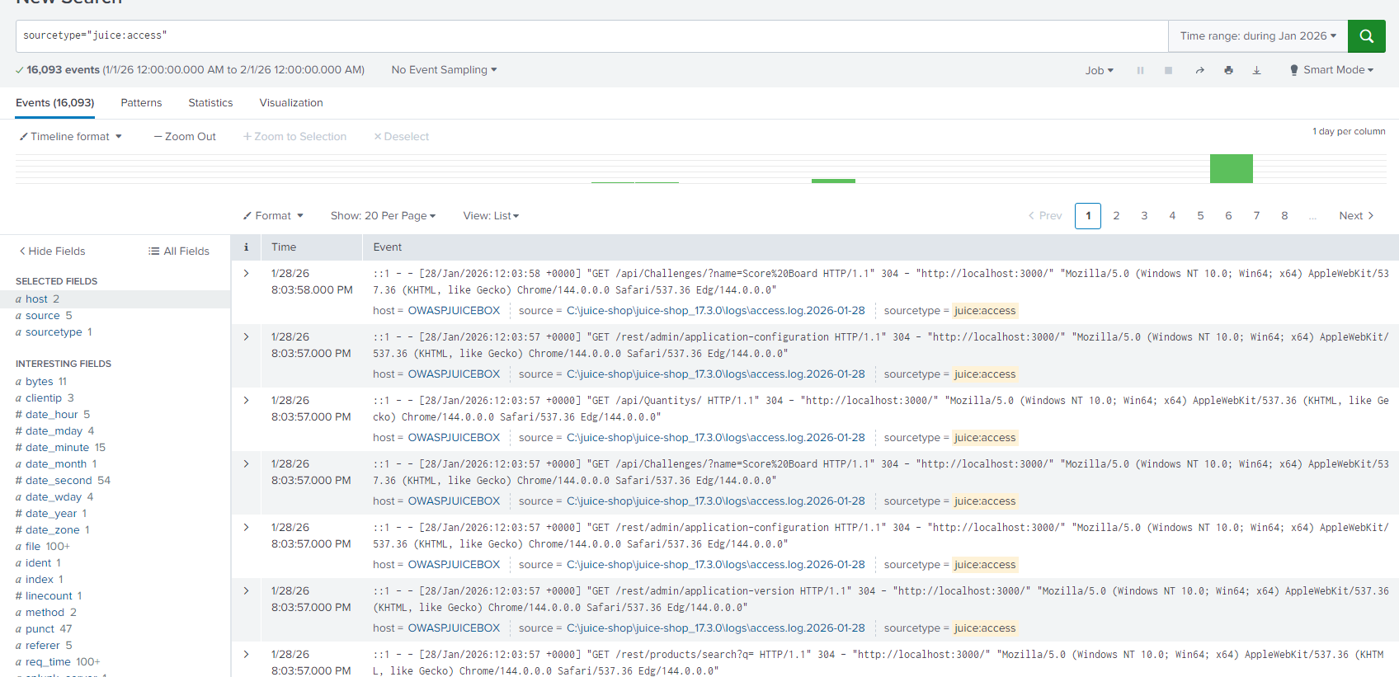Figure 6.3: Splunk View of Raw Access Logs Showing High-Frequency HTTP Requests from Attacker IP

Detection
Splunk Analysis Analysis in Splunk revealed a massive spike in HTTP requests originating from the attacker’s IP address (192.168.8.132).

During the analysis, it was observed that OWASP Juice Shop behaves as a Single Page Application and returning a 200 OK status even for non-existent pages. Therefore, standard error-based detection such as searching for status=404 was ineffective. Instead, detection relied on two distinct methods, namely:

- Volume-Based Anomaly Detection: The brute-force attack was identified by monitoring traffic volume. The logs showed thousands of requests per minute originating from a single IP address, a pattern distinct from human browsing behavior.

- Signature-Based Verification: While the noise indicated the attempt, specific queries for sensitive paths confirmed the compromise. Splunk successfully indexed the access to /ftp with a 200 OK status, allowing analysts to pinpoint exactly which hidden resource was exposed.

sourcetype="juice:access" | timechart count

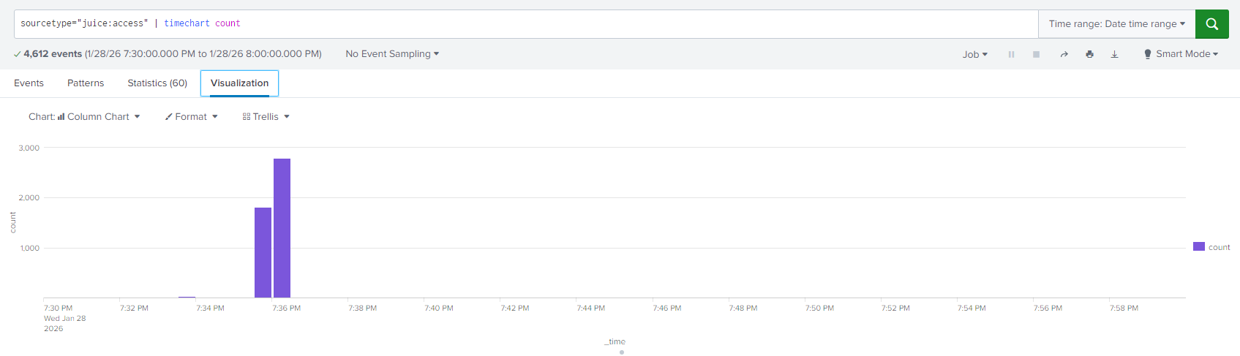Figure 6.4: Splunk timechart visualizing the high volume of traffic during the enumeration attack

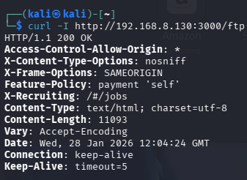
Figure 6.5: Splunk log detail showing the successful retrieval of the /ftp directory

Mitigation
To detect automated reconnaissance activity at the application layer, a real-time alert was configured in Splunk to identify abnormal request volume originating from a single source IP address. Unlike signature-based detection, this alert focuses on behavioural anomalies. Specifically, excessive request frequency within a short time window, regardless of HTTP response status.

Setting | Value
Alert Name | High Volume Scan Detected
Alert Type | Scheduled
Time Range | Last 24 hours
Schedule | Real-time
Trigger Condition | sourcetype="juice:access"  (Number of results > 100)
Severity | High
Trigger Action | Add to Triggered Alerts

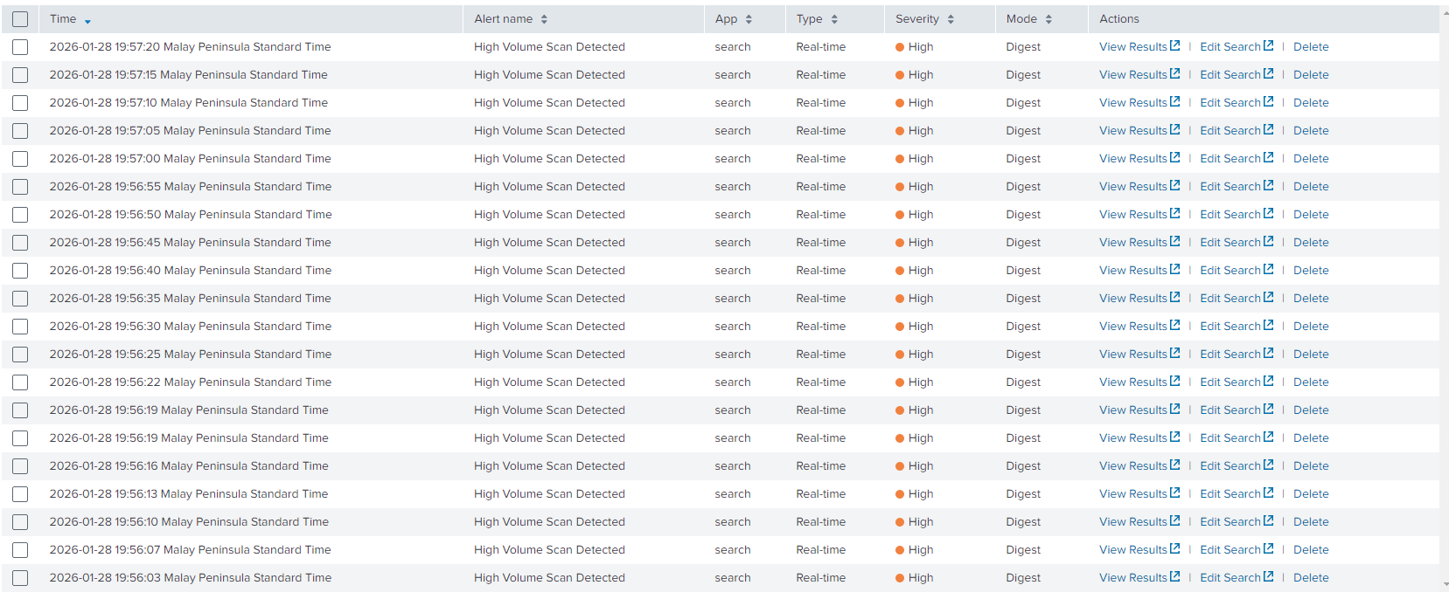Figure 6.6: Alert triggered by the excessive request volume

The triggered alerts demonstrate repeated activation due to sustained high-frequency HTTP requests from the attacker IP. This confirms that the behavioural threshold was exceeded during the scanning simulation.

Recommended Mitigation Steps
- Rate Limiting:
Implement strict rate limiting such as a max of 10 requests per second to slow down automated tools, making brute-forcing impractical.

- Disable Directory Listing:
Ensure the web server configuration has directory listing disabled so attackers cannot browse folder contents if they do guess a valid path.

- Standardize Error Codes:
Configure the web server to return proper 404 Not Found HTTP headers for invalid routes to improve visibility for monitoring tools.

- Implementation of a tarpit:
Configure the firewall to intentionally delay responses to suspected port scanners (Tarpitting). This drastically slows down the attacker's reconnaissance phase, making large-scale scanning impractical and giving the Blue Team more time to react.

Challenges Faced
A critical technical challenge encountered was the application's 'Soft 404' behavior. Because OWASP Juice Shop is a Single Page Application (SPA), it returns a generic 200 OK response for non-existent pages instead of a standard 404 error. This initially flooded the logs with false positives. To resolve this, I analysed the Content-Length of the generic response (80150 bytes) and configured gobuster to filter out these specific responses. This tuning was essential to isolate true hidden directories from application noise.

Figure 6.7: Gobuster Output Revealing Soft 404 Response Length (Content-Length 80150 Bytes)

One of the key observations noted was the robustness of the Snort sfportscan preprocessor. It successfully flagged both the 'Stealth' SYN scan and the noisy Version Detection scan under the same 'TCP Filtered Portscan' signature. This confirms that the detection logic is based on behavioral analysis (rapid connection attempts) rather than simple signature matching. This is critical for the client, as it ensures detection even if attackers modify their tool flags to evade static signatures."

Insecure Direct Object Reference (IDOR)

Simulations

Simulation 1: User Basket Enumeration
This simulation demonstrates an Insecure Direct Object Reference (IDOR) vulnerability affecting the OWASP Juice Shop basket API endpoint. By manipulating the basket identifier within a legitimate request, an attacker is able to access shopping cart data belonging to other users, even though the authentication cookie does not belong to the victim.

The vulnerability arises due to the application’s failure to enforce server-side authorisation checks. While the application verifies that a user is authenticated, it does not validate whether the authenticated user is authorized to access the requested basket resource. This results in unauthorised exposure of sensitive user data.

In this scenario, the attacker logs in as a normal user and first retrieves their own basket using a legitimate API request. The attacker’s account is associated with basket ID 1. Using Burp Suite, the attacker intercepts and replays this request, manually modifying the basket ID parameter in the API endpoint. By changing the request path to GET /rest/basket/2, GET /rest/basket/3, GET /rest/basket/4, and subsequent values, the attacker successfully retrieves shopping cart contents belonging to other users.

Each manipulated request receives an HTTP 200 OK response and returns valid basket data, confirming the presence of an IDOR vulnerability caused by missing authorisation enforcement.

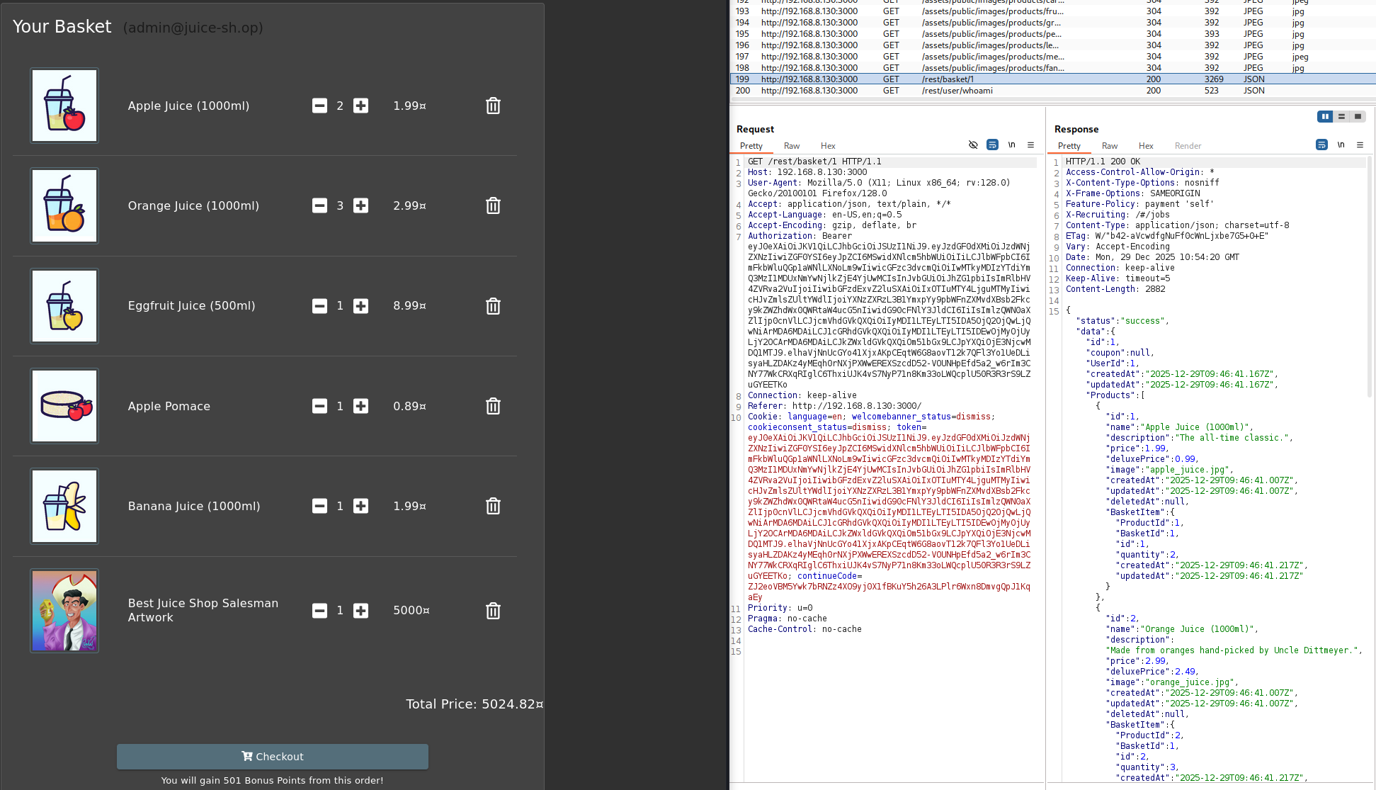
Figure 7.1: Legitimate basket retrieved by authenticated user through admin account
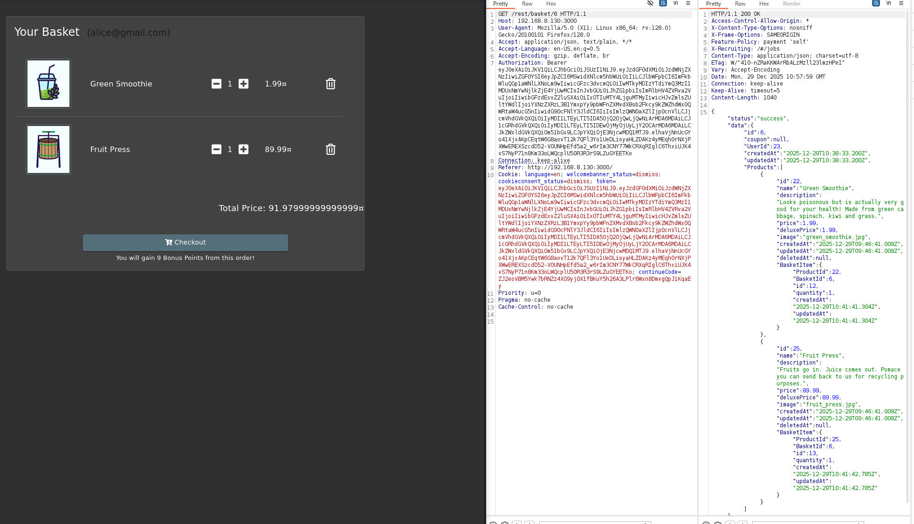
Figure 7.2: Unauthorised basket access via IDOR to get Alice’s cart

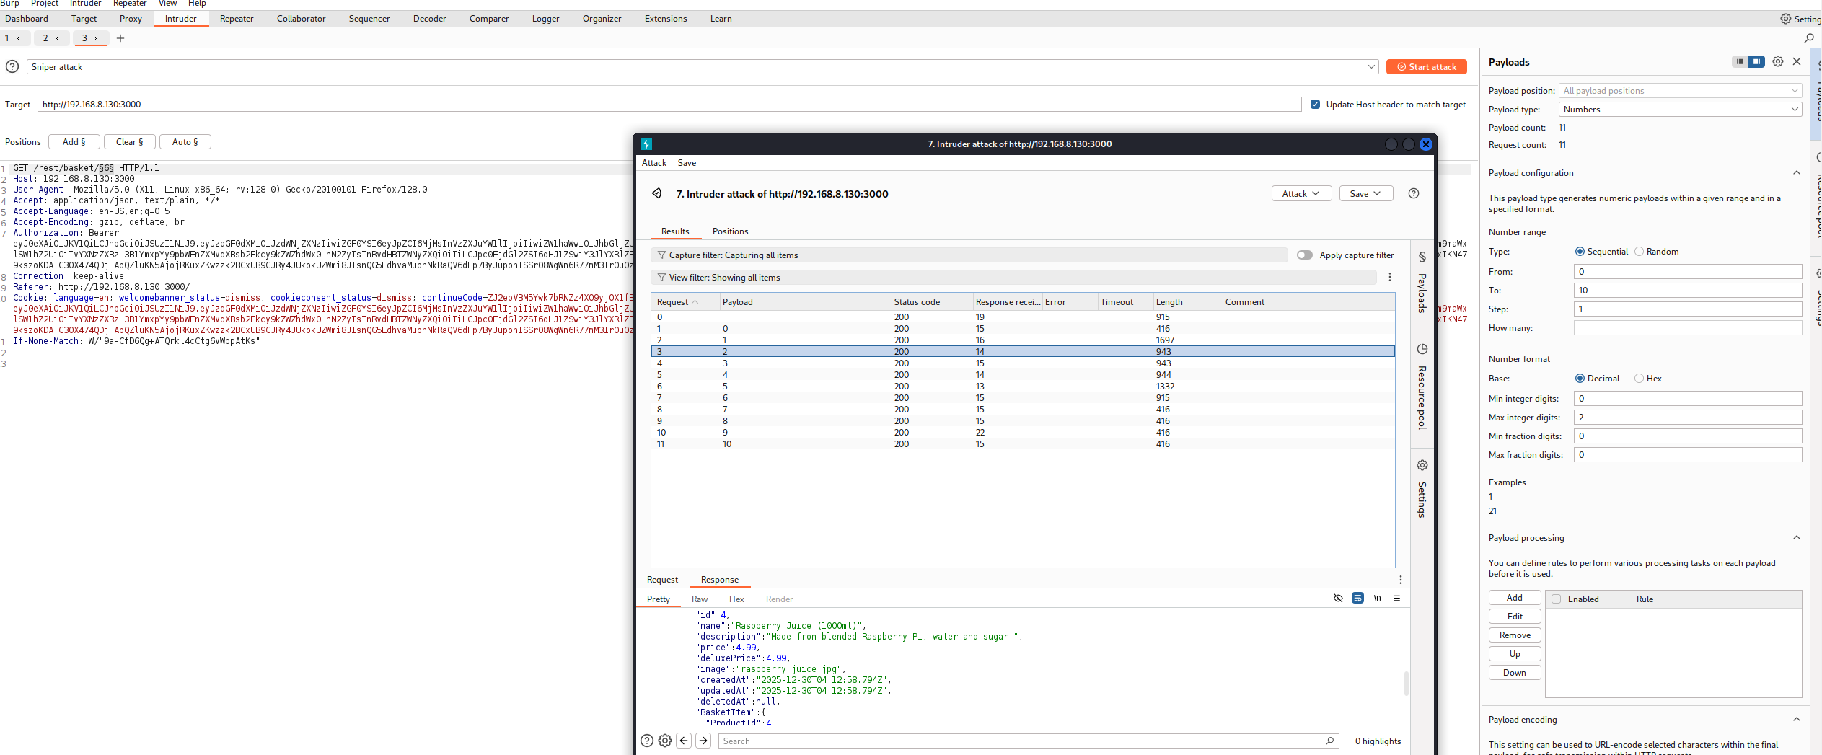
Figure 7.3: Burp Suite Intruder used to enumerate basket IDs

Logs Collected
During the basket enumeration attack, application access logs were generated by OWASP Juice Shop and forwarded to the Splunk Enterprise Indexer via the Splunk Universal Forwarder. These logs captured detailed HTTP request information, including request paths, response codes, timestamps, and source IP addresses.

Detection
Analysis in Splunk revealed multiple HTTP GET requests to the /rest/basket endpoint containing different numeric basket identifiers, all originating from the same source IP address (192.168.8.132) within a short time window.

Each request returned a successful response, indicating repeated unauthorised access attempts to multiple user baskets.

This access pattern is not consistent with normal user behaviour, as legitimate users typically interact only with their own basket. The repeated access to numerous basket IDs within a short period strongly indicates automated enumeration activity.

An initial search filter was used to identify access to the basket API endpoint:

host="owaspjuiceshop" sourcetype=juice:access "/rest/basket/"

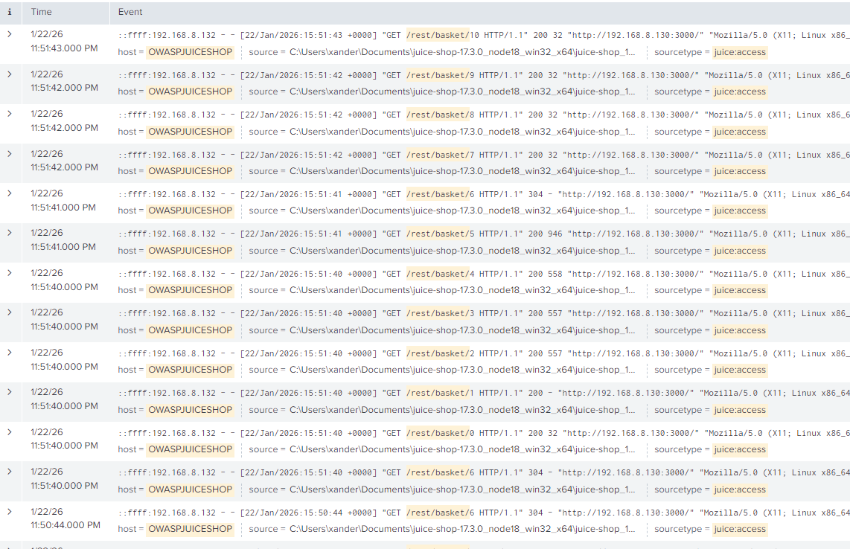
Figure 7.4: Raw Juice Shop logs in Splunk

Mitigation
To make the IDOR attack behaviour more clearly observable, an enhanced search query was implemented:
host="owaspjuiceshop" sourcetype=juice:access "/rest/basket/"
| stats dc(uri_path) as unique_baskets values(uri_path) as baskets_accessed by src_ip
| where unique_baskets >= 3

Two custom fields, src_ip and uri_path, were created to assist with more accurate searching and statistical analysis.
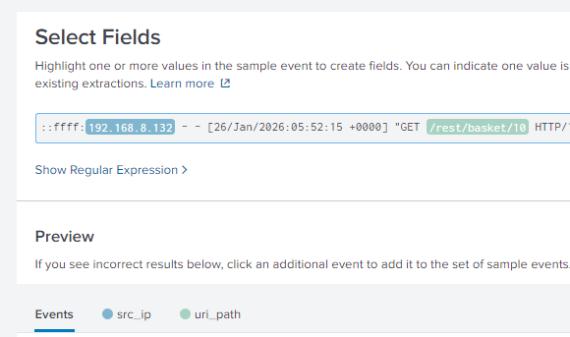
Figure 7.5: Extracting and creating custom fields in Splunk in order for the query to be valid

This query focuses on API requests related to the /rest/basket endpoint. The dc(uri_path) function counts the number of unique basket identifiers accessed by each source IP address, while values(uri_path) records the specific basket endpoints accessed.

The condition unique_baskets >= 3 flags any source IP accessing three or more distinct basket IDs within the defined time window.

Such behaviour is highly abnormal for legitimate users and is a strong indicator of basket enumeration associated with IDOR exploitation.

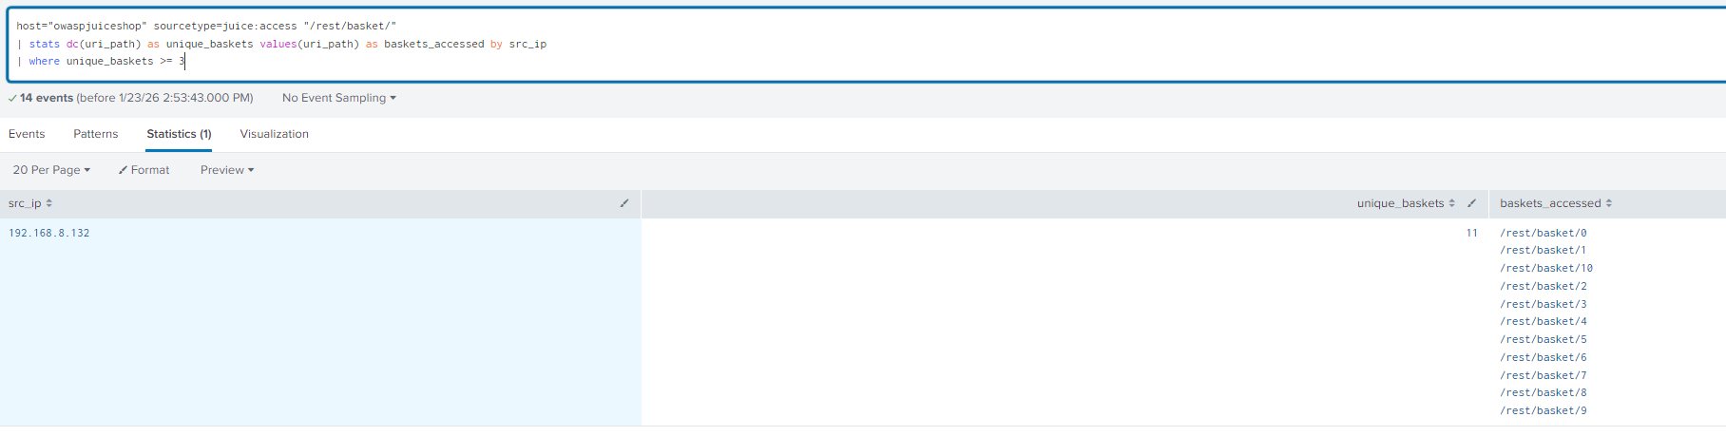
Figure 7.6: Splunk statistics view identifying a single source IP accessing multiple unique basket IDs.

Alert Configuration
This configuration ensures that suspicious enumeration activities are detected and logged in Splunk in real-time.
Setting | Value
Alert Name | Possible IDOR – Basket Enumeration Detected
Alert Type | Scheduled
Time Range | Last 24 hours
Schedule | Every 1 minute (cron-based : * /1 * * * * )
Trigger Condition | Number of results > 0
Severity | High
Trigger Action | Add to Triggered Alerts

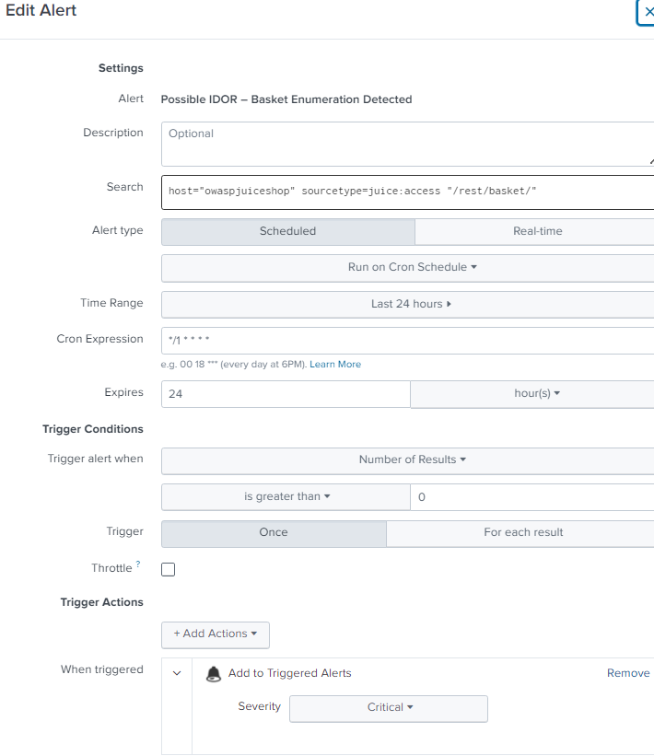
Figure 7.7: Splunk alert configuration for detecting possible IDOR basket enumeration.

Alert Trigger Explanation
The alert is triggered when a single source IP address, identified as the Kali Linux attacker machine (192.168.8.132) accesses multiple unique basket IDs through the /rest/basket endpoint within a short time frame.
The following indicators confirmed the IDOR attack:

- Repeated HTTP GET requests to the /rest/basket endpoint
- Sequential numeric basket identifiers (e.g. /rest/basket/201, /rest/basket/202, /rest/basket/203…)
- A single source IP generating all requests
- High request frequency indicative of automated activity

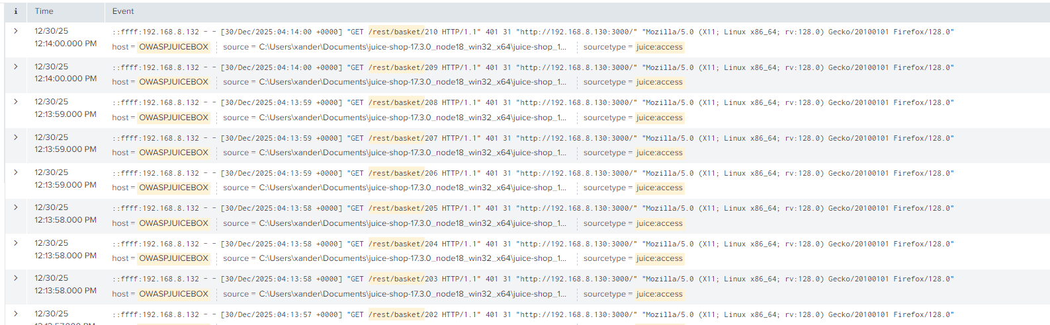

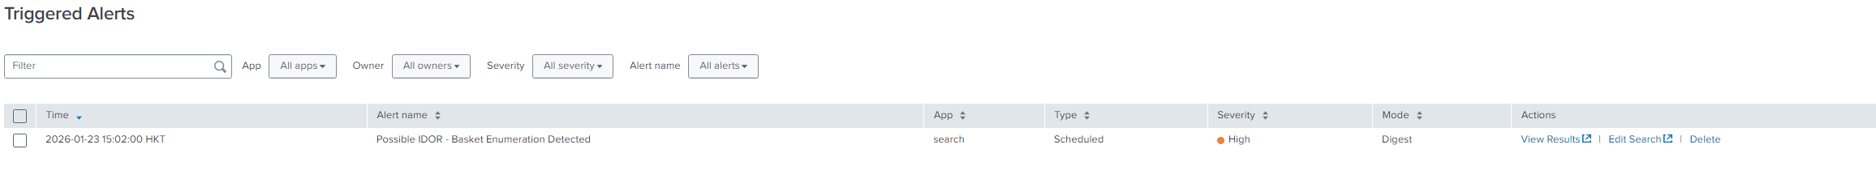
Figure 7.8: Splunk Triggered Alerts

Recommended Mitigation Steps
To mitigate IDOR vulnerabilities and minimise the risk of unauthorised data exposure, the following measures are recommended:

Application-Level Controls
- Enforce strict server-side authorization checks to ensure users can access only resources they own
- Replace predictable numeric identifiers with randomized or UUID-based object identifiers

Security Controls
- Implement rate limiting on sensitive API endpoints to restrict automated enumeration
- Deploy Web Application Firewall (WAF) rules to detect and block abnormal access patterns
- Maintain SIEM-based monitoring and alerting for anomalous API usage

Monitoring and Response
- Temporarily block or throttle source IP addresses exhibiting enumeration behaviour
- Review application logs to assess potential data exposure
- Conduct regular security testing and code reviews with a focus on access control mechanisms

Unauthorised Administrative Endpoint Access

Simulations

Simulation 1: Administrative Endpoint Reconnaissance
This simulation demonstrates unauthenticated access to an administrative configuration endpoint in OWASP Juice Shop using a command-line HTTP client.

In this scenario, the attacker does not authenticate or interact with the application through a browser. Instead, the attacker sends a direct HTTP request using the curl utility from the Kali Linux attacker machine.

The following command was executed:
curl -i http://192.168.8.130:3000/rest/admin/application-configuration

Despite the absence of any authentication credentials, session cookies, or prior login activity, the server responded with an HTTP 200 OK status and returned extensive administrative configuration data, including internal server settings, application feature flags (such as version display and local backup enablement), and third-party integration details, notably the Google OAuth client configuration.

This confirms that the administrative endpoint does not enforce authentication or authorization checks, resulting in unrestricted information disclosure.

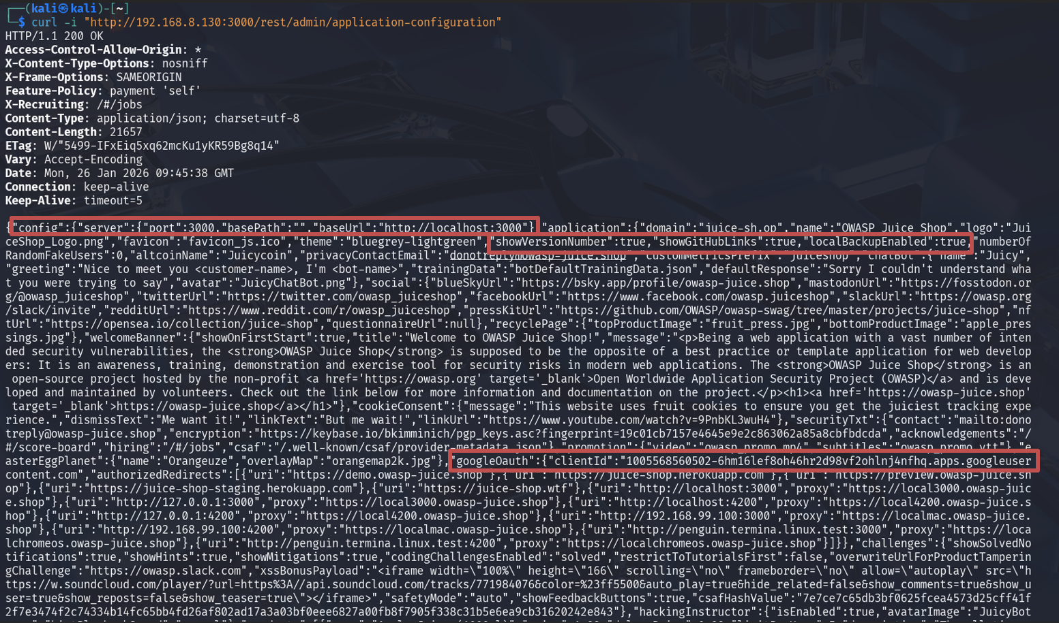
Figure 8.1: Successful retrieval of application configuration via unauthenticated admin API request.

Logs Collected
During the simulation, OWASP Juice Shop generated application access logs that were forwarded to the Splunk Enterprise Indexer via the Splunk Universal Forwarder.

These logs captured the direct request to the administrative endpoint, including the request URI, HTTP method, response status code, timestamp, user agent, and source IP address of the attacker machine (192.168.8.132).

Notably, no authentication or login-related log entries preceded the administrative endpoint access, confirming that the request was processed without user authentication.

Detection
Analysis in Splunk identified successful HTTP requests to the /rest/admin/application-configuration endpoint originating from the attacker’s source IP address, without any associated authentication events.

This behaviour is inconsistent with legitimate application usage, as unauthenticated users should not be able to access administrative APIs.

An initial Splunk search was used to identify unauthenticated access to administrative endpoints:

host="OWASPJUICESHOP" sourcetype="juice:access" "/rest/admin/"

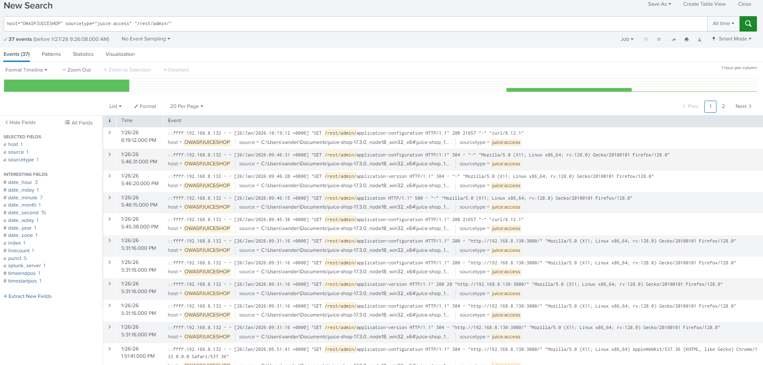 Figure 8.2: Raw OWASP Juice Shop access logs in Splunk showing /rest/admin endpoint requests

Mitigation
To make unauthorised access to administrative endpoints clearly observable, an enhanced Splunk search query was implemented to identify requests targeting /rest/admin/ endpoints originating from a single source IP address.

The search query shows access attempts by src_ip, counts the number of requests, and captures representative raw log entries for investigation:
host="OWASPJUICESHOP" sourcetype="juice:access" "/rest/admin/"
| stats count values(_raw) as sample_events by src_ip
| where count >= 1

This query focuses on identifying any interaction with administrative endpoints regardless of authentication state. Since legitimate users should not directly access /rest/admin/* endpoints without proper authorization, any matching result is considered suspicious and suitable for alerting.

By grouping events by source IP, the query provides visibility into repeated or systematic access attempts against sensitive administrative functionality, enabling efficient detection and response.

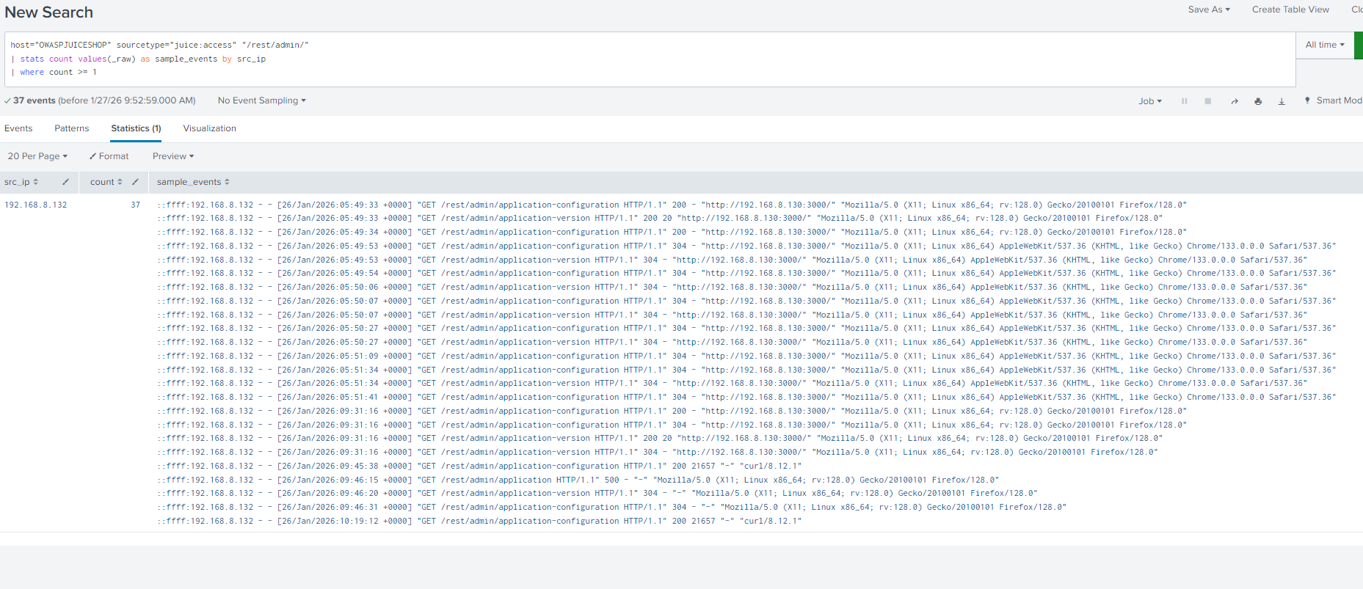
Figure 8.3: Splunk statistical view grouping administrative endpoint access by source IP.

Alert Configuration
This configuration ensures that unauthorised access to administrative API endpoints is detected and logged in Splunk in near real time.
Setting | Value
Alert Name | Possible Unauthorised Admin Endpoint Access
Alert Type | Scheduled
Time Range | Last 24 hours
Schedule | Every 1 minute (cron-based : * /1 * * * * )
Trigger Condition | Number of results > 0
Severity | Critical
Trigger Action | Add to Triggered Alerts

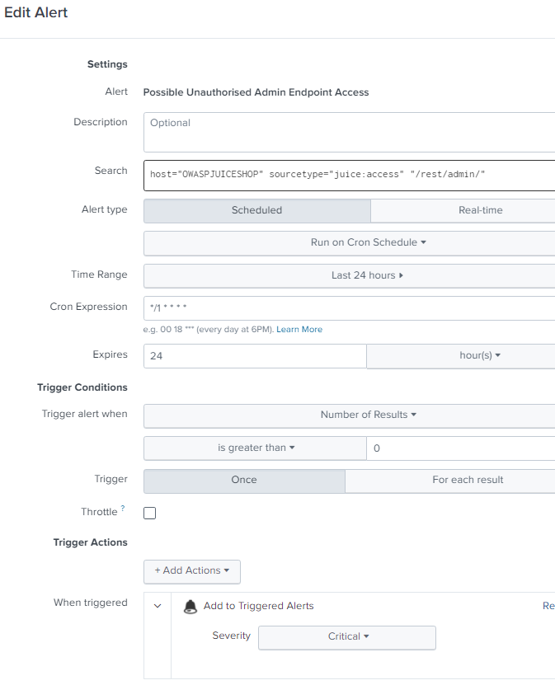
Figure 8.4: Splunk alert configuration for detecting possible unauthorised admin endpoint access

Alert Trigger Explanation
The alert is triggered when at least one HTTP request to a /rest/admin/ endpoint is detected from a source IP address.
In this scenario, several indicators confirmed unauthorised administrative access:
- Direct HTTP GET requests to sensitive administrative endpoints such as /rest/admin/application-configuration, /rest/admin/application-version, and related paths
- Requests originating from a non-browser client, specifically a curl/8.12.1 user agent
- Absence of any authentication credentials, session cookies, or preceding login activity
- Mixed response outcomes, including HTTP 200 OK responses where configuration data was successfully retrieved, as well as HTTP 500 Internal Server Error responses when non-existent or unsupported administrative endpoints were accessed
- Repeated access attempts originating from a single source IP address (192.168.8.132)

The occurrence of HTTP 500 responses indicates that the attacker actively probed additional administrative endpoints, causing backend errors. This behaviour is consistent with reconnaissance and endpoint discovery activities rather than normal application usage.

All in all, these indicators strongly suggest unauthorised access and information disclosure attempts targeting administrative interfaces.
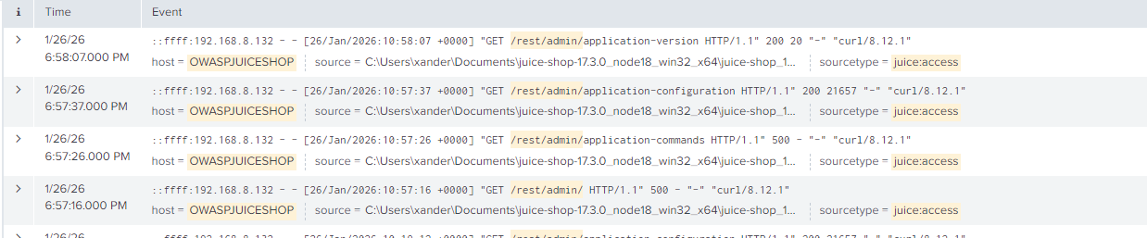
Figure 8.5: Detailed logs showing mix of HTTP response codes from continuous admin endpoint probing.
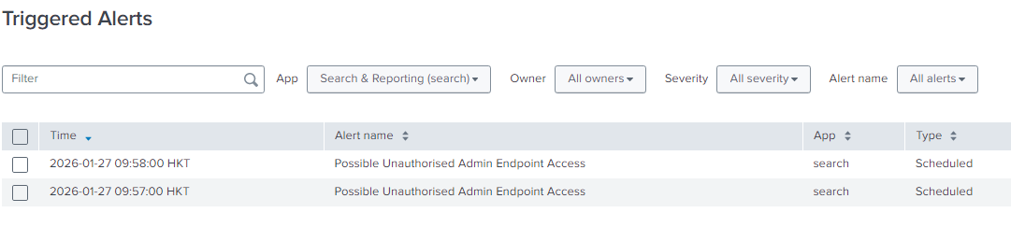
Figure 8.6: Splunk triggered alerts indicating possible unauthorised administrative endpoint access

Recommended Mitigation Steps
Application-Level Controls
- Enforce strict authentication and authorisation checks on all sensitive and administrative endpoints
- Restrict administrative APIs to authenticated and authorised roles only
- Disable or limit exposure of sensitive configuration data through public-facing endpoints
Security Controls
- Implement rate limiting on administrative and sensitive API endpoints
- Deploy Web Application Firewall (WAF) rules to block unauthorised access to /rest/admin/* paths
- Restrict access to administrative endpoints by IP allowlisting where feasible
Monitoring and Response
- Maintain SIEM-based monitoring and alerting for administrative endpoint access
- Investigate any triggered alerts to assess potential data exposure
- Temporarily block or throttle source IP addresses exhibiting suspicious access behaviour
- Conduct regular security testing to identify and remediate information disclosure vulnerabilities

This approach reduces the risk of administrative information leakage and improves early detection of attacker reconnaissance activity.

Brute Force Attack

Simulations

Simulation 1: Brute Force Using Burp Suite
A brute force attack involves repeatedly attempting different password combinations to gain unauthorised access to user accounts. Web applications without adequate login protection are especially vulnerable to such attacks.

The objective of the attack is to generate repeated failed authentication attempts to test log collection, detection, and mitigation capabilities using Splunk. If successful, it may lead to data breaches, account compromise and privilege escalation.

The attack was conducted in a controlled lab environment to demonstrate how brute force behaviour can be identified using log analysis rather than to compromise real credentials.

To simulate a brute force attack, multiple failed login attempts were generated against the OWASP Juice Shop login endpoint (/rest/user/login) within a short period using BurpSuite. A payload was created to automate the brute force.
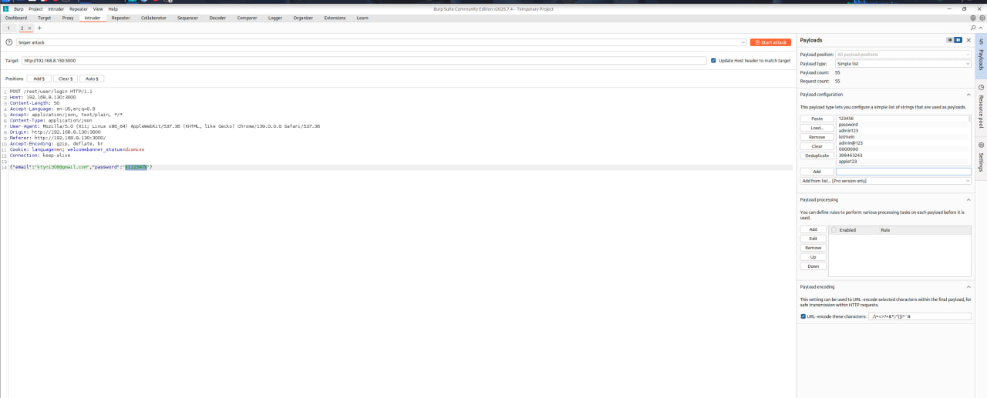
Figure 9.1: Using a payload to automate the brute force

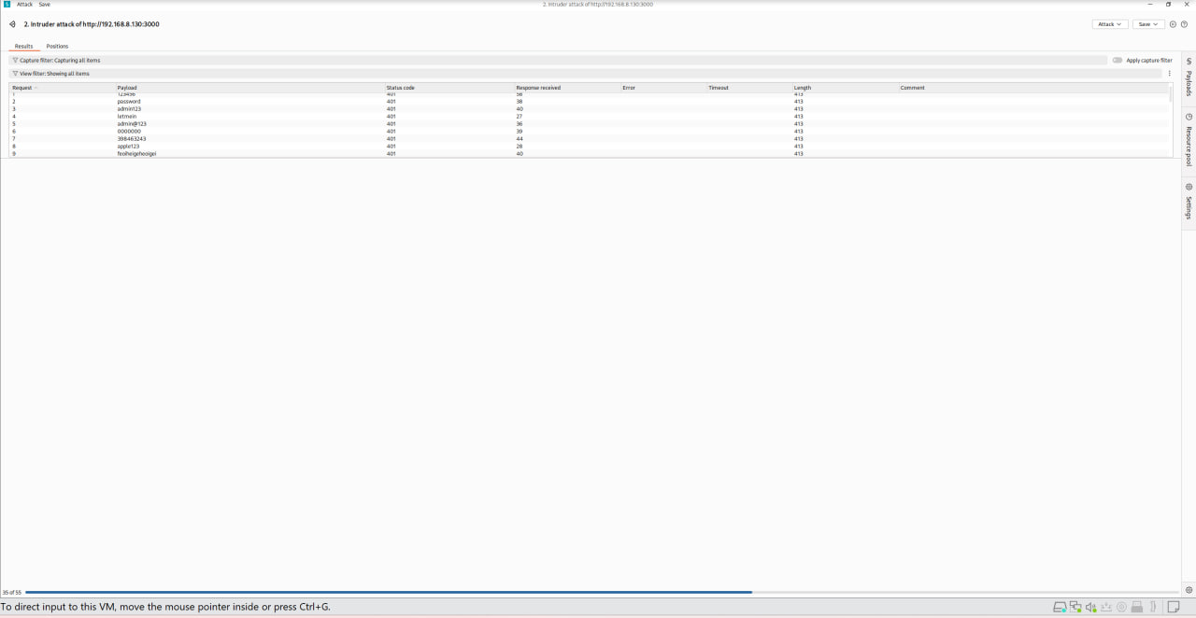
Figure 9.2: The attack happening to get the password

Logs Collected
The Juice Shop access logs were then collected and forwarded to the Splunk SIEM. The logs contained timestamps, source IP addresses, HTTP methods, requested URLs and response status codes.
Each log entry captured the following information:
- Source IP address of the attacker
- Timestamp of the request
- HTTP method (POST)
- Target endpoint (/rest/user/login)
- HTTP response status code (401 for failed login)
- User-Agent string

Detection
As the logs were ingested using a custom sourcetype, key HTTP fields were manually extracted using regular expressions. Failed login attempts (HTTP 401) were analysed using time-based aggregation. A spike of failed login attempts within a short interval indicated a potential brute force attack.

In the figure below, you can see that 56 login attempts were made, which is far above the normal user behaviour.
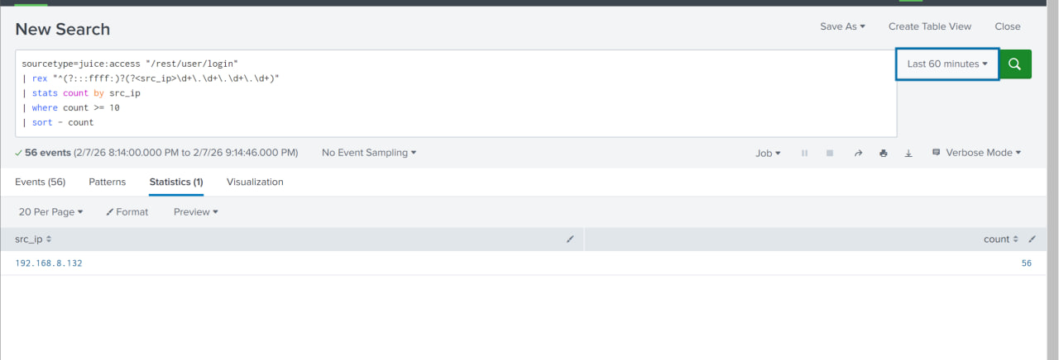
Figure 9.3: The search query identifying the amount of log in attempts

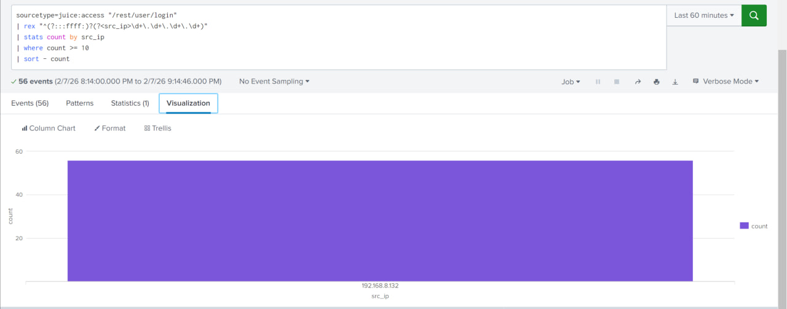
Figure 9.4: Visual graph of the sudden increase of activity

Search Query | What does it do?
Sourcetype=juice:access “/rest/user/login” | This filters the dataset to only Juice Shop access logs that contain the request to the login endpoint, since that is where the brute force was performed.
| rex “^(?:::ffff:)?(?<src_ip>\d+\.\d+\.\d+\.\d+)” | Rex: helps to manually create a usable field.  (?::::ffff:)?: handles ipv6 mapped ipv4 addresses  This helps extracts the attacker IP address from the raw log entry and stores it in a new field labelled as src_ip.
| stats count by src_ip | Counts how many login requests were made by each source IP address.  As brute force attacks generate many login attempts from one IP, this helps spot unusual high activity.
| where count >= 10 | Filter to show IP addresses that made 10 or more login attempts, since 10 attempts is above normal user behaviour. This helps reduce false positives in detection.
| sort - count | Sorts the results in descending order, which shows the IP with the highest number of logins attempts first. This makes analysis easier and helps to quickly identify the most aggressive attacker.

Mitigation
Recommended mitigation strategies include:
- Implementing account lockout policies or CAPTCHA after repeated failure attempts to log in
- Enforcing strong password policies
- Enabling multi-factor authentication (MFA)
- Blocking suspicious IP addresses via firewall or WAF rules
- Continuously monitor authentication logs using SIEM alerts

Alert Configuration
To enable real time detection, the search was saved as a scheduled alert in Splunk. The following is how I configured the alert.
Alert Configuration | Value
Title | Possible Brute Force Login Detected
Description | Detects excessive login attempts to /rest/user/login from a single source IP within 5 minutes, consistent with brute-force activity.
Alert Type | Scheduled
Time Range | Last 10 minutes
Schedule | Every 1 minute
Cron Expression | */1 * * * *
Trigger Condition | Number of results > 0
Trigger Mode | Once
Severity Mode | High

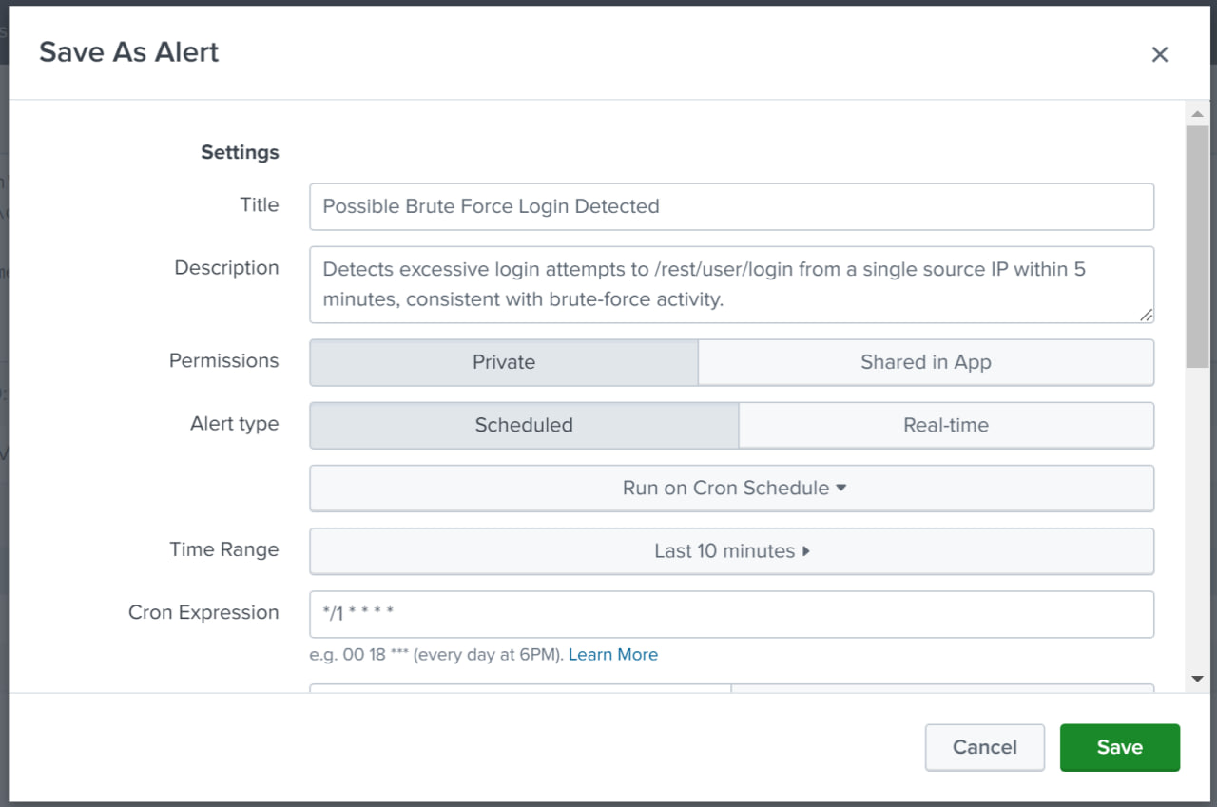
Figure 9.5: The alert configuration
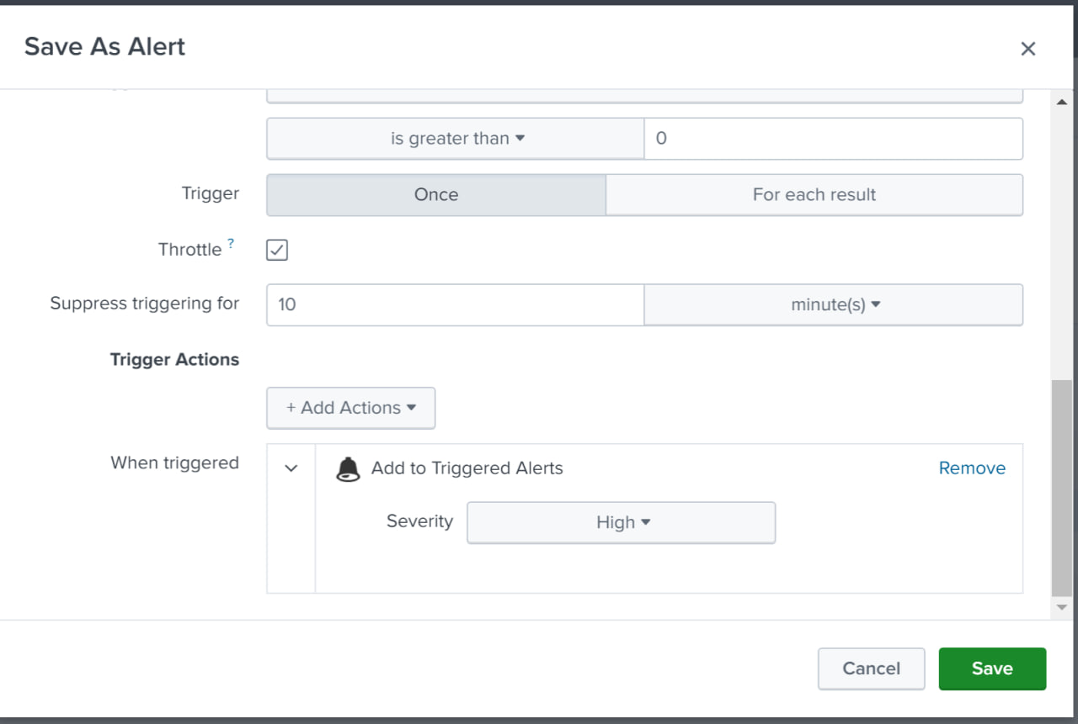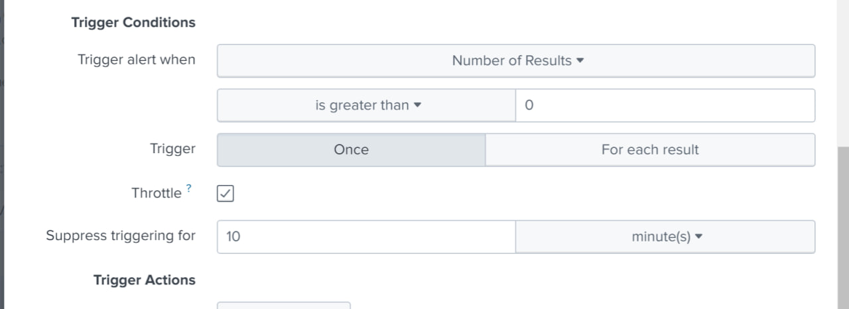
Figure 9.6: Continuation of the alert configuration

The alert is triggered whenever Splunk detects one or more source IP addresses making excessive login attempts against the /rest/user/login endpoint within a 5-minute window.

This alert operates on a rolling 10-minute time range and executes every minute, allowing rapid identification of brute force activity shortly after it begins. The alert helps security analysts respond quickly by investigating the source IP, blocking malicious traffic, or enforcing additional authentication controls.
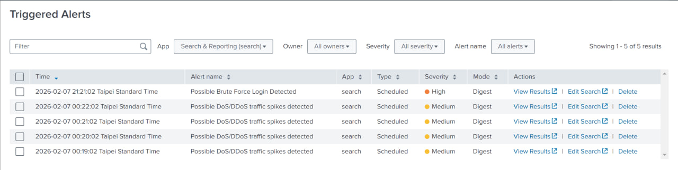
Figure 9.7: Alerts triggered from a potential activity of brute force

If such an attack were to occur in a real environment, it may lead to the following:
- Account compromise
- Unauthorised access to sensitive data
- Credential reuse attacks on other systems
- Loss of customer trust
This shows how early detection through SIEM alerts will significantly reduce the attack windows and limits potential damage, avoiding a disaster.

Denial of Service (DoS)

Simulations

Simulation 1:
In this simulation, a load testing attack scenario was conducted to emulate abnormal web traffic against a vulnerable web application.
The target system (OWASP Juice Shop) was attacked from the Kali Linux machine using the tool wrk. This tool helps generate a high volume of HTTP requests within a short period of time.
wrk is a high-performance HTTP benchmarking and load-testing tool. It is designed to generate a large volume of HTTP requests in a controlled manner to test how a web application or API behaves under stress
Wrk generates automated HTTP traffic, uses multiple threads and concurrent connections, and sends requests as far as possible for a specified duration.
This overall objective of the simulation was to
- Mimic automated high-rate traffic similar to a DoS attack
- Observe how the activity appears in log data
- Detect the attack using Splunk
- Propose mitigation and alerting mechanisms
This simulation demonstrates how benign tools such as load testers can resemble malicious activity when misused.
The following command was what I used to generate the HTTP requests
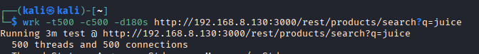
Figure 10.1:

Command | What it does
-t500 | T (Threads) 500 (how many threads)  Each thread generates requests independently, and a higher thread count increases CPU usage and request throughput  This means that –t500 means to specify 500 threads
-c500 | C (Connections) 500 (How many connections)  This opens TCP connections to the target, and it simulates hundreds of users accessing the application at the same time.  This means the –c500 means to generate 500 concurrent TCP connections to the target
-d180s | Duration of 180 seconds  In this time, traffic is continuously generated for the entire duration, which will cause sustained traffic spikes, and not just a short burst
http://192.168.8.130:3000/rest/products/search?q=juice | The target URL
I ran this command on multiple terminals to ensure I could send as much traffic as I could to the web application.
In the end, it will also show you the statistics of the thread
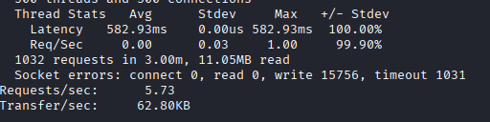
Figure 10.2: The statistics of attempting to overload the web application

The outcome of this would be not being able to access the web page at all, showing “a DoS attack has taken place.”
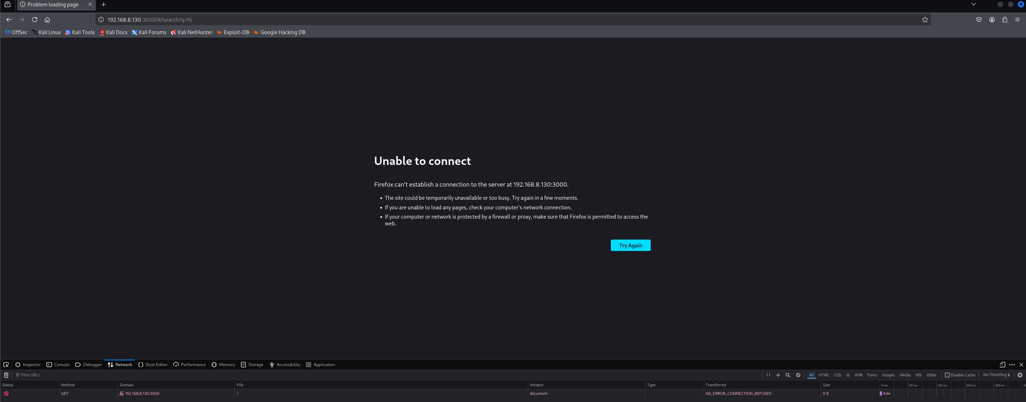
Figure 10.3: The outcome of all the HTTP requests, leading to the inaccessible web page

Logs Collected
During the simulation, Splunk successfully collected HTTP access logs from the OWASP Juice Shop application, including source IP address, request methods, and requested URI paths.

Detection
A Splunk search query was used to aggregate HTTP requests by source IP address and URI path. This enabled visibility into how frequently each endpoint was accessed by individual hosts.
The following query was used
Search Query | What it does
Index=* | Tells Splunk to search across all available indexes, which ensures that all relevant HTTP logs are included in the analysis, even if the exact storage location of the logs is unknown.  This helps prevent blind spots where malicious activity could be missed due to restrictive index selection
(“GET” OR “POST”) | This helps filter the search to HTTP GET or POST requests.  As GET and POST are the primary methods used for interacting with web applications and APIs, this query will remove unrelated system logs and focus on the analysis specifically on web traffic that could be abused by automated tools.
| stats count as req_count by src_ip uri_path | This is the statistical aggregation  “stats count” = counts the total number of matching log events  “as req_count” = renames the count field  “by src_ip uri-path" = groups the results by source IP address and requested URI path
| sort – req_count | Makes the results be sorted in descendin order based on the request count.
This search query transforms raw web logs into structured data that can be analysed for suspicious behaviour.
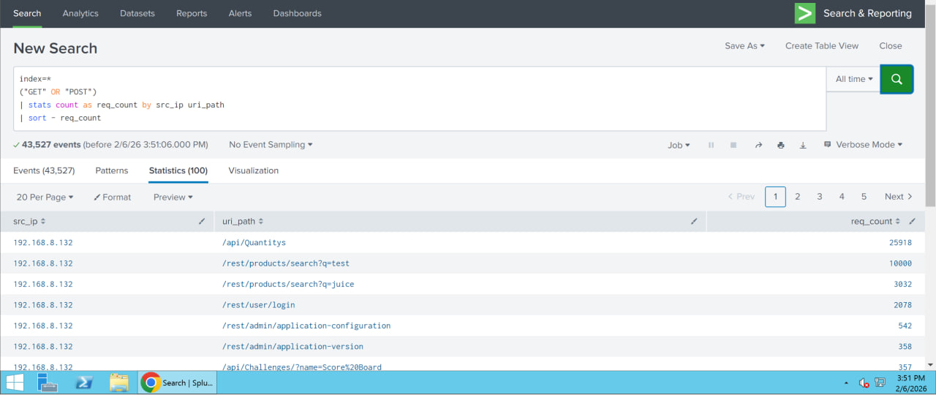
Figure 10.4: Splunk showing the amount of request count
When executed, the query revealed that a single source IP address generated an exceptionally high number of HTTP requests to multiple API endpoints within a short period.
Endpoints such as product search and quantity APIs showed request counts in the thousands, far exceeding normal user behaviour. This pattern is consistent with traffic generated by automated tools such as wrk.
Upon clicking the visualization button, it will show you a bar chart of the events logged.
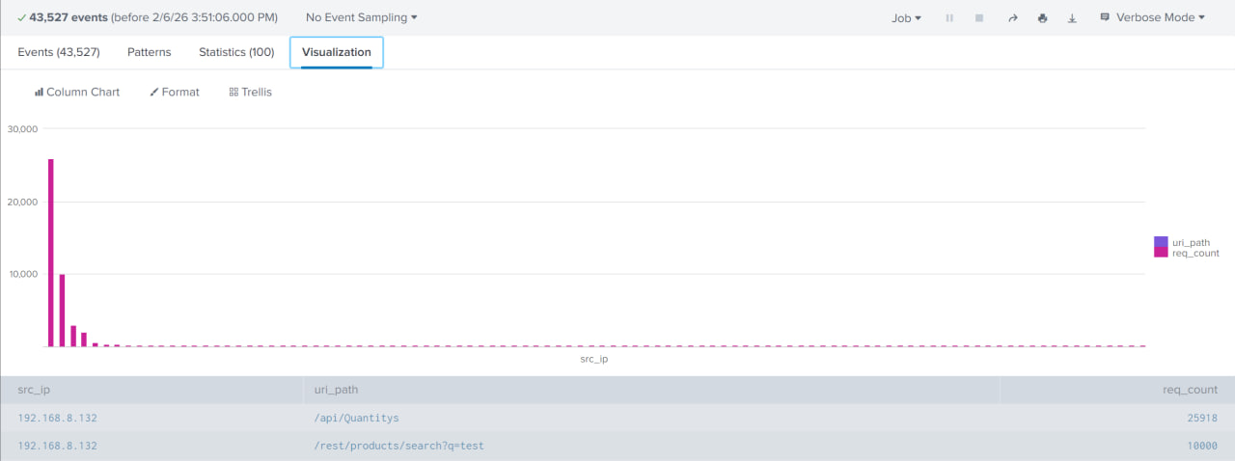
Figure 10.5: Visual chart of the sudden increase in HTTP requests, indicating a potential DoS attack
The concentration of requests from one source, combined with repeated access to the same endpoints, clearly indicates non-human activity.

Mitigation
To mitigate the risk and impact of DoS attacks, the following measures are recommended to reduce the impact of such attacks:
Application-level mitigation
- Implement rate limiting to restrict the number of requests per IP address
- Use CAPTCHA or challenge-response mechanisms for suspicious clients
- Enforce authentication and authorisation on sensitive endpoints
Network-level mitigation
- Deploy Web Application Firewalls (WAFs) to filter or challenge malicious traffic
- Block or throttle abusive IP addresses identified by the SIEM
Monitoring and Hardening
- Continuously monitor traffic patterns and maintain alerting mechanisms
- Keep applications and dependencies updated to reduce attack surface
These measures, combined with SIEM-based detection and alerting, will help prevent a DoS attack from happening onto the web application.

Alert Configuration
An alert was configured in Splunk to provide automated detection of abnormal HTTP request activity identified during the simulation.
Alert Configuration | Value
Title | Abnormal HTTP Request Volume Detected
Description | Detects unusually high HTTP request volumes by source IP and endpoint
Time range | Last 5 minutes
Cron expression | */5 * * * *
Trigger conditions | Trigger when number of results is more than zero
Trigger actions | Add to triggered alerts, severity medium

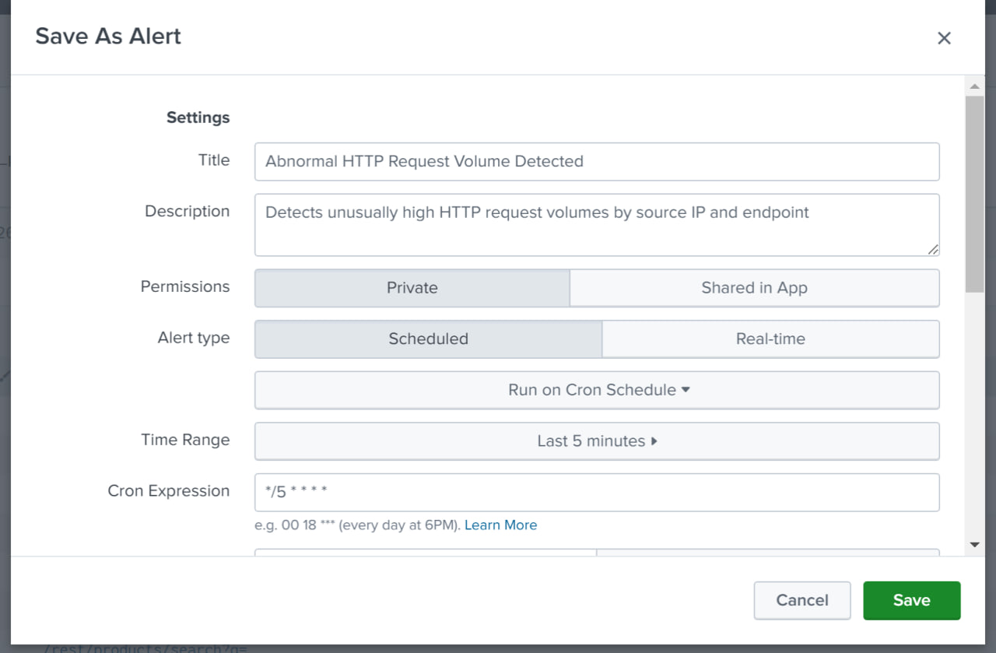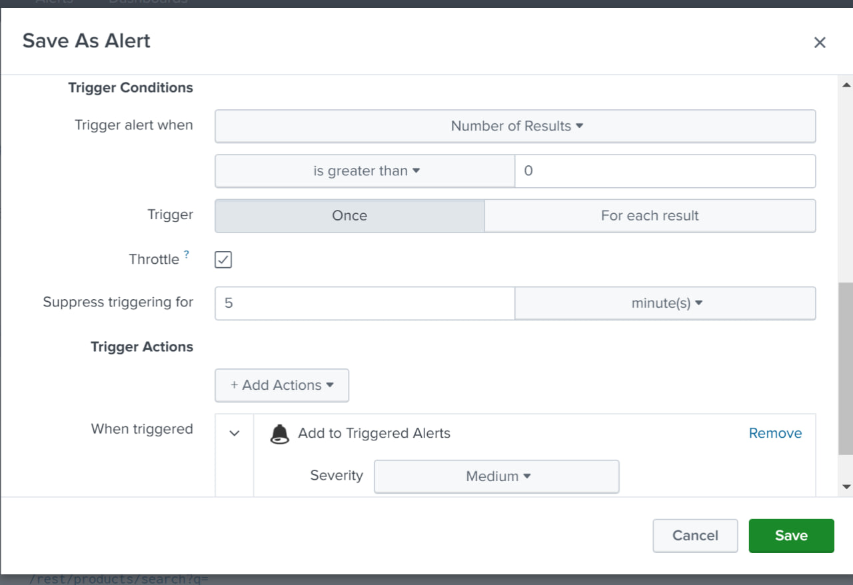Figure 10.6: Alarm configuration for DoS
A give minute execution interval was selected for the alert schedule to balance timely detection, system performance, and alert reliability. A five-minute window is sufficient to accumulate enough events to distinguish automated behaviour from normal user activity, while still allowing the alert to trigger promptly.
The alert is triggered when Splunk detects abnormal HTTP request volumes originating from a single source IP and targeting specific web application endpoints.
In this scenario, the following indicators confirmed automated or abusive web activity:
- Excessive HTTP GET and POST requests generated within a short time window
- High request concentration originating from a single source IP address
- Repeated access to the same API endpoints, particularly product search and quantity-related resources
- Sustained request generation over multiple execution intervals
- Aggregated request counts significantly exceeding normal user browsing behaviour
This behaviour is consistent with real-world automated activity such as load testing, denial-of-service attempts, or scripted abuse, rather than legitimate human interaction with the web application.

Malware Infection

Simulations

Simulation 1: Deployment of Malware Disguised as a Legitimate Document
This simulation demonstrates a post-compromise malware infection scenario in which an attacker leverages valid user credentials obtained during earlier SMB enumeration to deploy malware onto the Windows host running OWASP Juice Shop.
In this scenario, the attacker previously identified valid SMB credentials belonging to the user Jimmy during authenticated SMB enumeration. Using this compromised account, the attacker is assumed to have gained user-level access to the target host.
Following access, the attacker deployed a malicious file into the compromised user’s directory. To safely simulate malware activity without introducing real malicious software, the EICAR standard antivirus test string was used. The EICAR test file is an industry-recognised artefact designed to trigger antivirus detection mechanisms while remaining non-destructive.
X5O!P%@AP[4\PZX54(P^)7CC)7}$EICAR-STANDARD-ANTIVIRUS-TEST-FILE!$H+H*

To reflect realistic attacker techniques, the malicious file was disguised as a legitimate business document using a double-extension filename (e.g. Sales_Report_2026.pdf.exe) and placed within Jimmy’s Documents directory. This simulates common malware delivery tactics where executables are disguised as documents to evade user suspicion.
Upon creation of the file, Windows Defender real-time protection detected the malicious signature and automatically quarantined the file, preventing execution and further impact on the system.
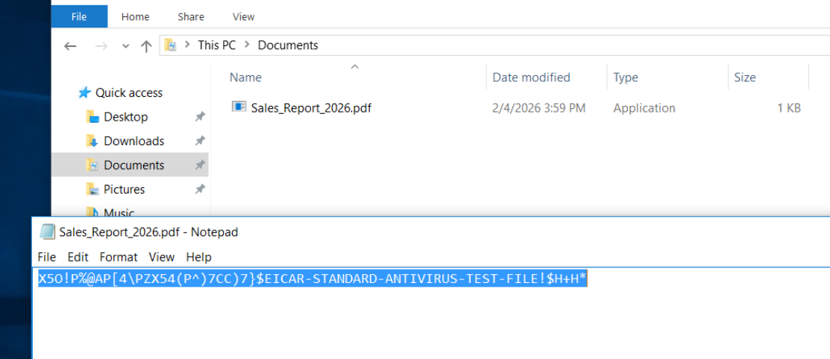
Figure 11.1: Creation of an executable containing the EICAR test string
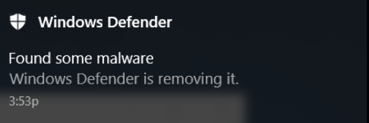
Figure 11.2: Windows Defender alert indicating malware detection and removal

Logs Collected
During the simulation, Windows Defender Operational logs were generated and forwarded to Splunk via the Splunk Universal Forwarder installed on the OWASP Juice Shop host.

Detection
Splunk identified Windows Defender malware detection events, specifically EventCode 1117, which indicates that malware was detected and an action was taken to protect the system.
The detection is significant because:
- The malicious file was located within a user-writable directory
- The file was associated with a previously compromised user account (Jimmy)
- The filename disguised as a legitimate document, consistent with real-world malware tactics
- The detection occurred after authenticated access, supporting a post-compromise attack chain
The following Splunk search query was used to identify malware detection activity:
index=main sourcetype="WinEventLog:Microsoft-Windows-Windows Defender/Operational"
(EventCode=1116 OR EventCode=1117 OR EventCode=1121)

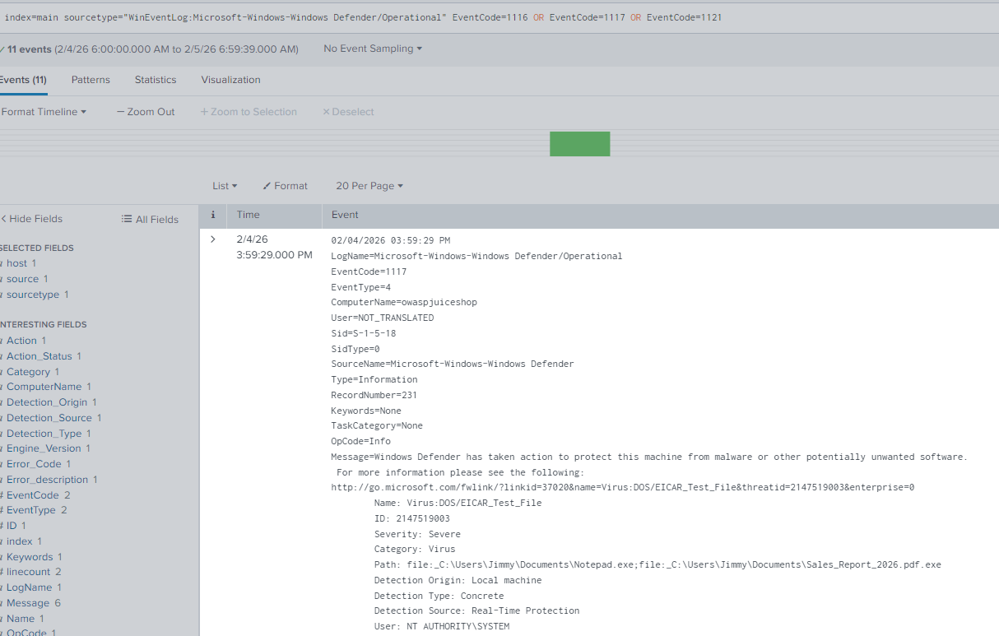
Figure 11.3: Splunk search results showing malware detection events

The collected logs included the following key details:
- Malware detection and remediation events
- Threat name: Virus:DOS/EICAR_Test_File
- Severity: Severe
- Category: Virus
- Action taken: Quarantine
- File path: C:\Users\Jimmy\Documents\Sales_Report_2026.pdf.exe
- Detection source: Real-time protection
- Detection origin: Local machine
- Hostname: owaspjuiceshop

These logs confirm that endpoint protection successfully identified and mitigated the malicious artefact deployed under the compromised user account.
This activity is not consistent with normal user behaviour and indicates a malware infection attempt following credential compromise.

Mitigation
To ensure malware activity is promptly detected and mitigated, Windows Defender automatically quarantined the malicious file upon detection, preventing execution or persistence on the host.
To further enhance detection and response, a Splunk search was implemented to continuously monitor for endpoint malware events based on hostname:
index=main sourcetype="WinEventLog:Microsoft-Windows-Windows Defender/Operational"
(EventCode=1116 OR EventCode=1117 OR EventCode=1121)
| stats count by ComputerName, EventCode

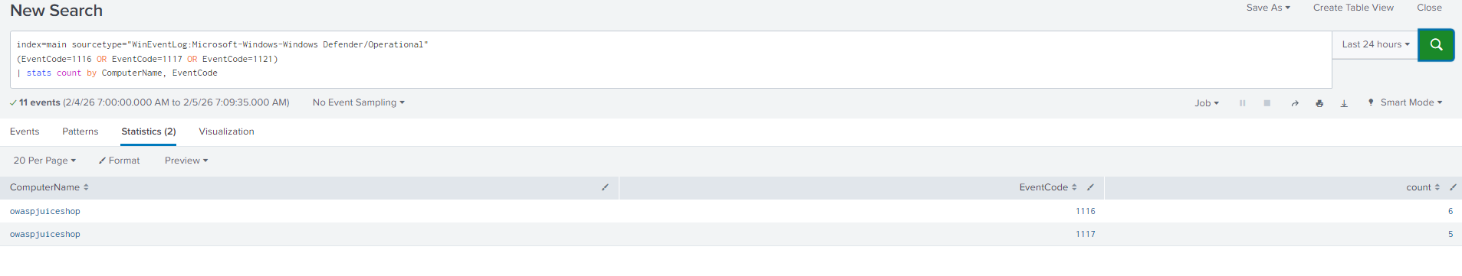
Figure 11.4: Splunk statistical view of malware detection events by host

Alert Configuration
This configuration ensures that suspicious enumeration activities are detected and logged in Splunk in real-time.
Setting | Value
Alert Name | Possible Malware Infection Detected (Endpoint Protection)
Alert Type | Scheduled
Time Range | Last 24 hours
Schedule | Every 1 minute (cron-based : * /1 * * * * )
Trigger Condition | Number of results > 0
Severity | High
Trigger Action | Add to Triggered Alerts

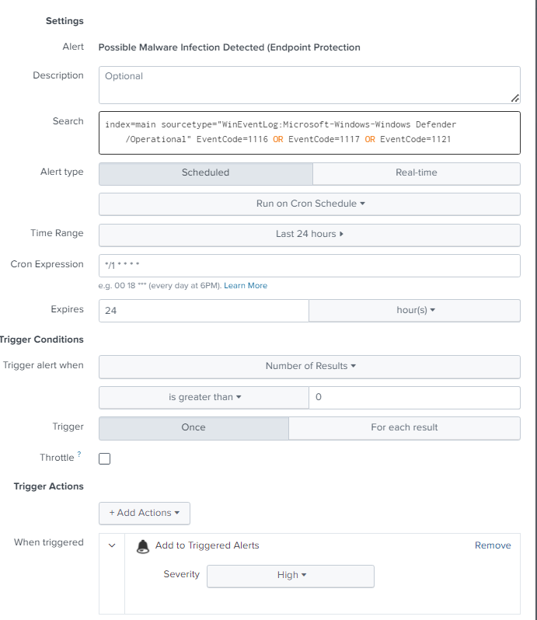
Figure 11.5: Splunk alert configuration for detecting possible malware infection

Alert Trigger Explanation
The alert is triggered when Windows Defender reports malware detection or remediation activity on the host.
In this scenario, the following indicators confirmed a malware infection attempt:
- Endpoint protection detection of a known malware signature
- EventCode 1117 indicating successful quarantine
- File located within a compromised user’s directory
- Filename masquerading as a legitimate document
- Detection occurring after authenticated SMB access
This behaviour is consistent with real-world post-compromise malware deployment rather than normal user activity.
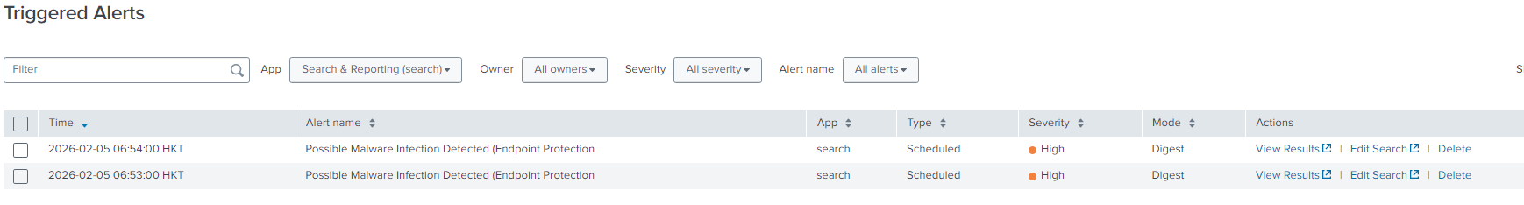
Figure 11.6: Splunk triggered alerts indicating possible malware infection

Recommended Mitigation Steps
Endpoint Controls
- Maintain real-time antivirus protection on all hosts
- Perform full system scans following malware detection
- Restrict execution of binaries from user-writable directories
Account and Access Controls
- Reset compromised user credentials
- Enforce strong password policies and multi-factor authentication
- Apply least-privilege access to limit post-compromise actions
Monitoring and Response
- Maintain continuous SIEM monitoring for malware-related events
- Correlate malware alerts with authentication and SMB activity
- Investigate affected hosts for additional indicators of compromise
- Isolate hosts exhibiting repeated malware detections where necessary
This approach reduces the risk of malware persistence and improves early detection of post-compromise attacker activity.

Business Logic Abuse (Negative Quantity Manipulation)

Simulations

Simulation 1: Business Logic Abuse via Negative Quantity Manipulation
This simulation demonstrates a business logic vulnerability in OWASP Juice Shop where an attacker manipulates the quantity parameter during an add-to-cart request to create a negative basket value.
In a legitimate transaction, users are expected to submit positive integer values when adding products to their basket. However, by intercepting the HTTP request using a proxy tool from the attacker machine (192.168.8.132), the quantity parameter was modified to a negative value before forwarding the request to the server.
Specifically, the attacker intercepted the request to /api/BasketItems, modified the quantity value in the JSON payload to -1.
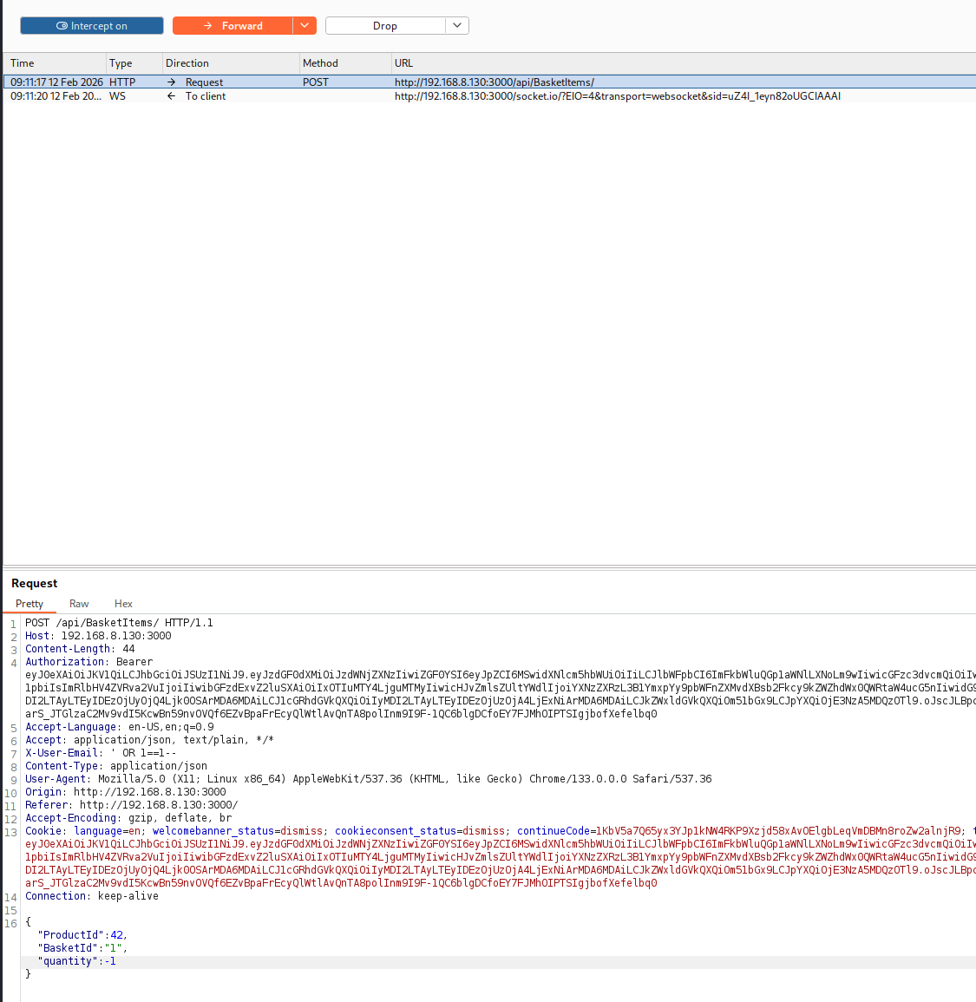
Figure 12.1: Intercepted HTTP POST request to /api/BasketItems with modified quantity parameter
The effect of this manipulation was observable within the application interface. The affected product displayed a quantity of -1, resulting in a negative total price of $-4997.33.
Despite the invalid transaction state, the application allowed the user to proceed with checkout successfully, even though the basket reflected a negative balance. This indicates that the system did not enforce validation checks during the checkout process to prevent processing of abnormal totals.
This confirms that the server failed to enforce proper input validation and allowed a negative value to directly impact transaction calculations and order processing.
This behaviour does not rely on injection or code execution. Instead, it exploits insufficient enforcement of business rules within the application logic.
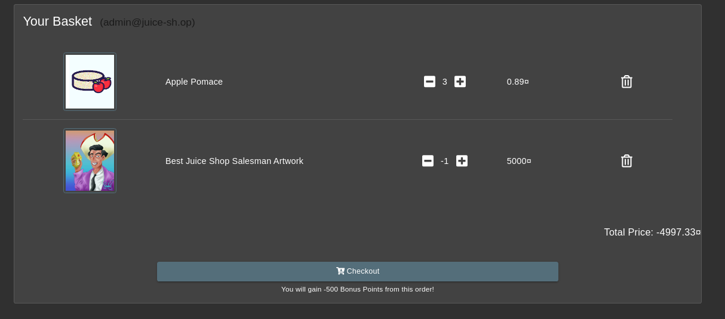
Figure 12.2: Juiceshop basket displaying negative product quantity and total price
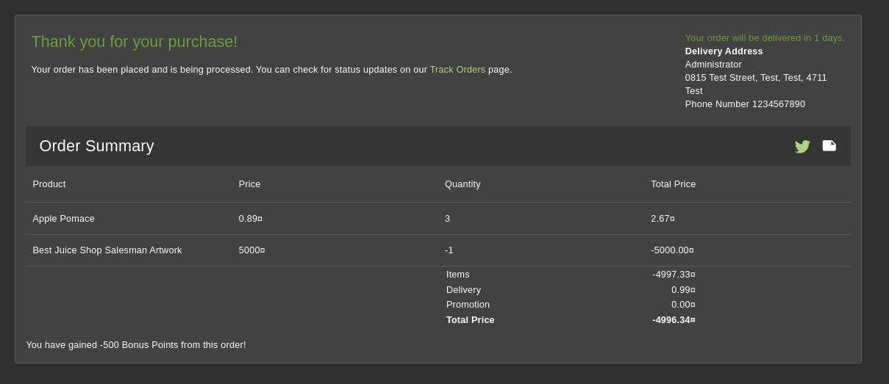
Figure 12.3: Checkout page showing successful purchase with invalid total price

Logs Collected
By default, OWASP Juice Shop access logs did not record application-layer parameters such as the basket quantity value. As a result, a manipulated request containing a negative quantity would appear as a normal HTTP 200 response in access.log, making detection through SIEM monitoring ineffective.
To enable visibility of this business logic abuse, internal server-side logging was modified. Specifically, the server.js file was updated to append the basket quantity parameter to each HTTP access log entry. This change ensured that the quantity value submitted in the request body was explicitly written into the access log as: basket_qty=<value>
After modification, each relevant POST request to /api/BasketItems produced log entries containing:
- Source IP address (e.g. 192.168.8.132)
- HTTP Method (POST)
- URI Path (/api/BasketItems/)
- HTTP Status Code (200)
- Extracted Parameter (basket_qty=-1)
- Associated BasketId
This logging enhancement exposed application-layer transaction data at the web server level. Once forwarded to Splunk via the Splunk Universal Forwarder, the manipulated parameter became searchable and suitable for alert-based detection.
Without modification of server.js, the negative quantity abuse would not be distinguishable from legitimate traffic because the HTTP response remained successful (200 OK). Therefore, application-level logging changes were necessary to enable SIEM-based detection of business logic violations.

Detection
A new field, basket_qty, was created in Splunk to extract the quantity value from the HTTP access log string for monitoring and alerting purposes.
After the logging modifications were applied, Splunk was able to identify negative quantity submissions using the following query:
index=main sourcetype=juice:access "/api/BasketItems" "basket_qty="
| rex field=_raw "basket_qty=(?<basket_qty>-?\d+)"
| eval basket_qty=tonumber(basket_qty)
| where basket_qty < 0
| table _time src_ip uri_path method status basket_qty
| sort - _time

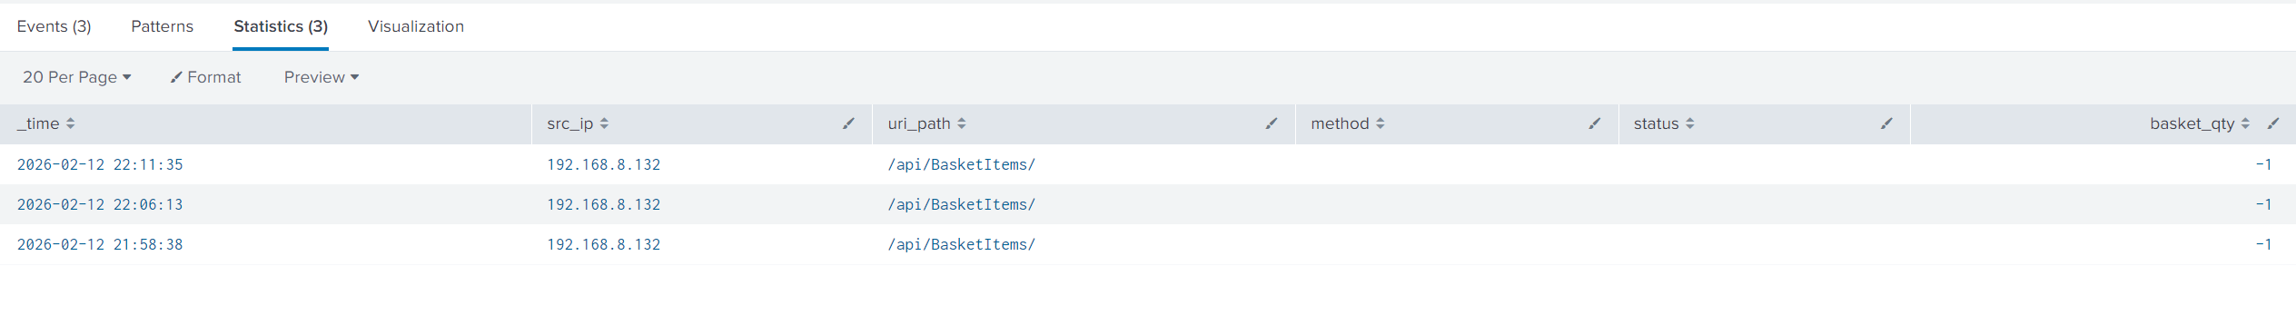
Figure 12.4: Splunk results identifying negative basket quantity requests

Mitigation
To ensure business logic abuse is detected in real time, a Splunk alert was implemented to monitor negative basket quantity submissions.
The following search query is used for continuous monitoring:
index=main sourcetype=juice:access "/api/BasketItems" "basket_qty="
| rex field=_raw "basket_qty=(?<basket_qty>-?\d+)"
| eval basket_qty=tonumber(basket_qty)
| where basket_qty < 0

Alert Configuration
This configuration ensures that suspicious enumeration activities are detected and logged in Splunk in real-time.
Setting | Value
Alert Name | Negative Basket Quantity Detected (Business Logic Abuse)
Alert Type | Scheduled
Time Range | Last 24 hours
Schedule | Every 1 minute (cron-based : * /1 * * * * )
Trigger Condition | Number of results > 0
Severity | High
Trigger Action | Add to Triggered Alerts
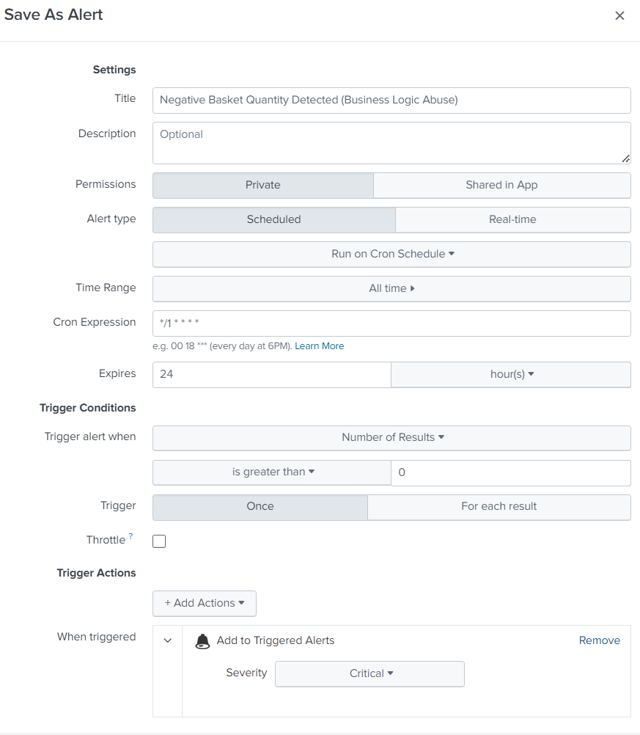
Figure 12.5: Splunk Alert Configuration – Negative Basket Quantity Detected (Business Logic Abuse)

Alert Trigger Explanation
The alert is triggered when:
• A request is made to /api/BasketItems
• The logged basket quantity is negative
This indicates successful manipulation of transaction logic.
Because normal users do not submit negative product quantities, any such occurrence represents suspicious activity requiring investigation.

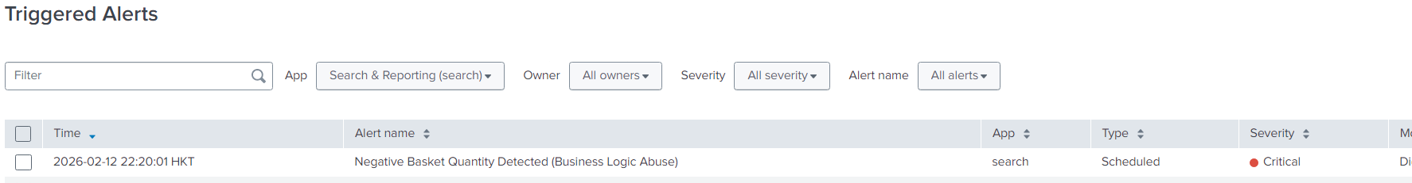
Figure 12.6: Splunk Triggered Alert – Critical Severity Business Logic Abuse Detection

Recommended Mitigation Steps
Application-Level Controls
- Implement strict server-side validation to reject negative or zero quantity values before processing transactions
- Enforce positive integer constraints within API request validation logic
- Return HTTP 400 (Bad Request) for invalid quantity submissions
- Implement business rule validation to prevent transaction totals from becoming negative
Secure Coding Practices
- Apply input validation at both client-side and server-side layers
- Use centralized validation middleware for numeric parameters
- Conduct code review of transaction-related APIs for logic enforcement gaps
- Implement automated security testing for parameter tampering scenarios
Monitoring and Detection
- Maintain enhanced application logging for sensitive transactional parameters
- Continuously monitor negative basket quantities using SIEM correlation rules
- Correlate suspicious basket manipulation with user authentication logs\
- Investigate repeated negative quantity attempts from the same source IP
Access and Session Controls
- Monitor high-privilege accounts for abnormal transaction behaviour
- Implement anomaly detection for unusual purchasing patterns
- Rate-limit repeated modification requests to /api/BasketItems
Incident Response
- Review transaction history for financial inconsistencies
- Invalidate affected sessions if business logic abuse is detected
- Perform integrity checks on order records and pricing calculations

Cross Site Request Forgery (CSRF)

Simulations

Simulation 1: Change of Profile Picture
CSRF was conducted on the profile page and in this simulation, a change to the victim’s profile picture will be made via a cross-site request.

The request was created with the following code in a .html file:
<html>
<body>
<form action="http://192.168.8.130:3000/profile/image/url" method="POST">
<input name="imageUrl" value="https://media.istockphoto.com/id/1455658894/photo/system-hacked-warning-alert-on-notebook-cyber-attack-on-computer-network-virus-spyware.jpg?s=2048x2048&w=is&k=20&c=Np9GhBSzgUM1d3NFxOLY1E94-XkeitDFk3LCOKpg90g="/>
<input type="submitUrl"/>
</form>
<script>document.forms[0].submit();</script>
</body>
</html>

This is based on the code for the image URL box which we can get by inspecting the page. This script will set the value of imageUrl to a malicious looking image and submit a POST request to change the profile picture to the value.

We will input this code into csrf_img.html and start a python server in the location folder with “python3 -m http.server [port of choice]”. The file is now accessible via “http://serverip:port/csrf_img.html” and will execute the picture change once visited in the same browser with the target site open.
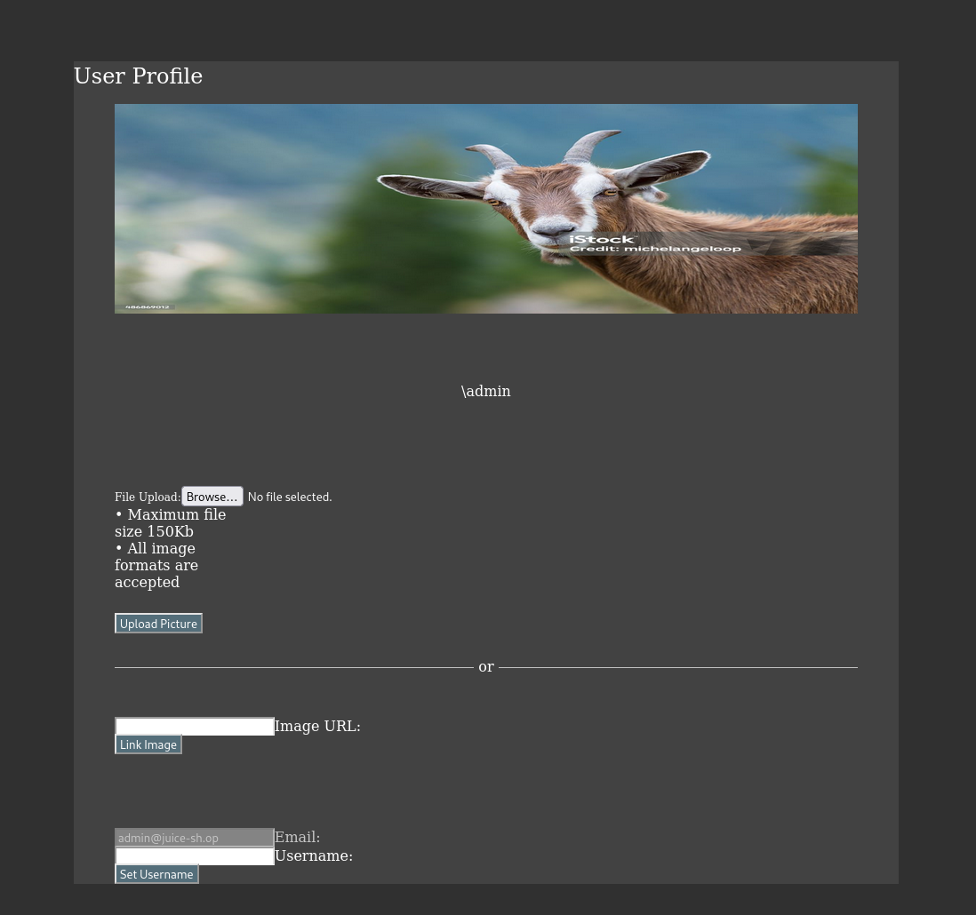
Figure 13.1: Original Profile

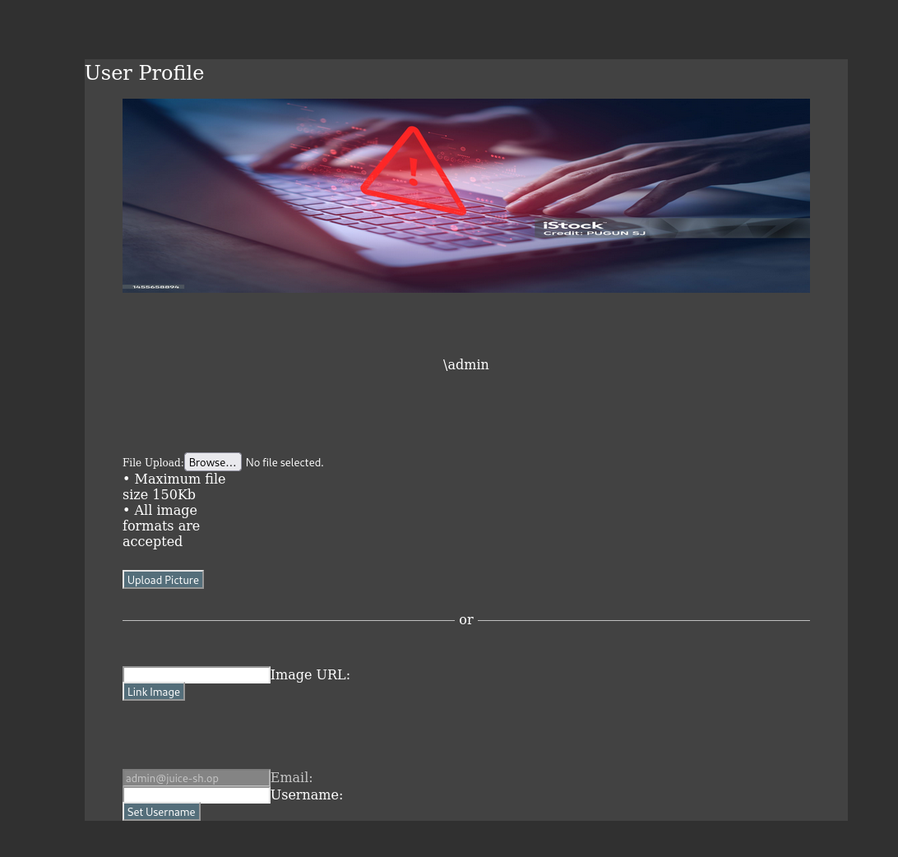
Figure 13.2: After Executing CSRF – Picture Change

Simulation 2: Change of Username
CSRF was conducted on the profile page and in this simulation, a change to the victim’s username will be made via a cross-site request.

To create the request, the following code must be put inside a .html file:
<html>
<body>
<form action="http://192.168.8.130:3000/profile" method="POST">
<input name="username" value="ilovecoti"/>
<input type="submit"/>
</form>
<script>document.forms[0].submit();</script>
</body>
</html>

This is based on the code for the username box which we can get by inspecting the page. This script will set the value of username to “ilovecoti” and submit a POST request to change the username to the value.

We will input this code into csrf_un.html and store it in the same folder as csrf_img.html. We can then execute it the same way.

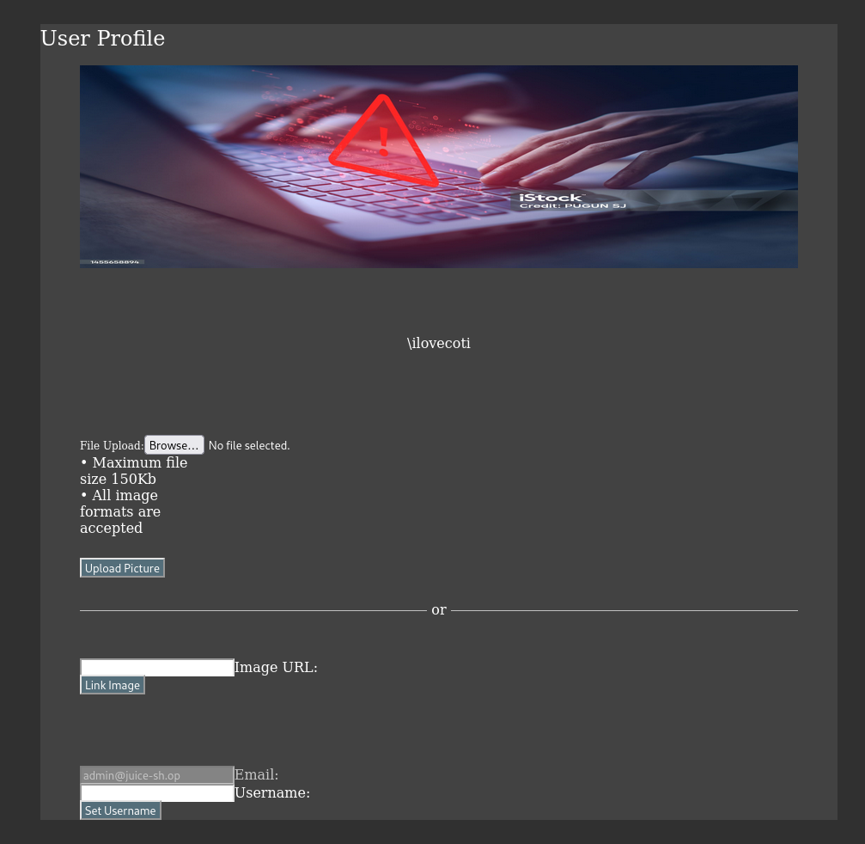
Figure 13.3: After Executing CSRF – Username Change

Logs Collected
Application logs generated by Juice Shop are forwarded to the Splunk Enterprise Indexer via the Splunk Universal Forwarder, where the target endpoint, request method and referrer are included. These logs are especially important for the endpoint “/profile” and referrer that is not the host IP.

These logs provide insight into the CSRF attacks carried out.

Detection
Analysis has shown there are requests originating from another IP which targeted the endpoint “/profile”. The events show:
- Both “GET” and “POST” requests
- HTTP 302, indicating a redirect
- Requests from no IP

This shows that profile changes were not done from the Juice Shop, but rather through a redirect from another IP which is unknown

An initial query was done to isolate “/profile” events:
host="owaspjuicebox" sourcetype=juice:access NOT “192.168.8.130:3000” "/profile"

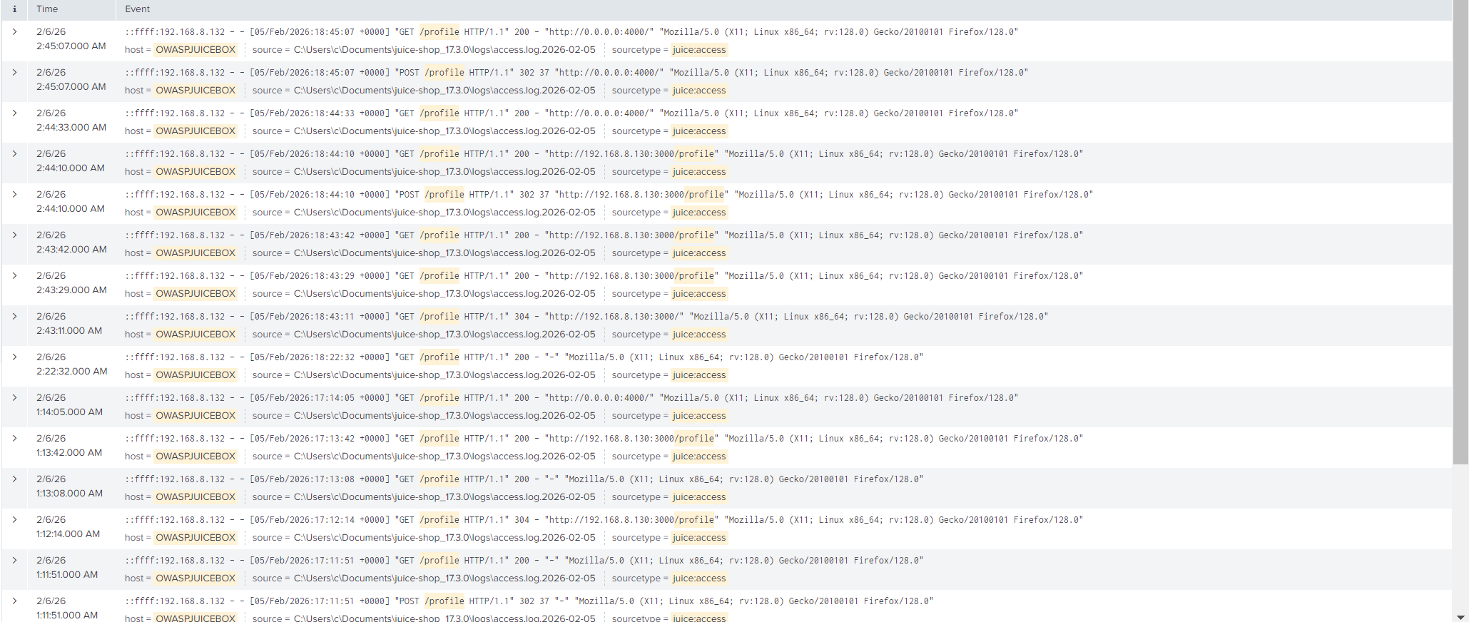
Figure 13.4: Splunk search results showing requests to /profile

Mitigation
To clearly show CSRF, we need a query which will clearly find requests made from a different referrer to the /profile and has the status of 302. This will clearly indicate CSRF as we can see that the requests are all redirects, showing cross-site origin.
host="owaspjuicebox" sourcetype="juice:access"
| rex "\"\s(?<status>\d{3})\s"
| rex "\"(?<referrer>http[^\"]+)\""
| search "/profile"
| where NOT like(referrer, "%192.168.8.130:3000%")

Query Component | Explanation
host="owaspjuicebox" sourcetype="juice:access" | Specify search in JuiceShop logs
| rex "\"\s(?<status>\d{3})\s" | Specify events with the “302” status code
| rex "\"(?<referrer>http[^\"]+)\"" | Defines the referrer
| search "/profile" | Specifies the endpoint
| where NOT like(referrer, "%192.168.8.130:3000%") | Filters for results where the referrer is not the IP of Juice Shop

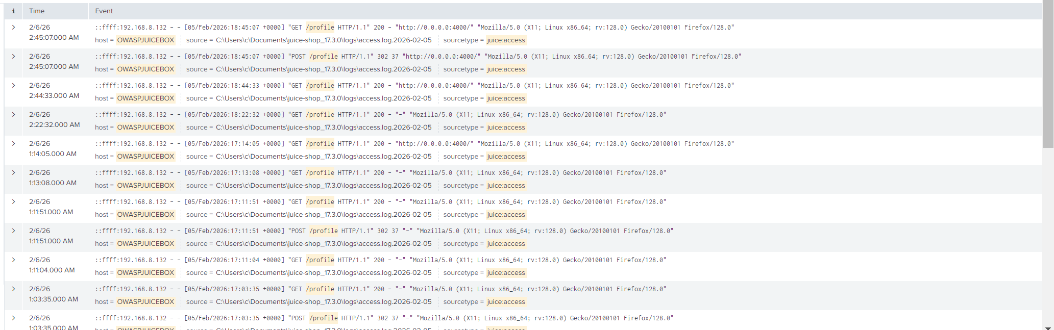
Figure 13.5: Mitigation Query Result

Alert Configuration
Setting | Value
Alert Name | CSRF - GET or POST from unknown IP
Alert Type | Scheduled
Time Range | Last 24 hours
Schedule | Every 1 minute (cron-based : * /1 * * * * )
Trigger Condition | Number of results > 0
Severity | High
Trigger Action | Add to Triggered Alerts

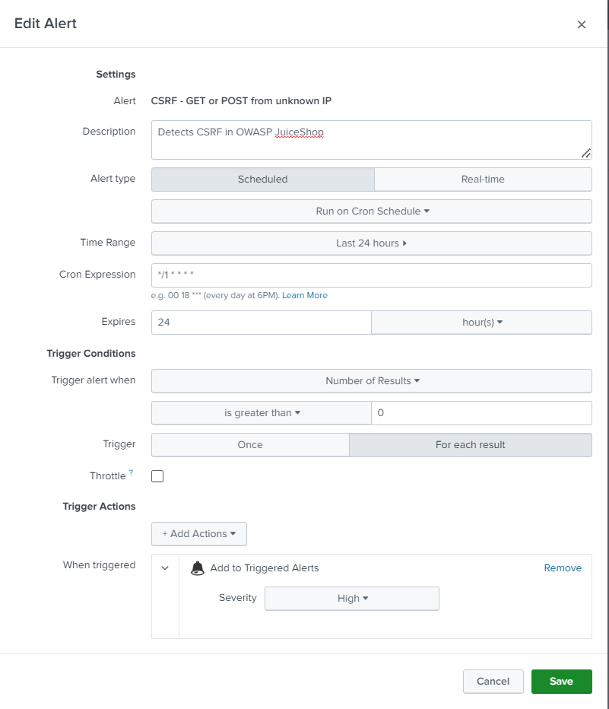
Figure 13.6: Splunk alert configuration for detecting possible CSRF

Alert Trigger Explanation
CSRF is a highly severe vulnerability as attackers can edit or access information without any form of infiltration, this makes it easy to attack. Any form of CSRF should be deemed highly severe, thus the severity is set to high.

The alert runs on a scheduled time of every 1 minute to not miss out any hits to the query above, which is what the alert is based on. It will catch any cross-site requests to /profile from another IP, a sign of CSRF.

It will trigger for every hit, to ensure that it is caught every time.

Figure 13.7: Triggered CSRF Alert

Recommended Mitigation Steps
1. Enable SameSite Cookies
- Set SameSite=Lax or SameSite=Strict
- This will prevent the website from sending cookies with cross-site requests

2. Origin/Referrer Header Validation
- Verify that the origin/referrer are legitimate and trusted
- Reject requests from unknown sites

3. Synchronizer Token Pattern
- CSRF tokens should be generated on server-side
- Tokens should be one-use per session and unpredictable

4. Anti-Forgery Tokens
- Ensure every state-change request (POST, PUT etc.) is required to have a unique token
- This token is verified by the server

Conclusion
This assignment demonstrated the effectiveness of deploying a Security Information and Event Management (SIEM) solution in enhancing BrightMart’s ability to detect, analyse, and respond to cybersecurity threats. Through the simulation of realistic attack scenarios, including SQL injection, cross-site scripting, brute-force attacks, network scanning, denial of service activity, and malware infection, the SIEM provided centralised visibility across application, system, and security logs, enabling faster and more informed incident response.

The implementation of Splunk as the SIEM significantly improved BrightMart’s response process by enabling real time monitoring, log correlation and automated alerting. Instead of relying on isolated logs or manual investigation, security relevant events from multiple sources were aggregated and analysed in a single platform. This allowed suspicious behaviours, such as repeated failed logins, abnormal request patterns and unauthorised access attempts to be identified quickly and accurately.

Custom alert rules ensured that potential attacks were flagged promptly, reducing the time required to detect and investigate incidents. Dashboards further enhanced situational awareness by providing a clear overview of attack trends and severity levels, enabling security teams to prioritise responses effectively.

Overall, the SIEM transformed incident response from a reactive process into a more proactive and structured workflow, supporting early detection and faster mitigation of threats.

To further strengthen BrightMart’s cybersecurity posture, several improvements are recommended. First off, continuous SIEM tuning should be conducted to refine alert thresholds, reduce false positives, and adapt detection rules to evolving attack techniques. Integrating additional log sources, such as firewall, endpoint detection, and database logs, would provide deeper visibility into both network-level and host-based threats.

Second, BrightMart should enhance preventive security controls, including enforcing multi-factor authentication (MFA), implementing stricter access control policies, and applying secure coding practices to mitigate common web vulnerabilities such as SQL injection and XSS. The deployment of a Web Application Firewall (WAF) and rate-limiting mechanisms would further reduce the effectiveness of automated attacks.

To finish off, regular security assessments and incident response drills should be conducted to validate detection capabilities and ensure that staff are familiar with response procedures. By combining improved preventive controls with ongoing SIEM monitoring and staff rediness, BrightMart can significantly reduce its exposure to cyber threats and maintain a stronger overall security posture.

