

Emerging AI Trends in Cybersecurity
(EATC)
Year 3, Semester 5

SCHOOL OF INFOCOMM TECHNOLOGY

Diploma in Cybersecurity & Digital Forensics

ASSIGNMENT

Contents
1 Problem Statement 4
1.1 Description of the Cybersecurity Issue 4
1.2 Motivation & Relevance 4
2 Technical Setup 5
2.1 Programming Languages 5
2.2 Tools Used 5
2.2.2 Libraries and Frameworks 6
3 Dataset Source and Structure 7
4 Modelling Process 9
4.1 Data Pre-processing 9
4.1.1 Handling Missing Data & Duplicated Rows 9
4.1.2 Handling Irrelevant Columns 12
4.1.3 Feature Engineering 15
4.1.4 Handling Outliers & Extreme Values 16
4.1.5 Handling Classes with Insufficient Records 19
5 Random Forest Model 21
5.1 Label Encoding 22
5.2 Separating Features and Target 23
5.3 Train & Test Splits 23
5.4 Model Configuration & Training 25
5.5 Model Evaluation & Analysis 27
5.5.1 Model Prediction 27
5.5.2 Converting Predictions Back to Traffic Labels 27
5.5.3 Evaluation of Accuracy 27
5.5.4 Classification Report 28
5.5.5 Confusion Matrix 29
5.6 Model Analysis 29
5.7 Model Extraction 30
6 Application Development 32
6.1 Application Architecture 32
6.2 Loading the model 32
6.3 Aligning uploaded data to the model's feature columns 33
6.4 Prediction and Confidence 33
6.5 Triage Dashboard 35
6.6 Application Testing 36
6.7 Schema Handling Test 36
6.8 Prediction Accuracy Test 37
7 Application Deployment 38
7.1 Repository Setup and Version Control 38
7.2 Streamlit Cloud Configuration & Porting 40
7.3 End-to-End Application Testing & Validation 42
8 Summary and Reflection 45
8.1 Key Findings 45
8.2 Challenges and Issues Resolved 45
8.3 Future Improvements 47
9 References 48

1 Problem Statement
“How can machine learning be used to automatically classify network traffic and help SOC analysts detect malicious activities more quickly and accurately?”

1.1 Description of the Cybersecurity Issue

Modern enterprise networks process gigabytes of log and network traffic every second. This makes manual detection and investigation of network anomalies difficult and inefficient.

Intrusion Detection Systems, IDS, and Intrusion Prevention Systems, IPS, serve as important frontline security controls. However, traditional signature-based systems rely on known attack patterns. They may fail to detect new or evolving threats, including multi-vector Distributed Denial of Service, DDoS attacks and lateral movement within a network.

The development of anomaly-based intrusion detection systems also faces limitations. Many existing solutions rely on outdated or unreliable datasets that lack traffic diversity, current attack methods, and useful network metadata. This can reduce the accuracy and practical effectiveness of trained detection models.

1.2 Motivation & Relevance
This project aims to bridge the gap between theoretical anomaly detection methods and practical, real-time cybersecurity operations.
The proposed AI-powered Security Operations Centre, SOC, Triage Tool will automate the classification of network flows. It will distinguish malicious traffic from normal operational traffic and support faster identification of threats.
The project addresses an important industry need by reducing the workload placed on SOC analysts. Automated traffic classification can shorten investigation and response times for threats such as brute-force attacks, denial-of-service attacks, infiltration attempts, and other network intrusions.
By detecting suspicious activity earlier, the tool can help security teams respond before attacks disrupt enterprise systems and services.

2 Technical Setup

2.1 Programming Languages

Python

Python 3.14.6 was used to process the network traffic dataset, train the machine learning model, and develop the main functions of the application.

CSS
CSS was used to improve the appearance and layout of the web application, making it clearer and easier for users to navigate.

2.2 Tools Used

Google Colab

Google Colab was used as a shared cloud-based coding environment, allowing team members to access the same notebook, work on the code together, and review changes in one place.

Streamlit

Streamlit was used to build the web application interface and allow users to interact with the trained machine learning model.

GitHub

GitHub was used as the cloud-based version control repository to host the application’s source code, requirements configuration, and pre-trained model artifacts. It served as the central integration point for continuous deployment via Streamlit Cloud.

2.2.2 Libraries and Frameworks

Data Processing:
- NumPy - Handles arrays and numerical data efficiently. It also supports mathematical calculations used during data preparation.
- Pandas - Makes it easier to load, clean, filter, and organise datasets in rows and columns.

Data Visualisation:
- Matplotlib - Creates basic charts such as bar graphs, line graphs, scatter plots, and histograms.
- Seaborn - Improves statistical visualisations by making graphs such as heatmaps, distribution plots, and correlation charts easier to create.

Machine Learning:
- Scikit-learn - Includes tools for preparing data, splitting datasets, training models, making predictions, and checking model performance.

Model Storage
- Joblib - Used to save the trained machine learning model and label encoder into files. These files could then be loaded by the web application without retraining the model each time.

3 Dataset Source and Structure
The project utilises the CIC-IDS2017 dataset, published by the Canadian Institute for Cybersecurity (CIC). The development of robust anomaly-based intrusion detection approaches has historically suffered due to the lack of reliable datasets. To resolve this, CIC-IDS2017 was engineered to capture realistic background traffic alongside common, up-to-date attack vectors.
Generating realistic background traffic was a top priority for the creators. They utilized a B-Profile system to simulate the abstract behaviour of 25 human users utilizing common protocols like HTTP, HTTPS, FTP, SSH, and email.
The network topology featured complete interactions between an internal LAN (Victim-Network) and an external Attack-Network. All traffic was captured over a five-day period from Monday, July 3, 2017, to Friday, July 7, 2017.
Instead of processing raw packet payloads (PCAPs), this project leverages the provided MachineLearningCSV files. These files contain network traffic analysis processed through CICFlowMeter, delivering over 80 extracted network flow features (such as flow duration, packet length, and forward/backward counts) natively formatted for machine learning.
The dataset is structured chronologically, with the data segmented into individual CSV files representing different attack scenarios:
- Benign Baseline (Monday): Represents a normal operational day and exclusively contains benign traffic.
- Brute Force (Tuesday): Contains FTP-Patator and SSH-Patator brute force attacks.
- Denial of Service (Wednesday): Contains multiple DoS attack types including DoS Hulk, DoS GoldenEye, DoS Slowloris, and DoS Slowhttptest.
- Web & Infiltration (Thursday): Focuses on Web Attacks (XSS, SQL Injection, Brute Force) and internal lateral movement via infiltration.
- DDoS (Friday): Includes high-volume DDoS attacks.
To maximise the attack coverage, all six CSV files spanning the full five-day capture period were selected for training. The two remaining Friday Afernoon (PortScan) and Friday Morning (Botnet) were intentionally excluded from the training set.
Port scanning represents a reconnaissance activity rather than an active intrusion, while Botnet traffic was excluded due to its behavioural similarity to benign traffic, which would introduce significant classification ambiguity without sufficient representation.
To prevent computational bottlenecks, a randomized 15% sample was drawn from each of the six selected files and concatenated into a single master dataset. The resulting training_data_raw.csv contains a highly diverse, multi-vector dataset spanning the full spectrum of common network intrusion types.
The concatenated dataset used for model training contains over 80 extracted network flow features natively formatted for machine learning. Instead of utilising raw packet bytes, these fields provide statistical metadata about the network flows.
The most critical fields utilized for our model's training include:
- Time & Duration Metrics: Flow Duration, Flow Bytes/s, and Flow Packets/s. (Crucial for detecting DoS attacks, which manipulate connection times and bandwidth).
- Packet Characteristics: Total Length of Fwd Packets, Fwd Packet Length Max/Min/Mean. (Useful for identifying anomalous payload sizes seen in infiltration or web attacks).
- Target Variable: Label. (The dependent variable for our supervised learning model, classifying each flow as BENIGN, DDoS, DoS Hulk, FTP-Patator, Web Attack – XSS, Infiltration, etc.).
With the raw dataset defined, the following section outlines the data preprocessing and modelling techniques applied to achieve accurate traffic classification.

4 Modelling Process
Supervised learning was selected because the CIC-IDS2017 dataset contains labelled network flows. Each record is identified as benign traffic or a specific attack type. These labels allow the model to learn the relationship between network flow features and their corresponding traffic classes, then the trained model can classify new network traffic as benign or malicious.

4.1 Data Pre-processing

4.1.1 Handling Missing Data & Duplicated Rows
The dataset was first check for missing values using the isna() function.

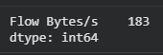
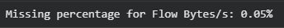
Figure 1.1: Identifying Missing Values

It is observed that the Flow Byte/s column has a total of 156 missing values, which is approximately 0.07% of the dataset. The Flow Byte/s column contains the total amount of data transferred during a network flow each second, and its values may indicate heavy traffic such as file transfers, or Dos and DDoS attacks. As such, we do not want to remove this column.

Instead, we fill these missing values with the median of the Flow Byte/s column. The median was selected because network traffic rates may contain extreme values, and the median is less affected by these values, compared to the mean and provides a more representative replacement. A value of zero should not be used because zero bytes per second could represent a valid network flow and could affect the model predictions. Thus, using the fillna() function, we filled in the missing values with the median After filling in the missing values, the dataset was rechecked again to confirm that no missing values remained in the Flow Byte/s column.

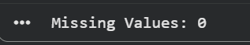
Figure 1.2: Replacing Missing Values in Flow Byte/s Column
The dataset was then checked for duplicated rows, using the duplicated().sum() functions.
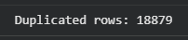
Figure 1.3: Checking For Duplicated Rows
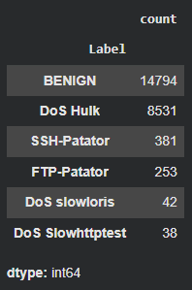
Figure 1.4: Distribution of Missing Values

A total of 12153 duplicated rows were identified in the dataset. Most duplicates were identified in the DoS Hulk and Benign classes, while the rest were identified in the DoS slowloris and DoS Slowhttptest classes.

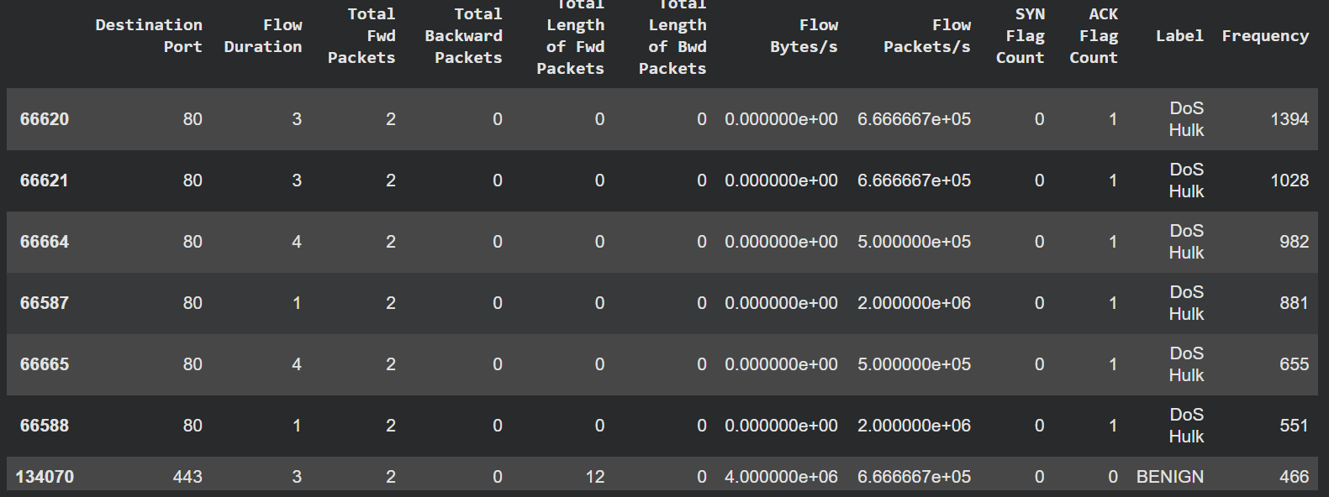
Figure 1.5: Duplicated Rows Displayed

After in-depth analysis of the duplicated rows, it can be observed that some DoS Hulk records appeared hundreds of times with identical flow durations, ports, packet counts and traffic rates. This is not surprising, as repetition such as this is consistent with automatic attack tools generating similar network flows.
Although some duplicated rows may represent genuine, repeated network behaviour, keeping and retaining every identical record could cause certain classes and patterns to become overrepresented, which could skew the predictions. It might also increase the risk of overfitting because the model can memorise repeated records instead of learning general traffic patterns.

Thus, only fully identical rows were removed. The first occurrence of each duplicated row was retained, while later identical rows were dropped, using the drop_duplicates() function. The DataFrame index was then reset.

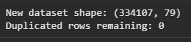
Figure 1.6: Dropping Duplicated Rows

After, the dataset was rechecked and found to contain 205.102 rows and 79 columns, with no duplicated rows remaining. This approach we took reduced unnecessary repetition of data while preserving one example of each observed network flow pattern. However, the model recall and F1-score should still be reviewed after training to ensure that the duplicate removal does not reduce the detection performance of the less common attack classes.

4.1.2 Handling Irrelevant Columns

The dataset was reviewed to identify columns that did not provide additional information for model training. Some CICFlowMeter features contained exactly the same values because they were calculated from the same network flow data.

Several subflow columns were identical to their corresponding main flow columns. A subflow refers to a smaller section of a network flow. However, most records in the dataset were not divided into multiple subflows. As a result, the subflow features contained the same packet and byte values as the full flow features.

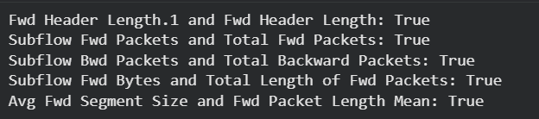
Figure 1.7: Checking for Columns with Exact Same Values

The following duplicated feature columns were removed:
Column removed | Column retained | Reason
Fwd Header Length.1 | Fwd Header Length | Same forward header length values.
Subflow Fwd Packets | Total Fwd Packets | Same number of forward packets.
Subflow Bwd Packets | Total Backward Packets | Same number of backward packets.
Subflow Fwd Bytes | Total Length of Fwd Packets | Same total number of forward bytes.
Avg Fwd Segment Size | Fwd Packet Length Mean | Same average forward packet size.

The main flow columns were retained because their names were clearer and easier to interpret. Removing the duplicated columns reduced unnecessary features, lowered computational requirements and prevented the same information from being represented more than once during model training.
Figure 1.8: Removing Chosen Classes

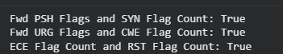
Figure 1.9: Flag Classes with Same Values

Several TCP flag columns also contained identical values in the sampled dataset. These included Fwd PSH Flags and SYN Flag Count, Fwd URG Flags and CWE Flag Count, and ECE Flag Count and RST Flag Count. These columns were not removed automatically because each flag represents a different TCP behaviour. Retaining these features preserves their network meaning and allows the model to process future traffic where their values may differ.

Column | Flag | Meaning
Fwd PSH Flags | PSH, Push | Tells the receiving system to pass the received data to the application quickly instead of waiting for more data.
SYN Flag Count | SYN, Synchronize | Starts a TCP connection and synchronizes sequence numbers between two devices.
Fwd URG Flags | URG, Urgent | Indicates that the packet contains urgent data that should be processed quickly.
CWE Flag Count | CWR, Congestion Window Reduced | Indicates that the sender reduced its transmission rate after receiving a congestion notification.
ECE Flag Count | ECE, ECN Echo | Indicates network congestion or confirms support for Explicit Congestion Notification during connection setup.
RST Flag Count | RST, Reset | Immediately resets, rejects, or terminates a TCP connection.

Columns containing only one unique value were also removed. These constant columns did not vary between benign and malicious records, so they could not help the model distinguish between traffic classes. Removing them simplified the dataset without losing useful predictive information.

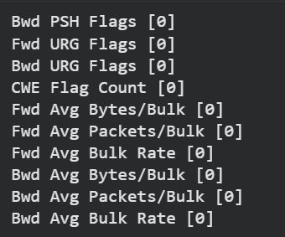
Figure 1.10: Columns with One Unique Value

4.1.3 Feature Engineering

The CIC-IDS2017 dataset already contains more than 80 network flow features. These features were extracted from raw network packet captures using CICFlowMeter. Therefore, extensive manual feature creation was not required for this project.

CICFlowMeter

CICFlowMeter is an open-source network traffic analysis tool developed by the Canadian Institute for Cybersecurity. It converts raw packet capture files, commonly stored as PCAP files, into bidirectional network flows and exports the extracted information into CSV format. (UNB, n.d)

CICFlowMeter separates each flow into two directions:
- Forward direction, from the source device to the destination device.
- Backward direction, from the destination device to the source device.

The direction of the first packet determines which side is treated as the forward direction. CICFlowMeter then calculates statistical features for the complete flow and for each direction separately.

Feature Selection and Transformation

The existing CICFlowMeter features were reviewed to ensure that they were suitable for model training. Duplicate and constant features were removed during preprocessing because they did not provide additional predictive information. Relevant numerical features, including flow duration, packet counts, packet lengths and traffic rates, were retained.

No major new features were created because CICFlowMeter had already transformed the raw network packets into meaningful statistical measurements. Creating additional features from the same values could introduce unnecessary complexity or duplicate information.

4.1.4 Handling Outliers & Extreme Values

The numerical features were reviewed for outliers and extreme values before model training. Network traffic datasets often contain unusually high flow durations, packet rates and byte rates. These values may represent real malicious behaviour, especially during DoS and DDoS attacks. Therefore, statistical outliers were not removed automatically. Removing them could cause the model to lose important attack patterns.

Box plots were used to examine the distribution of selected numerical features, including Flow Bytes/s, Flow Packets/s, packet lengths and flow duration. The standard box plots appeared compressed because a small number of records contained very large values. Log-scaled plots were therefore used to display the central distribution more clearly.
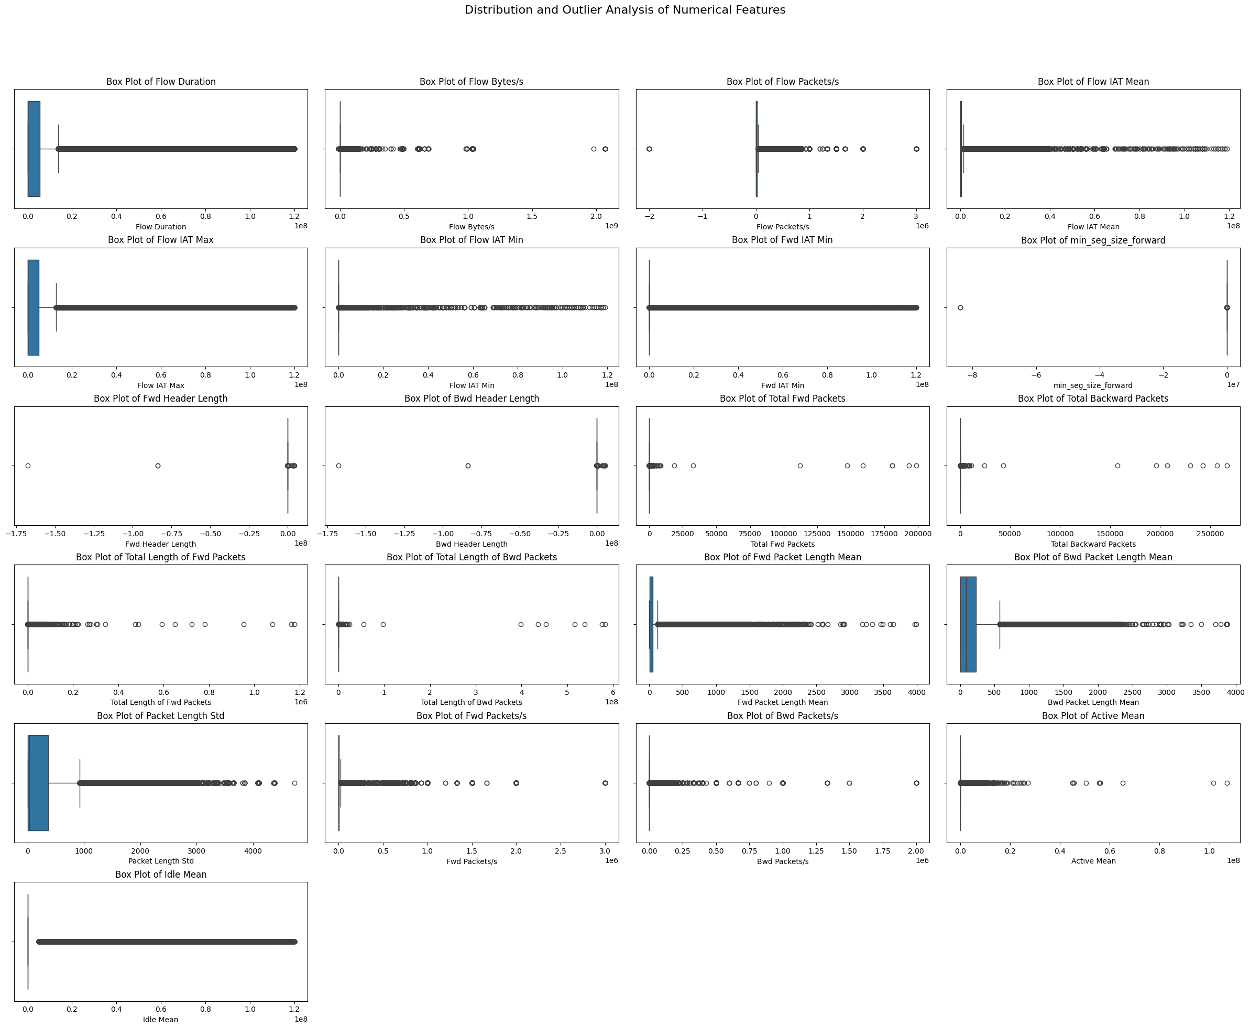Figure 1.11: Box Plots
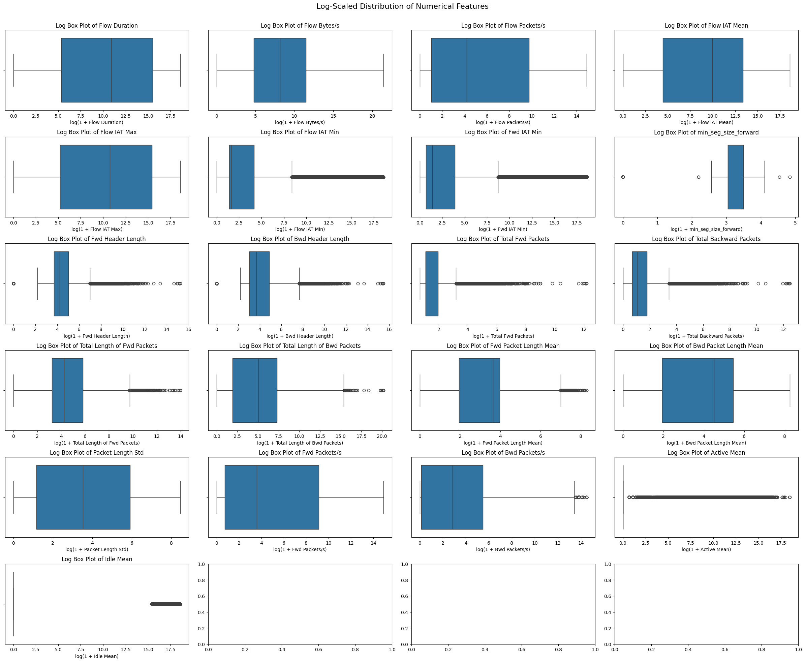Figure 1.12: Log- Scale Plots

Most extreme values were retained because they could represent genuine attack traffic. DoS and DDoS attacks can generate unusually high packet and byte rates, while brute-force and infiltration attacks may also produce abnormal flow behaviour. Retaining these values allowed the model to learn the characteristics of malicious network activity.

Only clearly invalid values were replaced. These included infinite values and negative values in features where negative measurements were not logically possible, such as flow duration, packet counts and traffic rates. Infinite values may occur when a rate is calculated using a flow duration of zero or an extremely small value.

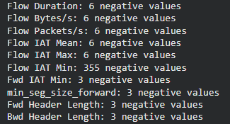
Figure 1.13: Identifying Classes with Negative Values

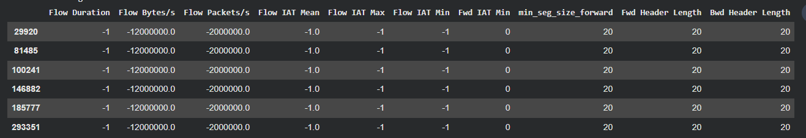Figure 1.14: Rows with Negative Values

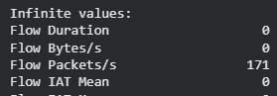
Figure 1.15: Rows with Infinite Values

The invalid values were converted into missing values using the .nan() function and then replaced with the fillna() function, using the median of the respective column. The median was selected because it is less affected by extreme network traffic values than the mean. After processing, the dataset was checked again to confirm that no invalid, infinite or missing values remained.

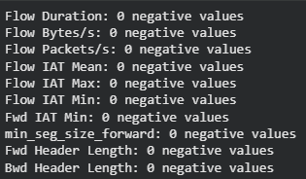
Figure 1.16: Rechecking for Any Remaining Negative Values

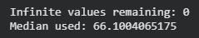
Figure 1.16: Rechecking for Any Remaining Infinite Values

4.1.5 Handling Classes with Insufficient Records

The class distribution was reviewed before label encoding and data splitting. Several attack classes contained very few records compared with the other traffic classes. These included Heartbleed, Infiltration, and Web Attack - Sql Injection.

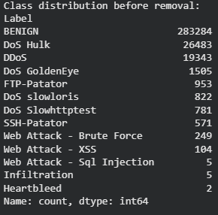
Figure 1.17: Classes with Insufficient Records

Classes with insufficient records can cause problems during model training and evaluation. When the dataset is divided into training and testing sets, a rare class may contain too few samples or may not appear in the test set at all. This prevents the model’s performance for that class from being measured reliably. It can also cause inconsistencies in the classification report and confusion matrix.

One possible method for handling minority classes is the Synthetic Minority Over-sampling Technique, SMOTE. SMOTE creates new synthetic records by using existing samples from a minority class and generating similar data points between neighbouring records. This can increase the number of training examples without simply copying the same rows. However, SMOTE was not suitable for the three underrepresented classes in this dataset. These classes contained too few original records for SMOTE to learn a reliable pattern. Generating synthetic samples from such a small number of examples could produce unrealistic traffic records and cause the model to learn inaccurate attack behaviour.

Thus, the three underrepresented classes were removed before label encoding and the train-test split. This ensured that every remaining traffic class had enough records to appear in both the training and testing sets. It also allowed stratified sampling to preserve a similar class distribution across both sets.

Removing these classes improved the reliability of the evaluation process. However, it also introduced a limitation. The final model cannot identify Heartbleed, Infiltration, or SQL Injection traffic because it was not trained on these classes. Future improvements should focus on collecting more genuine traffic records for these attack types. Once enough valid samples are available, SMOTE, class weighting, or other balancing methods can be tested safely.
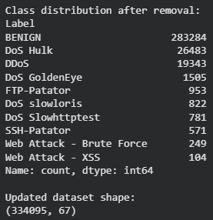
Figure 1.18: Re-checking Class Distribution

5 Random Forest Model
A Random Forest classifier was selected to classify each network flow into its corresponding traffic category. Random Forest is a supervised ensemble learning algorithm that combines the predictions of multiple decision trees. Each tree learns from a different sample of the training data and considers a random subset of features when making decisions. The model determines the final class through majority voting across all trees.

Random Forest was suitable for this project because the processed CIC-IDS2017 dataset contained 334,095 records and 67 input features. The algorithm can efficiently process large datasets with many numerical variables without requiring feature scaling. It can also identify complex relationships between network characteristics such as flow duration, packet rates, packet lengths and packet counts. The model supports multiclass classification, which allowed it to distinguish benign traffic from several attack categories, including DDoS, DoS Hulk, DoS GoldenEye, brute-force attacks and web attacks. It also provides feature importance scores that can help identify which network flow characteristics contributed most to its classifications.

A major advantage of Random Forest is its resistance to overfitting compared with a single decision tree. A single tree may learn patterns that are too specific to the training dataset. Random Forest reduces this problem by combining multiple trees that have learned from different samples and features. Incorrect decisions made by individual trees have less influence on the model’s final prediction.

The model was trained using Scikit-learn’s RandomForestClassifier. It contained 100 decision trees and used balanced class weighting to account for the unequal number of records across the traffic classes. A fixed random state was also used to produce consistent and reproducible results.

Feature scaling was not applied because Random Forest separates records using decision thresholds rather than distance calculations. Therefore, differences in the measurement ranges of features such as flow duration, packet count and byte rate did not directly affect the model’s training process.

5.1 Label Encoding

The target column, Label, contained categorical text values such as BENIGN, DDoS, FTP-Patator, and Web Attack - XSS. These values could not be used directly as the prediction target because the Random Forest model requires numerical class values during training.

Scikit-learn’s LabelEncoder was used to assign a unique integer to each remaining traffic class. Using the LabelEncoder() function, the encoded values were stored in a new column named Encoded_Label. This allowed the model to process the traffic categories while preserving the relationship between each numerical value and its original class name.

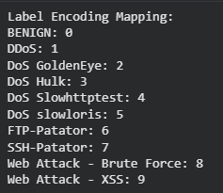
Figure 2.1: Re-checking Class Distribution

The original Label column was retained for reference. The Encoded_Label column was used as the target variable during model training. Both columns were removed from the model’s input features because including either one would cause data leakage. Data leakage occurs when the model receives information that directly reveals the correct answer during training.

The label mapping was generated only after the underrepresented classes had been removed. This ensured that the encoded values matched the final set of traffic classes used for training and evaluation. The same encoder was later reused to convert numerical predictions back into readable traffic labels for display in the application.

5.2 Separating Features and Target

The dataset was separated into input features and the target variable before model training.

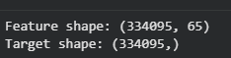
Figure 2.2: Separating Features and Target

The Label and Encoded_Label columns were removed from the input features because both contain the correct traffic class. Including either column in X would cause data leakage, where the model receives the answer during training. The Encoded_Label column was used as the target because machine learning models require numerical class values. The original Label column was retained only for reference and for converting predictions back into readable traffic names.

5.3 Train & Test Splits

The processed dataset was divided into training and testing sets before the Random Forest model was trained. The training set contained 80% of the records, while the remaining 20% formed the testing set. This produced 267,276 training records and 66,819 testing records, with 65 input features in each set. The training set was used to allow the model to learn the relationships between network flow features and their corresponding traffic classes. The testing set contained unseen records and was used to measure how well the trained model could classify new network traffic.
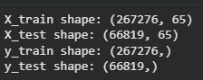
Figure 2.3: Train Test Split

An 80:20 split was selected because it provided enough data for model training while retaining a sufficiently large testing set for reliable evaluation. The random_state value was set to 42 so that the same split could be reproduced whenever the notebook was rerun.

The stratify=y setting was also applied during the split. This maintained a similar class distribution in both the training and testing sets. Stratification was important because the dataset was imbalanced, with substantially more records from classes such as BENIGN and DoS Hulk than from smaller classes such as DoS slowloris and DoS Slowhttptest. Without stratification, some smaller classes could have been poorly represented in the testing set, making the evaluation less reliable.

5.4 Model Configuration & Training

The Random Forest classifier was created using Scikit-learn’s RandomForestClassifier. The model was configured with 100 decision trees, a fixed random state, balanced class weights and parallel processing.
Parameter | Value | Justification
n_estimators | 100 | Builds 100 decision trees and combines their predictions. This provides more stable results than using a single decision tree.
random_state | 42 | Ensures that the model produces reproducible results when trained again with the same data.
class_weight | balanced | Gives greater importance to classes with fewer records and reduces bias towards larger classes such as BENIGN and DoS Hulk.
n_jobs | -1 | Uses all available processor cores to reduce model training time.

The model used 100 trees as a practical starting point. This provides a balance between prediction performance and training time. A larger number of trees may improve stability but would require more processing time and memory. The class_weight="balanced" setting was important because the dataset contained an uneven number of records for each traffic class. Without class weighting, the model might focus mainly on the larger classes and perform poorly when detecting less common attacks.

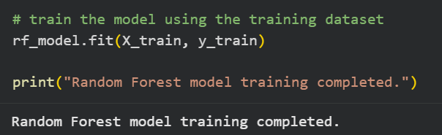
Figure 2.4: Training the Model

The model was trained using the fit() function with X_train and y_train. During training, each tree learned different traffic patterns from random samples of the training records and input features. The Random Forest then combined the predictions from all trees to determine the final traffic class.
Feature scaling was not applied because Random Forest is a tree-based algorithm. It makes decisions using feature thresholds and is not affected by differences in measurement scales in the same way as algorithms such as logistic regression, K-nearest neighbours, or support vector machines.

5.5 Model Evaluation & Analysis

5.5.1 Model Prediction

The prediction output was initially returned as encoded numerical values. Each number represented one of the original traffic labels. The first 10 predictions were displayed as a quick check that the model was generating output successfully.

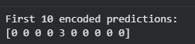
Figure 2.5: Prediction

5.5.2 Converting Predictions Back to Traffic Labels

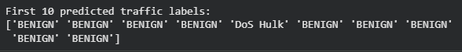
Figure 2.6: Converting Back to Traffic Labels

The conversion was necessary because numerical predictions such as 0, 1, and 2 are difficult for users and SOC analysts to interpret directly.

Using inverse_transform() allowed the application to display the traffic names into a readable format. The same label encoder used during preprocessing was reused so that the numerical values were mapped back to the correct original classes.

5.5.3 Evaluation of Accuracy

The overall model accuracy was calculated by comparing the predicted labels with the actual labels from the testing set.

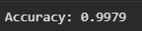
Figure 2.6: Accuracy Score

As seen, the model has the prediction accuracy of 0.9991. Although accuracy provides a general overview of model performance, it should not be used alone because the dataset is imbalanced. A model could achieve high accuracy by correctly predicting the larger classes while performing poorly on less common attack types.

For this reason, precision, recall, F1-score, and the confusion matrix were also used.

5.5.4 Classification Report

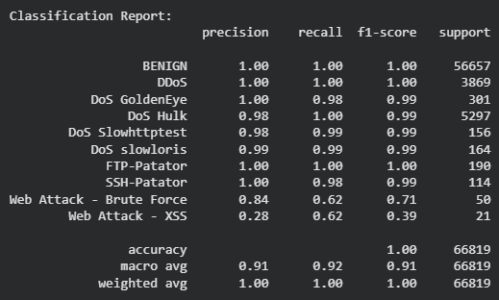
Figure 2.6: Classification Report

The classification report displayed the following metrics:
Metric | Meaning
Precision | Measures how many records predicted as a specific class were actually from that class.
Recall | Measures how many actual records from a class were successfully detected.
F1-score | Provides a balance between precision and recall.
Support | Shows the number of actual test records belonging to each class.

Recall was especially important because a low recall value means that the model failed to detect real attacks. In a SOC environment, missed attacks may remain undetected and continue affecting the network. The F1-score was also important because it considers both missed attacks and incorrect alerts.

The target_names parameter was used to display readable traffic class names instead of encoded numbers, and the zero_division=0 setting prevents errors when a class has no predicted samples. In such cases, the affected metric is displayed as zero instead of producing a warning.

5.5.5 Confusion Matrix

The confusion matrix provides a detailed view of correct and incorrect predictions for every traffic type.
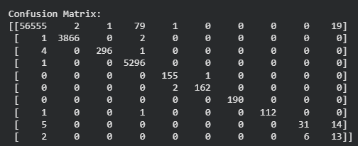
Figure 2.7: Confusion Matrix

5.6 Model Analysis

The Random Forest model achieved an accuracy of approximately 99.8% to 99.9% on the testing dataset. This indicates that most test records were assigned to the correct traffic class. However, the high score should be interpreted together with the characteristics of the CIC-IDS2017 dataset and the class-level evaluation results. Accuracy alone may hide weaker performance for smaller traffic classes.

The model achieved very high prediction accuracy because CIC-IDS2017 is often considered a relatively clean and easily separable dataset. Its traffic records contain clear patterns that allow machine learning models to distinguish benign traffic from attack traffic with limited ambiguity.

Random Forest is also a well-known and effective model for CIC-IDS2017. It performs strongly on structured network-flow data and can learn complex relationships between many numerical features. The combination of CIC-IDS2017 and Random Forest therefore commonly produces very high classification results.

However, this performance may be higher than what the model would achieve on real-world network traffic. Live environments contain more varied user behaviour, changing traffic patterns and previously unseen attacks. Therefore, the high accuracy should be treated as strong performance on the selected dataset rather than guaranteed performance in an operational network.

5.7 Model Extraction

To avoid retraining the Random Forest model every time the application runs, the trained model was saved into a file. The label encoder and feature list were also saved because the application needs them to interpret the prediction and maintain the same input column order.

The joblib library was used because it can store trained Scikit-learn models efficiently. Three objects were saved after training:
- The random forest model
- The label encoder used to convert traffic names into numbers
- The ordered list of feature column names used during training
All three are required as the model alone cannot make predictions, since the label encoder is needed to convert results back into readable traffic names, and the feature list is needed to make sure an uploaded flow's columns are read in the same order the model was trained on.

The code used to save the files:
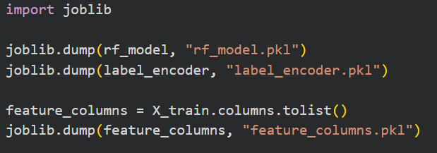
Figure 3: Using Joblib to Save Files

These three files were then used by the Streamlit application to load the model without needing to retrain it every time the application runs.

6 Application Development

6.1 Application Architecture

The application was built as a single-page Streamlit dashboard. Streamlit was chosen because it allows a Python script to be turned directly into an interactive web interface without needing separate frontend code (HTML, CSS, or JavaScript).

The application is structured around four components that run in sequence each time the user uploads a file:
1. Model loading: The saved rf_model.pkl, label_encoder.pkl, and feature_columns.pkl files are loaded once and cached, so the model is not reloaded from disk on every interaction.

2. File upload: The user uploads a CSV of network flow records through a file uploader widget.

3. Preprocessing and prediction: The uploaded data is cleaned, and its columns are aligned to match the exact feature order the model was trained on, then passed to the model for prediction.

4. Triage dashboard: The predictions are summarised as metrics, a traffic-type chart, a filterable results table, and a downloadable CSV of annotated results.

This design reflects the intended use case described in the Problem Statement: a SOC analyst reviewing a batch of network flows rather than entering traffic details one at a time, since a single flow record contains 65 numerical features that would be impractical to type in manually.

6.2 Loading the model

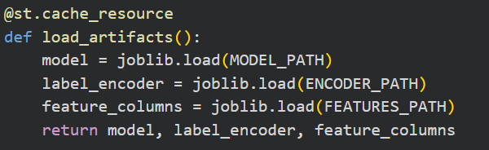
Figure 4.1: Loading the Model using Joblib

The three files produced during Model Extraction are loaded using a function with the decorator, @st.cache_resource. Streamlit reruns the entire script from top to bottom every time a user interacts with the application, so without caching, the model would be reloaded from disk on every single interaction. The cache decorator ensures the model is only loaded once per session.

6.3 Aligning uploaded data to the model's feature columns

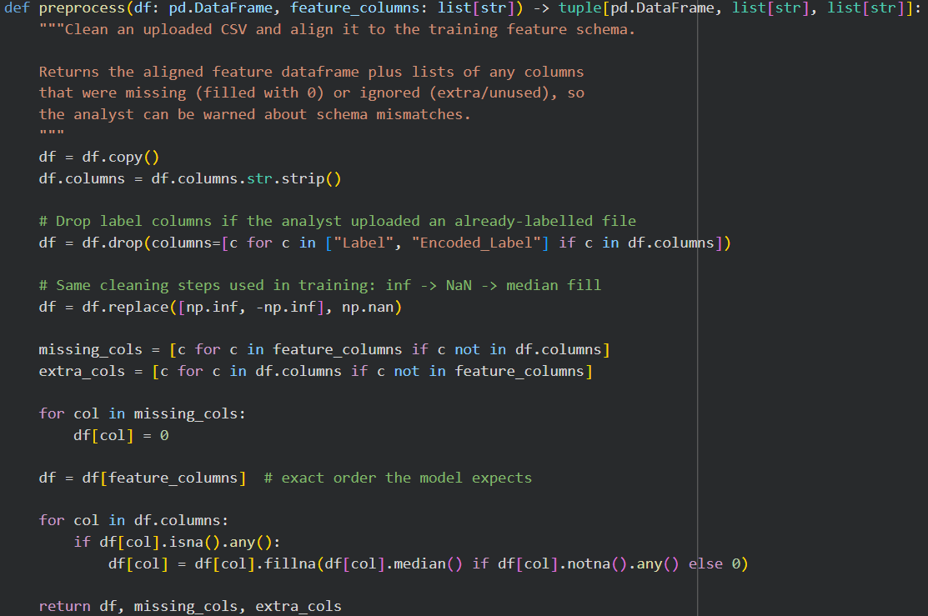
Figure 4.2: Aligning Uploaded Data to Model’s Feature Columns – Code Snippet

A key challenge in application development was ensuring that the uploaded CSV matches the exact column structure the model was trained on. Raw CIC-IDS2017 files contain columns such as Flow ID, Source IP, and Timestamp that were removed during preprocessing and are therefore not part of the model's 65 expected features. If these columns were passed to the model directly, or if columns were in a different order, the model would misread which value belongs to which feature. A preprocess function was written to handle this: it strips column names, removes label columns if present, fills any missing expected columns with zero, reorders the columns to match the training order exactly, and reports back which columns were missing or ignored so the analyst is warned about potential data quality issues.

6.4 Prediction and Confidence

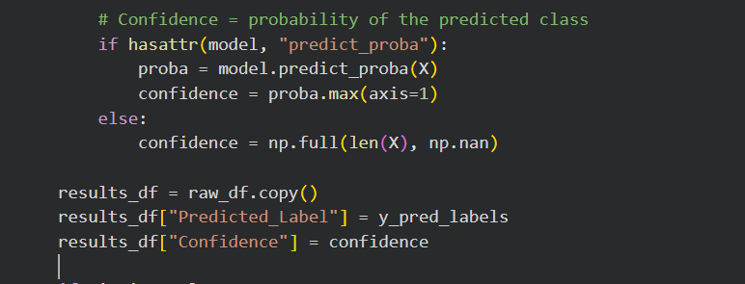
Figure 4.3: Confidence Score Prediction

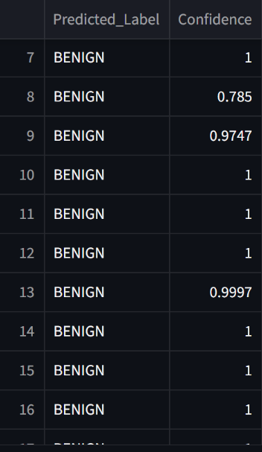
Figure 4.4: Confidence Score Output

Once the uploaded data is aligned, the model predicts an encoded label for every row. inverse_transform() from the same LabelEncoder used during training converts these numbers back into readable traffic names such as BENIGN or DDoS, consistent with the approach used in Section 4.4.2. predict_proba() is also used to report a confidence score for each prediction, calculated as the probability of the predicted class, so an analyst can judge how certain the model was, not just what it predicted.

6.5 Triage Dashboard

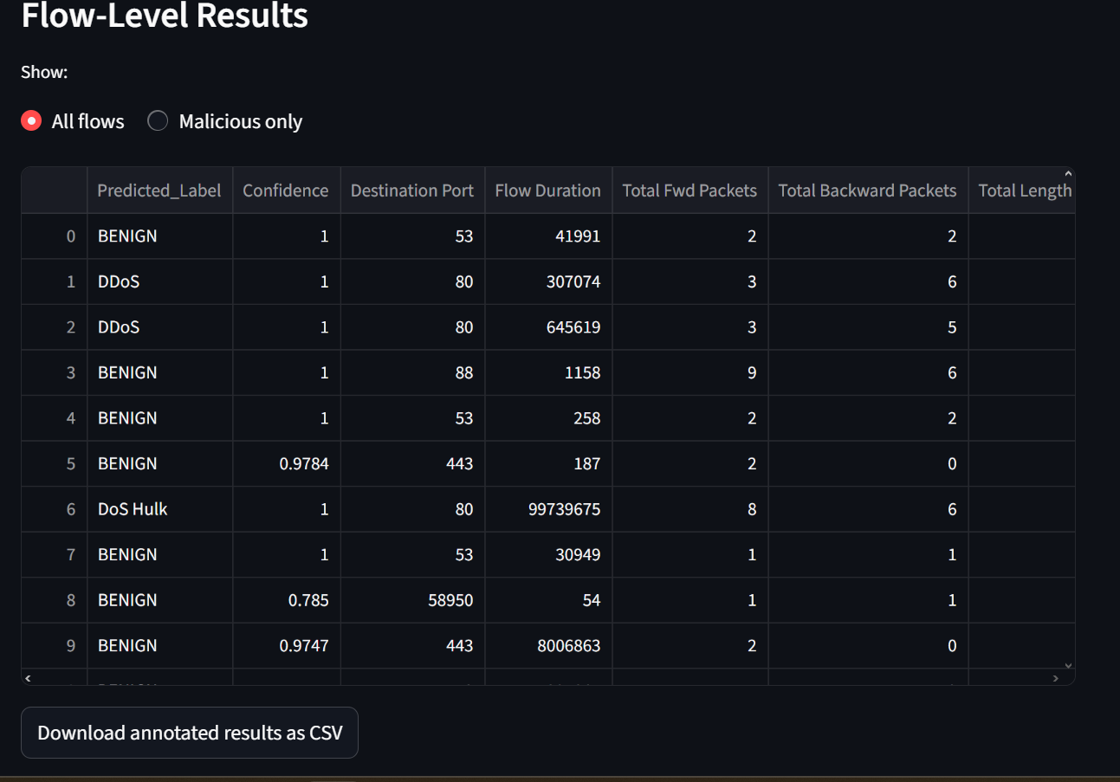Figure 4.5: Triage Dashboard

The results are presented as a dashboard, since the intended user is a SOC analyst who needs to quickly judge whether a batch of traffic requires attention. The dashboard includes summary metrics (total flows analysed, benign count, malicious count, and malicious rate), a bar chart showing the breakdown of predicted traffic types, a filterable results table that can be switched between all flows and malicious-only, and a download button that exports the original data with the predicted labels and confidence scores added as new columns.

6.6 Application Testing

The application was tested manually by running it locally with the command streamlit run app.py and uploading sample CSV files exported from the same data pipeline used in Section 4.

6.7 Schema Handling Test

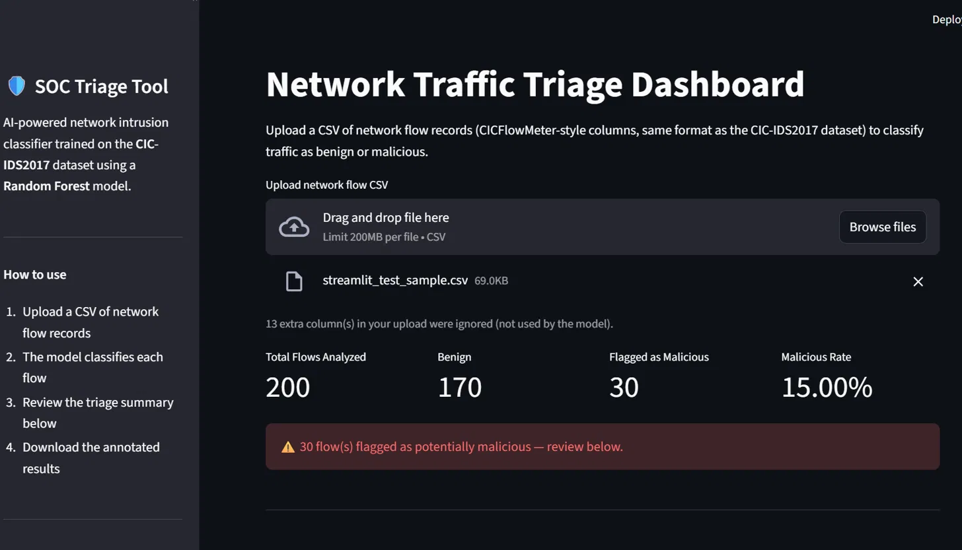Figure 4.6: Schema Handling Testing

(The code has been removed from the notebook after obtaining the evidence to prevent confusion)

A raw sample containing the full set of original CIC-IDS2017 columns (including columns removed during preprocessing, such as Flow ID and Source IP) was uploaded to confirm the preprocess function correctly identifies and ignores columns not used by the model, rather than causing an error. The application correctly reported that 13 extra columns were ignored and produced predictions for all rows.

6.8 Prediction Accuracy Test
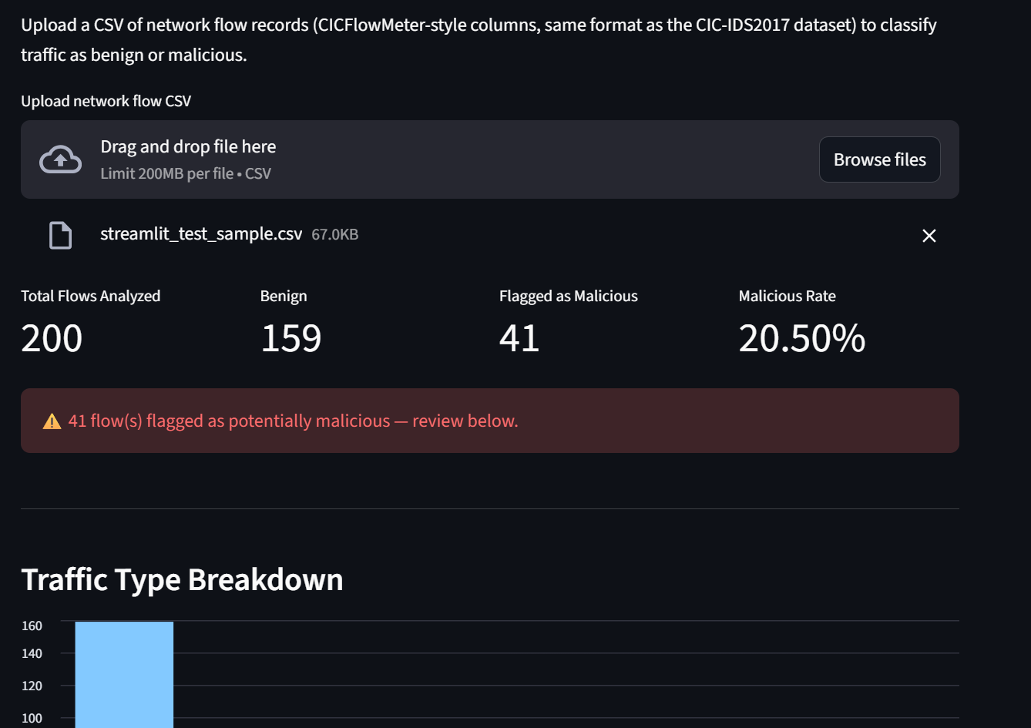
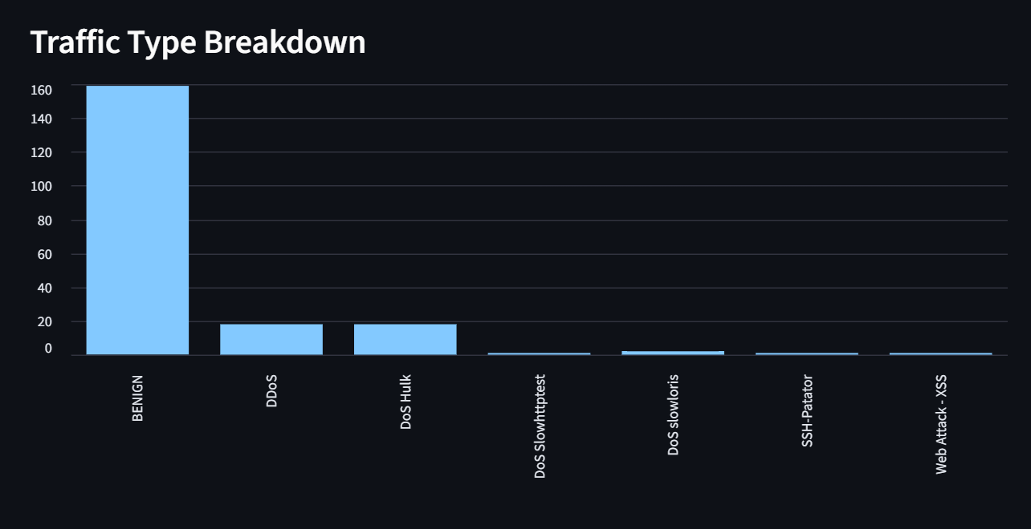
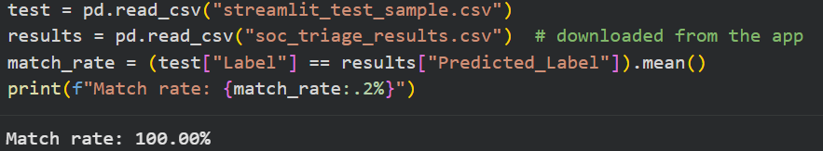
Figure 4.7: Prediction Accuracy Test

A 200-row sample was first tested by sampling randomly from X_test, the held-out portion of the data the model was evaluated on. This test returned a 100% match rate between the application's predictions and the true labels (159 BENIGN, 41 malicious flows correctly classified). Given the model's overall test accuracy of 99.79% and that most misclassifications occur within a small number of rare attack classes, a 200-row random sample achieving zero errors is a statistically reasonable outcome, confirming that the deployed application reproduces the model's evaluated performance correctly.

7 Application Deployment
The application deployment process involved making the trained machine learning models, pre-processing logic, and Streamlit user interface available as a live web application accessible through a public web URL.

The deployment pipeline consisted of three primary steps:
- Version control and code repository hosting via GitHub.
- Cloud hosting platform configuration via Streamlit Cloud.
- Live application execution, file ingestion testing, and output validation in Microsoft Excel.

7.1 Repository Setup and Version Control
To prepare the application for cloud hosting, a public GitHub repository named EATC-SOC-Triage-Tool was created.

The repository serves as the remote source code repository and stores all application dependencies and pre-trained model artifacts required for live deployment.
The repository structure consists of the following essential components:

- app.py: The main Streamlit web application script responsible for handling UI rendering, CSV file ingestion, feature alignment, model inference, and displaying the triage dashboard.
- rf_model.pkl: The serialized, trained Random Forest classifier.
- label_encoder.pkl: The serialized Scikit-learn LabelEncoder object required to convert numerical predictions back into human-readable attack labels.
- feature_columns.pkl: The serialized ordered list of 65 feature names ensuring input CSV columns match the exact feature order expected by the model.
- requirements.txt: The configuration file specifying required Python dependencies (streamlit, pandas, numpy, scikit-learn, joblib) for the cloud environment setup.
- streamlit_test_sample.csv: A pre-extracted sample CSV dataset used for quick validation testing.
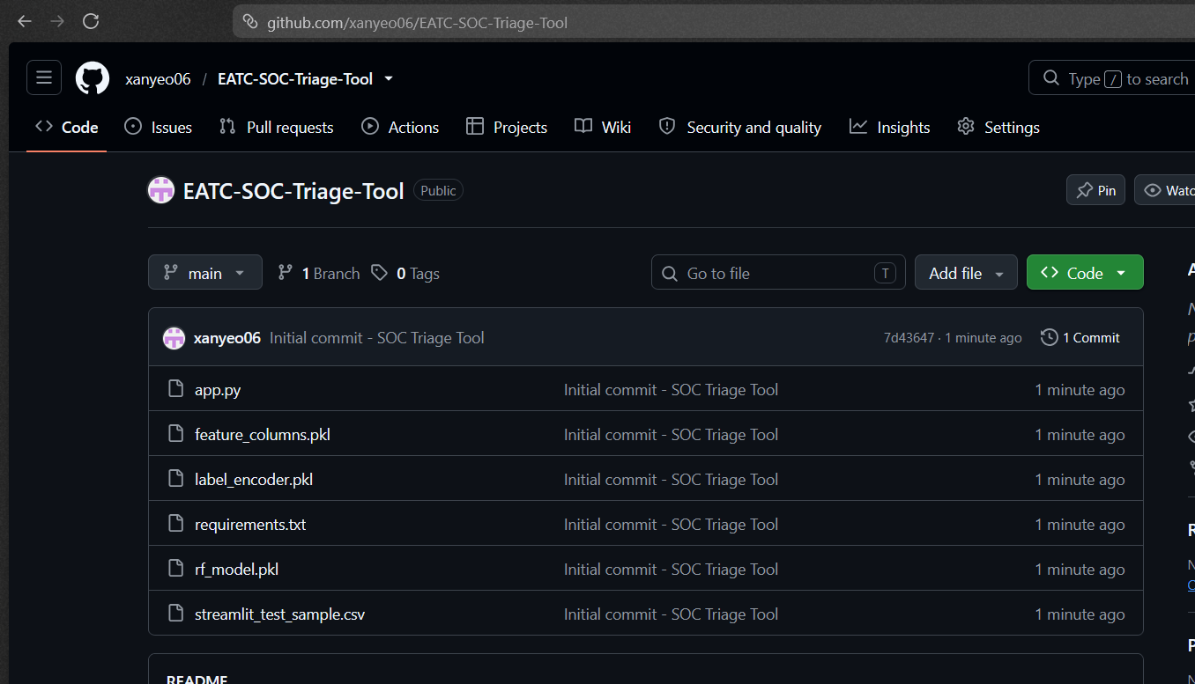

Figure 5.1: GitHub Repository Setup containing application code, serialized model artifacts, and dependency specifications

7.2 Streamlit Cloud Configuration & Porting

Streamlit Cloud was selected as the cloud hosting platform due to its native integration with GitHub repositories and automated continuous deployment pipeline.

Step-by-Step Deployment Steps:
- Repository Linking: Logged into Streamlit Cloud and connected the platform to the GitHub account
- Deployment Parameter Configuration:
  - Repository: xanyeo06/EATC-SOC-Triage-Tool
  - Branch: main
  - Main file path: app.py
  - App URL: eatc-soc-triage-tool.streamlit.app
- Build Execution: Streamlit Cloud automatically installed the environment dependencies listed in requirements.txt and launched the web service.

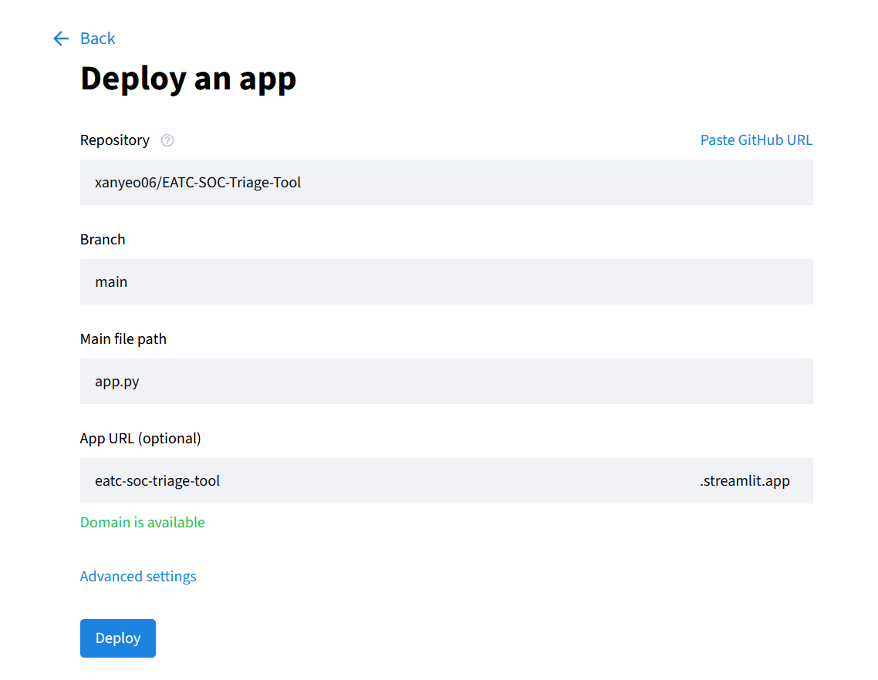
Figure 5.2: Streamlit Cloud Deployment Configuration linking to the GitHub repository.

Upon completion of the cloud build process, the web application became live and accessible globally at https://eatc-soc-triage-tool.streamlit.app.

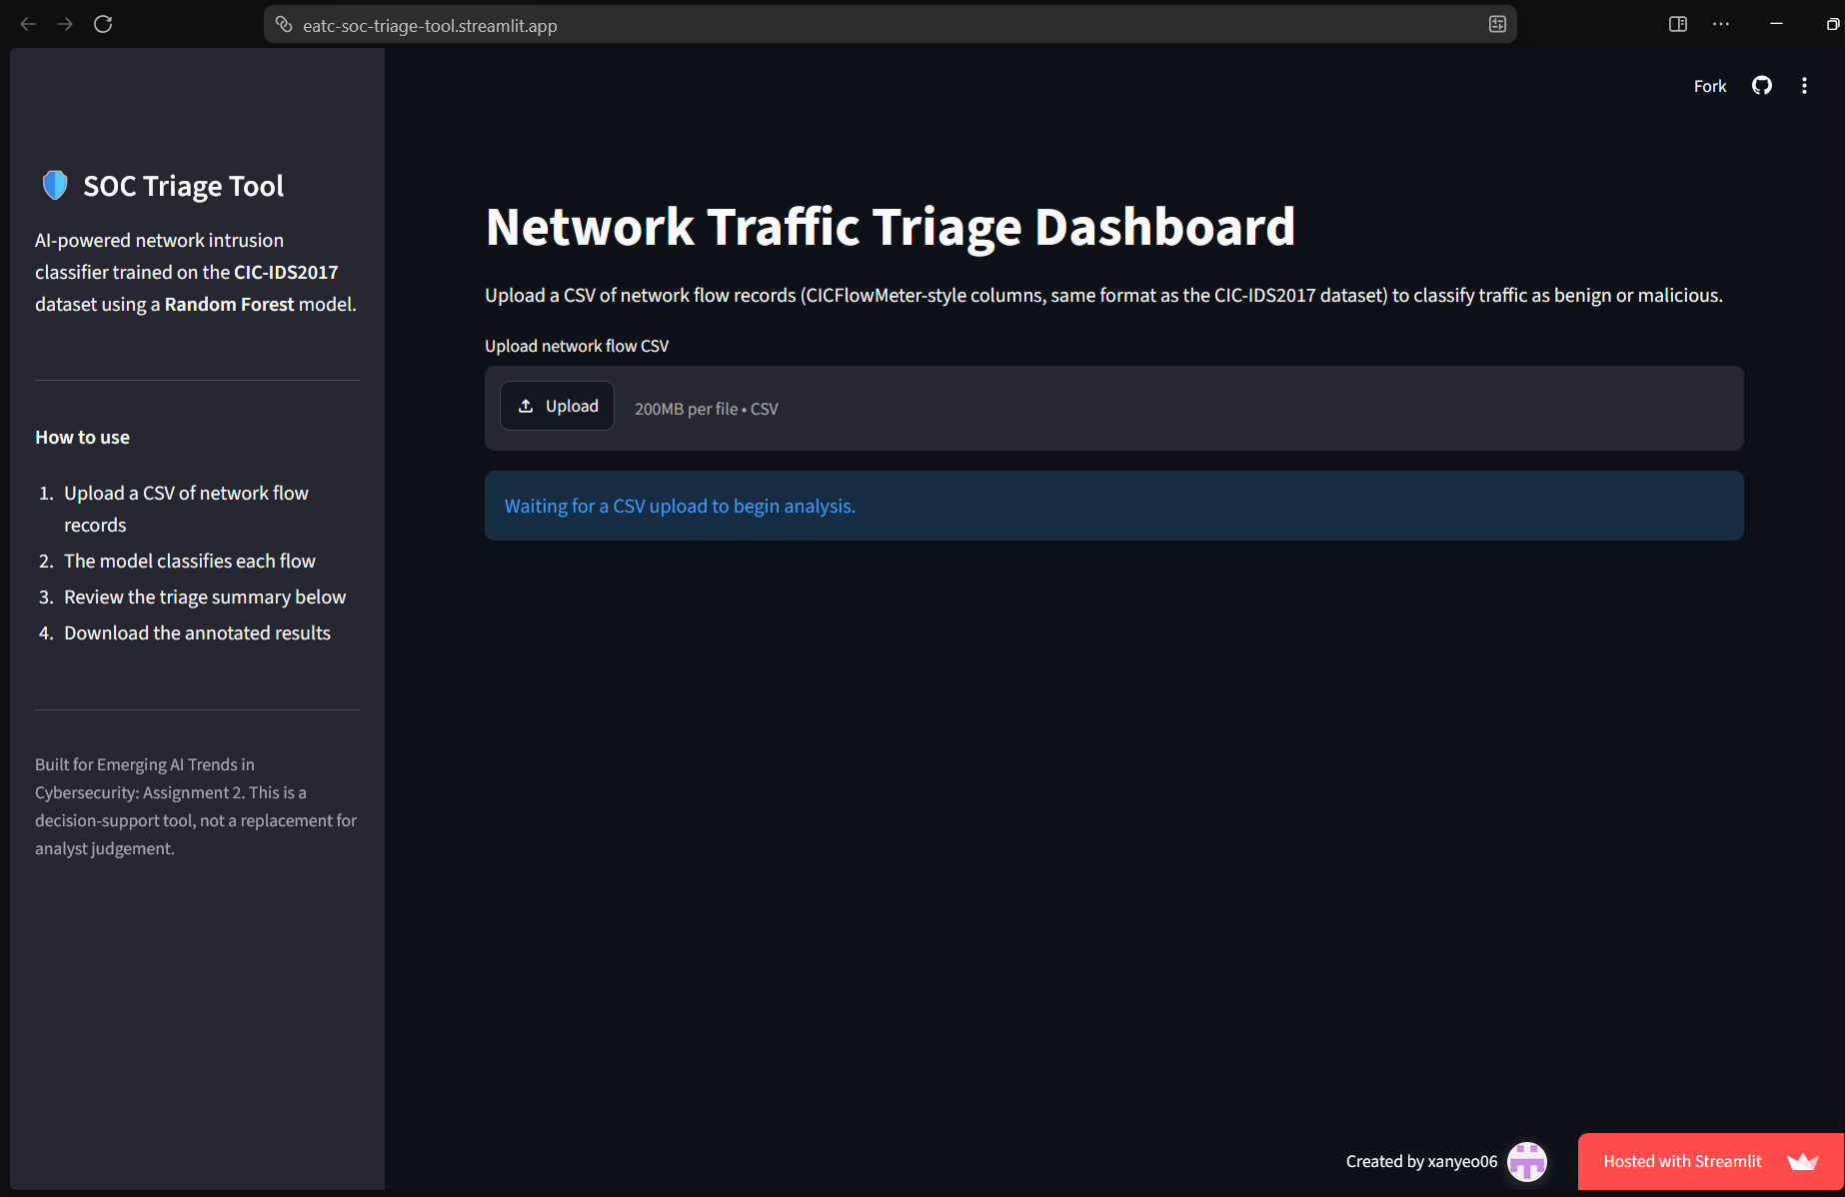
Figure 5.3: Live Streamlit Application Landing Page awaiting user input.

7.3 End-to-End Application Testing & Validation

To verify the functionality, stability, and detection capability of the deployed application, testing was performed using raw CSV files from the original CIC-IDS2017 dataset.

A raw dataset file (Thursday-WorkingHours-Afternoon-Infilteration.pcap_ISCX.csv, size: ~49.6 MB) was uploaded directly into the web application via the uploading interface.

The model processed 170,366 network flows in real time, identifying 167,941 benign flows and flagging 2,425 flows as potentially malicious (a 1.42% overall malicious rate).

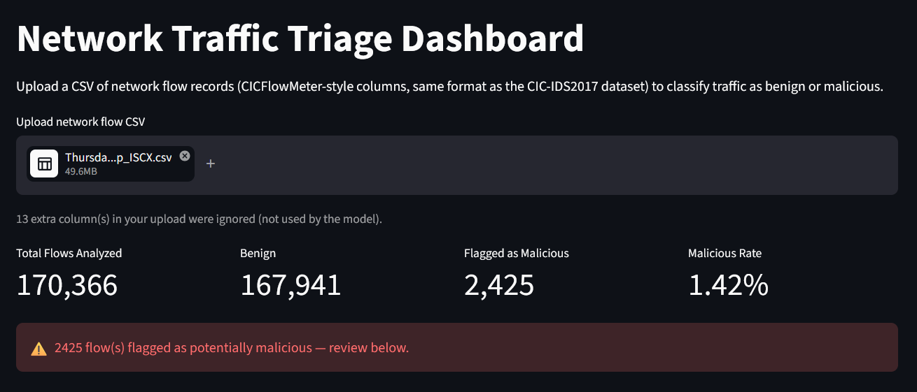
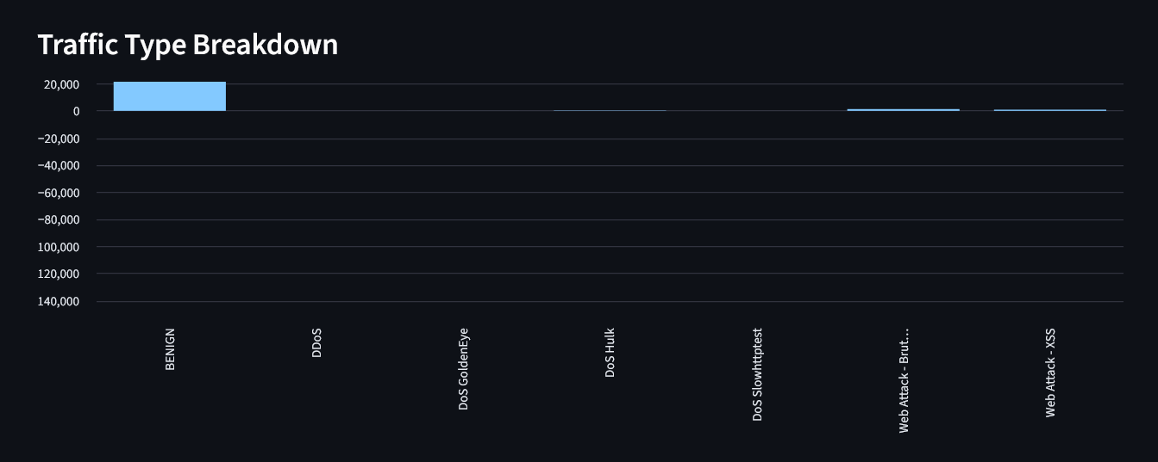

Figure 5.4: Ingestion of a raw dataset file and generated high-level triage metrics.

The dashboard dynamically generated a Traffic Type Breakdown bar chart categorising the uploaded flows into specific threat categories.

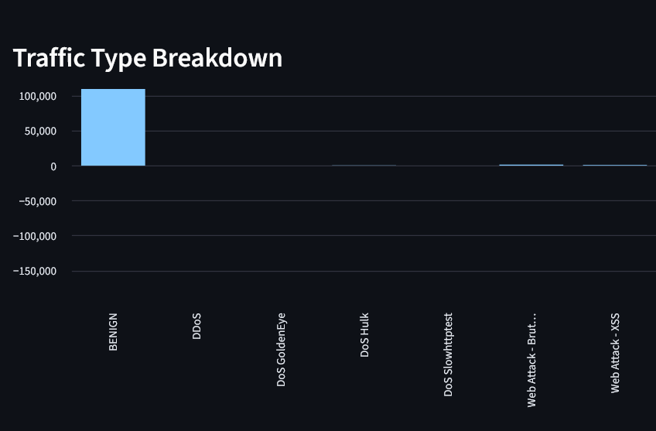
Figure 5.5: Traffic Type Breakdown bar chart displaying categorical classification results.

SOC analysts can review individual flow predictions along with calculated model confidence scores via the interactive data viewer, which supports filtering between all flows and malicious-only traffic.

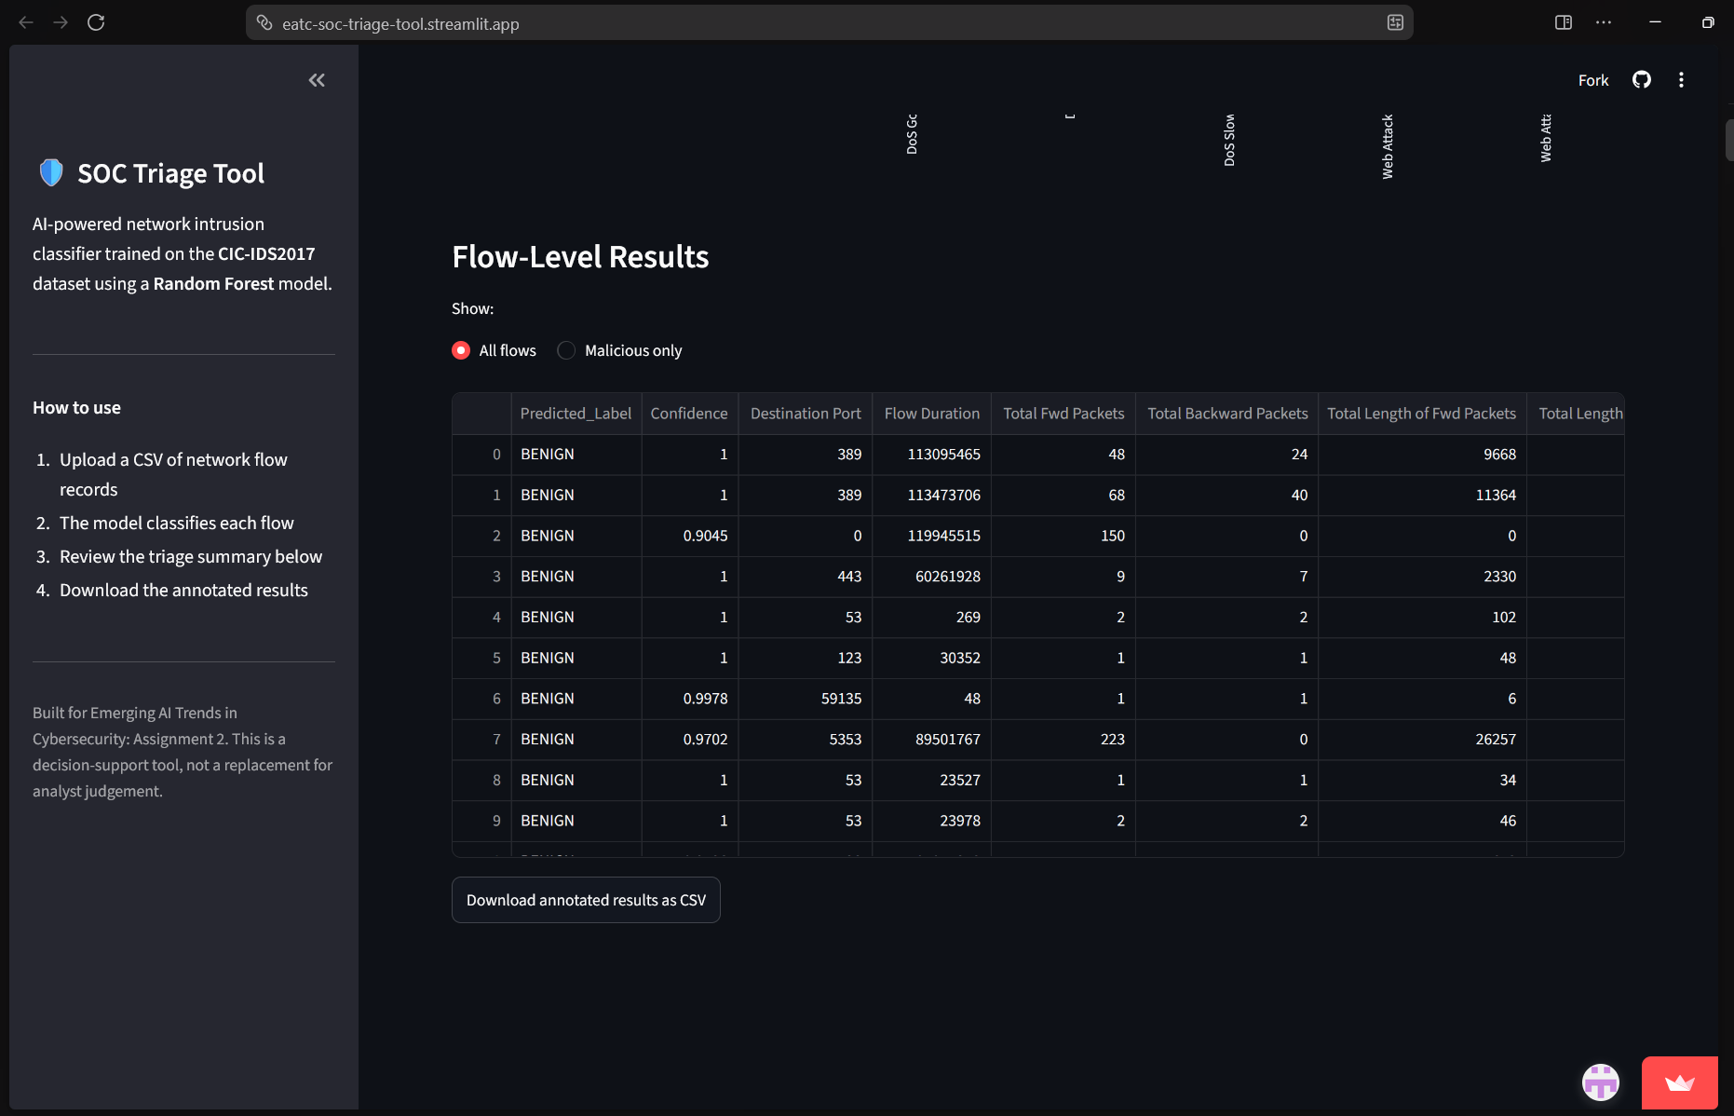
Figure 5.6: Flow-level results table displaying predicted labels, confidence scores, and flow metadata.

The annotated dataset was exported by clicking the "Download annotated results as CSV" button, which produces soc_triage_results.csv.

Opening the exported file in Microsoft Excel verified that two new evaluation columns were appended to the original flow data:
- Predicted_Label: The string classification produced by the Random Forest model (e.g., BENIGN, DoS Hulk, DDoS).
- Confidence: The prediction probability score (ranging between 0.0 and 1.0) output by predict_proba().

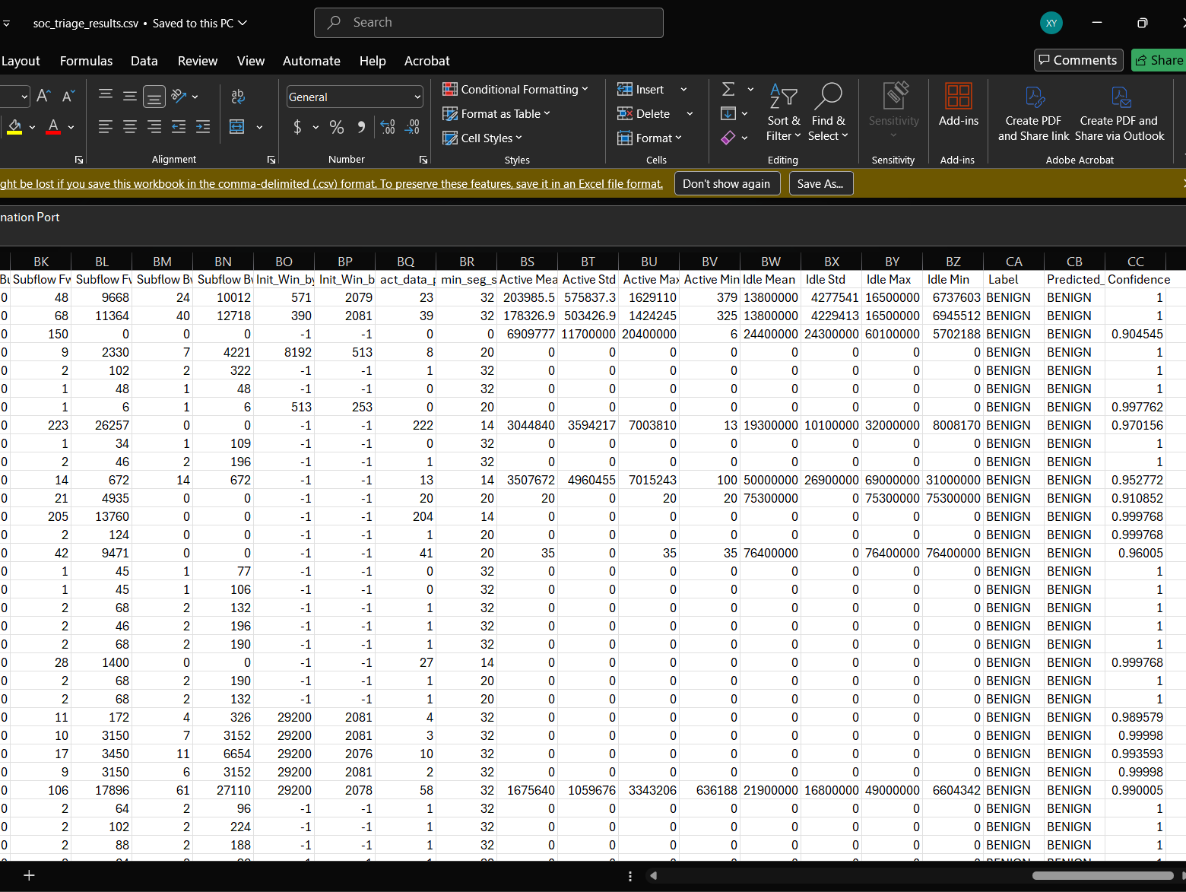
Figure 5.7: Exported dataset opened in Microsoft Excel showing original network flow characteristics alongside appended Predicted_Label and Confidence scores.

The deployment test confirmed that the public web application functions as an automated decision-support tool for SOC analysts, accepting arbitrary raw flow CSV files, performing feature schema alignment, running model inference, rendering triage analytics, and exporting annotated datasets for downstream security investigations.

8 Summary and Reflection

8.1 Key Findings

The objective of this project was to construct an automated, AI-powered Security Operations Centre (SOC) Triage Tool capable of classifying complex multi-vector network traffic into benign baseline activity and distinct intrusion types.

Key analytical and technical findings from this initiative include:
- High-Accuracy Anomaly Detection: The trained Random Forest classifier demonstrated high overall performance, achieving a 99.79% overall accuracy on unseen test data. The model achieved high macro and weighted average F1-scores, demonstrating strong detection capabilities across high-volume traffic types as well as lower-density classes.

- Real-Time Deployment Feasibility: Caching the serialized model artifacts via @st.cache_resource in Streamlit allowed large batch uploads (e.g., 170,000+ rows) to be processed and triaged within seconds without needing to retrain the model on every app execution.

- Practical Decision Support: The dashboard format provides clear visualization metrics and confidence scores for each prediction, allowing SOC analysts to filter out benign noise and export annotated CSVs directly for further forensic investigation in tools like Microsoft Excel.

8.2 Challenges and Issues Resolved

Throughout the development and deployment phases, we encountered several technical challenges that required systematic problem-solving:

- Data Schema Mismatches During CSV Upload

  - Raw network flow captures from CICFlowMeter contain metadata columns (such as Flow ID, Source IP, Destination IP, and Timestamp). When uploading raw CSV files to the Streamlit app, passing these extra unmodeled columns caused schema mismatch errors and shifted feature alignments.

  - A dedicated preprocess() pipeline function was built into app.py. It automatically detects and strips extra metadata columns, fills any missing expected training features with zeros, orders the inputs to match feature_columns.pkl, and alerts the analyst of ignored/filled columns in the UI banner.

- Extreme Outliers, Infinite Values, and Negative Measurements

  - Initial exploratory data analysis revealed infinite values in traffic rate columns (e.g., Flow Packets/s) due to short flow durations, as well as invalid negative measurements generated by underlying capture tools.

  - Outliers were not blindly removed using standard IQR thresholds because high packet/byte counts are representative of active DoS/DDoS attacks. Instead, negative timing measurements and infinite values were converted to NaN and imputed using column medians, preserving genuine attack signatures without distorting mathematical inputs.

- Severe Class Imbalance and Underrepresented Classes

  - The CIC-IDS2017 dataset is heavily imbalanced, with benign traffic and DoS Hulk dominating the sample counts. Certain attack classes like Heartbleed, Infiltration, and Web Attack - Sql Injection contained as few as 2 to 5 records across the entire dataset.

  - Underrepresented classes with insufficient records were removed prior to label encoding and stratified splitting to ensure stable cross-validation and evaluation metrics. Additionally, class_weight="balanced" was configured on the Random Forest classifier during training to adjust loss weightings dynamically for less frequent attack categories.

8.3 Future Improvements

While the application achieves its primary design goals, the team has identified several key areas for future iteration:

- Acquiring additional real-world datasets containing low-density attack vectors (e.g., SQL Injection, Infiltration, Ransomware, and Botnet traffic) to reintroduce those categories into the model schema with adequate statistical representation.

- Upgrading the application from batch CSV file upload processing to a streaming pipeline that interfaces directly with network interfaces or PCAP files via live packet processing libraries.

9 References
Applications | Research | Canadian Institute for Cybersecurity | UNB. (n.d.-a). In www.unb.ca. Retrieved July 29, 2026, from https://www.unb.ca/cic/research/applications.html
CIC Dataset Download. (2026). Cicresearch.Ca. https://cicresearch.ca/CICDataset/CIC-IDS-2017/
joblib: running python functions as pipeline jobs — joblib 1.3.2 documentation. (n.d.-b). In joblib.readthedocs.io. Retrieved July 29, 2026, from https://joblib.readthedocs.io/en/stable/
mhadhbi, N. (2021). Python tutorial: streamlit. In www.datacamp.com. https://www.datacamp.com/tutorial/streamlit
st.cache_resource - streamlit docs. (2026). In Streamlit.io. https://docs.streamlit.io/develop/api-reference/caching-and-state/st.cache_resource
W3Schools. (2022). Introduction to numpy. In www.w3schools.com. https://www.w3schools.com/python/numpy/numpy_intro.asp
Wikipedia Contributors. (2021). Python (programming language). In Wikipedia. Wikimedia Foundation. https://en.wikipedia.org/wiki/Python_%28programming_language%29

