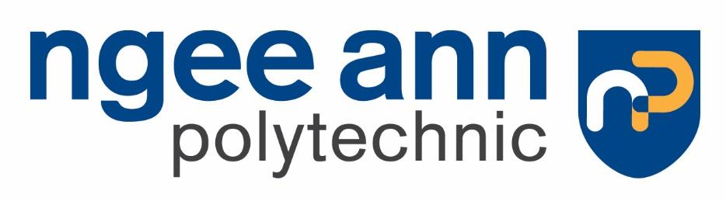
Malware Analysis Tools and Techniques
Year 2 (2025/26), Semester 3
SCHOOL OF INFOCOMM TECHNOLOGY
Diploma in Cybersecurity & Digital Forensics
ASSIGNMENT REPORT

Contents
Lab Setup 3
Analysis of Malicious Executable 4
Basic Static Analysis 4
WinMD5 4
PeiD 6
BinText 7
Dependency Walker 10
PEview 12
VirusTotal 13
Summary 14
Basic Dynamic Analysis 15
Procmon 15
ProcExp 18
RegShot 19
CaptureBAT 20
ApateDNS 21
Wireshark 21
Summary 22
Advanced Static Analysis 23
IDA Pro 23
Advanced Dynamic Analysis 28
OllyBDG 28
General Analysis of Malware 33
Malware Defences 33
Malware Removal 34
Video Submission Link 35

Lab Setup
VMWare Workstation Pro
Windows XP
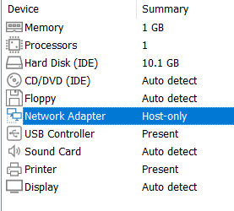

Analysis of Malicious Executable
We will be conducting analysis on a malicious executable. The malware that we have chosen to analyse is as shown in the table below. The malware comes in a zip file to protect users who download it unknowingly. The password for the zip file is “infected”

Type | Win32 Executable
Filename | db400e3300adaedd5612bdc415b2c224c0ad7c59617f9c19ed5bb0b1907a998d.exe
MD5 Hash | 610cd392b20787dafc7ea94d151c760b
URL Download | https://www.capesandbox.com/analysis/14070/#

Basic Static Analysis
Basic Static Analysis is examining the executable file without viewing the actual instructions, it can confirm whether a file is malicious and provides information about its functionality without actually running the malware.
It is straightforward and quick, but it is ineffective against sophisticated malware as it can miss important behaviours.

WinMD5
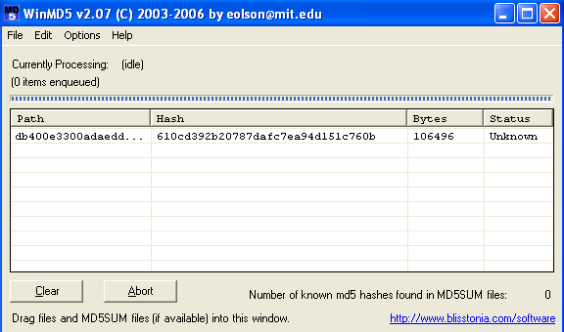

WinMD5 is used primarily for file integrity verification through MD5 checksums.
WinMD5 computes the MD5 hash of a selected file which acts as a unique fingerprint of the file contents.

It allows for verification of file integrity by comparing the generated hash calculated by MD5, with a known hash from a trusted source to check if the file has been corrupted or altered with. Any changes to the file, even a single byte will result in a completely different MD5 hash.

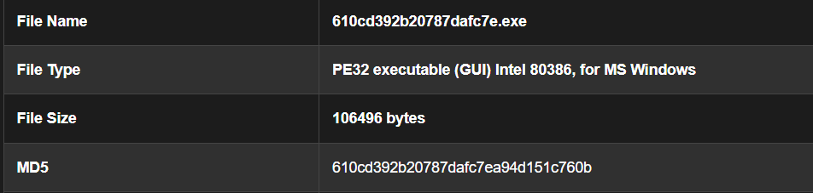

The above is the MD5 hash shown on the website we found the malware sample from.

Using WinMD5, the file's MD5 hash was computed and found to match the reference value, confirming that the file is unmodified and thus a valid representation of the original sample. This hash consistency is crucial in malware analysis, as it ensures the integrity of the sample during examination.

PeiD
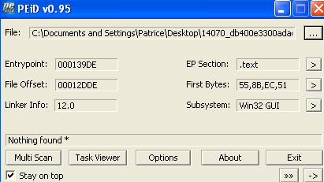

PEiD is a classic Windows static analysis tool that identifies packers and compilers used in Portable Executable (PE) files. Since the malware we are working with is a .exe file, we can use this software to detect whether a file is packed or obfuscated. Malwares can often be packed or obfuscated to evade detection and analysis.

The file was analyzed using PEiD, a tool designed to detect packers and compilers in Windows executables. PEiD reported that the file's entry point is located within the .text section, which is the standard code section in typical PE files. Furthermore, no known packer signatures were detected. This strongly suggests that the file is not packed or obfuscated using common methods. As a result, the malware can be studied without requiring any unpacking or decryption routines.

BinText

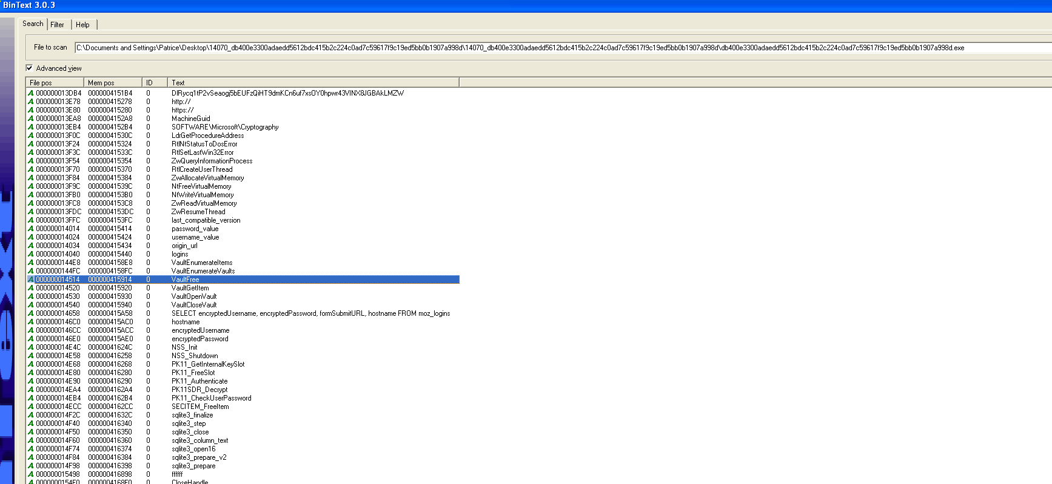

BinText is a static analysis tool that extracts text strings from binary files like .exe and .dll. It is commonly used in malware analysis to reveal hardcoded information that may not be visible through typical file inspections. BinText can reveal information like hardcoded URLs and Ips, suspicious API calls, registry keys, file and folder paths and error messages.
Using BinText, various embedded strings were extracted from the binary. These strings provided significant insight into the malware’s intended behavior. Several artifacts indicate credential theft from web browsers, including references to Chrome’s Login Data and Firefox’s logins.json and signons.sqlite files. API functions such as sqlite3_open16 and sqlite3_prepare_v2 show that the malware interacts with SQLite databases, which are commonly used to store encrypted credentials in browsers.

Other strings reveal the malware’s attempts to extract information from Windows Credential Manager, with calls to functions such as VaultEnumerateVaults and VaultGetItem. Additionally, the malware contains references to Outlook and FileZilla configurations, suggesting it targets email and FTP credentials as well. Strings like SMTP Password, recentservers.xml, and FtpPassword support this conclusion. Collectively, these indicators point to an information-stealing malware.

Extracted strings | What can be inferred | Screenshot
origin_url, username_value, password_value, logins  SELECT encryptedUsername, encryptedPassword, formSubmitURL | Browser credential theft-  Chrome : malware accesses the login data | 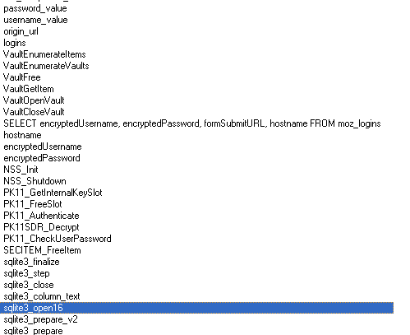
logins.json, signons.sqlite | Accesses Firefox encrypted credentials | 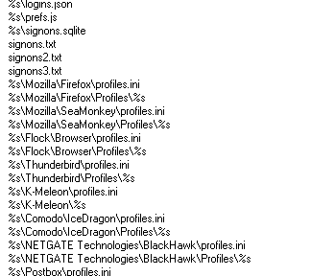
sqlite3_open16, sqlite3_prepare_v2, sqlite3_column_text | SQL query strings queries SQLite databases where browsers store credentials
VaultEnumerateVaults, VaultOpenVault, VaultGetItem | Extracting and stealing credentials from Windows Credential Manager | 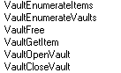
Software\...\Outlook  SMTP Email Address  SMTP Password  POP3 Password | Email client credential theft – steals email addresses, SMTP/IMAP/POP3 usernames and passwords | 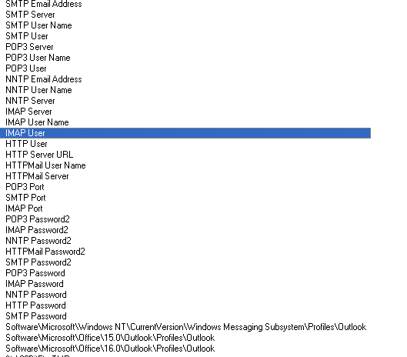
Filezilla.xml, recentservers.xml, FtpServer, FtpUserName, FtpPassword, _FtpPassword | FTP client credential theft – Filezilla is a commonly used FTP client | 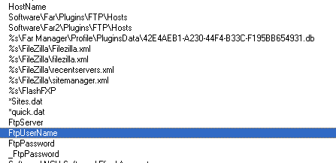

Dependency Walker
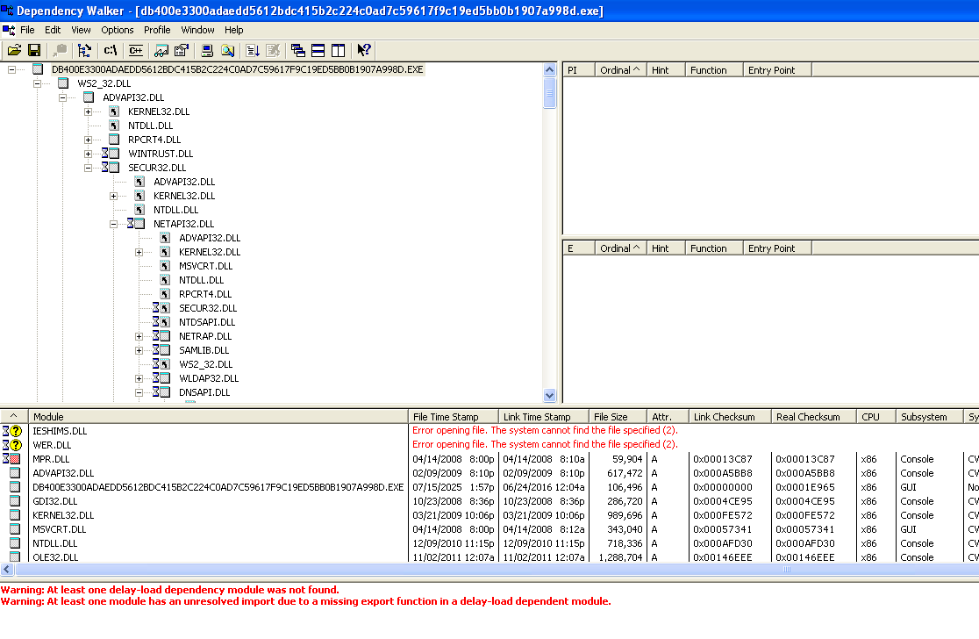

Dependency Walker inspects a Windows PE file and shows the following
- Imported DLLS : the dynamic link libraries the malware requires
- Exported Functions : which functions the malware uses from those DLLs
- Missing Dependencies : check if the executable is broken or corrupted
- Delay-loaded DLLS : libraries which are loaded only when needed which can mean stealthy behaviors
- Ordinal-based imports : if a malware author is hiding function names

The above is useful in malware analysis as it gives the user information on what system APIs the malware uses, giving insight into the behaviour, for example, stealing data, network communications, persistence etc.

Using Dependency Walker, it was confirmed that the malware imports several critical Windows libraries. The inclusion of ADVAPI32.DLL indicates registry access capabilities, which may be used to disable system features or store persistent configurations. The presence of KERNEL32.DLL with imported functions such as CreateMutexW, CreateProcessInternalA, and CreateFileMapping implies that the malware employs mechanisms to avoid multiple instances, spawn child processes, and handle custom memory operations. Notably, NTDSAPI.DLL is also present, suggesting that the malware may attempt interactions with Active Directory environments, possibly for credential scraping or domain enumeration.
DLL | What can be inferred | Screenshot
ADVAPI32.DLL : a common Windows API library that provides access to registry, service control manager, security functions and event logging | Malware edits the registry, it might be disabling system features by editing registry keys to disable antivirus, firewall, Task Manager, User Account Control (UAC).  It can even store payloads or settings in the registry, which can create persistence, or tamper with the victim’s system. | 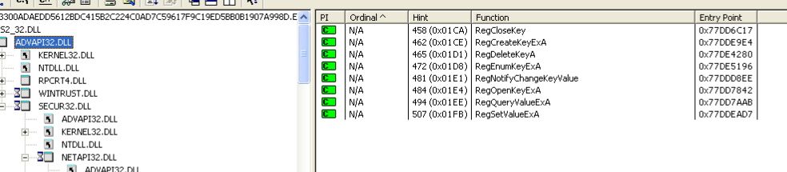
KERNEL32.DLL | CreateMutexW – prevents the malware from running more than once, detects if its being executed in a sandbox  CreateProcessInternalA – launch payloads  CreateFileW, CreateFileMapping – write / read configuration or stolen data | 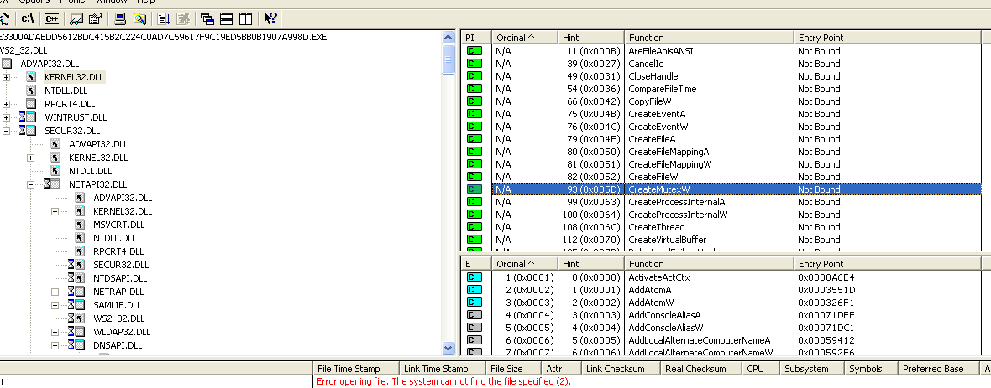
NTDSAPI.DLL – Active Directory (AD) interaction and authentication | DsMakePasswordCredentialsW – Attempting to authenticate to a domain controller or trying to bruteforce, extract or reuse credentials  DsCrackNamesW – interacting with a domain, resolve usernames or domain accounts | 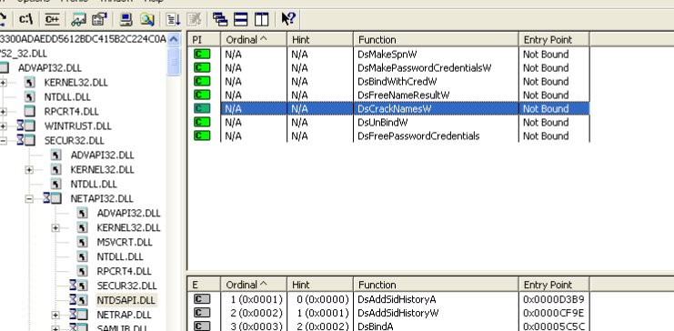

PEview
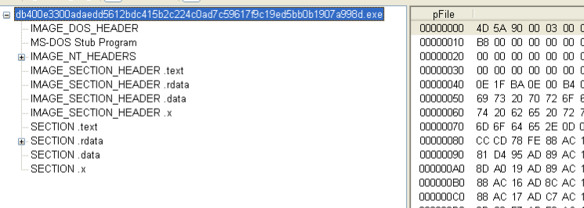

PEview is a tool used to inspect the internal structure of a PE file. It shows the file’s headers and sections, which can be used to understand how the binary behaves.

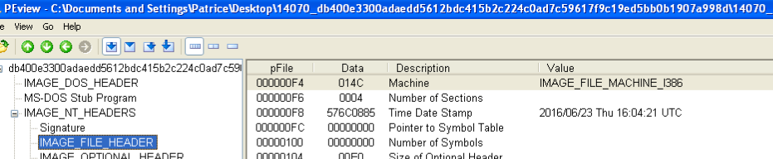

Further structural inspection of the binary was carried out using PEview, which revealed that the TimeDateStamp of the executable is set to June 23, 2016. This timestamp likely represents the compilation date, although malware authors often spoof such metadata. The binary contains standard sections such as .text, .rdata, and .data, along with an additional custom section .x. The presence of a custom section may indicate the use of embedded payloads, configuration data, or runtime routines. No irregularities were found in the PE headers that would suggest corruption or malformed data structures.

VirusTotal
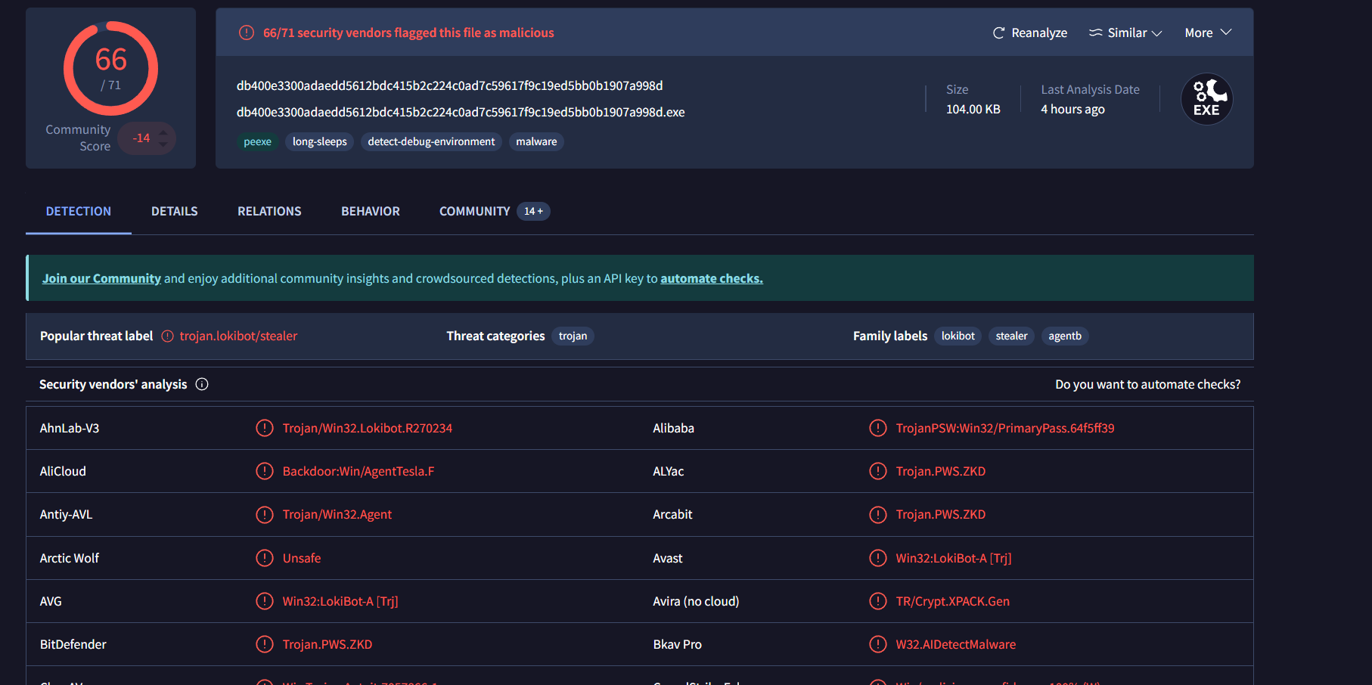

Analysis via VirusTotal reveals that the executable is strongly identified as LokiBot by a large number of antivirus engines, with 66 out of 71 vendors flagging the file as malicious. Common threat labels assigned to the sample include “Trojan.LokiBot,” “Trojan.PWS.ZKD,” and “Win32.LokiBot-A.” Multiple engines also associate the sample with other known stealer families such as Fareit and AgentTesla, although these are likely due to shared code signatures or behaviors.

The malware is classified as a password stealer or Trojan, known for extracting a wide array of credentials from compromised systems. Tags such as long-sleeps, detect-debug-environment, and stealer were also assigned, which indicate anti-analysis behavior and the primary functional goal of credential exfiltration.

Summary
After conducting Basic Static Analysis, we conclude that this malware executable is a Windows executable identified as a variant of the well-known LokiBot malware family.

This executable is a confirmed variant of LokiBot, an information-stealing Trojan with wide-reaching capabilities targeting web browsers, email clients, FTP tools, and Windows credential stores. The file is unpacked and unprotected by modern obfuscation or packing mechanisms, as shown by both PEiD and PEview analysis. This makes the sample ideal for static analysis and reverse engineering. The malware leverages well-documented Windows APIs to carry out credential theft and potentially evade detection through mutex creation and anti-debugging techniques.

The malware sample was analysed and based on hash verification, and multi-engine antivirus detection using VirusTotal, has been confirmed as an unaltered an functional copy of the original malicious payload. No obfuscation or packing was observed, allowing for direct analysis of the file’s structure and indicators.

Basic Dynamic Analysis

Procmon
Process Monitor (ProcMon) is a powerful real time monitoring tool that allows you to observe the file system activity, registry access, process and thread activity.
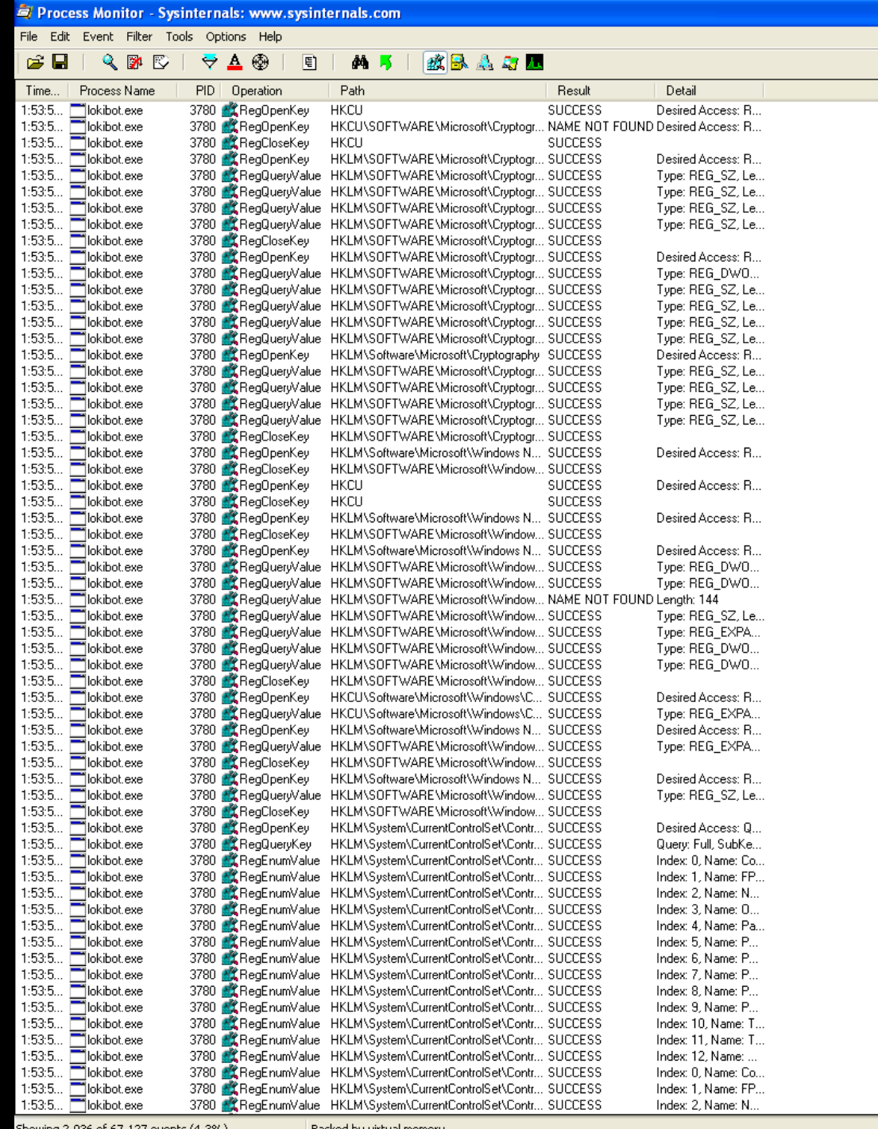
In the picture above, I can tell that the LokiBot’s primary goal is to steal info. This is because in ProcMon, LokiBot is seen interacting with several sensitive registry locations.

Notice how there is a lot of usage of RegQueryValue and RegEnumValue? Querying values is typical of reconnaissance behaviour, and enumerating keys under is often associated with profiling the Operating System (OS)

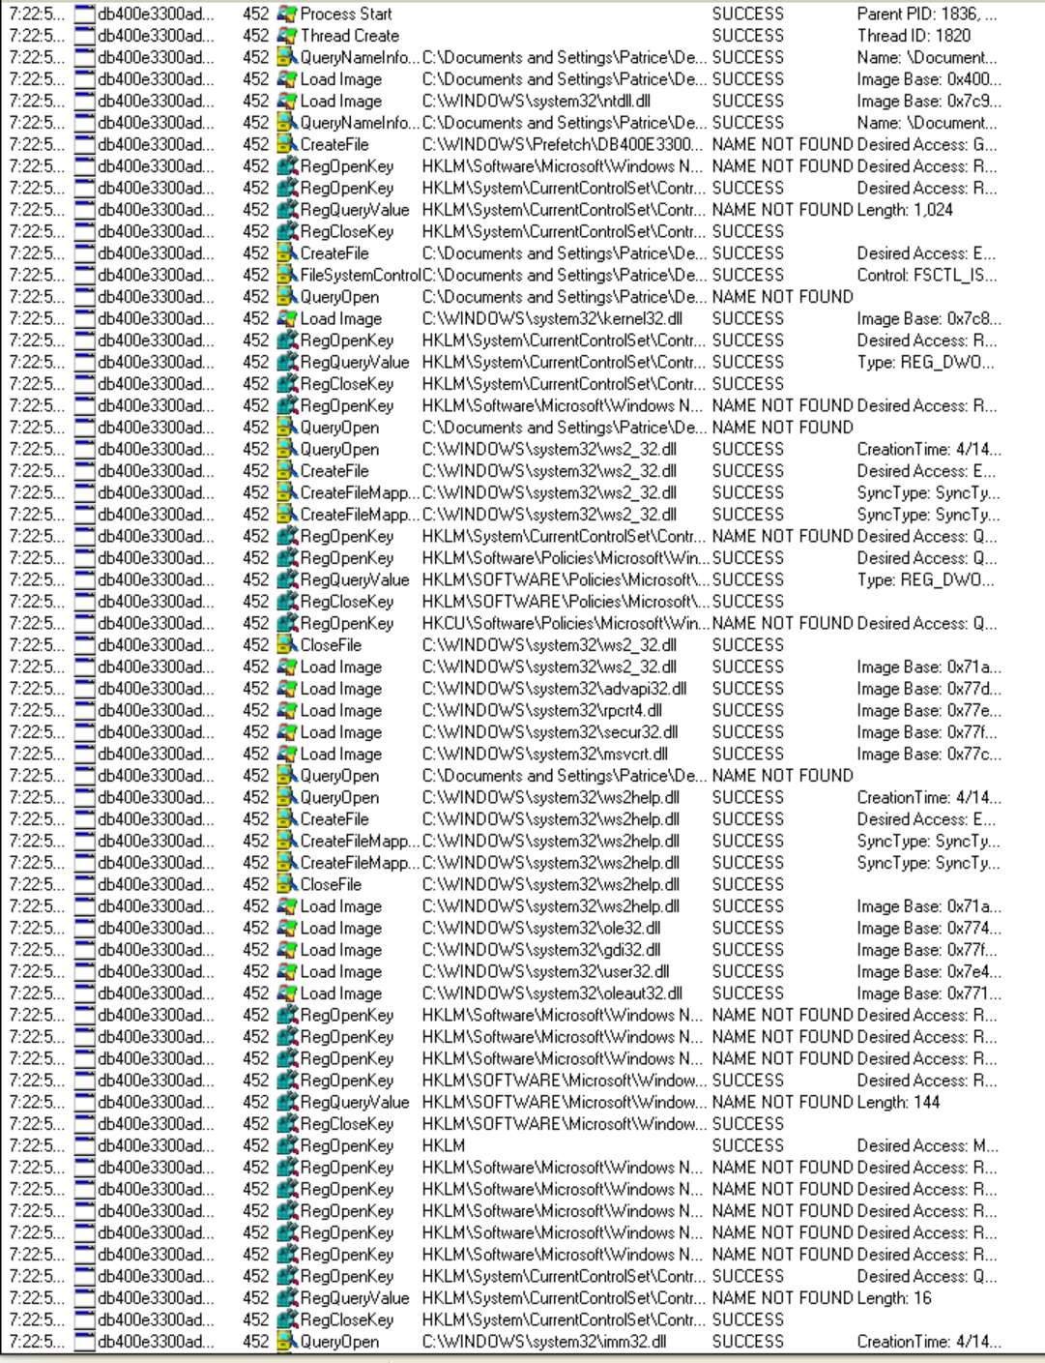

The malware also creates and loads several DLLs
File loaded | What it does | Screenshot
secur32.dll | Used for authentication and credential handling APIs (usually to steal stored Windows credentials)
advapi32.dll | Provides registry access, privilege management which can be used for password harvesting
ws2_32.dll | Sets up network communications for server connection
Rsaenh.dll | Name stands for RSA Enhanced Cryptographic Provider. It provides strong encryption, decryption, hashing and key management functions. Supports algorithms like RSA and AES. Used to handle sensitive data | 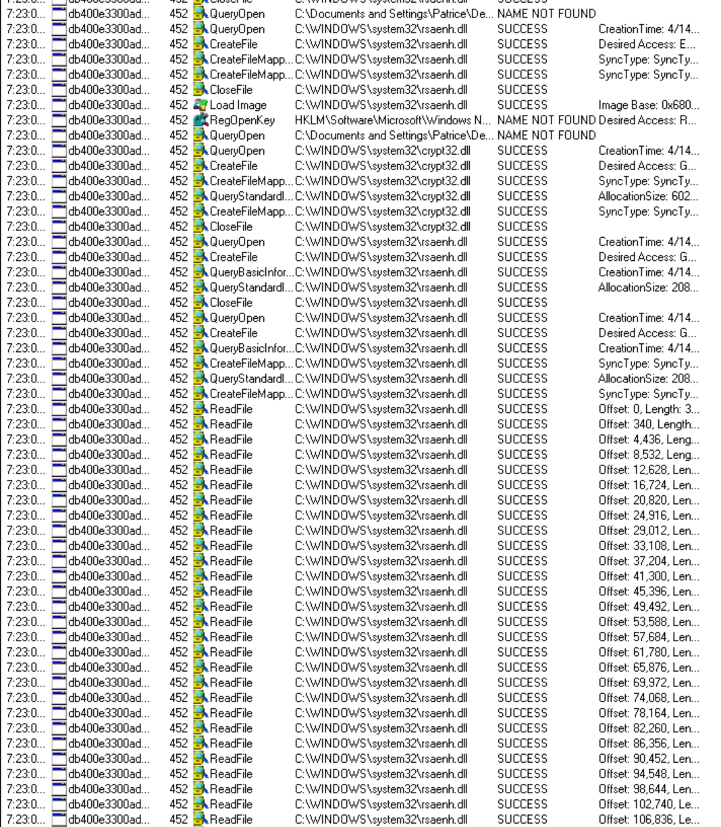
Msvcrt.dll | Provides standard C library functions. Lokibot probably used it for basic data processing | 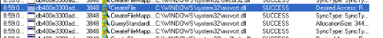
Kernel32.dll | Handles low level system functions like memory management, file operations and process creation. Lokibot uses
Ntdll.dll | Core windows API for low level operations. LokiBot might use it for stealthy system calls that bypass higher level detection.
Ws2help.dll | Provides functions for network communication. LokiBot needs this to establish connections to its command and control (C2) severs
Rpcrt4.dll | Enables communication between processes and networks. LokiBot may use this to communicate between its components or with remote systems
Ole32.dll | Manages COM (Component Object Model) objects. Lokibot might use it to interact with COM based APIs like file manipulation.
User32.dll | Handles UI interactions. LokiBot may use it for keylogging or monitoring user actions
Imm32.dll | IMM (input method manager) handles keyboard input and text services. LokiBot could use this for keylogging
Shell32.dll | Deals with file operations and launching programs. LokiBot might user it to navigate file systems or execute files.
Shlwapi.dll | Functions for string handling, registry access and file paths. LokiBot might use it to manipulate file or registry data.
Crypt32.dll | Encryption, decryption and certificate management. LokiBot might use it to encrypt stolen data or communicate with its C2 server securely.

Based on Process Monitor, LokiBot is an infostealer trojan that focuses on stealing sensitive data and credentials, and the data is then sent to an attacker’s command and control (C2) server.

ProcExp
ProcExp (Process Explorer) provides more insight to the running processes. By using ProcExp, I’m able to see the list of active processes, DLLs loaded for each process, the properties of the process, active TCP connections and create/kill/validate processes.
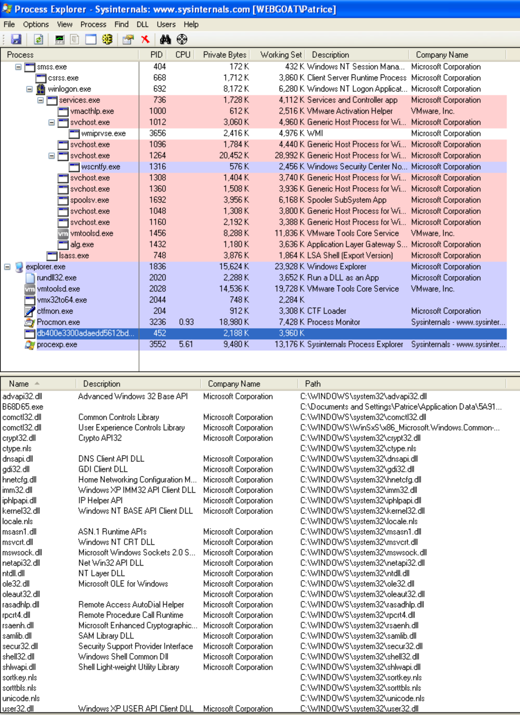

As you can see from the image above, it shows the DLLs loaded into this process, and there are several that tells us more about LokiBot’s behaviour

DLLs | What it does
Advapi32.dll | Access to registry, service management and privilege handling
Crypt32.dll | Certificate handling, message encoding/decoding
Rsaenh.dll | RSA encryption provider; used to encrypt stolen data
Secur32.dll | Credential handling
Samlib.dll | Access to the Security Accounts Manager
Wininet.dll | HTTP/HTTPS communication
Ws2_32.dll | Winsock API for network connections

The LokiBot is also under the parent folder of “explorer.exe”. This means that it was executed interactively, like a user double clicking.

Looking at the DLLs loaded, currently the LokiBot can do several things.
- Steal stored credentials (samlib.dll, secur32.dll)
- Read browser data
- Encrypt stolen data (rsaenh.dll, crypt32.dll)
- Send data to a remote server (wininet.dll, ws2_32.dll)
- Hide in user’s space

Based on Process Explorer, LokiBot is a process often started by explorer.exe, and it loads DLLs related to networking and cryptography, which shows that it steals and sends data. It also maintains network connections to external servers.

RegShot
Regshot is a comparison tool where it compares two registry shots (Before opening the malware and after opening the malware), compare them then report on the difference.
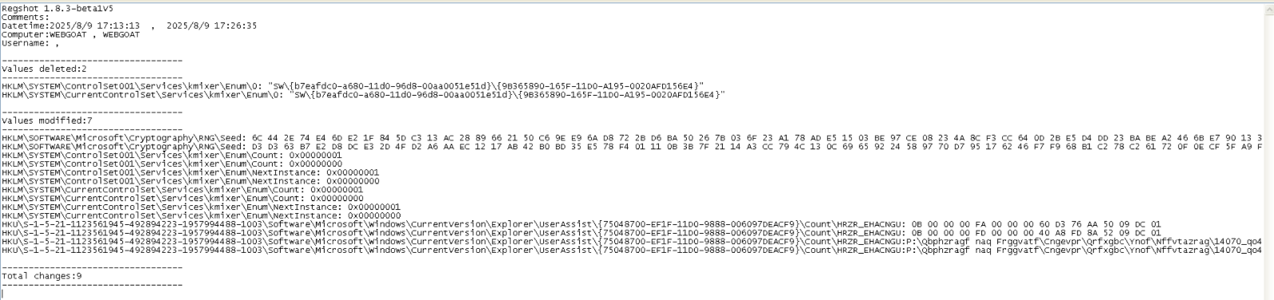
The picture above shows the Regshot comparing the two shots. It shows that there were values were deleted, modified, and added. This tells us that LokiBot is an information stealer malware that modifies system registry to establish persistence, targets credentials and system information, and uses registry keys to store data or execution triggers.

In the image above, it shows that there were changes in the cryptography RNG (Random Number Generator) seed. This is a registry value to initialize its random number generator, and the seed is that starting value that determines the sequence of random numbers that RNG produces. This means that if LokiBot changed the RNG seed, it can make generated keys predictable, and this could weaken the encryption of it.

Notice that the UserAssist entries has been changed too. UserAssist stores information about programs running on the system, encoded in ROT13 (Rotate by 13 characters)
This is an example of a ROT13 string, from the Regshot report. When the string is decoded, it reveals file paths and executables LokiBot launched. This indicates that LokiBot executed something from the user’s system, potentially a payload.

Regshot shows that
- LokiBot was executed (shown in UserAssist changes)
- Made registry changes for persistence or obfuscation
- Potentially altered cryptographic settings

CaptureBAT
CaptureBAT is a behavioural analysis tool that monitors the state of a system during the execution of the applications and processing of documents.
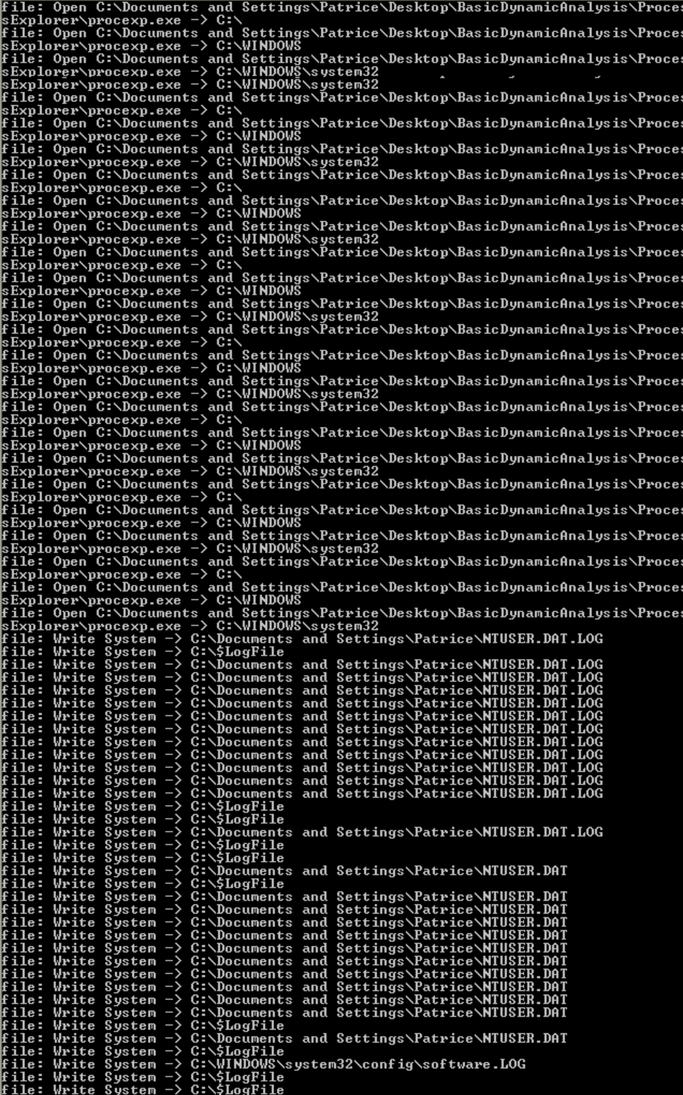
In the screenshot above, there are multiple entries of file system access, where it writes to
- There are registry hives like “NTUSER.DAT”, “.LOG” and “software.LOG”

This shows that LokiBot is accessing system directories and writing to registry hive files. This suggests that it is storing configuration or startup instructions and is persistence related. And the .LOG files indicate registry modifications in progress.

ApateDNS
ApateDNS allows us to list DNS requests made by malware, and it spoofs the DNS responses
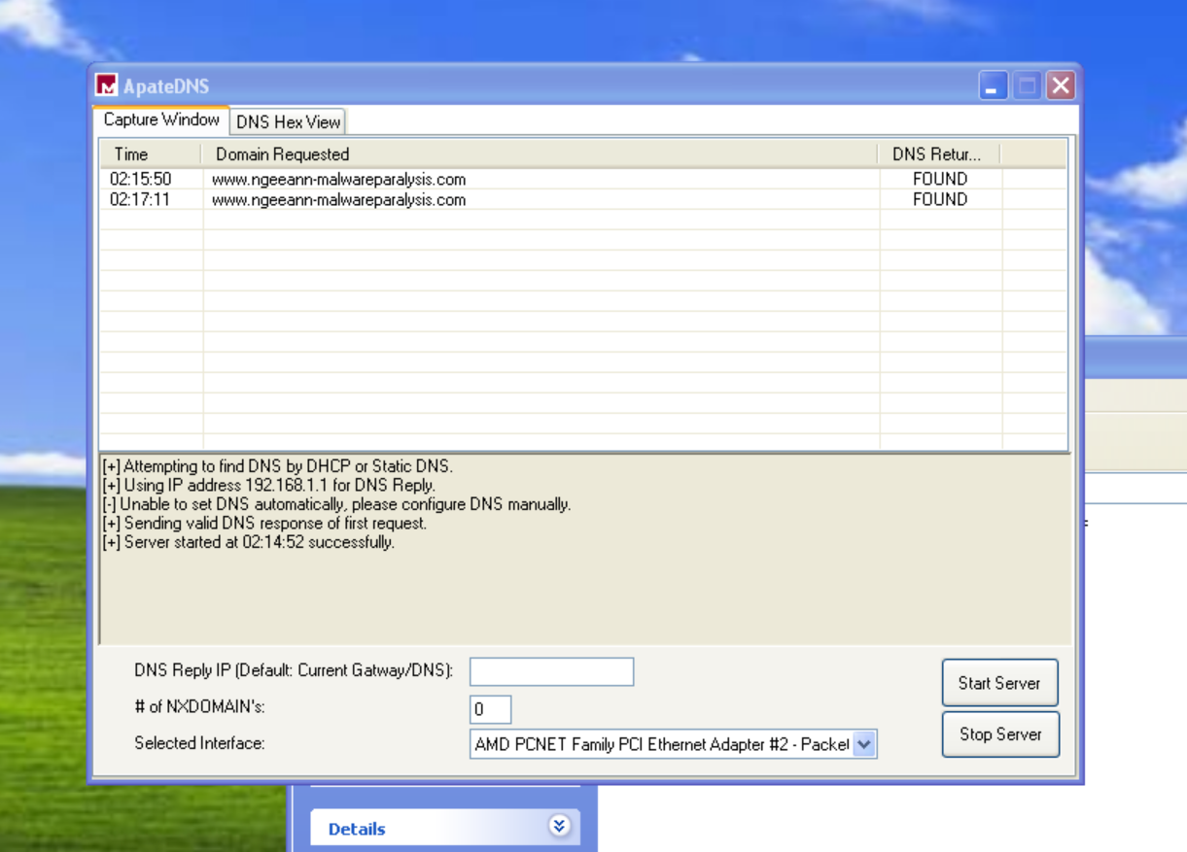
I could not get any information from ApateDNS, which suggests that LokiBot isn't trying to resolve domain names via DNS during the execution.

Wireshark
Wireshark is an opensource network sniffer that captures network packet, and we can see the visualisation of the network packets, and a more in-depth packet analysis.
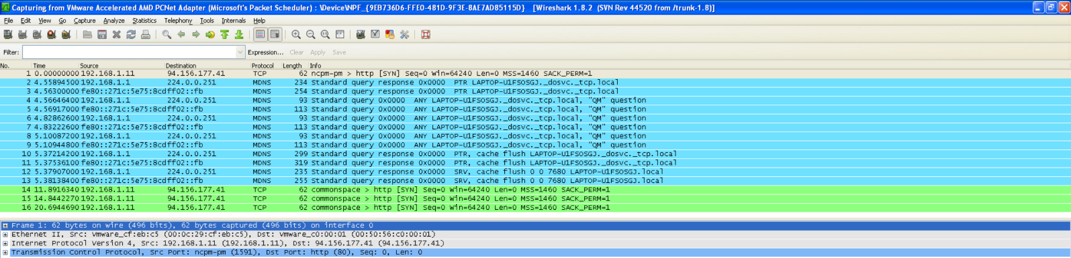
In wireshark, notice the ip 94.156.177.41 appears. Since this is not a local or standard network service, this is most likely a hardcoded C2 ip used by LokiBot

It also shows that “TCP [SYN] -> http (80)”. This means that LokiBot is attempting an http session, probably for data exfiltration.

Based on Wireshark, there was an external C2 communication, most likely to exfiltrate stolen data and receive commands. There were also multiple queries like “.local”. This shows that it may be trying to identify the local services or hostname resolution. There were also HTTP SYN requests to the C2 ip address 94.156.177.41 which shows that it is actively trying to establish or maintain a connection. There was also a process of SYN to SYN/ACK. This suggests that it’s about to transmit data.

Summary
LokiBot steals information from the device, encrypts the data and proceeds to send it to their own server. Since I did not get anything in ApateDNS when running LokiBot, but in Wireshark it shows LokiBot connecting to 94.156.177.41, this suggets that the malware directly connects to the server, and if the malware already has the C2 server’s IP hardcoded, there is no DNS request and the ApateDNS won’t log anything.

Advanced Static Analysis

IDA Pro
Interactive Disassembler Professional (IDA Pro) is a powerful tool used in reverse engineering, vulnerability research, malware analysis and debugging, ideal for professionals engaged in detailed code analysis and reverse engineering tasks.

Analysing the flow graph of the start function

Doing this will give us valuable insights into the malware’s initialisation routine and possible looping behavior. The start function is the entry point, it sets up the stacks and registers, calls subroutines, iterates over a data structure over a loop and performs conditional logic and cleanup.

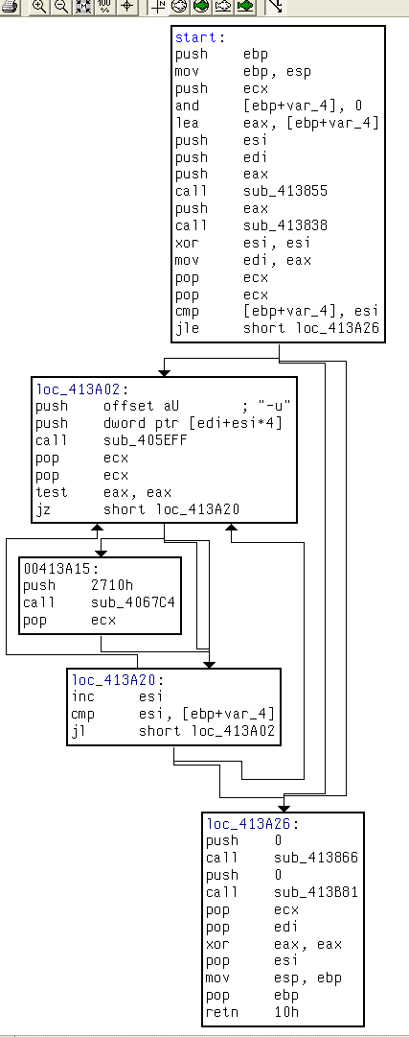

From the above screenshot of the flow graph, we can infer the following:

Prologue and Setup:
push ebp
mov ebp, esp
These are standard function prologue instructions used to set up the stack frame and preserve the caller’s base pointer (ebp)

and [ebp+var_4],0
lea eax,[ebp+var_4]
The local variable var_4 is initialised to zero using a bitwise AND operation. Its address is then loaded into eax. This variable is likely used as a loop counter for subsequent iteration logic.
call sub_413855
call sub_41383818
Two subroutines are called after setup. These are likely initialisation routines potentially responsible for setting up memory, decoding strings and data, or preparing network configurations or environment variables

Loop Construct
cmp [ebp+var_4], esi
jle short loc_413A26
A comparison is made between the initialised loop counter [ebp+var_4] and the index register esi. If the loop condition fails, control jumps to the cleanup block at loc_413A26, else the loop beings at loc_413A02

Loop Body
push offset aU ; “—u”
push dword ptr [edi+esi*4]
call sub_405EFF
This section forms the core of the loop logic. The string “--u" is pushed onto the stack, possibly as a flag, command or decryption key. A value is fetched from the memory location [edi+esi*4], suggesting iteration over an array or pointer table.
Both values are then passed to sub_405EFF, which likely acts as a handler or parser for decryption, string evaluation, or command.
test eax,eax
jz short loc_413A20
If sub_405EFF returns 0 due to failure or invalid input, execution jumps to the next iteration steps, skipping any remaining logic in this iteration

Time Delay (00413A15)
push 2710h
call sub_4067C4
The constant 2710h equals 10 000 milliseconds or 10 seconds. This strongly suggests a sleep or delay function. Delays like this are often used in malware to evade sandbox detection by avoiding rapid execution typically observed in controlled analysis environments.

Increment and Continue Loop
inc esi
cmp esi,[ebp+var_4]
jl short loc_413A02
The loop counter, esi is incremented. If it remains less than the loop boundary [ebp+var_4], the loop continues.

Cleanup Block (loc_413A26)
push 0
call sub_413866
push 0
call sub_413881
These subroutines are called after the loop completes and right before the function returns. It suggests that they are finalisation routines as their execution occurs at the very end, a common location for resource cleanup. Each calling of subroutine is also called with a 0 argument, a typical convention for shutdown or default finalisation. These functions likely perform tasks such as releasing memory or heap allocations.

Imports

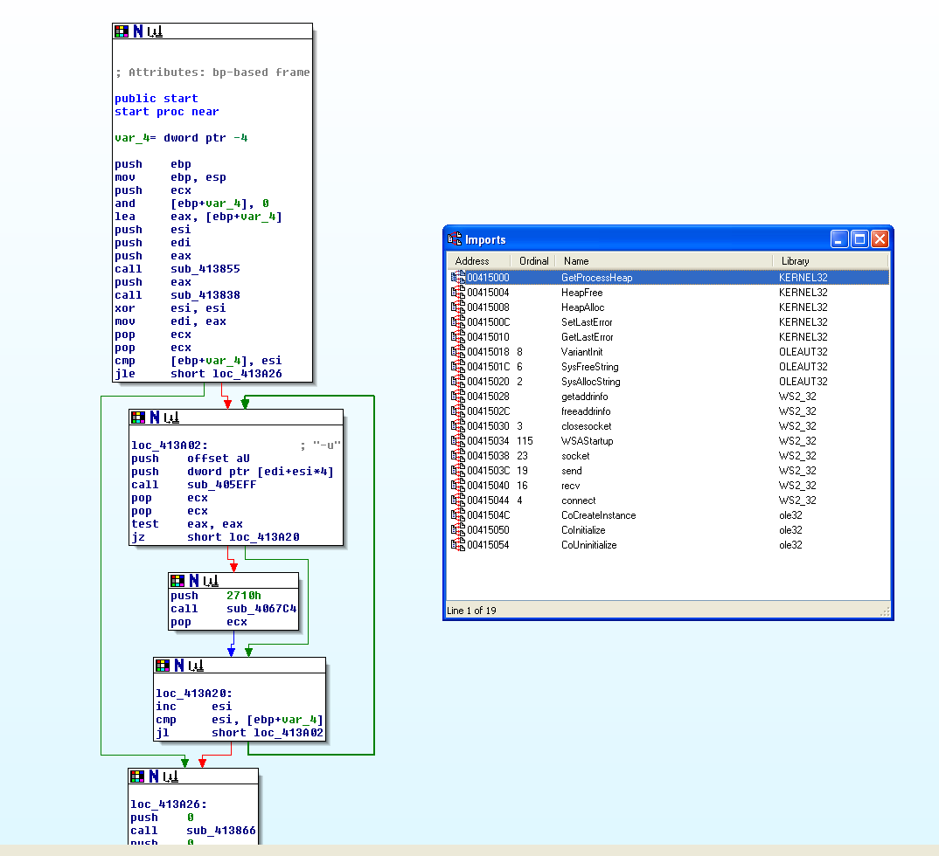
We have several imported functions here.

Imports like GetProcessHeap, HeapAlloc and HeapFree shows that the malware is manually allocating and freeing memory, possible for custom buffers or payloads. This might indicate custom memory handling or code injection.

Imports like SetLast Error and GetLastError are often used for error handling, often seen in malware.

WSAStartup, socket, connect, send, recv, closesockets are classic Winsock functions, which further confirms that the malware is capable of creating network connections, potentially for data exfiltration, command and control, or even remote command execution. Getaddrinfo and freeaddrinfo are DNS resolution imports, hinting it connects to hostnames.

Advanced Dynamic Analysis

OllyBDG
OllyDbg is a debugger that lets you examine the execution of another program, where it provides a different perspective from disassemblers.

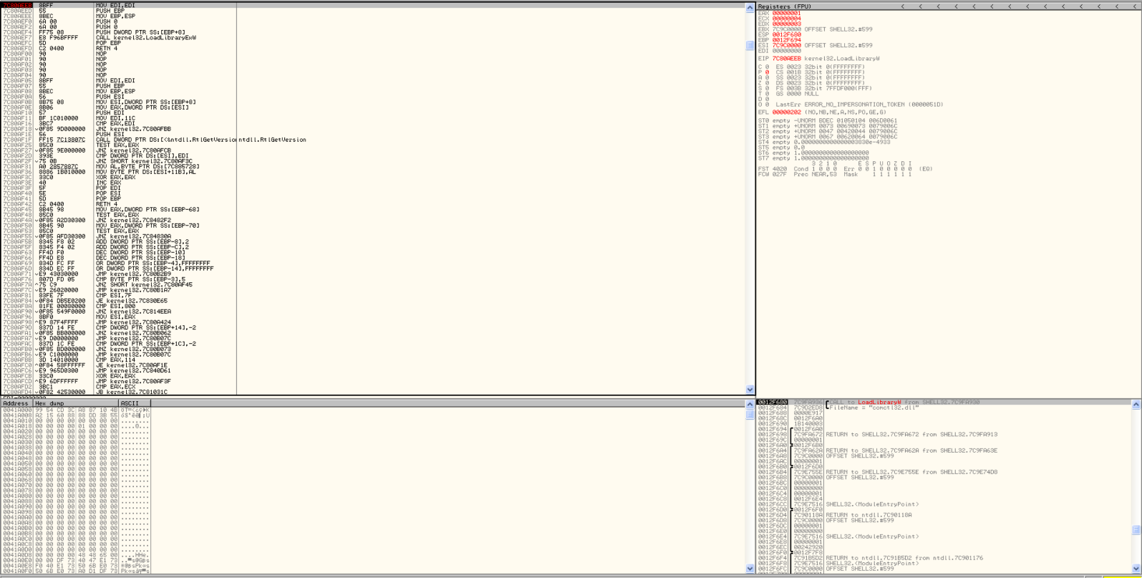
This is what the overall debugger looks like when you open the Malware, where it is split into several sections.
Disassembler
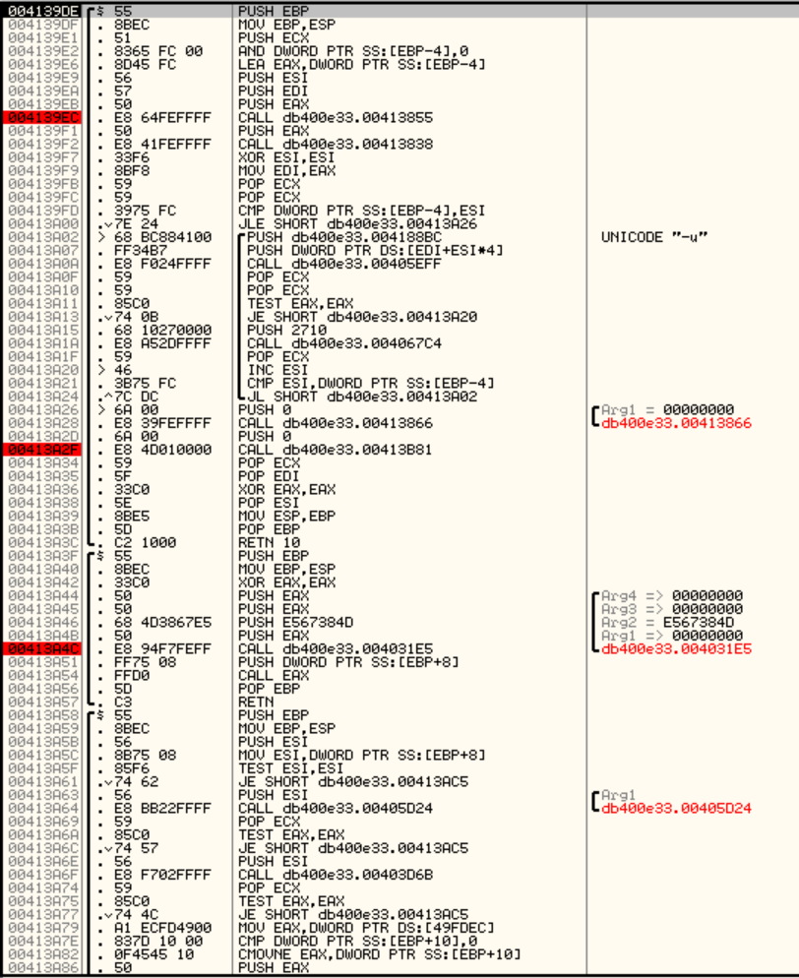

Notice there is a repeating pattern when analysing the Disassembler.
Push -> Mov -> Call -> Pop -> Retn

This shows the behaviour of unpacked LokiBot, where there are short functions are wrappers around API calls or small logic blocks.

There are also several addresses being called, including these ones below.

This shows that there are in the same memory region, where it shows the code has already been unpacked or decrypted into memory.
Notice how there is also no call with import. This is probably because the LokiBot tends to avoid the Import Address Table (IAT) to evade static detection.

Register
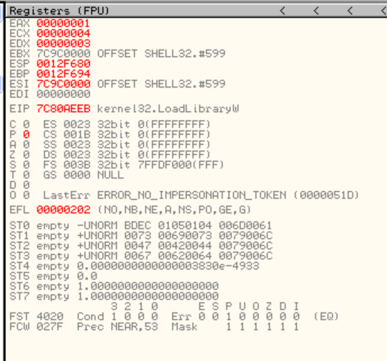

From the register, the Instruction Pointer (EIP) s at kernel132.LoadLibraryW. This means that the malware is loading a DLL by name.

This shows the LokiBot avoids using the normal IAT so that we don’t see the APIs. It instead calls LoadLibraryW to load a DLL, or uses GetProcAddress. It first unpacks/decrypts the payload in memory, then dynamically resolves the windows APIs, where it will use those APIs to steal stored credentials, gather system information, and then send it to the C2 server.

Stack
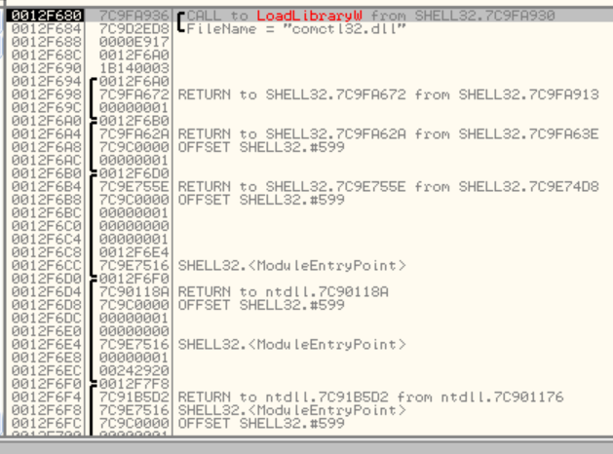
In stack, the filename shows “comctl32.dll”. Comctl32.dll is the common controls library that provides standard UI components. The malware loaded it most likely because it wanted to reach for deeper APIs, that could be used for credential stealing though the dialog hooks.

Memory Map
The memory map allows us to see everything the process has loaded into the address space.
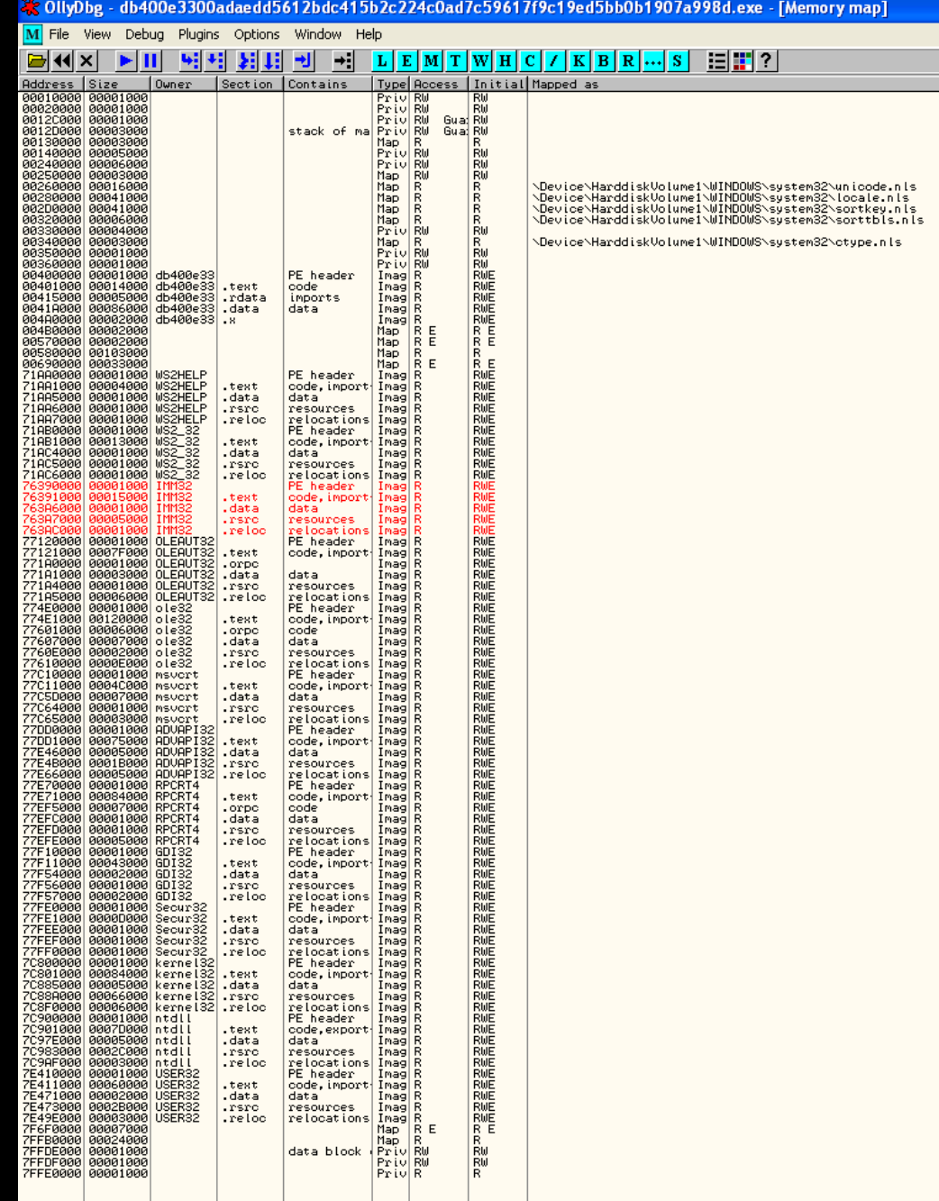
From this, it shows the LokiBot all marked with RWE shows its unpacked and is running from memory. There are also several DLLs loaded that are consistent with credential theft.

LokiBot will move into an API resolution phrase, dynamically loading DLLs using the LoadLibraryW and retrieving functions. There are also short wrapper functions that calls into libraries for registry and authentication data theft.

General Analysis of Malware
This analysis shows that LokiBot is a credential stealing Trojan, where Static and Dynamic analysis showed several things
Static:
- No modern packing/obfuscation — executable was unpacked in .text section, making it easy to analyse.
- Extracted strings pointed to SQLite interactions, credential storage files, and API calls for password retrieval.
- API imports suggest registry editing, process creation, encryption, Active Directory interaction, and file operations.
Dynamic:
- Registry queries/modifications for system profiling and persistence.
- Loading of DLLs linked to credential access, encryption, networking, and UI manipulation.
- Use of LoadLibraryW and GetProcAddress to resolve APIs dynamically, often by ordinal, avoiding static IAT detection.
- Hardcoded C2 server with the IP address of 94.156.177.41 for direct HTTP exfiltration, where no DNS queries logged.

Malware Defences

Static analysis revealed hardcoded references to credential storage files, SQLite database interactions, and API imports for registry manipulation, process creation, encryption, and Active Directory interaction. Dynamic analysis showed that LokiBot resolves APIs dynamically via LoadLibraryW, often by ordinal to evade static detection, modifies registry keys for persistence, and loads DLLs associated with credential harvesting, encryption, and network communications. It communicates directly with a hardcoded C2 IP over HTTP, encrypting stolen data before exfiltration, and uses anti-analysis techniques such as mutex creation and execution delays. Effective defences include blocking known malicious IPs, monitoring processes for suspicious DLL loads and registry changes, restricting execution of untrusted executables, and using endpoint detection tools to flag unusual outbound connections. In the event of infection, immediate isolation, process termination, registry cleaning, malware removal scans, and comprehensive credential changes are critical, followed by continuous monitoring for reinfection.

Malware Removal
Step 1: Isolate the Infected Machine
- Disconnect from network immediately to prevent credential exfiltration.
- If on a domain, remove from network to prevent lateral movement.

Step 2: Boot into Safe Mode
- Restart and enter Safe Mode with Networking to limit active processes.

Step 3: Identify & Terminate Malicious Processes
- Use Task Manager or Process Explorer to locate suspicious processes.
- Kill processes associated with LokiBot.

Step 4: Remove Malicious Executable & Files
- Search for and delete the identified malware executable.
- Check browser credential storage, FileZilla config, and Outlook settings for theft.

Step 5: Clean Registry
- Open regedit and search for persistence-related entries.
- Remove suspicious keys under:
  - HKCU\Software\Microsoft\Windows\CurrentVersion\Run
  - HKLM\Software\Microsoft\Windows\CurrentVersion\Run

Step 6: Full System Scan
- Use reputable anti-malware tools:
  - Malwarebytes
  - Microsoft Defender Offline

Step 7: Change Compromised Credentials
- Change all passwords for:
  - Email accounts
  - FTP accounts
  - Domain logins
  - Online services

Step 8: Monitor for Re-infection
- Enable logging and intrusion detection.
- Check outbound connections for suspicious activity.

