Mobile Device Security & Forensics
Year 3 (2025/26), Semester 5

SCHOOL OF INFOCOMM TECHNOLOGY
Diploma in Cybersecurity & Digital Forensics

ASSIGNMENT
Mobile Forensic Investigation: Evidence Acquisition, Recovery, and Analysis

Contents
Executive Summary 4
Introduction 5
Process 6
Tools and Software Used 6
Investigative Process 7
Phase 1: Evidence Acquisition 7
Phase 1.1: APK Static Analysis 9
Phase 2: Evidence Preservation 13
Phase 3: Analysis Setup 15
Phase 4: Evidence Analysis and Recovery 18
Phase 4.1: File Obfuscation Analysis 18
Phase 4.2: EXIF Metadata Analysis 22
Limitations of the Investigation 25
Conclusion 25
Recommendation 26
References 27

Executive Summary

This report documents a simulated mobile forensic investigation into a suspected case of corporate data theft, in which an employee was reported to have used a disguised vault application, Calculator, to photograph and conceal confidential financial documents on a personal Android device.

The investigation followed a structured forensic methodology consisting of evidence acquisition, preservation, analysis setup, and evidence analysis and recovery, supported by static analysis of the application itself.

Using Android Debug Bridge (ADB) for logical extraction, FTK Imager for forensically sound imaging, Autopsy for structured analysis, and ExifTool for content-level metadata examination, the investigation recovered image files that had been deliberately obfuscated through filename scrambling, extension stripping, and metadata sanitisation.

File signature analysis and content-based identification confirmed the recovered files as JPEG images consistent with photographs of a computer monitor, matching the whistleblower's account.

Static analysis of the application's decompiled manifest further revealed excessive permissions, undisclosed cloud backup functionality, and a deliberately disabled backup mechanism, indicating that the obfuscation was a deliberate design feature of the application rather than incidental behaviour.

Based on these findings, this report recommends the adoption of mobile device management, camera geofencing, data loss prevention controls, and follow-up investigation of associated cloud accounts to prevent and detect similar incidents in future.

Introduction

On 4th July 2026, corporate security was alerted to a potential insider threat involving the unauthorized duplication of sensitive financial records.

An employee is suspected of photographing and stealing confidential corporate financial documents. The investigation was initiated following a whistleblower report from a colleague who observed the suspect using a personal smartphone to photograph sensitive information displayed on a company monitor.

The whistleblower noted that immediately after taking the photos, the suspect opened what appeared to be a "Calculator" application and spent an unusual amount of time interacting with it, behaviour inconsistent with sending or saving files through conventional means.

Following the confiscation of the suspect's device, a preliminary manual inspection of the Android Gallery and accessible file system returned no evidence of the stolen documents.

Based on the whistleblower's account, investigators suspected the use of a disguised vault application, a type of software that presents itself as a functional calculator but conceals a PIN-protected storage area used to hide images, documents, or other sensitive files.

The objective of this investigation was to perform a logical extraction of the device using the Android Debug Bridge (ADB), locate the vault application's obfuscated storage directory, and analyse the recovered files using Autopsy and ExifTool to confirm the nature and origin of the hidden evidence.

Process
Specifically, this investigation sought to:
- Identify and extract the storage location used by the suspected vault application on the seized Android device
- Preserve the extracted evidence in a forensically sound manner that maintains chain of custody and verifiable integrity
- Analyse the recovered files to determine their true file type, content, and timeline, notwithstanding any obfuscation applied by the application
- Assess the application itself through static analysis to determine whether its obfuscation and data-handling behaviour were intentional design decisions

Tools and Software Used
The following tools were used throughout the investigation, each selected for a specific stage of the forensic workflow:

Tool | Version | Investigation Phase | Purpose
Android Debug Bridge (ADB) | - | Evidence Acquisition | Logical extraction of the vault directory and installed application from the seized device
APKTool | 3.0.2 | Evidence Acquisition (Static Analysis) | Decompilation of the vault application's APK to inspect its manifest and declared permissions
Autopsy | 4.23.1 | Analysis and Recovery | Case management, content-based file type identification, and extension mismatch detection
ExifTool | 13.59 | Analysis and Recovery | Content-level metadata extraction, independent of filesystem-level timestamp stripping
FTK Imager | 8.2.0.26 | Evidence Preservation | Creation of a hash-verified AD1 logical image and read-only mounting of the image for analysis

Investigative Process

Phase 1: Evidence Acquisition

The investigation began by connecting to the seized Android device via ADB. While the whistleblower's account pointed to a disguised calculator application, the exact package name was unknown and could not be determined through manual inspection alone.

To identify it, a full listing of installed third-party packages was obtained using the command
adb shell pm list packages. A review of the output revealed a suspicious entry: com.calculator.hideu.

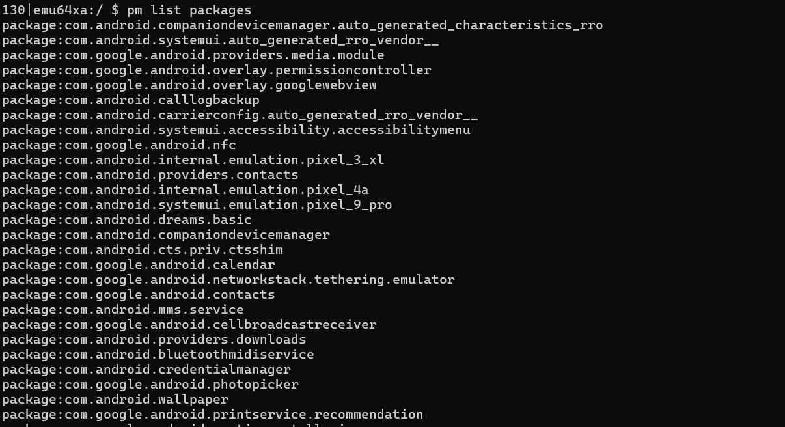

Figure 1.0.1: Full output of adb shell pm list packages, listing installed third-party packages on the seized device.

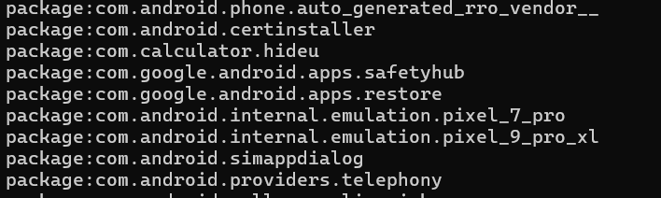

Figure 1.0.2: Suspicious package com.calculator.hideu identified within the installed package list.

With the package identified, the investigation turned to the device's file system. By navigating to the shared storage partition (cd /sdcard/) and running ls -la to surface hidden entries, a concealed directory named .dont_delete_me_by_hideu was discovered.

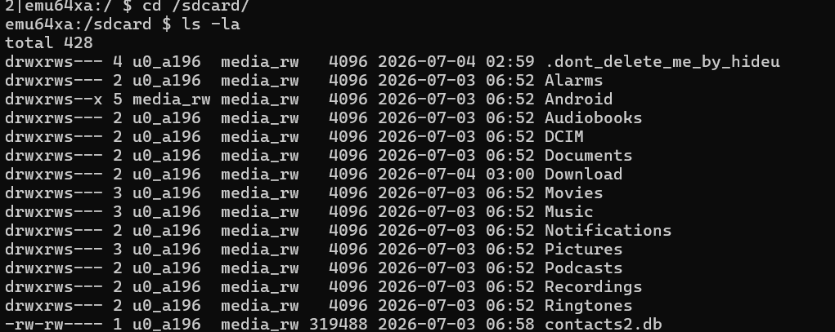
Figure 1.0.3: Hidden directory .dont_delete_me_by_hideu revealed under shared storage using ls -la.

It is worth noting that, unlike app-private data stored under /data/data/ (which requires root access to read), the vault application stored its files in the shared storage partition (/sdcard/).

This is a design trade-off inherent to the app: shared storage does not require elevated privileges to write, but equally, it does not require elevated privileges to read.

This inadvertently made the evidence accessible via a standard ADB logical extraction without the need to root the device.

A logical extraction of the hidden directory was performed using adb pull, transferring the raw obfuscated files to the forensic workstation for further analysis.

Figure 1.0.4: adb pull used to extract the hidden vault directory to the forensic workstation.

Phase 1.1: APK Static Analysis
To go beyond file recovery and understand the design intent of the application itself, the APK was separately extracted from the device using adb shell pm path to locate its install path, followed by adb pull to retrieve it.

Figure 1.1.1: Locating and extracting the application's APK using adb shell pm path and adb pull.

The APK was then decompiled using APKTool, which disassembled the application's bytecode and resources into human-readable form, including a decoded AndroidManifest.xml.

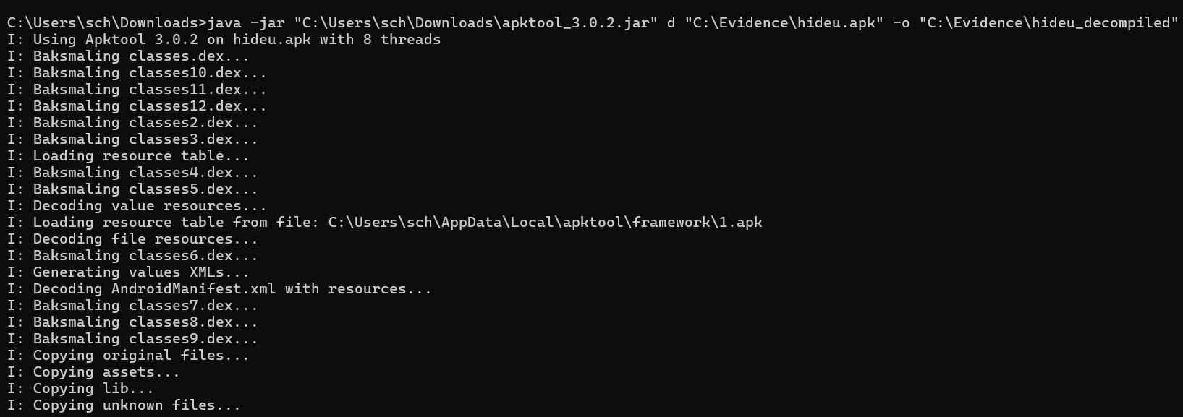
Figure 1.1.2: Decompilation of the HideU APK using APKTool v3.0.2.

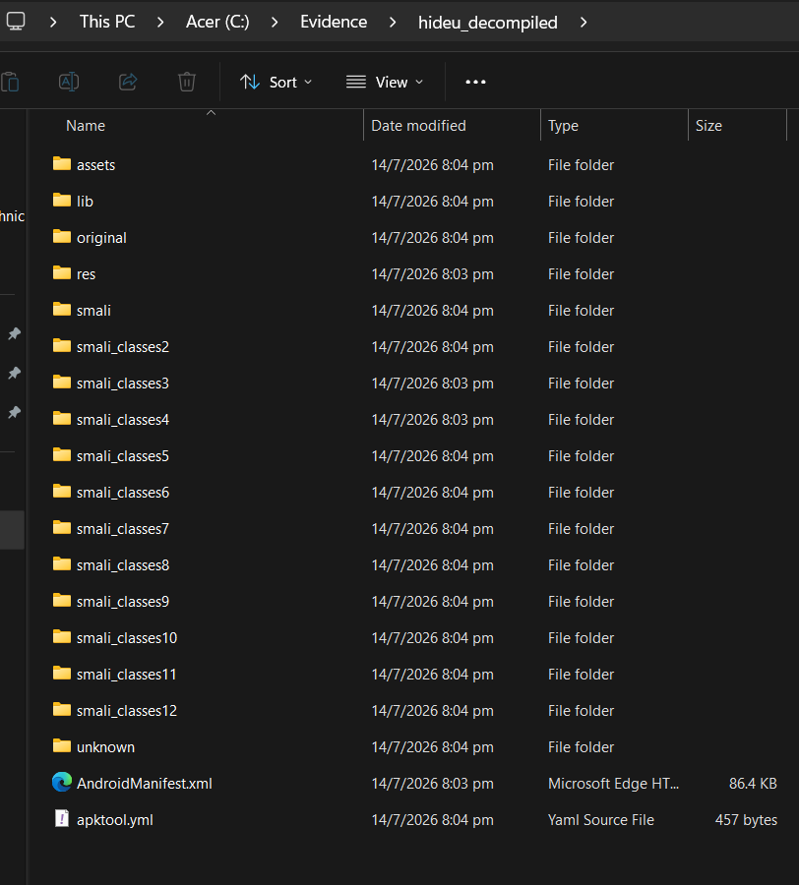
Figure 1.1.3: Decoded AndroidManifest.xml of the HideU application.

Analysis of the manifest revealed several findings of forensic significance.

The application declared an extensive set of permissions far beyond what a legitimate calculator would require, including CAMERA, RECORD_AUDIO, READ_CONTACTS, INTERNET, and MANAGE_EXTERNAL_STORAGE.

The presence of RECORD_AUDIO confirms the app can capture both photos and audio recordings within its hidden environment, indicating the scope of concealed files could potentially extend beyond still images.

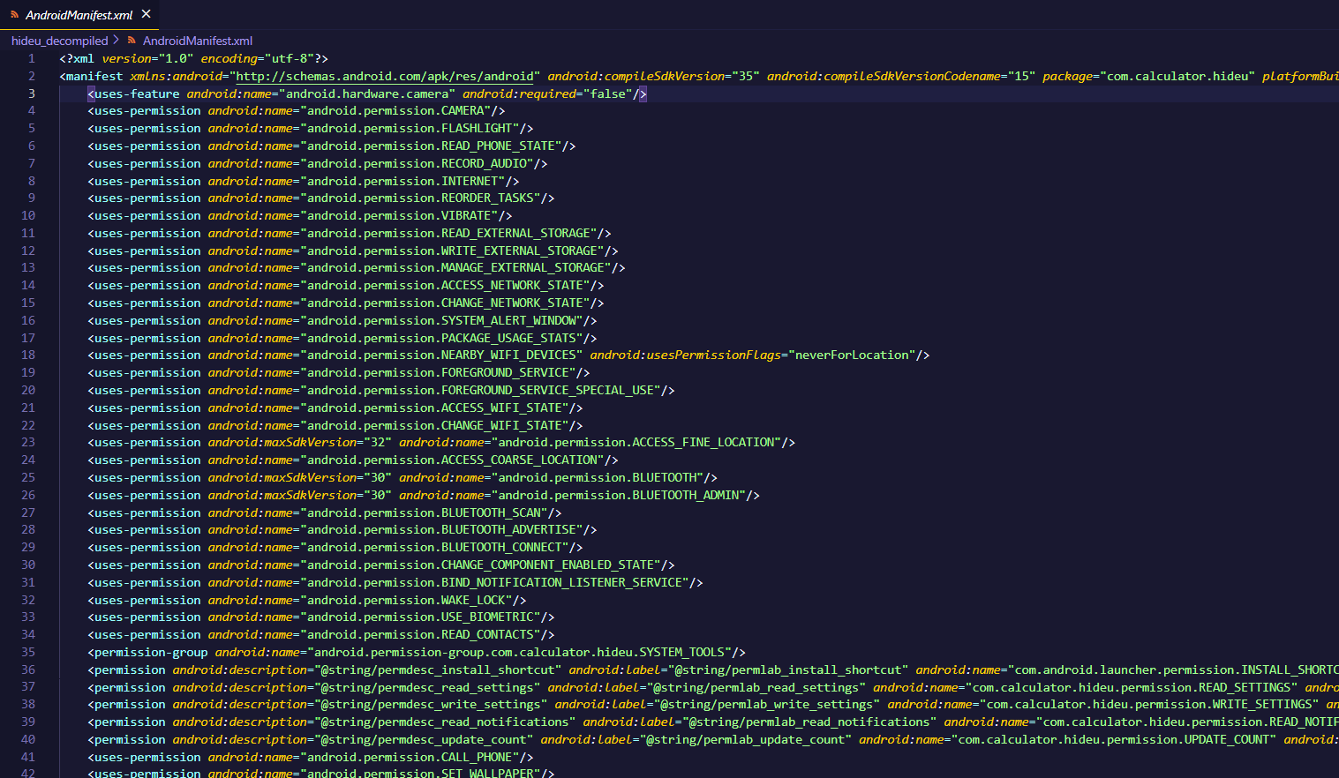
Figure 1.1.4: Excessive permissions declared in the application manifest.

Furthermore, the manifest declared an INTERNET permission alongside a DriveBackupService component and a GoogleLoginHelper activity, indicating the application supports cloud backup functionality. This raises the possibility that the stolen files may have been synchronised to an external account beyond the device itself.

Figure 1.1.5: DriveBackupService component declared in the manifest, indicating built-in cloud backup capability.

Figure 1.1.6: GoogleLoginHelper activity declared in the manifest, supporting the cloud backup functionality.

Finally, the application explicitly sets android:allowBackup="false", disabling Android's native backup mechanism. This prevents vault contents from appearing in routine device backups, representing a deliberate anti-forensic measure designed into the application at the development level, consistent with the broader pattern of obfuscation observed throughout this investigation.

Figure 1.1.7: android:allowBackup="false" attribute disabling Android's native backup mechanism.

Phase 2: Evidence Preservation

To maintain evidence integrity and establish a proper chain of custody, the extracted folder was not analysed directly. Instead, FTK Imager was used to create a forensically sound logical image of the extracted folder, producing an AD1 image file.

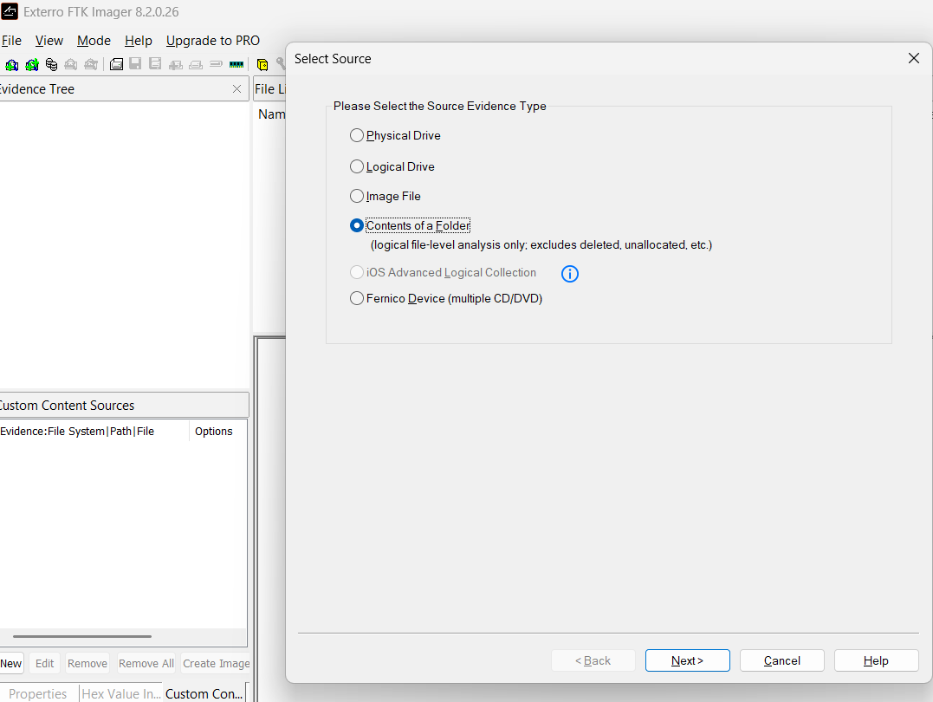
Figure 2.0.1: Creating a forensically sound logical image of the extracted evidence using FTK Imager.

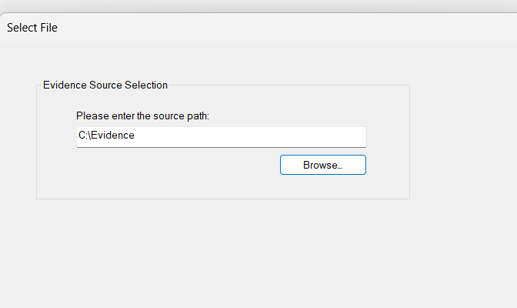
Figure 2.0.2: AD1 image creation settings configured in FTK Imager.
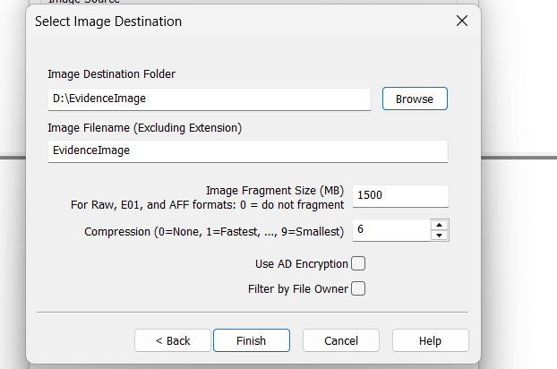
Figure 2.0.3: Logical image creation progress in FTK Imager.

Upon completion of the imaging process, FTK Imager generated MD5 and SHA1 hash values for the image. The hashes of the source and the resulting image were verified to match, confirming that the logical copy was an exact, unaltered representation of the extracted evidence.

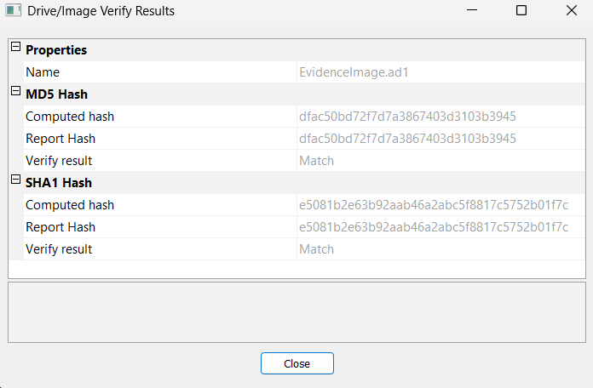
Figure 2.0.4: MD5 and SHA1 hash verification confirming the integrity of the forensic image.

Phase 3: Analysis Setup

A new case was created in Autopsy to begin the structured analysis phase.

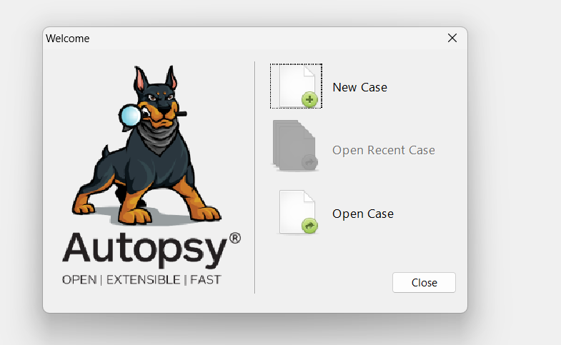
Figure 3.0.1: Creating a new case in Autopsy for structured analysis.

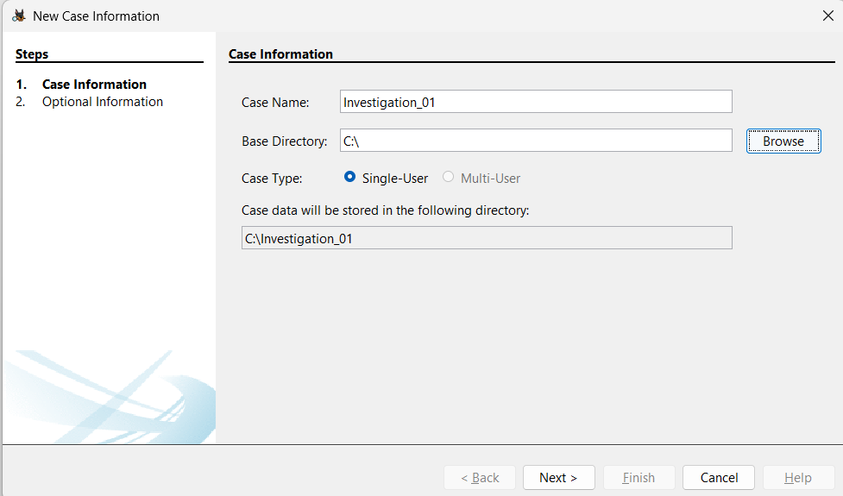
Figure 3.0.2: Case configuration settings in Autopsy.

During setup, a compatibility issue was encountered: Autopsy does not natively support the AD1 logical image format as a data source.

Rather than reverting to analysing the raw extracted files directly which would have bypassed the forensic image and broken the chain of custody, FTK Imager's "Mount Image" feature was used to mount the AD1 file as a read-only virtual drive on the workstation.

This approach ensured the forensic image remained unmodified throughout the analysis, preserving evidentiary integrity while resolving the tool limitation.

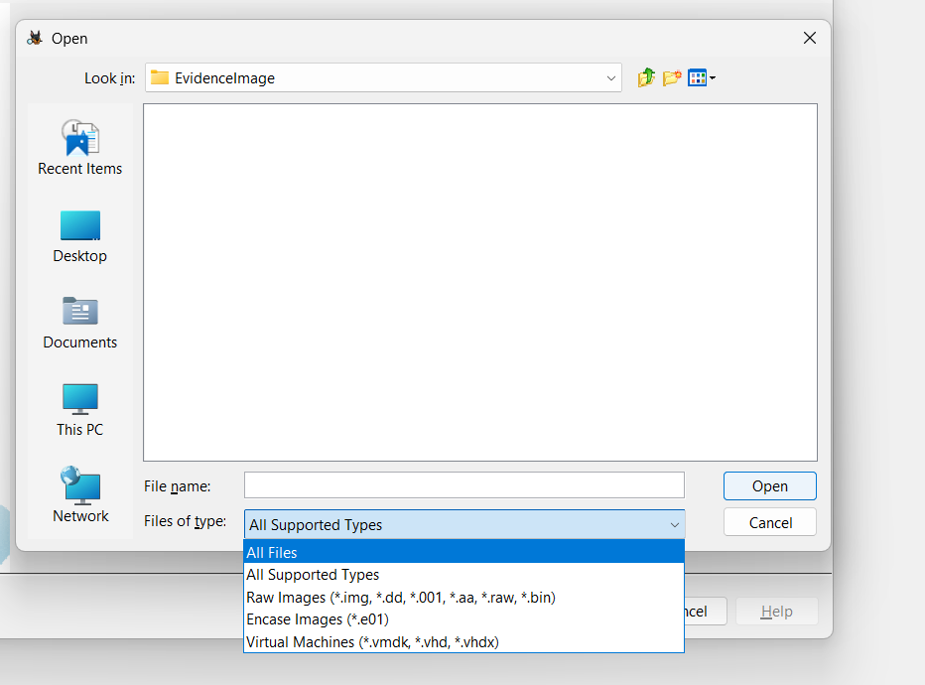
Figure 3.0.3: Autopsy data source dialog showing no native support for the AD1 logical image format

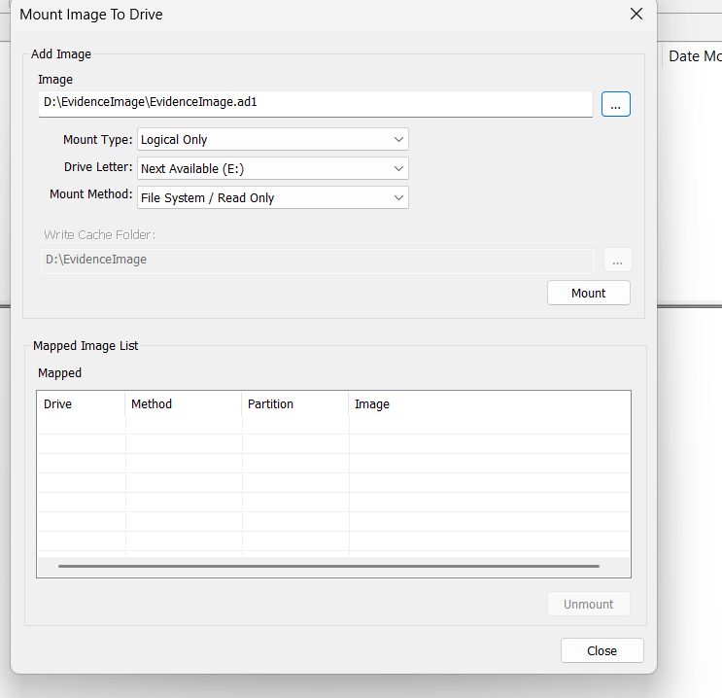
Figure 3.0.4: Mount Image options configured to preserve read-only access.
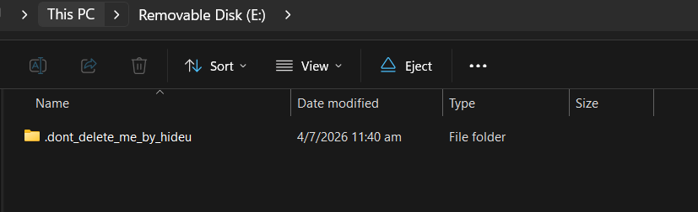
Figure 3.0.5: Mounted image visible as a virtual drive on the forensic workstation.

With the image mounted, it was added to Autopsy as a data source using the "Logical Files" option. The "File Type Identification" and "Extension Mismatch Detector" ingest modules were enabled to specifically target the obfuscation techniques employed by the vault application.

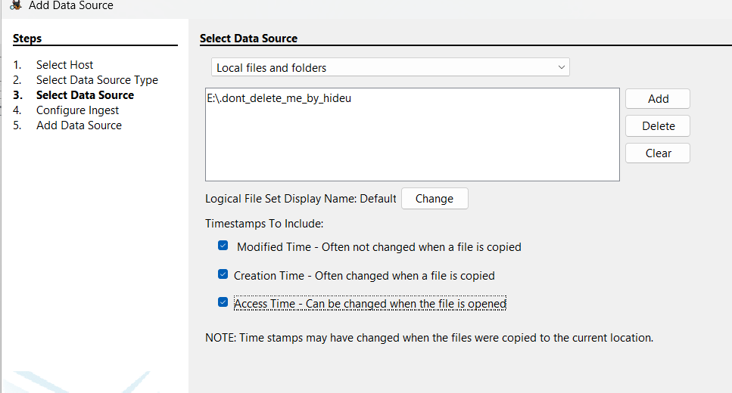
Figure 3.0.6: Adding the mounted image to Autopsy as a data source using the Logical Files option.

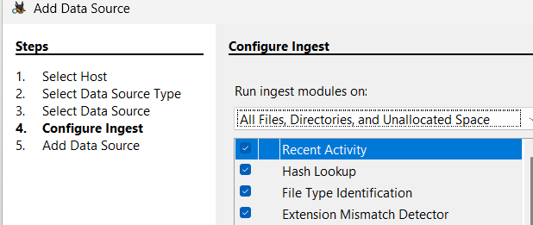
Figure 3.0.7: Ingest modules configured, including File Type Identification and Extension Mismatch Detector.

Phase 4: Evidence Analysis and Recovery

Phase 4.1: File Obfuscation Analysis

Autopsy's Extension Mismatch Detector module flagged multiple files within the vault directory. The HideU application had obfuscated the stored files by scrambling their filenames into random alphanumeric strings and stripping their file extensions entirely. Despite this, Autopsy correctly identified the true MIME type of these files as image/jpeg, bypassing the fake filenames through content-based identification.

Using Autopsy's application viewer, the recovered files were rendered visually, providing direct confirmation that the suspect had photographed sensitive corporate documents and stored them within the vault.

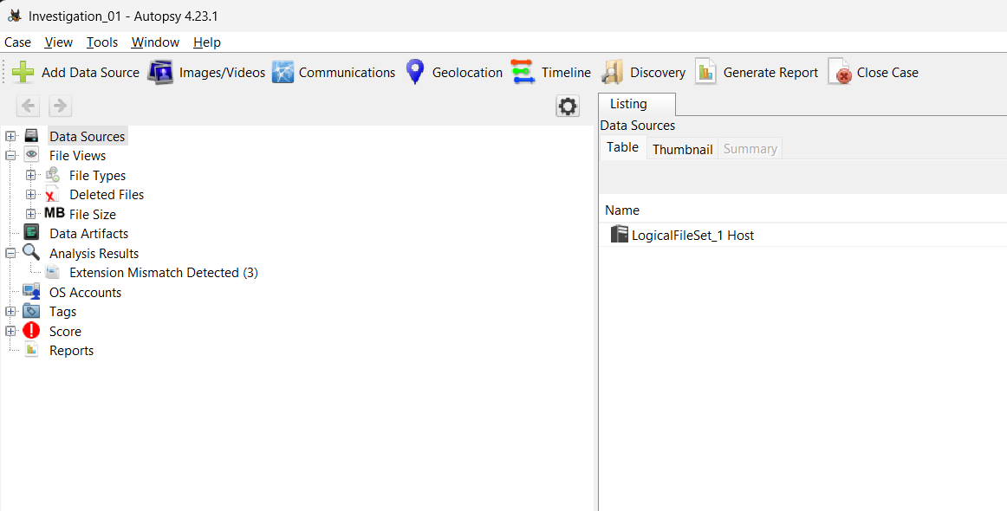
Figure 4.1.1: Files flagged by Autopsy's Extension Mismatch Detector, showing scrambled filenames with stripped extensions.

The Modified Time values recorded by Autopsy for all three recovered files fell between 10:57:16 and 10:57:20 SGT on 4 July 2026, matching the case timeline in which the suspect was observed photographing documents on that date. This establishes when the files were written into the vault directory.

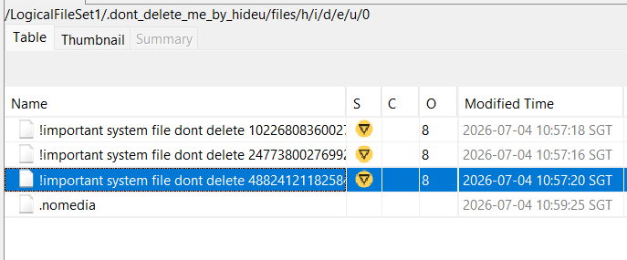
Figure 4.1.2: Autopsy file listing showing Modified Time values for all recovered vault files, consistent with the date of the incident.

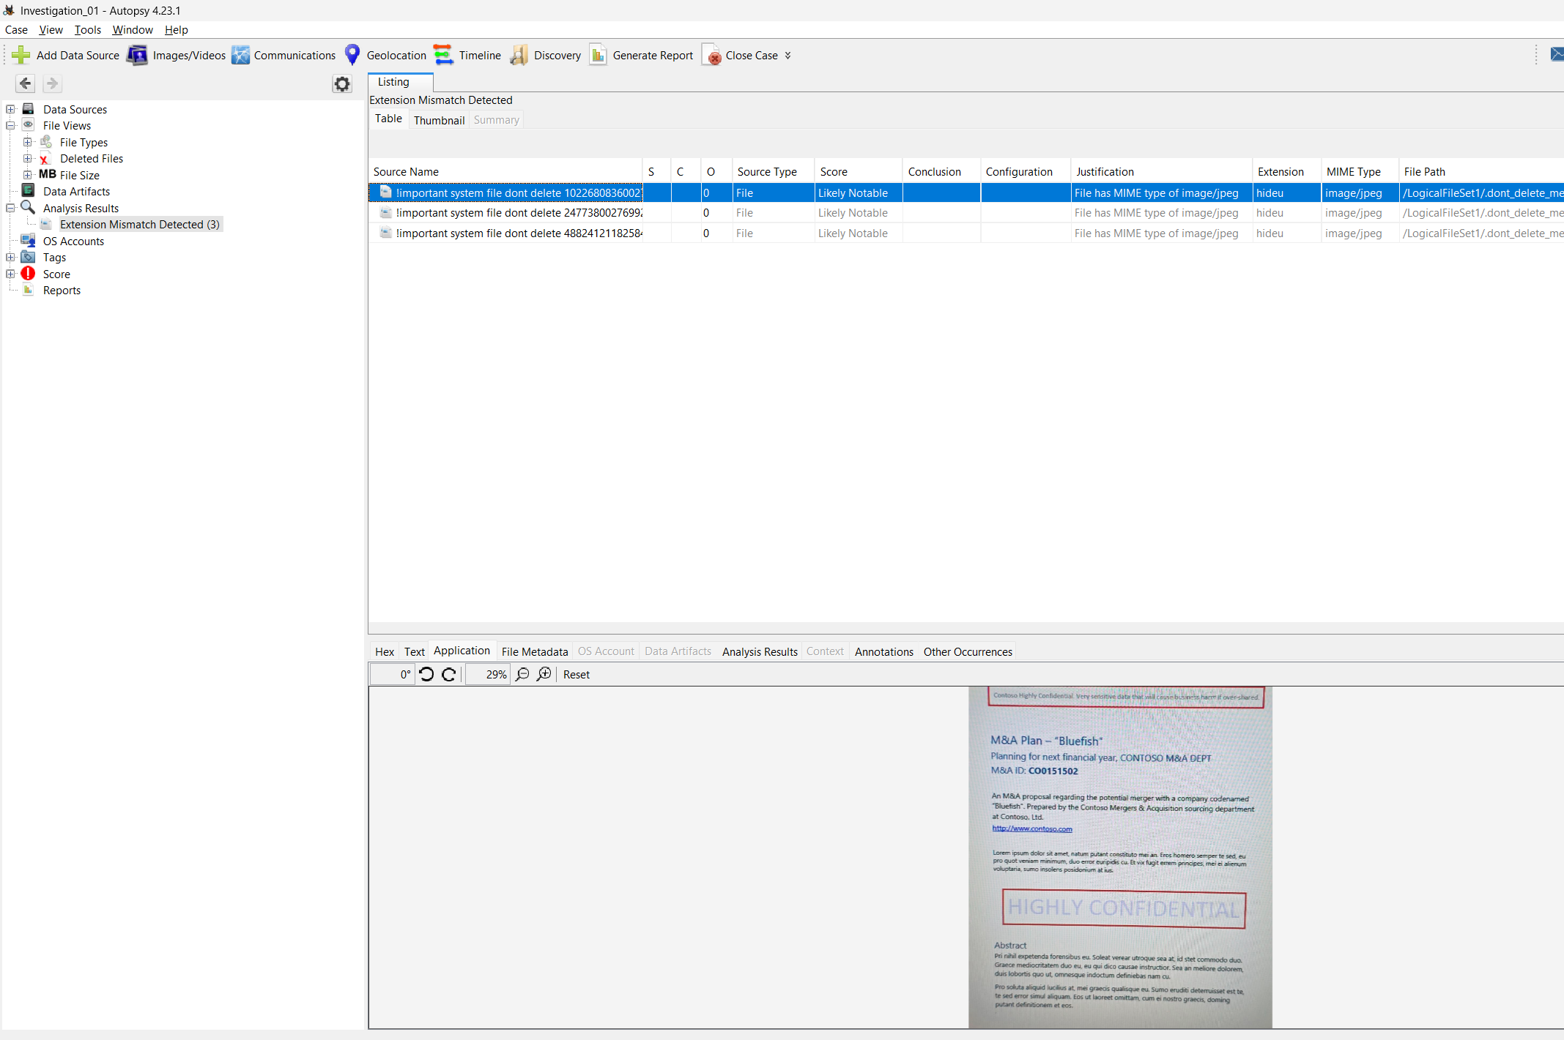
Figure 4.1.3: Recovered image rendered in Autopsy's application viewer, confirming a photograph of sensitive corporate information.

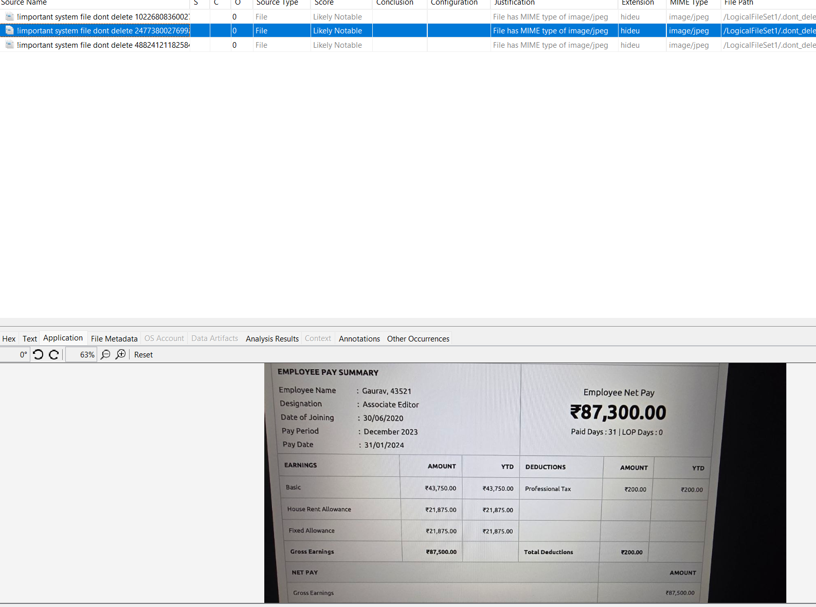
Figure 4.1.4: Second recovered image rendered in Autopsy, further confirming the contents of the vault.

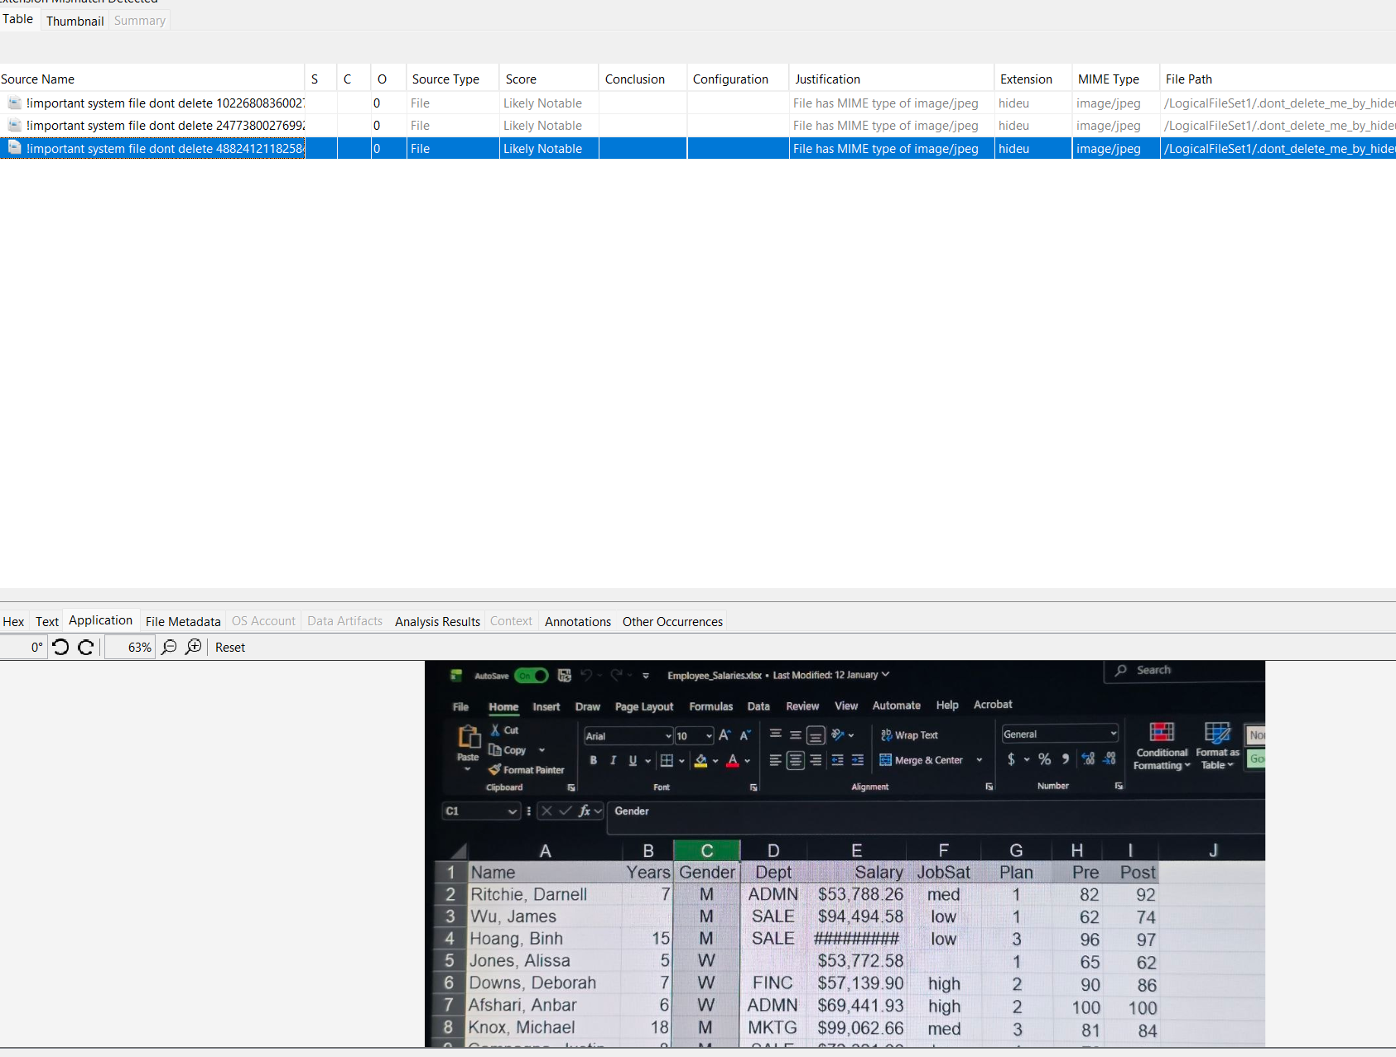
Figure 4.1.5: Additional recovered image confirming the pattern of photographed corporate documents.

To provide technically verifiable proof, the hex signatures of the files were examined. The magic bytes at the start of each file read FF D8 FF E0, the universal file signature for the JPEG format, definitively confirming the file type regardless of the absent extensions or scrambled filenames.

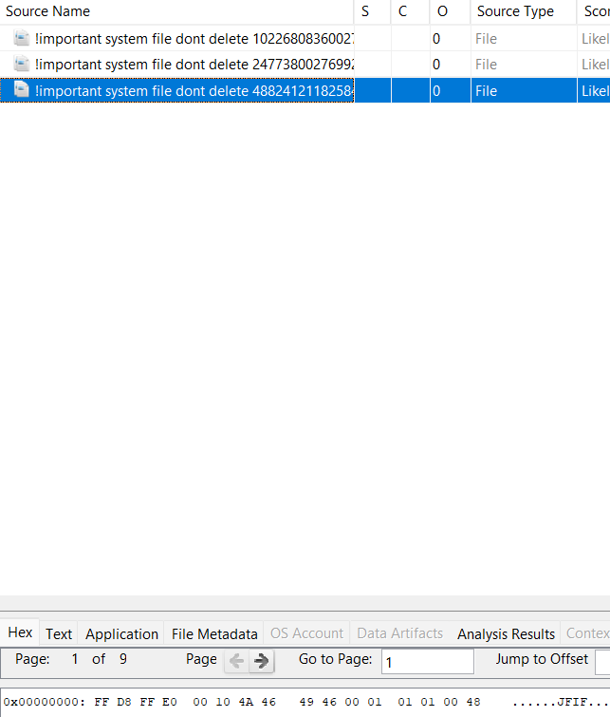
Figure 4.1.6: Hex signature analysis showing the magic bytes FF D8 FF E0 at the start of a recovered file.

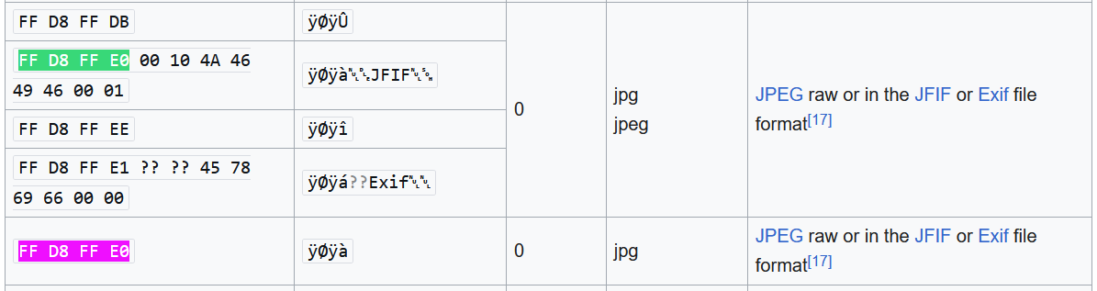
Figure 4.1.7: File signature confirming JPEG format despite the absence of file extensions.

Phase 4.2: EXIF Metadata Analysis

To extract metadata beyond what Autopsy's ingest modules could surface, ExifTool v13.59 was run directly against the recovered files. This provided a second, independent means of file analysis operating at the content level rather than the filesystem level, unaffected by any filename obfuscation or extension stripping.

ExifTool independently confirmed the files as JPEG images with MIME type image/jpeg, matching the magic byte findings from Section 4.1.

The File Modification Date/Time was recorded as 2026:07:04 10:57:18+08:00, consistent with the Modified Time values observed in Autopsy's file listing (Section 4.1), further confirming that the files were written into the vault directory on 4 July 2026.

Notably, the File Creation Date/Time reflects 2026:08:07 — the date the file was copied to the forensic workstation, and is therefore an artefact of the extraction process rather than evidence of when the file originated.
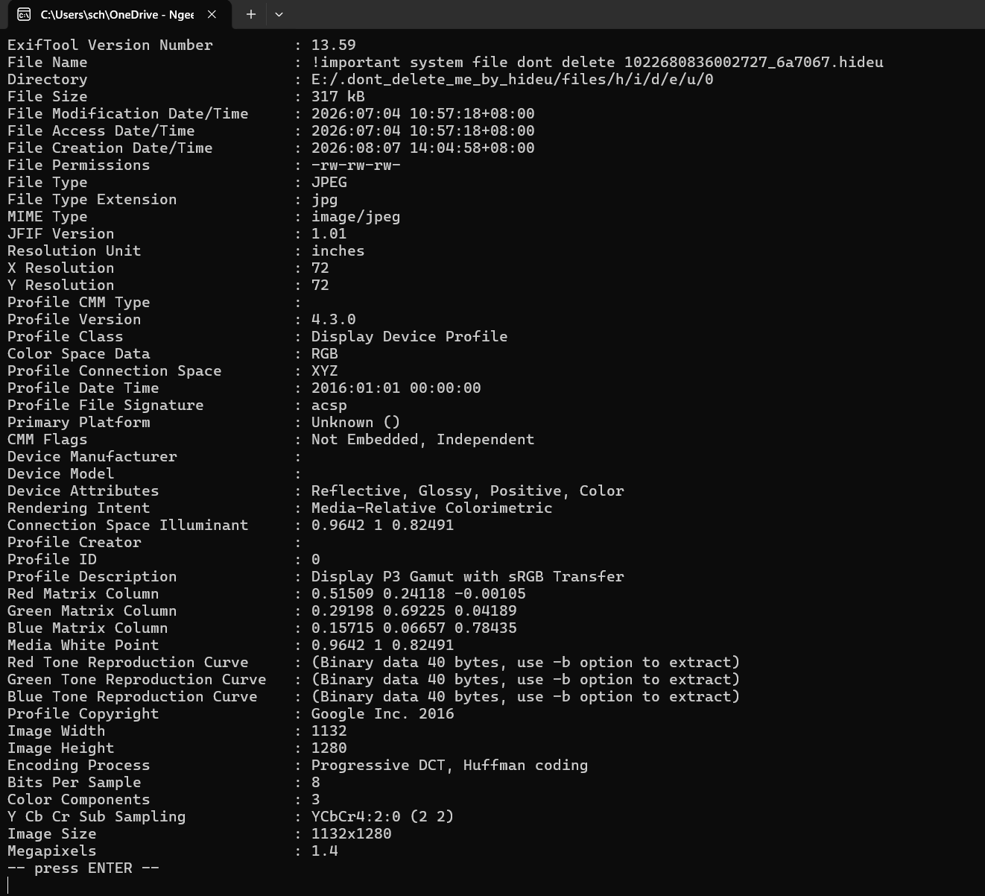
Figure 4.2.1: ExifTool output showing content-level metadata embedded within a recovered JPEG file, including file creation time and ICC colour profile.

The embedded ICC colour profile, Display P3 Gamut with sRGB Transfer, with copyright attributed to Google Inc. 2016, is characteristic of Android's native camera pipeline.

This confirms the images were captured on an Android device, consistent with the suspect's confiscated phone.

Furthermore, the recovered image resolution of 1132×1280 pixels (1.4 megapixels) is low for a modern smartphone camera. This is consistent with a photograph taken of a monitor or screen rather than a direct digital document, matching the whistleblower's account that the suspect was seen photographing a company monitor.

However, no GPS coordinates, device make/model (Device Manufacturer and Device Model fields were blank), or original capture timestamp were present in the EXIF data.

This absence, combined with the filesystem-level obfuscation observed in Section 4.1, indicates the vault application systematically sanitises identifying metadata upon file ingestion, a deliberate anti-forensic design feature of the application.

Limitations of the Investigation

- Scope of Extraction: As the investigation relied on a logical, ADB-based extraction rather than a physical extraction, any data residing in unallocated space, deleted database entries, or areas of app-private storage not accessible without root privileges could not be recovered or examined.

- Cloud backup activity: while the decompiled manifest confirmed the presence of a Google Drive backup service, verifying whether files were synchronised to a cloud account would require account-level access, which was outside the scope of this investigation.

Conclusion

This investigation successfully demonstrated a complete mobile forensic workflow across acquisition, preservation, and analysis phases.

Through ADB, investigators were able to identify the suspect vault application and extract its obfuscated storage directory from shared storage, without requiring root access, due to the inherent design trade-off of the application storing files in the shared partition rather than app-private storage.

A technical incompatibility between Autopsy and the AD1 image format was resolved by mounting the forensic image as a read-only virtual drive using FTK Imager, ensuring the chain of custody remained intact throughout the analysis.

The primary finding of this investigation is that the HideU vault application employed multiple layers of obfuscation: filename scrambling, extension stripping, and metadata sanitisation.

Despite these measures, the file content itself could not be altered without destroying the data.

Professional forensic tools operating on file signatures and embedded metadata were able to definitively identify, recover, and contextualise the hidden evidence. The recovered files were confirmed as JPEG images captured on an Android device, stored in the vault on 4 July 2026, with resolution characteristics consistent with photographs of a monitor, directly supporting the whistleblower's account and the allegation of corporate data theft.

Recommendation
Based on the findings of this investigation, the following security measures are recommended to mitigate the risk of similar insider threats:

- Implement Mobile Device Management (MDM): Deploy an MDM solution with application whitelisting to prevent employees from installing unauthorised applications on corporate-issued devices, including disguised vault or utility apps.

- Restrict Camera Use in Sensitive Areas: Use MDM geofencing policies to automatically disable device cameras when connected to the corporate network or within physically sensitive zones such as finance or server rooms.

- Enforce Data Loss Prevention (DLP) and Clean Desk Policies: Implement DLP controls that govern how sensitive documents are displayed and accessed. Enforce strict policies on the use of personal mobile devices in areas where confidential data is handled, to prevent photographic exfiltration.

- Extend Investigation to Cloud Storage: Static analysis of the application identified a built-in Google Drive backup service. Investigators if needed, can examine the suspect's linked Google account activity logs for evidence of file uploads occurring around the time of the incident, to determine whether the data breach extended beyond local device storage.

References

Android Debug Bridge (adb). (2026). Android Developers. https://developer.android.com/tools/adb

Apktool. (2026). Apktool.Org. https://apktool.org/

Autopsy - Digital Forensics - Sleuth Kit Labs. (2019, August 12). Autopsy. https://www.autopsy.com/

ExifTool by Phil Harvey. (2026). Exiftool.Org. https://exiftool.org/

Exterro FTK Imager. (2026). Exterro.Com. https://www.exterro.com/digital-forensics-software/ftk-imager

Contributors to Wikimedia projects. (2010, February 9). Wikimedia list article. Wikipedia.Org; Wikimedia Foundation, Inc. https://en.wikipedia.org/wiki/List_of_file_signatures

