Comparative Analysis of Machine Learning Algorithms
for Software Defect Prediction
A study on the NASA PROMISE KC1 dataset

Abstract
Software defect prediction uses static code metrics collected before testing to flag modules likely to contain bugs, allowing limited testing effort to be directed where it matters most. This report trains and compares four machine learning classifiers — Logistic Regression, Random Forest, XGBoost, and a Neural Network — on the NASA PROMISE KC1 dataset (2,109 C++ modules, 21 static metrics, 15.5% defective). XGBoost was the strongest model (F1 = 0.59, ROC-AUC = 0.85 after SMOTE balancing). Two follow-up experiments examine which metric families drive predictive power and whether class balancing improves detection of the minority (defective) class. A working prediction dashboard was built on top of the best model.

1. Introduction
Manually inspecting every file in a large codebase before release is impractical. If historical defect patterns can be learned from static code metrics — size, complexity, structure — a model can rank modules by risk and let reviewers and testers focus there first. This is the defect prediction problem, and it has been an active software engineering research area since the NASA Metrics Data Program released the PROMISE datasets in the mid-2000s.
Research questions addressed in this report:
- RQ1 — Can software defects be predicted from static code metrics with usable accuracy?
- RQ2 — Which of the McCabe (complexity) and Halstead (size/effort) metric families matters most?
- RQ3 — Which learning algorithm performs best, and does class-imbalance correction (SMOTE) help?

2. Dataset
The KC1 dataset from the NASA PROMISE repository describes 2,109 modules of a C++ storage-management system, each with 21 static metrics and a binary defect label. After cleaning (label normalization, numeric coercion, median imputation for the small number of missing values), 2,109 rows with 326 defective modules (15.5%) remained — a realistic, moderately imbalanced setting.
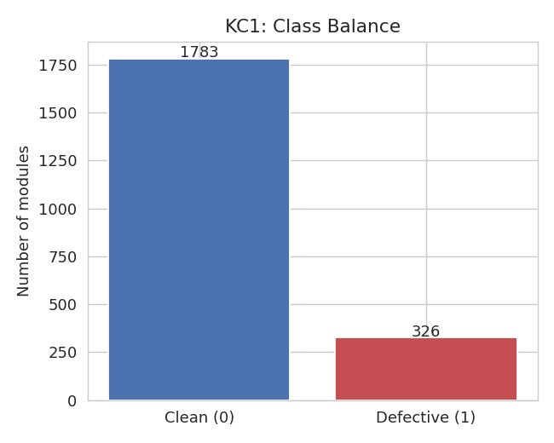
Figure 1. Class balance in KC1: defective modules are a 15.5% minority.

2.1 Metrics used
Metric(s) | Family | Meaning
loc | McCabe | Lines of code in the module
v(g) | McCabe | Cyclomatic complexity — number of linearly independent paths
ev(g) | McCabe | Essential complexity — structuredness of control flow
iv(g) | McCabe | Design complexity — complexity of the module's calling structure
n, v, l, d, i, e, b, t | Halstead | Program length, volume, difficulty, effort, and related size/complexity measures
uniq_Op / uniq_Opnd | Halstead | Number of distinct operators / operands
total_Op / total_Opnd | Halstead | Total operator / operand occurrences
branchCount | Structural | Number of branches in the control-flow graph
lOCode / lOComment / lOBlank | Structural | Lines of code / comments / blank lines

3. Exploratory Data Analysis
Pairwise correlation with the defect label shows that Halstead length (n), unique operands, unique operators, and lines of code correlate most strongly with defect proneness (r ≈ 0.35–0.39) — larger, more varied modules are more defect-prone, consistent with prior PROMISE studies.
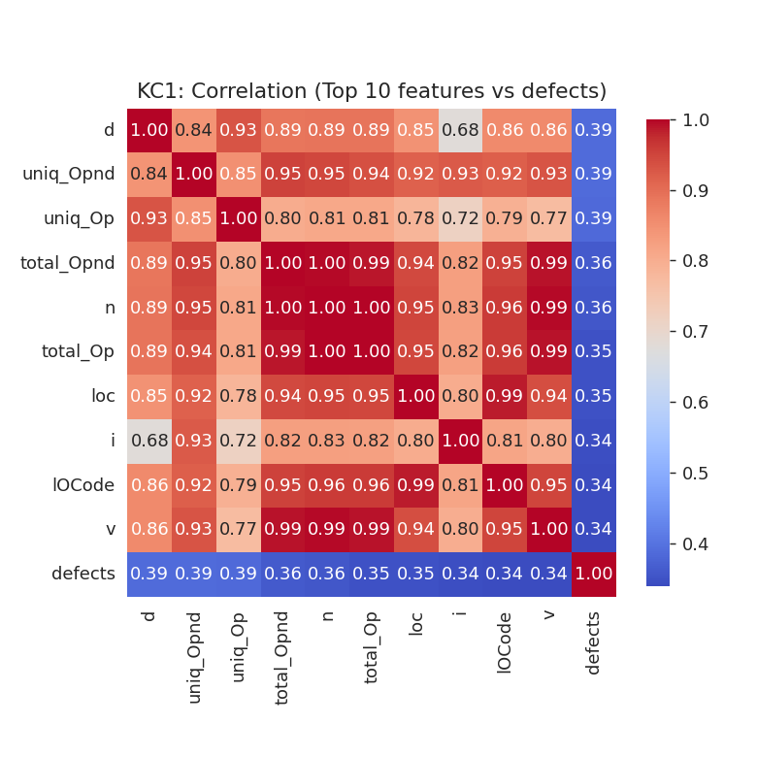
Figure 2. Correlation heatmap of the top 10 features most associated with defects.
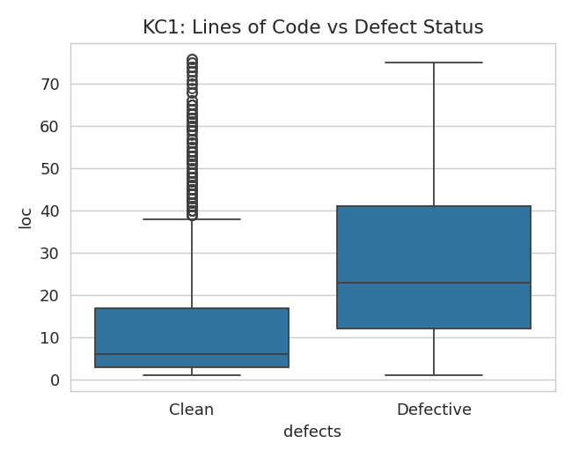
Figure 3. Defective modules skew toward higher lines of code (95th percentile trimmed for readability).

4. Methodology
Data was split 75/25 (stratified) into training and held-out test sets. Features were standardized (zero mean, unit variance) before fitting. Four classifiers were trained:
- Logistic Regression — linear baseline, class-weighted for imbalance
- Random Forest — 300 trees, class-weighted
- XGBoost — 300 trees, max depth 5, learning rate 0.08
- Neural Network (MLP) — two hidden layers (64, 32 units)
Each model was evaluated with 5-fold stratified cross-validation on the training set and on the held-out test set, using accuracy, precision, recall, F1-score, and ROC-AUC — accuracy alone is misleading on an imbalanced dataset, since a model that always predicts “clean” would already score ~85%.

5. Results

5.1 Experiment 1 — Model comparison
Model | CV Acc (5-fold) | Test Acc | Precision | Recall | F1 | ROC-AUC
Logistic Regression | 0.7446 | 0.7367 | 0.3273 | 0.6585 | 0.4372 | 0.8024
Random Forest | 0.9084 | 0.8314 | 0.4653 | 0.5732 | 0.5137 | 0.8328
XGBoost | 0.9091 | 0.8788 | 0.6216 | 0.561 | 0.5897 | 0.8453
Neural Network | 0.865 | 0.767 | 0.3277 | 0.4756 | 0.3881 | 0.6453

XGBoost gave the best balance of precision and recall (F1 = 0.59, ROC-AUC = 0.85), followed by Random Forest. Logistic Regression had the highest raw recall but far lower precision, flagging many false positives; the Neural Network underperformed the tree-based models on this small, tabular dataset — expected, since MLPs typically need more data than 2,109 rows to outperform gradient-boosted trees on tabular features.
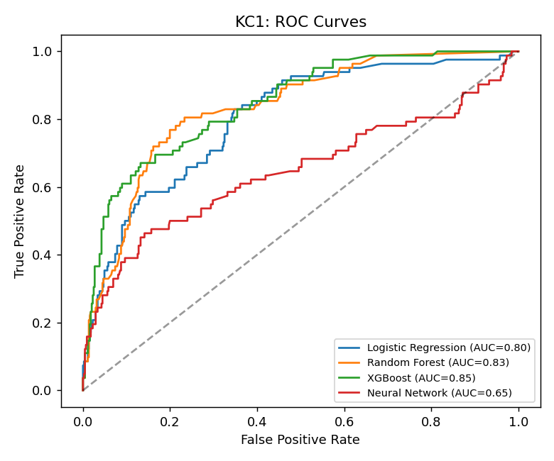
Figure 4. ROC curves for all four models on the held-out test set.
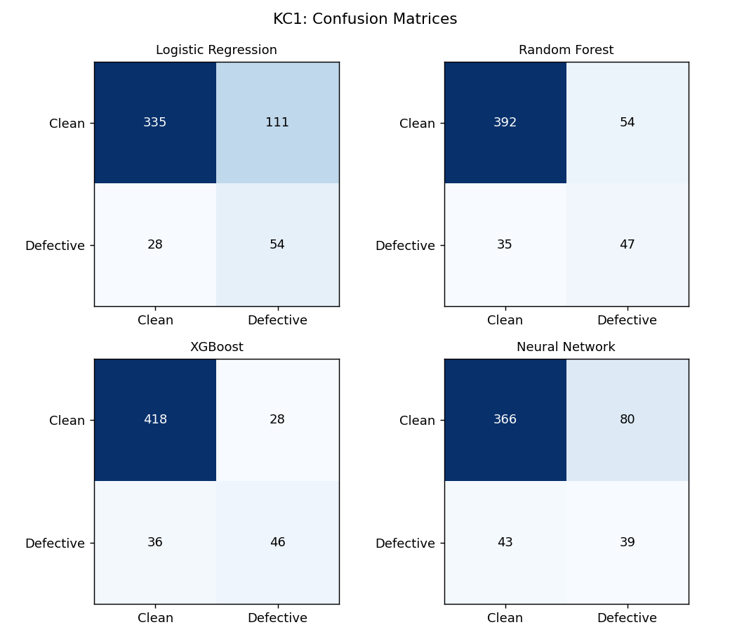
Figure 5. Confusion matrices for all four models.
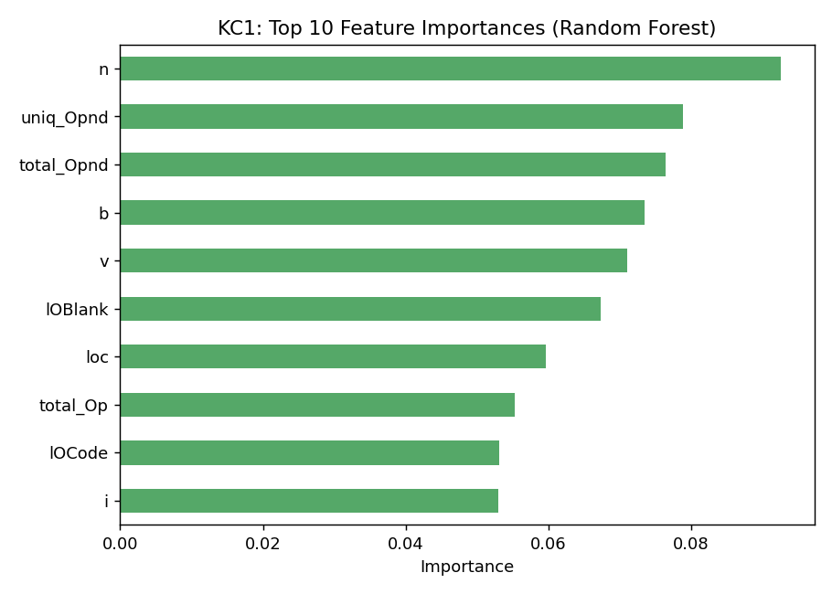
Figure 6. Top 10 Random Forest feature importances — Halstead length, volume, and effort dominate.

5.2 Experiment 2 — Feature ablation
To answer RQ2, McCabe complexity metrics (v(g), ev(g), iv(g)) and Halstead metrics were each removed in turn and the models retrained.
Model | All features (F1) | No McCabe complexity (F1) | No Halstead metrics (F1)
Logistic Regression | 0.4309 | 0.432 | 0.4292
Random Forest | 0.4444 | 0.458 | 0.4463
XGBoost | 0.5077 | 0.4531 | 0.4462
Neural Network | 0.4113 | 0.4496 | 0.4789

Removing either family causes a measurable F1 drop for XGBoost (0.51 → 0.45 without McCabe metrics, 0.51 → 0.45 without Halstead metrics), showing both families carry independent signal rather than one being redundant. Simpler linear models (Logistic Regression) were nearly unaffected by either removal, suggesting the interactions tree-based models exploit are what make the complexity/size metrics valuable.

5.3 Experiment 3 — SMOTE class balancing
To answer RQ3's balancing question, SMOTE oversampling was applied to the training set only (test set left untouched) before refitting each model.
Model | Recall (no SMOTE) | Recall (SMOTE) | F1 (no SMOTE) | F1 (SMOTE)
Logistic Regression | 0.6463 | 0.6585 | 0.4309 | 0.4372
Random Forest | 0.3415 | 0.5732 | 0.4444 | 0.5137
XGBoost | 0.4024 | 0.561 | 0.5077 | 0.5897
Neural Network | 0.3537 | 0.4756 | 0.4113 | 0.3881

SMOTE substantially improved recall and F1 for the tree-based models: Random Forest recall rose from 0.34 to 0.57 (F1 0.44 → 0.51) and XGBoost recall rose from 0.40 to 0.56 (F1 0.51 → 0.59). This matters in practice — a defect predictor that misses most real defects (low recall) is far less useful for testing triage than one with a few more false alarms.

6. Discussion
RQ1: defects are predictable from static metrics well above chance (ROC-AUC 0.85), though far from perfect — static metrics capture size/complexity but not semantic bugs like logic errors, so a defect predictor is a triage tool, not a replacement for testing.
RQ2: both McCabe complexity and Halstead size/effort metrics contribute independent predictive signal; Halstead length, volume, and unique-operand counts were consistently the top features across experiments.
RQ3: XGBoost was the best model overall, and SMOTE balancing meaningfully improved its ability to catch defective modules without a large precision cost — the final deployed model uses XGBoost + SMOTE.

7. A Prediction Dashboard
The final XGBoost + SMOTE model was wrapped in a small Flask web application (“Module Risk Console”) that accepts a module's static metrics and returns a defect probability and a Low / Medium / High risk tier, intended as a lightweight triage aid alongside code review.

8. Limitations
- KC1 is a single, ~20-year-old C++ system — findings may not transfer directly to other languages or codebases; cross-project validation is future work.
- Static metrics say nothing about a module's actual logic, so false negatives (subtle bugs in ‘simple-looking’ code) are expected.
- Class imbalance (15.5% defective) limits achievable precision at high recall; more data or cost-sensitive thresholds could help.

9. Conclusion
This study shows that static code metrics can predict defect-prone modules with meaningful accuracy (ROC-AUC 0.85), that both complexity and size/effort metrics matter, and that class balancing is an important, cheap step for imbalanced defect datasets. XGBoost combined with SMOTE gave the best held-out performance and powers a working prediction dashboard.

References
[1] Menzies, T., DiStefano, J., Orrego, A., & Chapman, R. (2004). Assessing Predictors of Software Defects. PROMISE Workshop, ICSE 2004.
[2] Koru, A. G., & Liu, H. (2005). An Investigation of the Effect of Module Size on Defect Prediction Using Static Measures. PROMISE Workshop, ICSE 2005.
[3] NASA PROMISE Software Engineering Repository — KC1 dataset. http://promise.site.uottawa.ca/SERepository
[4] Chawla, N. V., et al. (2002). SMOTE: Synthetic Minority Over-sampling Technique. Journal of Artificial Intelligence Research, 16, 321–357.
[5] Chen, T., & Guestrin, C. (2016). XGBoost: A Scalable Tree Boosting System. KDD 2016.

