# **Persol**

**APTECH**

#### Computer Education

#### Gulistan e Johar, Karachi.

**CPISM E-Project**

**1st Semester**

#### Project Mentor

**Miss. Fatima Bukhari**

**Developed and designed by:**

**SAQIB ALISHBA QASIM**

## This is to certify that:

**Std: SAQIB**

**Std: ALISHBA**

**Std: QASIM**

**Has successfully designed and developed the**

**E-PROJECT “Persol”**

**Starting Date:**

**22-June-2024**

**Submit Date:**

**22-July-2024**

## **ACKNOWLEDGMENT**

We are thankful to almighty, ***ALLAH*** for his grace and mercy for giving us the strength and ability to make us complete this e-Project website. We hereby present the project on ***‘Persol*** in your hands. We have tried our best to take all relevant and important topics into consideration so that this project may become more effective& a better outlook to come. This project has been developed with the help of **HTML5, JSON, Angular JS, JavaScript, and Geolocation**.***”***.

We earnestly hope that this project will provide all the necessary information required for the user to fulfill their requirement. However, suggestions for improvement of the project will be thankfully acknowledged

**THANK YOU**

## **PREFACE**

First of all, we would like to thank ***ALLAH*** the almighty, who gave us the mind to think and the heart to feel creativity and creation depends on thinking.

Many people contributed to this project, and I would like to thank all of them. Very special thanks to our teacher ***Miss Fatima*** of ***APTECH*** for her expert advice and brilliant suggestion and for always encouraging us to do our best. Indeed, class fellows are very important and we would like to thank all of them for their kind appreciation, encouragement, and moral support.

We would also like to express our deepest gratitude to our parents whose well wishes enabled us to transform our dream into a reality. Finally our sincere thanks to our teacher ***Miss Fatima*** for all their assistance in making this concept a reality.

**PROJECT BRIEF**

PROBLEM STATEMENT:

**Introduction:**

Their sunglasses offer full UV protection from the sun's harmful rays, allowing you to be stylish and safe in the sun. Their frames are durable and strong, proving that persol glasses are an investment that will last for years, rather than a fair-weather purchase.

**SOLUTION:**

The solution for the problem, mentioned in the problem part persol has decided to develop a site ***persol.com*** where the user will get information related to Glasses. We managed to create a website that provides every kind of information about the particular lenses for the user. Everything is clear and doesn’t confuse the viewer.

The website we made is named ***persol.com***. It contains the entire encyclopedia about some particular glasses mentioned above. The information is totally authentic and up-to-date. Users can easily find all the information about the glasses on this site.

**CUSTOMER REQUIREMENTS & SPECIFICATION**

###### PROJECT SCOPE & REQUIREMENTS:

The Web site is to be created based on the following requirements.

1. The Home Page should have a suitable logo and decent color combination.
2. The site should display a menu that will contain options such as Home, About us, Contact us, etc.

.

1. The information should be categorized according to different Product line-ups e.g., “GLASSES” etc.
2. When a user selects any product line-up, a complete list of Glasses for that product line-up will be displayed.
3. Price List for all Glasses should be available for Purchase.
4. There should be a “Contact Us” page which will have the Address of the Stores selling glasses and the mail address which when clicked will invoke the local mail client from where they can send an email.

###### **STANDARDS PLAN:**

* Every code block must have comments.
* The logic of the program needs to be explained. Proper documentation should be maintained.
* Complete Project Report along with synopsis, code, and documentation should be prepared.

###### **HARDWARE REQUIREMENTS:**

* A minimum computer system that will help you access all the tools in the courses is a Pentium 166 or better
* 64 Megabytes of RAM or better

###### **SOFTWARE REQUIREMENTS:**

Notepad/ HTML Editor

Visual Studio

Sublime

IE 5.0/ Netscape 6.0

### **PROJECT PLAN**

###### **CORE STRENGTH**:

* + - Our site has a professional look & is user-friendly so that a user can access any page of our website easily.
    - We have a unique drop-down MENU that contains links to the cards on our website.
    - We have a special type of Contact Us Page which contains not only the contact information but a comment box, which, the user can contact directly. Due to this customer can contact us easily.
    - We have developed the whole website on <Div>s. Tables are used only for tabular forms of data that had to be entered into our website.
    - Our website is cross-browser compatible. We have tested our website on all A-Grade Browsers.
    - Us, we have entered information in bulks for giving the user the maximum amount of information and knowledge about the specific cards.
    - We have made it as simple as possible so that a user doesn’t have to deal with any complications and browse any page he/she likes easily.

**DELIVERABLES:**

* Working Websites with Source Code
* Status Report 1
* Status Report 2
* Final Documentation

**PROJECT DEPENDENCE:**

* Not completely compatible on Internet Explorer 6.

**TESTING & QUALITY PLAN:**

* Do All Pages Open?
* Are all hyperlinks working?
* Are the web page contents devoid of spelling mistakes?
* Are all the web components working?
* Is websites working properly on Google Chrome?

**APPENDIX**

**TASK SHEET:**

|  |  |  |  |  |
| --- | --- | --- | --- | --- |
| Project Title | Persol | Activity Plan prepared by | Aliza Ashfaq | |
| S. # | **Task** | **Actual Start Date** |  | Status |
| 01. | Problem Review | 13 Oct 2022 | Aliza Ashfaq | Done |
| 02. | Layout of Website | 14 Oct 2022 | Aliza Ashfaq | Done |
| 03. | Article Data Searching | 16 Oct 2022 | Aliza Ashfaq | Done |
| 04. | Collection of Images | 19 Oct 2022 | Raza ali | Done |
| 05. | Inner Pages | 22 Oct 2022 | Aliza Ashfaq | Done |
| 06. | Checking Links | 23 Oct 2022 | Raza ali | Done |
| 07. | Data Searching | 25 Oct 2022 | Aliza Ashfaq | Done |
| 08. | Checking of cross Browsers compatibility | 27 Oct 2022 | Aliza Ashfaq | Done |
| 09. | Documentation | 2 Nov 2022 | Aliza Ashfaq | Done |

**SNAPSHOTS**

Home Page

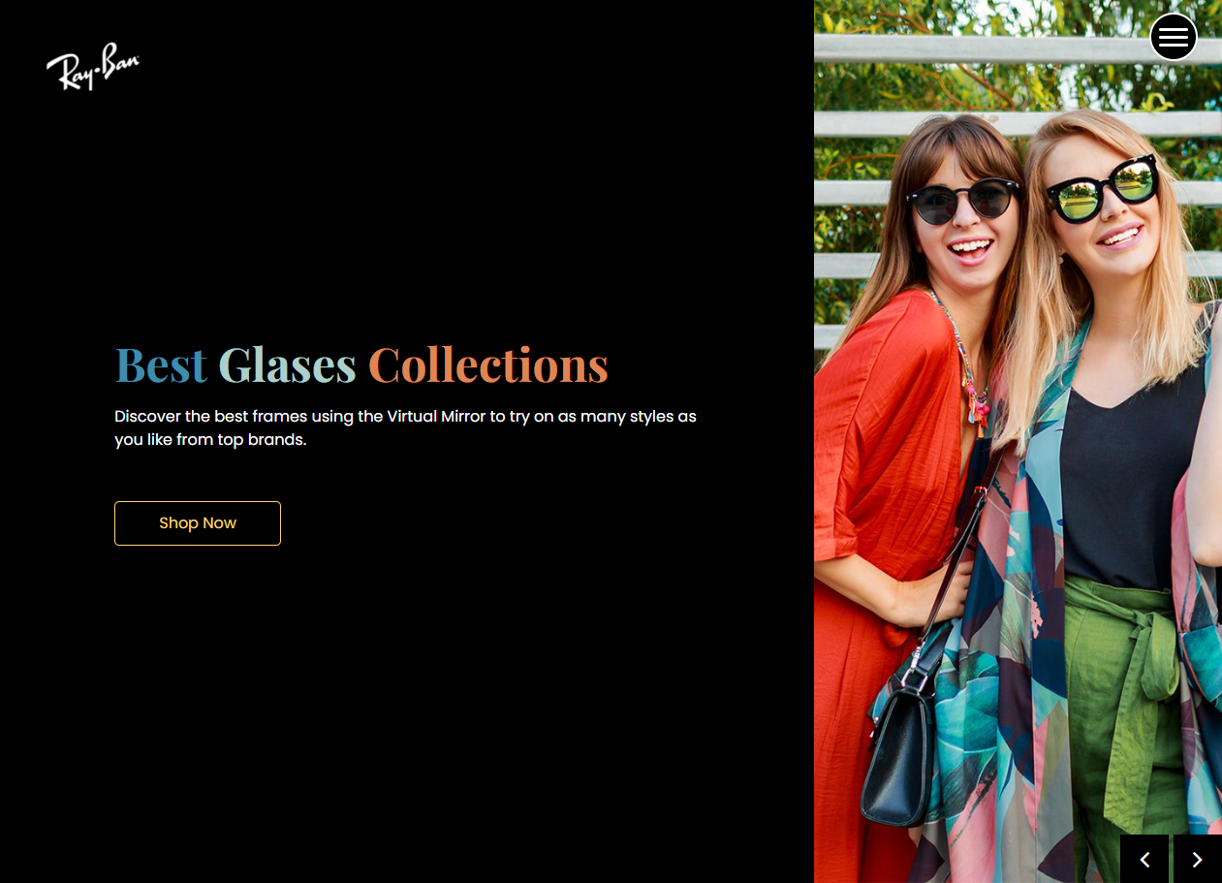

About Us

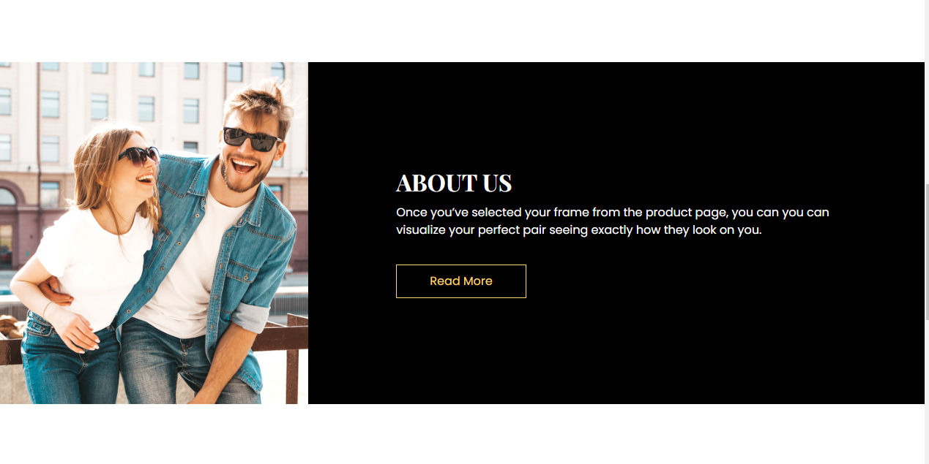

GLASSES

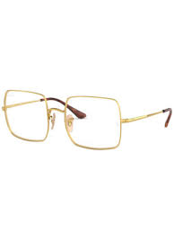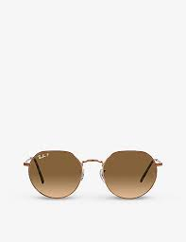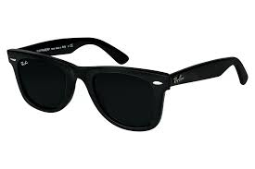

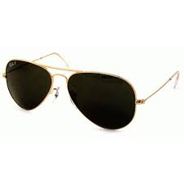

HOME/INDEX PAGE CODING:

    <meta name="viewport" content="width=device-width, initial-scale=1">

    <title>Image Gallery using Bootstrap 5 | Coder Uncle</title>

    <link href="https://cdn.jsdelivr.net/npm/bootstrap@5.0.0-beta3/dist/css/bootstrap.min.css" rel="stylesheet">

    <link rel="stylesheet" type="text/css" href="style.css">

    <!-- JavaScript Bundle with Popper -->

<!-- <script src="https://cdn.jsdelivr.net/npm/bootstrap@5.2.2/dist/js/bootstrap.bundle.min.js"></script> -->

<link rel="stylesheet" href="https://cdn.jsdelivr.net/npm/bootstrap-icons@1.3.0/font/bootstrap-icons.css">

</head>

<body>

    <div id="navbar" class="navel">

        <nav class="navbar navbar-expand-lg navbar-light bg-light">

            <div class="container-fluid">

              <a class="navbar-brand" href="#"><img src="images/Papyrus_logo.svg.png" alt=""></a>

              <button class="navbar-toggler" type="button" data-bs-toggle="collapse" data-bs-target="#navbarSupportedContent" aria-controls="navbarSupportedContent" aria-expanded="false" aria-label="Toggle navigation">

                <span class="navbar-toggler-icon"></span>

              </button>

              <div class="collapse navbar-collapse" id="navbarSupportedContent">

                <ul class="navbar-nav me-auto mb-2 mb-lg-0">

                  <li class="nav-item">

                    <a class="nav-link active" aria-current="page" href="#">HOME</a>

                  </li>

                  <li class="nav-item">

                    <a class="nav-link active" aria-current="page" href="#about">ABOUT US</a>

                  </li>

                  <li>

                    <a class="nav-link active" aria-current="page" href="#contact">CONTACT US</a>

                  </li>

                  <li class="nav-item dropdown">

                    <a class="nav-link dropdown-toggle" href="#" id="navbarDropdown" role="button" data-bs-toggle="dropdown" aria-expanded="false">

                      CARDS

                    </a>

                    <ul class="dropdown-menu" aria-labelledby="navbarDropdown">

                      <li><a class="dropdown-item" href="#birthday">BIRTHDAY</a></li>

                      <li><a class="dropdown-item" href="#aniversary">ANNIVERSARY</a></li>

                      <li><a class="dropdown-item" href="#mother">MOTHERSDAY </a></li>

                      <li><a class="dropdown-item" href="#friend">FRIENDSHIP</a></li>

                      <!-- <li><hr class="dropdown-divider"></li>

                      <li><a class="dropdown-item" href="#">Something else here</a></li> -->

                    </ul>

                  </li>

                  <li class="nav-item">

                    <!-- <a class="nav-link disabled" href="#" tabindex="-1" aria-disabled="true">Disabled</a> -->

                  </li>

                </ul>

                <form class="d-flex">

                  <input class="form-control me-2" type="search" placeholder="Search" aria-label="Search">

                  <button class="btn btn-outline-success btne" type="submit">Search</button>

                </form>

              </div>

            </div>

          </nav>

    </div>

    <!-- navbar end  -->

    <section id="aniversary">

        <div class="container">

            <br><br><br><br><br>

            <h1>ANNIVERSARY CARDS</h1>

            <div class="row row-margin">

                <div class="col-md-3 col-sm-3 cad">

                    <img src="anniversary/anni1.webp" class="gallery-item" alt="Gallery1">

                    <p>Lorem ipsum dolor sit amet consecteturepellendus ea quae aspernatur autem veritatis?</p>

                    <button class="btn btn-primary cart">Add to cart</button>

                </div>

                <div class="col-md-3 col-sm-3 cad">

                    <img src="anniversary/anni10.jpg" class="gallery-item" alt="Gallery1">

                    <p>Lorem ipsum dolor sit amet consect repellendus ea quae aspernatur autem veritatis?</p>

                    <button class="btn btn-primary cart">Add to cart</button>

                </div>

                <div class="col-md-3 col-sm-3 cad">

                    <img src="anniversary/anni11.webp" class="gallery-item" alt="Gallery2">

                    <p>Lorem ipsum accusamus repellendus ea quae aspernatur autem veritatis?</p>

                    <button class="btn btn-primary cart">Add to cart</button>

                </div>

                <div class="col-md-3 col-sm-3 cad">

                    <img src="anniversary/anni2.jpg" class="gallery-item" alt="Gallery3">

                    <p>Lorem ipsum dolor sit amet consectetur asamus repellendus ea quae aspernatur autem veritatis?</p>

                    <button class="btn btn-primary cart">Add to cart</button>

                </div>

            </div>

            <div class="row row-margin">

                <div class="col-md-3 col-sm-3 cad">

                    <img src="anniversary/anni8.webp" class="gallery-item" alt="Gallery1">

                    <p>Lorem ipsum dolstinctio accusamus repellendus ea quae aspernatur autem veritatis?</p>

                    <button class="btn btn-primary cart">Add to cart</button>

                </div>

                <div class="col-md-3 col-sm-3 cad">

                    <img src="anniversary/anni3.webp" class="gallery-item" alt="Gallery1">

                    <p>Lorctio accusamus repellendus ea quae aspernatur autem veritatis?</p>

                    <button class="btn btn-primary cart">Add to cart</button>

                </div>

                <div class="col-md-3 col-sm-3 cad">

                    <img src="anniversary/anni7.jpg" class="gallery-item" alt="Gallery2">

                    <p>Lorem ique distinctio accusamus repellendueritatis?</p>

                    <button class="btn btn-primary cart">Add to cart</button>

                </div>

                <div class="col-md-3 col-sm-3 cad">

                    <img src="anniversary/anni6.jpg" class="gallery-item" alt="Gallery3">

                    <p>Lorem ipsum dsamus repellendus ea quae aspernatur autem veritatis?</p>

                    <button class="btn btn-primary cart">Add to cart</button>

                </div>

            </div>

        </div>

    </section>

    <section id="birthday">

        <div class="container">

            <br><br><br><br><br>

            <h1>BIRTHDAY CARDS</h1>

            <div class="row row-margin">

                <div class="col-md-3 cad">

                    <img src="birthday/b10.webp" class="gallery-item" alt="Gallery1">

                    <p>Lorem ipsum dolor sit amet consecteturepellendus ea quae aspernatur autem veritatis?</p>

                    <button class="btn btn-primary cart">Add to cart</button>

                </div>

                <div class="col-md-3 cad">

                    <img src="birthday/b2.jpg" class="gallery-item" alt="Gallery1">

                    <p>Lorem ipsum dolor sit amet consect repellendus ea quae aspernatur autem veritatis?</p>

                    <button class="btn btn-primary cart">Add to cart</button>

                </div>

                <div class="col-md-3 cad">

                    <img src="birthday/b3.webp" class="gallery-item" alt="Gallery2">

                    <p>Lorem ipsum accusamus repellendus ea quae aspernatur autem veritatis?</p>

                    <button class="btn btn-primary cart">Add to cart</button>

                </div>

                <div class="col-md-3 cad">

                    <img src="birthday/b1.jpg" class="gallery-item" alt="Gallery3">

                    <p>Lorem ipsum dolor sit amet consectetur asamus repellendus ea quae aspernatur autem veritatis?</p>

                    <button class="btn btn-primary cart">Add to cart</button>

                </div>

                <div class="col-md-3 cad">

                    <img src="birthday/b5.png" class="gallery-item" alt="Gallery3">

                    <p>Lorem ipsum dolor sit amet consectetur asamus repellendus ea quae aspernatur autem veritatis?</p>

                    <button class="btn btn-primary cart">Add to cart</button>

                </div>

                <div class="col-md-3 cad">

                    <img src="birthday/b11.jpg" class="gallery-item" alt="Gallery3">

                    <p>Lorem ipsum dolor sit amet consectetur asamus repellendus ea quae aspernatur autem veritatis?</p>

                    <button class="btn btn-primary cart">Add to cart</button>

                </div>

                <div class="col-md-3 cad">

                    <img src="birthday/b7.webp" class="gallery-item" alt="Gallery3">

                    <p>Lorem ipsum dolor sit amet consectetur asamus repellendus ea quae aspernatur autem veritatis?</p>

                    <button class="btn btn-primary cart">Add to cart</button>

                </div>

                <div class="col-md-3 cad">

                    <img src="birthday/b9.jpg" class="gallery-item" alt="Gallery3">

                    <p>Lorem ipsum dolor sit amet consectetur asamus repellendus ea quae aspernatur autem veritatis?</p>

                    <button class="btn btn-primary cart">Add to cart</button>

                </div>

            </div>

            <!-- <div class="row row-margin">

                <div class="col-md-3 cad">

                    <img src="images/a (1).jpg" class="gallery-item" alt="Gallery1">

                    <p>Lorem ipsum dolstinctio accusamus repellendus ea quae aspernatur autem veritatis?</p>

                    <button class="btn btn-primary cart">Add to cart</button>

                </div>

                <div class="col-md-3 cad">

                    <img src="images/a (1).jpg" class="gallery-item" alt="Gallery1">

                    <p>Lorctio accusamus repellendus ea quae aspernatur autem veritatis?</p>

                    <button class="btn btn-primary cart">Add to cart</button>

                </div>

                <div class="col-md-3 cad">

                    <img src="images/a (2).jpg" class="gallery-item" alt="Gallery2">

                    <p>Lorem ique distinctio accusamus repellendueritatis?</p>

                    <button class="btn btn-primary cart">Add to cart</button>

                </div>

                <div class="col-md-3 cad">

                    <img src="images/a (3).jpg" class="gallery-item" alt="Gallery3">

                    <p>Lorem ipsum dsamus repellendus ea quae aspernatur autem veritatis?</p>

                    <button class="btn btn-primary cart">Add to cart</button>

                </div> -->

            </div>

        </div>

    </section>

<section id="friend">

        <div class="container">

            <br><br><br><br><br>

            <h1>FRIENDSHIP CARDS</h1>

            <div class="row row-margin">

                <div class="col-md-3 cad">

                    <img src="friend/bf.jpg" class="gallery-item" alt="Gallery1">

                    <p>Lorem ipsum dolor sit amet consecteturepellendus ea quae aspernatur autem veritatis?</p>

                    <button class="btn btn-primary cart">Add to cart</button>

                </div>

                <div class="col-md-3 cad">

                    <img src="friend/bf9.jpg" class="gallery-item" alt="Gallery1">

                    <p>Lorem ipsum dolor sit amet consect repellendus ea quae aspernatur autem veritatis?</p>

                    <button class="btn btn-primary cart">Add to cart</button>

                </div>

                <div class="col-md-3 cad">

                    <img src="friend/bf10.jpg" class="gallery-item" alt="Gallery2">

                    <p>Lorem ipsum accusamus repellendus ea quae aspernatur autem veritatis?</p>

                    <button class="btn btn-primary cart">Add to cart</button>

                </div>

                <div class="col-md-3 cad">

                    <img src="friend/bf11.png" class="gallery-item" alt="Gallery3">

                    <p>Lorem ipsum dolor sit amet consectetur asamus repellendus ea quae aspernatur autem veritatis?</p>

                    <button class="btn btn-primary cart">Add to cart</button>

                </div>

                <div class="col-md-3 cad">

                    <img src="friend/bf12.jpg" class="gallery-item" alt="Gallery3">

                    <p>Lorem ipsum dolor sit amet consectetur asamus repellendus ea quae aspernatur autem veritatis?</p>

                    <button class="btn btn-primary cart">Add to cart</button>

                </div>

                <div class="col-md-3 cad">

                    <img src="friend/bf2.jpg" class="gallery-item" alt="Gallery3">

                    <p>Lorem ipsum dolor sit amet consectetur asamus repellendus ea quae aspernatur autem veritatis?</p>

                    <button class="btn btn-primary cart">Add to cart</button>

                </div>

                <div class="col-md-3 cad">

                    <img src="friend/bf3.jpg" class="gallery-item" alt="Gallery3">

                    <p>Lorem ipsum dolor sit amet consectetur asamus repellendus ea quae aspernatur autem veritatis?</p>

                    <button class="btn btn-primary cart">Add to cart</button>

                </div>

                <div class="col-md-3 cad">

                    <img src="friend/bf4.jpg" class="gallery-item" alt="Gallery3">

                    <p>Lorem ipsum dolor sit amet consectetur asamus repellendus ea quae aspernatur autem veritatis?</p>

                    <button class="btn btn-primary cart">Add to cart</button>

                </div>

            </div>

            </div>

        </div>

    </section>

    <section id="mother">

        <div class="container">

            <br><br><br><br><br>

            <h1>MOTHERSDAY CARDS</h1>

            <div class="row row-margin">

                <div class="col-md-3 cad">

                    <img src="mother/mother1.jpg" class="gallery-item" alt="Gallery1">

                    <p>Lorem ipsum dolor sit amet consecteturepellendus ea quae aspernatur autem veritatis?</p>

                    <button class="btn btn-primary cart">Add to cart</button>

                </div>

                <div class="col-md-3 cad">

                    <img src="mother/mother10.jpg" class="gallery-item" alt="Gallery1">

                    <p>Lorem ipsum dolor sit amet consect repellendus ea quae aspernatur autem veritatis?</p>

                    <button class="btn btn-primary cart">Add to cart</button>

                </div>

                <div class="col-md-3 cad">

                    <img src="mother/mother11.jpg" class="gallery-item" alt="Gallery2">

                    <p>Lorem ipsum accusamus repellendus ea quae aspernatur autem veritatis?</p>

                    <button class="btn btn-primary cart">Add to cart</button>

                </div>

                <div class="col-md-3 cad">

                    <img src="mother/mother12.jpg" class="gallery-item" alt="Gallery3">

                    <p>Lorem ipsum dolor sit amet consectetur asamus repellendus ea quae aspernatur autem veritatis?</p>

                    <button class="btn btn-primary cart">Add to cart</button>

                </div>

                <div class="col-md-3 cad">

                    <img src="mother/mother2.jpg" class="gallery-item" alt="Gallery3">

                    <p>Lorem ipsum dolor sit amet consectetur asamus repellendus ea quae aspernatur autem veritatis?</p>

                    <button class="btn btn-primary cart">Add to cart</button>

                </div>

                <div class="col-md-3 cad">

                    <img src="mother/mother3.jpg" class="gallery-item" alt="Gallery3">

                    <p>Lorem ipsum dolor sit amet consectetur asamus repellendus ea quae aspernatur autem veritatis?</p>

                    <button class="btn btn-primary cart">Add to cart</button>

                </div>

                <div class="col-md-3 cad">

                    <img src="mother/mother4.jpg" class="gallery-item" alt="Gallery3">

                    <p>Lorem ipsum dolor sit amet consectetur asamus repellendus ea quae aspernatur autem veritatis?</p>

                    <button class="btn btn-primary cart">Add to cart</button>

                </div>

                <div class="col-md-3 cad">

                    <img src="mother/mother5.jpg" class="gallery-item" alt="Gallery3">

                    <p>Lorem ipsum dolor sit amet consectetur asamus repellendus ea quae aspernatur autem veritatis?</p>

                    <button class="btn btn-primary cart">Add to cart</button>

                </div>

            </div>

            </div>

        </div>

    </section>

    <section id="about">

        <div class="container">

            <br><br><br><br><br>

            <div class="row">

                <h1>ABOUT US</h1>

                <div class="col-md-6 image">

                    <img src="images/office2.jpg" alt="">

                </div>

                <div class="col-md-6">

                    <h1>PAPYRUS,DESIGN THE BEST</h1>

                    <p class="para">

                         paprus,founded on december.20th,2021, is a high-quality

                         design templates platform.We are trying our best to make

                         Graphic design more easier than ever.With the help of our

                         work you can creat the most impressive designs and bring

                         your ideas to life.

                    </p>

                </div>

            </div>

        </div>

    </section>

    <section id="contact">

        <div class="container">

            <br><br><br><br><br>

            <div class="row">

                <h1>CONTACT US</h1>

                <div class="col-md-6">

                    <iframe src="https://www.google.com/maps/embed?pb=!1m14!1m8!1m3!1d28947.368321368864!2d67.0988391!3d24.9177227!3m2!1i1024!2i768!4f13.1!3m3!1m2!1s0x3eb339203217ff53%3A0xb7f4cf18c2c07151!2sAPTECH%20COMPUTER%20EDUCATION!5e0!3m2!1sen!2s!4v1666615274526!5m2!1sen!2s" width="600" height="450" style="border:0;" allowfullscreen="" loading="lazy" referrerpolicy="no-referrer-when-downgrade"></iframe>

                </div>

                <div class="col-md-6">

                    <form >

                        <input type="text" placeholder="NAME" class="form-control"><br>

                        <input type="email" placeholder="E-MAIL" class="form-control"><br>

                        <textarea name="" id="" cols="30" rows="10" placeholder="MESSAGE US!" class="form-control"></textarea>

                        <input type="submit" value="Send" class="btn btn-primary send">

                    </form>

                </div>

                <div class="col-md-12 footer">

                    <footer class="text-center text-white" style="background-color: #f1f1f1;">

                        <!-- Grid container -->

                        <div class="container pt-4">

                          <!-- Section: Social media -->

                          <section class="mb-4">

                            <!-- Facebook -->

                            <a

                              class="btn btn-link btn-floating btn-lg text-dark m-1"

                              href="#!"

                              role="button"

                              data-mdb-ripple-color="dark"

                              ><i class="bi bi-facebook"></i></a>

                            <!-- Twitter -->

                            <a

                              class="btn btn-link btn-floating btn-lg text-dark m-1"

                              href="#!"

                              role="button"

                              data-mdb-ripple-color="dark"

                              ><i class="bi bi-twitter"></i

                            ></a>

                            <!-- Google -->

                            <a

                              class="btn btn-link btn-floating btn-lg text-dark m-1"

                              href="#!"

                              role="button"

                              data-mdb-ripple-color="dark"

                              ><i class="bi bi-google"></i

                            ></a>

                            <!-- Instagram -->

                            <a

                              class="btn btn-link btn-floating btn-lg text-dark m-1"

                              href="#!"

                              role="button"

                              data-mdb-ripple-color="dark"

                              ><i class="bi bi-instagram"></i

                            ></a>

                            <!-- Linkedin -->

                            <a

                              class="btn btn-link btn-floating btn-lg text-dark m-1"

                              href="#!"

                              role="button"

                              data-mdb-ripple-color="dark"

                              ><i class="bi bi-linkedin"></i

                            ></a>

                            <!-- Github -->

                            <a

                              class="btn btn-link btn-floating btn-lg text-dark m-1"

                              href="#!"

                              role="button"

                              data-mdb-ripple-color="dark"

                              ><i class="bi bi-github"></i

                            ></a>

                          </section>

                          <!-- Section: Social media -->

                        </div>

                        <!-- Grid container -->

                        <!-- Copyright -->

                        <div class="text-center text-dark p-3" style="background-color: rgba(0, 0, 0, 0.2);">

                          © 2020 Copyright:

                          <a class="text-dark" href="https://mdbootstrap.com/">MDBootstrap.com</a>

                        </div>

                        <!-- Copyright -->

                      </footer>

                </div>

            </div>

        </div>

    </section>

<!-- Modal -->

<div class="modal fade" id="gallery-popup" tabindex="-1" aria-labelledby="exampleModalLabel" aria-hidden="true">

  <div class="modal-dialog modal-dialog-centered modal-lg">

    <div class="modal-content">

      <div class="modal-header">

        <!-- <h5 class="modal-title" id="exampleModalLabel">Modal title</h5> -->

        <button type="button" class="btn-close" data-bs-dismiss="modal" aria-label="Close"></button>

      </div>

      <div class="modal-body">

        <img src="images/a (1).jpg" class="modal-img" alt="Modal Image">

      </div>

    </div>

  </div>

</div>

    <script src="https://cdn.jsdelivr.net/npm/bootstrap@5.0.0-beta3/dist/js/bootstrap.bundle.min.js"></script>

    <script type="text/javascript">

        document.addEventListener("click",function (e){

          if(e.target.classList.contains("gallery-item")){

              const src = e.target.getAttribute("src");

              document.querySelector(".modal-img").src = src;

              const myModal = new bootstrap.Modal(document.getElementById('gallery-popup'));

              myModal.show();

          }

        })

    </script>

</body>

</html>

[ THE END ]