**COMSATS Institute of Information Technology

## Abbottabad

**Lab Sessional 1**

**Group 1**

|  |  |  |  |
| --- | --- | --- | --- |
| Class: | BSE 7B | Date: | 16-5-2016 |
| Subject: | Software Construction | Instructor: | Miss Bushra |
| Time Allowed: | 1 hr 25 min | Max Marks: | 10 |
| Name |  | Full Reg No | ______-____-___ |

**Lab Task**

**Perform each of the following tasks, show screenshots of your output for each task. Upload your word document on portal.**

A Java project has been uploaded on your portal. Download it. Extract it. Then perform the following steps using Git Bash tool:

1. 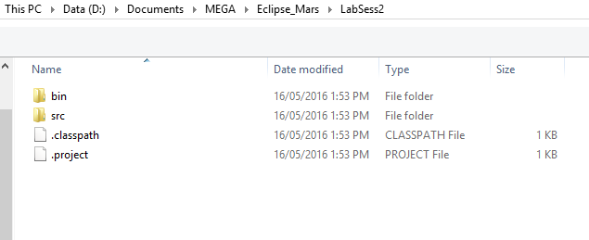Go to LabSess2 folder. You should see these files:
2. Change your directory so that Git is now looking at the LabSess2 folder. (1)
3. Initialize a git repository in this folder (1)
4. Configure your user name and email. (2)
5. Add all files in this folder to git staging area (1)
6. Commit all files to git repository (1)

Manually copy the Main.java file (uploaded separately on the portal) and paste it in src folder. You will be asked to replace existing Main.java. Click yes.

1. Check the status of your repository. Which files are modified?(1)
2. Using Git Bash, find the difference between previous main.java file and the new Main.java file which you have recently pasted. (1)
3. Replace the latest Main.java file (in your working directory) with the previous Main.java file. DO NOT PERFORM THIS STEP MANUALLY. Use a git command to do so.