OS homework 3 – virtual memory
0016045 李晏銘

loopup_paddr.c:

I inserted a customized system call to the Linux kernel which will translate virtual address to physical address. As mentioned in the TA's instructions pdf, the virtual memory hierarchy: pgd → pud → pmd → pte, in the template file loopup_paddr.c, we only need to finish the pmd to pte part. pte_offset_kernel is the key point of this assignment. The only task we need to do is using this function to get the physical address and mask that with proper mask.

Insert the function to the table in arch/x86/syscall/syscall_64.tbl and include/linux/syscalls.h, copy the modified source into the kernel and edit the Makefile. kernel/loopup_paddr.c, kernel/Makefile

After compilation, the new customized kernel works fine after reboot.

fork_ex.c:

We have to check the copy-on-write mechanism in Linux system, add our syscall(314, getpid(), mem_alloc) to get the physical address of the pointer mem_alloc and see if the value has been modified after some write instructions.

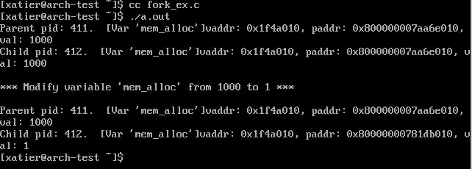

The only hard (?) part of this assignment is how to compile Linux kernel. I have used Linux at daily work for a very long time, it's just a piece of cake for me ._.

I don't follow TA's instructions in the PDF and I use Archlinux as my Operating system.
The following are my steps for kernel compilation.

# fetch the kernel source code and extract it
wget https://www.kernel.org/pub/linux/kernel/v3.x/linux-3.12.5.tar.xz
tar Jxvf linux-3.12.5.tar.xz
cd linux-3.12.5/

# prepare for the compilation, this will delete all current configuration and all generated files
make mrproper

# copy the config from the running system
zcat /proc/config > .config

# configure my customized kernel
make menuconfig

# Go to play some games
# n for num of my process, e.g. make -j 8
make -j 16

# install modules under /lib/modules/
sudo make modules_install

# prepare the new kernel under /boot/
sudo cp arch/x86_64/boot/bzImage /boot/vmlinuz-KernelName
sudo mkinitcpio -k /boot/vmlinuz-KernelName -c /etc/mkinitcpio.conf -g /boot/initramfs-KernelName.img
sudo cp System.map /boot/System.map-KernelName

# update grub configuration
sudo grub-mkconfig -o /boot/grub/grub.cfg

