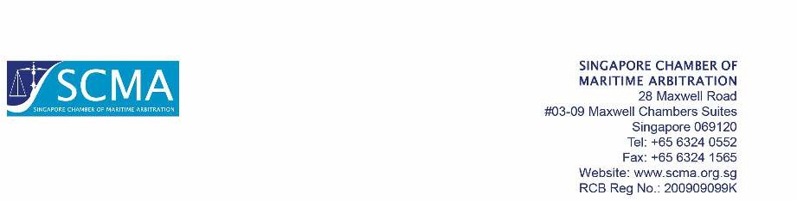

|  |  |  |
| --- | --- | --- |
| SCMA Ref | Terms | Currency |
|  |  | SG Dollars |

{#contacts}

{display_name}({email})

{/contacts}

Invoice To

|  |  |  |  |  |  |
| --- | --- | --- | --- | --- | --- |
| **Description** | | **Qty** | | **Unit Price** | **Amount** |
| {#products}{name} | | {quantity} | | {unit_price} | {amount}{/products} |
|  | | |  | | |
|  | | |  | | |
| Direct Credit (please quote our invoice number):  Payable to: Singapore Chamber of Maritime Arbitration  Bank: DBS Bank Ltd  Address: 12 Marina Boulevard, MBFC Tower 3, Singapore 018982  A/C No: 0720250460 (SGD)  Swift Code: DBSSSGSGXXX  Bank Code: 7171  Branch Code: 072  (Note: All bank charges to be borne by the remitting party) | | | **Subtotal:** {#deal}{base_currency_amount}{/} | | |
| **GST({gst}%):** {#deal}{vat}{/} | | |
| **Total Due:** {#deal}{total_due}{/} | | |
|  | | |
| Company Business Number | 200909099K | |

This is a computer-generated invoice. No signature is required.

Invoice

|  |  |
| --- | --- |
| Date | Invoice No. |
| {date} | {#deal}{id}{/} |