LPDynR: a new tool to calculate the Land Productivity Dynamics indicator

Xavier Rotllan-Puig1, Eva Ivits2, and Michael Cherlet3, ✉

1 ASTER Projects. Barri Reboll, 9, 1r. 08694 Guardiola de Berguedà (Barcelona), SPAIN 2 European Environment Agency. Geospatial Information Services Group. Copenhagen, DENMARK  
3 European Commission – Joint Research Centre (JRC). Directorate D – Sustainable Resources. Unit D6 – Knowledge for Sustainable Development & Food Security Unit. Via Enrico Fermi 2749. I-21027 Ispra (VA), ITALY

✉ Correspondence: Michael Cherlet <michael.cherlet@ec.europa.eu>

**Keywords:** Land Productivity, Ecosystem Dynamics, Land Degradation, Desertification, Vegetation

**Abstract**

The United Nations Sustainable Development Goal 15 (Life on Land), adopted the indicator 15.3.1 to measure the Land Degradation Neutrality. This indicator is based on three sub-indicators: (1) Trends in Land Cover, (2) Land Productivity and (3) Carbon Stocks. The Land Productivity sub-indicator refers to the total above-ground Net Primary Production and reflects changes in health and productive capacity of the land. It can be calculated using the Land Productivity Dynamics approach, which performs a combined assessment of the long term tendency of change of land productivity and its current level relative to homogeneous land areas.

Here, we present the R-based tool *LPDynR*, which implements the Land Productivity Dynamics approach for the calculation of the Land Productivity sub-indicator. *LPDynR* ingests vegetation-related indices derived from time series of remote sensed imagery. The final indicator is a 5-class map, ranging from declining to increasing land productivity. As an example of *LPDynR* functionalities and applicability, we present a case study for Europe. First, we show the general way to calculate the indicator for the entire time series (2000-2019), explained in a step by step process. Secondly, we show how to alternatively calculate the indicator based only on the long term tendency of change, but we evidence the added value of including the current level of productivity to refine the final indicator. Finally, we present some code for the calculation of “partial indicators” in terms of time scale along the observation period, which may help the user to understand the land productivity dynamics within the time series, as well as to assess the stability of the final product. While the indicator shows a general positive dynamics across Europe during the period 2000-2019, some of the partial maps show more negative trends, demonstrating the highly fluctuating character of vegetation.

# Introduction

The United Nations General Assembly designed in 2015 a collection of 17 global goals, so called Sustainable Development Goals (SDGs; UN, 2015), with the general aim of “achieving a better and more sustainable future for all”, and which are intended to be accomplished by 2030. Each SDG is subdivided into a list of targets which, in turn, go together with indicators to be able to measure their progress and success. Such indicators have to be credible, based on standardized methodologies and, often, have to be spatially explicit (Dubovyk, 2017).

The SDG-15, entitled Life on Land, has among its targets the 15.3, which expects “to combat desertification, restore degraded land and soil, including land affected by desertification, drought and floods, and strive to achieve a land degradation-neutral world”. In this context, Land Degradation Neutrality (LDN) is defined as the stable (or increasing) state regarding the amount and quality of land resources required to support ecosystem functions and services and enhance food security during a certain period of time (United Nations Convention to Combat Desertification - UNCCD, 2015).

The indicator 15.3.1 is adopted to measure the Land Degradation Neutrality and is expressed as the proportion of land that is degraded over total land area. It is a binary indicator (i.e. degraded/not degraded) based on three sub-indicators calculated separately: (1) Trends in Land Cover, (2) Land Productivity and (3) Carbon Stocks (Sims et al., 2020, 2017). While the first two can capture relatively fast changes, carbon stocks reflect slower changes which suggest a longer-term trajectory (Orr et al., 2017). Following a “one-out-all-out” process, the indicator identifies an area as degraded if one of the sub-indicators shows degradation. The three sub-indicators must be comparable among territories and based on standardized sources and methods. The data can be collected through existing sources, such as maps, reports or databases, but also can be derived from Earth observation (EO) imagery using remote sensing tools.

The Land Productivity sub-indicator (LP), addressed in this document, approximates the dynamics of the total above-ground net primary production (NPP; i.e. total energy fixed by plants minus their respiration). Such energy is transformed into biomass which, in turn, allows ecosystems to develop their functions and deliver essential services. Therefore, the Land Productivity sub-indicator reflects changes in health and productive capacity of the land and its declining trends can be usually understood as land degradation (Cherlet et al., 2018; Prince, 2009; Yengoh et al., 2015). The World Atlas of Desertification (Cherlet et al., 2018) suggests that the LP sub-indicator can be calculated using the Land Productivity Dynamics (LPD) approach. LPD was first developed by Ivits and Cherlet (2013) and is the methodological basis of the *LPDynR* tool presented in this article. In addition, Sims et al. (2021) reports as the only Land Productivity Dynamics global product available so far the one calculated with this same approach, and provided by the Joint Research Centre (European Commission) to the UNCCD to assist the countries for the calculation of the LP sub-indicator.

# Land Productivity Dynamics and *LPDynR*

The Land Productivity Dynamics approach is based fundamentally on the use of time series of vegetation-related indices derived from remote sensed imagery, such as the normalized difference vegetation index (NDVI) or the plant phenology index (PPI). NDVI, for example, can be used as a proxy for land productivity, as many studies at global and local scales have identified a strong relationship between NDVI and NPP (Ivits and Cherlet, 2013; Prince, 2009; Yengoh et al., 2015, and references therein). The LPD approach often uses phenological and productivity-related variables derived from time series of NDVI, given that these can provide additional information on several aspects of vegetation/land cover functional composition in relation to ecosystem dynamics and change (Ivits et al., 2013). These dynamics of the ecosystems, which might eventually drive land degradation, can be caused by human activities and/or biophysical processes, as well as other processes indirectly tied to them, such as climate change (Yengoh et al., 2015). While the most commonly used phenological parameters are the beginning and the end date of the vegetation growing season, together with the season length in number of days, the ones related to land productivity are e.g. accumulations of vegetation index values over time, mostly during the growing season as defined by the season start and end date. These approximate Net Primary Production within the growing season.

The final result of the LPD indicator is a categorical map with 5 classes of land productivity dynamics, ranging from declining to increasing productivity over a target time period. It is the result of a combined assessment of two sources of information, as indicated in different colours in Figure 1. The first layer (in blue) is the Long-Term Change Map. In general terms, it shows the tendency of change of land productivity (positive or negative) and the effect on productivity levels that this tendency might have had on a particular original point after a certain period of time. The second layer (in orange) is the Current Status Map, which provides information on the current levels of land productivity in relation to its potential, being current the end of the target time period. It compares the local productivity with the range of productivity across similar areas in terms of land cover or bioclimatic traits (Sims et al., 2017). Further explanations for both branches will be given in the respective sections below.

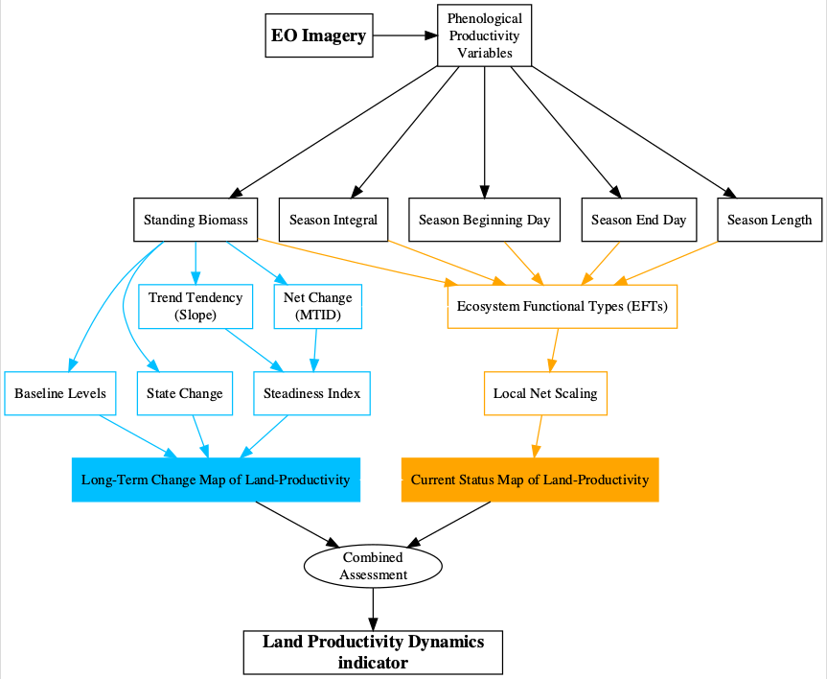

Figure 1: Flowchart of the process to calculate the Land Productivity Dynamics indicator and used by LPDynR

Following the LPD approach, *LPDynR* is an R-based tool (i.e. an R package) which allows the user to produce the final Land Productivity Dynamics Map using as inputs a set of time series of phenological and/or productivity variables (multi-band GeoTIFF rasters). By means of the different functions included in the package, it produces intermediate layers (e.g. Steadiness Index, Ecosystem Functional Types; see Figure 1) which are used to calculate both the Long-Term Change Map and the Current Status Map. In addition, several parameters can be set along the process in order to reflect the preferences of the user. The functions included in the package have no limitations regarding the number of years included in the time series, the variables to use or the spatial extent and resolution. While *LPDynR* v1.0.2 can be installed from CRAN (<https://CRAN.R-project.org/package=LPDynR>), the latest version is available at <https://github.com/xavi-rp/LPDynR>.

# Data set preparation

A case study is presented in order to illustrate the methodology implemented in the *LPDynR* package to calculate the Land Productivity Dynamics indicator. In this case, a data set of 5 phenological and productivity-related variables were used, at European level and on a 0.5km of spatial resolution, produced by the European Environment Agency - European Commission (EEA). They are all derived from time series (2000-2019) of MODIS imagery and its derived product Plant Phenology Index (PPI; Jin and Eklundh, 2014). PPI is linearly related to the canopy green leaf area index (LAI) and has a temporal pattern very similar to the one shown by the gross primary productivity (GPP) estimated by flux towers at ground reference stations. The five variables are produced using the software TIMESAT (Jönsson and Eklundh, 2004). At the moment of writing this article, these time series are not yet published, however more information about the previous freely distributed data set (2000-2016) by the EEA can be found in their website ([https://sdi.eea.europa.eu/catalogue/srv/eng/catalog.search#/home](https://sdi.eea.europa.eu/catalogue/srv/eng/catalog.search" \l "/home)). The five variables used were:

* Above ground vegetation productivity
* Above ground season vegetation productivity
* Start of vegetation growing season
* End of vegetation growing season
* Vegetation growing season length

In the *LPDynR* v.1.0.2, the functions use multi-band GeoTIFF rasters to start the process, one per phenological/productivity variable. Each band of each raster contains one of the years of the time series.

It is also important to note that *LPDynR* comes with a sample data set, which can be used to run tests, as well as some examples in the form of “vignettes” attached to the package.

# Long Term Change Map of land productivity

As seen in Figure 1 and explained above, the Land Productivity Dynamics indicator is produced by combining two input layers. The first layer is the Long-Term Change Map (also called “tendency map”). The tendency layer combines information on the trend of land productivity dynamics (positive or negative), the level of productivity of the ecosystem at the start of the time series, as well as whether it has changed its productivity state or not in the period under study (Ivits and Cherlet, 2013). Using such multi-source information for the Long-Term Change Map instead of a trend significance assessment was chosen to better describe the state and change of ecosystems. For instance, even though vegetation development presents a long-term negative dynamics (e.g. negative slope of a linear trend), the negative trend might not be strong enough to decrease the level of productivity such that the starting productivity state changes drastically. This could result to be a non-significant trend in linear trend analysis leaving the pixel out for further analysis which is not wishful in the land degradation analysis. The way in which the three sources of information are calculated for the Long Term Change Map using a land productivity variable is described in the following subsections.

## Steadiness Index

The first of the three metrics which integrates the Long-Term Change Map represents the long-term tendency of change of the natural systems, being either a growing or a declining tendency of change. This metrics is the Steadiness Index (Ivits et al., 2013) and can be calculated using the function *steadiness()*. The Steadiness Index is a discrete indicator based on the combination of two other metrics which are calculated per pixel by the same function: (1) the slope derived from fitting a linear trend on the time series and (2) the net change of the productivity level of the same period.

The use of a linear regression would imply to respect the linear trend results by strict statistical assumptions for confidence intervals and significance tests, such as heteroscedasticity, normal distribution of the errors, no autocorrelation between the observations and a deterministic process. Most often, these assumptions are not accomplished when working with time series of remote sensed products, and the use of non-parametric trend measures are not adequate either (Ivits et al., 2013). This is why the Steadiness Index only keeps classes of tendency, and not continuous values, so that no more tests need to be run for assessing its significance. Therefore, only the sign (positive or negative) of the slope of the trend is kept as the value of each pixel’s tendency of ecosystem dynamics. In addition, the net change of the productivity variable, in the units of the applied vegetation index, is calculated for the same time window and per pixel using the Multi-Temporal Image Differencing method (MTID; Guo et al., 2008). Afterwards, MTID is also transformed into positive or negative net change, avoiding the use of the actual value. Finally, the two classes of both metrics (sign of the slope of the linear function and sign of the net change) are combined into four “steadiness” categories as seen in Table 1. As an example, for a particular pixel, a negative slope (meaning that the tendency of change is negative) combined with a negative net change confirms the strong negative dynamics of an ecosystem compared to a negative slope combined with a positive net change which points to still negative but more moderate dynamics. Figure 2A represents the 4-class map of the Steadiness Index for the case study, being pixels in reds for negative dynamics and in greens for positive.

Table 1: Description of the four Steadiness Index classes and how they are derived based on the combination of the signs of both the slope of the linear function and the net change

|  |  |  |  |
| --- | --- | --- | --- |
| **Steadiness Class** | **Slope** | **Net Change** | **Description** |
| Steadiness1 | - | - | Strong negative ecosystem dynamics (possibility changing equilibrium) |
| Steadiness2 | - | + | Moderate negative ecosystem dynamics (likely remain in current equilibrium) |
| Steadiness3 | + | - | Moderate positive ecosystem dynamics (likely remain in current equilibrium) |
| Steadiness4 | + | + | Strong positive ecosystem dynamics (possibility changing equilibrium) |

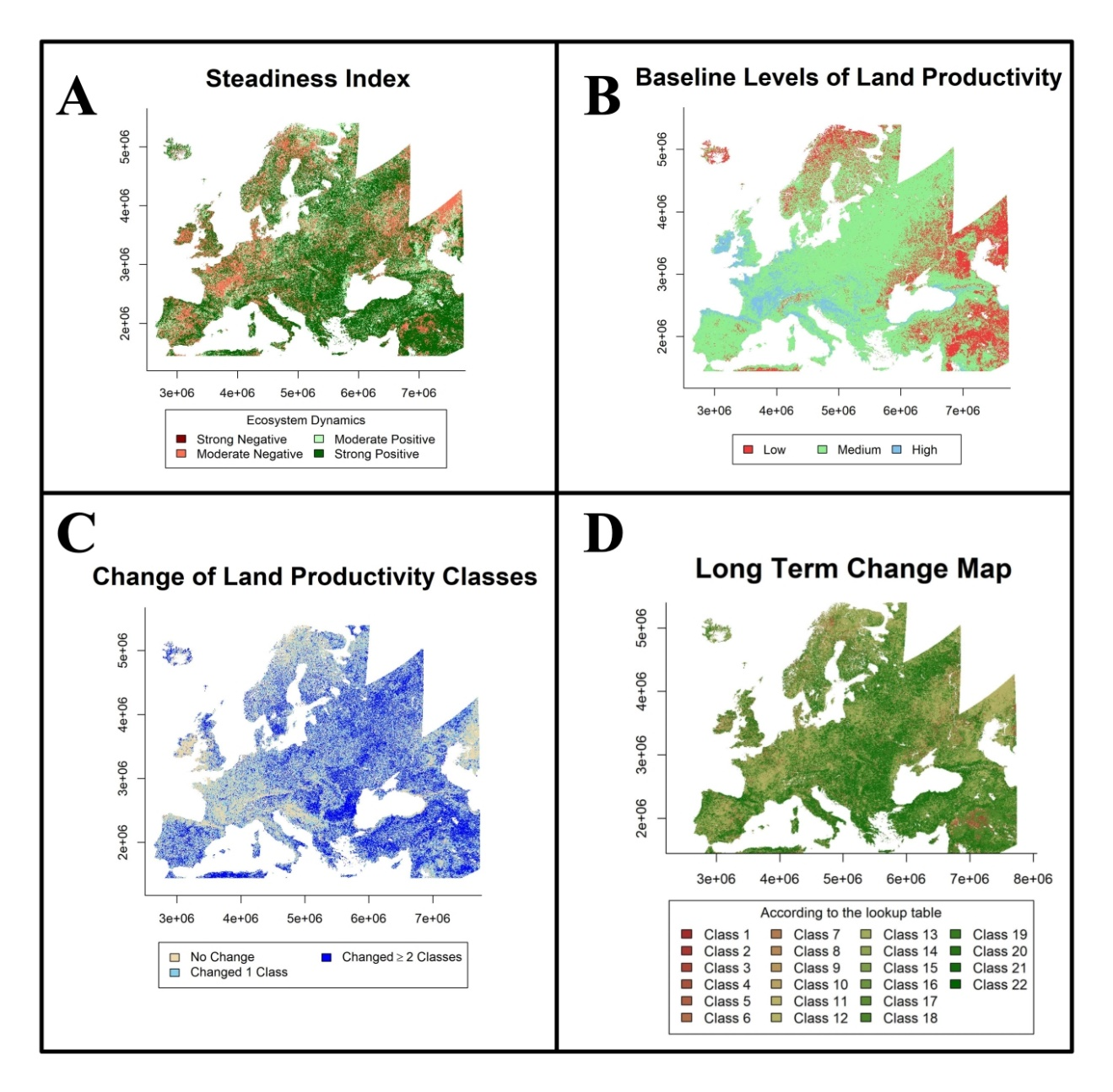

Figure 2: (A) Steadiness Index, (B) baseline levels of land productivity at the beginning of the time series and (C) state change maps (end of time series versus beginning) for the case study based on the ‘Above ground vegetation productivity’ variable. (D) Land productivity Long Term Change Map for the case study based on the combination of the previous three maps. Descriptions respectively in sections 4.1, 4.2, 4.3 and 4.4

## Baseline levels of productivity

The second source of information for the derivation of the Long-Term Change Map is the baseline levels of the productivity variable at the beginning of the time series.

For the calculation of the baseline levels of land productivity at the beginning of the time series, *LPDynR* categorizes productivity values into three classes: low, medium and high. To do that, the function *baseline_lev()* averages the first *n* years of the time series in order to avoid extreme events, such as abnormal droughts in wet areas, etc, which would skew the distribution of productivity values into too high or low values. The number of years to be considered by the average function can be set by passing the argument *yearsBaseline* to the function. The default value is 3 years; averaging more years would move the baseline value closer to the mean of the time series, which would not describe the baseline anymore.

After the average of the *n* number of years is calculated, *baseline_lev()* first classifies the pixels into 10 classes using 10-quantiles equalling to the corresponding percentile levels. The reason for this intermediate step is that, if directly opted for three classes (i.e. low, medium and high), the number of pixels per category would be classified homogeneously (i.e. 33.3% of pixels/class), which is a statistically correct but an over simplified representation of baseline status. Instead, *LPDynR* allows the user to define the percentile level to be used based on local knowledge. For example in dryland ecosystems or in boreal regions different average productivity level can be defined as low, medium or high values. The United Nations Development Programme (UNPD, [https://www.undp.org](https://www.undp.org/)) for example declares that 40% of the World’s land resources are drylands (Middleton et al., 2011), while the World Atlas of Desertification updated this proportion to 37.2% (Cherlet et al., 2018). Therefore, in global applications one might choose 37.2% of pixels to be classified as “low level” of productivity. Consequently, as default, the global application of *LPDynR* classifies the first four groups of pixels, i.e. 40 percentile (after rounding 37.2%), as “low” baseline productivity level, the five consecutive groups between 50 and 90 percentile as “medium” productivity level and the rest 10% of pixels with the highest average productivity levels, as “high” baseline. Both the proportion of pixels classified as low level and high level of land productivity can be set by passing to *baseline_lev()* the arguments *drylandProp* and *highprodProp*, respectively. The function classifies the rest of the pixels ((100 - (*drylandProp* + *highprodProp*)) as medium level. The assumption of classifying 40% of pixels as low productive is valid at global level, however, the proportion of drylands/low level of productivity should be modified for local and regional studies. For example, at the European level, drylands cover 20% of total land (FAO, 2019). This proportion has been used in the case study and the resulting 3-class map showing the estimation of levels of productivity at the beginning of the time series can be seen in Figure 2B.

## Change of state of productivity

The third layer used for the land productivity Long-Term Change Map is the change of the state of the productivity level during the time window under study. This aspect is necessary for land degradation assessments as it reports whether pre-set productivity state thresholds have been surpassed or not, which can be a consequence of either the natural resilience, new land use/practices that have been introduced, or impacts of other manmade or natural phenomena (Ivits and Cherlet, 2013).

To calculate the state change per pixel, the function *state_change()* uses both the productivity baseline level at the beginning of the time series, as described in the previous subsection, and the productivity state level at the end of the time series. This final state is calculated in the same way as the baseline level, i.e. (1) averaging the last 3 years and (2) classifying into 10 categories using 10-quantiles. The reason for using a 10-class classification is that it would be difficult to approximate if the change of one state to another was due to a big or a small change. Instead, using the 10-class classification for the final productivity state, one can address if a pixel has moved from class 5 to 4 (small change) or from class 9 to 4 (big change).

Once the class change per pixel has been calculated, either with positive or negative results, the map is categorized into 3 final classes: (1) no change, (2) changed between 1 and *x* classes or (3) changed more than *x* classes, where *x* can be defined by the user by passing the argument *changeNclass* to the function (default is 1). See Figure 2C for a map of the state change in the case study.

## Long Term Change Map

The land productivity Long-Term Change Map is one of the two pillars of the Land Productivity Dynamics indicator derived with *LPDynR*. This map is calculated by the combination of the Steadiness Index, the productivity levels at the beginning of the time series and the change of the state of productivity between the beginning and the end of the time series.

The function *LongTermChange()* performs the combination of the three qualitative metrics mentioned before into the Long-Term Change Map, resulting in 22 new categories as shown in Table 2. The resulting map for the case study is presented in Figure 2D. Note that lower numbers should not be interpreted as worse dynamics, and vice versa, but only as a way to categorise the pixels in a lookup table with the purpose of plotting the figure.

Table 2: Lookup table for the land productivity Long Term Change Map (Steadiness Index + BaseLine Levels + State Change). The numbers (1-22) correspond to the class of each pixel in the map

|  |  |  |  |
| --- | --- | --- | --- |
|  | **Change of productivity at the end of the time series** | | |
|  | **No Change** | **Changed 1 to *x* classes** | **Changed > *x* classes** |
| **Steadiness Index / Baseline productivity** |  |  |  |
| St1 low | 1 | 2 | 3 |
| St1 med. | 4 | 5 | 6 |
| St1 high | 7 | 8 | 9 |
| St2 low | 10 | 10 | 10 |
| St2 med. | 11 | 11 | 11 |
| St2 high | 12 | 12 | 12 |
| St3 low | 13 | 13 | 13 |
| St3 med. | 14 | 14 | 14 |
| St3 high | 15 | 15 | 15 |
| St4 low | 16 | 17 | 18 |
| St4 med. | 19 | 20 | 21 |
| St4 high | 22 | 22 | 22 |

At this point, the user might want to finalise the LPD calculation avoiding the second part of the methodology proposed by Ivits and Cherlet (2013), which is the Current Status Map of Land Productivity. To do this, the function *LPD_CombAssess* (see further explanations in the respective subsection below) can be called to reclassify the 22-class Long-Term Change Map into the final 5 classes of land productivity dynamics.

# Current Status Map of land productivity

The Land Productivity Dynamics indicator is composed of two base layers: the Long-Term Change Map of Land Productivity and the Current Status Map of Land Productivity (as shown in Figure 1). After the long-term productivity dynamics described previously (i.e. Long-Term Change Map) is calculated, the second source of information needed is the current level of land productivity. For this purpose, a Local Net Scaling approach is implemented (Prince, 2009). Such approach estimates the level of land productivity of each pixel relative to its neighbours with similar characteristics of their land functions. In other words, it calculates the potential level of productivity of each pixel within a homogeneous land unit. The Current Status Map may help, for instance, to identify areas which, although having a positive trend of productivity over time, their levels of current productivity are low relative to the pixels in the same homogeneous land unit and, thus, they might be still suffering land degradation (Sims et al., 2017). A first step for the calculation of the Current Status Map, therefore, is the derivation of the homogeneous land units across the area of study.

## Ecosystem Functional Types (EFTs)

The methodology implemented in *LPDynR* to derive homogeneous land units, or Ecosystem Functional Types (EFTs), is adapted from Ivits et al. (2013). It is basically a clustering process which uses, in this case, phenological and productivity variables to create the ecosystem functional groups. Among the different unsupervised clustering techniques available for data grouping, K-means has been chosen. K-means is widely used in data science mainly due to its relative simplicity of implementation and interpretation.

Originally, the unsupervised classification was performed after a three-steps pre-processing of the phenology and productivity variables (see Chapter 3, Dataset preparation): (1) removing highly correlated variables to avoid multicollinearity; (2) a first Principal Component Analysis (PCA) to select the optimal number of PCs and their associated variables showing the highest loadings; and (3) a final PCA to clearly associate each PC with one variable. However, test runs in this study (see Supplementary Material S1) have shown that the final LPD indicator does not differ significantly when it is derived using the raw phenological/productivity variables. Therefore, although the two-PCAs step is also implemented in *LPDynR*, only the removing of highly correlated variables (e.g. |r| > 0.7) is recommended before running the k-means clustering.

In order to check for multicollinearity among the variables, the function *rm_multicol()* first calculates their averages among the years of the time series. Then, the process internally runs the function *removeCollinearity()* from the package *virtualspecies* (Leroy et al., 2016). This function allows the user to set up the minimum Pearson’s correlation absolute value, which can be modified by passing the argument *multicol_cutoff*. It is established to be r = 0.7 as default. A subset of random points of the data set can be used for the calculation of the correlation coefficient in case the rasters have a large number of pixels and the user wants to speed up the process. The default number of randomly selected points is 10% of total pixels in the raster. However, the number of points can be selected by passing *sample.points = FALSE* and *nb.points* equal to the required amount of points. Finally, the function automatically creates a multi band raster where each band corresponds to one randomly selected variable of each group of correlation. In addition, a dendrogram to visualize the groups of intercorrelated variables can be plotted if the user wants to, although not by default. For the present case study, which was run with five variables, the dendrogram produced can be seen in Supplementary Material S2. At the cut-off value of r = 0.7, three groups of intercorrelated variables were found and one variable of each group was selected to continue with the analysis (i.e. Cyclic fraction, Season end day and Season length).

In case the user would like to run the two-PCAs steps, both the first “screening PCA”, which is done over the uncorrelated variables, and the “final PCA” are subsequently performed with the same function *PCAs4clust()*. In order to know the optimal number of variables to be used in the “final PCA”, a threshold of cumulative variance of the PCs is implemented. This threshold is established to be 0.9, i.e. 90% of the variance of the variables explained, as default.

Finally, the clustering algorithm can be run over either the selected PCs or the uncorrelated raw (phenology and productivity) variables using the function *EFT_clust()*. This function uses *kmeans()* from the package *stats*. K-means is an iterative unsupervised method, one of the main limitations being that it is not able to optimize the number of clusters by itself. Instead, the optimal number of clusters needs to be determined by the user. In the *LPDynR* package, the optimal number of clusters can be determined using the “scree-plot method”. This method is implemented with the function *clust_optim()* and it is based on running several K-means clustering with different number of clusters each, in order to assess how the quality of the models change with the number of clusters. Then, a plot is produced with the number of clusters in the x-axis and the total within-cluster sum of squares in the y-axis. A break line, the so-called “elbow”, indicates the number of clusters where the quality of the model no longer improves substantially as the number of clusters (model complexity) increases. In the present study the clustering was run with ten different number of clusters (5 to 50, with the increment of 5) to give a good amount of points to plot the curve, and the maximum number of iterations was set to 10 (see the plot produced in Supplementary Material Figure S3.1).

The “scree plot” method undoubtedly has some level of subjectivity, as the user decides where the curve flattens enough for the appropriate number of clusters. Alternatively, to remove such subjectivity, several numerical methods exist to calculate the optimal number of clusters, although they take also some statistical assumptions. These methods might be explored in the future if a higher level of accuracy is believed to be necessary or if the process shall be performed without user intervention. In addition, other hierarchical clustering methods could be explored in order to avoid calculating the optimal number of clusters beforehand, although previous tests run with ISODATA have been shown to be highly resource demanding, especially in terms of computing time.

Once the optimal number of clusters is estimated, the final clustering is run with the function *EFT_clust()* using the defined number of clusters and passed with the argument *n_clust*. Other parameters which can be passed to the function *EFT_clust()* are those that will be passed to *stats::kmeans()*, such as *nstart*, *iter.max* or *algorithm* (see <https://stat.ethz.ch/R-manual/R-devel/library/stats/html/kmeans.html> for further information)*.* It is important to note that when setting the argument *nstart*, the larger the value the more accurate the clustering result will be. This is because the function uses different sets of starting random centroids and runs the clustering *nstart* times. From these number of clustering runs, the best classification result is chosen. Therefore, a larger *nstart* value increases the chances of having a better cluster classification. In addition, *kmeans()* can use different algorithms to perform the clustering (e.g. “MacQueen”, “Hartigan-Wong”, etc.; see references in *kmeans()* documentation). As stated in the function documentation (*?kmeans*), “Hartigan-Wong” usually gives better results, although it is recommended to try several starts (*nstart > 1*). However, when using “Hartigan-Wong” with a (too) large number of clusters, and a lot of values of the variables are very similar, *kmeans()* is not able to converge in an acceptable amount of time (even increasing the number of iterations with *iter.max*). In these cases when the clustering does not converge, instead of stopping the process with an error, the function *kmeans()* only gives a warning after finishing the clustering, so that the obtained clusters are based on a non-converged process. Diminishing the number of clusters or rounding variables’ values might be good strategies to help *kmeans()* to converge.

*EFT_clust()* produces a RasterLayer object, where each pixel is linked to a cluster, plus an index of the clustering performance, which measures the compactness of individuals (i.e. pixels) within the groups. This index, which is expected to be as high as possible, is calculated as:

(1)

where *CI* is the compactness index, *BSS* is between-cluster sum of squares (i.e. *betweenss*,provided by *kmeans()*) and *TSS* is total sum of squares (i.e. *totss*, also provided by *kmeans()*).

Finally, as previous tests of K-means with up to 100 iterations were showing problems to converge in a certain limit of time, the maximum number of iterations is set to 500 as default in the function. Within this number of iterations and rounding variables, for almost all the tests performed, the process did achieve convergence with no issues (see Supplementary Material S4). For the running example, the EFTs resulted from the whole process can be seen in Figure 3A.

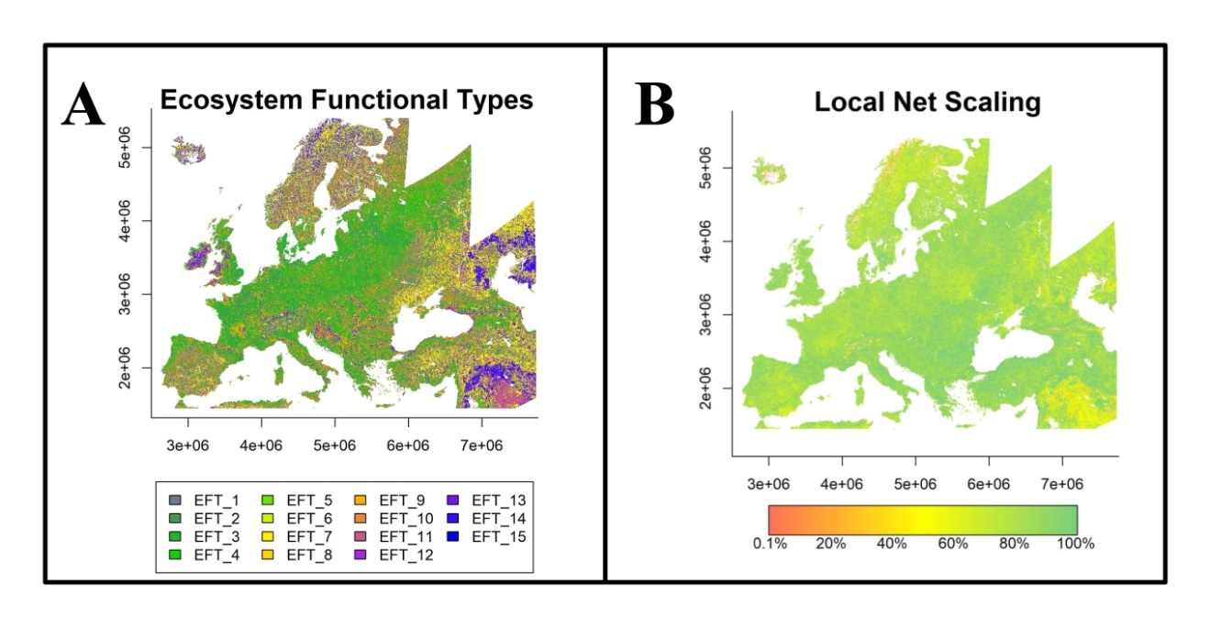

Figure 3: (A) Ecosystem Functional Types (EFTs) derived from phenological and productivity variables using the K-means clustering method. (B) Local Net Primary Production Scaling (LNS): proportion of annual production (i.e. average of the last 5 years of cyclic fraction) over the local potential production (i.e. the 90-percentile within the Ecosystem Functional Type)

## Local Net Production Scaling

The Local Net Primary Production Scaling (from now on, Local Net Scaling or LNS) method (Prince, 2009) is based on the use of multi-temporal satellite data to calculate the difference between the potential and actual Net Primary Production for each pixel in homogeneous land functional units. Potential productivity in the *LPDynR* method is defined as the productivity level which could be reached without human influence in natural landscapes (Prince, 2009, and references therein) or as the result of human activity e.g. in agriculture areas or managed forests, and is estimated as the maximum value of productivity within each Ecosystem Functional Type. The deviation of the productivity found in a particular place and time as referred to the local maximum within its phenological homogeneous cluster, reflects a level of productivity anomaly which is useful for the productivity status map (Ivits and Cherlet, 2013).

The cyclic fraction of vegetation productivity (e.g. the summed NDVI over the growing season) is widely used as a proxy for the estimation of the current land productivity (Fensholt, 2013), as it incorporates both natural and anthropogenic factors which define the inter-annual variability of land production. Therefore, it represents that part of the standing biomass which is potentially appropriated to be used by humans and the environment (Ivits and Cherlet, 2013) and it is the one appropriated to calculate the Local Net Scaling.

The function *LNScaling()* is implemented in *LPDynR* to calculate the LNS. The productivity variable (i.e. Cyclic fraction) and the EFTs clusters as explained under 5.1 are passed to *LNScaling()* to calculate the potential productivity within each EFT. Instead of the maximum productivity value within each cluster, the 90-percentile value is established as the potential productivity value, given that values higher than this threshold could be outliers. Finally, the Local Net Scaling (LNS) for each pixel is calculated as

(2)

where *AP* is the annual production of the pixel (i.e. the average of the last 5 years of cyclic fraction) and *PPEFT* is the potential production within its Ecosystem Functional Type (i.e. the 90-percentile).

For the calculation of the final LPD indicator (i.e. combined assessment), the Local Net Scaling values are aggregated into two categories: (1) LNS pixels with less than 50% of the potential local production (within the EFT) and (2) LNS pixels with more or equal to 50% of potential local production. This percentage, being 50% the default in *LPDynR*, can be set by the user.

The result for the LNS calculation is presented in Figure 3B.

# Combined assessment of land productivity

The Land Productivity Dynamics indicator, as shown in the processing flowchart in Figure 1, is based on the combination of two main sources of information: a map of the tendency, positive or negative, of the level of land productivity along the time series, and another map capturing the current level of productivity of each pixel relative to the maximum productivity in a homogeneous land area. As seen above, both branches to calculate the indicator are qualitative methods. Therefore, the final LPD indicator, produced with the function *LPD_CombAssess()*, is also a qualitative measure with 5 possible values or categories after the reclassification of each pixel as shown in Table 3. Such categories are (1) d - Declining, (2) ed - Early signs of decline, (3) st - Stable but stressed, (4) sn - Stable and not stressed and (5) i - Increasing land productivity.

Table 3: Lookup table for the combination of the two branches assessment (i.e. Long Term Change Map and Current Status Map of land productivity) to derive the Land Productivity Dynamics categories (i.e. (1) d - Declining land productivity, (2) ed - Early signs of decline of land productivity, (3) st - Stable but stressed land productivity, (4) sn - Stable and not stressed land productivity and (5) i - Increasing land productivity). The Local Scaling is defined as 50% by default, but it can be modified by the user

|  |  |  |  |  |
| --- | --- | --- | --- | --- |
|  |  |  | **Local Scaling** | |
| **Steadiness I.** | **Baseline L.** | **State Change** | < 50% | >= 50% |
| st1 | lo | 0 | **d** | **ed** |
| st1 | lo | 1 | **d** | **ed** |
| st1 | lo | 2 | **d** | **d** |
| st1 | me | 0 | **d** | **ed** |
| st1 | me | 1 | **d** | **ed** |
| st1 | me | 2 | **d** | **d** |
| st1 | hi | 0 | **ed** | **st** |
| st1 | hi | 1 | **d** | **ed** |
| st1 | hi | 2 | **d** | **ed** |
| st2 | lo | 0 | **st** | **st** |
| st2 | me | 0 | **st** | **st** |
| st2 | hi | 0 | **st** | **st** |
| st3 | lo | 0 | **sn** | **sn** |
| st3 | me | 0 | **sn** | **sn** |
| st3 | hi | 0 | **sn** | **sn** |
| st4 | lo | 0 | **sn** | **i** |
| st4 | lo | 1 | **sn** | **i** |
| st4 | lo | 2 | **i** | **i** |
| st4 | me | 0 | **sn** | **i** |
| st4 | me | 1 | **i** | **i** |
| st4 | me | 2 | **i** | **i** |
| st4 | hi | 0 | **i** | **i** |

In the present study, the Land Productivity Dynamics indicator final map (Figure 4) is the result of the combined assessment of the Long Term Change Map (Figure 2D) and the Current Status Map of land productivity (Figure 3B), both based on the “Above ground vegetation productivity” variable, plus the two phenological variables for the derivation of the EFTs. The map shows an overall positive trend pattern in Europe in the period 2000-2019, with some aggregations of declining and early signs of decline areas in the Iberian Peninsula as well as in the Middle East region.

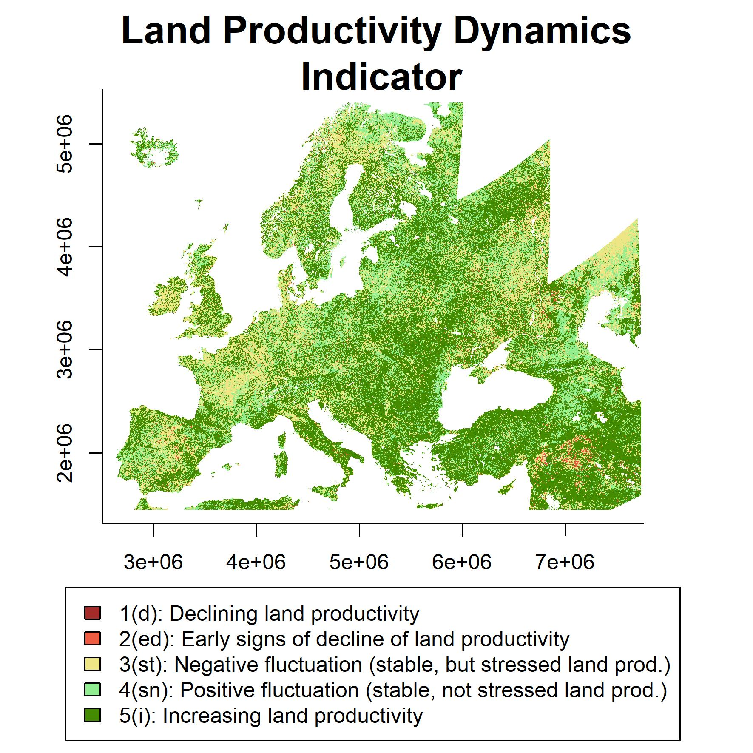

Figure 4: Land Productivity Dynamics indicator final map (2000-2019). Combined assessment of the Long Term Change Map and the Current Status Map of land productivity.(1) d - Declining land productivity, (2) ed - Early signs of decline of land productivity, (3) st - Stable but stressed land productivity, (4) sn - Stable and not stressed land productivity and (5) i - Increasing land productivity

The pattern shown by the indicator (Fig. 4) is similar to the one published in the World Atlas of Desertification (Cherlet et al., 2018), produced with a similar approach, but with a shorter time series (1999-2013) of Copernicus Global Land SPOT VGT products of NDVI. Similarly, for another example, but getting focused on Italy, the results of the case study are also quite in line with Sciortino et al. (2020), although they used a very different methodology and slightly shorter time series (2000-2015). Finally, Figure 5 shows the indicator calculated with *LPDynR*, but using time series (2000-2015) of the sum of the NDVI Copernicus products for complete calendar years, and the Copernicus Land Cover product to derive the Ecosystem Functional Types (Gianoli et al., unpublished data). Apart from some similarities found for some areas, the difference between the two maps are due to the characteristics of the two datasets but mainly due to difference in length of the time series. The latter map ends in 2015 which was a particular dry year in Europe (Orth et al., 2016) and in the *LPDynR* method, being tailored for land degradation assessment purposes, the last years of the series weight substantially on the results. However, in-depth thematic analysis is not within the scope of this paper.

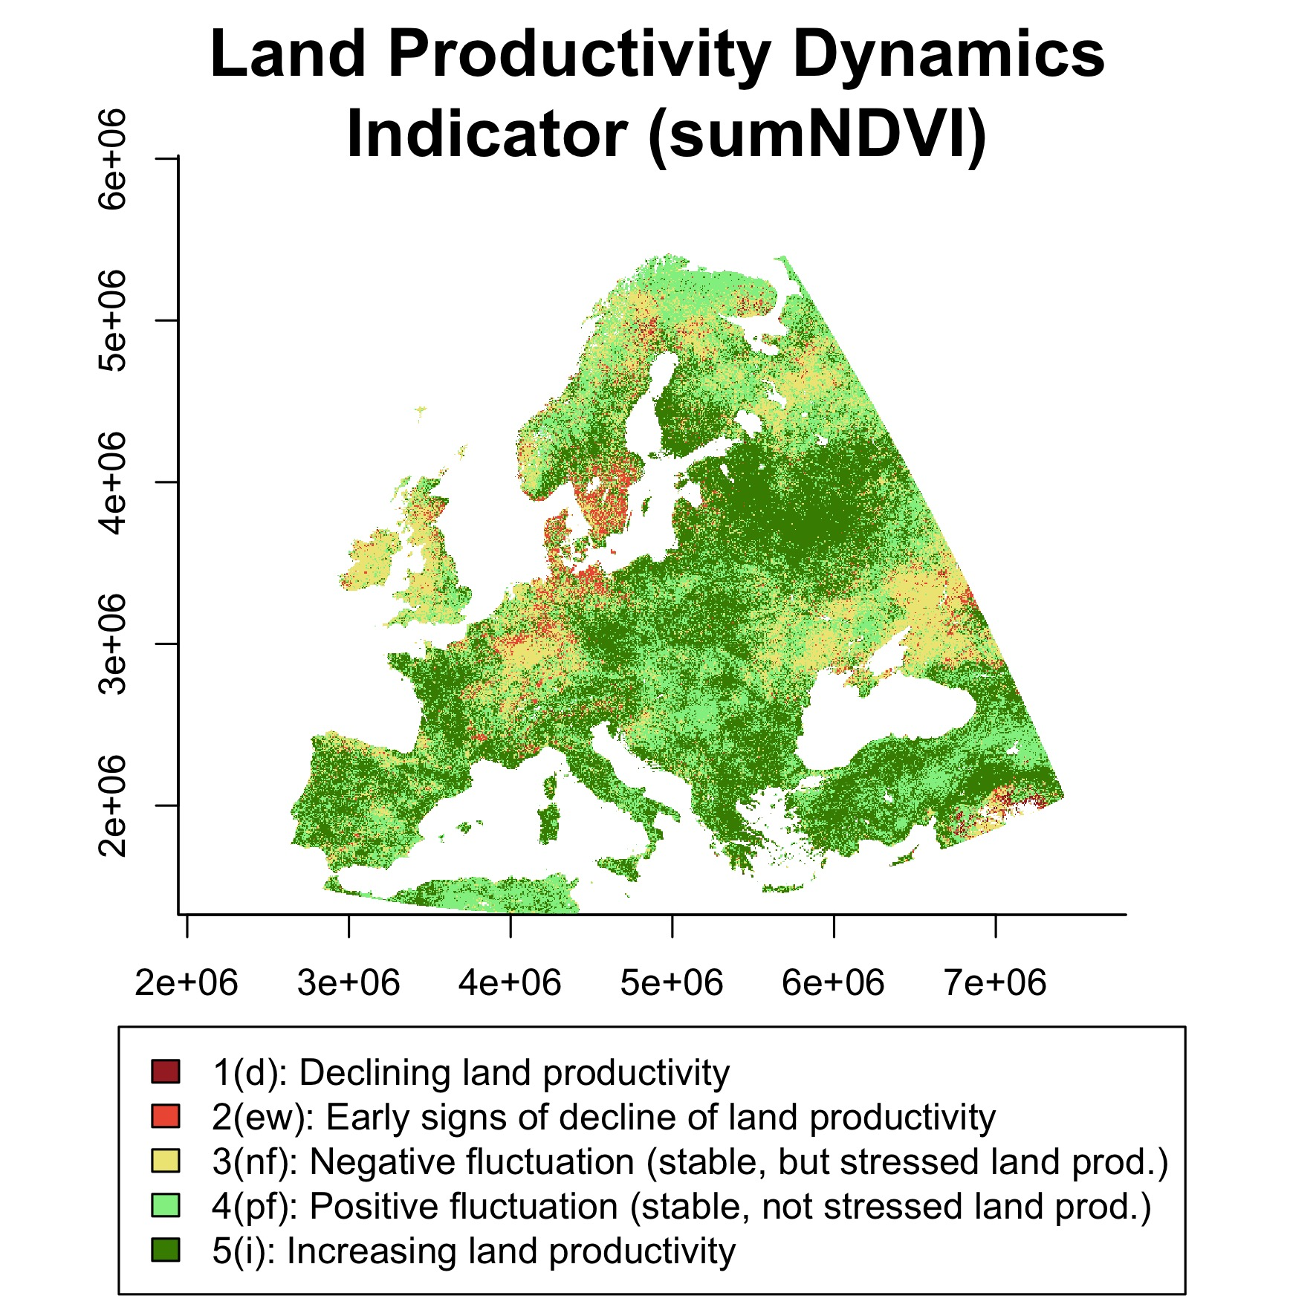

*Figure 5: Land Productivity Dynamics indicator calculated using time series (2000-2015) of the sum of the NDVI Copernicus products for complete calendar years, and the Copernicus Land Cover product to derive the Ecosystem Functional Types (Gianoli et al., unpublished data). (1) d - Declining land productivity, (2) ed - Early signs of decline of land productivity, (3) st - Stable but stressed land productivity, (4) sn - Stable and not stressed land productivity and (5) i - Increasing land productivity*

## Alternative method for the Land Productivity Dynamics indicator

Including the current level of land productivity relative to its potential (Chapter 5; Local Net Scaling) in the final Land Productivity Dynamics calculation (Chapter 6) improves the land productivity indicator. For example, pixels which may indicate a negative tendency along the observation period, may still remain at high levels of productivity relative to other similar areas nearby at the end of the period. Despite this additional information the Local Net Scaling provides, the user might want to derive the final product based only on the tendency map (i.e. Long Term Change Map; Chapter 4), leaving out the Current Status Map (Chapter 5). The function *LPD_CombAssess()* performs this step by passing the argument *LandProd_current = NULL*. By doing so, the function reclassifies the Long Term Change Map into the same 5 categories of the LPD indicator described above. Table 4 shows how the function executes the reclassification of the first three columns, resulting in the LPD class in the 4th column.

Table 4: Lookup table for the reclassification of the Long Term Change Map into the Land Productivity Dynamics categories (i.e. (1) d - Declining land productivity, (2) ed - Early signs of decline of land productivity, (3) st - Stable but stressed land productivity, (4) sn - Stable and not stressed land productivity and (5) i - Increasing land productivity)

|  |  |  |  |
| --- | --- | --- | --- |
| **Steadiness I.** | **Baseline L.** | **State Change** | **LPD class** |
| st1 | lo | 0 | **d** |
| st1 | lo | 1 | **d** |
| st1 | lo | 2 | **d** |
| st1 | me | 0 | **d** |
| st1 | me | 1 | **d** |
| st1 | me | 2 | **d** |
| st1 | hi | 0 | **ed** |
| st1 | hi | 1 | **d** |
| st1 | hi | 2 | **d** |
| st2 | lo | 0 | **st** |
| st2 | me | 0 | **st** |
| st2 | hi | 0 | **st** |
| st3 | lo | 0 | **sn** |
| st3 | me | 0 | **sn** |
| st3 | hi | 0 | **sn** |
| st4 | lo | 0 | **sn** |
| st4 | lo | 1 | **sn** |
| st4 | lo | 2 | **i** |
| st4 | me | 0 | **sn** |
| st4 | me | 1 | **i** |
| st4 | me | 2 | **i** |
| st4 | hi | 0 | **i** |

A comparison of the final Land Productivity Dynamics indicator map produced using the combined assessment (i.e. Long Term Change Map + Current Status Map) with the one developed without the Current Status Map can be seen in Figure 6 (Map 1 and Map 2, respectively). In addition, the “differences map” in the same figure represents pixels which have a different class between the two approaches. The difference between the classes was always equal to minus 1, indicating that the difference between the two approaches is only one class. Furthermore, the combined indicator using the Local Net Scaling approach had higher values in all cases indicating a better potential to differentiate between land productivity conditions. Table 5 shows the number of pixels which changed from one class to another. From this table it can be seen how pixels never changed from negative to positive dynamics (class 3 to 4) or from positive to negative (class 4 to 3).

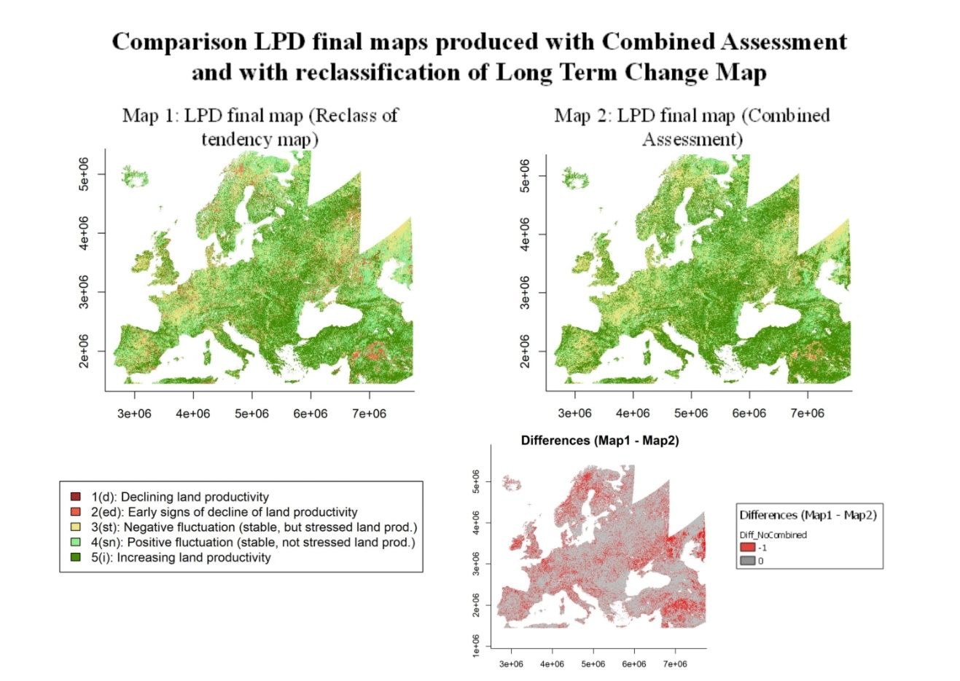

Figure 6: Land Productivity Dynamics indicator final maps derived by the reclassification of the Long Term Change Map of land productivity (Map 1) and produced by the combined assessment (Map 2; Long Term Change Map + Current Status Map). Differences Map (Map 1 - Map2) represents in red those pixels showing different resulting classes from both approaches

Table 5: Number of pixels showing different class in the combined assessment approach and in the non-combined one (i.e. reclassification of the Long Term Change Map). Only these three combinations were found in the case study

|  |  |  |  |
| --- | --- | --- | --- |
| **Non-combined Assessment - Class** | **Combined Assessment - Class** | **Number Pixels** | **Description** |
| 1 | 2 | 2439370 | Declining to early signs of decline |
| 2 | 3 | 355412 | Early signs of decline to Stable but stressed |
| 4 | 5 | 4964183 | Stable not stressed to Increasing |

Finally, Figure 7 shows the proportion of pixels per land productivity dynamic class under each approach, both for the whole extent (i.e. Europe) and also splitting the map by biogeographical regions. The biogeographical regions were defined with the official delineations used in the Habitats Directive (92/43/EEC) and for the EMERALD Network, which are freely distributed as a spatial data set by the European Environmental Agency - European Commission (<https://www.eea.europa.eu/data-and-maps/figures/biogeographical-and-marine-regions-in>).

The plots show that there were some differences in the proportion of pixels per class for each of the two approaches. For example, the Alpine, the Anatolian, and the Steppic regions were the three showing more differences, which ranged from 12.1 to 15.5% for some LPD classes. This fact evidences the added value of including the Current Status Map in the calculations to refine the Land Productivity Dynamics indicator final results.

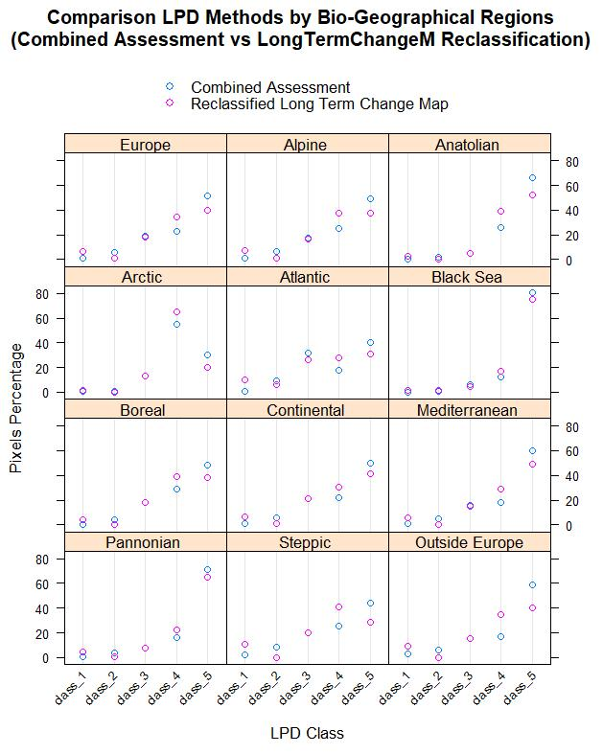

Figure 7: Proportion of pixels per Land Productivity Dynamics class for the combined assessment (light blue) and for the reclassified Long Term Change Map (purple), for Europe and by biogeographical regions

## Land Productivity Dynamics partial indicator

As seen in the previous subsections regarding the derivation of the tendency map (i.e. Long Term Change Map; Chapter 4), the final result is related to the years at the beginning and the end of the time series. In case the time series is long, the Land Productivity Dynamics indicator shows a long term assessment of what has happened regarding the land productivity dynamics between the beginning and the end of the period in the study. However, to understand the dynamics of the biomass within the observation period, as well as to assess the stability of the final product, it might be useful to produce several “partial LPD indicators”, or even “partial Long-Term Change Maps”, using different time windows of the time series.

This process is not yet implemented in *LPDynR* as a function, but we propose the following code to produce partial LPD maps of *n* years and with an overlap of *y* years between the end of the last period and the beginning of the next one. This example was implemented for the same case study shown along this article and the final partial Land Productivity Dynamics maps can be seen in Figure 8.

## Running LPDynR for partial time series ##   
   
ts_length <- 5 # time series length to run 'partial LPD maps'  
ts_years_overlap <- 2 # number of years of overlapping  
partial_dir <- "/LPD_partial" # directory to save the 'partial LPD' results  
first_year <- 1 # first year of the whole time series  
last_year <- nlayers(cf) # last year of the whole time series  
last_year_run <- first_year + ts_length - 1 # last year of the 'partial LPD'  
  
while(last_year_run <= last_year){  
 # subsetting the years (layers) to run  
 cf_run <- cf[[first_year:last_year_run]]  
  
 # a directory to save the data  
 dir2save0 <- paste0(getwd(), partial_dir)  
 if(!dir.exists(dir2save0)) dir.create(dir2save0)  
 dir2save <- paste0(getwd(), partial_dir, "/LPD_", first_year, "_", last_year_run, "/")  
 if(!dir.exists(dir2save)) dir.create(dir2save)  
   
 ## ##  
 ## ##  
 ## Here all the steps to calculate the ##   
 ## final LPD map as in the examples ##  
 ## ##  
 ## ##

# Cleaning temp

removeTmpFiles(h = 0.5)

# Parameters for the loop  
 first_year <- last_year_run - ts_years_overlap + 1  
 last_year_run <- first_year + ts_length - 1  
}

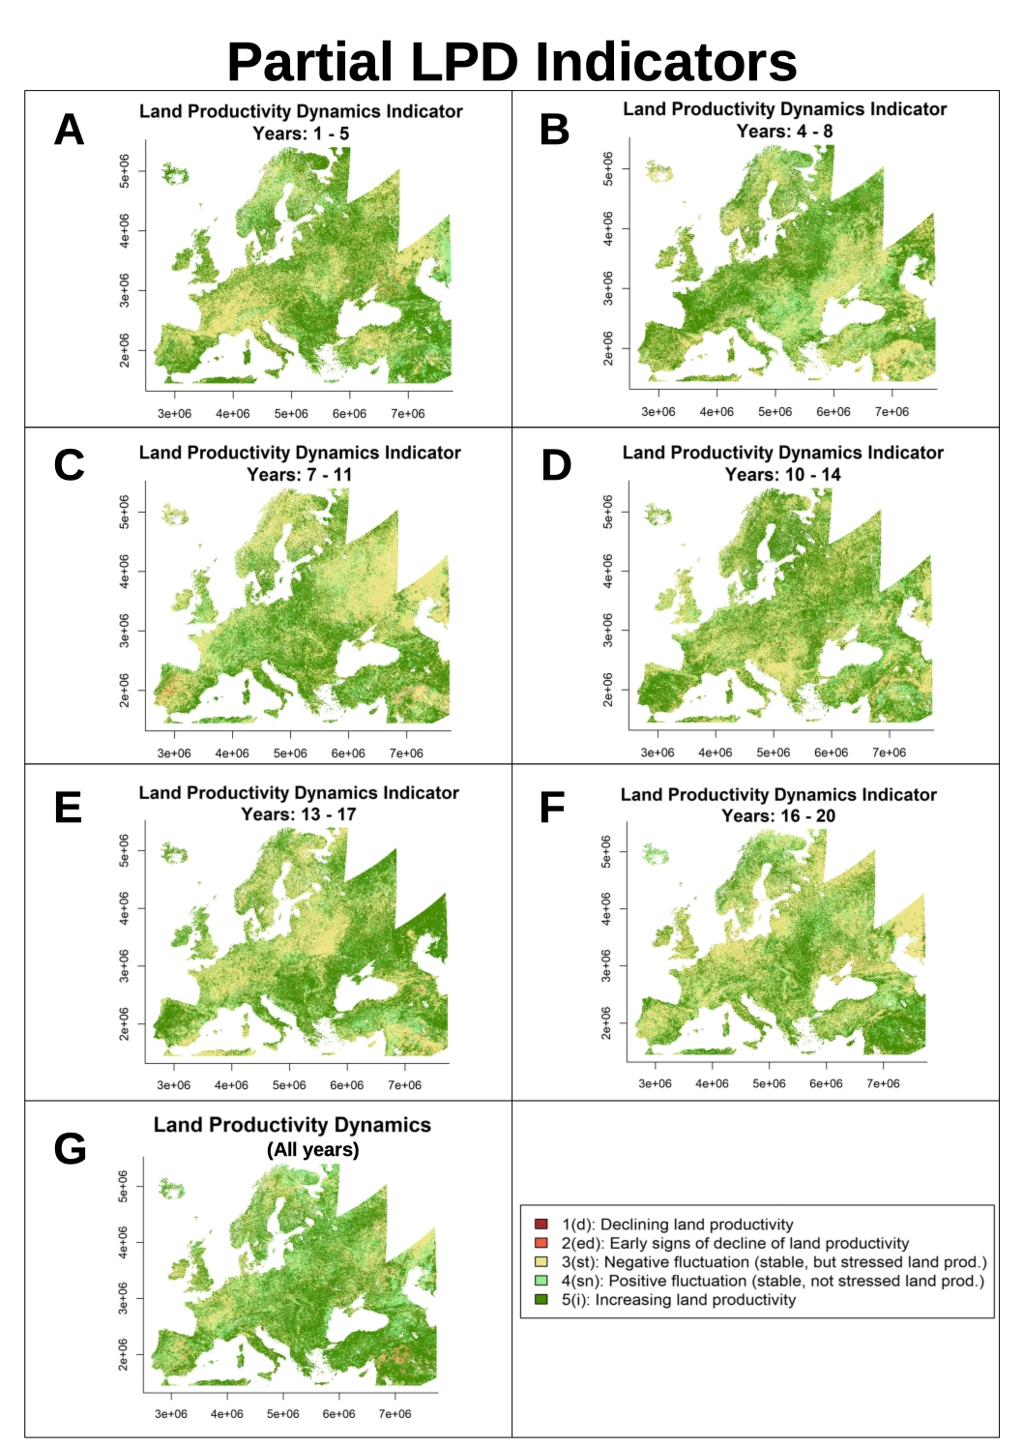

Figure 8: Partial LPD indicators (plots A to F) and LPD indicator for the whole time series (plot G). The partial LPD indicators were produced for time windows of 5 years with an overlap of 2 year between the end of the last period and the beginning of the next one

The complete LPD indicator (i.e. for the whole time series; Figure 8G) shows, in general terms, a positive dynamics pattern across Europe (i.e. more pixels in greens). However, some of the intermediate plots show more negative dynamics (i.e. yellow and light red pixels). This, besides demonstrating the highly fluctuating character of vegetation due mainly to weather conditions, specially rainfall (Kalisa et al., 2019), confirms the influence of the edges of the time series on the final result, such as dry spells and droughts in Europe (Moravec et al., 2021).

The fact that the LPD indicator calculated with the approach included in *LPDynR* is influenced by the beginning and the end of the time series is not a limitation, as the main goal of the LPD indicator is to know the current state of vegetation in relation to a previous state, and not the fluctuations due to, for example, to extreme climatic events such as e.g. droughts. However, being able to map these fluctuations in space and time might add information for further analysis.

# Conclusions

*LPDynR* is a comprehensive set of open source programming code, written in the well-known R language and properly packaged, ready to be freely distributed in order to let the users with a minimum knowledge of the R language calculate the Land Productivity Dynamics indicator. The package, once installed, includes several examples and a small data set for testing the functionalities and the different parameters to tune them. We have used *LPDynR* to calculate the indicator for Europe, showing that, in general terms, land productivity has experienced a positive dynamics during the past two decades in most of this area. Results obtained for intermediate or other time windows showed effects of specific growing conditions, such as droughts, during the end years of the time series. This is similar to other areas of the globe, where several processes of land degradation and desertification are occurring and affecting land productivity (Cherlet, et al., 2018).

As stated by the Intergovernmental Science-Policy Platform on Biodiversity and Ecosystem Services (IPBES), land degradation leads to a loss of biodiversity and a reduction of ecosystem functions and delivered services all over the world. Therefore, combating land degradation and restoring degraded lands has become an urgent priority in order to protect all life on Earth as well as to ensure human well-being (IPBES, 2018). In this sense, satellite observations provide valuable data which might help to monitor the Earth’s land cover to evaluate the state of land degradation. Moreover, knowledge on the current condition of land productivity as resulting from a longer term trend is useful when considering mitigation strategies.

As part of the Sustainable Development Goals, its indicator 15.3.1 aims at contributing to the assessment of the state of land degradation and desertification at global, regional and local scales. In this framework, the *LPDynR* new tool has been developed to compute the Land Productivity Dynamics indicator using phenological and land productivity variables derived from long-term time series of Earth observation imagery. *LPDynR* has, thus, the ambition of being a widely used tool to help scientists and practitioners to produce their own indicator.

# References

Cherlet, M., Hutchinson, C., Reynolds, J., Hill, J., Sommer, S., Maltitz, G. von (Eds.), 2018. World atlas of desertification. Publication Office of the European Union, Luxembourg.

Dubovyk, O., 2017. The role of remote sensing in land degradation assessments: Opportunities and challenges. European Journal of Remote Sensing 50, 601–613. <https://doi.org/10.1080/22797254.2017.1378926>

FAO, 2019. Trees, forests and land use in drylands: The first global assessment (FAO Forestry Paper No. 184). FAO, Rome.

Fensholt, K.K., Rasmus Rasmussen, 2013. Assessing land degradation/recovery in the african sahel from long-term earth observation based primary productivity and precipitation relationships. REMOTE SENSING 5, 664–686.

Guo, W.Q., Yang, T.B., Dai, J.G., Shi, L., Lu, Z.Y., 2008. Vegetation cover changes and their relationship to climate variation in the source region of the yellow river, china, 1990–2000. International Journal of Remote Sensing 29, 2085–2103. <https://doi.org/10.1080/01431160701395229>

IPBES, 2018. The ipbes assessment report on land degradation and restoration. Montanarella, l., scholes, r., and brainich, a. (Eds.). Secretariat of the Intergovernmental Science-Policy Platform on Biodiversity; Ecosystem Services, Bonn, Germany.

Ivits, E., Cherlet, M., 2013. Land-productivity dynamics towards integrated assessment of land degradation at global scales (Technical Report No. EUR 26052). Joint Research Centre of the European Commission.

Ivits, E., Cherlet, M., Horion, S., Fensholt, R., 2013. Global biogeographical pattern of ecosystem functional types derived from earth observation data. Remote Sensing 5, 3305–3330. <https://doi.org/10.3390/rs5073305>

Ivits, E., Cherlet, M., Mehl, W., Sommer, S., 2013. Ecosystem functional units characterized by satellite observed phenology and productivity gradients: A case study for europe. Ecological Indicators 27, 17–28. <https://doi.org/10.1016/j.ecolind.2012.11.010>

Ivits, E., Cherlet, M., Sommer, S., Mehl, W., 2013. Addressing the complexity in non-linear evolution of vegetation phenological change with time-series of remote sensing images. Ecological Indicators 26, 49–60. <https://doi.org/https://doi.org/10.1016/j.ecolind.2012.10.012>

Jin, H., Eklundh, L., 2014. A physically based vegetation index for improved monitoring of plant phenology. Remote Sensing of Environment 152, 512–525. <https://doi.org/https://doi.org/10.1016/j.rse.2014.07.010>

Jönsson, P., Eklundh, L., 2004. TIMESAT—a program for analyzing time-series of satellite sensor data. Computers & Geosciences 30, 833–845.

Kalisa, W., Igbawua, T., Henchiri, M. et al., 2019. Assessment of climate impact on vegetation dynamics over East Africa from 1982 to 2015. Scientific Reports 9, 16865. https://doi.org/10.1038/s41598-019-53150-0

Leroy B., Meynard C.N., Bellard C., Courchamp F., 2016. virtualspecies, an R package to generate virtual species distributions. Ecography 39, 599-607. https://doi.org/10.1111/ecog.01388

Middleton, N., Stringer, L., Goudie, A., Thomas, D., 2011. The forgotten billion. MDG achievement in the drylands. United Nations Development Programme, New York, NY, 10017, USA.

Moravec, V., Markonis, Y., Rakovec, O., Svoboda, M., Trnka, M., Kumar, R., Hanel, M., 2021. Europe under multi-year droughts: How severe was the 2014–2018 drought period? Environmental Research Letters 16, 034062. https://doi.org/10.1088/1748-9326/abe828.

Orr, B.J., Cowie, A.L., Castillo Sanchez, V.M., Chasek, P., Crossman, N.D., Erlewein, A., Louwagie, G., Maron, M., Metternicht, G.I., Minelli, S., Tengberg, W., A. E., Welton, S., 2017. Scientific conceptual framework for land degradation neutrality. In: A report of the science-policy interface. UNCCD, Bonn, Germany.

Orth, R., Zscheischler, J. & Seneviratne, S., 2016. Record dry summer in 2015 challenges precipitation projections in Central Europe. *Scientific Reports* 6, 28334 (2016). https://doi.org/10.1038/srep28334

Prince, I.R., S. D. Becker-Reshef, 2009. Detection and mapping of long-term land degradation using local net production scaling: Application to zimbabwe. REMOTE SENSING OF ENVIRONMENT 113, 1046–1057.

Sciortino, M., de Felice, M., de Cecco, L., Borfecchia, F., 2020. Remote sensing for monitoring and mapping Land Productivity in Italy: A rapid assessment methodology, Catena 188, 104375. https://doi.org/10.1016/j.catena.2019.104375.

Sims, N.C., Newnham, G.J., England, J.R., Guerschman, J., Cox, S.J.D., Roxburgh, S.H., Viscarra Rossel, R.A., Fritz, S. and Wheeler, I., 2021. Good Practice Guidance. SDG Indicator 15.3.1, Proportion of Land That Is Degraded Over Total Land Area. Version 2.0. United Nations Convention to Combat Desertification, Bonn, Germany.

Sims, N.C., Barger, N.N., Metternicht, G.I., England, J.R., 2020. A land degradation interpretation matrix for reporting on un sdg indicator 15.3.1 and land degradation neutrality. Environmental Science & Policy 114, 1–6. <https://doi.org/https://doi.org/10.1016/j.envsci.2020.07.015>

Sims, N.C., Green, C., Newnham, G.J., England, J.R., Held, A., Wulder, M.A., al., 2017. Good practice guidance sdg indicator 15.3.1. Proportion of land that is degraded over total land area, First. ed. United Nations Convention to Combat Desertification.

UN, 2015. Transforming our world: The 2030 agenda for sustainable development (No. A/RES/70/1). United Nations.

UNCCD, 2015. Integration of the sustainable development goals and targets into the implementation of the United Nations convention to combat desertification and the report of the intergovernmental working group on land degradation neutrality (No. ICCD/COP(12)/4). UNCCD Conference of the Parties, Ankara, Turkey.

Yengoh, G.T., Dent, D., Olsson, L., Tengberg, A.E., Tucker, C.J., 2015. Use of the normalized difference vegetation index (ndvi) to assess land degradation at multiple scales, Springer briefs in environmental science. Springer.