LAND PRODUCTIVITY DYNAMICS

19/03/2020

Table of Contents

# Abstract

(Ivits et al. 2016)

# Introduction (Background)

Table 1

1. general introduction UNCCD, SDG 15.3, Indicator
2. Land Productivity Dynamics Map:

Include here a diagram of the whole process

Figure 1

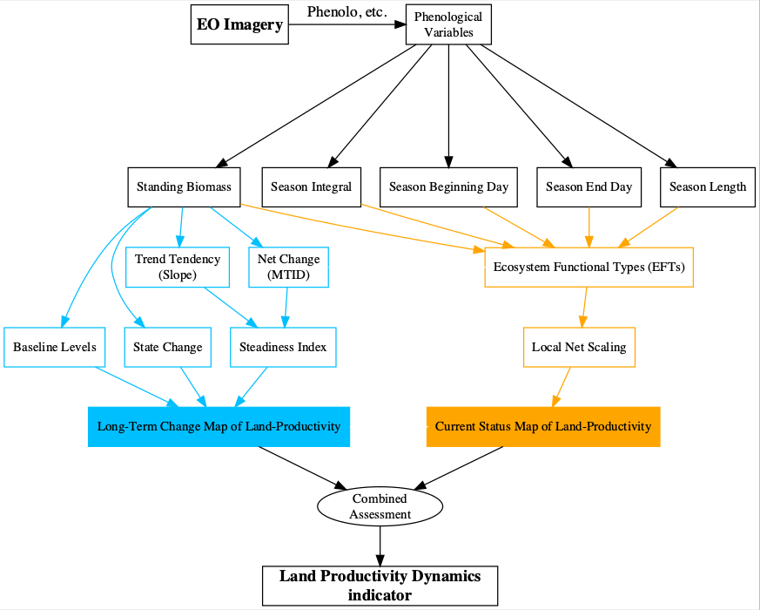

Figure 1: Flowchart of the process to calculate the Land-Productivity Dynamics indicator

Phenological variables (Phenolo or others), Net Primary Productivity, etc (include here Eva’s graph: Figure 3: Schematic representation of the main phenological and productivity variables calculated by Phenolo (reprint from Ivits et al., 2013a).)

Land Productivity Dynamics Map = Long Term Change Map + Current Status Map of Land-Productivity

Qualitative indicator…

In order to illustrate the methodology presented in this document, we use a data set of 5 phenological variables, at global level and 1km resolution, obtained with *Phenolo*, a software developed at the EC - Joint Research Centre. *Phenolo* uses time series from different satellite sensors (NOAA, SPOT, etc.) and products (NDVI, fAPAR, etc.)(Ivits et al. 2013). In this case, the phenological products (i.e. Standing Biomass, Season Integral, Season Beginning Day, Season End Day, Season Length) are derived from SPOT Vegetation NDVI of the period 1999-2012.

# Phenolo

Should this part be removed?? I think so…

# Long-Term Change Map of Land-Productivity

## Steadiness Index for Standing Biomass

Figure 2

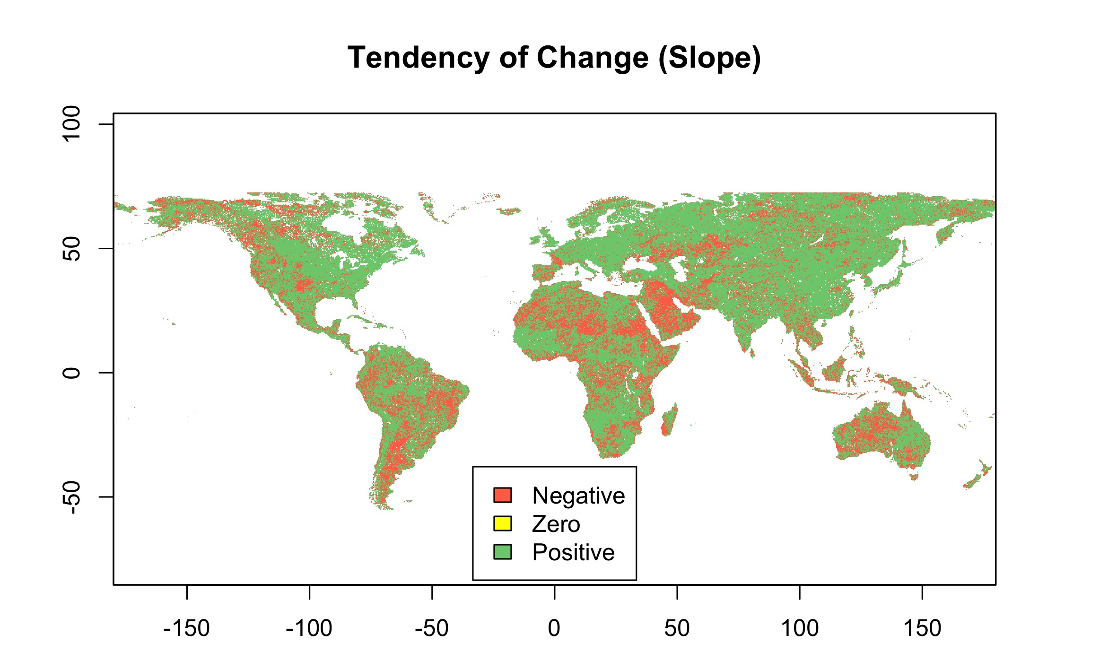

Figure 2: ble ble ble

## Combining Steadiness Index with Baseline Levels of Standing Biomass

## Standing Biomass State Change

## Land-Productivity Long Term Change Map

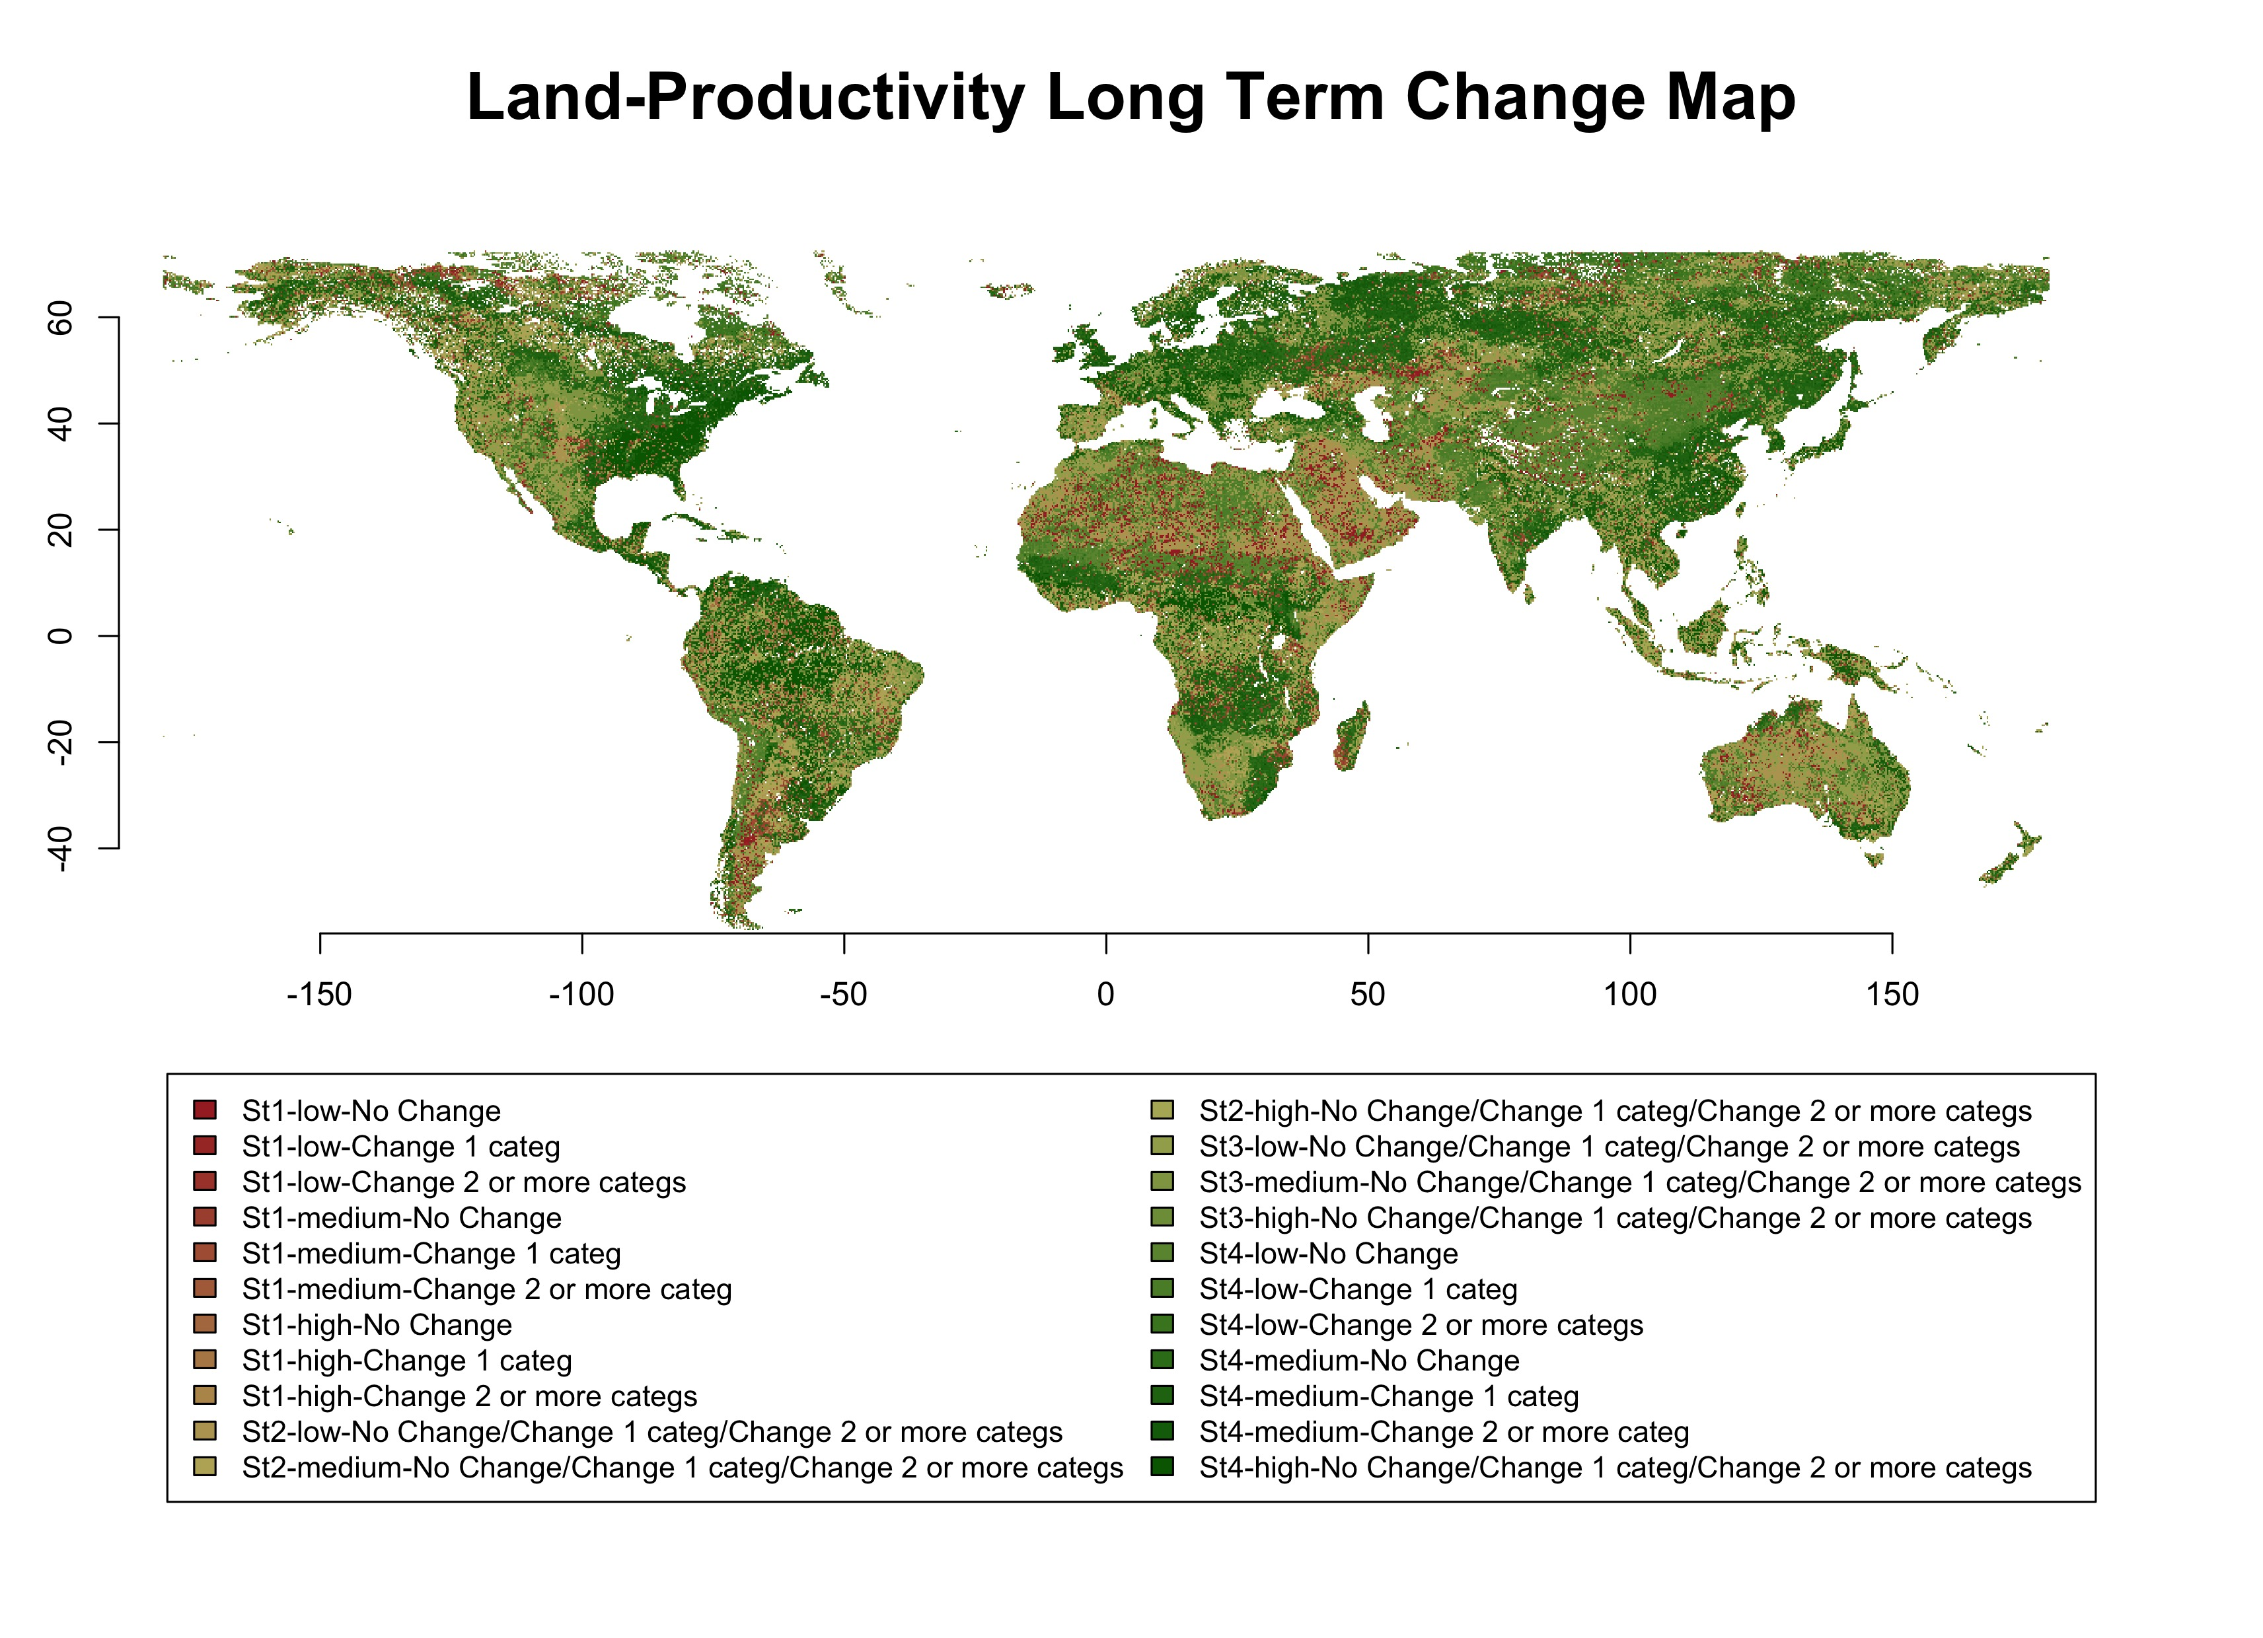

Figure 3: blu blu blu

# Current Status Map of Land-Productivity

## Ecosystem Functional Types (EFTs)

## Local Net Scaling

# Long Term Change Map + Current Status Map of Land-Productivity

# References

Ivits, E., M. Cherlet, W. Mehl, and S. Sommer. 2013. “Ecosystem Functional Units Characterized by Satellite Observed Phenology and Productivity Gradients: A Case Study for Europe.” *Ecological Indicators* 27: 17–28. doi:[10.1016/j.ecolind.2012.11.010](https://doi.org/10.1016/j.ecolind.2012.11.010).

Ivits, E., S. Horion, M. Erhard, and R. Fensholt. 2016. “Assessing European Ecosystem Stability to Drought in the Vegetation Growing Season.” *Global Ecology and Biogeography* 25 (9): 1131–43. doi:[10.1111/geb.12472](https://doi.org/10.1111/geb.12472).