DETERMINING THE MINIMAL BACKGROUND AREA FOR SPECIES DISTRIBUTION MODELS: MinBAR PACKAGE. SUPPLEMENTARY MATERIAL

Xavier Rotllan-Puig1,✉, and Anna Traveset2

1 ASTER Projects. Barri Reboll, 9, 1r. 08694 - Guardiola de Berguedà (Barcelona). Spain  
2 Terrestrial Ecology Laboratory. Global Change Research Group. Institut Mediterrani d’Estudis Avançats (CSIC-UIB). C/ Miquel Marqués, 21. 07190 - Esporles (Mallorca - Illes Balears). Spain

✉ Correspondence: [Xavier Rotllan-Puig <xavier.rotllan.puig@aster-projects.cat>](mailto:xavier.rotllan.puig@aster-projects.cat)

# Introduction

This is the Supplementary Material to the article “Determining the minimal background area for MaxEnt species distribution models: MinBAR package” (<https://CRAN.R-project.org/package=MinBAR>)

##### 

# Supplementary Material S1

Table S1: Example of an output of MinBAR. Buffer in km. (continued below)

|  |  |  |  |  |  |
| --- | --- | --- | --- | --- | --- |
| Species | Buffer | BoyceIndex_part | BoyceIndex_tot | SD_part | SD_tot |
| Prunus spinosa | 126.8 | 0.968 | 0.954 | NA | NA |
| Prunus spinosa | 228.1 | 0.982 | 0.185 | NA | NA |
| Prunus spinosa | 304.2 | 0.995 | 0.946 | NA | NA |
| Prunus spinosa | 384.3 | 0.989 | 0.992 | 0.01162 | 0.39 |
| Prunus spinosa | 476.3 | 0.993 | 0.996 | 0.005737 | 0.3971 |
| Prunus spinosa | 591.5 | 0.997 | 0.992 | 0.003416 | 0.02374 |
| Prunus spinosa | 746.1 | 1 | 1 | 0.004787 | 0.00383 |
| Prunus spinosa | 878.2 | 0.999 | 1 | 0.003096 | 0.00383 |
| Prunus spinosa | 1068 | 0.996 | 0.994 | 0.001826 | 0.004123 |
| Prunus spinosa | 3668 | 1 | 0.999 | 0.001893 | 0.002872 |

Table continues below

|  |  |  |  |  |  |
| --- | --- | --- | --- | --- | --- |
| ExecutionTime | rankBI_part | rankBI_tot | rankTime | rankFinalNoTime | rankFinalWithTime |
| 0.7504 | 10 | 8 | 1 | 9 | 8 |
| 0.9735 | 9 | 10 | 2 | 10 | 10 |
| 1.257 | 6 | 9 | 3 | 8 | 6 |
| 1.417 | 8 | 6 | 4 | 7 | 7 |
| 1.519 | 7 | 4 | 5 | 5 | 4 |
| 1.753 | 4 | 7 | 6 | 6 | 5 |
| 2.226 | 1 | 1 | 7 | 1 | 1 |
| 2.63 | 3 | 2 | 8 | 2 | 2 |
| 2.66 | 5 | 5 | 9 | 4 | 9 |
| 8.862 | 2 | 3 | 10 | 3 | 3 |

# Supplementary Material S2

Table S2.1: List of species used in case study 1

|  |  |
| --- | --- |
| Case.Study.1 | Abbreviation1 |
| Pinus sylvestris L. | pin_syl |
| Quercus ilex L. | que_ile |
| Fagus sylvatica L. | fag_syl |
| Fraxinus excelsior L. | fra_exc |
| Quercus petraea (Matt.) Liebl. | que_pet |
| Quercus robur L. | que_rob |
| Quercus pyrenaica Willd. | que_pyr |
| Quercus suber L. | que_sub |
| Abies alba Mill. | abi_alb |
| Acer platanoides L. | ace_pla |
| Alnus glutinosa (L.) Gaertn. | aln_glu |
| Juniperus oxycedrus L. | jun_oxy |
| Arbutus unedo L. | arb_une |
| Crataegus monogyna Jacq. | cra_mon |
| Prunus spinosa L. | pru_spi |
| Buxus sempervirens L. | bux_sem |
| Cotoneaster tomentosus Lindl. | cot_tom |
| Viola mirabilis L. | vio_mir |
| Diplotaxis erucoides DC. | dip_eru |
| Centaurea alba L. | cen_alb |
| Geranium lucidum L. | ger_luc |
| Linaria alpina Mill. | lin_alp |
| Pistacia terebinthus L. | pis_ter |
| Muscari comosum (L.) Mill. | leo_com |
| Lotus edulis L. | lot_edu |

The occurrences were downloaded from GBIF using *PreSPickR* (Rotllan-Puig, 2018)

Table S2.2: Citations of the data sets downloaded from GBIF and used in case study 1

|  |  |  |  |
| --- | --- | --- | --- |
| species | source | DOI | date_downloaded |
| ABIES ALBA MILL. | GBIF | 10.15468/dl.eo0lqe | 2018-03-04T17:37:26.441+0000 |
| ACER PLATANOIDES L. | GBIF | 10.15468/dl.idbrjq | 2018-03-04T17:43:00.642+0000 |
| ALNUS GLUTINOSA (L.) GAERTN. | GBIF | 10.15468/dl.6stmlq | 2018-03-04T17:53:48.872+0000 |
| ARBUTUS UNEDO L. | GBIF | 10.15468/dl.mez7r0 | 2018-03-04T17:59:43.726+0000 |
| BUXUS SEMPERVIRENS L. | GBIF | 10.15468/dl.vitxba | 2018-03-04T18:30:04.506+0000 |
| CENTAUREA ALBA L. | GBIF | 10.15468/dl.izlpzu | 2018-03-07T22:20:10.052+0000 |
| COTONEASTER TOMENTOSUS LINDL. | GBIF | 10.15468/dl.51ud43 | 2018-07-12T14:53:51.438+0000 |
| CRATAEGUS MONOGYNA JACQ. | GBIF | 10.15468/dl.lshmvs | 2018-03-04T18:10:29.057+0000 |
| DIPLOTAXIS ERUCOIDES DC. | GBIF | 10.15468/dl.djvzg0 | 2018-03-07T22:18:38.525+0000 |
| FAGUS SYLVATICA L. | GBIF | 10.15468/dl.u60ogx | 2018-02-22T23:14:34.322+0000 |
| FRAXINUS EXCELSIOR L. | GBIF | 10.15468/dl.fxzzxv | 2018-03-04T17:04:11.166+0000 |
| GERANIUM LUCIDUM L. | GBIF | 10.15468/dl.srgkdi | 2018-03-07T22:22:17.220+0000 |
| JUNIPERUS OXYCEDRUS L. | GBIF | 10.15468/dl.lnykuh | 2018-03-04T17:57:27.889+0000 |
| LINARIA ALPINA MILL. | GBIF | 10.15468/dl.phqgk3 | 2018-03-07T22:23:42.077+0000 |
| LOTUS EDULIS L. | GBIF | 10.15468/dl.gphxhp | 2018-03-07T22:29:38.764+0000 |
| MUSCARI COMOSUM (L.) MILL. | GBIF | 10.15468/dl.ff8tqr | 2018-03-07T22:28:23.186+0000 |
| PINUS SYLVESTRIS L. | GBIF | 10.15468/dl.lpqpm3 | 2018-02-22T23:00:00.299+0000 |
| PISTACIA TEREBINTHUS L. | GBIF | 10.15468/dl.g0zyyj | 2018-03-07T22:25:47.461+0000 |
| PRUNUS SPINOSA L. | GBIF | 10.15468/dl.dzldah | 2018-03-04T18:25:37.314+0000 |
| QUERCUS ILEX L. | GBIF | 10.15468/dl.yfpx0f | 2018-02-22T23:03:47.122+0000 |
| QUERCUS PETRAEA (MATT.) LIEBL. | GBIF | 10.15468/dl.1htw8l | 2018-03-04T17:15:52.716+0000 |
| QUERCUS PYRENAICA WILLD. | GBIF | 10.15468/dl.mpmnvw | 2018-03-04T17:31:41.099+0000 |
| QUERCUS ROBUR L. | GBIF | 10.15468/dl.ihampz | 2018-03-04T17:28:03.035+0000 |
| QUERCUS SUBER L. | GBIF | 10.15468/dl.uzpt1x | 2018-03-04T17:33:45.764+0000 |
| VIOLA MIRABILIS L. | GBIF | 10.15468/dl.6vyew0 | 2018-03-07T22:16:25.766+0000 |

##### 

# Supplementary Material S3

Figures S3.1 - S3.25: Evolution of Boyce Index Total (green) and Partial (blue), and the execution time in minutes (pink), for all the species in case study 1. The origin of the x-axis corresponds to the geographical centre of the species distribution (mean location for longitude/latitude coordinates dealing with angularity). The x-axis increases (in kilometres) with buffers 1 to 10, respectively the closest and the most distant to the centre of species distribution

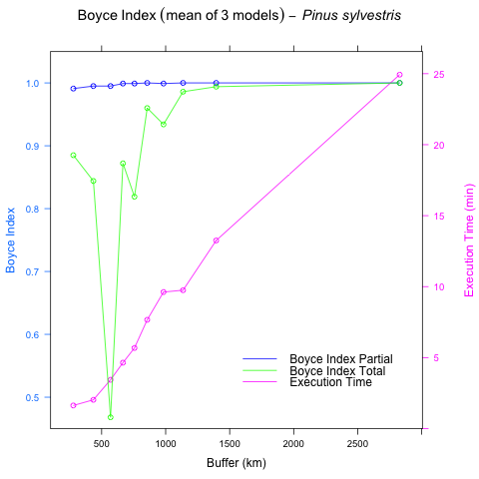

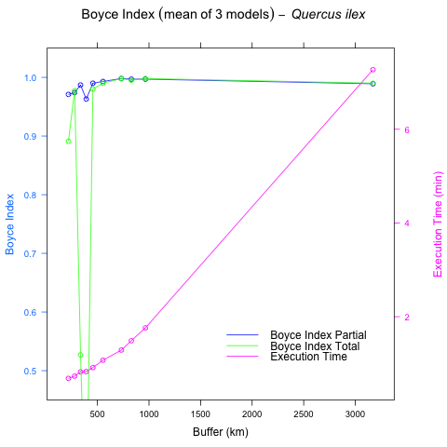

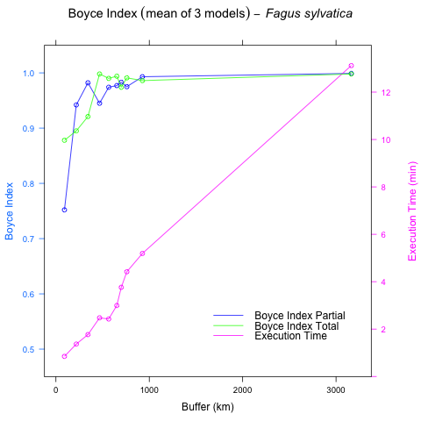

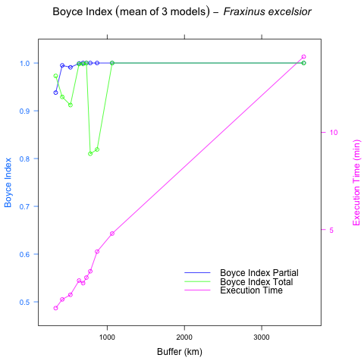

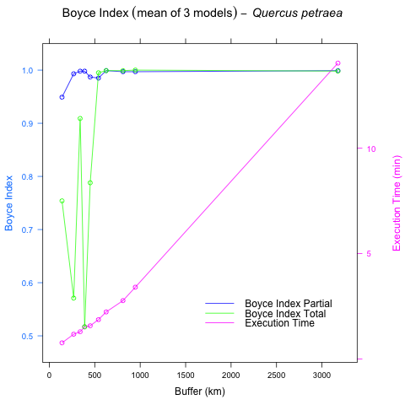

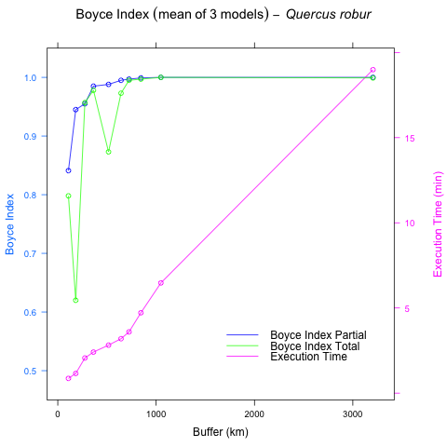

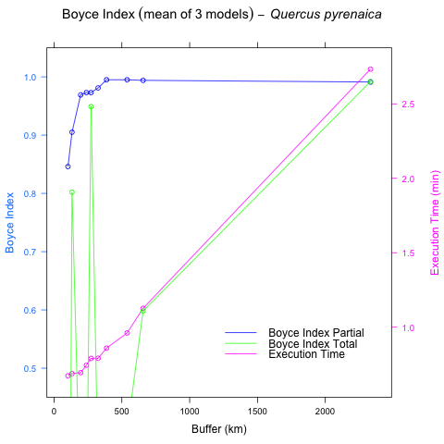

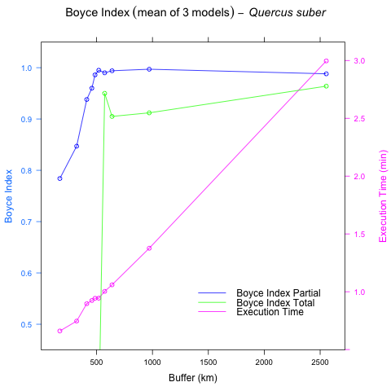

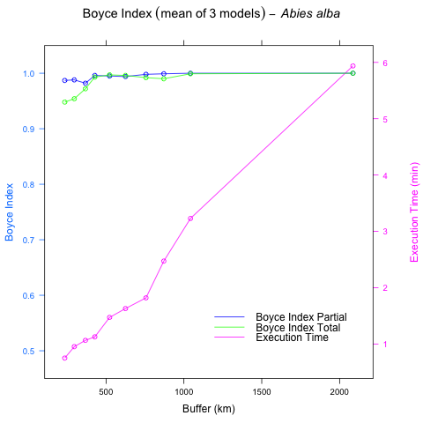

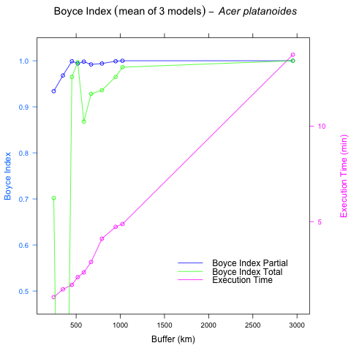

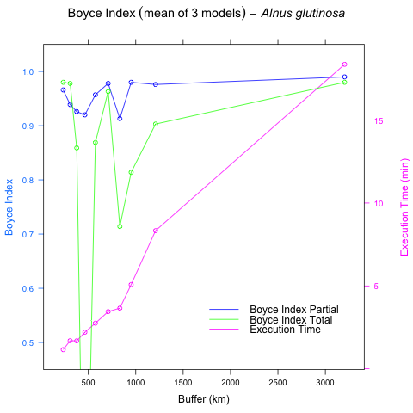

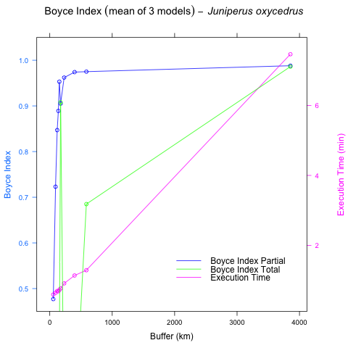

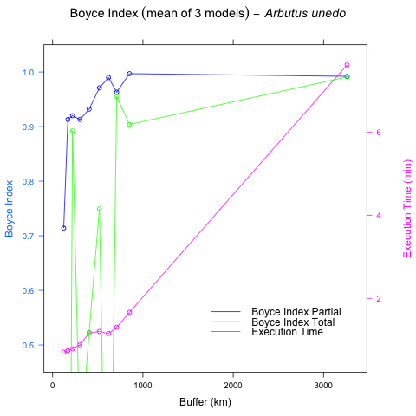 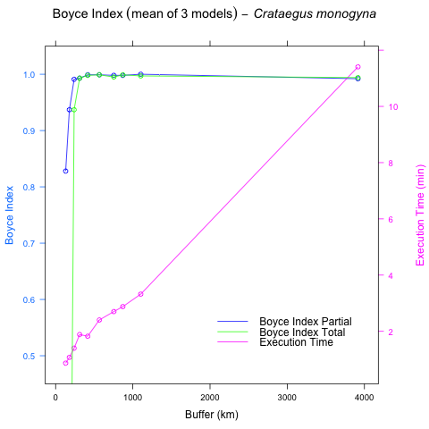 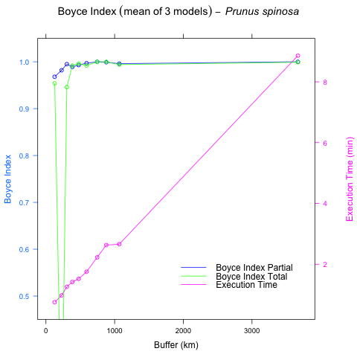 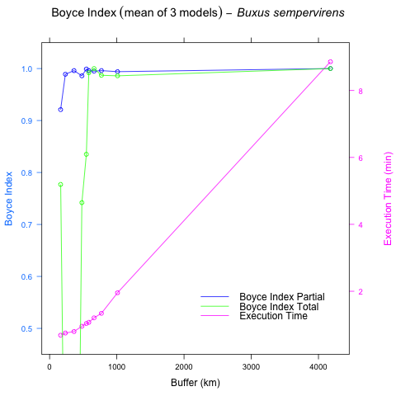 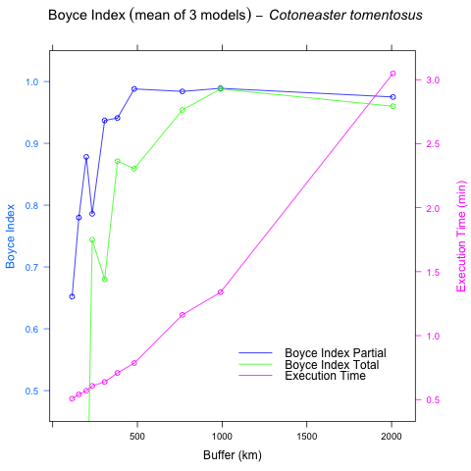 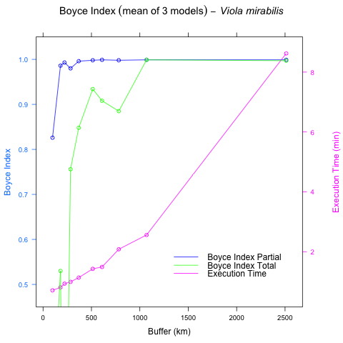

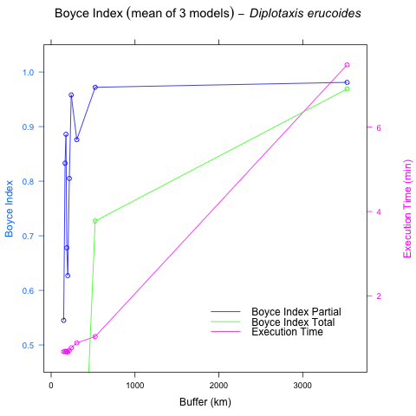

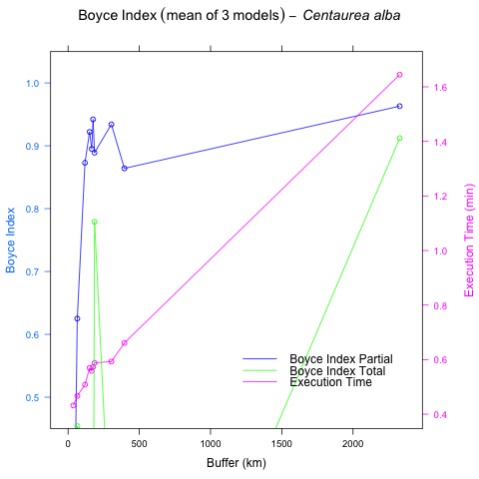

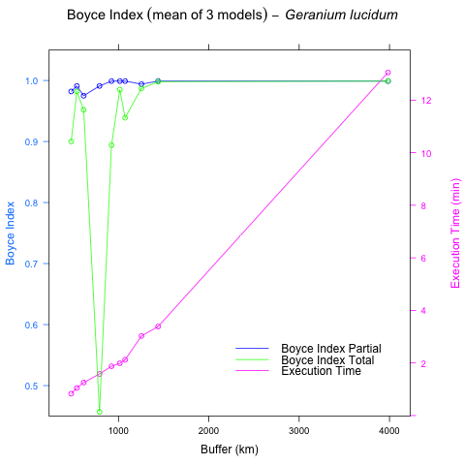

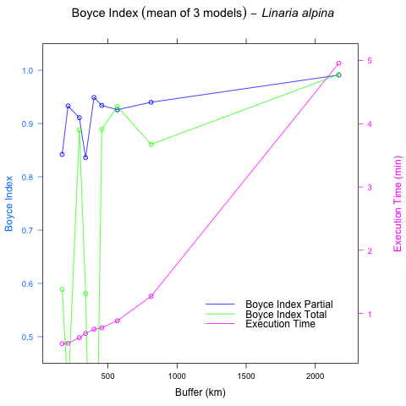

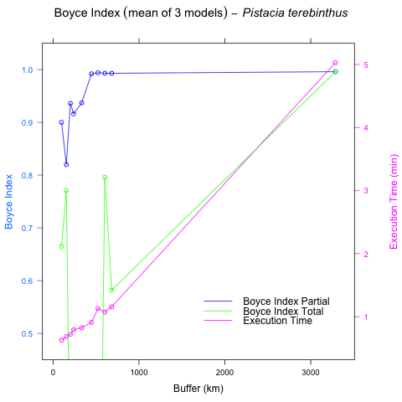

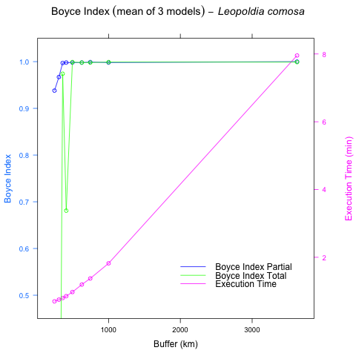

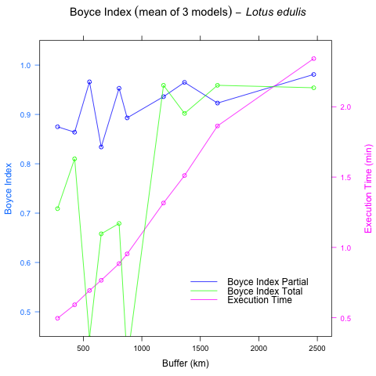

##### 

# Supplementary Material S4

Table S4.1: List of species used in case study 3 (Balearic Islands)

|  |  |
| --- | --- |
| Case.Study.2 | Abbreviation2 |
| Arbutus unedo L. | arb_une |
| Asphodelus aestivus Rchb. | asp_aes |
| Chamaerops humilis L. | cha_hum |
| Ephedra fragilis subsp. fragilis Desf. | eph_fra |
| Helichrysum stoechas (L.) Moench | hel_sto |
| Juniperus oxycedrus subsp. oxycedrus L. | jun_oxy |
| Pistacia lentiscus L. | pis_len |
| Quercus coccifera L. | que_coc |
| Rhamnus alaternus L. | rha_ala |
| Viburnum tinus L. | vib_tin |

Figure S4.1: Frequencies of best buffer with and without taking into account execution time in Case Study 3 (Balearic Islands)

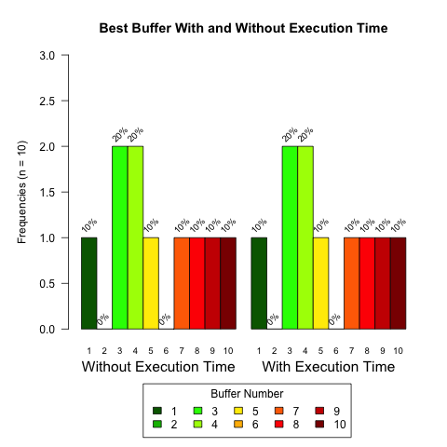

Figures S4.2 - S4.11: Evolution of Boyce Index Total (green) and Partial (blue), and the execution time in minutes (pink), for all the species in Case Study 3 (Balearic Islands). The origin of the x-axis corresponds to the geographical centre of the species distribution (mean location for longitude/latitude coordinates dealing with angularity). The x-axis increases (in kilometres) with buffers 1 to 10, respectively the closest and the most distant to the centre of species distribution

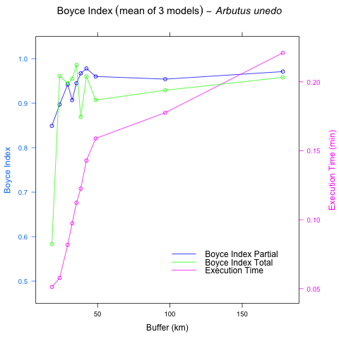

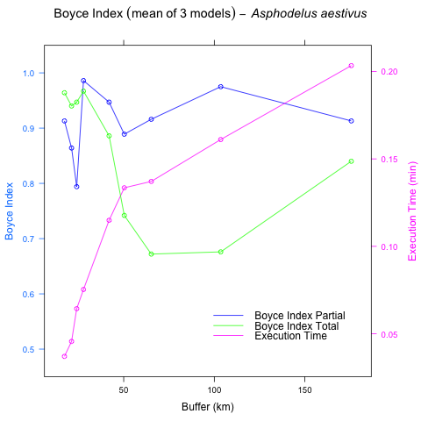

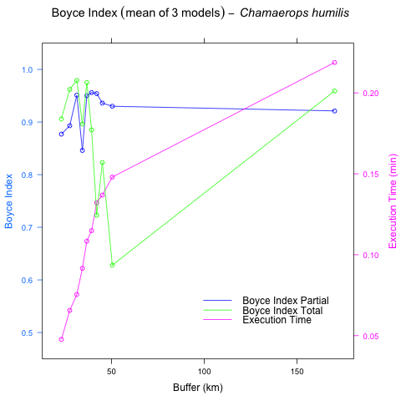

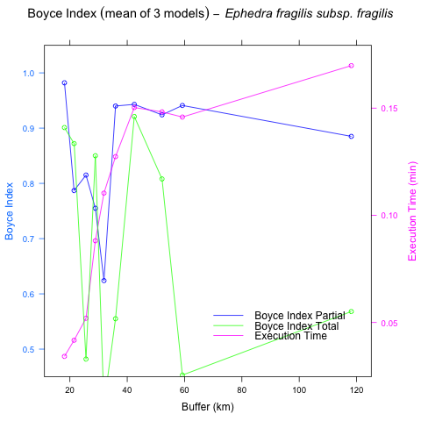

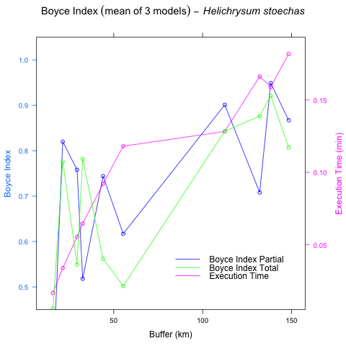

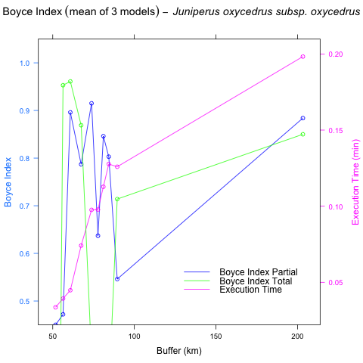

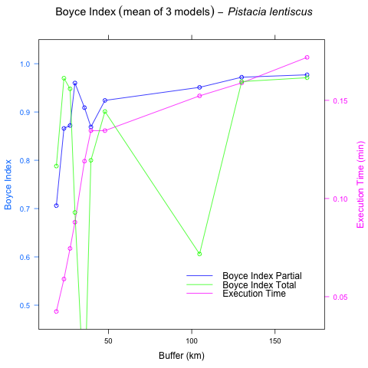

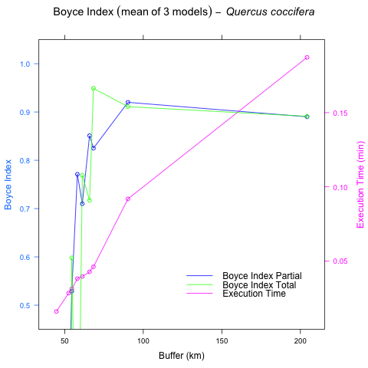

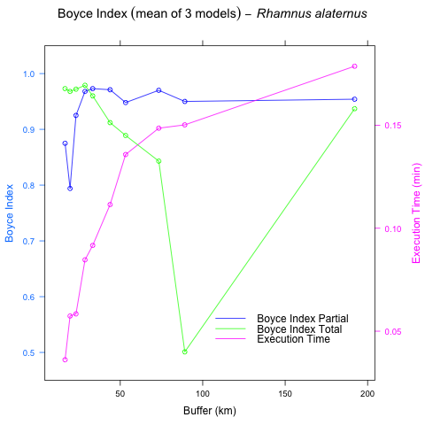

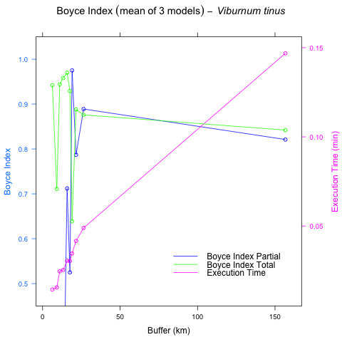

##### 

# References

Rotllan-Puig, X., 2018. PreSPickR: Downloading species presences (occurrences) from public repositories. <https://doi.org/10.13140/RG.2.2.10574.97607/1>