DETERMINING THE MINIMAL BACKGROUND AREA FOR SPECIES DISTRIBUTION MODELS: MinBAR PACKAGE. SUPPLEMENTARY MATERIAL

Xavier Rotllan-Puig & Anna Traveset(?)

# Introduction

This is the Supplementary Material to the article “Determining the minimal background area for MaxEnt species distribution models: MinBAR package”, published as a pre-print in BioRxiv with the DOI:

# Supplementary Material S1

Table S1: Example of an output of MinBAR. Buffer in km. (continued below)

|  |  |  |  |  |
| --- | --- | --- | --- | --- |
| Species | Buffer | BoyceIndex_part | BoyceIndex_tot | SD_part |
| Prunus spinosa | 126.8 | 0.986 | 0.843 | NA |
| Prunus spinosa | 228.1 | 0.992 | 0.911 | NA |
| Prunus spinosa | 304.2 | 0.988 | 0.913 | NA |
| Prunus spinosa | 384.3 | 0.999 | 0.946 | 0.005737 |
| Prunus spinosa | 476.5 | 0.998 | 0.912 | 0.005188 |
| Prunus spinosa | 591.5 | 0.999 | 0.988 | 0.005354 |
| Prunus spinosa | 746.2 | 0.988 | 0.976 | 0.005354 |
| Prunus spinosa | 878.1 | 0.999 | 0.995 | 0.005354 |
| Prunus spinosa | 1068 | 0.998 | 0.98 | 0.005354 |
| Prunus spinosa | 4942 | 0.999 | 0.999 | 0.005354 |

Table continues below

|  |  |  |  |  |
| --- | --- | --- | --- | --- |
| SD_tot | ExecutionTime | rankBI_part | rankBI_tot | rankTime |
| NA | 3.039 | 10 | 10 | 1 |
| NA | 3.461 | 7 | 9 | 2 |
| NA | 3.655 | 8 | 7 | 3 |
| 0.04325 | 3.794 | 1 | 6 | 4 |
| 0.01702 | 3.814 | 5 | 8 | 5 |
| 0.03584 | 4.017 | 2 | 3 | 6 |
| 0.03396 | 4.29 | 9 | 5 | 7 |
| 0.03799 | 5.061 | 3 | 2 | 9 |
| 0.008461 | 5.048 | 6 | 4 | 8 |
| 0.01121 | 8.097 | 4 | 1 | 10 |

|  |  |
| --- | --- |
| rankFinalNoTime | rankFinalWithTime |
| 10 | 9 |
| 9 | 5 |
| 8 | 6 |
| 4 | 1 |
| 6 | 7 |
| 1 | 2 |
| 7 | 10 |
| 2 | 3 |
| 5 | 8 |
| 3 | 4 |

# Supplementary Material S2

Table S2.1: List of species used in case study 1

|  |  |
| --- | --- |
| Case.Study.1 | Abbreviation1 |
| Pinus sylvestris L. | pin_syl |
| Quercus ilex L. | que_ile |
| Fagus sylvatica L. | fag_syl |
| Fraxinus excelsior L. | fra_exc |
| Quercus petraea (Matt.) Liebl. | que_pet |
| Quercus robur L. | que_rob |
| Quercus pyrenaica Willd. | que_pyr |
| Quercus suber L. | que_sub |
| Abies alba Mill. | abi_alb |
| Acer platanoides L. | ace_pla |
| Alnus glutinosa (L.) Gaertn. | aln_glu |
| Juniperus oxycedrus L. | jun_oxy |
| Arbutus unedo L. | arb_une |
| Crataegus monogyna Jacq. | cra_mon |
| Prunus spinosa L. | pru_spi |
| Buxus sempervirens L. | bux_sem |
| Cotoneaster tomentosus Lindl. | cot_tom |
| Viola mirabilis L. | vio_mir |
| Diplotaxis erucoides DC. | dip_eru |
| Centaurea alba L. | cen_alb |
| Geranium lucidum L. | ger_luc |
| Linaria alpina Mill. | lin_alp |
| Pistacia terebinthus L. | pis_ter |
| Muscari comosum (L.) Mill. | leo_com |
| Lotus edulis L. | lot_edu |

Table S2.2: List of species used in case study 2

|  |  |
| --- | --- |
| Case.Study.2 | Abbreviation2 |
| Ephedra fragilis subsp. fragilis | eph_fra |
| Quercus coccifera | que_coc |
| Chamaerops humilis | cha_hum |
| Asphodelus aestivus | asp_aes |
| Pistacia lentiscus | pis_len |
| Arbutus unedo | arb_une |
| Taxus baccata | tax_bac |

##### pagebreak

# Supplementary Material S3

Figures S3.1 - S3.25: Evolution of Boyce Index Total (green) and Parcial (blue), and the execution time in minutes (pink), for all the species in Case Study 1

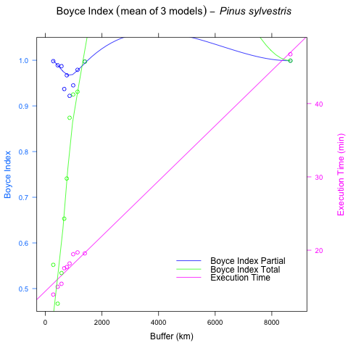

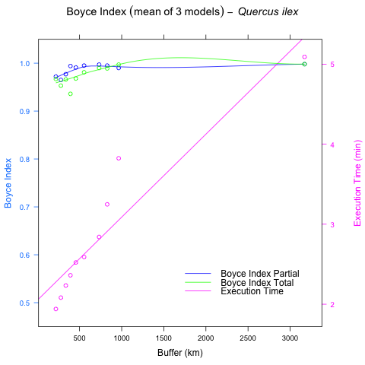

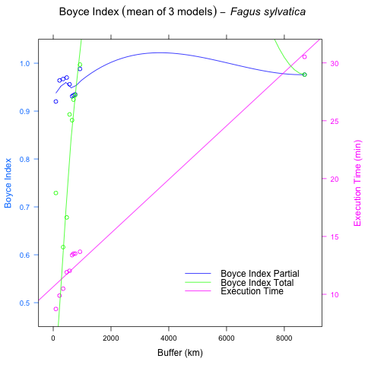

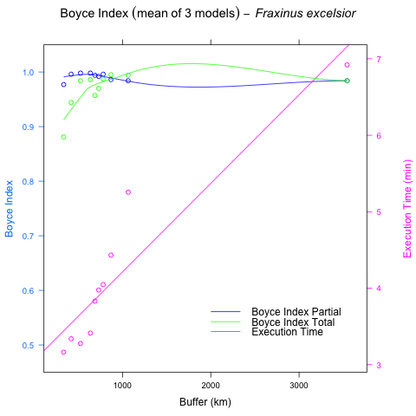

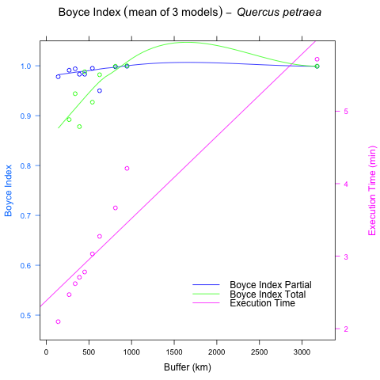

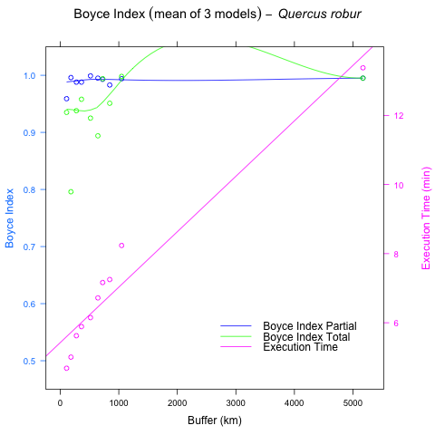

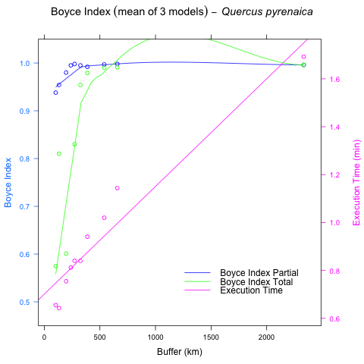

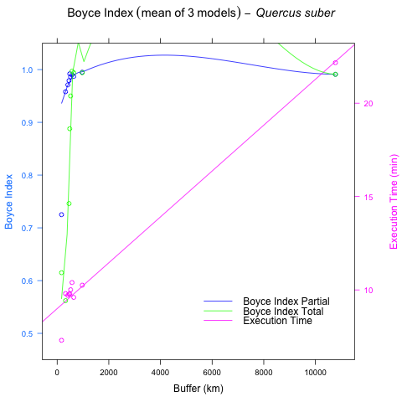

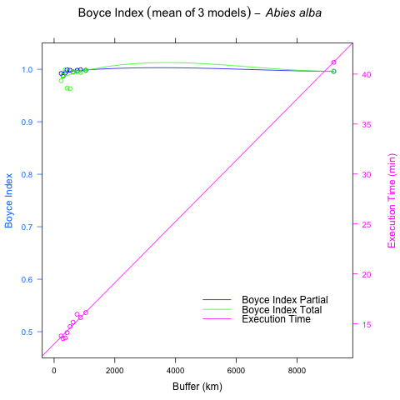

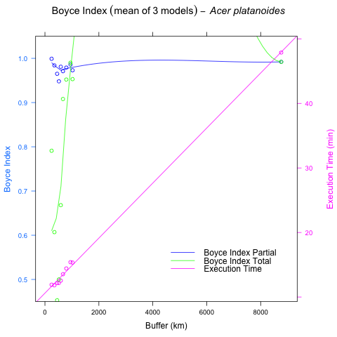

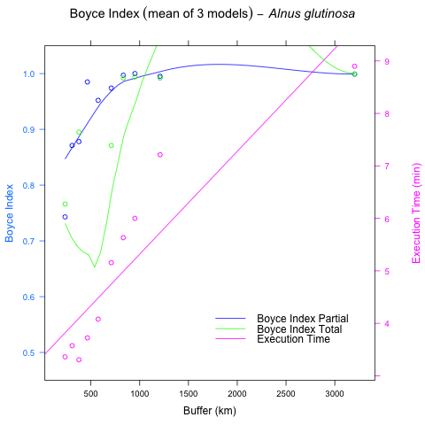

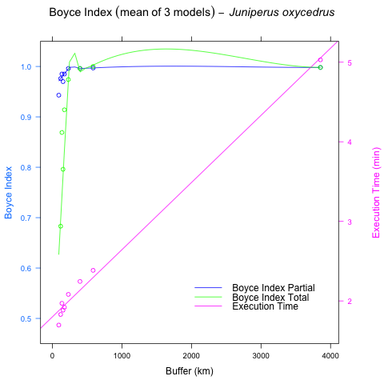

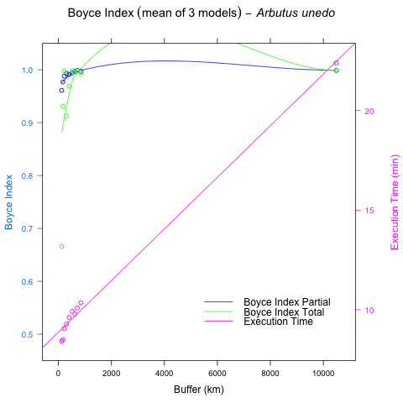 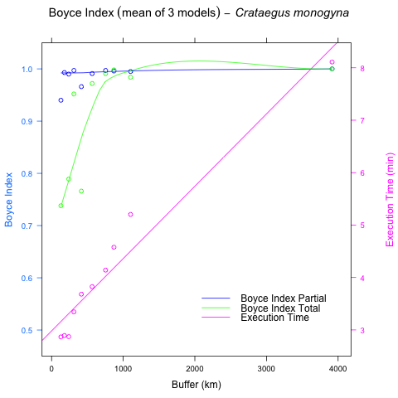 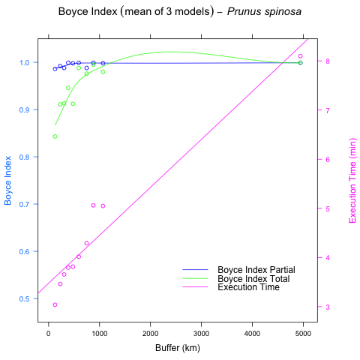 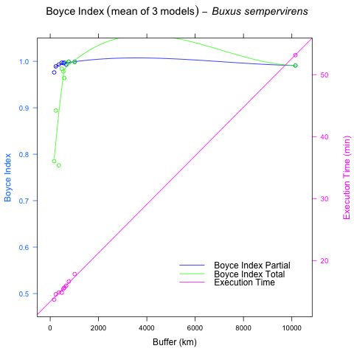 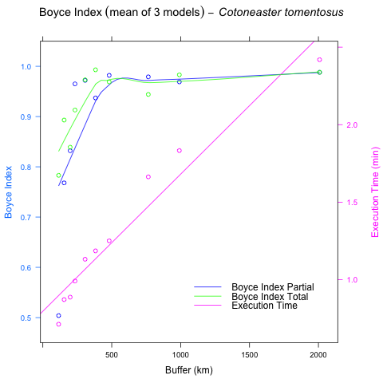 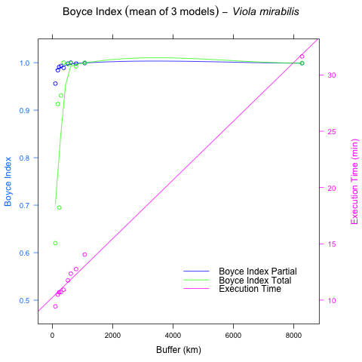

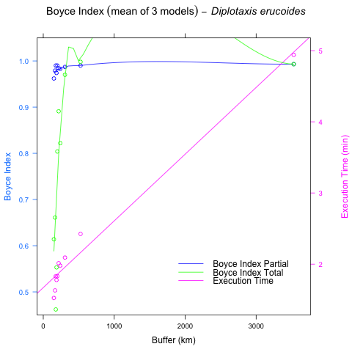

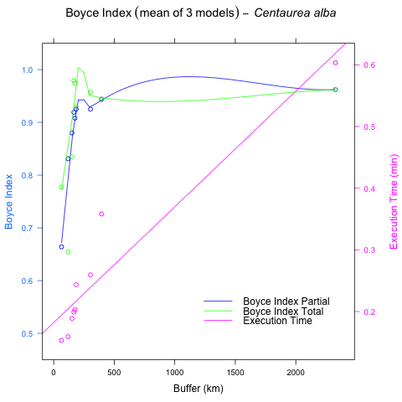

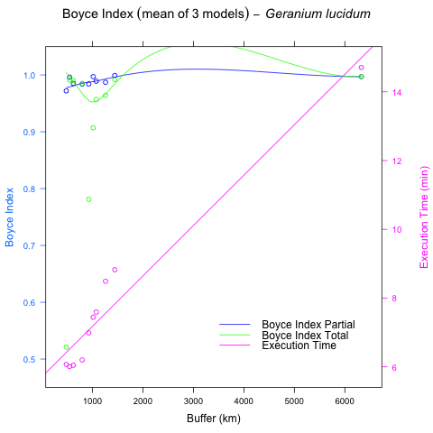

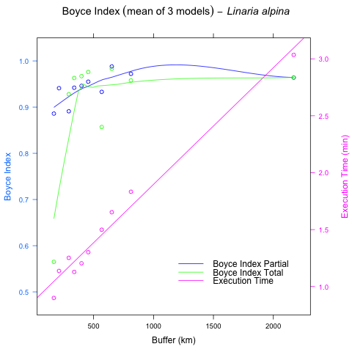

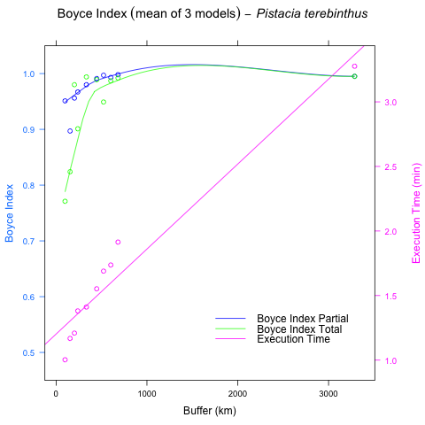

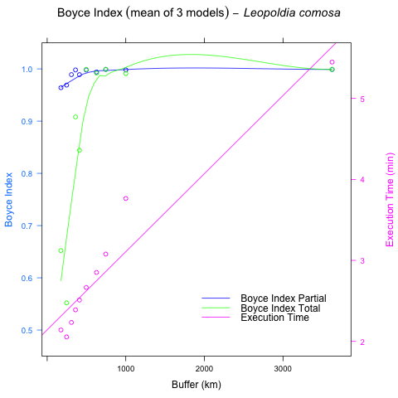

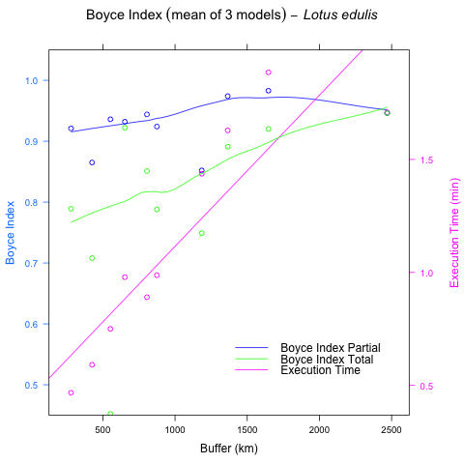

##### pagebreak

# Supplementary Material S4

Figures S4.1 - S4.7: Evolution of Boyce Index Total (green) and Parcial (blue), and the execution time in minutes (pink), for all the species in Case Study 2

