TUTORIAL EXAMPLE
SCIENTIFIC SUPPORT DOCUMENT FOR WORKFLOWS’ DEVELOPMENT BY ICT EXPERTS
Guidelines to help translating research questions into ICT requirements

- WORKFLOW TITLE – Soil and subsoil carbon sequestration metadata analysis as a function of land uses and agroecological practices

- COLLABORATORS –
Collaborator | Affiliation | Role in the Workflow | Contact
Xavier Rotllan-Puig | LifeWatch ERIC | Coordinator | xavier.rotllan@lifewatch.eu
Rosa Mosquera-Losada | USC | Scientific leader | mrosa.mosquera.losada@usc.es
José M. Avila | LifeWatch ERIC | Participant | josem.avila@lifewatch.eu
Iria Soto | LifeWatch ERIC | Participant | iria.soto@lifewatch.eu
Julio Paneque | LifeWatch ERIC | Participant | julio.paneque@lifewatch.eu

- CONTEXT & SCIENTIFIC QUESTIONS TO BE ANSWERED –
Background
AgroServ is a EU-funded project (2022-27) aimed at supporting research and innovation in agriculture and agroecology. It addresses challenges such as sustainable food production, climate change, resource conservation, and biodiversity enhancement by providing researchers with a wide range of research infrastructures and services.

Introduction
Soil carbon sequestration is key to mitigating climate change and improving agroecosystem productivity, with soils storing 85% of terrestrial carbon. However, data fragmentation hampers understanding of soil organic matter and its link to land use and management practices. To address this, AGRECOLVRE, funded under AgroServ's 1st Transnational/Virtual access call for research projects, will use a multi-dimensional approach. It will start with a stakeholder mapping and assessment of existing databases. A Qualitative Stakeholder Panel will capture user needs to customize a Soil Health module in the LifeWatch ERIC Virtual Research Environment (VRE) for Agroecology. Interdisciplinary collaboration will ensure the integration of specialized tools, providing researchers and policymakers with a standardized database and analytical platform to model, monitor, and enhance soil carbon sequestration. A case study will analyze the carbon storage potential as a result of the soil pH gradient and type of land use.

Aims
The primary goal of this workflow is to lay the foundation for the Soil Health VRE within the LifeWatch ERIC infrastructure, tailored to support research in agroecology and soil carbon dynamics, among others. The VRE will provide an integrated, user-oriented digital workspace for researchers and policy-makers to access, harmonise, visualise and analyse soil-related datasets, such as LUCAS and SUS-SOIL.
To develop, implement and validate the VRE’s capabilities, a case study on the carbon storage potential of soils across different land use types (forestlands, shrublands and grasslands) will be conducted. This study will use the available EU-wide LUCAS datasets to test data integration, workflow design, and numerical and visual outputs.

Scientific questions - Through the development of this workflow we aim at addressing the main scientific questions as follows:
Q1: Can we use LUCAS data (Topsoil and Core datasets) to assess the long-term impact of land use on the soils chemical variables at different scales (regional to EU)?
Q2: Can we assess the carbon sequestration potential of soils in relation to a soil pH gradient and different land use types across EU?

4. WORKFLOW DESCRIPTION:
4.1. INSERT YOUR WORKFLOW DIAGRAM
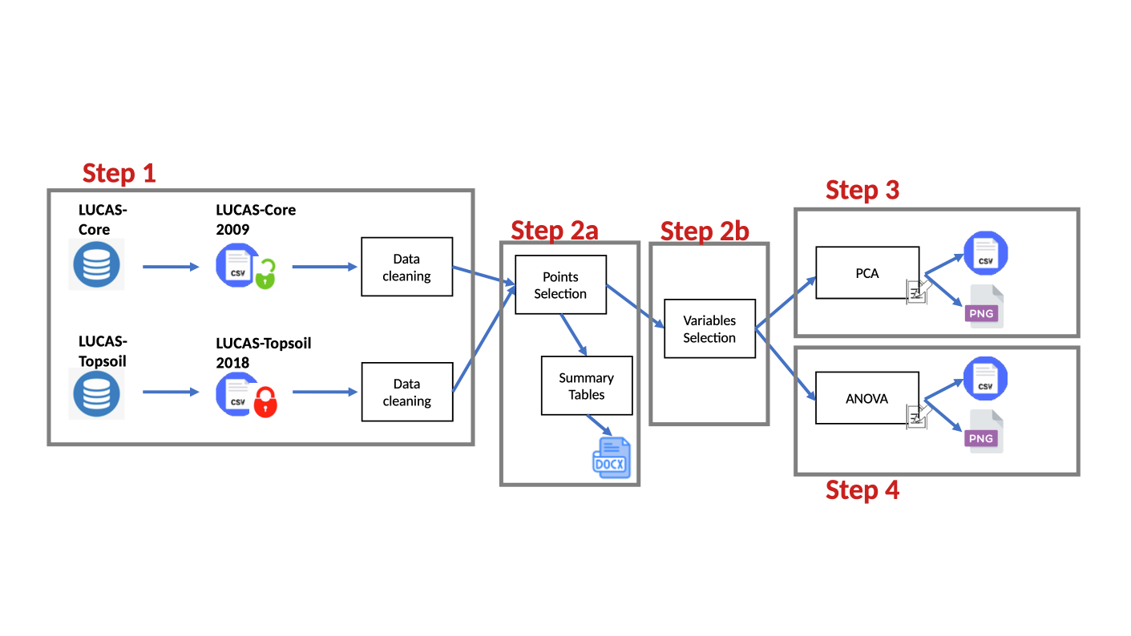

4.2. INCLUDE STEP BY STEP DESCRIPTIONS

STEP 1. Reading in LUCAS data

INPUT FILE: 1
- Nickname: LUCAS_TOPSOIL_v1.xlsx
- Format: xlsx
- Source: https://esdac.jrc.ec.europa.eu/content/lucas-2009-topsoil-data
- Description: Input name is self-descriptive. Year 2009. Record descriptors and/or metadata can be found in the same webpages where downloaded from.
- Structure: None.
- Image: None

INPUT FILE: 2
- Nickname: LUCAS-SOIL-2018.csv
- Format: csv
- Source: https://esdac.jrc.ec.europa.eu/content/lucas-2018-topsoil-data
- Description: Input name is self-descriptive. Year 2018. Record descriptors and/or metadata can be found in the same webpages where downloaded from.
- Structure: None.
- Image: None

INPUT FILE: 3
- Nickname: EU_2009_20200213.CSV
- Format: csv
- Source: https://ec.europa.eu/eurostat/web/lucas/database/2009
- Description: LUCAS-Core. Year 2009. Record descriptors and/or metadata can be found in the same webpages where downloaded from.
- Structure: None.
- Image: None

INPUT FILE: 4
- Nickname: EU_2018_20200213.CSV
- Format: csv
- Source: https://ec.europa.eu/eurostat/web/lucas/database/2018
- Description: LUCAS-Core. Year 2018. Record descriptors and/or metadata can be found in the same webpages where downloaded from.
- Structure: None.
- Image: None

OUTPUT FILE: 1
- Nickname: None
- Format: None
- Source: None
- Structure: None
- Image: None

SERVICE: 1
- Nickname: Reading in LUCAS data
- Description: LUCAS-Core and LUCAS-Topsoil datasets for 2009 and 2018 are read in.
On the one hand, the LUCAS-Topsoil datasets have to be stored in our system, as they can’t be directly downloaded from EUSO. A pre-authorisation form has to be submitted, and a link is provided. For this same reason, the raw datsets can’t be distributed with any 3rd party, and under any circumstance, outside the VRE.
On the other hand, LUCAS-Core are freely downloadable from EUROSTAT. In future versions, when LUCAS-Topsoil 2022 will be fully available, the year to be analised should be selectable by the user.
Some cleaning and standardisations are made.
- Type: R code
- Status: Developed and operational
- Availability: Open source
- Dependencies: tidyverse, readxl, flextable, officer, webshot2, ggplot2, ggpmisc, ggfortify, openxlsx.
- Development type: R open source routine
- Author: XRP
- Reference: none.
- Image: none.

STEP 2a. LUCAS data selection and exploration

INPUT FILE: 1
- Nickname: None
- Format: None
- Source: None
- Description: LUCAS tables (data frames/tibbles) from Step 1.
- Structure: None.
- Image: None

OUTPUT FILE: 1
- Nickname: summary_table1.docx
- Format: docx
- Source: None
- Description: A table with 8 columns ("region", "LUCAS_Core", "LUCAS_TopSoil", "LUCAS_TopSoil_UnchangedLU", "LUCAS_TopSoil_Broadleaf", "LUCAS_TopSoil_Coniferous", "LUCAS_TopSoil_Shrubland" and "LUCAS_TopSoil_Forests_Shrubland") and one row per each region, that summarises the number of LUCAS points per each category.
- Structure: None
- Image: None

SERVICE: 1
- Nickname: LUCAS data selection and exploration
- Description: (1) It selects LUCAS-Soil 2018 that have the same LU than in 2009. (2) It filters all regions and count the number of rows (LUCAS points with same LU) per region. (3) Also, it counts the total number of LUCAS topsoil (2018) per region. (4) Then, it counts the LUCAS points (unchanged 2009-2018) by region and by LC (Broadleaf, Coniferous, Shrubland, Forests+Shrubland). (5) Finally, it counts the total sampled points in LUCAS-Core 2018. (6) A table with the previous numbers is exported in docx format to be able to easily fit in a page and include a caption.
- Type: R code
- Status: Developed and operational
- Availability: Open source
- Dependencies: tidyverse, readxl, flextable, officer, webshot2, ggplot2, ggpmisc, ggfortify, openxlsx.
- Development type: R open source routine
- Author: XRP
- Reference: none.
- Image: none.

STEP 2b. LUCAS data selection (Area of Study)
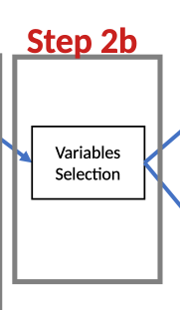
INPUT FILE: 1
- Nickname: None
- Format: None
- Source: None
- Description: LUCAS tables (data frames/tibbles) from Step 2a.
- Structure: None.
- Image: None

OUTPUT FILE: 1
- Nickname: None
- Format: None
- Source: None
- Description: None
- Structure: None
- Image: None

SERVICE: 1
- Nickname: LUCAS data selection (Area of Study)
- Description: (1) Selecting LUCAS-Topsoil points by the area of study (AoS). The parameter ‘region_study’ can be provided by the user as an argument, and goes into the R environment as a vector. It can be a NUTS0, NUTS1, NUTS2 or NUTS3. If ‘region_study’ is not provided, ‘region_study’ is "ES11" by default (this region is the one from the original study).
Only forests, shrublands and grasslands points are selected, as these are the relevant LU.
(2) Selection relevant variables for the study (those of the original study).
- Type: R code
- Status: Developed and operational
- Availability: Open source
- Dependencies: tidyverse, readxl, flextable, officer, webshot2, ggplot2, ggpmisc, ggfortify, openxlsx.
- Development type: R open source routine
- Author: XRP
- Reference: none.
- Image: none.

STEP 3. Principal component analysis (PCA)
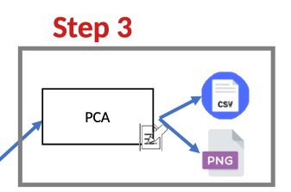
INPUT FILE: 1
- Nickname: None
- Format: None
- Source: None
- Description: LUCAS tables (data frames/tibbles) from Step 2b.
- Structure: None.
- Image: None

OUTPUT FILE: 1
- Nickname: pca_plot.png
- Format: png
- Source: None
- Description: A PCA plot showing PC1 vs PC2.
- Structure: None
- Image: Yes

OUTPUT FILE: 2
- Nickname: pca_summary.xlsx
- Format: xlsx
- Source: None
- Description: An Excel file summarising the main results of the PCA.
- Structure: None
- Image: None

SERVICE: 1
- Nickname: Principal component analysis (PCA)
- Description: Performing a PCA on the eight LUCAS soil variables. Since the dataset contained missing values (NAs), we considered three common approaches to handle them (the code remains for future considerations): (i) removing rows with missing data, (ii) imputing missing values using statistical methods (e.g., mean), and (iii) using PCA methods that can accommodate missing data directly (e.g., iterative PCA). For simplicity and transparency, we opt for the first approach and exclude rows containing any missing values from the analysis. However, we acknowledge that this method can reduce the sample size and potentially introduce bias if the missingness is not completely at random.
- Type: R code
- Status: Developed and operational
- Availability: Open source
- Dependencies: tidyverse, readxl, flextable, officer, webshot2, ggplot2, ggpmisc, ggfortify, openxlsx. missMDA
- Development type: R open source routine
- Author: XRP
- Reference: none.
- Image: none.

STEP 4. ANOVA
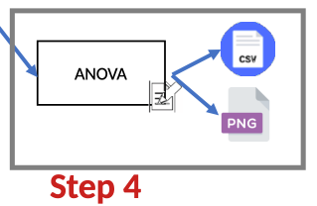
INPUT FILE: 1
- Nickname: None
- Format: None
- Source: None
- Description: LUCAS tables (data frames/tibbles) from Step 2b.
- Structure: None.
- Image: None

OUTPUT FILE: 1
- Nickname: bxplt_variable_LC.png
- Format: png
- Source: None
- Description: Boxplots for each LC, grouped by each soil parameter.
- Structure: None
- Image: Yes

OUTPUT FILE: 2
- Nickname: histograms_variable_LC.png
- Format: png
- Source: None
- Description: Histograms for each LC and soil parameter.
- Structure: None
- Image: Yes

OUTPUT FILE: 3
- Nickname: anova_boxplots_tukey.png
- Format: png
- Source: None
- Description: Plot with ANOVA and Tukey results.
- Structure: None
- Image: Yes

OUTPUT FILE: 4
- Nickname: ANOVA_summary.xlsx
- Format: xlsx
- Source: None
- Description: ANOVA results (Excel file).
- Structure: None
- Image: None

SERVICE: 1
- Nickname: ANOVA
- Description: To assess whether soil parameters differ among Land Cover types, a one-way Analysis of Variance (ANOVA) is conducted. The categorical factor considered is LC, which includes four groups: broadleaved forests, coniferous forests, shrublands, and grasslands. The analysis focuses on comparing the means of the 8 soil variables across these land cover categories. This allowes evaluate whether differences in soil characteristics, such as nutrient levels, pH, EC or OC are statistically significant among the different LC types. Post-hoc comparisons are also considered where applicable to identify which specific groups differ.
Before running the ANOVA, LUCAS LC classes are grouped and standardised. Some exploratory plots (boxplot) are exported.
- Type: R code
- Status: Developed and operational
- Availability: Open source
- Dependencies: tidyverse, readxl, flextable, officer, webshot2, ggplot2, ggpmisc, ggfortify, openxlsx. Broom, multcompView
- Development type: R open source routine
- Author: XRP
- Reference: none.
- Image: none.

