HW1

Problem (1) Data Mining Marketing

related part of the code for this problem:

set.seed(100)
df.incomedata = read.csv("Marketing/Income_Data.txt", header = FALSE)

incomedata_names = c("income", "sex", "marital", "age", "edu", "occu", "timelive",
"dual_income", "num.in.house", "p.under18", "house.status", "hometype", "ethnic", "language")

names(df.incomedata) = incomedata_names

factors = c(2, 3, 6, 8, 11, 12, 13, 14)
df.incomedata[, factors] = lapply(df.incomedata[, factors], factor)

temp = rpart.control(minsplit = 10, cp = 0)
fit = rpart(income ~ ., data = df.incomedata,
method = 'class', control = temp)

printcp(fit)

fit.prune = prune(fit, cp = 1.7936e-03)
rpart.plot(fit.prune)

> printcp(fit)

Classification tree:
rpart(formula = income ~ ., data = df.incomedata, method = "class",
control = temp)

Variables actually used in tree construction:
[1] age dual_income edu ethnic hometype house.status language marital
[9] num.in.house occu p.under18 sex timelive

Root node error: 7248/8993 = 0.80596

n= 8993

CP nsplit rel error xerror xstd
1 8.4989e-02 0 1.00000 1.00000 0.0051741
2 2.7594e-02 1 0.91501 0.90618 0.0058063
3 6.0706e-03 3 0.85982 0.86065 0.0060313
4 5.2428e-03 5 0.84768 0.85306 0.0060643
5 4.2770e-03 6 0.84244 0.85127 0.0060719
6 4.1851e-03 7 0.83816 0.84216 0.0061096
7 3.7942e-03 10 0.82561 0.83582 0.0061348
8 3.7252e-03 12 0.81802 0.83195 0.0061497
9 3.0353e-03 13 0.81429 0.82864 0.0061623
10 2.8284e-03 14 0.81126 0.82699 0.0061685
11 2.4834e-03 16 0.80560 0.82368 0.0061807
12 2.3455e-03 17 0.80312 0.82092 0.0061907
13 1.9316e-03 18 0.80077 0.82105 0.0061902
14 1.7936e-03 19 0.79884 0.82078 0.0061912
15 1.6556e-03 20 0.79705 0.81940 0.0061961
16 1.5177e-03 21 0.79539 0.81912 0.0061971
17 1.3797e-03 23 0.79236 0.81774 0.0062020
18 1.3107e-03 24 0.79098 0.81650 0.0062064
19 1.2417e-03 26 0.78836 0.81429 0.0062141
20 1.1038e-03 30 0.78339 0.81291 0.0062189
21 9.6578e-04 33 0.78008 0.80850 0.0062339
22 8.2781e-04 35 0.77815 0.80960 0.0062302
23 7.5883e-04 36 0.77732 0.80836 0.0062343
24 6.8985e-04 38 0.77580 0.81222 0.0062212
25 6.2086e-04 42 0.77304 0.81360 0.0062165
26 5.9787e-04 44 0.77180 0.81650 0.0062064
27 5.5188e-04 48 0.76863 0.81623 0.0062074
28 5.2428e-04 59 0.76256 0.81526 0.0062107
29 4.8289e-04 67 0.75828 0.81595 0.0062083
30 4.5990e-04 69 0.75731 0.81692 0.0062049
31 4.1391e-04 78 0.75317 0.81816 0.0062006
32 3.7942e-04 92 0.74738 0.82036 0.0061927

From the list of complexity parameters, the orange one provides the optimal tree in terms of validation.
But it has 36 splits, which is not easy to show here, we choose the yellow one, which is cp = 1.7936e-03, in order to print the tree here:

After pruned, the decision tree looks like:
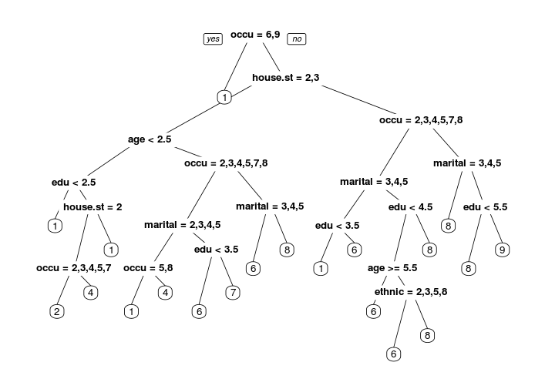
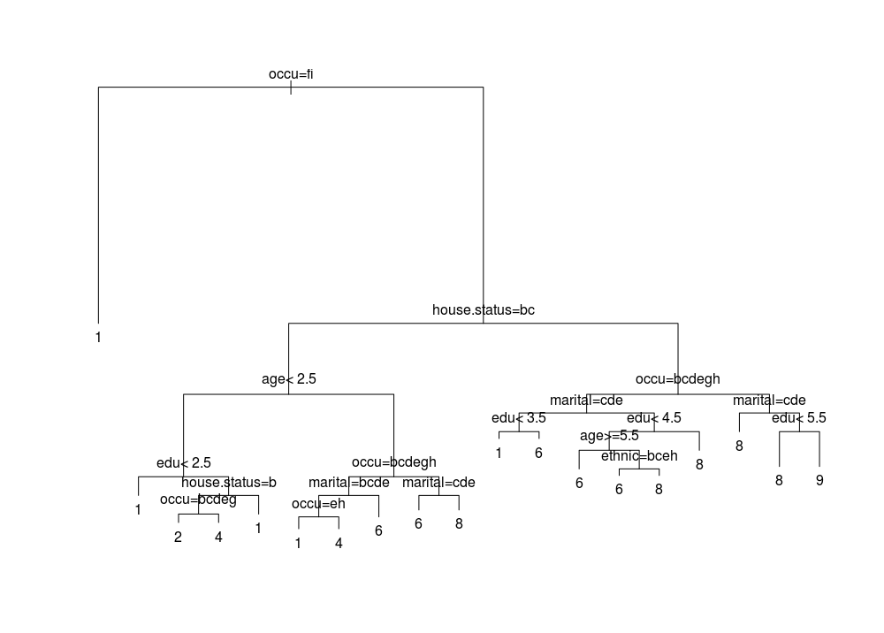

(b)

Problem (2) Multi-Class Calssification: Marketing Data
The related code is here:
#problem 2
df.housetypedata = read.csv("Marketing/Housetype_Data.txt", header = FALSE)
housetype_names = c("typeofhouse", "sex", "marital", "age", "edu", "occu", "income", "timelive",
"dual_income", "num.in.house", "p.under18", "house.status", "ethnic", "language")
names(df.housetypedata) = housetype_names

factors = c(1, 2, 3, 6, 9, 12, 13, 14)
df.housetypedata[, factors] = lapply(df.housetypedata[, factors], factor)

temp = rpart.control(cp = 0)
fit.housetype = rpart(typeofhouse ~ ., data = df.housetypedata,
method = 'class', control = temp)
printcp(fit.housetype)

temp = rpart.control(cp = 1.0828e-03)
pruned.housetype = rpart(typeofhouse ~ ., data = df.housetypedata,
method = 'class', control = temp)
rpart.plot(pruned.housetype)

summary(pruned.housetype)
printcp(pruned.housetype)

Here is the result after I use printcp
> printcp(pruned.housetype)

Classification tree:
rpart(formula = typeofhouse ~ ., data = df.housetypedata, method = "class",
control = temp)

Variables actually used in tree construction:
[1] ethnic house.status income num.in.house occu timelive

Root node error: 3694/9013 = 0.40985

n= 9013

CP nsplit rel error xerror xstd
1 0.3286410 0 1.00000 1.00000 0.012640
2 0.0167840 1 0.67136 0.67136 0.011478
3 0.0078506 3 0.63779 0.64104 0.011311
4 0.0048728 4 0.62994 0.63563 0.011280
5 0.0025717 5 0.62507 0.63211 0.011260
6 0.0018950 7 0.61992 0.63021 0.011249
7 0.0017596 8 0.61803 0.63021 0.011249
8 0.0016243 10 0.61451 0.63102 0.011254
9 0.0012182 11 0.61289 0.63021 0.011249
10 0.0010828 13 0.61045 0.62859 0.011239
11 0.0010828 14 0.60937 0.62805 0.011236

So the misclassification error is: 0.40985 * 0.62805 = 0.25748

The optimal tree looks like this way:
