Front End Web Engineer

A short test project for Front End Web Engineer

Timeframe: It should take about 2 hours.

For this test, we want you to build a simple HTML form. This test is not designed to trick you or be too challenging, but it should give you the opportunity to show us how you work.

There are 4 parts to the test:

* Creating a repo on GitHub to hold your work
* Writing markup, styles and validation for a form
* Setting up and writing automated tests
* Automating your build steps

Greating a Git repo

1. Make a new git repo and check it into GitHub
2. Make the repo public.

From now on, please commit frequently and write meaningful commit messages.

Form markup, styles and validation

1. Create an HTML form and add the following fields:
   * “Name” (required)
   * “Email” (required)
   * “Type of cake” with 4 options
   * “Celebration type” (required) with 4 options and a text input
   * “Tell us about your dream cake”
   * “Send away” button to submit the form
   * “Restart” button to reset the form
2. Using a CSS pre-processor of your choice (e.g. [SASS](http://sass-lang.com/)) write styles to make the form’s layout match the screenshot below, as closely as you can.
3. Using JavaScript, but without using any libraries, add validation to ensure that, if the Celebration type is “Other”, the text input is not empty.

Tips

* We’ve used a custom font: Open Sans (hosted on Google Fonts)
* Try to use valid and semantic HTML elements
* You don’t have to do anything with the submitted form data.
* The form should look and work the same way in all [Modern Browsers](http://browsehappy.com/). You can improve on the design if any improvements occur to you and you can’t resist, but that’s not the point of this exercise.

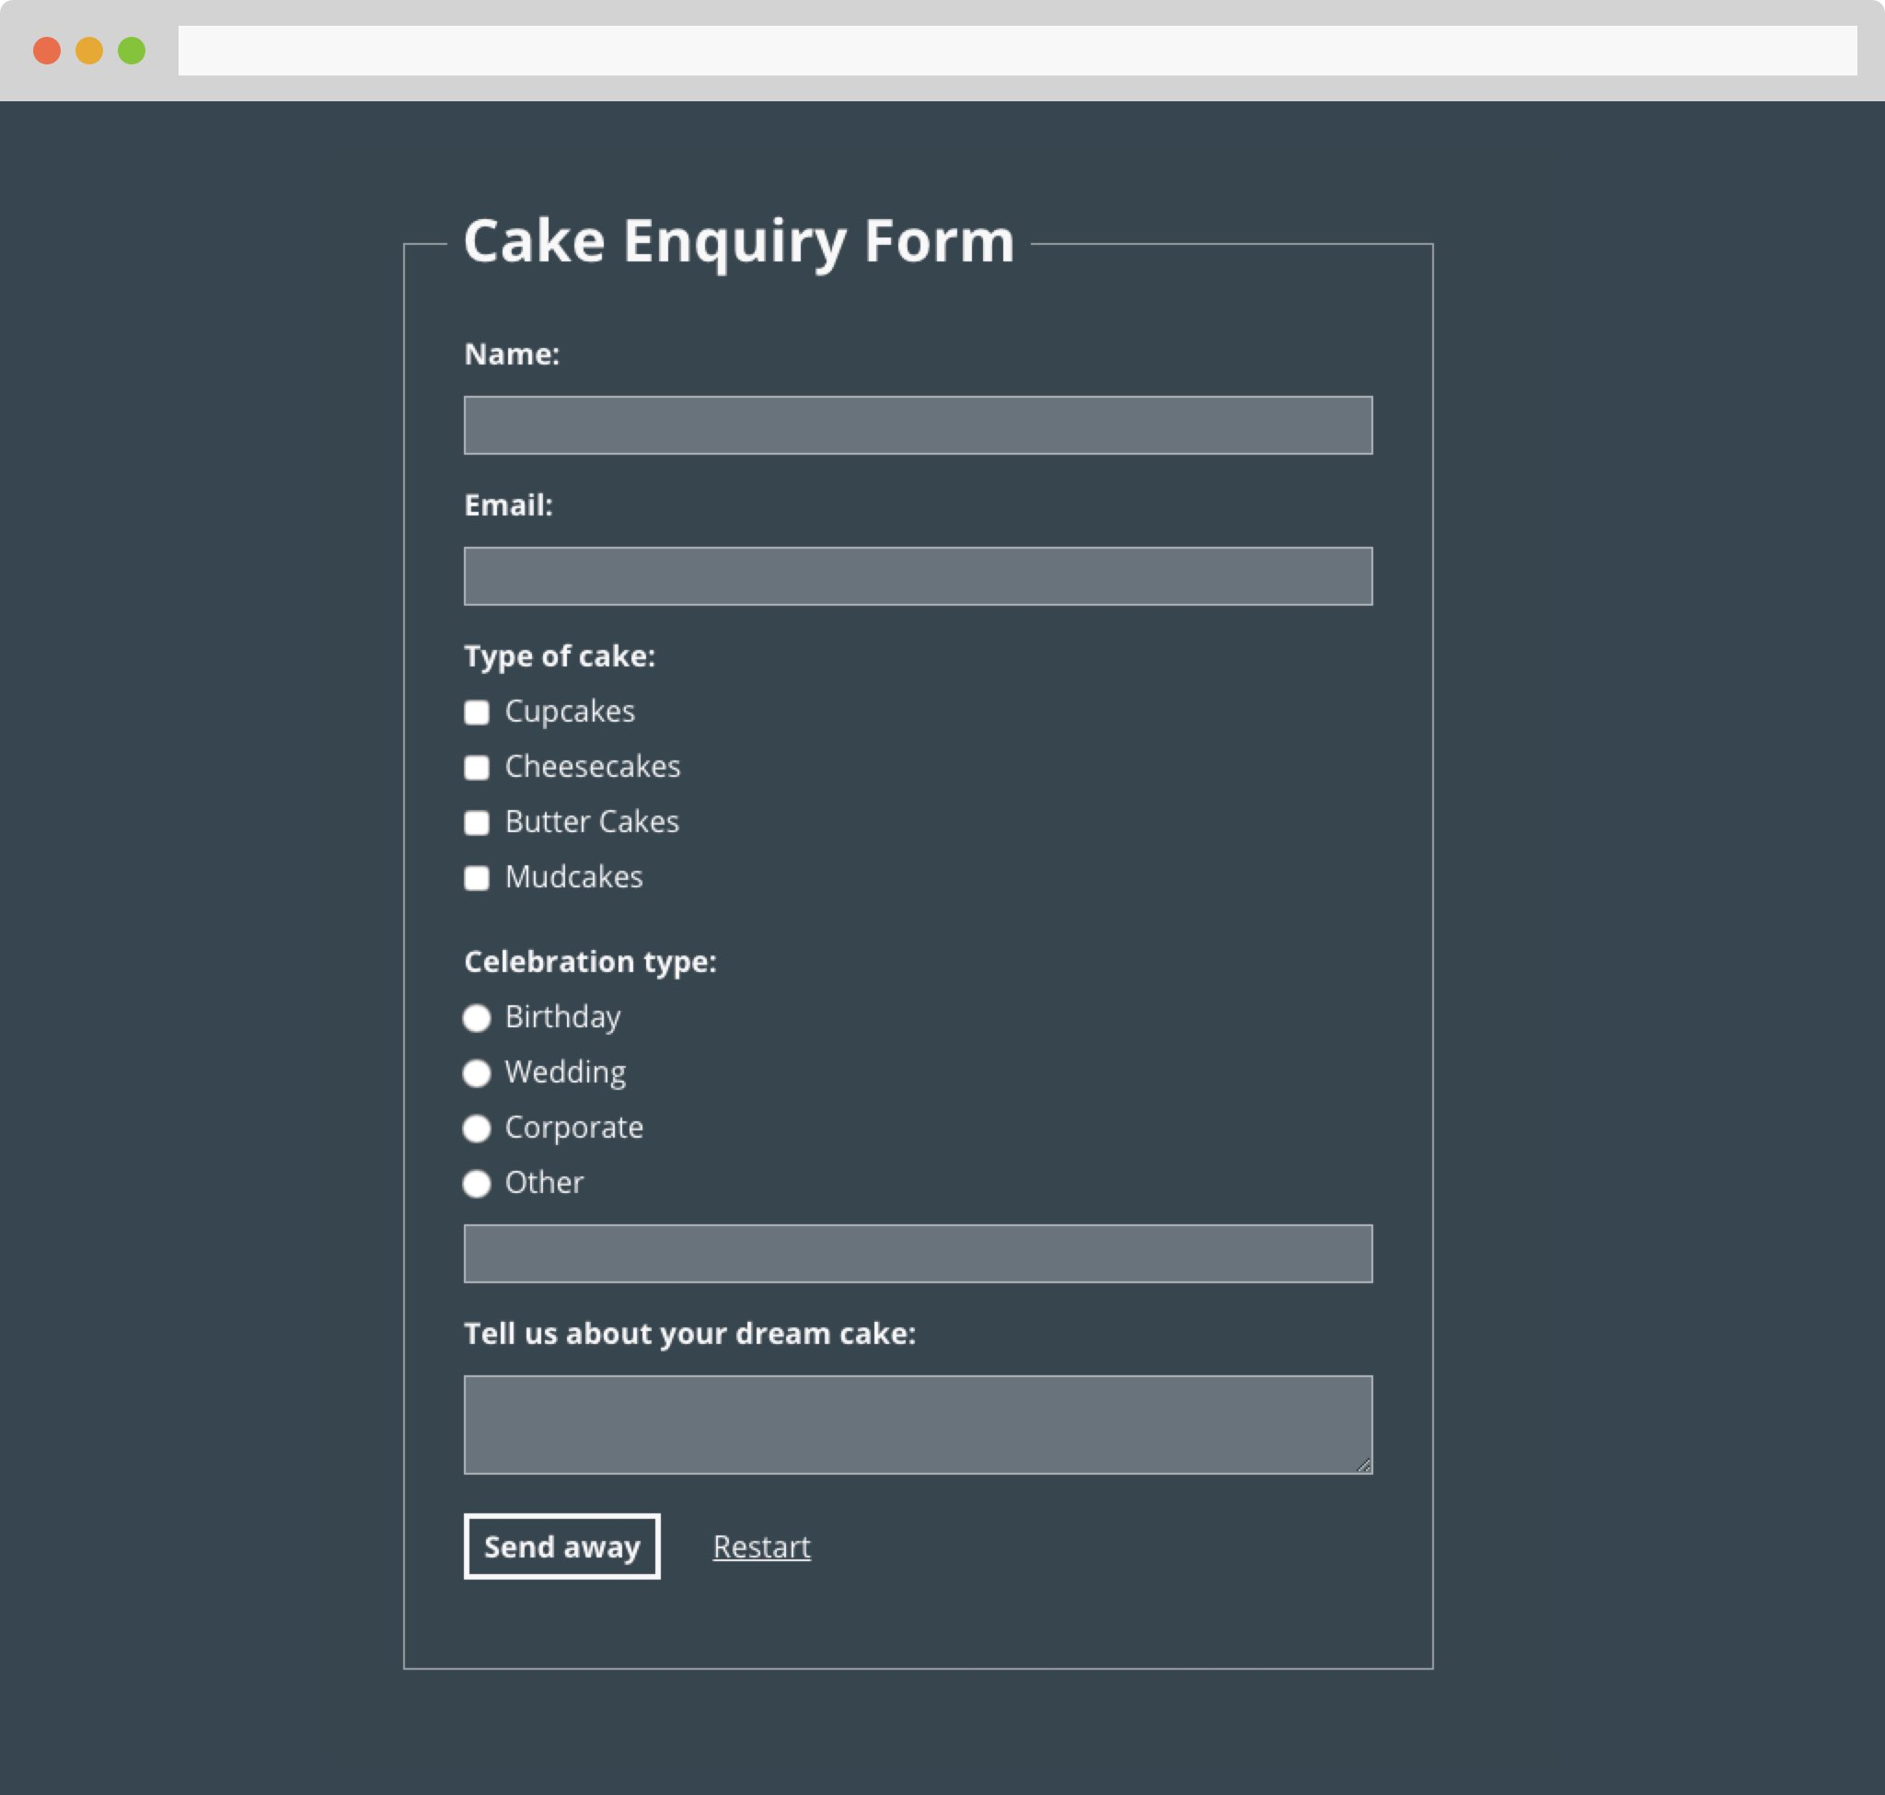

Front end tests

Using any combination of [Mocha](https://mochajs.org/), [Chai](http://chaijs.com/), and [CasperJS](http://casperjs.org/) (or equivalent) that you’re comfortable with, write a test for the form’s validation.

Build automation

Using [Gulp](http://gulpjs.com/), [Grunt](http://gruntjs.com/) or a similar tool of your choice, set up some task automation for your build:

* Compile your SASS
* Lint your JavaScript
* Run your tests

Include a README file describing dependencies and instructions.

Finished?

Push all work to GitHub and send the URL of the repo on GitHub to dev.syd[[AT]]ustwo.com. Feel free to include some comments - anything you think could be improved with this test.

Finally, don’t be daunted. We have a friendly team of developers in here. If you have any problems, please feel free to get in touch. We’ll be happy to help you past any potholes you might be stuck in. At the very least we’ll be able to point you in the right direction.

😎