Preliminary Report on Exome Variant Analysis

Statistics and Bioinformatics Unit (UEB)
Vall d'Hebron Research Institute (VHIR)
Passeig de la Vall d'Hebron, 119-129
08035 Barcelona. Catalonia. Spain

Ph. +34 934894007 / Fax +34 934894185
ueb@vhir.org
http://ueb.vhir.org

Table of contents
1.Analysis details 2
Samples 2
Goals 2
2.Short description of the pipelines in development 3
3.Computational Issues 4
4.Preliminary results 4

Analysis details

Researcher: XXX
Analysts: Alex Sánchez Pla, Xavier de Pedro Puente

Samples
4 samples from 2 breast cancer patients: 1 with BRCA1 and another one with BRCA2.
Sample from each individual has been processed using 2 different kits: Illumina and Sure.
Illumina doesn't allow to combine more than one patient per plate, and Sure allows multiplexing.

The four plates analyzed were:
- Patient A with Illumina kit
- Patient B with Illumina kit
- Patient A+B with Sure kit
- Patient A+B with Sure kit

In a later stage, sequences from patients A and B with Sure kit were splitted into separate files with their corresponding sequences each. This has been done by the Bioinformatics team of the Genomics Unit at VHIO.

Therefore, the data sets submitted to the UEB to be analyzed were included in these four sample files (one for each case analyzed):

 | 1. GA_Illumina.sequence.fastq  2. GA_Sure.sequence.fastq | 3. GB_Illumina.sequence.fastq  4. GB_Sure.sequence.fastq

Goals
This is a preliminary study. Therefore, the goal is not as much detecting variants already, as setting up the analysis pipelines in order to efficiently process the samples.

The idea is to determine which from these kits and pipelines is more efficient and effective in detecting variants. These will be tested by means of analyzing which known variants associated with BRCA1 and BRCA2 can be detected by each kit and each pipeline.

Short description of the pipelines in development
The first step will be performing quality control of the samples received. Based on that analysis, some preprocessing tasks will be executed, which include trimming sequences for usual several criteria (too short or too long reads; adapter sequences, if present, ...), so that bad quality reads are filtered out from the samples to be analyzed.
Next step will be mapping against a reference genome, which in this case will be the latest available for Human Genome (hg19).
That mapping will be used to detect SNP and Indels/DIP in the sequences respect to the reference genome.
Those variants will be annotated against dbSNP, and variant lists plus other data will be provided so that the researcher can perform further analysis or visualization of those variants with standard tools.
Two different approaches will be used to implement the previous workflow (Figure 1).
- CLC Genomics Workbench is a commercial platform which implements state-of-the-art algorithms to manage and analyze NGS data. This software platform is available at the Statistics and Bioinfomatics Unit (UEB). The program supports all the steps described from data import to basic report generation, and it will be used to provide one version of the analysis.
- There exists multiple public tools (such as BWA, SAMtools, GATK, ANNOVAR) that may be used to perform the different steps in Exome Variant Analysis processes. A pipeline based on these tools outlined in Figure 1 is being implemented. The analysis will also be performed with this pipeline, and results will be compared with those obtained with CLC Genomics Workbench for consistency.
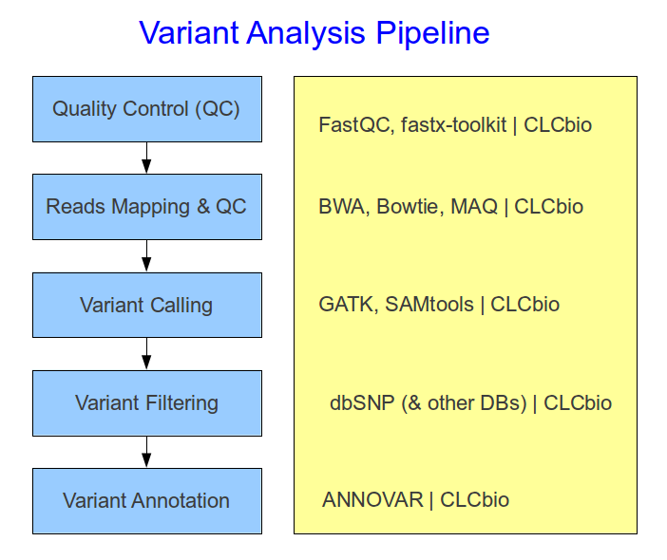Figure 1: Variant Analysis Pipeline, being developed at the UEB

Computational Issues
The initial attempts to run the pipeline were limited by some issues in the server setup at the UEB, so that some adjustments had to be made in order to have the processes running successfully.
However, it was detected that computer infrastructure of higher level (specialized bioinformatics clusters and supercomputing centers) are needed to run the pipelines efficiently.
Several options are currently being considered and we expect to have a successful implementation in a short period of time.

Preliminary results
Quality control of the sequences from the four cases analyzed showed a clear indication that Illumina Kit produced better quality reads than the Sure kit, as it can be seen by comparing sequence qualities for all bases (Figure 2)
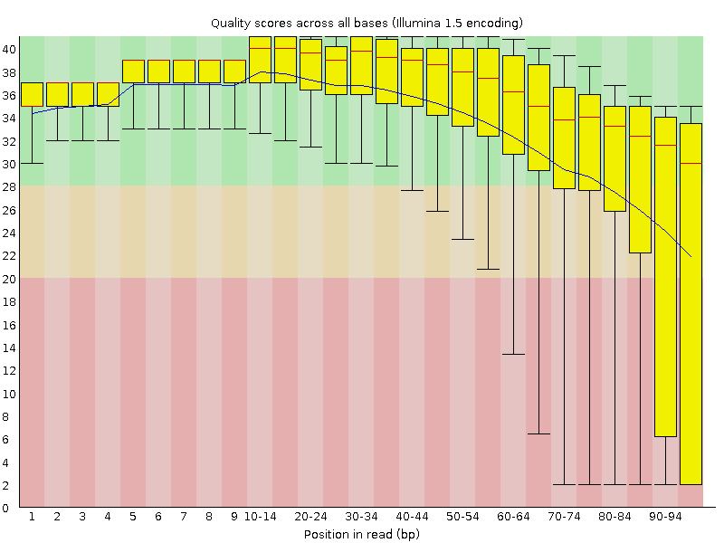  Gutierrez_A_Illumina.sequence.fastq | 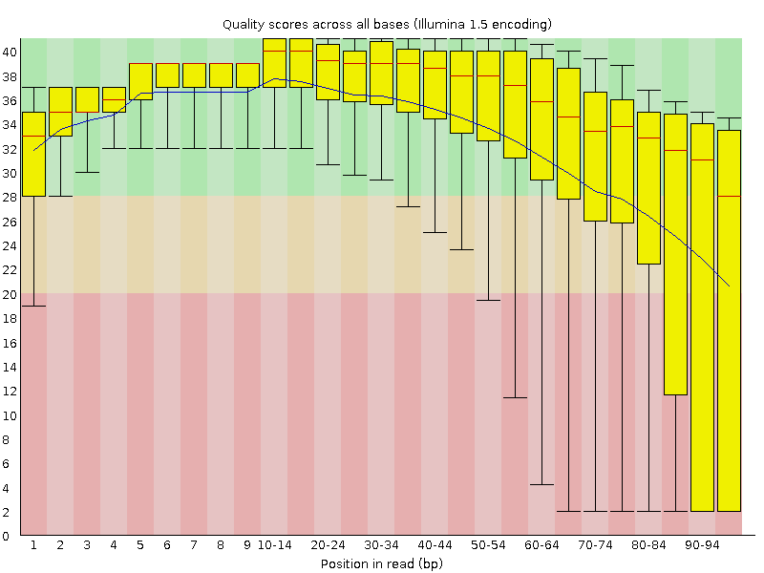  Gutierrez_B_Illumina.sequence.fastq
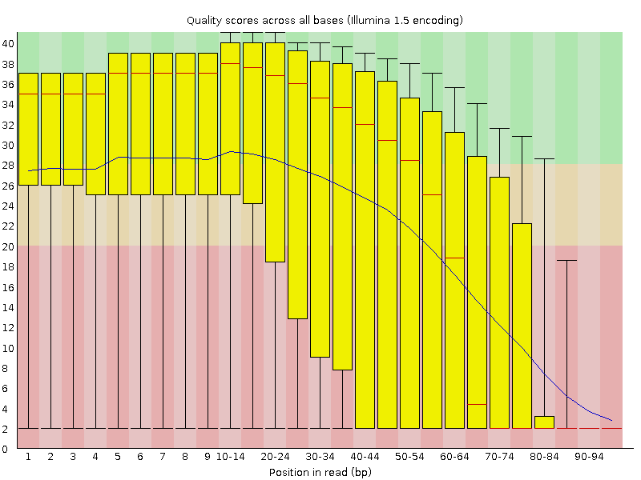  Gutierrez_A_Sure.sequence.fastq | 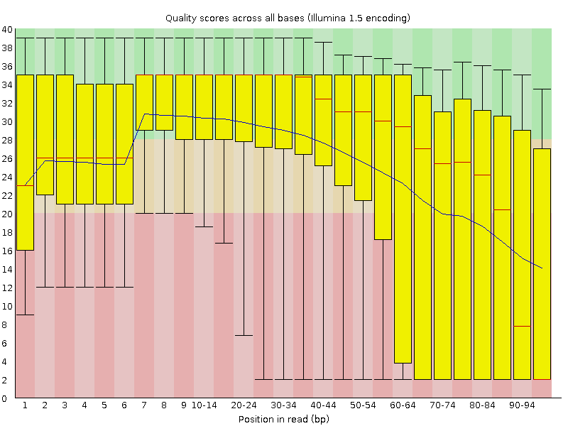  Gutierrez_B_Sure.sequence.fastq
Figure 2: Comparison of per base sequence qualities from the 4 cases analyzed

To understand these graphs, a few comments have to be made. The central red line is the median value. The yellow box represents the inter-quartile range (25-75%). The upper and lower whiskers represent the 10% and 90% points. The blue line represents the mean quality. Therefore, the more location of the yellow bars and blue lines in the upper region of each figure (over the green zone: higher that quality score 28), the better the quality. Sequences falling within the orange region (with quality scores between 20 and 28) have reasonable quality, and those falling over the red region (below quality score 20) have poor quality.
To explain the results shown in Figure 2 in short, we could focus on higher part of the graphs (the one over the green background), and see the evolution of the blue line (mean quality), as well as the yellow bars (interquartile range). Samples processed with Illumina Kit have an average very good quality up to 70 bp at least, while samples processed with Sure Kit only fall within the range of very good quality up to 20 or 40 bp at the most. Interquartile ranges show a similar distribution of differences (higher quality for most sequences with Illumina Kit).

In order to show some information of the progress so far with the early tests with our pipeline, some basic descriptive statistics are included regarding the exome sequences mapping against the human genome (Table 1).
Table 1: Summary mapping report

2012-00-Template-XXX-NNN-Report_v00.odt - 06/21/12

