MISINFORMATION DETECTOR

for Immigration News in Spanish Digital Media
Milestone 2. Model Building and Evaluation
PROIII-06
Contents
1. Introduction 1
2. Data Preparation 2
2.1 Dataset Construction 2
2.2 Analysis of Label Distribution and Final Dataset Construction 3
2.3 Cleaning and Transformation Pipeline 3
2.4 Data Understanding and Exploratory Data Analysis 3
3. Task description 4
3.1 Materialising minable view 5
4. Model prototype and evaluation 12
4.1 Model Selection and Architecture 12
4.2 Training Configuration 12
4.3 Integration and Experimental Strategy 13
4.4 Evaluation Metric Justification 13
4.5 Results 13
4.6 Training Behaviour 14
4.7 Analysis 14
4.8 Deployment mockup 14
4.9 Limitations 14
5. Discussion 14
5.1 Use of technology 15
5.2 Seminar and AI Use 15
5.3 Comparison with existing systems 15
5.4 Legacy and future work 16
5.5 Sustainability and SDG impact 16
5.6 Lessons learnt 16
6. References 17
7. Appendices 18
8. Table index 28

1. Introduction
Misinformation is a major problem in today’s digital public sphere because it spreads quickly and affects how citizens understand political and social issues. A large-scale study published in Science found that false news on Twitter spread farther, faster, deeper and more broadly than true news, with political falsehoods reaching especially high levels of diffusion (Vosoughi, Roy & Aral, 2018). This is particularly concerning because many users find it difficult to identify misleading information: according to the European Commission’s Flash Eurobarometer on fake news and online disinformation, 83% of Europeans considered fake news a danger to democracy, while in Spain 83% of respondents considered disinformation a problem for the country, 78% said they often encountered false or distorted news, and only 55% said they found it easy to detect it (European Commission, 2018; Newtral, 2023).
This issue is especially relevant in the case of migration, where misinformation can reinforce stereotypes, increase social polarisation and legitimise hate speech against vulnerable groups. Migration-related hoaxes often present migrants as a threat to public security, the economy, national identity or access to public services. Research on migration misinformation in Spain has shown the persistence of false narratives about migrants, and recent studies have analysed how disinformation links migration with crime, reproducing classic moral panic dynamics in the digital environment (Narváez-Linares, 2022; Aguerri, 2025). In this context, our project focuses on detecting and explaining misinformation about migration in Spanish political news. The proposed system combines automatic classification, evidence retrieval and a conversational interface to help users verify claims and understand why a piece of content may be misleading.

2. Data Preparation

2.1 Dataset Construction
A custom dataset was created by scraping news from four sources. Data sources were selected based on reliability, relevance, and representativeness within the Spanish context. For mainstream news, we used El País (n.d.) and Cadena SER (n.d.), two widely read outlets with high daily output and broad audiences. For wire coverage, we included Agencia EFE (n.d.), which provides high-volume, factual reporting across a wide range of topics. For misinformation, we incorporated Maldita Migración (n.d.), a specialized branch of Maldita.es, a Spanish fact-checking organization and member of the European Fact-Checking Standards Network (EFCSN), which produces reliably labeled examples of false or misleading information. The source scope was kept intentionally narrow to prioritize dataset quality and consistency, with expansion to additional outlets or social media platforms left as future work.
All articles were unified into a common schema of eight columns: titulo, etiqueta, texto, tema, url, fecha_publicacion, medio, and fecha_extraccion. The initial real-only dataset contained news items labelled VERDADERO, FALSO, or CONTEXTO. This is due to the fact that the only source with misinformation articles is Maldita, and they label these news as FALSE or CONTEXTO. Maldita.es defines the category CONTEXTO as cases in which “there is a public debate about an issue with multiple dimensions, but it is necessary to provide information about it and/or it is pending an ongoing investigation, procedure, or process that prevents it from being considered concluded”.

2.2 Analysis of Label Distribution and Final Dataset Construction
We noticed that the number of false and context news was small in comparison to the number of true news. The real dataset alone was highly imbalanced: VERDADERO articles dominated, while FALSO and CONTEXTO were scarce. The literature stresses that high-quality fake-news datasets should be representative, reliable, and diverse, and that labels, annotation rules and dataset biases directly affect downstream model performance. It also highlights that balanced class distributions usually reduce majority-class bias, but synthetic data should complement real distributions rather than hide their limitations (Kuntur, S.).
To make model training feasible, we generated synthetic false or misleading variants from true articles using AI. We generated a synthetic dataset of manipulated news items from the real ones. We used the API of Gemini 3.1, asking to create these articles and explain in two different columns the technique from a given list used to make false the true article (Figure 1) and the modification done to it. Synthetic items were labelled as either FALSO or CONTEXTO. The synthetic schema comprises seven columns: titulo, etiqueta, texto, tema, técnica, modificación, and fecha_publicacion. Finally, we integrated these two datasets and had the final dataset.
The plot in Figure 2 shows that the imbalance was mitigated with this operation. The final combined dataset reduces the original 11:1 ratio to approximately 0.86:1, achieving a practically balanced corpus.

2.3 Cleaning and Transformation Pipeline
The preparation pipeline applied the following transformations to the news dataset:
- Null removal: Rows with a null title or text were eliminated using dropna().
- Length filtering: Entries with a title shorter than 5 characters or a text shorter than 20 characters were discarded.
- Normalisation: Whitespace was stripped and UTF-8 encoding was standardised.
- Stratified split: The data was partitioned into 80% training, 10% validation, and 10% test sets using train_test_split with stratify=label, thereby preserving the class proportions in each partition.
Text length analysis of the news revealed a mean of approximately 1200 characters per item (title+text), with the 90th percentile at around 3000 characters, equivalent to 450-500 XLM-RoBERTa tokens. Concatenating the title and text into a single model input maximises the information available for classification. This concatenated input remains within the 512-token limit of XLM-RoBERTa for the 85th percentile of examples.

2.4 Data Understanding and Exploratory Data Analysis
Before designing the misinformation detection pipeline, we performed an exploratory analysis to understand the dataset composition, the distribution of topics, the origin of the articles, and the relationship between labels and textual features. This is relevant because the dataset combines synthetic examples, fact-checking content and articles from different media outlets, which may introduce differences in style, length and label distribution.
Figure 3 shows the topic distribution by media outlet. The dataset covers several migration-related topics, such as “convivencia y racismo”, “política y leyes”, “infancia”, “vigilancia de fronteras”, “criminalidad”, “trámites de extranjería” and “sanidad”. The most frequent topics are “convivencia y racismo” and “política y leyes”, especially in the synthetic subset and in some media outlets. This confirms that the dataset focuses on socially and politically sensitive areas of migration, which are common targets of misinformation.
The same figure also shows that topic coverage is not balanced across sources. Some outlets contribute many more articles to certain topics than others. This is important because the model could learn source-specific or topic-specific patterns instead of identifying misinformation only from the claim and its evidence.
Figure 4 shows the label distribution by media outlet. Traditional news sources such as EFE, Cadena SER and El País are mostly labelled as true, while synthetic examples and Maldita Migración contain a higher proportion of false or contextualised claims. This is expected, since fact-checking sources often focus on debunking false or misleading claims. However, it also introduces a potential bias: the model may associate certain sources with specific labels.
Figure 5 shows the label distribution by topic. False and contextualised claims appear across multiple areas. This suggests that the dataset includes false, true and context-labelled articles across all topics, indicating that the label distribution is relatively consistent across thematic categories.
Figures 6 and 7 analyse article and title length by label. True articles tend to have longer and more variable body texts, while false and contextualised examples are generally shorter and more concentrated. Title length is more similar across labels, although true articles appear to have slightly shorter median titles. These differences matter because text length can become an indirect signal for classification, even though the system should ideally rely on semantic content and supporting evidence.
Figure 8 shows the most frequent title words by label. Migration-related terms such as “inmigrantes”, “inmigración”, “ilegales”, “menores”, “gobierno” and “España” appear frequently across labels. However, false and contextualised claims include more alarmist or emotionally charged terms such as “invasión”, “masiva”, “secreto” or “escándalo”. This suggests that misinformation about migration often relies on sensationalist framing and threat narratives.
Overall, the exploratory analysis shows relevant patterns in source, topic, label distribution and language use. These findings support the need for an explainable pipeline that combines classification with evidence retrieval. Since some labels may be correlated with source, topic or writing style, the system should avoid relying only on superficial patterns and provide users with evidence-based explanations.

3. Task description
The task is a classification problem. Given a news item about migration, the system must classify it into one of the following categories: VERDADERO, FALSO, or CONTEXTO. The input is the text of the news item, and the output consists of a label, a confidence score, and a probability distribution over the three classes.
The model is designed to operate as part of a larger pipeline. First, the classifier analyses the text and returns a predicted label together with class probabilities. Then, the RAG system retrieves similar verified news items to provide supporting evidence. Finally, the LLM uses both the classifier output and the retrieved documents to generate an explained response in natural language.
The role of the classifier is limited to prediction. It provides the label and confidence scores, but it does not explain the decision. The explanation is generated separately by the LLM using the evidence retrieved by the RAG system.

3.1 Materialising minable view
The problem is formulated as a supervised text classification task.
- Input (X): the text of a news item or claim.
- Output (Y): a categorical label indicating whether the news is VERDADERO, FALSO, or CONTEXTO. In this context, classifying a news item as CONTEXTO means that the information is factually correct but presented in a misleading or incomplete way, for example through omission of relevant context, selective use of statistics, or biased framing that leads to an incorrect interpretation.
- Sample unit: one individual news item.
- Dataset size: the final dataset consists of 5,740 news items.
In terms of feature representation, a baseline approach using TF-IDF vectors was considered but discarded due to its inability to capture semantic nuance. The final models use contextual embeddings from fine-tuned Transformer encoders (BETO and XLM-RoBERTa), which capture deeper semantic and contextual information in Spanish text and improve the detection of subtle cases such as CONTEXTO.
4. System Architecture and Technical Integration
4.1 Problem Formulation and Minable View
The project is formulated as a supervised multiclass classification problem focused on misinformation detection in Spanish immigration-related narratives. Unlike traditional fake news systems that only distinguish between true and false information, our approach explicitly models a third category, CONTEXTO, which represents information that is factually grounded but misleading through omission, framing or selective emphasis.
This distinction is especially important in real-world misinformation scenarios, where manipulation frequently occurs through contextual distortion rather than through completely fabricated claims. The system therefore aims not only to detect falsehoods, but also to identify narratives that manipulate interpretation while remaining partially factual.
The input of the model consists of Spanish textual news content combining headline and article body whenever available. Each sample is mapped to one of the following labels:
- VERDADERO: factually correct and not misleading.
- FALSO: objectively incorrect or fabricated information.
- CONTEXTO: partially true information presented in a manipulative or misleading way.
- INCIERTO: abstention label returned during inference when the confidence of the classifier falls below a predefined threshold.
The minable view is therefore defined as a semantic text classification task in which the model learns a mapping between tokenized textual representations and a probability distribution over misinformation-related classes.
This formulation goes beyond traditional keyword-based fake news detection. In particular, CONTEXTO requires semantic and pragmatic understanding, since the manipulation often emerges not from explicit false statements but from what is omitted, exaggerated or selectively framed.

4.2 End-to-End System Architecture
The final system integrates multiple machine learning and retrieval components into a unified misinformation detection pipeline deployed through a Telegram chatbot.
At inference time, the user submits a claim, sentence or news headline through the Telegram interface. The system first applies a lightweight keyword-based relevance filter in order to determine whether the query is related to immigration topics. This prevents unnecessary execution of expensive language models on unrelated inputs and restricts the domain of the system to the target problem.
If the query is considered relevant, the system generates dense semantic embeddings using Gemini Embedding 2 Preview. These embeddings are used to query a ChromaDB vector database containing verified immigration-related articles and fact-checking content. The retrieval stage returns the eight most semantically similar verified documents.
Simultaneously, the user input is processed by the main classifier based on XLM-RoBERTa fine-tuned for misinformation classification. The classifier outputs probabilities over the three main classes: VERDADERO, CONTEXTO and FALSO.
A confidence threshold mechanism is then applied to the softmax probabilities. If the maximum predicted probability falls below the calibrated threshold, the system abstains from forcing a classification and returns the label INCIERTO instead. This mechanism is particularly important for CONTEXTO cases, where ambiguity and uncertainty are substantially higher.
The retrieved documents, the classifier prediction and the confidence distribution are then incorporated into a structured prompt processed by Llama 3.3 70B through the Groq API. This model generates a forensic explanation grounded on the retrieved evidence.
To improve reliability, a second independent validation stage is introduced using Llama 3.1 8B. This secondary model validates or challenges the reasoning produced by the primary LLM. If both models agree, the verdict is presented with higher confidence. If disagreement occurs, the system explicitly indicates that the response required arbitration between models.
Finally, the chatbot returns:
- the predicted class,
- confidence scores,
- an evidence-based forensic explanation,
- and links to the most relevant retrieved verified sources.
This architecture combines semantic retrieval, transformer-based classification and evidence-grounded generation into a single end-to-end misinformation detection pipeline.

4.3 Retrieval-Augmented Generation (RAG) System
The Retrieval-Augmented Generation (RAG) module was designed to improve explainability and factual grounding.
The vector database is implemented using ChromaDB, while semantic representations are generated through Gemini Embedding 2 Preview. Each verified article is segmented into chunks of approximately 512 tokens with an overlap of 64 tokens in order to preserve semantic continuity between fragments while maintaining efficient retrieval.
Each chunk is enriched with metadata including:
- source,
- publication date,
- label type,
- and original article reference.
The final collection contains 4,051 verified immigration-related fragments collected from Spanish media and fact-checking sources between 2006 and 2026.
To reduce redundancy, semantic deduplication is applied using cosine similarity with a threshold of 0.97, preventing near-duplicate chunks from entering the database.
Importantly, only real verified articles are incorporated into the RAG system. Synthetic data generated during augmentation is used exclusively for classifier training and never included in the retrieval database. This separation was intentionally designed to avoid contaminating the evidence retrieval process with artificially generated information.
The retrieved documents serve two primary purposes:
- grounding LLM explanations on verifiable evidence,
- reducing hallucinations and unsupported claims during generation.
This retrieval-based architecture enables the system not only to classify misinformation but also to provide transparent evidence-based explanations to the user.

4.4 Model Selection and Iterative Improvement
The modelling process followed an iterative experimental strategy.
As an initial baseline, a TF-IDF + Logistic Regression classifier was implemented. Although computationally efficient, this approach achieved limited performance, particularly on the CONTEXTO class. The baseline obtained a macro F1-score of 0.61, confirming that lexical frequency-based representations are insufficient for detecting contextual manipulation patterns.
Two transformer-based models were then evaluated:
- BETO, pretrained exclusively on Spanish corpora,
- and XLM-RoBERTa, pretrained on multilingual datasets.
The initial hypothesis assumed that BETO would outperform multilingual alternatives due to its Spanish specialization. However, experimental results revealed the opposite behaviour.
Both transformer models achieved strong performance on VERDADERO and FALSO. Nevertheless, CONTEXTO consistently emerged as the most difficult category.
Error analysis revealed two major limitations:
- insufficient representation of contextual misinformation examples,
- and the intrinsic semantic ambiguity of CONTEXTO samples.
To address this issue, additional CONTEXTO examples were incorporated through a data-centric augmentation strategy. Synthetic contextual manipulations were generated from verified news articles while preserving semantic realism.
After retraining, XLM-RoBERTa demonstrated significantly better generalisation capacity, particularly for CONTEXTO detection. This suggests that multilingual pretraining provides a richer semantic representation space capable of modelling subtle pragmatic distortions more effectively than monolingual specialization.
Based on these results, XLM-RoBERTa was selected as the final classification backbone of the deployed system.

4.5 Hyperparameter Optimisation and Continuous Improvement Pipeline
Hyperparameters were selected through manual grid search over the following search space:
- Learning rate: {1e-5, 2e-5, 3e-5}
- Batch size: {16, 32}
- Warmup ratio: {0.06, 0.10}
Training was implemented using HuggingFace Trainer with:
- AdamW optimizer,
- cosine learning rate scheduling,
- FP16 mixed precision,
- inverse-frequency class weighting,
- label smoothing (α = 0.10),
- and early stopping with patience = 3.
The final configuration selected for XLM-RoBERTa used:
- learning rate = 1.5e-5,
- batch size = 32,
- warmup ratio = 0.10.
A confidence threshold mechanism was integrated into inference. If the maximum softmax probability remains below the calibrated threshold, the system returns INCIERTO instead of forcing a potentially incorrect prediction.
The threshold was calibrated using validation experiments in order to maximise macro F1 while maintaining the abstention rate below 15%.
Beyond static training, the project introduces a fully automated continuous-improvement pipeline inspired by modern MLOps principles. The script pipeline_completo.py automates four sequential stages:
- scraping new immigration-related articles,
- generating synthetic CONTEXTO and FALSO examples,
- updating the ChromaDB RAG collection,
- and incrementally retraining XLM-RoBERTa.
Incremental training uses low learning rates in order to mitigate catastrophic forgetting while incorporating new knowledge over time.
Unlike traditional academic prototypes trained once offline, this design enables continuous system evolution through automated periodic execution.

5. Evaluation
5.1 Evaluation Methodology
Given the multiclass nature of the task and the strong class imbalance present in the dataset, accuracy alone was considered insufficient as the primary evaluation metric.
Macro F1-score was selected as the main evaluation criterion because it assigns equal importance to all classes regardless of frequency. This is particularly important for CONTEXTO, the minority and most semantically challenging class.
In addition to macro F1, the evaluation reports:
- per-class precision,
- per-class recall,
- per-class F1,
- weighted F1,
- and overall accuracy.
Evaluation was conducted on a held-out test set. Additionally, a 5-fold cross-validation experiment over a 50% subsample confirmed stable performance with variance below ±0.03 macro F1 between folds.

5.2 Quantitative Results
Experimental results confirm the superiority of transformer-based semantic models over traditional lexical approaches.
The TF-IDF baseline achieved acceptable performance on explicit falsehood detection but failed to model contextual misinformation effectively, obtaining only 0.238 F1 on CONTEXTO.
Both BETO and XLM-RoBERTa substantially improved performance. However, XLM-RoBERTa achieved the best balance across all classes, reaching:
- 0.846 accuracy,
- 0.782 macro F1,
- and 0.554 F1 on CONTEXTO.
An additional manually curated set of 77 real-world ambiguous claims was evaluated in order to test robustness outside synthetic distributions. Performance decreased significantly on this subset, particularly for CONTEXTO cases, highlighting the difficulty of real-world pragmatic misinformation detection.
This gap between synthetic and naturally occurring ambiguity reveals an important limitation of current transformer-based approaches and motivates future research on pragmatic reasoning and discourse-level understanding.

5.3 Error Analysis
The most common failure mode corresponds to misclassification of CONTEXTO instances.
Three dominant patterns were identified:
Stylistic similarity with VERDADERO
CONTEXTO articles frequently use the same factual and journalistic register as legitimate news, including accurate statistics and references.
Headline-only inputs
When only headlines are available without article body, model confidence frequently falls below the abstention threshold due to insufficient contextual information.
Negation and pragmatic ambiguity
Certain claims involving negation or implicit framing are incorrectly interpreted because transformer models prioritise semantic co-occurrence patterns over pragmatic intent.
This third issue motivated the introduction of the ensemble validation stage using multiple LLMs.
The analysis suggests that transformer architectures operate effectively at the semantic level (“what is explicitly stated”) but remain weaker at the pragmatic level (“what is implied or omitted”), which is precisely where contextual misinformation emerges.

5.4 Deployment and User Validation
The final system was deployed as a functional Telegram chatbot called FakeNewsBot.
The deployment demonstrates the practical applicability of the complete pipeline in a realistic interaction scenario. Users receive:
- a misinformation verdict,
- confidence estimates,
- evidence-based explanations,
- and links to verified sources.
Particular attention was dedicated to CONTEXTO explanations. When contextual manipulation is detected, the system explicitly separates:
- the factual component,
- the misleading component,
- and the manipulation mechanism.
Informal validation conducted with non-expert users revealed positive feedback regarding explainability and usability, especially for contextual misinformation explanations.
The average end-to-end latency observed during testing ranged between 6 and 9 seconds per query, including retrieval, classification, generation and validation stages.

4. Model prototype and evaluation

4.1 Model Selection and Architecture
PIPELINE DEL MODELO (LA DE ABAJO ES UN EJ, NO ESTA BIEN)
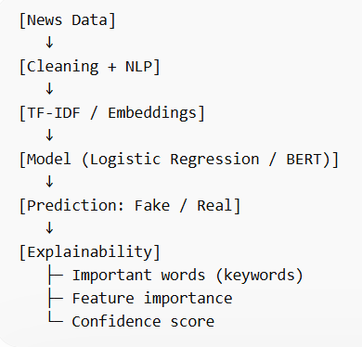
TRESHOLD
We fine-tune two Transformer-based models: BETO (dccuchile/bert-base-spanish-wwm-cased), pretrained exclusively on Spanish, and XLM-RoBERTa (xlm-roberta-base), a multilingual model. This allows us to compare domain specialisation versus generalisation capacity. Traditional approaches such as TF-IDF with logistic regression or SVM were discarded because they fail to capture the semantic nuance required to distinguish CONTEXTO from VERDADERO a distinction that depends on subtle framing and context rather than keyword frequency. Both models share the same architecture: a pretrained Transformer encoder, a fully connected classification head, and a softmax output over 3 classes. The input is the text, tokenized and truncated to 512 tokens.

4.2 Training Configuration
Both models are trained with AdamW, cosine LR scheduler with 10% warmup, early stopping (patience = 3), and FP16 mixed precision. Key hyperparameters are summarised below (table 1):
Hyperparameter | BETO | XLM-RoBERTa
Learning rate | 2e-5 | 1.5e-5
Batch size (per GPU) | 16 | 32
Max epochs | 6 | 6
Best model metric | F1_falso | F1_macro
Table 1: Hyperparameters used for each model
The learning rate and batch size differences are justified by model size and available hardware respectively. To handle class imbalance, both models apply inverse-frequency class weights and label smoothing (α = 0.1), which reduces overconfidence and improves probability calibration. A confidence threshold of 0.60 flags low-confidence predictions as INCIERTO rather than forcing an incorrect classification. Different evaluation metrics were used during training. BETO uses F1 for the FALSO class, while RoBERTa uses macro F1. This results in different optimization behaviours and is treated as part of the experimental comparison.

4.3 Integration and Experimental Strategy
The classifier is one component of a larger pipeline: it produces a label, confidence score, and a prompt_hint that is passed to an LLM, which combines this verdict with documents retrieved by a RAG system to generate a full forensic explanation for the user. Both models are fully trained and evaluated under identical conditions; XLM-RoBERTa is currently deployed in the chatbot while final model selection will be determined by the evaluation results in Section 5.

4.4 Evaluation Metric Justification
Given the multiclass nature of the task and the class imbalance present in the dataset, accuracy alone is insufficient as an evaluation metric. We use macro F1-scores as the primary metric, which treats all classes equally regardless of their frequency. We also report per-class precision, recall and F1, as well as weighted F1 and overall accuracy. This combination allows us to asses both global performance and the model’s behaviour on each individual class, particularly the minority class CONTEXTO.

4.5 Results
Both models were evaluated on the same held-out test set . Results are summarised below (table 2):
Metric | BETO | XLM-RoBERTa
Accuracy | 0.838 | 0.846
F1 Macro | 0.749 | 0.782
F1 Weighted | 0.824 | 0.843
F1 VERDADERO | 0.991 | 0.994
F1 CONTEXTO | 0.455 | 0.554
F1 FALSO | 0.801 | 0.798
Table 2: Comparing important metrics for both models
Per-class results – BETO (table 3):
Class | Precision | Recall | F1 | Support
VERDADERO | 0.992 | 0.989 | 0.991 | 264
CONTEXTO | 0.633 | 0.355 | 0.455 | 107
FALSO | 0.724 | 0.896 | 0.801 | 202
Table 3: Results of different metrics per-class in BETO model
Per-class results – XLM-RoBERTa (table 4):
Class | Precision | Recall | F1 | Support
VERDADERO | 1.000 | 0.989 | 0.994 | 264
CONTEXTO | 0.614 | 0.505 | 0.554 | 107
FALSO | 0.759 | 0.842 | 0.798 | 202
Table 4: Results of different metrics per-class in XLM- RoBERTa model

4.6 Training Behaviour
BETO converged in 4 epochs (early stopping triggered), with the best checkpoint selected from epoch 1 (F1_falso = 0.785) (Table 5).
XLM-RoBERTa ran all 6 epochs, reaching its best macro F1 of 0.783 at epoch 4 (Table 6).
Both models show a steady decrease in training loss, with validation loss stabilising after epoch 2, indicating no significant overfitting.

4.7 Analysis
Both models perform strongly on VERDADERO (F1 > 0.99) and achieve solid results on FALSO (F1 ≈ 0.80), the most critical class for misinformation detection. The most challenging class is CONTEXTO (BETO: 0.455, XLM-RoBERTa: 0.554), which is expected given its smaller size, its linguistic similarity to VERDADERO, and the inherent ambiguity of the class itself. XLM-RoBERTa outperforms BETO on CONTEXTO by +0.10 F1 and achieves higher macro F1 overall (0.782 vs 0.749), suggesting its multilingual pretraining generalises better to subtle semantic distortions. Based on these results, XLM-RoBERTa is selected for deployment in the final pipeline.

4.8 Deployment mockup
A functional Telegram prototype called FakeNewsbot was developed to simulate the real use of the system. The system integrates three components connected through the bot, the model and the RAG (Figure 9).
The user sends a claim or news sentence through the chat interface, and the bot returns: the predicted class generated by the classifier, the confidence scores for each class, and a short forensic explanation generated with the RAG + LLM module, supported by retrieved verified evidence. This prototype shows how the complete pipeline works in practice and demonstrates that the system can assist users not only by detecting potentially false migration-related claims, but also by providing an interpretable justification for the decision. In the Figure 10 and Figure 11 we can see a real interaction with the prototype, where we sent two headlines that were classified as false and true respectively, and the answer including classification output, confidence distribution and evidence-based explanation. Furthermore, a final section was included that gives other related news and their links.

4.9 Limitations
Both models show low confidence on short headline-only inputs (all predictions below the 0.60 threshold in the inference test), confirming that the models require full article text to produce reliable predictions. This is consistent with the training setup, where both title and body were always provided as input.

5. Discussion

5.1 Use of technology
Python was the primary language throughout the project. For model training, Hugging Face Transformers with PyTorch was used to fine-tune both BETO and XLM-RoBERTa, trained on Google Colab and Kaggle respectively using NVIDIA T4 GPUs. Practical challenges such as VRAM management, FP16 mixed precision, and checkpoint handling were solved autonomously.
For the retrieval system, ChromaDB was used as the vector database, with embeddings generated via the Gemini Embedding API. The Gemini API (gemini-2.5-flash) served as the LLM for generating forensic explanations. The full pipeline was deployed through two interfaces: a local web app built with Gradio and a functional Telegram bot, both integrating the classifier, RAG system, and LLM in real time.
In terms of performance, the system processes each query in approximately 10 seconds. The search for new information (ChromaDB retrieval of top documents) is fast (<0.5s), while the classifier processes inputs up to 512 tokens with low latency. The main delay comes from the Gemini model generating the final explanation.
Regarding token costs, each query combines the user input with retrieved documents (up to 512 tokens each), resulting in an estimated 1000–2000 input tokens plus 300–600 output tokens. This leads to a total of around 1300–2500 tokens per request, keeping the cost low due to the use of Gemini Flash.

5.2 Seminar and AI Use
The project applies key concepts from the course seminars across all stages. The problem is formulated as a supervised classification task (Unit 3) with clearly defined input and output variables and a well-specified minable view. Model selection followed the criteria discussed in the seminars: alternative approaches such as TF-IDF with Logistic Regression were considered and discarded in favour of Transformer-based models, justifying why they are more appropriate for capturing semantic nuance in Spanish misinformation detection. Evaluation was performed using macro F1-score, chosen specifically because of class imbalance — a metric selection criterion covered in Unit 4. The deployment prototype (Unit 5) demonstrates a first estimate of the system's practical value through a functional Telegram bot and Gradio interface.
AI tools were used in two controlled ways: to generate synthetic data addressing class imbalance, and as part of the RAG pipeline to produce evidence-based explanations. Both uses are justified and documented throughout the report.

5.3 Comparison with existing systems
Several tools and research projects address fake news detection and bias analysis. However, most of them focus on simplified tasks or lack integration of multiple components.
For example, the system developed by Simon Fraser University allows users to compare a text with a dataset of true and false news articles and analyse similarity patterns. While effective for quick exploration, it is limited to similarity-based inspection and does not provide a full classification–explanation pipeline.
Similarly, institutional tools such as OBERAXE and HODIO focus on monitoring hate speech and social discourse at an aggregate level, rather than analysing individual news items in real time. Other academic approaches rely on traditional machine learning models or isolated classification systems without contextual explanation.
In contrast, our system integrates three key components in a single pipeline: (1) a fine-tuned Transformer classifier specialised in migration-related misinformation, (2) a retrieval system (RAG) that provides real evidence from verified sources, and (3) a generative model that produces an interpretable explanation. This combination allows not only detecting misinformation, but also explaining it, which is essential for user trust and real-world applicability.
Therefore, the proposed system goes beyond standalone classification or monitoring tools by offering an end-to-end, explainable solution tailored to a specific high-impact domain.

5.4 Legacy and future work
All code, data, and model checkpoints will be published on a public GitHub repository (Lguilop, 2026), with sufficient documentation to allow replication. The dataset, scraping scripts, and annotation schema will be released under an open license, given the scarcity of Spanish-language misinformation resources in this domain. The data collection pipeline is already designed to update automatically, so new articles can be added over time without manual intervention.
We intend to submit this work to Information Processing & Management published by Elsevier, a leading Q1 journal in Scientific Journal Rank (SJR). The journal is internationally recognized for high-impact research in information retrieval, natural language processing and explainable AI, making it an excellent fit for our work on misinformation detection using transformer models and retrieval-augmented generation. With an Impact Factor of 6.9 and a CiteScore of 18.6, publishing in this venue would provide strong scientific visibility and maximize the academic impact of the project.
Several improvements could strengthen the system going forward. The most important is better handling of the CONTEXTO class, which remains hard to detect even for transformer models because manipulation often happens through omission or framing rather than explicit falsehoods. Expanding the dataset to include social media would also help generalize the model. In the longer term, the modular pipeline could serve as the basis for a browser extension or a lightweight web application. Finally, a formal user study with diverse audiences would replace the informal validation conducted so far, providing rigorous evidence of the system's real-world effectiveness and helping identify usability gaps before any broader deployment.

5.5 Sustainability and SDG impact
The project contributes to three UN Sustainable Development Goals, with a particular emphasis on social sustainability. Social sustainability is addressed directly through SDG 10 (Reduced Inequalities), as the project counters misinformation that fuels stigmatisation of migrant communities. It also supports SDG 16 (Peace, Justice and Strong Institutions) by promoting access to verified information and transparent, evidence-based fact-checking, which strengthens social trust and institutional accountability. The project aligns with SDG 17 (Partnerships for the Goals) by combining open data from official sources (the INE and the Ministerio de Inclusión) to improve public understanding of migration dynamics. These contributions together support the social dimension of sustainability by fostering more informed, equitable, and cohesive communities.

5.6 Lessons learnt
The hardest problem throughout the project was the CONTEXTO class. The boundary between misleading content and genuinely true content is genuinely ambiguous, and no amount of data balancing fully resolves this ambiguity. This problem also made clear why accuracy alone is a poor evaluation metric for this task, the model's weakness on a minority class would not have been visible without per-class reporting.
Building the dataset was more complex than expected. Synthetic augmentation worked well for balancing classes, but it required care to avoid introducing patterns that the model could exploit without actually learning to detect misinformation.
The comparison between BETO and XLM-RoBERTa was instructive: monolingual pretraining did not automatically yield better performance. XLM-RoBERTa generalised better on the hardest class, which suggests that the breadth of pretraining data can matter as much as language specificity.
Finally, deploying a working Telegram prototype early in the process was one of the best decisions the team made. Offline evaluation metrics do not reveal all limitations, in particular, the model's poor performance on headline-only inputs only became apparent through real use.

6. References
Agencia EFE. (n.d.). Agencia EFE. https://efe.com
Cadena SER. (n.d.). Cadena SER. https://cadenaser.com
EL PAÍS. (n.d.). EL PAÍS. https://elpais.com
Instituto Nacional de Estadística. (n.d.). INE. https://www.ine.es/
Kuntur, S., Wróblewska, A., Ganzha, M., Paprzycki, M., & Sachdeva, S. (2026). Fake news detection: It's all in the data! Applied Sciences.
Maldita.es. (n.d.). Maldita Migración. https://maldita.es/migracion/
Maldita.es. (2025). Metodología de Maldita.es. https://maldita.es/metodologia-maldita/
Ministerio de Inclusión, Seguridad Social y Migraciones. (n.d.). Observatorio Permanente de la Inmigración. https://www.inclusion.gob.es/web/opiCañete, J., Chaperón, G., & Pérez, J. (2020, February 7). BETO: la red neuronal que podría ser utilizada durante el próximo proceso constituyente. Instituto Milenio Fundamentos de los Datos. https://imfd.cl/notwg2025-beto-la-red-neuronal-que-podria-ser-utilizada-durante-el-proximo-proceso-constituyente/
Lguilop. (2026). proyecto [GitHub repository]. GitHub. https://github.com/lguilop/proyecto
Vosoughi, S., Roy, D., & Aral, S. (2018). The spread of true and false news online. Science, 359(6380), 1146–1151.
European Commission. (2018). Flash Eurobarometer 464: Fake News and Disinformation Online.
Newtral. (2023). El 83% de españoles considera la desinformación un problema, según el Eurobarómetro.
Narváez-Linares, Á. (2022). Fake news y desinformación sobre migración en España.
Aguerri, J. C. (2025). Disinformation Linking Migration and Crime in Spain: Classic Moral Panic in a New Digital Ecosystem.
European Digital Media Observatory. (2024). Disinformation narratives on migration during the summer in Spain.

7. Appendices

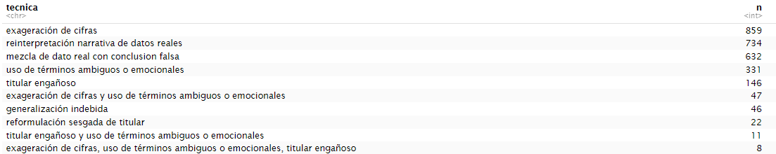
Figure 1: Techniques used by AI to make the synthetic news

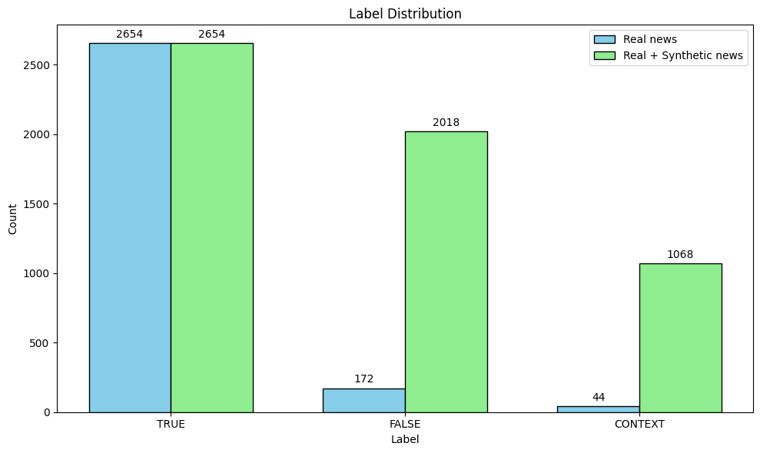
Figure 2: Label distribution of real news versus combined real and synthetic news
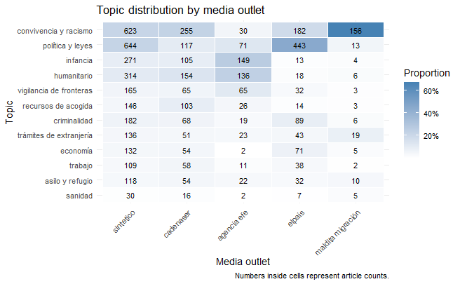
Figure 3: Heatmap showing the number and relative proportion of articles for each migration-related topic across the different media outlets

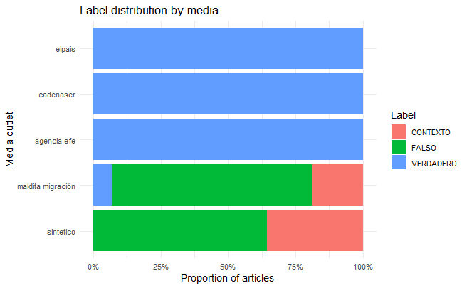
Figure 4: Label distribution by media outlet

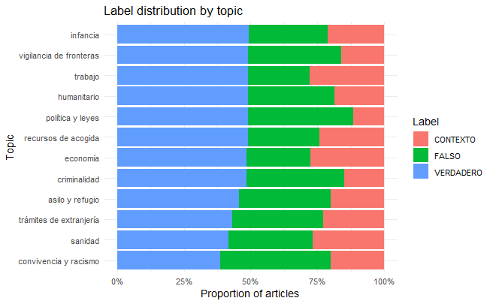
Figura 5: Label distribution by topic

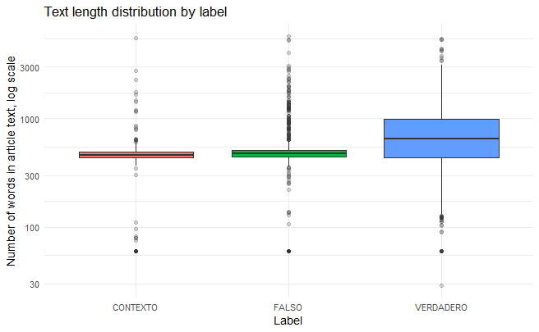
Figure 6: Article length distribution by label
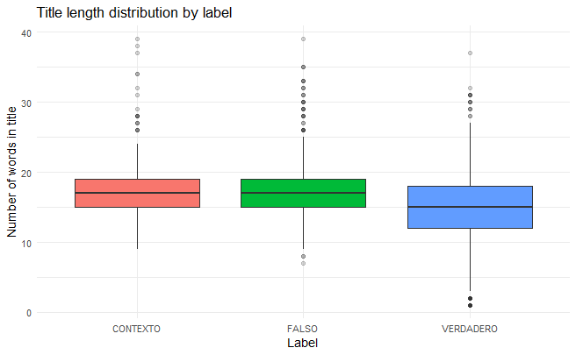
Figure 7: Title length distribution by label

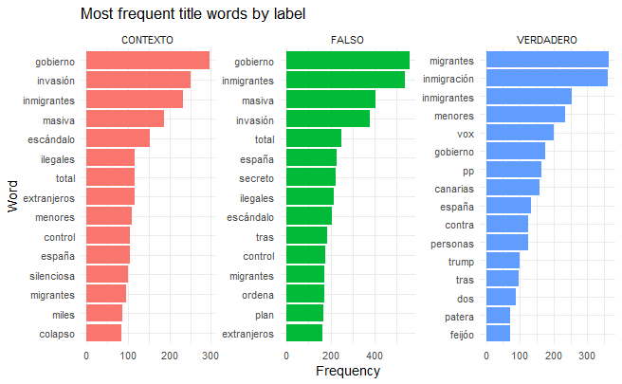
Figure 8: Most frequent words by label
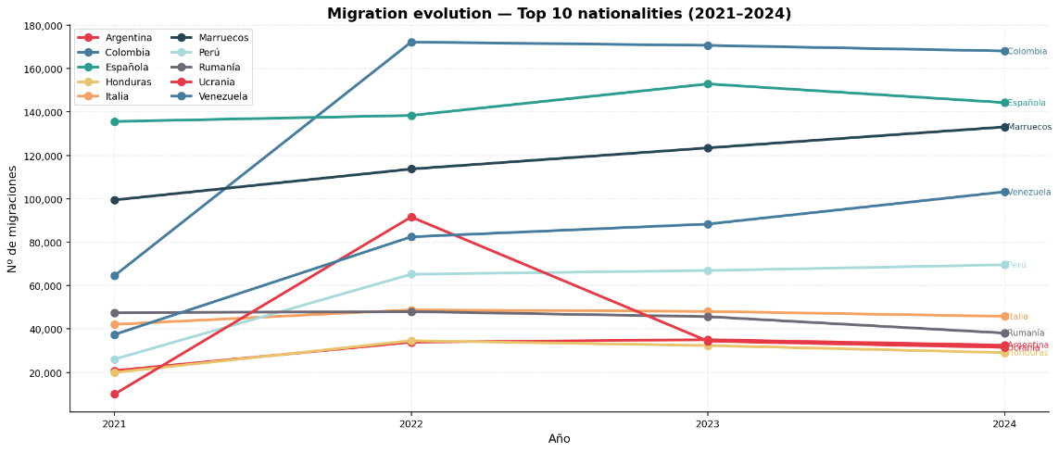

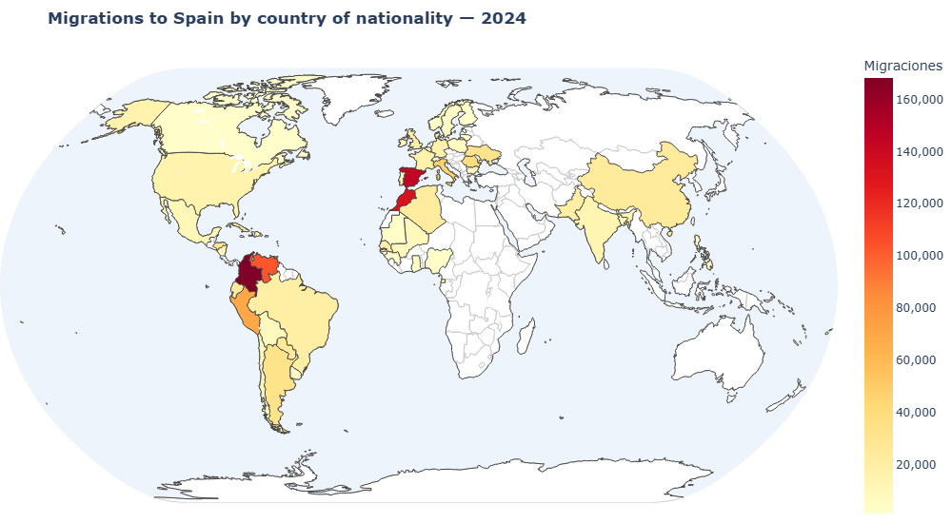

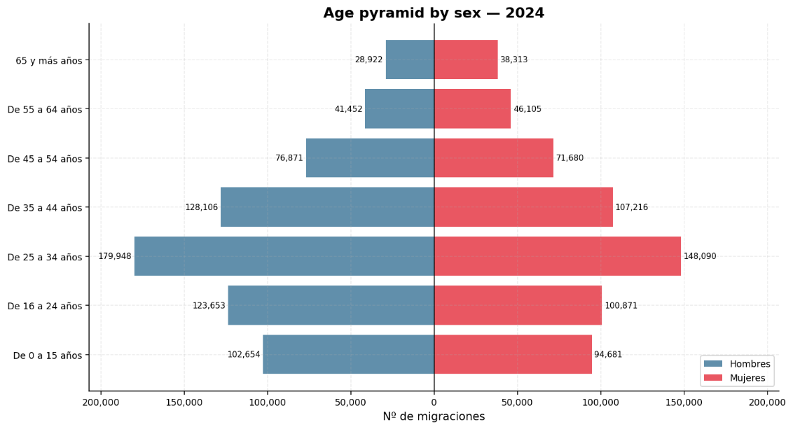

.
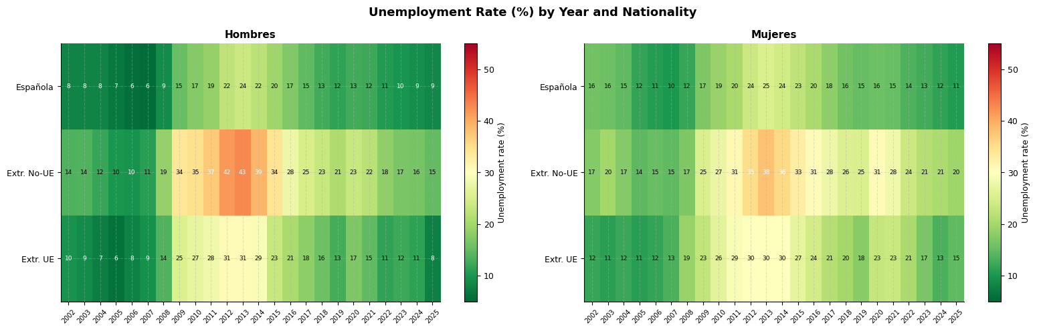

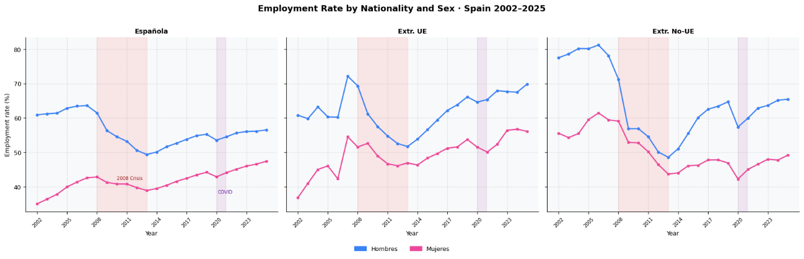

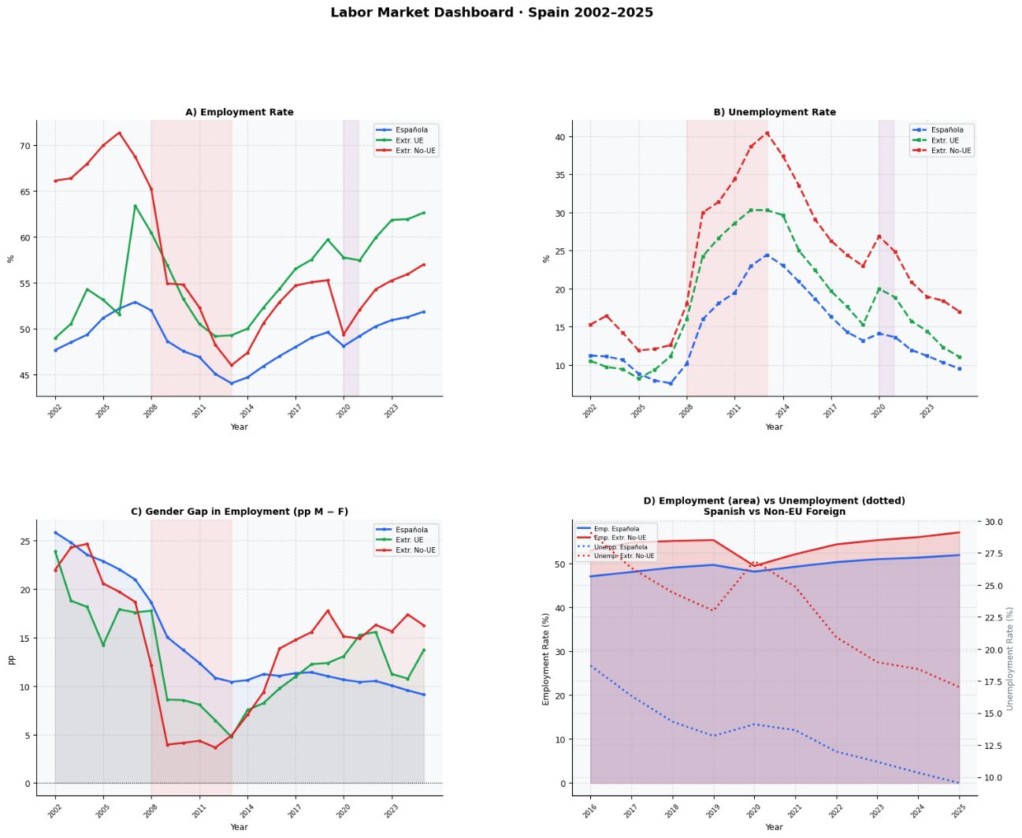
The Truth About Criminality Another huge topic for disinformation is crime. Fake articles constantly blame foreigners for crimes and say the country is getting extremely dangerous because of them. If we look at the graph of total registered crimes (Figure 8), it is true that crimes have gone up recently, reaching about 450,000 in 2024.
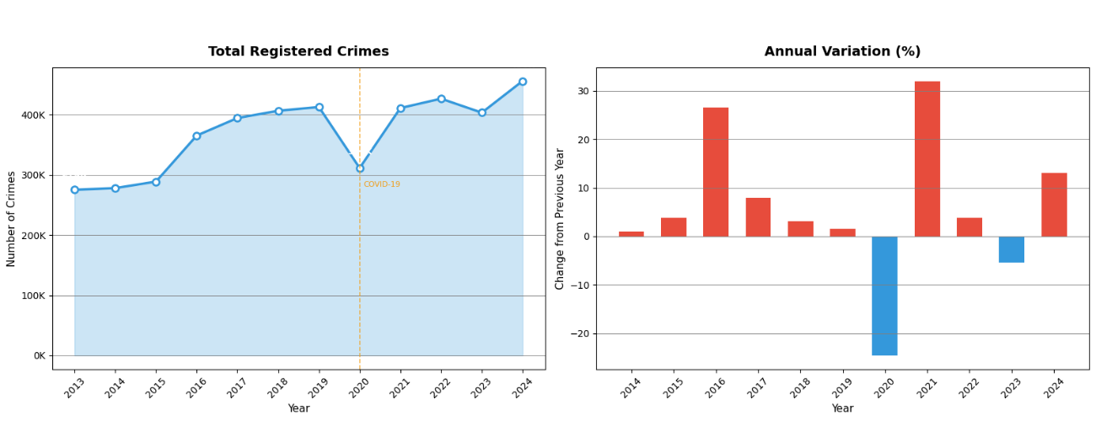
But we have to look at the context: there was a massive drop in 2020 because of the COVID-19 lockdown, so the big 30% increase in 2021 was mostly just the numbers going back to normal, combined with regular population growth.
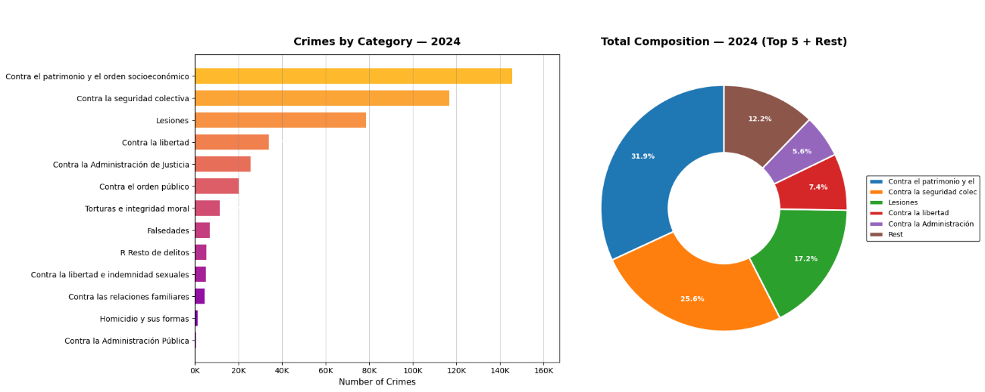
Also, we need to understand what kind of crimes are actually happening. The bar chart and donut chart showing crimes by category in 2024 (Figure 9) prove that the vast majority are just property and socioeconomic crimes (like theft), followed by collective security issues and injuries. Fake news always focuses on super violent stories to make people afraid, but those are simply not the most common crimes.
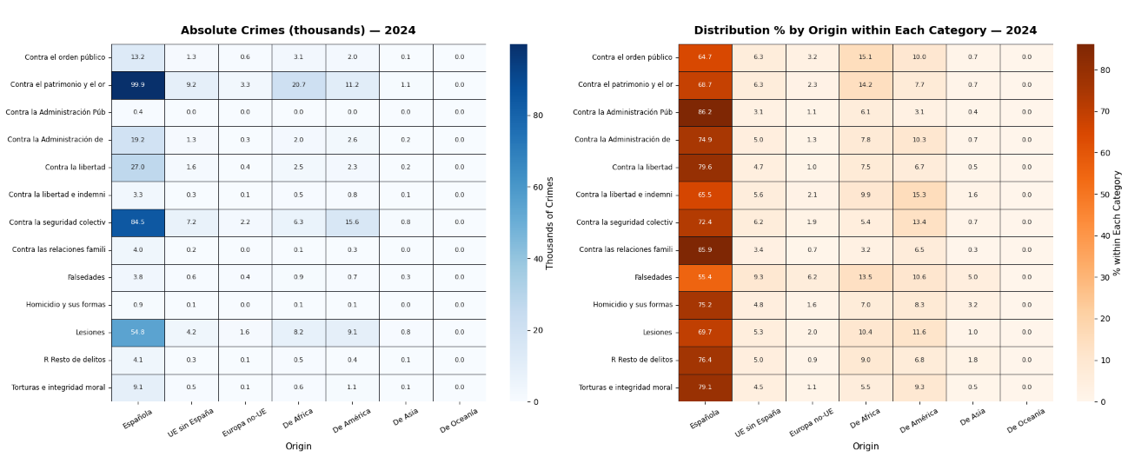
The most important detail that fake news ignores is who is actually committing these crimes. If we look at the heatmaps showing the absolute numbers and percentages by origin (Figure 10), the reality is very clear. Spanish nationals are responsible for the massive majority of crimes in almost every single category. For example, out of all property crimes in 2024, Spanish people committed nearly 100,000 of them, which is almost 69% of the total for that category. People from the Americas, the next highest group, committed about 20,700.
Finally, even when we look at terrible things like sexual crimes (which fake news heavily uses to attack migrants) the data shows a completely different reality. The dashboard for sexual crimes shows that in 2024 (Figure 11), Spanish nationals committed over 3,300 of these offences. The next groups were people from the Americas (under 800) and Africa (around 500). This completely destroys the fake narrative that migrants are the main ones causing a wave of sexual violence.
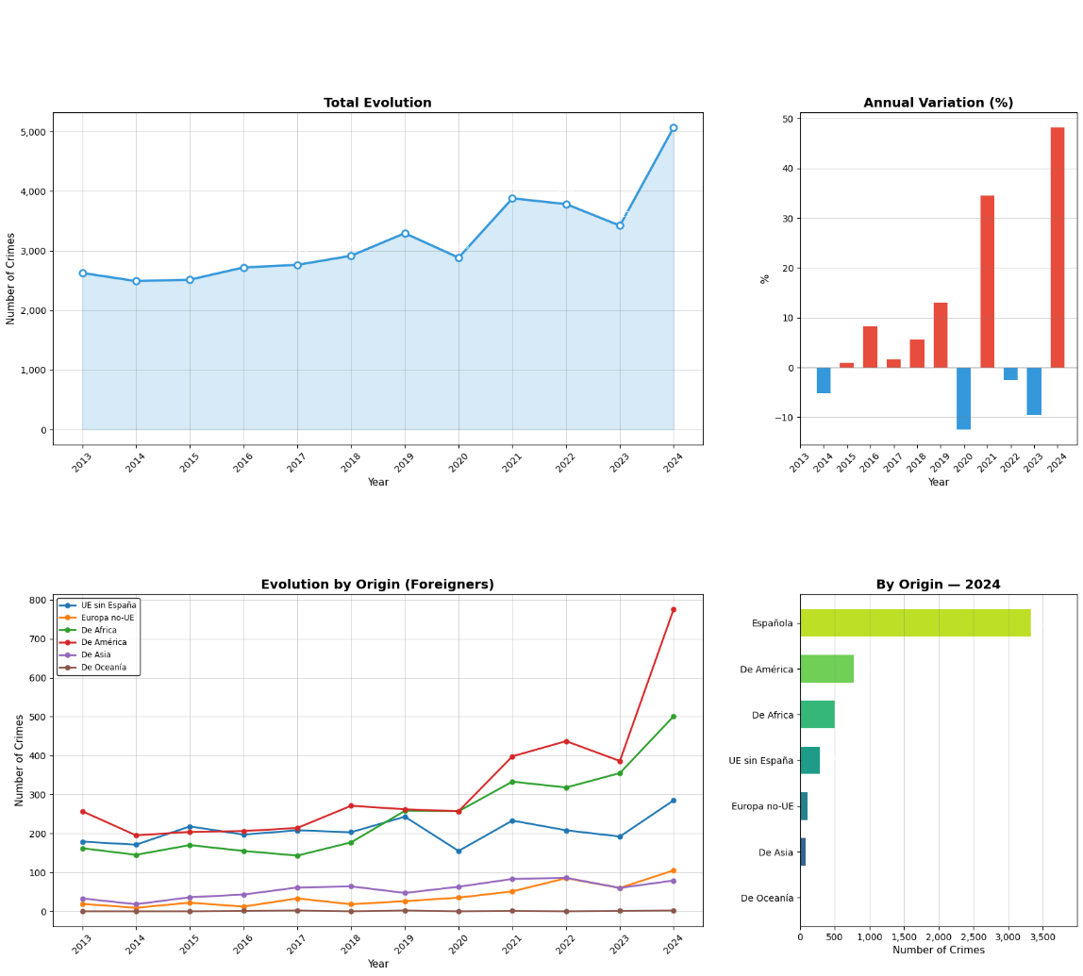

This analysis confirms that misinformation deliberately manipulates real statistics across these three themes. This directly justifies our use of advanced language models like BETO or XLM-RoBERTa, as simple keyword approaches cannot capture the deeper semantic context and alarmist tone required to trick readers. In the end, relying on true data and using smart technology to stop disinformation is essential to fight against hate speech and build a fairer society. to detect fake news.

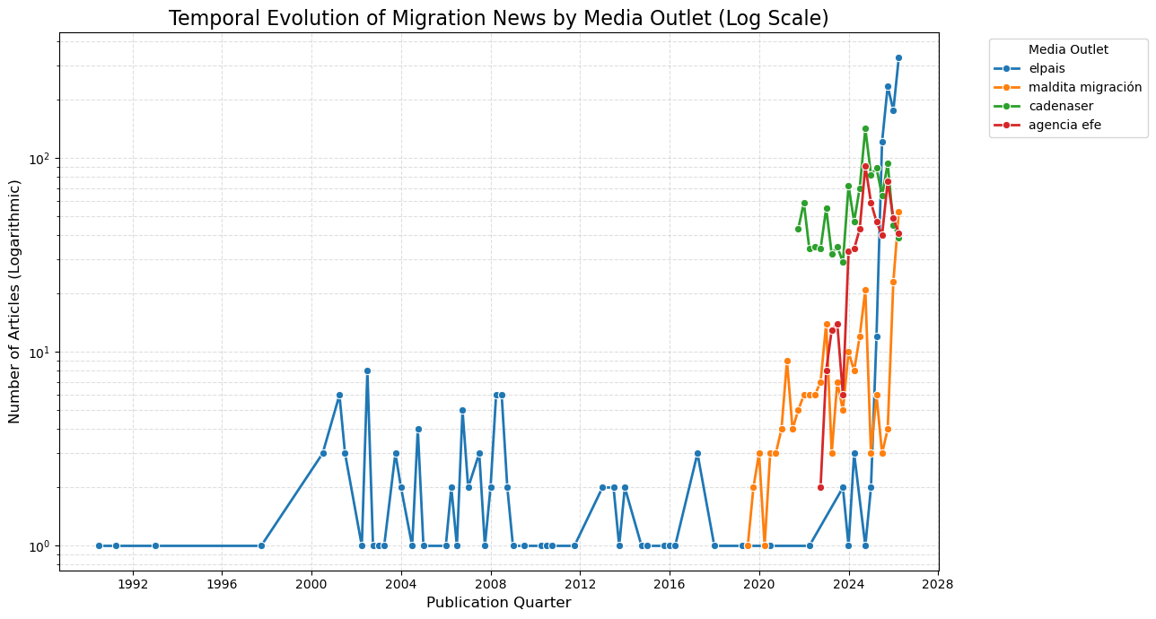
Figure 2: temporal evolution of article volume per outlet on a logarithmic scale.

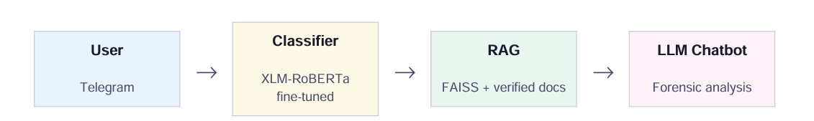
Figure 9: Full pipeline architecture

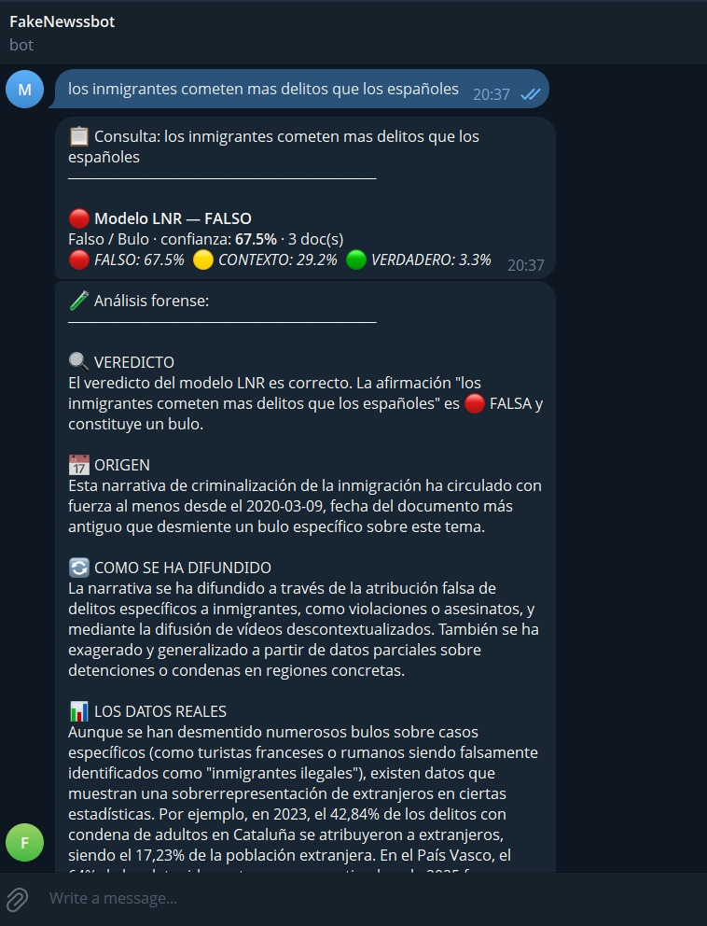
Figure 10: Example of the answer of the bot to a news headline, classified as false


Figure 11: Example of the answer of the bot to a news headline, classified as true

8. Table index
Table 1: Hyperparameters used for each model
Table 2: Comparing important metrics for both models
Table 3: Results of different metrics per-class in BETO model
Table 4: Results of different metrics per-class in XLM- RoBERTa model
Table 5: Results of training of BETO model
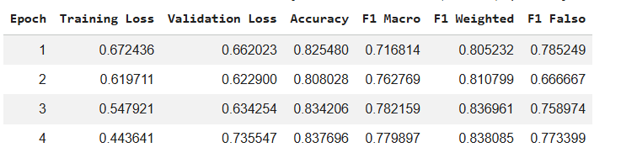
Table 6: Results of training of Roberta Model
