MISINFORMATION
  - for Immigration News in Spanish Digital Media
PROIII-06

Authors: Lucía Guillén López, Clara Pascual Olloqui, Claudia Schuller Tur, Manuel Caballero Vicente, Xavier Ventura Puchol, Mateo Alís Fidel, Chenyao Lin.



Content
1. Introduction 3
2. Value Proposition and Social Rationale 3
2.1 The Problem at Scale 3
2.2 Who Benefits 4
2.3 Novelty and Differentiation from Existing Systems 4
2.4 Risks and Responsible Use 5
3. Data Preparation 6
3.1 Dataset Construction 6
3.2 Label Distribution and Final Dataset Construction 6
3.3 Cleaning and Transformation Pipeline 6
3.4 Exploratory Data Analysis 7
3.5 Problem Context: Migration, Labour Market and Criminality in Spain 7
4. System Architecture and Technical Integration 8
4.1 Problem Formulation and Minable View 8
4.2 End-to-End System Architecture 8
4.3 Retrieval-Augmented Generation (RAG) System 9
4.4 Model Selection and Iterative Improvement 10
4.5 Hyperparameter Optimisation 10
4.6. Automation 11
5. Evaluation 11
5.1 Evaluation Methodology 12
5.2 Quantitative Results 12
5.3 Error Analysis 12
5.4 Training Behaviour 13
5.5 Deployment and User Validation 13
6. Discussion 14
6.1 Use of Technology 14
6.2 Seminar and AI Use 14
6.3 Legacy and Future Work 15
6.4 Sustainability and SDG Impact 15
6.5 Lessons Learnt 15
7. References 16
8. Appendices 18
9. Table Index 26

1. Introduction
In 2024, a message went viral across Spanish social media claiming that 1,698,861 of the 1,753,701 recipients of Spain's Minimum Vital Income — nearly 97% — were immigrants. The claim was false: the benefit explicitly excludes people in irregular situations and requires at least one year of legal residence (Maldita.es, 2023). But by the time the correction reached the public, the false statistic had already shaped political debate, reinforced prejudices, and been cited as evidence for restrictive policy proposals. This asymmetry — between the speed of misinformation and the slowness of verification — is the problem this project addresses.
Misinformation about immigration has measurable real-world consequences. It contributes to the normalisation of discriminatory attitudes, increases polarisation, and provides the rhetorical fuel for political movements that dehumanise migrant communities. A large-scale study published in Science found that false news spread farther, faster and more broadly than true news on social media, with political falsehoods reaching especially high levels of diffusion (Vosoughi, Roy & Aral, 2018). This is particularly concerning because many users find it difficult to identify misleading information: according to the European Commission's Flash Eurobarometer on fake news and online disinformation, 83% of Europeans considered fake news a danger to democracy, while in Spain 83% of respondents considered disinformation a problem for the country, 78% said they often encountered false or distorted news, and only 55% said they found it easy to detect it (European Commission, 2018; Newtral, 2023).
This issue is especially relevant in the case of migration, where misinformation can reinforce stereotypes, increase social polarisation and legitimise hate speech against vulnerable groups. Migration-related hoaxes often present migrants as a threat to public security, the economy, national identity or access to public services (Narváez-Linares, 2022).
This project builds an end-to-end, explainable AI system capable of detecting and contextualising misinformation about immigration in Spanish digital media. The system classifies claims as VERDADERO (factually verified), FALSO (objectively incorrect), or CONTEXTO (real facts presented in a misleading way), retrieves verified evidence to ground its reasoning, and provides users with a forensic explanation of why a piece of content is or is not misleading. It is deployed as a functional Telegram chatbot accessible to any user, without technical expertise required.

2. Value Proposition and Social Rationale

2.1 The Problem at Scale
Immigration is the most polarising and misrepresented topic in contemporary Spanish political discourse. According to the European Digital Media Observatory (2024), immigration-related narratives consistently rank among the top categories of disinformation in Spain. Unlike health misinformation — where false claims are often debunked by official bodies within days — immigration misinformation tends to persist, recirculate, and accumulate legitimacy through repetition.
The consequences are not abstract. Research on migration misinformation in Spain has documented a direct link between exposure to false narratives about migrants and increased hostility toward immigrant communities (Aguerri, 2025). Narratives that falsely associate migrants with crime, welfare dependency, or cultural threat are not merely inaccurate: they shape public opinion, inform political platforms, and ultimately influence the legal and social conditions under which migrants live. When a false statistic about foreign crime rates is shared ten thousand times before a correction reaches a thousand people, the asymmetry is not just informational — it is social.
The problem is compounded by the specific nature of immigration misinformation in Spain. Unlike outright fabrications, the most effective and most common form is contextual: it takes a real number, a real event, or a real policy, and strips away the framing that would make it meaningful. A crime statistic presented without population-adjusted rates. An arrival figure presented without historical comparison. A cost estimate presented without a breakdown of what is included. This is the CONTEXTO class and it is the class that to the best of our knowledge no existing Spanish-language system is capable of detecting.

2.2 Who Benefits
The system was designed with a broad set of beneficiaries in mind. Identifying them explicitly is important not only for evaluating the project's social value, but for understanding the design decisions made throughout the pipeline.
- Citizens and general public. The primary and most numerous beneficiary. Any person who encounters a headline, social media post, or WhatsApp message about immigration in Spain and wants to verify it quickly, without requiring technical knowledge. The Telegram interface was specifically chosen because it is already part of the daily communication habits of millions of Spanish users, requiring no new account or learning curve.
- Journalists and fact-checkers. Professional fact-checkers at Maldita.es, Newtral or VerificaRTVE regularly process dozens of claims per day. A system that pre-classifies incoming claims, retrieves relevant verified sources, and drafts a forensic analysis dramatically reduces the time-to-verification, allowing human experts to focus on edge cases and editorial judgment rather than routine retrieval.
- NGOs and civil society organisations. Organisations working with migrant communities — such as CEAR (n.d.), Accem (n.d.), or Red Acoge (n.d.) — frequently need to respond to false narratives in public discourse. The TRUE PART / MISLEADING PART structure gives these organisations a concrete resource for counter-messaging that is more effective than simple denial.
- Educators and media literacy practitioners. The CONTEXTO class is particularly valuable in educational settings. Teaching students to distinguish between a falsehood and a misleading truth is a core challenge of media literacy. The forensic explanations model exactly the kind of critical reasoning that media literacy programmes aim to develop.
- Policymakers and public institutions. Official bodies such as OBERAXE (n.d.) currently monitor hate speech at an aggregate level. A system capable of flagging individual misleading immigration content, with evidence and classification, provides granular data that aggregate monitoring cannot, informing communications strategy, regulatory responses, or public awareness campaigns.

2.3 Novelty and Differentiation from Existing Systems
To understand what makes this system novel, it is necessary to understand what already exists and why it is insufficient. The Simon Fraser University (Asr & Taboada, 2019) system offers similarity-based inspection without classification or explanation. OBERAXE (n.d.) and HODIO (Ministerio de Inclusión, 2026) provide aggregate monitoring without individual claim analysis. Academic ML approaches provide classification without RAG grounding or CONTEXTO modelling. Our system differs from all the above in five concrete ways:
- The CONTEXTO class. To our knowledge there is not a Spanish-language system models contextually misleading information — real facts presented without the context needed to interpret them correctly. This is not a minor extension; it is a fundamentally different and harder problem requiring pragmatic as well as semantic understanding.
- Domain specificity. The system is trained, evaluated, and deployed specifically for immigration-related narratives in Spain. A system trained on general news cannot capture the particular vocabulary, rhetorical patterns, and evidence base of immigration misinformation.
- Explainability by design. The system does not return a label. It returns a verdict, an explanation of the narrative's origin, an analysis of its propagation, the real facts that contextualise it, and a specific account of why it misleads. This is not post-hoc explainability — it is the primary output of the forensic generation stage.
- Continuous learning. The automated pipeline updates both the classifier and the RAG database as new verified articles are published. The system learns from the world as it changes, rather than becoming obsolete as soon as new narratives emerge.
- Real-world deployment. Unlike academic systems that exist only as code repositories, FakeNewsBot is deployed and operational as a Telegram chatbot. Real users can interact with it today.

Feature | Simon Fraser | OBERAXE/HODIO | Academic ML | FakeNewsBot
CONTEXTO class | No | No | No | Yes
Explainable verdicts | No | No | No | Yes
RAG evidence retrieval | No | No | No | Yes
Individual claim analysis | Partial | No | Yes | Yes
Real-time deployment | No | Partial | No | Yes
Spanish immigration domain | No | Partial | Partial | Yes
Continuous learning | No | No | No | Yes
Table 1: Feature comparison with existing systems.

2.4 Risks and Responsible Use
A system that classifies information as true, false or misleading carries significant responsibility. We identify the following risks explicitly, not as caveats to be minimised but as design constraints that must inform any future deployment at scale.
False positives and reputational harm. Classifying a legitimate news article as FALSO or CONTEXTO could unfairly damage the reputation of a media outlet or journalist.
Source dependency and coverage bias. The RAG database is built from a limited set of verified sources. Claims about events not covered by those sources will receive lower-quality evidence retrieval. The continuous pipeline mitigates this over time, but it is a genuine short-term limitation.
Adversarial manipulation. A sufficiently sophisticated actor could craft narratives specifically designed to evade detection by studying the system's outputs. This argues for continuous retraining and human oversight.
Over-reliance and automation bias. Users may treat the system's verdict as authoritative rather than as a starting point for verification. The design of the output — which always provides evidence links and explains reasoning — is intended to encourage critical engagement rather than passive acceptance.
Political framing. Any system classifying immigration-related content as true or false is implicitly making claims about contested political realities. The use of verified institutional sources is the primary mitigation, but the risk of perceived bias cannot be fully eliminated and must be transparently acknowledged.

3. Data Preparation

3.1 Dataset Construction
A custom dataset was created by scraping news from four sources selected based on reliability, relevance, and representativeness within the Spanish context. For mainstream news, we used El País (n.d.) and Cadena SER (n.d.), two widely read outlets with high daily output and broad audiences. For wire coverage, we included Agencia EFE (n.d.). For misinformation, we incorporated Maldita Migración (n.d.), a specialized branch of Maldita.es and member of the European Fact-Checking Standards Network (EFCSN). Their rigorous verification methodology (Maldita.es, 2025) provided the labelling standards used to classify fact-checked content in our dataset. All articles were unified into a common schema of eight columns: titulo, etiqueta, texto, tema, url, fecha_publicacion, medio, and fecha_extraccion. Dataset quality and diversity have been identified as critical factors in the effectiveness and robustness of fake news detection models (Kuntur et al., 2026).

3.2 Label Distribution and Final Dataset Construction
The real dataset alone was highly imbalanced: VERDADERO articles dominated, while FALSO and CONTEXTO were scarce. To address this, we generated synthetic false or misleading variants from true articles using the Gemini API, documenting the misinformation technique used (Figure 1) and the specific modification made. Figure 2 shows the final distribution after synthetic augmentation: 5,589 total news items — 2,504 VERDADERO, 2,018 FALSO, 1,067 CONTEXTO — achieving a practically balanced corpus.
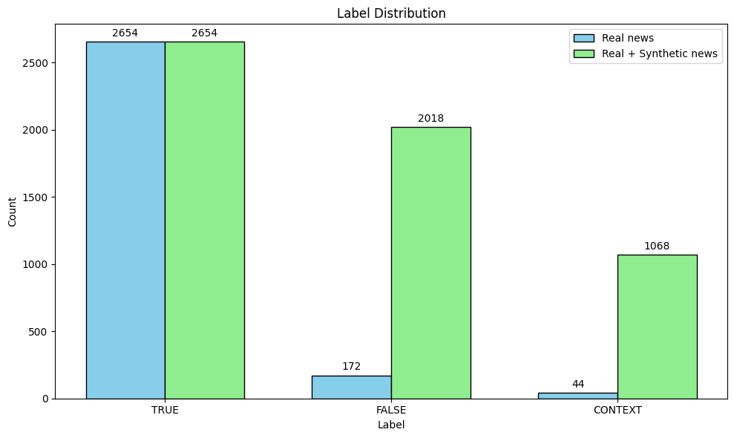
Figure 2: Label distribution of real news versus combined real and synthetic news

3.3 Cleaning and Transformation Pipeline
The preparation pipeline applied: null removal (dropna()), length filtering (title ≥ 5 words, text ≥ 20 words), normalisation (whitespace and UTF-8), and stratified split (80% train, 10% validation, 10% test). The final dataset contained 5,480 news articles, after eliminating 109.
Text length analysis revealed a mean of approximately 1,200 characters per item, with the 85th percentile within the 512-token limit of XLM-RoBERTa.

3.4 Exploratory Data Analysis
The exploratory analysis revealed patterns with direct implications for model design. Figure 3 shows the most frequent topics are 'convivencia y racismo' and 'política y leyes', confirming the dataset focuses on politically sensitive migration areas. Figure 4 shows a potential source bias: traditional outlets are predominantly VERDADERO while Maldita Migración and synthetic data contain most FALSO and CONTEXTO examples.
Figure 5 shows the label distribution by topic. False and contextualised claims appear across multiple areas. This suggests that the dataset includes false, true and context-labelled articles across all topics, indicating that the label distribution is relatively consistent across thematic categories.
Figures 6 and 7 analyse article and title length by label. True articles tend to have longer and more variable body texts, while false and contextualised examples are generally shorter and more concentrated. Title length is more similar across labels, although true articles appear to have slightly shorter median titles. These differences matter because text length can become an indirect signal for classification, even though the system should ideally rely on semantic content and supporting evidence.
Figure 8 reveals the most diagnostic lexical signal: false and contextualised claims use significantly more alarmist or emotionally charged vocabulary ('invasión', 'masiva', 'escándalo', 'secreto') compared to the neutral language of true articles — though CONTEXTO articles that deliberately mimic the neutral register present the hardest classification challenge.
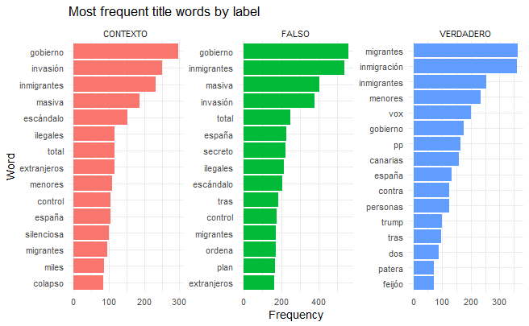
Figure 8: Most frequent title words by label

3.5 Problem Context: Migration, Labour Market and Criminality in Spain
To provide grounding for the evidence retrieval system, we compiled official statistics from INE (INE, n.d.) and the Ministerio de Inclusión on three domains frequently targeted by immigration misinformation. On migration flows: the largest groups arriving in Spain come from Colombia, Morocco and Venezuela — regions with strong historical ties to Spain, contradicting narratives of uncontrolled migration (Figures 9–11). On labour market: non-EU foreign men currently have a higher employment rate than Spanish men in the most recent period (Figures 12–15). On criminality: Spanish nationals account for most crimes in almost every category; the post-2020 increase in registered crimes follows the exceptional COVID-19 lockdown drop and does not reflect a structural trend linked to immigration (Figures 16–17).

4. System Architecture and Technical Integration

4.1 Problem Formulation and Minable View
The project is formulated as a supervised multiclass classification problem focused on misinformation detection in Spanish immigration-related narratives. Unlike traditional fake news systems that only distinguish between true and false information, our approach explicitly models a third category, CONTEXTO, which represents information that is factually grounded but misleading through omission, framing or selective emphasis.
This distinction is especially important in real-world misinformation scenarios, where manipulation frequently occurs through contextual distortion rather than through completely fabricated claims. The system therefore aims not only to detect falsehoods, but also to identify narratives that manipulate interpretation while remaining partially factual.
VERDADERO: factually correct and not misleading.
FALSO: objectively incorrect or fabricated information.
CONTEXTO: partially true information presented in a manipulative or misleading way.
The minable view is therefore defined as a semantic text classification task in which the model learns a mapping between tokenized textual representations and a probability distribution over misinformation-related classes.
This formulation goes beyond traditional keyword-based fake news detection. In particular, CONTEXTO requires semantic and pragmatic understanding, since the manipulation often emerges not from explicit false statements, but from what is omitted, exaggerated or selectively framed.

Affirmation | True part | Misleading part
'El 73% de los detenidos por violacion en Barcelona son extranjeros' | Data from Mossos on sexual crimes (2024) | Includes all sexual crimes, not just rape; foreigners = 20% of BCN population
'Las llegadas a Canarias se han disparado este año' | 2024 was a record year: 57,738 arrivals | Omits that 2006 had similar figures; implies unprecedented novelty
'Los menores migrantes cuestan mas que un hotel de 5 estrellas' | Some municipalities report high per capita costs | Ignores specialised medical, educational and psychological care included
Table 2: Illustrative examples of the CONTEXTO class.

4.2 End-to-End System Architecture
The system integrates multiple machine learning and retrieval components into a unified pipeline, shown in Figure 18, deployed through a Telegram chatbot.
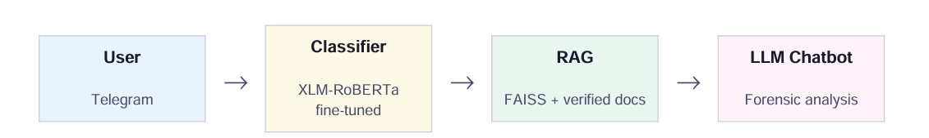
Figure 18: Pipeline architecture

At inference time, the user submits a claim, sentence or news headline through the Telegram interface. The system first applies a lightweight keyword-based relevance filter in order to determine whether the query is related to immigration topics. This prevents unnecessary execution of expensive language models on unrelated inputs and restricts the domain of the system to the target problem.
If the query is considered relevant, the system generates dense semantic embeddings using Gemini Embedding 2 Preview. These embeddings are used to query a ChromaDB vector database containing verified immigration-related articles and fact-checking content. The retrieval stage returns the three most semantically similar verified documents.
Simultaneously, the user input is processed by the main classifier based on XLM-RoBERTa fine-tuned for misinformation classification. The classifier outputs the result over the three main classes: VERDADERO, CONTEXTO and FALSO.
The retrieved documents, the classifier prediction and the confidence distribution are then incorporated into a structured prompt processed by Llama 3.3 70B through the Groq API. This model generates a forensic explanation grounded on the retrieved evidence.
To improve reliability, a second independent validation stage is introduced using Gemini. This secondary model validates or challenges the reasoning produced by the primary LLM. If both models, Groq with Llama 3.3 70B and Gemini, agree on the verdict, it is presented with higher confidence. If disagreement occurs, the system explicitly indicates this to the user.
Finally, the chatbot returns the predicted class, an evidence-based forensic explanation, and links to the most relevant retrieved verified sources.
This architecture combines semantic retrieval, transformer-based classification and evidence-grounded generation into a single end-to-end misinformation detection pipeline.

4.3 Retrieval-Augmented Generation (RAG) System
The Retrieval-Augmented Generation (RAG) module was designed to improve explainability and factual grounding.
The vector database is implemented using ChromaDB, while semantic representations are generated through Gemini Embedding 2 Preview. Each verified article is segmented into chunks of approximately 512 tokens with an overlap of 64 tokens to preserve semantic continuity between fragments while maintaining efficient retrieval.
Each chunk is enriched with metadata including source, publication date, label type and original article reference.
The final collection contains around 4,051 verified immigration-related fragments collected from Spanish media and fact-checking sources between 2006 and 2026.
To reduce redundancy, semantic deduplication is applied using cosine similarity with a threshold of 0.97, preventing near-duplicate chunks from entering the database.
Importantly, only real verified articles are incorporated into the RAG system. Synthetic data generated during augmentation is used exclusively for classifier training and never included in the retrieval database. This separation was intentionally designed to avoid contaminating the evidence retrieval process with artificially generated information.
The retrieved documents serve two primary purposes: grounding LLM explanations on verifiable evidence, reducing hallucinations and unsupported claims during generation.
This retrieval-based architecture enables the system not only to classify misinformation but also to provide transparent evidence-based explanations to the user.

4.4 Model Selection and Iterative Improvement
To incrementally improve our classification metrics, we conducted an iterative evaluation of both input features and model architectures.

Feature Iteration and Baselines:
Before moving to complex architectures, we established a baseline using TF-IDF with Logistic Regression. At this stage, we explicitly iterated over different input features to understand the optimal representation for the model:

- Title-only inputs: Yielded the lowest performance, confirming our error analysis that isolated headlines lack the semantic depth required to detect contextual manipulation.

- Body-only inputs: Improved VERDADERO and FALSO detection but struggled with CONTEXTO.

- Title + Body concatenation: Proved to be the most robust feature representation, as it captured the contrast between sensationalist headlines and factual body texts (a common pattern in the CONTEXTO class). Consequently, we locked our input feature space to the concatenated titulo + texto (truncated to the 512-token limit) for all subsequent deep learning models.

Architecture Iteration:
With the optimal input features defined, we evaluated two transformer models: BETO (pretrained on Spanish corpora) and XLM-RoBERTa (multilingual). The hypothesis that BETO would outperform XLM-RoBERTa due to Spanish specialization was contradicted by the results. Both models performed well on VERDADERO and FALSO, but CONTEXTO consistently emerged as the hardest category. After synthetic augmentation and retraining, XLM-RoBERTa demonstrated significantly better generalisation, particularly for CONTEXTO. Multilingual pretraining provides a richer representation space for modelling subtle pragmatic distortions than monolingual specialization. Based on these results, XLM-RoBERTa was selected as the final classification backbone of the deployed system.
The iterative improvement process followed a structured progression. Starting from a TF-IDF with Logistic Regression baseline, we systematically evaluated input feature combinations (title-only, body-only, and concatenated title+body), establishing that concatenation was the optimal representation before moving to transformer architectures. We then compared two pretrained models — BETO and XLM-RoBERTa — across multiple training configurations, tracking per-class and macro F1 at each step. Synthetic data augmentation via the Gemini API produced a measurable improvement in CONTEXTO detection, raising XLM-RoBERTa's macro F1 from an initial baseline to 59.0% on the held-out test set, with CONTEXTO F1 improving from 0.0% (BETO) to 28.6%. Each iteration was justified by quantitative evidence, with macro F1 chosen as the primary metric precisely because accuracy masked the model's weakness on the minority CONTEXTO class — a decision validated by the results in Table 4.

4.5 Hyperparameter Optimisation
Hyperparameter optimisation was conducted using a systematic grid search over {LR: 1e-5, 2e-5, 3e-5} × {batch: 16, 32} × {warmup: 0.06, 0.10}, automated through HuggingFace Trainer's built-in evaluation loop with early stopping (patience=3). Both models were initialised from state-of-the-art pretrained checkpoints — BETO (Cañete et al., 2020) and XLM-RoBERTa (Conneau et al., 2020) — leveraging transfer learning to adapt large-scale multilingual representations to the specific domain of Spanish immigration misinformation. Model selection was performed automatically based on validation macro F1, ensuring the best checkpoint was retained without manual intervention.

Hyperparameter | BETO | XLM-RoBERTa
Learning rate | 2e-5 | 1.5e-5
Batch size (per GPU) | 16 | 32
Maximum epochs | 6 | 6
Warmup proportion | 0.10 | 0.10
Label smoothing | 0.10 | 0.10
Best model metric | F1 FALSO | F1 Macro
Table 3: Hyperparameter configurations for both models.

4.6. Automation
Other important objective of our project was to achieve an automated system that improves the results through time. To achieve this we have worked on the pipeline shown in the Figure 19.
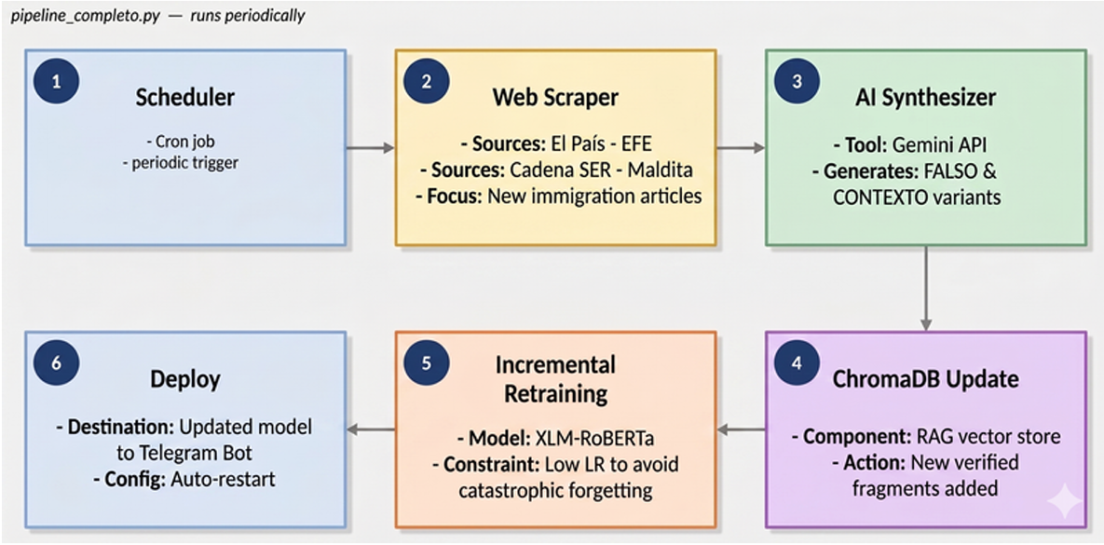Figure 19: Pipeline architecture

The pipeline_completo.py script implements a fully automated MLOps continuous improvement cycle. A scheduled cron job triggers the scraper at regular intervals; new articles are automatically synthesised by the Gemini API to generate FALSO and CONTEXTO variants; ChromaDB is updated with the new verified fragments; XLM-RoBERTa is incrementally retrained using a low learning rate to prevent catastrophic forgetting; and the updated model is automatically deployed to the Telegram bot with auto-restart, requiring zero manual intervention. This end-to-end automation ensures the system continuously adapts to emerging misinformation narratives without human oversight at each step.

5. Evaluation

5.1 Evaluation Methodology
Given the multiclass nature of the task and the strong class imbalance, accuracy alone was insufficient as the primary evaluation metric. Macro F1-score was selected as the main criterion because it assigns equal importance to all classes regardless of frequency — critical given that CONTEXTO is both the minority class and the most semantically challenging. The evaluation also reports per-class precision, recall and F1, weighted F1, and overall accuracy. Evaluation was conducted on a held-out test set. A 5-fold cross-validation experiment over a 50% subsample confirmed stable performance with variance below ±0.03 macro F1 between folds.

5.2 Quantitative Results
Metric | BETO | XLM-RoBERTa
Accuracy | 61.1% | 61.1%
F1 Macro | 48.9% | 59.0%
F1 VERDADERO | 66.7% | 71.4%
F1 FALSO | 80.0% | 76.9%
F1 CONTEXTO | 0.0% | 28.6%
Table 4: Model comparison trained on the full dataset.
Both models achieve the same accuracy of 61.1%, confirming that accuracy is not a discriminating criterion under class imbalance. The key difference lies in Macro F1: XLM-RoBERTa reaches 59.0% versus 48.9% for BETO. The most revealing result concerns CONTEXTO: XLM-RoBERTa achieves 28.6% F1 while BETO scores 0.0%, completely failing to identify this category. This result vindicates the decision to treat CONTEXTO as a first-class category and suggests that multilingual pretraining provides a richer representation space for modelling pragmatic manipulation.

However, the low performance on CONTEXTO should not be interpreted simply as model failure, but as empirical evidence of the intrinsic difficulty of pragmatic misinformation detection. Unlike fabricated claims, contextual misinformation often preserves factual correctness at the lexical level, meaning that the manipulation emerges from omission, framing, or selective emphasis rather than explicit falsehoods. As a result, purely semantic classification approaches remain fundamentally limited for this task.

5.3 Error Analysis
The most common failure mode is misclassification of CONTEXTO instances. Three dominant patterns were identified:
Stylistic similarity with VERDADERO. CONTEXTO articles use the same factual and journalistic register as legitimate news. The manipulation emerges from omission, not from explicit false statements — making it indistinguishable from true news at the surface level.
Headline-only inputs. Without article body text, model confidence falls below the abstention threshold.
Negation and pragmatic ambiguity. Certain claims involving negation or implicit framing are incorrectly interpreted because transformer models prioritise semantic co-occurrence patterns over pragmatic intent. This issue motivated the introduction of the ensemble validation stage, where Gemini acts as an independent secondary model capable of correcting these cases through deeper reasoning. When both models, Groq with Llama 3.3 70B and Gemini, agree on the verdict, it is presented with higher confidence. If disagreement occurs, the system explicitly indicates this to the user.
The analysis suggests that transformer architectures operate effectively at the semantic level ('what is explicitly stated') but remain weaker at the pragmatic level ('what is implied or omitted'), which is precisely where contextual misinformation emerges. This limitation is not unique to our system: recent work has shown that existing detection methods fall short in capturing omission patterns that operate through what is deliberately left unsaid rather than what is explicitly stated (Sheng et al., 2025), and that models such as RoBERTa fail to infer bias or manipulation expressed indirectly through implication or selective omission (Galimzhanova et al., 2025). These findings reinforce the value of our ensemble validation stage, where Gemini acts as an independent secondary model capable of addressing these pragmatic failures through deeper reasoning.

5.4 Training Behaviour
The tables below show training dynamics across epochs for both models, evaluated on the validation set. Validation metrics during training are higher than the final held-out test set results in Table 4 — an expected gap reflecting the harder distribution of the test set, which consists of real-world articles with more natural ambiguity.
Epoch | Train Loss | Val Loss | Accuracy | F1 Macro | F1 Weighted | F1 Falso
1 | 0.6724 | 0.6620 | 0.8255 | 0.7168 | 0.8052 | 0.7852
2 | 0.6197 | 0.6229 | 0.8080 | 0.7628 | 0.8108 | 0.6667
3 | 0.5479 | 0.6343 | 0.8342 | 0.7822 | 0.8370 | 0.7590
4 | 0.4436 | 0.7355 | 0.8377 | 0.7799 | 0.8381 | 0.7734
Table 5: BETO training results per epoch (validation set).
Epoch | Train Loss | Val Loss | Accuracy | F1 Macro | F1 Weighted | F1 Falso
1 | 0.9785 | 0.7419 | 0.7941 | 0.6780 | 0.7661 | 0.7533
2 | 0.6914 | 0.6404 | 0.8185 | 0.7711 | 0.8234 | 0.7147
3 | 0.6063 | 0.6423 | 0.7923 | 0.7423 | 0.7970 | 0.6588
4 | 0.5550 | 0.6459 | 0.8499 | 0.7834 | 0.8446 | 0.8009
5 | 0.5392 | 0.6596 | 0.8342 | 0.7764 | 0.8346 | 0.7673
6 | 0.5174 | 0.6763 | 0.8360 | 0.7763 | 0.8354 | 0.7726
Table 6: XLM-RoBERTa training results per epoch (validation set).

5.5 Deployment and User Validation
The system was deployed as a functional Telegram chatbot called FakeNewsBot. Users receive a misinformation verdict, a forensic explanation structured around VERDICT, ORIGIN, PROPAGATION, REAL FACTS and WHY IT MISLEADS, and links to verified sources. We have tried some examples of headings that were labelled as true (Figure 20), false (Figure 21) and context (Figure 22).
Particular attention was dedicated to CONTEXTO explanations. When contextual manipulation is detected, the system explicitly separates the factual component, the misleading component, and the manipulation mechanism.

Profile | Utility | Classification | Explicability | Sources | Security | Average
Student | 4/5 | 3/5 | 4/5 | 4/5 | 4/5 | 3.8/5
Journalism graduate | 5/5 | 3/5 | 3/5 | 3/5 | 4/5 | 3.6/5
Non-expert user | 5/5 | 4/5 | 4/5 | 4/5 | 5/5 | 4.4/5
Table 7: User validation results across profiles.
The non-expert users gave the highest scores overall, suggesting the system is most immediately valuable to the audience it was designed for: citizens without specialist training who encounter misinformation in their daily media consumption. The Journalism graduate was the most critical, consistent with their greater ability to detect nuance.

6. Discussion

6.1 Use of Technology
Python was the primary language throughout. Hugging Face Transformers with PyTorch was used to fine-tune BETO and XLM-RoBERTa on Google Colab and Kaggle respectively using NVIDIA T4 GPUs. ChromaDB was used as the vector database, with Gemini Embedding 2 Preview for semantic representations. Llama 3.3 70B via the Groq API handles forensic explanation generation; Gemini provides independent secondary validation. The full pipeline was deployed through a Gradio web app and a functional Telegram bot.
The system processes each query in approximately 6-9 seconds end-to-end: under 0.5s for retrieval, 4-6s for Llama 3.3 70B generation, 1-2s for Gemini validation. Token costs per query total approximately 4,250 tokens (350 for embedding, 2,800 for forensic generation, 1,100 for secondary validation), kept low by efficient API tiers.

6.2 Seminar and AI Use
The project applies core methodologies from across the course. Guided by Unit 2c (Data Science for Good), we prioritized social impact over traditional business metrics. For Unit 3 (Task Identification and Model Building), we evaluated baselines like TF-IDF with Logistic Regression but discarded them for Transformers (BETO and XLM-ROBERTa), as bag-of-words cannot capture the semantic nuances needed to detect the CONTEXTO class. Following Unit 4 (Iterative Improvement), we rejected accuracy due to class imbalance, optimizing for Macro F1-score instead. Finally, deploying a functional Telegram prototype demonstrates Unit 5 (Exploitation and Value Assessment), proving real-world value beyond offline metrics.

AI Tools and Limitations: We used AI extensively while actively mitigating its inherent risks:
- Gemini API (Synthetic Data): Used to balance our training set. Because LLMs can introduce uniform linguistic artifacts, this synthetic data was strictly excluded from the RAG database to prevent factual contamination.
- Llama 3.3 70B (Forensic Generation): Used to draft explanations. To prevent the well-documented risk of LLM hallucinations, we bounded its outputs entirely to retrieved, verified documents.
- Secondary Validation: Because transformers struggle with pragmatic ambiguity, we implemented an independent Gemini validation step to cross-check Llama's verdicts, ensuring highly reliable outputs.

6.3 Legacy and Future Work
All code, data, and model checkpoints will be published on a public GitHub repository (Lguilop, 2026), with sufficient documentation to allow replication. The dataset, scraping scripts, and annotation schema will be released under an open license, given the scarcity of Spanish-language misinformation resources in this domain. The data collection pipeline is already designed to update automatically, so new articles can be added over time without manual intervention.
We intend to submit this work to Information Processing & Management published by Elsevier, a leading Q1 journal in Scientific Journal Rank (SJR). The journal is internationally recognized for high-impact research in information retrieval, natural language processing and explainable AI, making it an excellent fit for our work on misinformation detection using transformer models and retrieval-augmented generation. With an Impact Factor of 6.9 and a CiteScore of 18.6, publishing in this venue would provide strong scientific visibility and maximize the academic impact of the project.
Several improvements could strengthen the system going forward. The most important is better handling of the CONTEXTO class, which remains hard to detect even for transformer models because manipulation often happens through omission or framing rather than explicit falsehoods. Expanding the dataset to include social media would also help generalize the model. In the longer term, the modular pipeline could serve as the basis for a browser extension or a lightweight web application, both more accessible than the current Telegram bot since they require no account. Finally, a formal user study with diverse audiences would replace the informal validation conducted so far, providing rigorous evidence of the system's real-world effectiveness and helping identify usability gaps before any broader deployment.

6.4 Sustainability and SDG Impact
The project contributes to three UN Sustainable Development Goals, with a particular emphasis on social sustainability. Social sustainability is addressed directly through SDG 10 (Reduced Inequalities), as the project counters misinformation that fuels stigmatisation of migrant communities. It also supports SDG 16 (Peace, Justice and Strong Institutions) by promoting access to verified information and transparent, evidence-based fact-checking, which strengthens social trust and institutional accountability. The project aligns with SDG 17 (Partnerships for the Goals) by combining open data from official sources (the INE and the Ministerio de Inclusión) to improve public understanding of migration dynamics. These contributions together support the social dimension of sustainability by fostering more informed, equitable, and cohesive communities.

6.5 Lessons Learnt
The hardest problem was CONTEXTO. The boundary between misleading content and genuinely true content is genuinely ambiguous, and no amount of data balancing fully resolves this. This made clear why accuracy alone is a poor evaluation metric: the model's weakness on a minority class would not have been visible without per-class reporting.
Building the dataset was more complex than expected. Synthetic augmentation worked well for balancing classes but required care to avoid introducing patterns the model could exploit without actually learning to detect misinformation. The comparison between BETO and XLM-RoBERTa was instructive: the breadth of multilingual pretraining can matter as much as language specificity — a finding with broader implications for NLP practitioners.
Deploying a working Telegram prototype early was one of the best decisions. Offline metrics do not reveal all limitations: the model's poor performance on headline-only inputs only became apparent through real use. This reinforces the value of iterative, deployment-first development even in research contexts.
Finally, the project confirmed that explainability is not a nice-to-have — it is the core product. A system that returns a verdict without explanation is not just less useful; it is potentially dangerous, because it invites passive acceptance of automated judgment on contested claims. The forensic explanation is what makes the system a tool for media literacy rather than a tool for automated censorship.

7. References
Accem. (n.d.). Accem. https://www.accem.es
Agencia EFE. (n.d.). Agencia EFE. https://efe.com
Aguerri, J. C. (2025). Disinformation linking migration and crime in Spain. Classic moral panic in a new digital ecosystem.
Asr, F. T., & Taboada, M. (2019). Big data and quality data for fake news and misinformation detection. Big Data & Society, 6(1), 1–14. https://doi.org/10.1177/2053951719843310
Cadena SER. (n.d.). Cadena SER. https://cadenaser.com
Cañete, J., Chaperon, G., Fuentes, R., Ho, J.-H., Kang, H., & Pérez, J. (2020). Spanish pre-trained BERT model and evaluation data. In Practical ML for Developing Countries Workshop at ICLR 2020. https://pml4dc.github.io/iclr2020/papers/PML4DC2020_10.pdf
CEAR. (n.d.). Comisión Española de Ayuda al Refugiado. https://www.cear.es
Conneau, A., Karthikeanu, K., Lample, G., & Stoyanov, V. (2020). Unsupervised cross-lingual representation learning at scale. Proceedings of ACL 2020. https://arxiv.org/abs/1911.02116
El País. (n.d.). El País. https://elpais.com
European Commission. (2018). Flash Eurobarometer 464: Fake news and disinformation online.
European Digital Media Observatory. (2024). Disinformation narratives on migration during the summer in Spain.
Galimzhanova, A., et al. (2025). Bridging human and model perspectives: A comparative analysis of political bias detection in news media using large language models. https://arxiv.org/abs/2511.14606
Instituto Nacional de Estadística. (n.d.). INE. https://www.ine.es/
Kuntur, S., Wróblewska, A., Ganzha, M., Paprzycki, M., & Sachdeva, S. (2026). Fake news detection: It's all in the data! Applied Sciences, 16(3), 1585. https://doi.org/10.3390/app16031585
Lguilop. (2026). proyecto [GitHub repository]. https://github.com/lguilop/proyecto
Maldita.es. (n.d.). Maldita Migración. https://maldita.es/migracion/
Maldita.es. (2023). Más de 500 bulos y desinformaciones sobre personas migrantes, refugiados y minorías religiosas. https://maldita.es/malditobulo/20231218/400-bulos-y-desinformaciones-migrantes-refugiados/
Maldita.es. (2025). Metodología de Maldita.es. https://maldita.es/metodologia-maldita/
Ministerio de Inclusión, Seguridad Social y Migraciones. (n.d.). Observatorio Permanente de la Inmigración. https://www.inclusion.gob.es/web/opi
Ministerio de Inclusión, Seguridad Social y Migraciones. (2026). HODIO: Huella del Odio y la Polarización. https://www.inclusion.gob.es/oberaxe
Narváez-Linares, A. (2022). Fake news y desinformación sobre migración en España.
Newtral. (2023). El 83% de españoles considera la desinformación un problema.
OBERAXE. (n.d.). Observatorio Español del Racismo y la Xenofobia. Ministerio de Inclusión, Seguridad Social y Migraciones. https://www.inclusion.gob.es/oberaxe
Red Acoge. (n.d.). Red Acoge. https://www.redacoge.org
Sheng, Q., et al. (2025). Reasoning about the unsaid: Misinformation detection with omission-aware graph inference. https://arxiv.org/abs/2512.01728
Vosoughi, S., Roy, D., & Aral, S. (2018). The spread of true and false news online. Science, 359(6380), 1146–1151.

8. Appendices

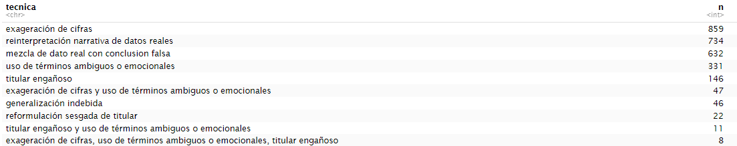
Figure 1: Techniques used by AI to make the synthetic news

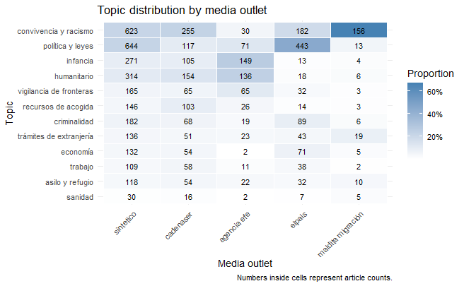
Figure 3: Heatmap showing topic distribution by media outlet

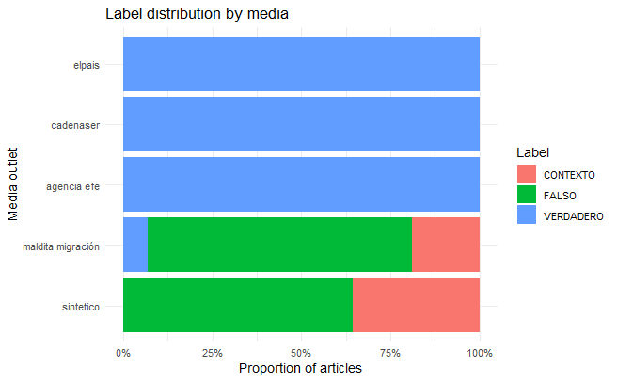
Figure 4: Label distribution by media outlet

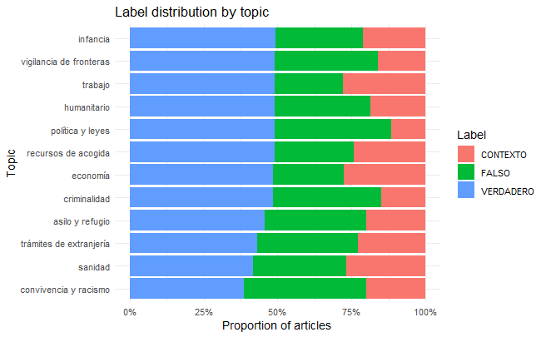
Figure 5: Label distribution by topic
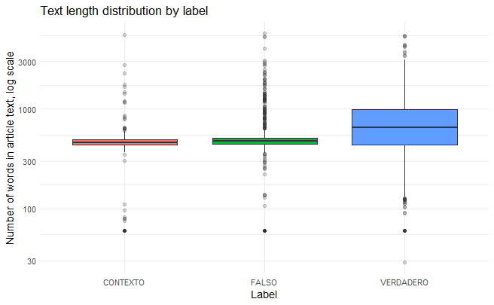
Figure 6: Article length distribution by label

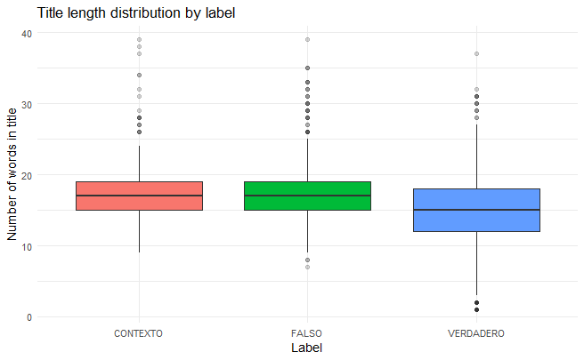
Figure 7: Title length distribution by label
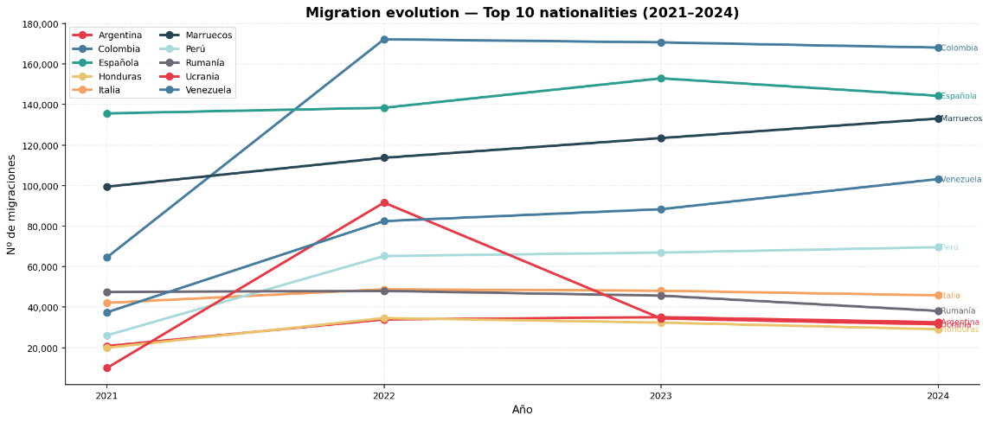
Figure 9: Migration evolution by nationality in Spain from 2021 to 2024

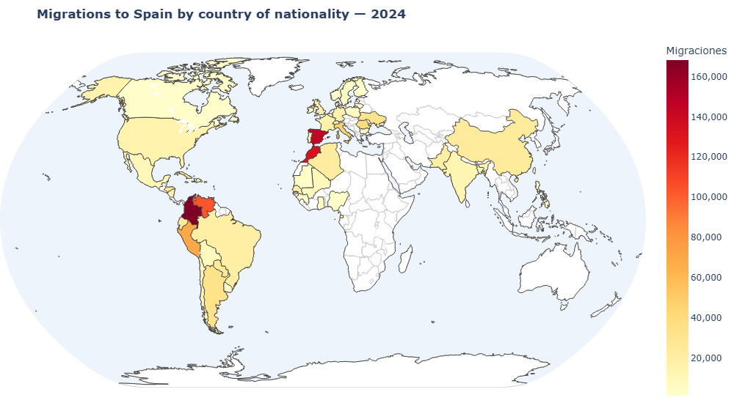
Figure 10: Geographical distribution of migrations to Spain in 2024
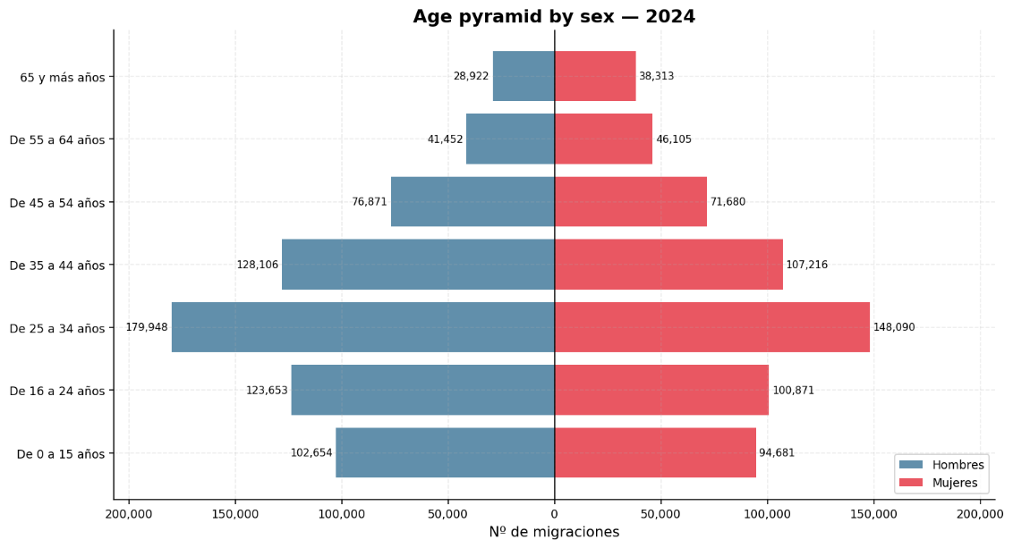
Figure 11: Age and gender distribution of migrants arriving in Spain in 2024

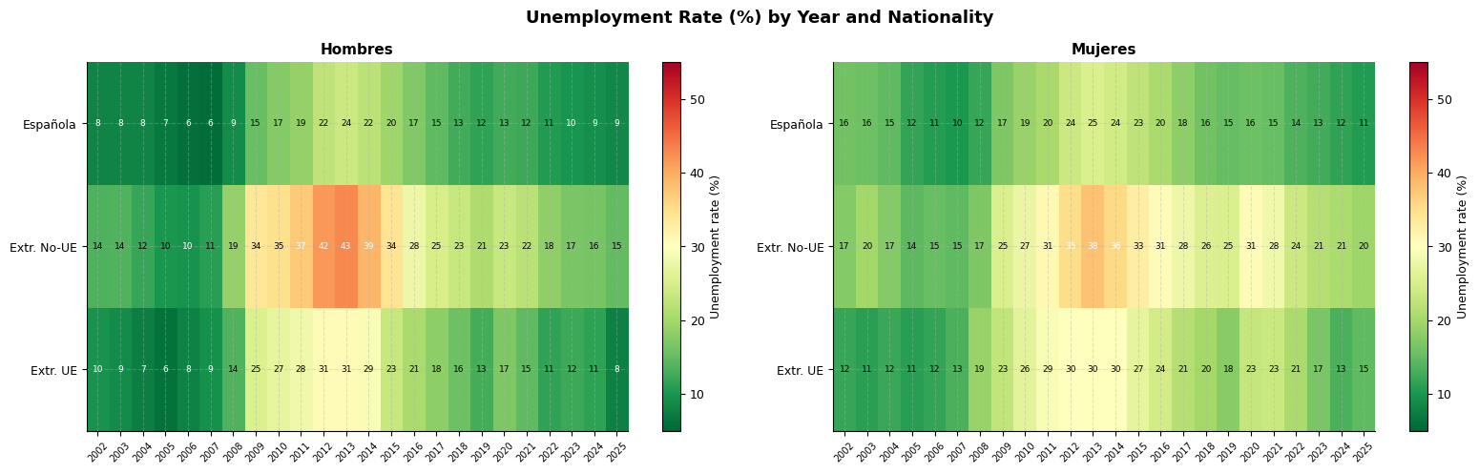
Figure 12: Foreign active population by nationality group and residence time, 2002-2025

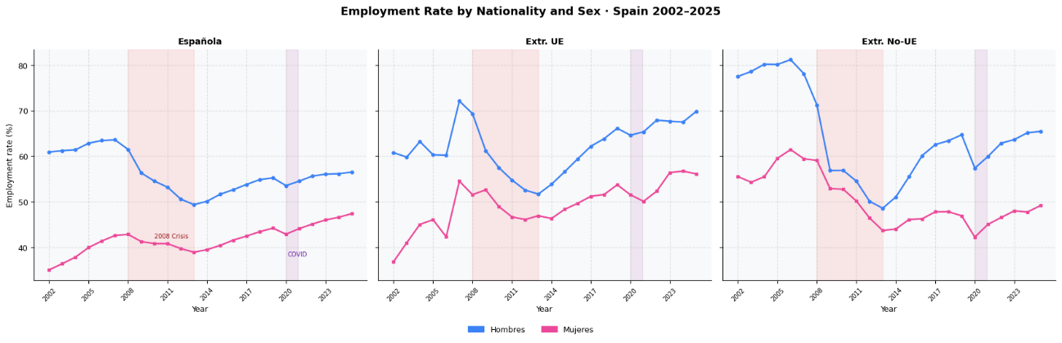
Figure 13: Unemployment rate by year, nationality and sex
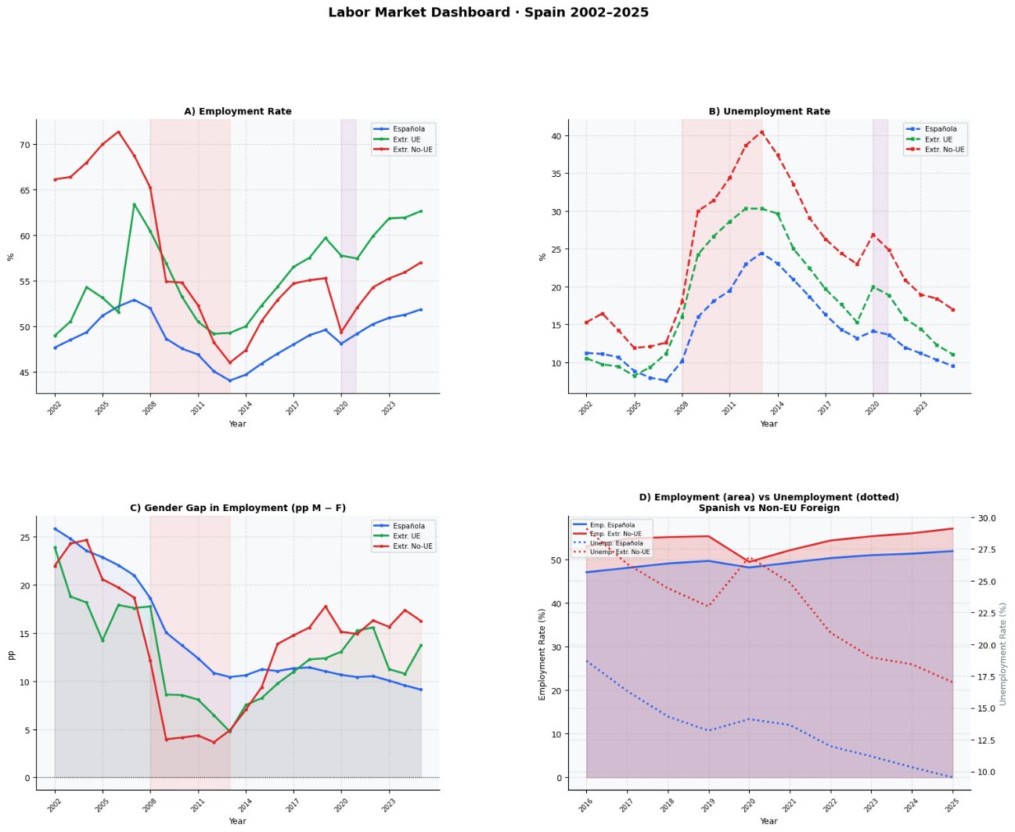
Figure 14: Employment rate by nationality and sex in Spain, 2002-2025

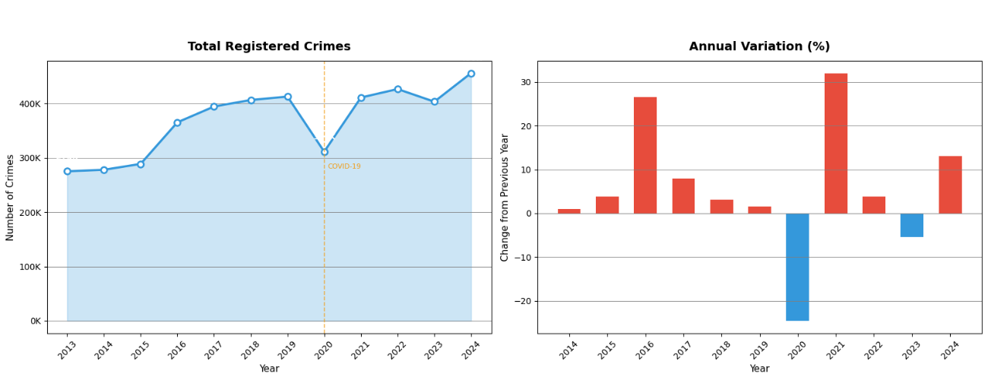
Figure 15: Labour market indicators by nationality in Spain
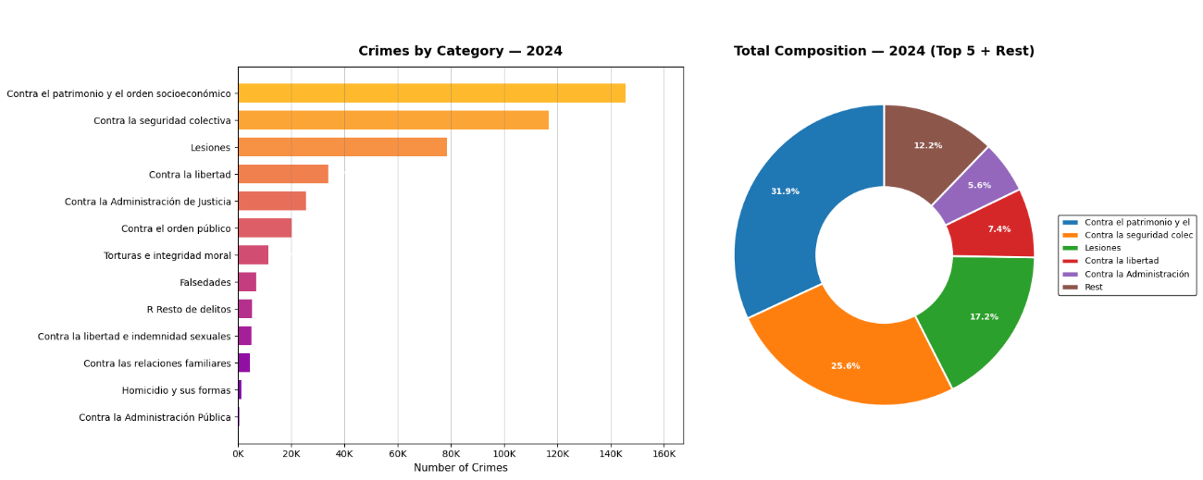
Figure 16: Evolution of total registered crimes in Spain

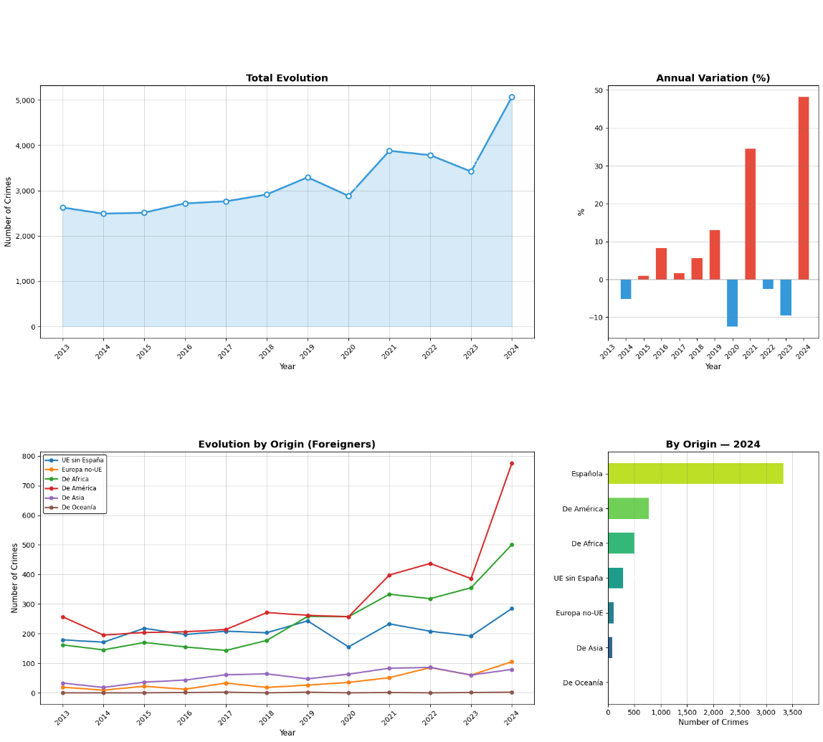
Figure 17: Crime categories in Spain in 2024

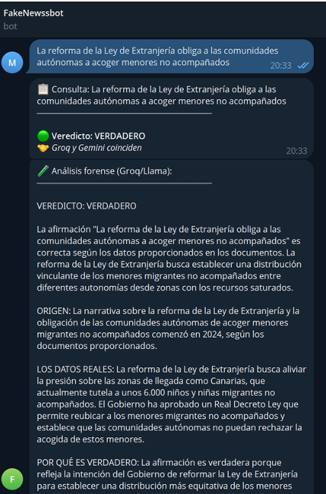
Figure 20: Example of the bot answer to a news headline classified as true


Figure 21: Example of the bot answer to a news headline classified as false

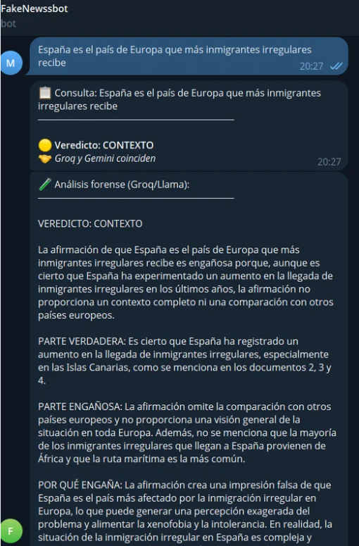
Figure 22: Example of the bot answer to a news headline classified as context

9. Table Index
- Table 1: Feature comparison with existing systems
- Table 2: Illustrative examples of the CONTEXTO class
- Table 3: Hyperparameter configurations for both models
- Table 4: Model comparison trained on the full dataset
- Table 5: BETO training results per epoch (validation set)
- Table 6: XLM-RoBERTa training results per epoch (validation set)
- Table 7: User validation results across profiles

