**Assignment 6: Forms**

**Description**

This week, you'll be practicing your form skills: Build and style the form in the screenshots. The form you build must include at least three different types of HTML form elements and some light CSS styling. Your form needs to be responsive.

**Real-World Applications**

* Be able to apply the proper HTML and CSS styles to create a modern web form
* Revisit applications and projects to iterate on code you've written

**Technical Requirements**

* Use at least three different types of HTML5 form elements: input, textarea, select, radio button, dropdown,checkbox
* Style forms lightly using CSS
* Use responsive media queries to allow for proper rendering on mobile devices

**Bonus**

* Use jQuery and display an error message if any of the input fields are left blank upon submission
* To replicate application flow, add another page that says "Thanks for Relaxing with us!" after submission

**Resources**

* [W3Schools: Form Elements](http://www.w3schools.com/html/html_form_elements.asp)
* [W3Schools: Input Types](http://www.w3schools.com/html/html_form_input_types.asp)
* [MDN: Styling HTML Forms](https://developer.mozilla.org/en-US/docs/Web/Guide/HTML/Forms/Styling_HTML_forms)
* [Webdesign.com: Form Validation with CSS3/HTML5](http://webdesign.tutsplus.com/tutorials/bring-your-forms-up-to-date-with-css3-and-html5-validation--webdesign-4738)
* [CSS-Tricks.com: Tips for Creating Great Web Forms](http://css-tricks.com/tips-for-creating-great-web-forms/)
* [jQuery API Docs: .val( ) function](http://api.jquery.com/val/)

### Evaluation / Submission

Create a new repository for your assignment. When ready for evaluation, students should push their code to the appropriate repository. Instructional team should evaluate against the solution code and the student's use of technical elements. They will provide a numeric grade on a scale: does not meet expectations (0); meets expectations (1); exceeds expectations (2). **Note**: If bullet points have child bullets, the instructional team should grade the child bullets and not the parent bullet belonging to the child; also, if students decide to build a form as part of their final project, it should be graded as part of the final project. The maximum possible score on this assignment is 10/10. Bonus sections are completely optional.

Desktop view

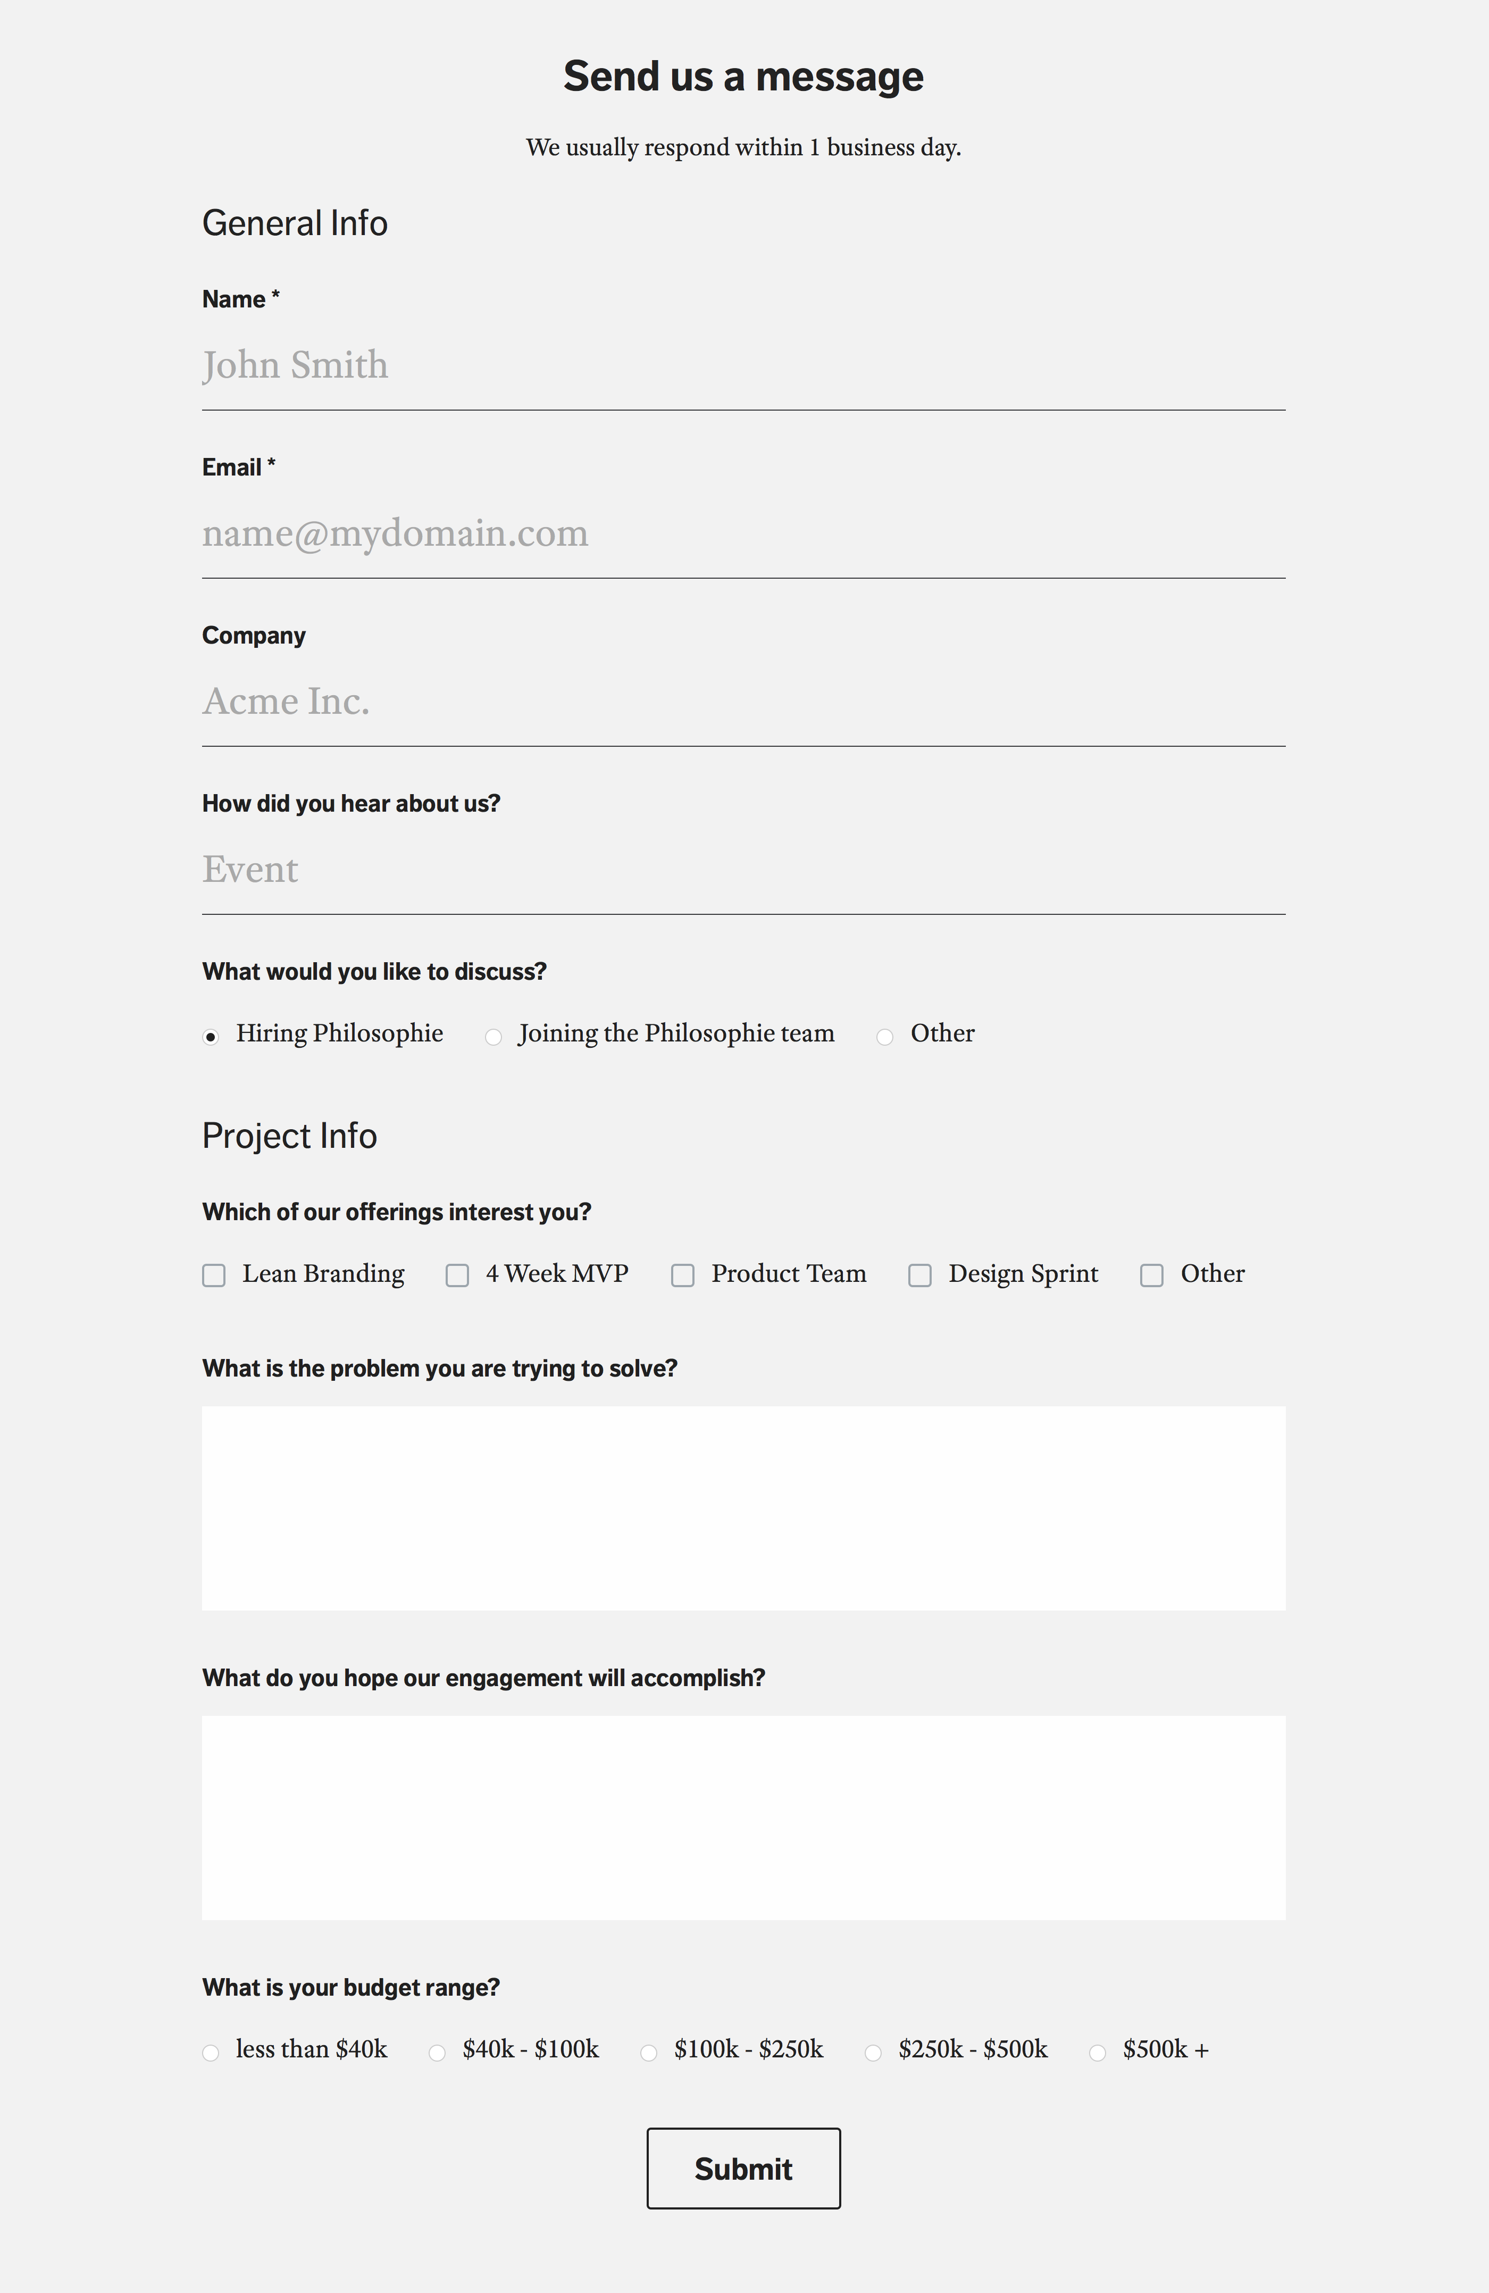

Mobile view

