**CS 245: Object-Oriented Programming**

**Homework due Friday, March 11 at 6pm**

**Face Tiles**

Yes, this is indeed the marriage of your two most recent projects, FaceDrawer and Tiles. It might seem like I must be running out of ideas. But, there is great value to see how easily you can redeploy the objects of the classes you’ve built for different purposes. This assignment gives you a chance to experience that.

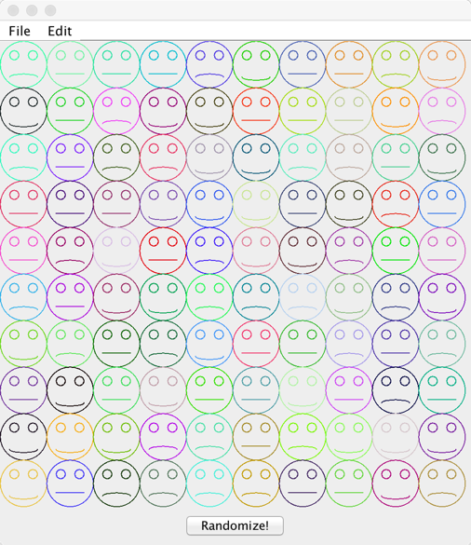

The application draws a set of 100 faces arranged in a matrix of 10 rows and 10 columns. The faces are randomly generated using a class called FaceRandomizer. Clicking the Randomize button at the bottom will change the faces to random smiles and colors.

The application also features a main menu. The File menu has two menu items, Save and Exit. The Save menu item saves information about the faces (their row, column, mouth type, and color components, all of which are included in the Face class’ toString representation) to a file named faces.txt. The Exit menu item closes the program. The other menu on the main menu bar is the Edit menu. The Edit menu has a Randomize menu item that does the same thing as the Randomize button at the bottom of the frame.

You will need to modify or define the following classes.

|  |  |
| --- | --- |
| Face | The model class, this stores each face’s row, column, mouth type (sad, happy, or indifferent), and color. It also has corresponding constructors, get and set functions, and a toString function that lists the values of all the private data members of the class. (3 points) |
| FaceTileFrame | The heavyweight component that houses the panel of faces as well as another panel that features the Randomize button. (3 points) |
| FaceTilePanel | The panel that occupies most of the FaceTileFrame and paints and displays the set of faces. Its paintComponent function will be responsible for rendering each face in its proper place with the proper color and attributes. (4 points) |
| FaceIO | This class is able to write the list of Face objects to the console window as well as to a file. (3 points) |
| FaceRandomizer | Has functions called buildFace and changeFace to create and change a Face, respectively, as well as changeFaces to randomly change a whole list of faces. (3 points) |

In addition to these graded items, you must

* submit your program on Blackboard as FaceTiles_LastName.java (1 point)
* comment your code sufficiently (1 point)

So, all together, this program is worth 16 points.

Some additional grading notes:

* if you program fails to compile, you will be penalized 8 points
* if you program crashes while running, you will be penalized 5 points
* if you copy your code from someone else or from online, as determined by MOSS and Internet searches, you will be penalized the full value of this assignment.

**YOU MUST DO THIS GRADUALLY, A LITTLE AT A TIME, or you will not finish it.**

Please let me know if and when you need help with this. **AGAIN, DO IT GRADUALLY, STARTING TODAY.**