Analyst agent for TS
This is a plugin to be added to the list of plugins available in the TS. In the first pass, it is not a separate component, it is a new feature aimed at:

- Making visualizations more flexible.
- Allowing advanced data exploration and analysis
- Facilitating interpretation of results

Motivation:
Running these models in the “smart” way, requires analysis and planning. This is not a tool that has the backup of Petrel or other software that can complement that. Basically, we only use spreadsheets. We have put effort in improving the usability and those efforts have paid remarkably off but there is always the need of some extra insight, some additional analysis (surveillance plots, correlations, etc). In the understanding that we cant cover every request/need by explicitly programming it, it becomes apparent that an agentic assistant that can could cover the gaps would be of great use.

Proposal:
The agent component:
An agentic system that runs behind the scenes as part of the Waterflood insights application. The agent is aware of the user selections in the UI, and basic concepts.

- The system allows then users to query historical data and simulation results and produce visual insights in response. The insights can be: 1. One or more charts. 2. One or more tables. 3. A textual response. These responses are expected to be conversational and presented in a chat-like control.

- The system is complemented by a database of pre-programmed visualization insights that should cover some of the standard surveillance charts in RE. There is a clear purpose of this component: Do not delegate to an agent the important visuals that we know in advance and hence can secure that those are produced to a high standard.

- The agent will then add the extra capabilities to produce custom analysis.

- The agent is also provided with the tools to describe the current project, and to launch workflows in the application under precise instructions.

Although the final look and feel will need to be designed, Figure 1 shows the first prototype embedded as part of the current graphical interface. Figure 2, highlights the idea that the agentic system is aware of the main concepts and state of the WF application.
Note in Figure 1 that the WF application might differ from other classical Dataiku applications where the flow of information follows a prescribed path. In WF insights, users can have several projects, each project can have multiple studies, a different dataset and each study can have its own parameters. The users can switch between projects and models in the UI. This feature motivated the clarification in Point 1 above (under proposal). As we don’t plan to preserve the state of the agent-related content across changes in the project selection.

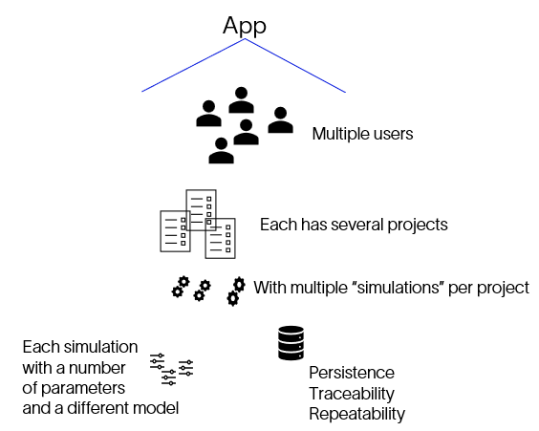 | 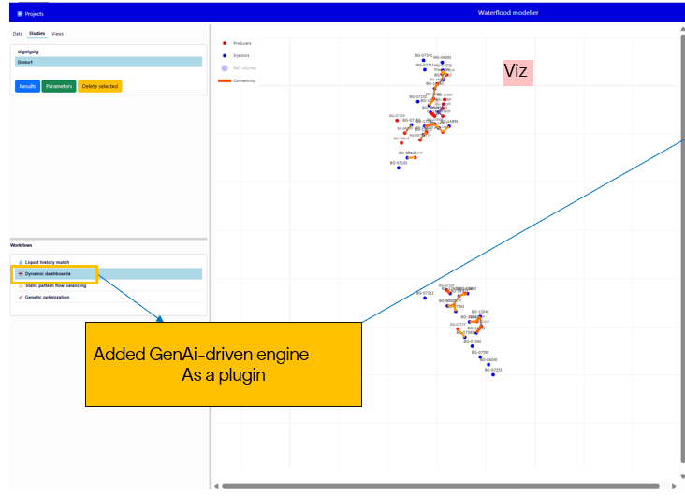
Figure 1. The new component is to be added as a feature of the current application

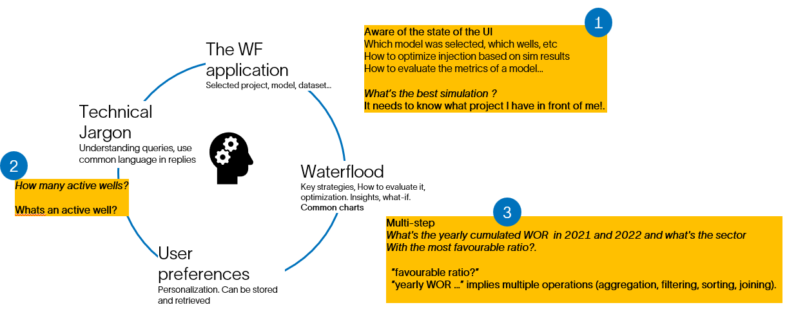
Figure 2. The agent is aware of basic concepts, technical jargon and the state of the application (project selection, filters)

The dynamic dashboard component:
The agent describe before has a wide-scope and was the first proposal in this initiative (can compare simulation results, launch workflows, etc). Yet, in terms of analytics, it is apparent that there is a subset of These insights can be collected in a “dynamic dashboard”, thus making the dashboard a fully customizable component. In the first version though, we don’t expect the dynamic dashboards to preserve their status across sessions or changes in the project selected (see Figure 1 for clarification).

Part 1:
Comprises two parts, in the first one, the user can create a “shopping list” of pre-configured surveillance or diagnostic plots, some of which might require a small (3-4) number of parameters. Once the shopping list is complete, the dashboard is generated. Figure below shows the first mock of the feature.
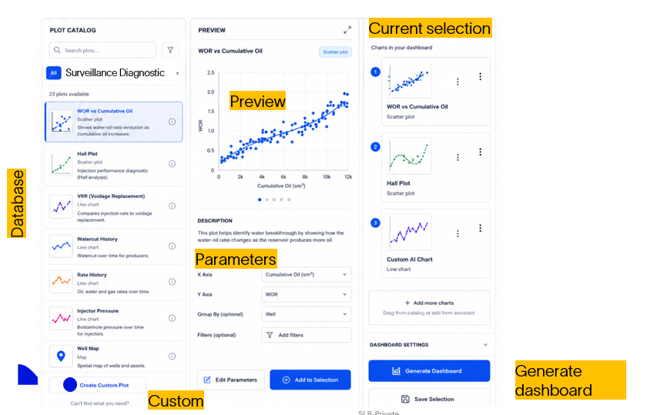
Figure 3. Mock of the feature. The component has 2 parts. Part 1 is a database of analytics that the user can select as a “shopping list”, The second part is an assistant for customized analytics (Part 2, below)
Part 2: The user is directed to the bottom of the control when the “Custom” button is selected. The figure below shows the main idea: Here, an agent is available to provide custom analytics. Analytics of the type “chart” can be added as part of the shopping list to produce the final dashboard.
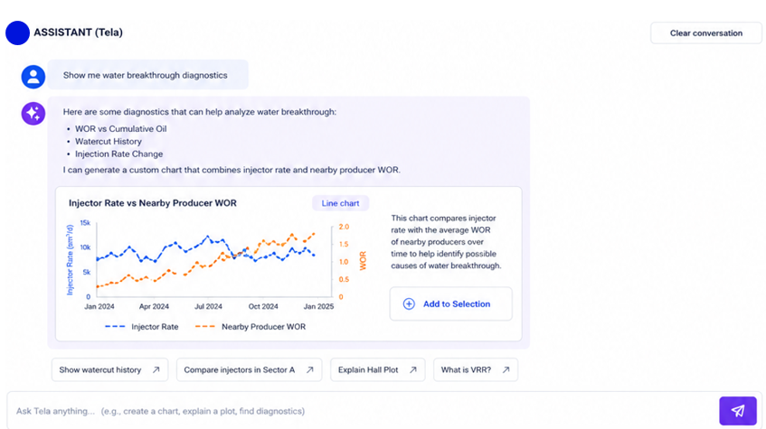
Integration with the current application
The overall functioning of the application is expected to be largely the same (figure below). There, selections of workflows (such as running simulations, or the dynamic dashboards) are selected at the bottom-left, just like in Petrel’s process pane. Configuration of those processes are done in a large component at the right, while keeping a visual on the map. Results of executing these are always displayed in their own window. The same process will be followed here except that, due to the expected need of a large display for the dashboards, a new tab will be added next to the tab displaying the map. Figure below shows the expected user journey.

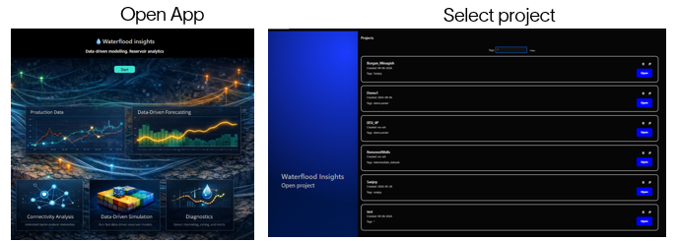

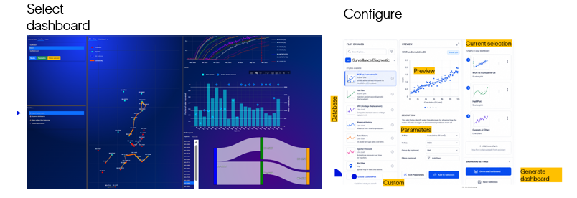

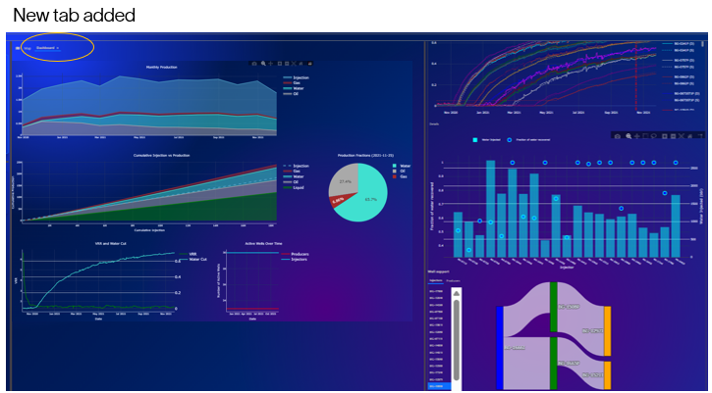

The dataset
As pointed before the agent is “aware” of the TS and the state of the UI. In the same sense it is aware of the data that the application consumes. This could be extended in the future.

