Contents
The analyst component (charter for historical data) 1
Current capabilities 1
Golden queries 1
Automatic tests 3
Some examples 3
Example 1: Complex grouping 3
Example 2: Multiple tables 3
Example 3: Memory 3

The smart-event and root-cause a component

The analyst component (charter for historical data)

Capabilities

Getting a sense of latency:

"List 10 countries in Asia and their capitals" | 10 seconds Evening  1.1 seconds Late night
“Tell me the total water injection volume by quarter and subzone aggregated across all years since 2018” | 45 seconds. Evening  4 seconds Late night  Took 38 seconds to execute up to the point where all the data was retrieved and processed just before the charting. It took nearly 7 seconds of planning the visualization and about 0.5 seconds to produce the chart.

The table above compares the time to response for two queries. The first one is considered trivial. It requires not tool calls, agents or any cognitive load. We take the time reported (10 seconds) as the latency. The response for a more complex query could be 5 times longer. Note that latency varies during the day. It could be as low as 0.4 seconds. Yet the relation 45-10 is more or less constant.

Golden queries

30 queries of different complexities were generated to test the charting capabilities. 8 queries involve only injection data, 8 involve only production and the rest involve combination of the former and geolocation data. The queries are listed below:

Injection data only:
This document summarizes a set of representative analytics queries together with estimated complexity, expected execution/planning time, and expected success rate.

Query ID | Query | Complexity | Time | Success
query1 | how many wells are there? | Low
query1.2 | what proportion of those are injectors | Low (follow-up)
query2 | What is the total water injection volume by year? | Low
query3 | Tell me the mean yearly water injection volume for each subzone | Medium
query3.2 | Tell me the total water injection volume for each subzone each year | Medium
query4 | rank wells by their variability (std) in water injection volume (the higher the greater the rank)? | Medium
query4.2 | whats the highest ranked well? | Low
query5 | whats the frequency of observations in the dataset (D, M, Y)? | Medium
query6 | summarize the injection data | Medium
query7 | Which well had the single highest WATER_INJECTION_VOLUME reading at any point in time and what was that reading? | Medium
query8 | What is the average monthly injection volume per well grouped by NAME and MONTH? | Medium
query9 | For each SUBZONE compute the year-over-year percentage change in total injection volume and report the largest drop | High
query10 | For each injector well, calculate its total water injection volume and join it with the well location information. Return a table with the well name, total injected water, latitude, longitude, and any available location/type fields. | High
query11 | Create two separate tables: one ranking injector wells by total water injection volume, and another ranking producer wells by total oil production volume. | High

Automatic tests

Some examples

Example 1: Complex grouping
Query "Tell me the total water injection volume for each quarter since 2018 split by subzone and year"
(this is a golden query)

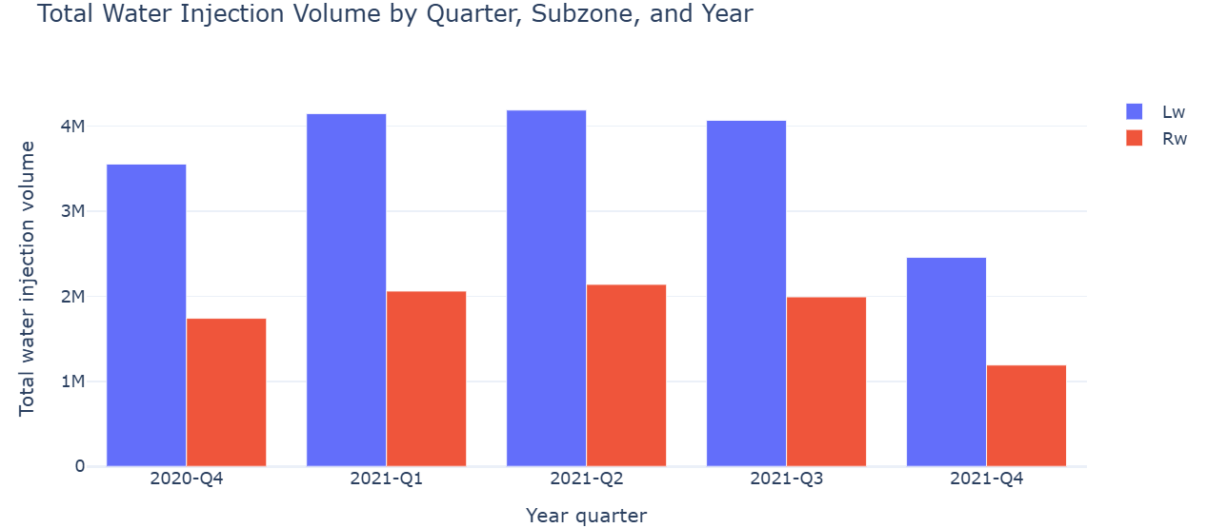

The complexity of this example lies in that there are three categorical variables to display. The x labels 2020-Q4, 2021-Q1, etc. Were generated and sorted by the analyst agent. The presented also checked the grouping.

Example 2: Queries involving multiple tables

Example 3: Memory

Development notes: Why some things were done in that way

