**Instructions to setup and run the kurtosis detector**

X. Mouy  
9 Nov 2023 (updated 16 June 2025)

# Download the python scripts from GitHub

1. Go to the GitHub repository: <https://github.com/xaviermouy/KurtosisDetector>
2. Option 1: Use Git to clone the repo on your local machine
3. Option 2: Click green button “Code”, then “Download ZIP”  
   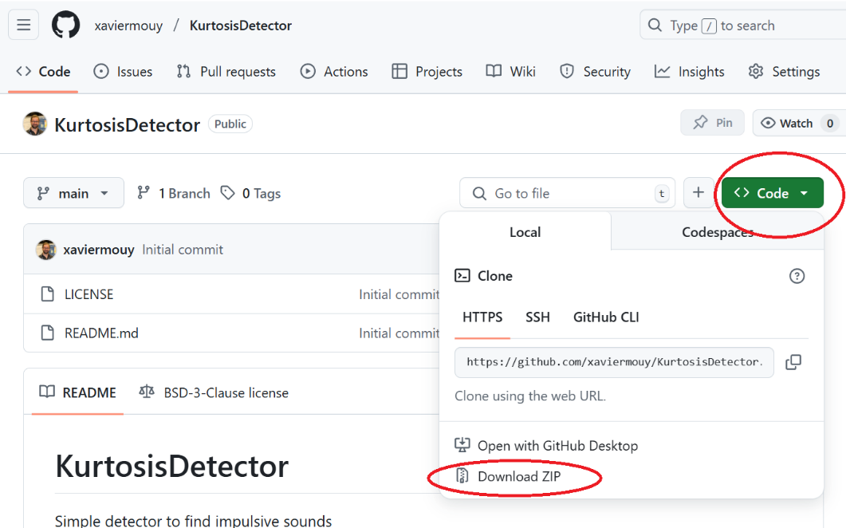

# Setting up the python environment

The following steps need to be done only once.

1. Download and install Anaconda: <https://www.anaconda.com/products/individual>
2. Launch Anaconda Navigator  
   Graphical user interface, application

   Description automatically generated
3. Click the Tab “Environments” on the left and click the “create” button at the bottom.Graphical user interface, text, application, email

   Description automatically generated
4. Create a new environment with Python 3.8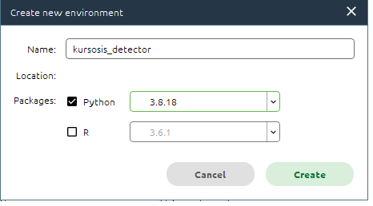
5. Once the new environment is created (it can take several minutes), click on the green triangle at the right of the new environment and select “Open Terminal”.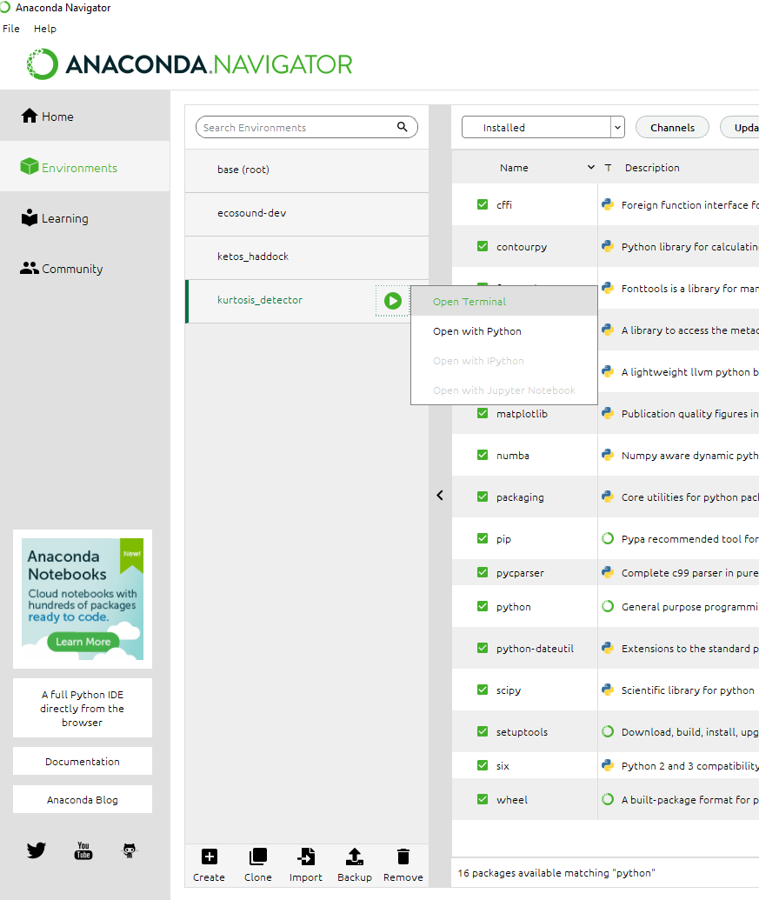
6. In the terminal type these command lines to install all the dependencies (one at a time):

* pip install fastdtw
* pip install soundfile
* pip install matplotlib
* pip install scipy
* pip install pandas
* pip install numba

# Configuring the detector

1. Open the file “config.ini” located in the “config” folder with NotePad++  
   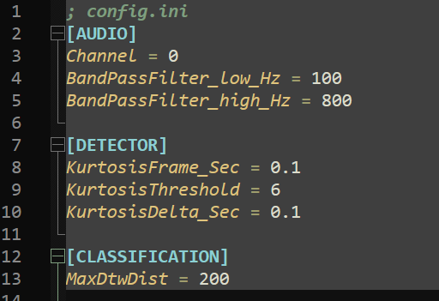
2. Modify the AUDIO parameters to your need
   1. Channel: channel to process. Starts at 0
   2. BandPassFilter_low_Hz: minimum frequency of interest in Hz
   3. BandPassFilter_high_Hz = maximum frequency of interest in Hz
3. Modify the DETECTOR parameters to your need
   1. KurtosisFrame_Sec: length of the analysis window in sec (should be greater than the duration of your signal of interest)
   2. KurtosisThreshold: Threshold to consider a detection. Typically a value greater than 3 (which is the kurtosis value of a Guassian distribution). High values of kurtosis mean highly impulsive signals (inside the analysis window)
   3. KurtosisDelta_Sec: Minimum time in sec between consecutive detections. Often used to avoid detection of echoes.
4. Set the MaxDtwDist parameter in the CLASSIFICATION section to a high value (eg. 1000). It was used a some point to perform classification but should be ignored now.

# Running the detector

1. Open a terminal window in Anaconda Navigator under the “kurtosis_detector” environment (see step 5 above).
2. Change the current directory to the where the detector script is. For example in MS Windows, type:

***Z:***

***cd Z:\STAFF\Xavier\kurtosis_detector***

where Z:\STAFF\Xavier\kurtosis_detector is the path of the kurtosis detector script “main.py”

1. Run the detector using the following syntax:

***python main.py <audio_folder> <output_folder> ./config/config.ini ./config/template_2006.csv --recursive –raven***

Change <audio_folder> and <output_folder> with the path of the audio data, and the results folder, respectively.

For example:

***python main.py "\\nefscfile\stellwagen\ACOUSTIC_DATA_NEW\NEFSC_MA-RI_202304_NS03_ST\6125_64kHz_UTC" "\\stellwagen.nefsc.noaa.gov\stellwagen\STAFF\Xavier\kurtosis_detector\results\Pile_driving_NEFSC_MA-RI_202304_NS03_ST" ./config/config.ini ./config/template_2006.csv --recursive --raven***

The detector will create one Raven table file (.txt) for each file that has detections

# Creating detections summary and spectrogram

The following steps describe how to create 1) a spreadsheet summarizing the number of detections per audio file and 2) spectrogram images of the detections

1. In a text editor (e.g. NotePad++) open the file Compile_detections_to_spreadsheet_pile-driving.py
2. Update the variable “detec_dir” and “audio_dir” with the path of the audio data and detection results folders, respectively. If needed, also update the variable “audio_file_ext” with the extension of the audio files of interest.

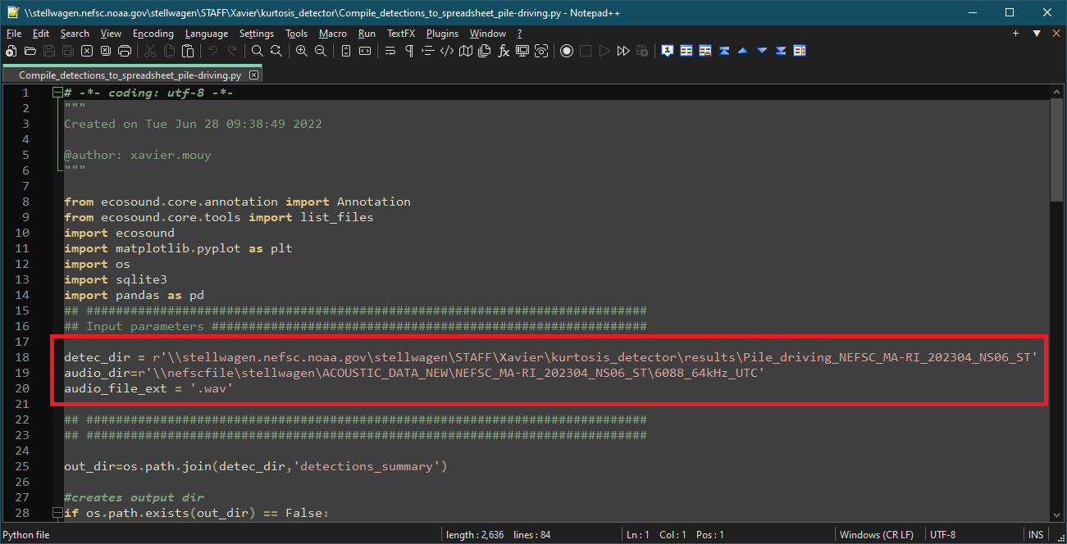

1. Save the changes and close the text editor
2. Open a terminal window in Anaconda Navigator under the “kurtosis_detector” environment (see step 5 at the top of this document)
3. Change the current directory to the where the detector script is. For example in MS Windows type:

***Z:***

***cd Z:\STAFF\Xavier\kurtosis_detector***

1. Type:

***python Compile_detections_to_spreadsheet_pile-driving.py***

The script will create a folder “detections_summary” with spectrogram images of each detection for each audio file processed.  
 