Ecosound Explorer: Instructions   
X. Mouy  
Initial draft - 7 Dec 2022

* Updated 27 June 2025 – Sophie Ferguson

# Purpose of this document

These notes provide instructions on how to setup and use Ecosound Explorer. This document was primarily written for the dolphin analysis of the MA-RI paper, but these instructions can be used for other analyses as well.

# Requirements

Before using the software you need to:

* Have Anaconda installed - C:\Users\Public\Public Programs
* Map \\nefscdata\PassiveAcoustics as the Z: drive

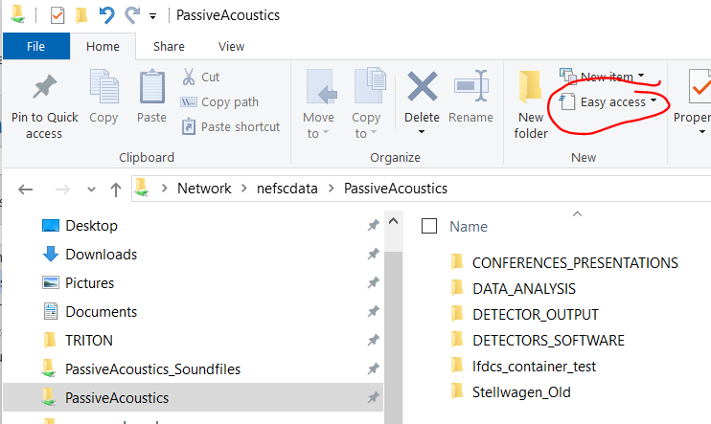

* Copy the folder Z:\Stellwagen_Old\MANUALS_SOFTWARE_CODE LIBRARY\SOFTWARE\SOUND ANALYSIS SOFTWARE\ECOSOUND locally (e.g desktop or documents)

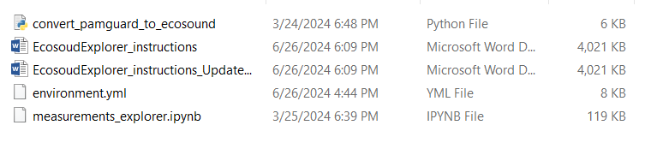

# Setting up Anaconda

*6 June 2024 - This section of the protocol has been updated due to an error encountered caused by an update in the numpy package (**ImportError**: numpy._core.multiarray failed to import)

This only needs to be done once. However, here are the required steps to setup Anaconda, should you need to replicate the setup on another computer:

* Open Anaconda Navigator (version 2.5.2)
* Click on the “Environments” tab on the left
* Click “Import” on the bottom left
* Navigate to Z:\Stellwagen_Old\MANUALS_SOFTWARE_CODE LIBRARY\SOFTWARE\SOUND ANALYSIS SOFTWARE\ECOSOUND on the local drive
* Open environment_C6PO.yml
* Rename (e.g ecosound, ecosound_dolphins, etc) and click import
* Once this is imported you can continue to launce ecosound explorer

# Launching Ecosound Explorer

* Open Anaconda Navigator
* Select the “ecosound” environment form the drop-down menu at the top

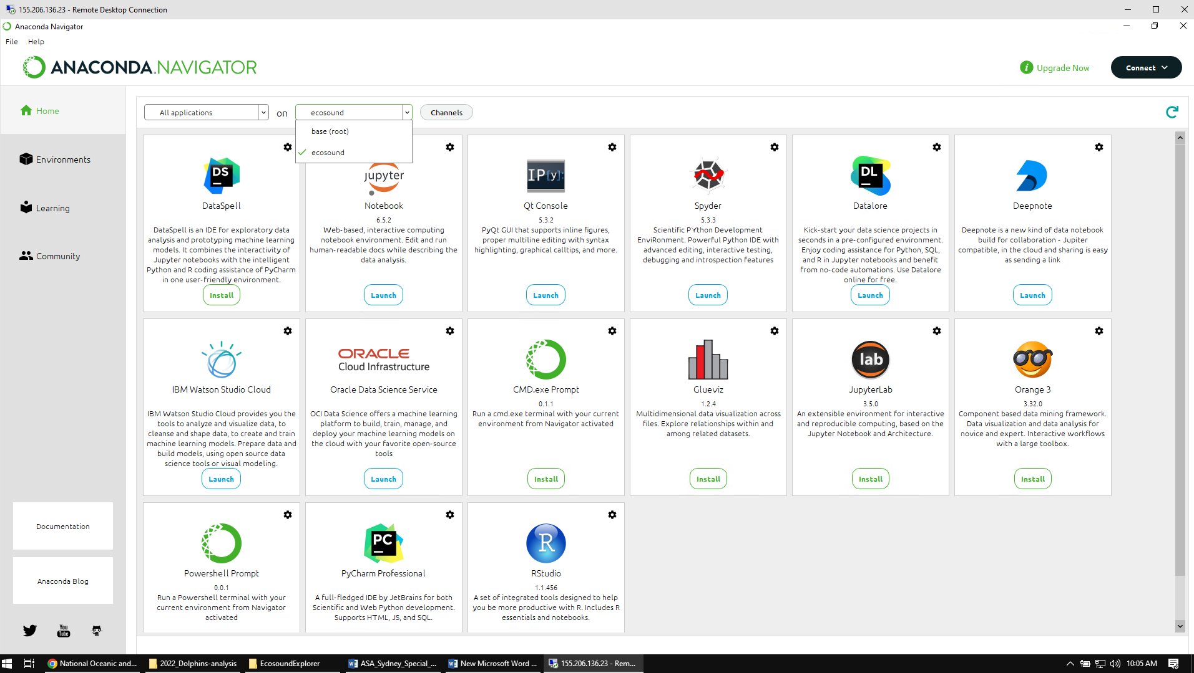

* Launch Jupyter Notebook (version 7.0.8). It will open in your web browser.

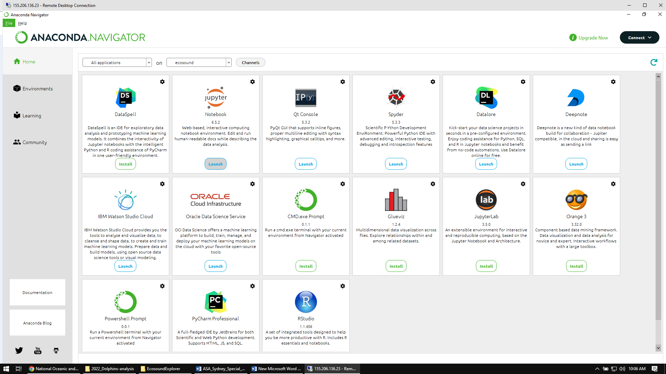

* Navigate to the folder “ecosound_explorer” (see section 2), and click on “measurements_explorer.ipynb”. It will open a new tab with the Notebook.

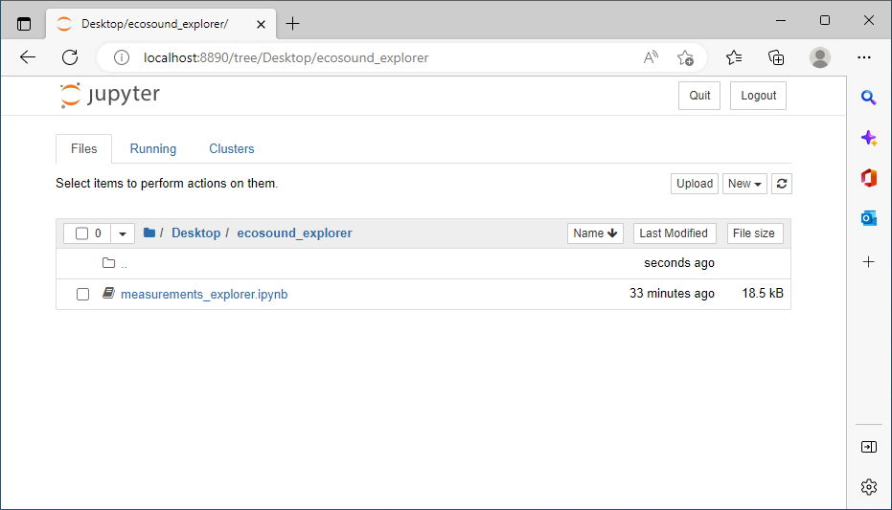

* In the Notebook, change the path of the data_file variable to the .nc file of the deployment you want to analyze. For this project, the .nc files for each deployment are in Z:\DATA_ANALYSIS\NEFSC_MA-RI\Dolphin_detector_development\EcosoundExplorer\.

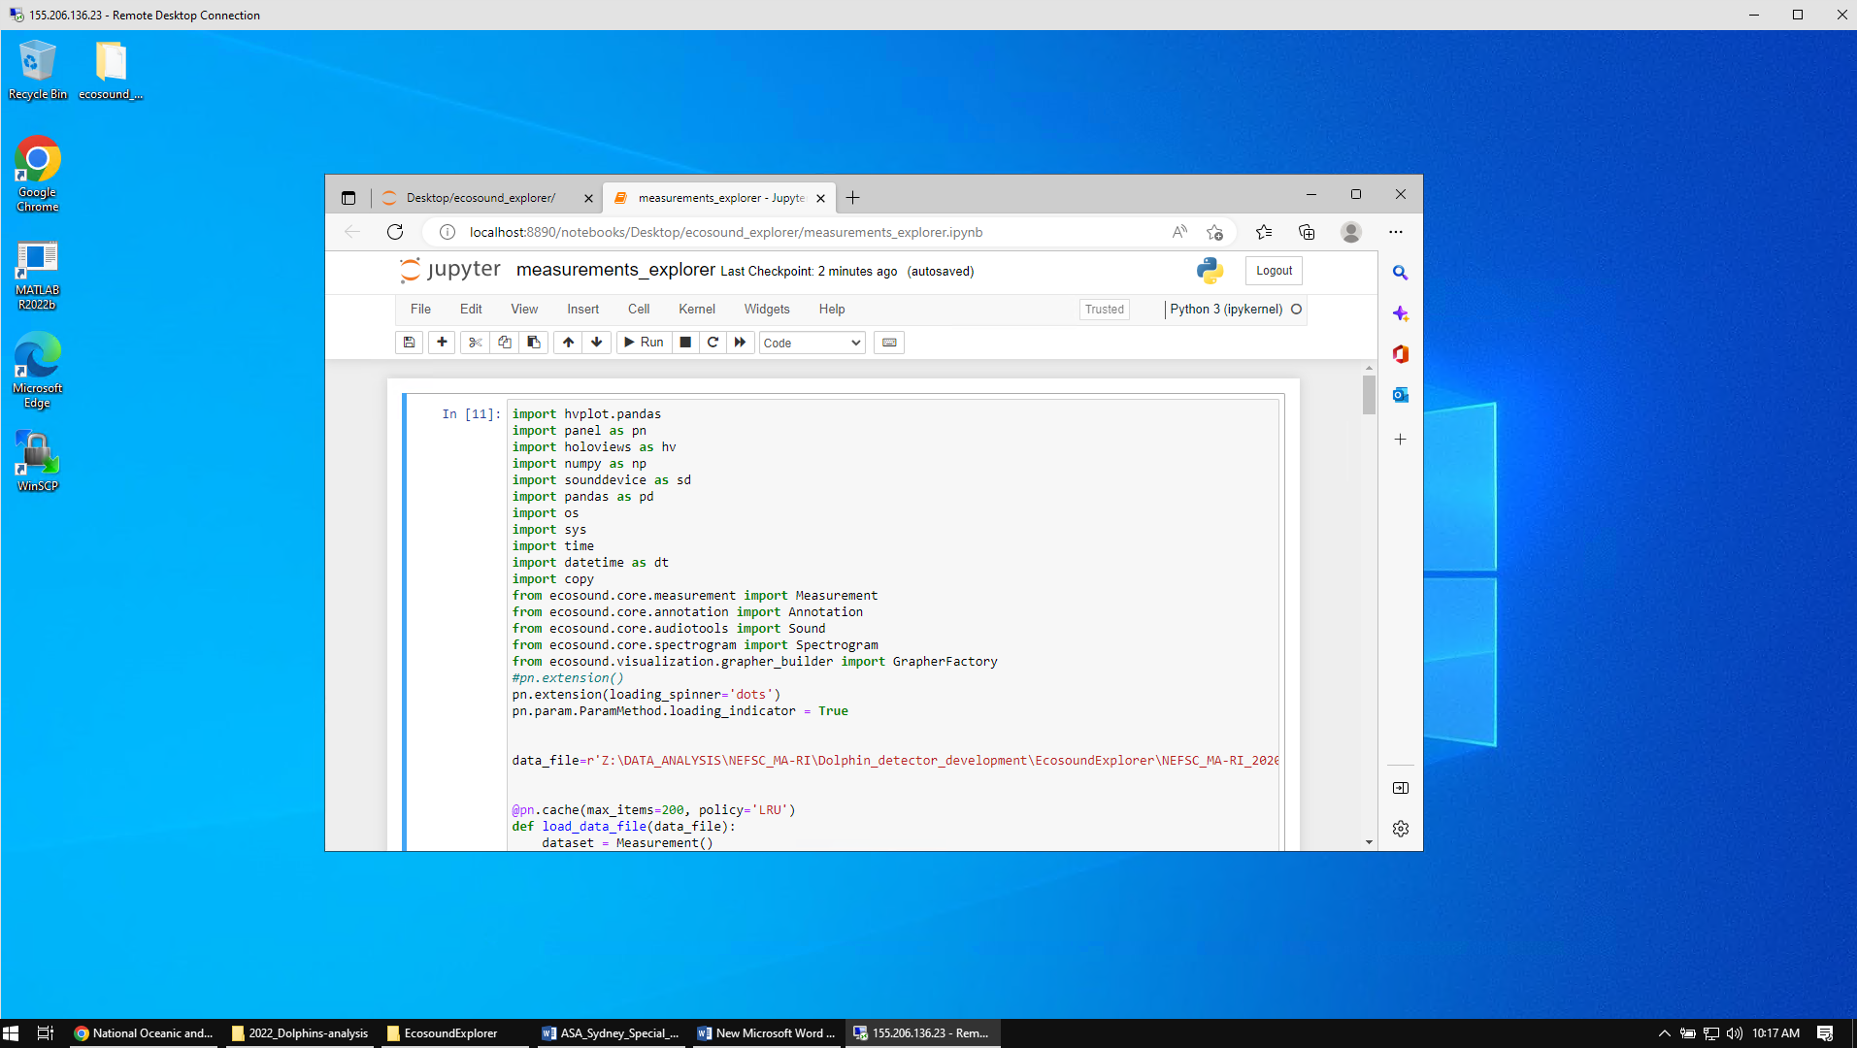

* Click on the save button, then on the Run button. It will take a few seconds for Ecosound Explorer to launch in a new tab. Note that the hour glass icon at the top of the tab indicate that it is “thinking”. If nothing happens and that there are not hourglass icon, then press again on Run and/or check that there are no errors displayed at the end of the notebook.

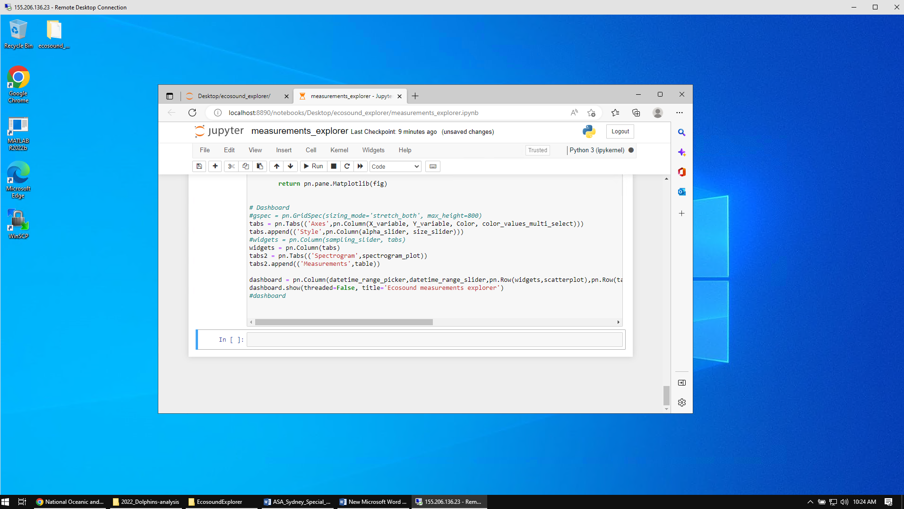

* Ecosound Explorer should open in a separate tab and should look like this:

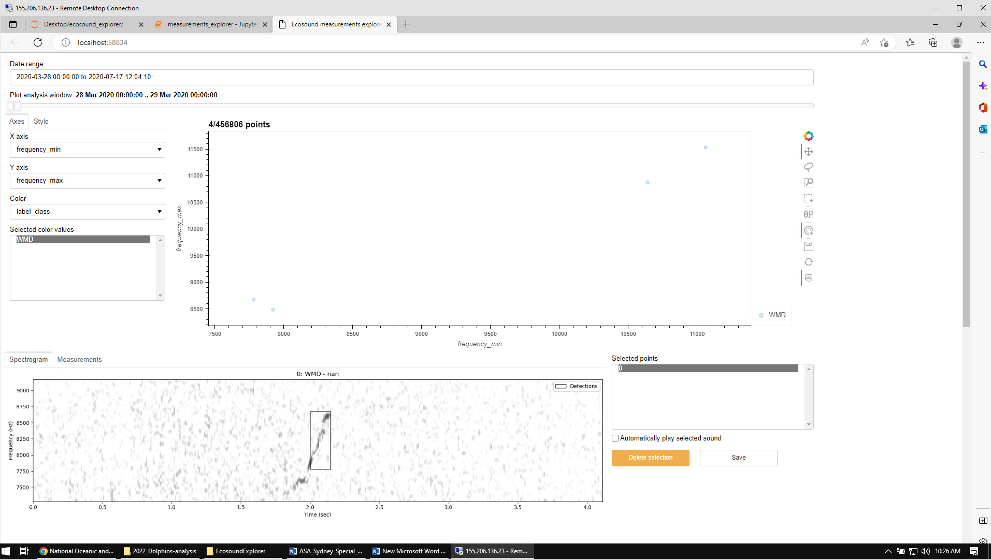

# Using Ecosound Explorer

* Go to the tab “Style” on the left and adjust the Point transparency and Point size to you liking

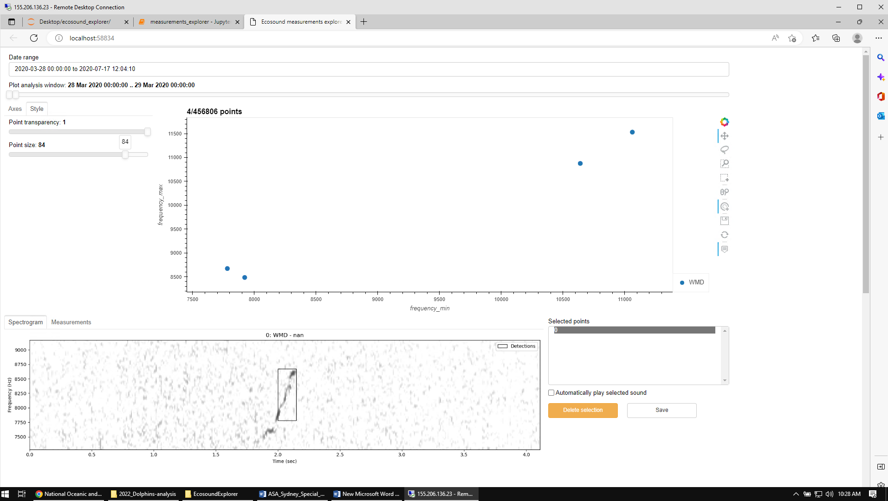

* In the Date Range control at the top, select 1 day of data. Note that it goes from midnight to midnight, so you need to select 2 dates.

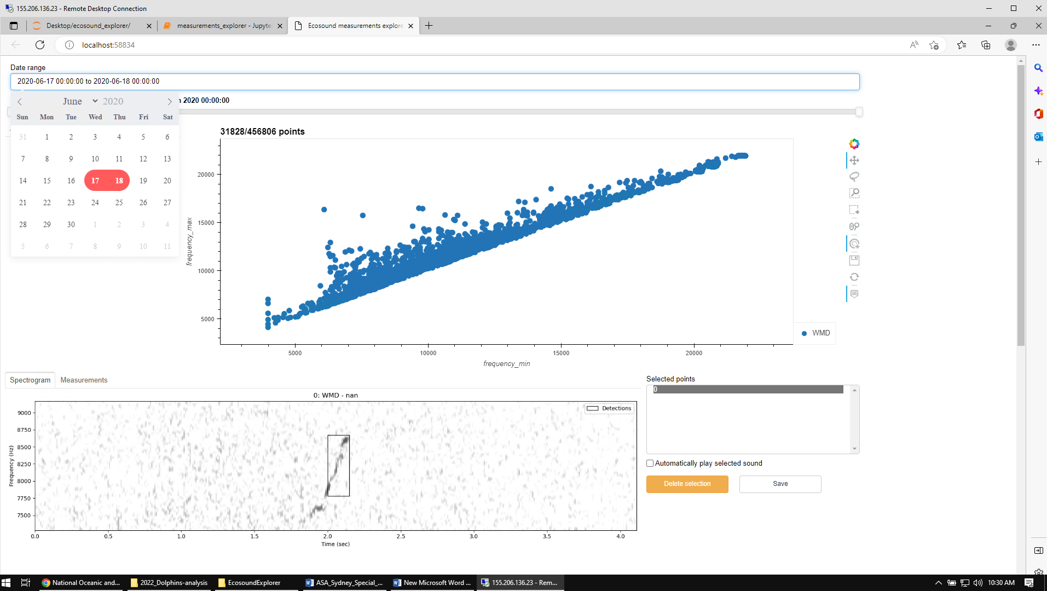

* By default it will show the entire day of data. But you can restrict the time range shown in the graph by adjusting the “Plot analysis window” slider.

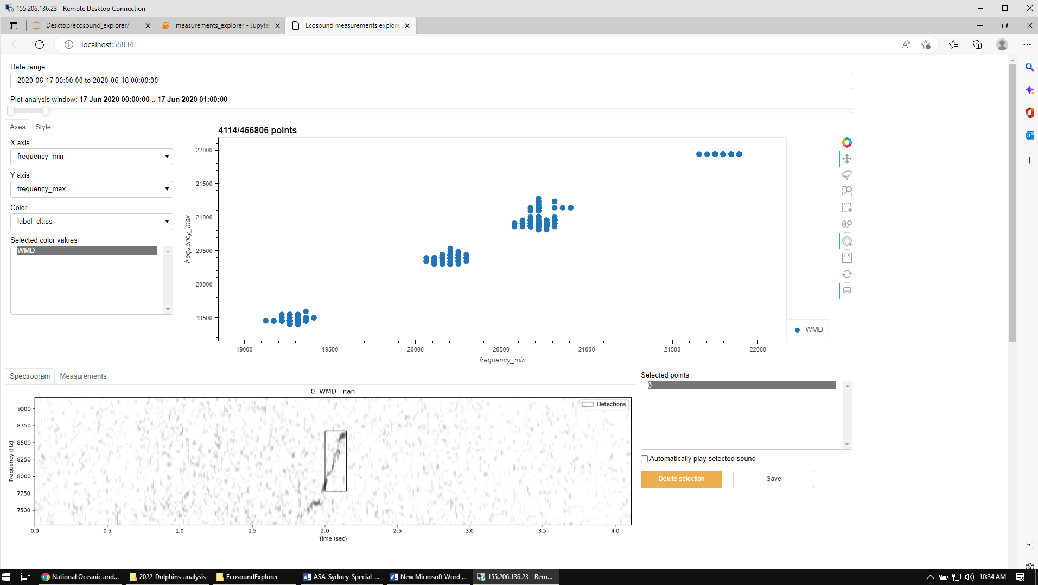

* In the “Axes” tab on the left, select “frequency_bandwidth”, “Duration”, and “frequency_bandwidth” for the X axis, Y axis, and Color menus, respectively.

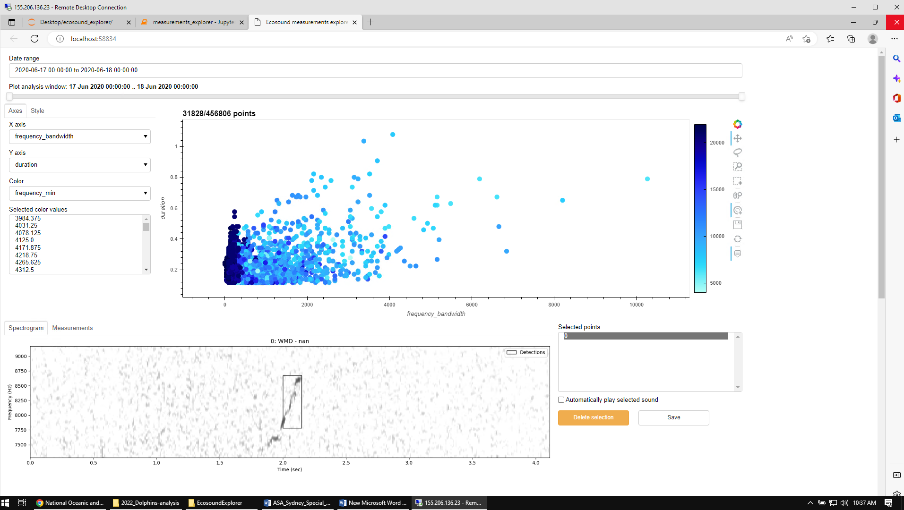

* With the mouse, click on any point in the plot to display its spectrogram. You can tick the check box “Automatically play selected sound” to listen to the sound selected. Note that if several detections are selected, they will be listed in the “Selected points” window. You can select each of these detections by clicking on the different items in that list.

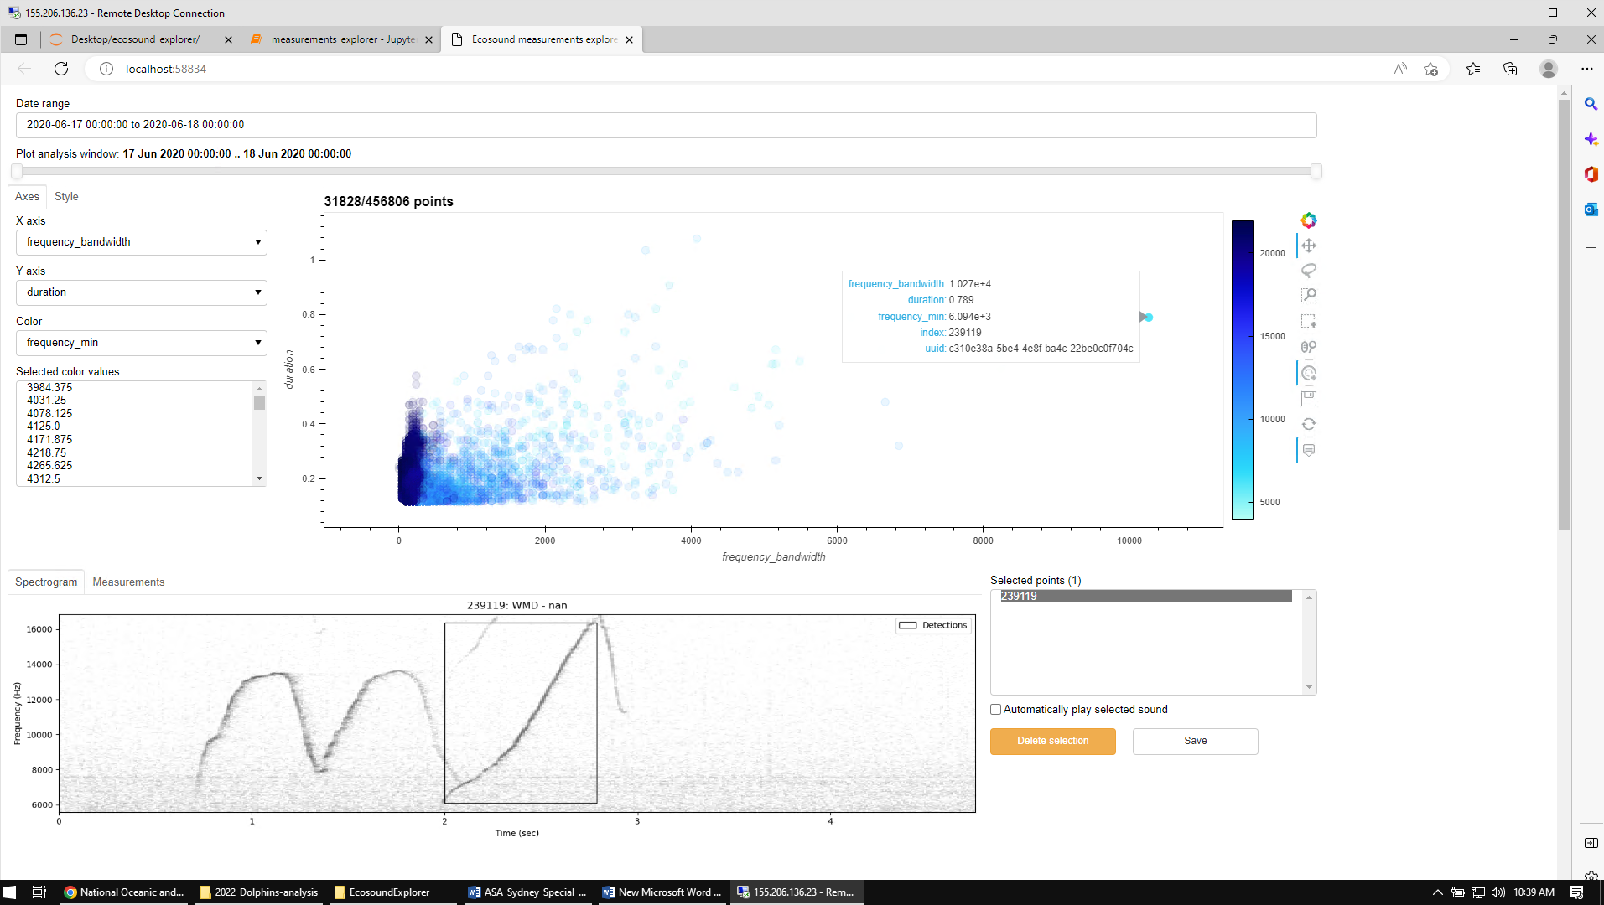

For zooming, and/or selecting several points, you can use the “Wheel Zoom” and “Lasso select” tools at the right of the scatter plot. To come back to the original plot settings, click the “Reset” button.

* Once a dolphin detection is confirmed, select another day and repeat the process.